

Financial Management for the Hotel Industry
BMIH5007

Case Study: The City Hotel

Student Name: Adriana Mitran
Student ID: 1920087
Lecturer’s Name: Tristan Hawkins
Word Count: 2151

Executive summary
This report evaluates the financial risks of The City Hotel, a business that has had its revenues, occupancy, and customer satisfaction that were down over the past few years. They have identified the reasons such as economic factors, market factors and internal factors arising from poor operational development. Therefore, it is proposed to develop a complete turn-around plan based on the integration of AI technology, and chatbots. This approach aims to advance guest interactions while seeking to minimize complexities and thereby improve the quality of service. Using technology appropriately ensures that The City Hotel can recover its lost financial strength and rebuild its image for sustainable development more competitively in a growing hospitality industry.

Table of Contents
Executive summary 3
1 Introduction 4
2 Scope and Objectives 4
2.1 Financial Performance 4
1.1.1 Revenue Trends 4
2.1.1 Expense Analysis 5
2.1.2 Profitability Ratio 6
2.1.3 Liquidity and Solvency Analysis 7
2.2 Key Issues Behind Declining 8
2.3 Turnaround Strategy 9
2.3.1 Bowman’s Strategy Clock 9
2.3.2 Ansoff Matrix 10
3 Conclusion 11
4 References 12

Introduction
The City Hotel is in a prominent urban landscape, and it is an establishing restaurant, bars, and event facilities. However, in the past few years, the City Hotel has a significant challenge in which they face declining revenue, occupancy rates, and customer satisfaction. The owner of the hotel is seriously concerned about the hotel's future viability and has sought expertise to determine an effective turnaround strategy that may salvage the operation of the hotel. This report aims to evaluate the key issues that contributed to the hotel's decline and propose an effective turnaround strategy.

Scope and Objectives

Financial Performance

Revenue Trends
The City Hotel income statement shows a troubling trend in revenue over the past three years,

Figure 1: Revenue Trend
(Source: Author)
The drastic decline in revenue from 2022 to 2023 represents that there is a surprising drop in hotels over 56%. There is a significant decrease in alarming and indicative of underlying challenges that need immediate attention. According to Deepika, (2022), the hospitality industry is experiencing a resurgence post-COVID-19, in which various hotels report and record the revenues that are driven by the increased demands for business travellers and vacations. In the other study Orîndaru et al., (2021), the travel industry recovered from the pandemic of COVID-19, and hotels have increased in guests and income because people wanted to travel and enjoy their lives again without any restrictions that were lifted. However, the City Hotel was also able to gain this opportunity and there was an extreme decrease in its revenue raising concerns about its business approach and finding how they operate its hotel effectively. In addition, issues such as poor marketing, limited services, and not consistently connecting with customers, are the basic issues that cause to drop the hotel revenue (Hayes et al., 2021). Consequently, when the new hotel enters the market, the competitors improve their services to maintain their customers, so this also causes the City Hotel to attract their guests.

Expense Analysis
Through the examination of The City Hotel's expenses, it is important to understand the financial challenges. Over the past three years, the following trends have emerged,

Figure 2: Expense Analysis
(Source: Author)
The graph shows that the Cost of Goods Sold and external expenses have decreased the revenues, but the costs on employees are still rather high. This effect may signify operational wastes, or the hotel has not reorganized in proportion to the decline in demand. As opposed to The City Hotel, many hotels in the industry, have managed to achieve improvements in Operational Expenses in the year 2023 and increase their Occupancy during the recovery stage. The City Hotel enhances its financial status by reviewing workforce and operations rationalisation. The company’s costs with revenue will help identify areas such as overstaffing due to high employee expenses against low revenues (Gurvich et al., 2019). The City Hotel need to choose the possible ways to cut costs without impacts on its customers’ satisfaction, as well as analyse modern tendencies. In addition, the industry is in the process of its revival after the crises and many of the contenders have improved their supply chains. Moreover, the staffing and operational strategies of the hotel and the proper budgeting helped the hotel recover from the downturn (Garrido-Moreno et al., 2021). This solving of expense issues is paramount for regaining profitability and achieving sustainable operations.

Profitability Ratio
To determine The City Hotel's Profitability, it can calculate the key financial metrics which include Gross Profit and Operating Income. The following calculations provide a basic understanding of the hotel's financial condition and the operating efficiency of the hotel over the past three years.
Gross Profit Calculation:
The formula for gross profit is:
Gross Profit = Revenue − COGS
Using the hotel’s revenue and COGS data:
2021
Gross Profit = £5,248,290 − £411,600 = £4,836,690
2022
Gross Profit = £5,307,480 − £401,510 = £4,905,970
2023
Gross Profit = £2,325,440 − £176,250 = £2,149,190
Operating Income Calculation
Operating income is calculated using the following formula:
Operating Income = Gross Profit − Employee Costs − External Expenses − Taxes and Duties – Depreciation
Calculating operating income for each year yields:
2021:
Operating Income = £4,836,690 − £1,724,760 − £1,894,720 − £144,070 − £409,190 = £664,160
2022:
Operating Income = £4,905,970 − £1,770,700 − £1,675,410 − £133,020 − £634,030 = £674,73
2023:
Operating Income = £2,149,190 − £1,233,160 − £1,071,030 − £88,950−£661,590 = (£1,218,850)
The above calculation shows that operating income became negative only in 2023. After such steady positive Operating income in the previous years, a huge loss implies certain operational inefficiency or mismatch in the market conditions. This negative operating income indicates that The City Hotel needs to apply strategies to generate sufficient revenue to supplement its operation costs. The City Hotel's comparisons with other successful hotels like Hilton or Premier Inn reporting a high increase in revenue per available room at the same time indicate the need for a more serious strategic review of its performance. Hospitality enterprises have recovered from COVID-19 impact but The City Hotel was not able to recover. To achieve better profits in the future, this hotel should ensure efficacy in its activities and strengthen its positioning. The use of strategic approaches in revenue management, changes in pricing and effectiveness of mobile distribution (Nagle et al., 2023). It may well go a long way in sustaining the occupancy rates and overall profitability of hotel chains. These problems remain obligatory for reaching positive results and achieving financial stability in a highly competitive economy.

Liquidity and Solvency Analysis
According to Kontuš and Mihanović, (2019), Liquidity ratios are significant in identifying the short-term financial health of the City Hotel, specifically as they represent the hotel's need to fulfil its immediate obligations. The current ratio helps to measure the capability, it will be calculated by using the following formula,

Current Ratio =$\frac{Current Assets}{Current Liabilities}$
For The City Hotel, the financial data shows the following:
Current Assets
Cash and equivalents decrease from the £740,590 in 2021 to £295,510 in 2023.
Current Assets
The current liabilities are increased from £1,957,360 in 2021 to £2,014,600 in 2023.
By taking these figures, it can be calculated as,
Current Ratio =$\frac{£295,510}{£2014,600}$
Current ratio = 0.15
This current ratio shows huge liquidity issues. A current ratio below 1 shows The City Hotel are in a poor position to meet its current obligations because its current assets cannot fully provide for the current liabilities. This situation is concerning because it implies that the hotel could face cash flow problems if immediate expenses arise. In addition to liquidity analysis, solvency is assessed using the debt-to-equity ratio:
Debt to Equity Ratio= $\frac{Total Equity}{Total Liabilities}$
The debt-to-equity ratio of The City Hotel has risen from 2021 to 2021 that is from 4.74 to 10.10. This significant rise indicates that the hotel making heavy use of debt for financing rather than equity. Leverage poses the firm with additional interest expenses and risks, more apparently during recession periods or low sales periods. Moreover, it may indicate in future the company may be unable to meet its long-term commitments, secondly, it may be faced with future solvency problems if the cash flows do not increase. According to Liebersohn et al., (2020), high-level debt means that many hotels struggle to service their debts mainly when revenues are low due to the downturn in business, such as low occupancy rates.
The City Hotel has several critical liquidity and solvency issues that need immediate consideration. There will also be a need to enhance the management of cash and effect a decrease in its usage from debt to enhance its solvency and sustainability for the future. Appropriate financial management and achieving the highest level of organisational performance are essential to restoration and further work.

Key Issues Behind Declining
Economic Factors
The post-COVID-19 recovery phase has been a challenging experience for the UK economy (Menoni and Schwarze, 2020). As the countries were able to recover less from their losses due to uncontrolled high inflation rates which has further eroded the consumer’s purchasing power. Moreover, when spending is reduced, different sectors such as the hospitality sector are highly affected. Additionally, other current developments suggest the low confidence of consumers and increased operating expenses as key drivers of the performance decline in the hotel sector and reduced occupancy rates (Ozdemir et al., 2022).
Market Positioning
The City Hotel could better balance its budget than its competitors. There are approximately 76 new hotels open in 2023 in major cities (Boutique Handbook, 2023), so the City Hotel may be unable to raise their prices and due to this, they lose their power from their competitors. This outcome raises questions about whether The City Hotel can provide enough perceived value as opposed to the competition which would not benefit its ability to attract guests.
Operational Inefficiencies
Employee expenses higher than sales show that the Hotel may have more employees than they need, or that service delivery is not efficient enough. While numerous hotels have been able to find ways to make their operations more efficient under current conditions, the lack of corresponding ability of The City Hotel to adapt its personnel and methods of work poses a challenge to its sustainability.

Turnaround Strategy

Bowman’s Strategy Clock
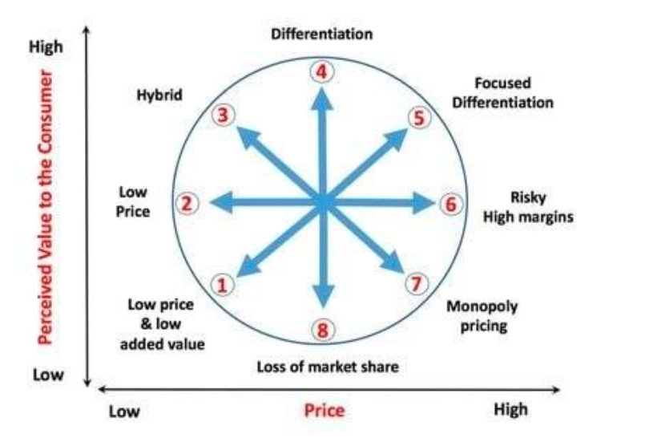
Figure 3: Bowman's Strategy Clock
(Source: Bhasin, 2019)

Bowman's Strategy Clock provides a framework for analysing competitive positioning based on two dimensions: price and perceived value (Consunt, 2025). The most appropriate position for The City Hotel is Differentiation. This strategy tends to focus and give customers value-added services that request a higher price compared to the services offered (Cakir, 2022). By applying AI chatbots, the hotel can give people more individualistic experiences, starting from individual recommendations, and finishing with instant answers to the questions. On the study of Kim et al., (2025), it also enhances the perception of the satisfaction of the consumers which in turn shows The City Hotel a cut above the competitors offering their services and even not offering such high-end service delivery solutions.
Furthermore, the hotel should also adopt a Hybrid Strategy which associates moderate pricing with moderate Levels of differentiation (Wu, C. 2021). By focusing on adding value to the proposed loyalty programs and special promotions The City Hotel will be able to attract a larger audience while at the same time keeping the business lines that are made possible by the integration of the AI technologies exclusive. This strategy enables the hotel to work on creating perceptions of higher value and at the same time step up pricing competitiveness.

Ansoff Matrix
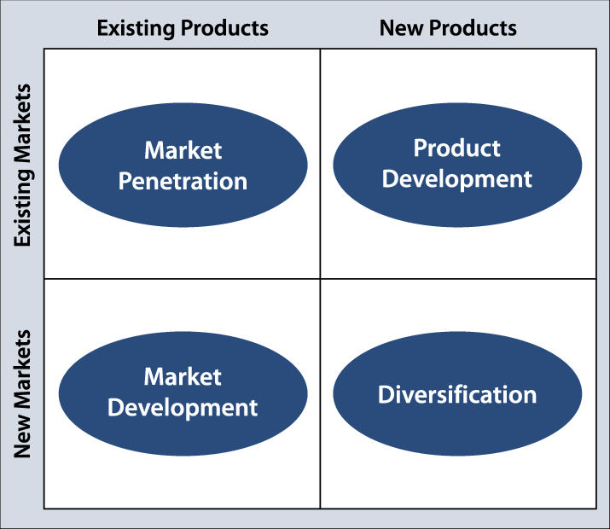
Figure 4: Ansoff Matrix
(Finney, 2025).
Ansoff Matrix defines four generic strategies: Market Penetration is most suitable for The City Hotel. It involved a drive to capture a larger share of the market in given markets through the improvement of market appeal without incurring additional capital investment in new products or market niches (Ferreira et al., 2024).
It will be important that the City Hotel put in place and integrate online advertising efforts to promote the facilities available. Marketing on social media platforms and OTAs will also target potential guests and provide information on the value of AI chatbots (Kumar, 2024).
Discounts can include offering special rates during the low season, that way, people will be encouraged to make a reservation (Ku, 2024). On a similar study Koo et al., (2020), loyalty programs that involve a company identifying clients and extending to them unique preferences will cultivate long-haul partnerships and revive traffic.
Organizing guest chat with the help of AI chatbot for some of the work requires fast answers and recommendations (Dutta et al., 2025). This improves the staying guests’ level of satisfaction, and they recommend other people to patronize the business by issuing positive comments and recommendations, which are paramount in marketing the business.
Bowman’s Strategy Clock and Ansoff Matrix allow The City Hotel to navigate through the appropriate turnaround strategy successfully. Considering differentiation based on the use of AI technology while engaging in a process of market penetration will improve its competitive advantage and guarantee sustainable development considering escalating conditions. This strategic alignment does not only resolve current problems, but more importantly, it will prepare and optimize The City Hotel for changes and indifferences in the future dynamic hospitality market.

Conclusion
The City Hotel faces numerous challenges including a lack of profitability, low revenue, high operation costs and high competition. The City Hotel needs to focus on a turnaround strategy that embraces AI technology, especially using chatbots to improve the guest’s experience, lessen operational costs, and make services a lot more efficient for the hotel. The efficient strategic approach undertakes the task of solving current issues but also places The City Hotel on the path towards future development in a competitive environment. If well implemented and sustained the hotel can improve the stability of its finances and again become known as one of the best places to visit.

References
Boutique Handbook, (2023). Online Available at: https://boutiquehandbook.com/new-uk-hotel-openings-for-2023/. Accessed Date: [23/01/2025].
Bhasin, 2019. Online Available at: https://www.researchgate.net/figure/Bowmans-strategy-clock-Bhasin-2019_fig2_355351264. Accessed Date : [17/01/2025]
Cakir, T, (2022). Online Available at: https://www.linkedin.com/pulse/bowmans-strategy-clock-framework-tim-cakir/. Accessed Date: [17/01/2025]
Consunt, (2025). Online Available at: https://www.consuunt.com/bowmans-strategy-clock/. Accessed Date: [17/01/2025]
Deepika, H. C. (2022). A STUDY ON HOSPITALITY AND TOURISM MANAGEMENT PRE AND POST COVID. NeuroQuantology, 20(16), 21.
Dutta, M. S. Chatbot Effectiveness in Enhancing Guest Communication: Insights from Secondary Data. Tuijin Jishu/Journal of Propulsion Technology, 45(04), 2024.
Ferreira, A. P. P. F. S., and de Sá, M. M. B. P. (2024). The importance of the Ansoff matrix for the study of the information services market. The Canadian Journal of Information and Library Science, 47(2), 78-84.
Liebersohn, J., Correa, R., & Sicilian, M. (2022). Debt overhang and the retail apocalypse. Available at SSRN 4102161.
Finney, A, (2025). Online Available at: https://www.researchgate.net/profile/Alec-Finney/publication/23961314/figure/fig1/AS:485861365161985@1492849784182/gor-Ansoffs-Product-Market-Growth-Matrix.png. Accessed Date: [17/01/2025]
Garrido-Moreno, A., Garcia-Morales, V. J., and Martín-Rojas, R. (2021). Going beyond the curve: Strategic measures to recover hotel activity in times of COVID-19. International Journal of Hospitality Management, 96, 102928.
Gurvich, I., Lariviere, M., and Moreno, A. (2019). Operations in the on-demand economy: Staffing services with self-scheduling capacity (pp. 249-278). Springer International Publishing.
Hayes, D. K., Hayes, J. D., and Hayes, P. A. (2021). Revenue management for the hospitality industry. John Wiley & Sons.
Kim, J. H., Kim, J., Park, J., Kim, C., Jhang, J., and King, B. (2025). When ChatGPT gives incorrect answers: the impact of inaccurate information by generative AI on tourism decision-making. Journal of Travel Research, 64(1), 51-73.
Kontuš, E., and Mihanović, D. (2019). Management of liquidity and liquid assets in small and medium-sized enterprises. Economic research-Ekonomska istraživanja, 32(1), 3247-3265.
Koo, B., Yu, J., and Han, H. (2020). The role of loyalty programs in boosting hotel guest loyalty: Impact of switching barriers. International journal of hospitality Management, 84, 102328.
Ku, E. C. (2024). Anthropomorphic chatbots as a catalyst for marketing brand experience: evidence from online travel agencies. Current Issues in Tourism, 27(23), 4165-4184.
Kumar, S. (2024). The Role of Digital Marketing on Customer Engagement in the Hospitality Industry. In Leveraging ChatGPT and Artificial Intelligence for Effective Customer Engagement (pp. 177-191). IGI Global.
Menoni, S., and Schwarze, R. (2020). Recovery during a crisis: Facing the challenges of risk assessment and resilience management of COVID-19. Environment Systems and Decisions, 40(2), 189-198.
Nagle, T. T., Müller, G., and Gruyaert, E. (2023). The strategy and tactics of pricing: A guide to growing more profitably. Routledge.
Orîndaru, A., Popescu, M. F., Alexoaei, A. P., Căescu, Ș. C., Florescu, M. S., and Orzan, A. O. (2021). Tourism in a post-COVID-19 era: Sustainable strategies for industry’s recovery. Sustainability, 13(12), 6781.
Ozdemir, O., Han, W., and Dalbor, M. (2022). Economic policy uncertainty and hotel occupancy: the mediating effect of consumer sentiment. Journal of Hospitality and Tourism Insights, 5(2), 253-273.
Wu, C. H. (2021). Exploring green hotel competitive strategies by using the hybrid method for complex data analysis. Mathematical Problems in Engineering, 2021(1), 9982387.

