

Title page
Student name: Mashud Ali
Student number: 1713109
Module name: Developing Relationships and Workplace Achievement
Module code: BMSW5002
Assignment title: Developing Relationships and Workplace Achievement
Tutor name: Isaiah Oino
Submission deadline: 31st March, 2020

Table of Contents
Executive Summary 3
Introduction 3
Task 1: Critically evaluate three development vehicles 3
Employee Engagement 3
Feedback and Reward 5
Leadership and Management Development 6
Task 2: Critically assess the benefits of the three development vehicles to an organisation 8
Introduction 8
Leadership and Management Development at Virgin Group PLC 11
Conclusion 11
Task 3: Employee Development Plan using six examples 12
Recommendation and conclusion 13
References 14

Executive Summary
It is well regarded not only amongst academic circles but also the corporate world, that building and maintaining workplace relationships is very important. Such relationships go to the heart of the workplace and can very often be the difference between a successful and a not so successful business.
The three development vehicles (employee engagement, feedback and reward, and leadership and management development) play an intrinsic role in the performance of an organisation. This is because these elements together help to increase motivation, productivity, performance, employee retention, loyalty and team culture, which in turn lead to increased sales and profit.

Introduction
My research study looks at the three development vehicles used within a workplace/organisation. This report critically assesses workplace relationships and illustrates how this will benefit the employee as well as the organisation itself. The research gives examples and describes Employee Engagement, Feedback & Reward and Leadership & Management Development.

Task 1: Critically evaluate three development vehicles

Employee Engagement
This has been defined in so many ways, however in my opinion HR Zone put it in the best way stating; “Employee engagement is the emotional attachment employees feel towards their place of work, job role, position within the company, colleagues and culture and the affect this attachment has on wellbeing and productivity.”
Put simply, engagement happens when an individual is motivated to perform at higher levels due to being committed to their job role and the organisation they work for.
This can be split in to two aspects:
- Job engagement: this is the emotional connection an individual has towards the work place, their position within the organisation, the job role, how they get on with their colleagues and the environment and culture within the work place.
- Organisational engagement: this is when an individual identifies themselves with the values and beliefs of the organisation.

The various elements of engagement
Commitment: When we speak of commitment, we mean the degree to which individuals identify themselves with their job role and how much they are aligned with the objectives of their organisation. Research has shown that employees who are engaged tend to enjoy their work, happily accept challenges in their jobs and are committed to attaining not only personal goals but also goals of the team and the wider business.
Motivation: This element refers to what tools organisations use to encourage employees towards a certain direction with the ultimate aim to achieve a certain goal. Achievement is the biggest motivator along with rewards and recognition.
Organisational Citizenship Behaviour: This refers to the discretionary behaviour portrayed by individuals, which is willingly and freely exerted. This is where an employee’s behaviour goes above and beyond their job role. This is an expression of engagement usually due to an individual having a positive attitude and feeling towards their job and the organisation they work for.
Before we discuss the importance of Employee Engagement, we need to delve in to it a little more. Employee Engagement is primarily comprised of a the following tripartite components being Intellectual, Affective and Social engagement:
- Intellectual engagement - an employee is intellectually engaged and stimulated if they enjoy their work. This means they have a genuine interest in the role that they have, are more likely to do it to the best of their ability and always pro-actively looking to better themselves.
- Affective engagement - employees are affectively engaged if they have positive connotations towards their job and the organisation. Put simply, this refers to where an employee is happy to be at work and does not merely attend as a means to an end.
- Social engagement - employees are socially engaged if they feel a positive connection with their co-workers and the organisation. This is usually done by encouraging collaboration and team work in an organisation which helps build friendships at work and having beliefs and values that the employee can relate to.
Significance and Outcomes of Engagement
As mentioned above, we will be delving into more detail with regards to employee engagement. The significance of employee engagement in an organisation is of great significance and should be put at the heart of the employee/employer relationship. This is because it influences an individual’s behaviour in the workplace and ultimately affects whether business objectives are met or not. The two are inter-linked and mutually inclusive.
The benefits of having employees who are engaged is that the employees will proactively go above and beyond their normal job role usually putting in extra time and effort to ensure goals and targets are achieved. Not only will engaged employees work harder, usually employees will not rationalise this by requesting additional benefits such as overtime pay, holiday in lieu, for example. As a result of this, employees are more likely to improve performance through better team work, as they will work together better and be more willing to share their ideas with others. They will also be more likely to talk highly about their work place to others and therefore promote a positive image of that company.
Employees who engaged are ultimately more productive, less likely to leave, are more passionate, easier to work with and feel valued. Thus in turn, this benefits the organisation by having increased productivity, retaining their best workers and better customer satisfaction.

Feedback and Reward
Feedback and appraisals are a means for which it is highlighted to an individual the areas of their job that they are succeeding at and highlight areas where they can improve or do better. It is also an opportunity to discuss the personal aspirations of an individual, such as things like job promotion, pay rise etc. However, it is not as simple as telling someone what their strengths and weaknesses are. It also focuses on the areas they need to improve with the objective of developing the employees skills and learning from their mistakes. It builds employee confidence by not only focussing on performance.
Feedback can come from many such as colleagues, peers, supervisors, managers and even customers to name just a few. Feedback can also be formal or informal.
Reward strategies are used to motivate employees to not only to continue to work hard but also aim to work harder and achieve their goals. Therefore, reward management systems are implemented to make sure an employee’s contribution to the business is recognised. The aim of reward management is to reward employees fairly, equally and in correlation to their value within the organisation. Rewards can vary from the financial rewards such as salary, bonuses, pension schemes and employee benefits, to the non-financial forms of rewards such as training/development, recognition, promotion and increased responsibility.

Significance of Feedback and Reward
Feedback is an important performance management strategy. It can be positive; to tell an employee they have done a good job, negative; to tell an employee they have performed poorly or it can be constructive; to tell an employee there are areas on which they can perform better and provide advice on how to improve. Ultimately, feedback is there to reinforce and retain effective behaviour and therefore shows if and where an employee’s behaviour may need to change.
Rewards management system is important due to the fact that it enables employees to be more productive and perform better. You have the financial component motivating employees to work harder and earn more, However, non-financial rewards are just as important as employees want to feel appreciated and valued, thus put this effort in to their work. When they receive appreciation and recognition from their work place they work harder, as a result the organisation sees an increase in productivity which leads to higher profits.
Feedback and reward work to improve employee’s morale and enhance their loyalty to the organisation. This creates a better understanding and stronger relationship between the company and its employees, and contributes to a better work environment, thus reducing staff turnover.

Leadership and Management Development
Leadership and management development programmes ensure that leaders and managers have or can gain the necessary skills and qualities needed which will equip them with the skills necessary to fulfil a management role. As is usually the case, an employee who works in an industry, working their way up to more senior roles and ultimately a management position, what we know is that they become very technical and an expert in their filed. However, a management role not only requires the technical skills, it also required a set of softer skills.
For talent management they form a vital role along with career planning. Usually a combination of learning methods are used which could include self-directed learning, previous experience, mentoring and formal education.
Leadership
Leaders inspire employees to always do their best in order to achieve their goals. This involves helping them develop a vision/goal and motivating them to achieve it. They are able to give their team a sense of purpose, get their team in to action and communicate what needs to be done effectively.
Leadership development focuses on the social aspects and includes interpersonal skills and awareness, team development and engaging employees to achieve the organisations vision. As suggested by Bolden (2010) the essential elements needed are self-awareness, reflection, opportunities to apply what they learnt, practice, it’s relevance to work and personal support.
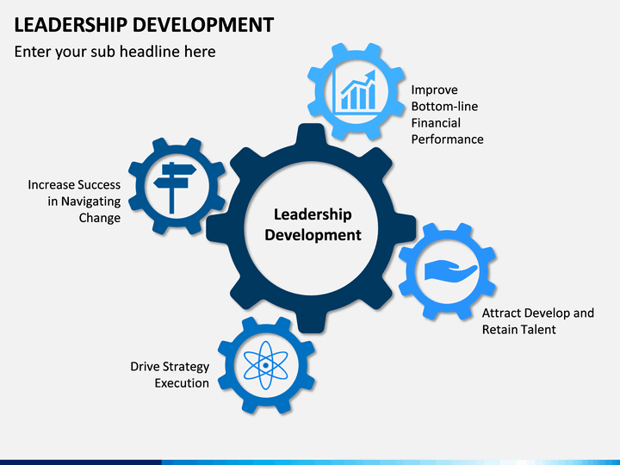
Figure 1
Management
Everyone is not born to have the natural structure to be a manager. That does not indicate that some a better others but however we all tend to have a natural skill that varies from one person to another. It is well known that management has a leadership component. However, their primary objective is to get results by effectively operating its department. They have been given the authority and responsibility for running the business by managing their employees and their other resources such as finances, technology and work systems.
Management is not as logical and systematic as some may think. They often run in to issues of unpredictability and turbulence and therefore must have the ability to cope with unclear requirements. Although, they deal with situations as they arise, they must also pre-empt and plan accordingly. They must have vision and know where they are going, which requires strategically think at a higher level.
Management development relies on managers having the right variety and sequence of experience to properly equip them for all levels of responsibility required. Therefore, organisations try to produce managers from within the company i.e. employees who have climbed the ladder and gained invaluable experience on the way. Management development may also be supplemented by self-directed learning, mentoring and courses on management which would also help to develop their leadership skills
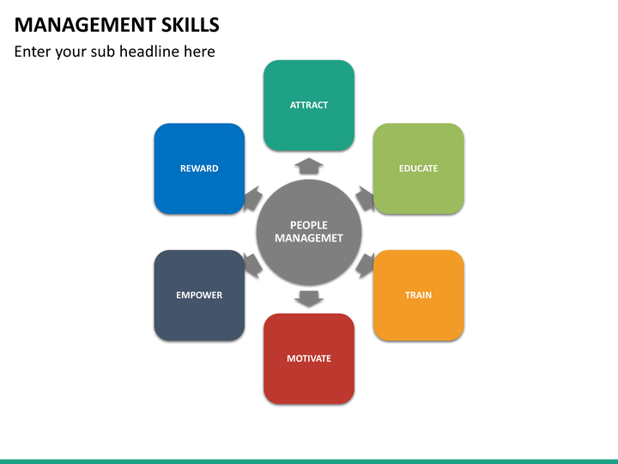
Figure 2

Task 2: Critically assess the benefits of the three development vehicles to an organisation

Introduction
In this paper we are going to assess how the Virgin Group PLC use the above three mentioned development vehicles to benefit their organisation.
Employee engagement at Virgin Group PLC
Richard Branson has built a globally successful business based around putting employees first. The one main aspect of his ethos is that if employees are happy then customers will naturally follow. He said in an interview “Some 80% of your life is spent working. You want to have fun at home; why shouldn’t you have fun at work?”
Virgin has been successful in employee engagement as they have been able to create an engaging culture within the organisation. Not only keeping their employees, but also attracting candidates due to them having heard what a great company Virgin is to work for.
Virgin also understands the importance passion has to employee engagement. Having products and services that make a real difference to people lives increase the passion employees have for what they are doing. Same goes for having organisational core values that your employees can align with.
By listening to its employees opinions it shows that they care and value their thoughts. This shows employees they are important and makes them feel more engaged with the organisation. And this in turn makes employees want to reciprocate by doing their best. Employee engagement is a vital strategy within companies and organisations it is a source of fuel where the individuals and the organisation itself can learn and improve.
Feedback and Reward at Virgin Group PLC
To quote Richard Branson “I am a firm believer in listening to your staff at all times. The moment you stop doing this, you are in danger of losing your best people.” He is known to continuously interact with staff on any given chance to always get feedback, and emphasises the importance of acting on that feedback as soon as possible.
Virgin Group PLC has a few feedback strategies in place. Employee needs to complete an online assessment known as ‘Your Story’, regular pulse check surveys, quarterly feedback cycles and bi-annual performance reviews all with 360 degree feedback. According to their website this is all done because to help their employees perform at their best, they must care and take time to understand them in order to understand their passions and challenges. Having effective feedback systems in place allows Virgin to find employees strengths/weaknesses, discuss with them on how they can improve and set goals and help them develop their skills. Ultimately this builds employee confidence by allowing them to learn from their mistakes.
Recognition runs throughout the Virgin Group. They understand that if employees are regularly recognised for their achievements and initiative, they become a part of the business and therefore work hard to help it flourish, employees can even win a weekend away to Richard Branson’s Necker Island.
Virgin Group is one of those companies who also believe in rewarding their employees with a vast amount of company benefits. See Figure 3
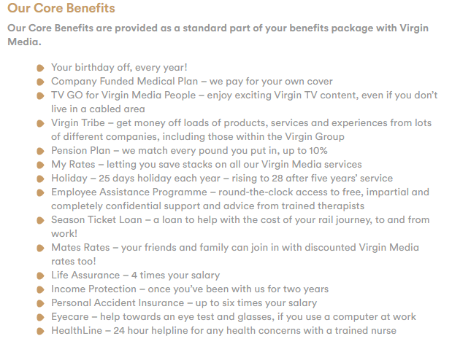
Figure 3
These are some of the packages that attract and retain employees such as health/dental/eye care, 25 days holiday each year and rising to 28 days after 5 years in employment. Up to 10% every year towards employees Pension plan. Virgin Group on top of the Core Benefits they have Voluntary Benefits which gives the option to employees to add further benefits such as Medical Plan where they are allowed to add their family on (see Figure 4).
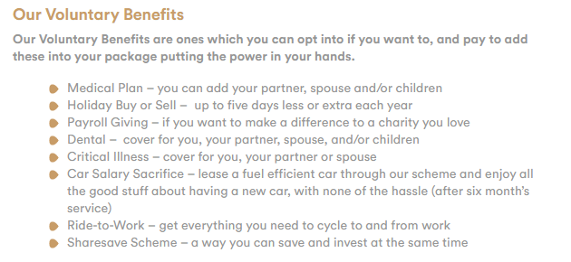
Figure 4

Leadership and Management Development at Virgin Group PLC
Virgin Group have invested a great amount in to leadership and management programmes over the years not only to improve and develop their managements skills but to also safeguard their work culture by fulfilling more management vacancies internally.
Virgin Group sends its management on personal development workshops which consist of individual coaching sessions and activities aimed at instilling their leadership principles. Using personality tests and 360 degree feedback they would help managers set personal development objectives for them not only to self monitor their progress but to also work with their colleagues and peers.
The personality tests usually assess an employees energy, courage, sense of responsibility and drive. An individual report is then produced about them regarding coaching, mentoring and developments plans linked to their personal traits.
This takes development planning to a unique, specific and individual level. Virgins aim isn’t to force an employee in to being something specific, but understanding them, recognising where they have their strengths in order to cherish and nurture their individuality whilst still aligning their goals with the organisations objectives. They have even extended this approach to helping to develop their top level managers.

Conclusion
Using our example of the Virgin Group the importance of Employee Engagement, Feedback & Reward and Leadership & Management in an organisation have become undeniably vital to the success of an organisation. Virgin has done things differently and put their employees first, their customers second, their shareholders third and these still remain at the core of the companies success.
This study does take account of the fact that people work for an income in return. Having said this, how efficiently and effectively they work, and indeed whether they decide to continue working at the organisation, is dependent on other factors. The key to an employee’s productivity is down to their work environment and how happy and valued they feel in their job. Ultimately, the three development vehicles help to increase motivation, productivity, performance, employee retention, loyalty and team culture thus leading to increased sales and profit. Therefore, the success of an organisation is dependent upon creating a work place where employees can learn, improve and flourish.
Employee Development Plan
Employee Name: |  |  | Reviewer Name:
Employee Position: Assistant Manager |  |  | Date:
Development Areas | Training and Development Goal | Competencies/Skills to be Acquired | Employee Action Steps | Resources Needed | Time Frame
What specific areas the employee needs to develop? | What specific workshops, mentoring etc are needed? | What competencies/skills will be enhanced? | What specific steps must the employee take? | Money, time, staff etc. | When will it be completed?
Work place culture | Team work activities, company social events | Better team work, better communication between colleagues | Converse, get to know colleagues |  | 6 months
Leadership skills | Mentoring from manager, increased responsibility, leadership activities | Manage more responsibility, increased leadership skills | Take managers advice, learn from them, get feedback from manager before and after leadership activity |  | 6 months
Adaptability | Variation of work, help colleagues in their roles | Improved knowledge of the job roles, can cover when needed | Ask colleagues if they need help |  | 6 months
Build coaching/mentoring skills | Mentor high performing staff/team leaders | Mentoring/coaching skills | Hold mentoring sessions, feedback on performance |  | 6 months
Business Understanding | Shadow the manager, research information | Learn the day to day running of the business, learn more about how the business operates | Research, take notes, learn, practice to improve |  | 6 months
Management skills | Mentoring from manager, attend Management Development Programmes | Gain the knowledge and skills to independently manage | Learn, implement, take feedback from manager, improve |  | 6 months

Task 3: Employee Development Plan using six examples

Recommendation and conclusion
From my research on Virgin Group PLC it clearly states that the Virgin Group put their employees 1st which has worked well within the Virgin organisation. However this strategy is not suitable or used by most other sectors of organisations outside of the Virgin Group. This emphasis on the old saying “Customers are always right”, this is a strategy commonly used by most companies and organisations all over the world.

References

(Skills, 2020)
(What employee wellbeing means to me: Richard Branson, 2020)
2020. [online] Available at: <https://www.employment-> [Accessed 26 March 2020].
2020. [online] Available at: https://www.researchgate.net/publication/242392127_Leadership_and_management_development [Accessed 28 March 2020].
Armstrong, Michael (2007). A handbook of employee reward management and practice(2nd ed.). Philadelphia: Kogan Page. ISBN 978-0-7494-4962-9.
Britishairways.com. 2020. [online] Available at: https://www.britishairways.com/cms/global/microsites/ba_reports0910/pdfs/Workplace.pdf [Accessed 28 March 2020].
Development, L., 2020. Leadership Development. [online] Sketchbubble.com. Available at: https://www.sketchbubble.com/en/presentation-leadership-development.html [Accessed 28 March 2020].
Employment-studies.co.uk. 2020. [online] Available at: https://www.employment-studies.co.uk/system/files/resources/files/469.pdf [Accessed 26 March 2020]
Employment-studies.co.uk. 2020. [online] Available at: https://www.employment-studies.co.uk/system/files/resources/files/mp141_Bridging_the_gap_evidence-based_approach_to_employee_engagement_0.pdf [Accessed 26 March 2020].
Employment-studies.co.uk. 2020. [online] Available at: https://www.employment-studies.co.uk/system/files/resources/files/469.pdf [Accessed 27 March 2020].
HRZone. 2020. Employee Engagement The Virgin Way. [online] Available at: https://www.hrzone.com/community/blogs/richard-roberts/employee-engagement-the-virgin-way [Accessed 29 March 2020].
HRZone. 2020. What Is Employee Engagement?. [online] Available at: https://www.hrzone.com/hr-glossary/what-is-employee-engagement [Accessed 25 March 2020].
Inc.com. 2020. 25 Rewards That Great Employees Actually Love To Receive. [online] Available at: https://www.inc.com/jeff-haden/25-creative-rewards-that-great-employees-actually-love-to-receive.html [Accessed 27 March 2020].
In-text: (Gruman and Saks, 2020)
Managementstudyguide.com. 2020. Motivation And Financial And Non-Financial Rewards. [online] Available at: https://www.managementstudyguide.com/motivation-and-financial-and-non-financial-rewards.htm [Accessed 28 March 2020].
Marsh, E., 2020. Personal Development And The Power Of Feedback. [online] T-three.com. Available at: https://www.t-three.com/soak/insights/personal-development-and-the-power-of-feedback [Accessed 25 March 2020].
Perkbox. 2020. Why Your Employees Need Reward And Recognition | Perkbox. [online] Available at: https://www.perkbox.com/uk/resources/blog/why-does-reward-and-recognition-matter [Accessed 28 March 2020].
Scott, K., 2020. EXCLUSIVE: Virgin Atlantic Reinvigorates Benefits Package For 10,000 Staff. [online] Employee Benefits. Available at: https://employeebenefits.co.uk/exclusive-virgin-atlantic-wellbeing/ [Accessed 30 March 2020].
U.S. Office of Personnel Management. 2020. Feedback Is Critical To Improving Performance. [online] Available at: https://www.opm.gov/policy-data-oversight/performance-management/performance-management-cycle/monitoring/feedback-is-critical-to-improving-performance/ [Accessed 25 March 2020].
Virgin Media Careers. 2020. Our Benefits | Virgin Media Careers. [online] Available at: https://careers.virginmedia.com/working-here/our-benefits/ [Accessed 29 March 2020].
Virgin Media. 2020. Boosting Internal Engagement With Sustainability. [online] Available at: https://www.virginmedia.com/corporate/sustainability/stories/boosting-internal-engagement-with-sustainability [Accessed 30 March 2020].
Virgin. 2020. Richard Branson: The Best Way To Engage Employees. [online] Available at: https://www.virgin.com/entrepreneur/richard-branson-best-way-engage-employees [Accessed 28 March 2020].
Virginincentives.co.uk. 2020. Reward And Recognition | Virgin Incentives. [online] Available at: https://virginincentives.co.uk/services/reward-and-recognition/ [Accessed 29 March 2020].
Your Bibliography: Gruman, J. and Saks, A., 2020. Performance Management And Employee Engagement.
Your Bibliography: Skills, M., 2020. Management Skills. [online] Sketchbubble.com. Available at: https://www.sketchbubble.com/en/powerpoint-management-skills.html#mz-expanded-view-927066095790 [Accessed 29 March 2020].
Your Bibliography: Virgin. 2020. What Employee Wellbeing Means To Me: Richard Branson. [online] Available at: https://www.virgin.com/disruptors/what-employee-wellbeing-means-me-richard-branson [Accessed 30 March 2020].

