____________________________________________________________________________________

The library is currently undergoing a restructure. We will be in touch to pass on details when they have been finalised. In the meantime, if you have any queries, please continue to contact us via the infoskills email at infoskills@uwtsd.ac.uk

Library web pages
Check out our library web pages! Find instant access to library resources, scroll down for useful information, help and support. Go to: Library & Learning Services at UWTSD

In-person Infoskills Sessions
Lecturers can book infoskills sessions for students. These can be either online via Teams or in-person, on campus. Sessions include basic and advanced use of library resources and referencing. Smaller, more informal groups or 1-2-1 sessions can also be booked by students.

To make a booking, or if you have any queries relating to searching for information, referencing or using our resources, please email us at infoskills@uwtsd.ac.uk

On-line InfoSkills Programme
In addition to our in-person infoskills sessions, we have developed an online infoskills programme, which has been designed to support all students to develop their academic and information literacy skills, independently and at their own pace.

Accessible via both Moodle and the library web pages, students can self-enrol and earn completion badges. Modules include:
- Finding and Using Information
- Referencing and Plagiarism

Go to Moodle: Course: Library Infoskills | Home or Library Web Pages Academic and InfoSkills

Digiskills
Lecturers can book digiskills sessions for groups of students. Students can contact Gwen Couch , your Digital Skills Advisor, directly to arrange 1-2-1 support on:
- Microsoft Office 365 - PowerPoint, Word, Teams etc.
- Tools for digital creation (videos, presentations, infographics etc.)
- Digital identity + wellbeing, productivity, collaboration etc.

Go to: g.couch@uwtsd.ac.uk or Book an Appointment | UWTSD Intranet

Use the Resource Finder to search for useful resources to develop digital skills:
- Digital Skills Homepage - The DigiCentre UWTSD
- Resource Finder - The DigiCentre UWTSD

Y Fforwm and Carmarthen Library Opening Hours

Please see https://digitalservices.uwtsd.ac.uk/library/library-locations-and-opening-times/
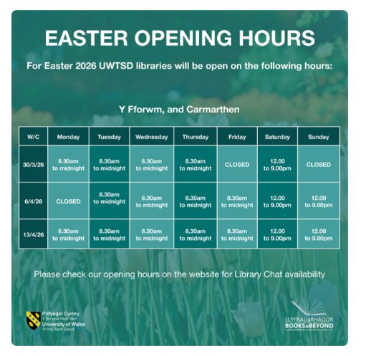

Library Tours
Please remember that you can book an individual library tour throughout the year! If you would like a reminder or missed your group tour, you can book your tour at Library Tour Bookings

Copyright Hub


The Copyright Hub has been updated and is now available on the library webpages. Find guidance on basic copyright legislation – eg. copyright exceptions and licences, using copyrighted material, authorship and ownership, copyright and AI, and Creative Commons. There are sections for students, researchers, and teaching staff.
Go to: Copyright Hub | Digital Services | University of Wales Trinity Saint David

JSTOR – new journal archives

UWTSD students and staff now have complete access to JSTOR’s archive journal collections through a new content agreement. JSTOR provides access to the archives of over 2,600 leading academic journals, with full text articles spanning 75+ disciplines across humanities, social sciences and natural sciences from over 1,200 publishers across 57 countries.
You can search JSTOR here or browse by subject to discover the range of content now available.
For more information or help using this resource please get in touch:
Contact the Library - Digital Services | University of Wales Trinity Saint David

Bookable rooms
We are working with IT to ensure that when library bookable rooms are not in use they can be booked by students on the spot, by using the pads outside. This new option should be available soon.

Get exam ready!
Keep an eye out on our social media channels @UWTSDlib (Facebook, Instagram & Bluesky)in the coming weeks for our studying techniques, tips and tricks! We’ll share advice on managing stress and anxiety, studying techniques and support they are able to access. We’ll also share a range of resources available to them in the library that can help them prepare and study for upcoming exams.
See our exam preparation guide – Exam Preparation Guide
Also if you have any study techniques, tips & tricks you want to share just scan the QR code below!
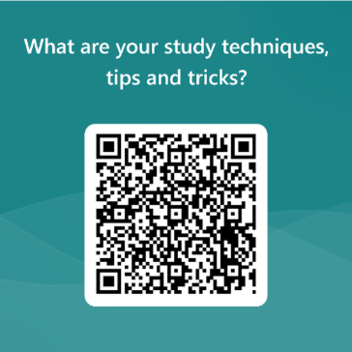

Customer Service Excellence Award We have recently had our CSE award revalidated. We are pleased with this independent recognition that we provide very good customer orientated services.

Additional links and contacts
- Library Chat icon on our web pages 
- Academic Liaison Librarians: infoskills@uwtsd.ac.uk
- Social media: @UWTSDlib on Facebook, Instagram or Bluesky.

All feedback on library services is welcome. If you’re not sure about something, ask us!

