

Group Tasks: Questionnaire
Submission Date: 5th April 2019

Group 2
Business name: I travel I money
Business identity: partnership

Team members
Abdella Abdella 1712468
Mohon 1712726
Fairda khatun 1712712
Fateha khanum 1712905
Landa rapi 1712701
Business plan questionnaire URL link
https://docs.google.com/forms/d/1SbRvDh46mUGet40-AcE8a9rl1xKYoNKUY70inXSj514/edit?vc=0&c=0&w=1#responses

customer satisfaction survey for I travel I money
The customer satisfaction survey is very important for as it helps us to understand the customers opinion about the service we provide on the websites or outside the internet so, we can bring a great strategy where you can see aspects that can be improved in our service. Because based on the views of the person who buys as inside the store, we can notice the possibility of small errors, so, as a team we design a questioner of 12 question to get feedback from the customer in order to provide the packages customers want.
I chose three question first one is. how long do you want for your holiday? I chose this question because it will give us the idea about how long our customer is willing to stay on the holiday so, we can give them a good deal. If we know how long they are willing to stay we make good links with flight and hotels so, we getting commission because they travelling for 2 weeks as we see 32% of our customer they traveling 2 weeks and 16% for 3 to 4 weeks so, we need to work hard to get more customer they travelling for the longer holiday.
I chose second one is do you travel light or with lots of luggage? I chose this question because it will help us to know how much luggage they will be carrying so, we can advise them and find for them a good deal because different airlines they have a different limit on the luggage and sometimes customer they need to pay extra money.
I chose the third question. Do you have any health restrictions? Just to know the about the health concerns. Because some customers have nut allergies or asthma so, we can advise our customers to have the right medicines especially when they go to hajj, they need injection of immunisation because the people who travel for hajj is over 2.2 million on one place from all over the world. as travel agent it is our responsibility inform our customer. Purohit, H. (2015), In order to get and retain customers, it is important to identify each one well, identify the points they evaluate positively, and those that are being evaluated negatively, to improve everything they offer.

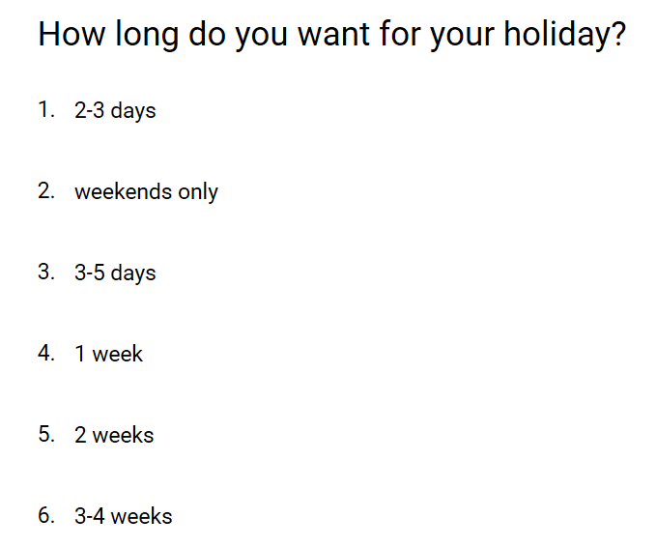

Respond


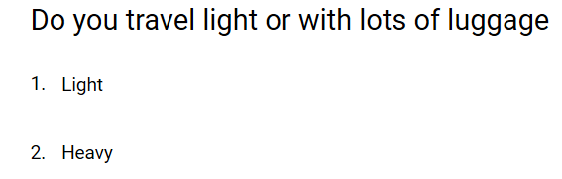
Respond

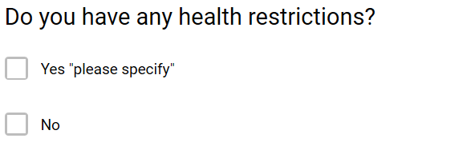

Respond
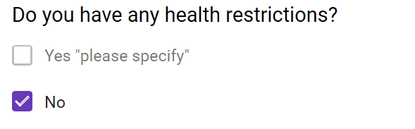

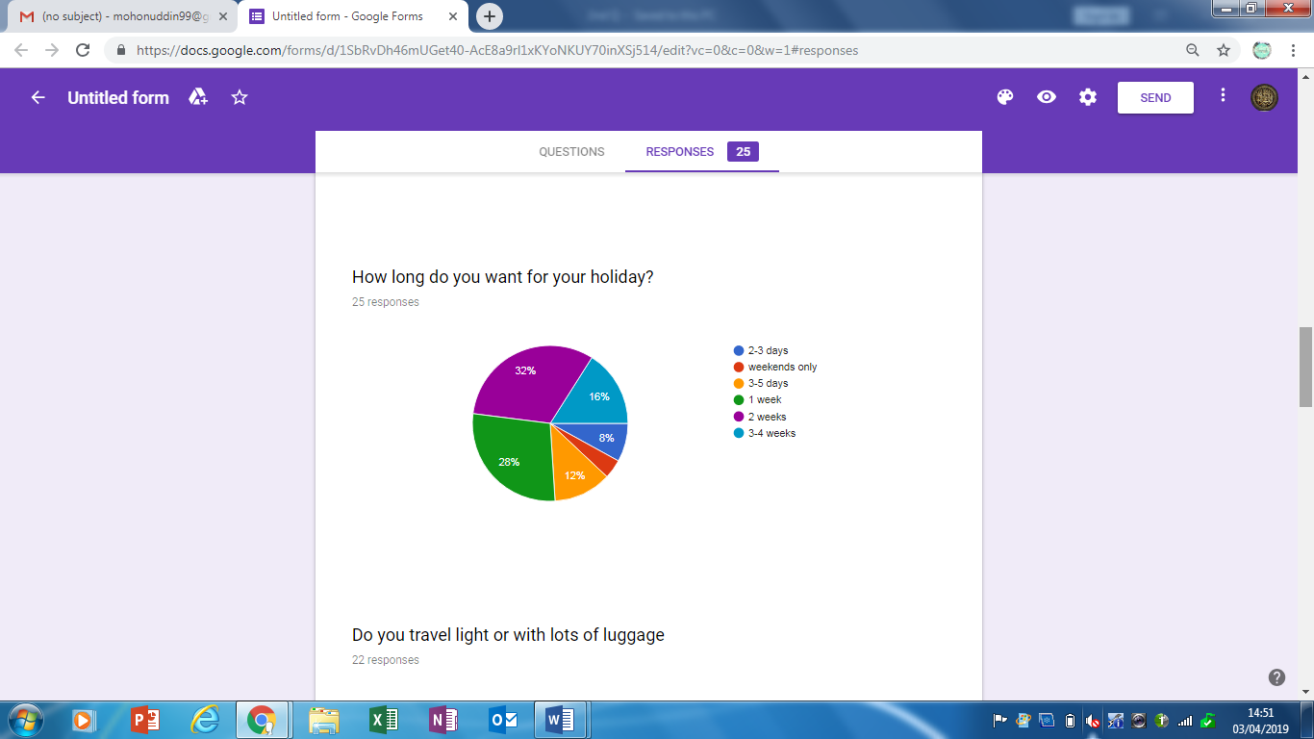

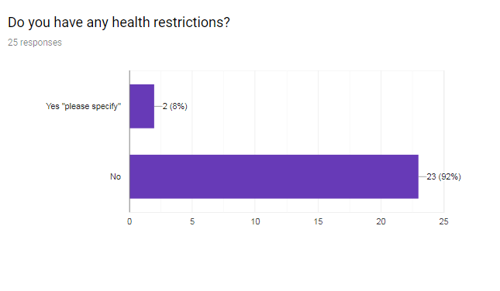
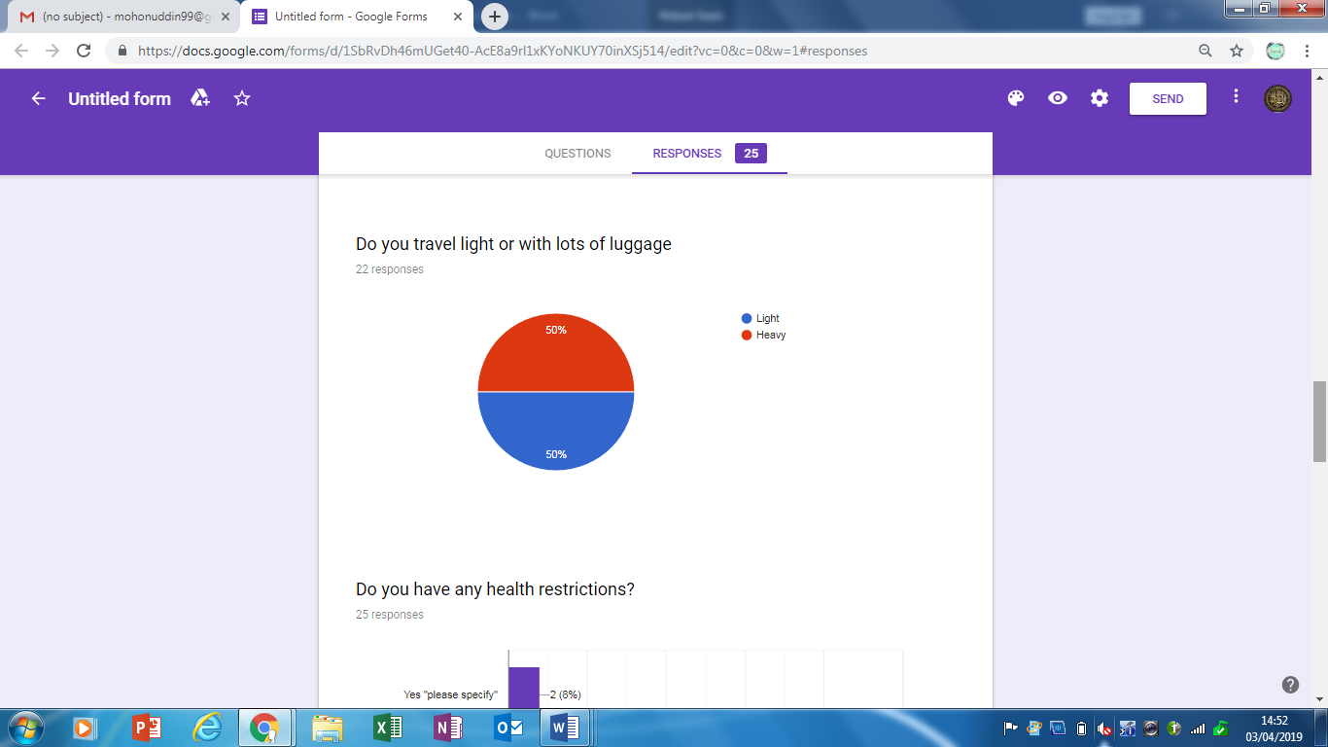

Reference
- Purohit, H. C. (2015) ‘Examining and Exploring the Relationships between Customer Satisfaction and Customer Loyalty’, Delhi Business Review, 16(2), pp. 37–46.

