Name: Emmanuel Itua
Student ID: 2019391
Module Code: BMSW5103
Module Title: Understanding and Engaging in the Customer Experience
Lecturer’s Name: Rula Alousi

Table of content
Introduction…………………………………………………………………………………………P3
Company History…………………………………………………………………………………..P3
Quality System and Control……………………………………………………………………….P4
SWOT Analysis (Internal)………………………………………………………………………….P4
Quality Management……………………………………………………………………………….P5
Quality Assurance…………………………………………………………………………………..P6
Quality Control………………………………………………………………………………………P6
SWOT Analysis External…………………………………………………………………………..P6
PESTLE Analysis…………………………………………………………………………………..P6
Ansoff Matrix………………………………………………………………………………………..P9
Porter’s Five Forces……………………………………………………………………………....P10
Covid 19 Effect…………………………………………………………………………………....P12
Task 2………………………………………………………………………………………..…….P13
References……………………………………………………………………..………………….P15

Introduction
In this report I will be writing about the organisation known as Uber. I will discuss how external and internal factors has influenced its quality systems and controls for Customers. I will be analyzing its environment using marketing theory and analytical tools such as PESTLE, SWOT, Ansoff Matrix and Porter’s five forces to find out how they affect Uber as an organization.
The Covid pandemic brought a lot of businesses and organisations worldwide to a standstill. I will discuss how it has affected Uber and some decisions it made to survive and keep the business afloat while keeping the customer happy by continuous provision of good customer service.
Company History
Formerly known as Uber Cab was founded in March 2009 and has its headquarters in San Francisco USA. It was founded by Garrett Camp and Travis Kalanick. The current Chief Executive Officer (CEO) is Dara Khosrowshahi.
The organisation has since spread to 71 countries and more than 900 metropolitan cities worldwide including the United Kingdom. Its services include mainly Ride hailing and Food delivery services (Uber Eats and Postmates), Courier and Freight transportation.
Its most popular service is the Uber ride hailing service, followed by Uber eats. Uber does not own any vehicles for its service but instead gets a 25% commission from the service fee while the driver gets 75%.
As at the last quarter of 2021, Uber had about 118million active users worldwide which make the organisation one of the most used rides hailing service in the world. Though there are other ride hailing services around, Uber has always been at the fore front due to its popularity.
It launched its services for the first time in UK in 2012, since then, it has accumulated over 70,000 drivers with more than 45,000 in London alone. Like every other ride hailing service, Uber is regulated by Transport for London (TfL) in the UK. In March 2022, Uber was granted a 30-month licence by Transport for London to continue operating its service in London.
By 2040, Uber has committed to having all its vehicles used for the service to be fully electric to help fight climate change and global warming.
Uber net worth as of April 29th, 2022, is $64.16Billion and its ownership type is the private sector.
Being an Uber driver myself with three years’ experience, I have had the opportunity to work with both the office staffs at Uber especially the customer service department and the customers who are the riders. I will be writing based on my experience and knowledge of the job together with other areas that I will research to get answers.
Quality System and Controls
Uber uses a CRM (Customer Relationship Management) software system to manage its customers. CRM is an information hub that keeps all customer data helping a business to maximise customer contact from all departments.
There are both internal and external factors that has influenced Uber’s quality systems and control for customers. I will start by discussing the internal factors below.
SWOT Analysis (Internal)
SWOT analysis is an analytic tool or management technique used by an individual or organisation to identify its strengths, weaknesses, opportunities, and threats. Its benefits included the following:
- It helps a business to know its competencies and allows it to improve them.
- It makes way for improving on its weaknesses.
- Helps with business growth by strategic planning.
- Business analysis of threats thereby helping to make changes ahead of time.
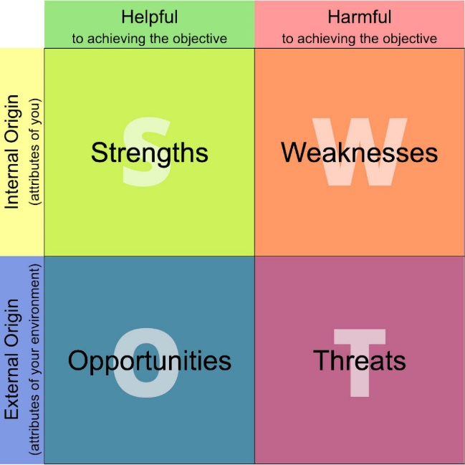
Diagram source- aiithingsadmin.com

Strengths-
A- Uber’s strength is undoubtedly the brand name it has built over the years. When you think of ride sharing service, the first name that comes to mind is Uber as other similar services are compared to the brand. It has established in more than 71 countries and 900 cities with the list still growing.
B- Uber has lower prices compared to its competitors. In London for example, Black cabs were the only traditional taxi service running in London but when Uber launched in 2012, it gave riders an opportunity to make choices. Uber’s prices were much cheaper.
C- Uber’s pricing system compared to other service providers is reasonable and drivers are happy with the pricing. When demand is high, drivers enjoy a much higher rate than usual. This higher rate is also enjoyed by driver who choose to work at night.
D- Uber riders at the end of every trip must rate the trip including the driver, this process ensures that the server is at its best because drivers want to be rated 5 out of 5 at all times.
Weaknesses-
A- There are situations where drivers are not very happy with their earnings due to the cost they must bear sometimes. An example is the recent introduction of charges when you drop a rider at the airport. A £5 charge is liable for each trip to drop a rider.
B- Uber is heavily reliant on its drivers to behave ethically to its riders during trips. Its image may be dented every time a negative report pops up on the news. There has been cases of sexual harassment and abuse on many occasions.
C- The service is app dependent which means it can only work where the internet is available. Its service can be disrupted in countries where internet is not readily available.
Quality Management
Quality management is the process of overseeing all activities and tasks in an organisation in other to maintain certain level of excellence.
Uber delivers its transportation services across the global market. To stay relevant and consistent in the market, it needs to regularly update its software and database as it has great implications towards its decisions and operations. Without doing this, its systems will be outdated which could lead to loss of important data.
The surge multiplier for example uses data from certain factors such as location, weather, events to calculate real time prices for surge purposes. When demand for service is high, and there aren’t enough drivers to meet the demand, the pricing increases while its vice versa the other way round.
Quality Assurance
Maintaining a level of quality in a service by giving attention to every stage of its production can be described as Quality Assurance.
Uber is committed to always giving its customers high quality service however this may not be the case all the time. I have had issues with my driver rating showing in the app in the past. My star rating should always show on my app profile but was disappearing occasionally.
I reported the case to customer service team and later got a call from the Quality Assurance team who made sure the problem was fixed.
Quality Control
This is the process of detecting mistakes during production and service delivery. This process makes sure that product requirements and specifications are met.
During the pandemic, Uber introduced a feature in the app that takes a photo of the driver, ensuring that he is wearing a mask before he/she can go online to start receiving trip requests. Before the feature was launched, it must have gone through tests to make sure it does exactly what it should do. It had gone through Quality Control for eventual perfection.
SWOT Analysis (External)
Opportunities-
Uber is a global brand that is known for its service. It’s already established in more than 70 countries and has the change of expanding even further to gain more customers. A great opportunity to increase its revenue.
Threats-
Uber faces substantial competition in the Taxi industry. The emergence of new competitors such as Lyft in the USA and Bolt, Ola and other local taxi services hinders its business. This competition reduces available customers for Uber as riders can choose other taxi services for their rides.
PESTLE Analysis
PESTLE stands for Political, Economic, Social, Technological, Legal and Environmental factors that affects an organisation.
It is a tool used by businesses and organisations to analyse the external environment factors that affect the organisation, and they use to improve their business.
Benefits of PESTLE analysis includes the following:
- It is cost effective and can be done at any time
- It helps keep a business on alert
- It opens a business to opportunities exploitation
- It gives a deeper understanding of your business.
Diagrammatical illustration of PESTLE Analysis
Diagram source- Enterslice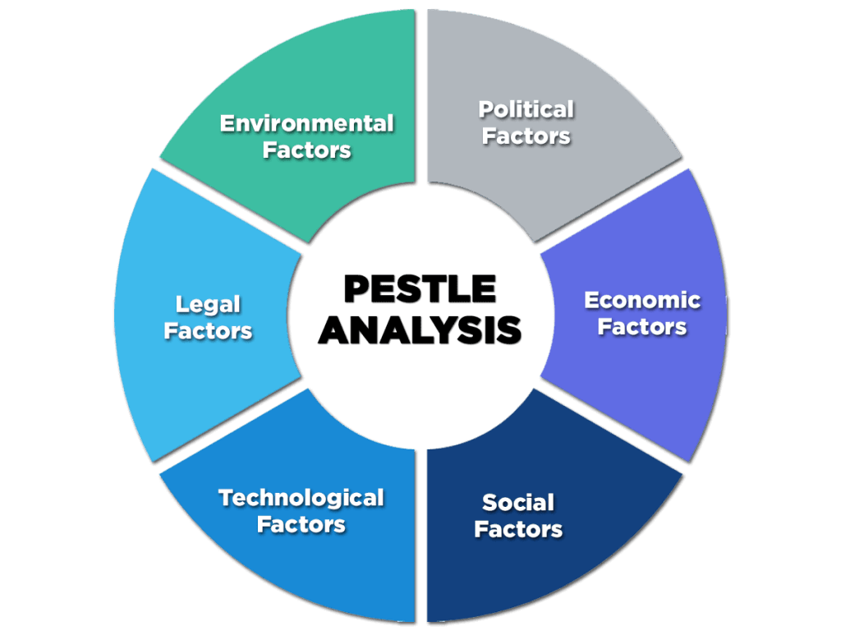
Political Factors
Uber has faced political issues all over the world with many traditional taxi businesses suing them to court. When Uber arrived in London for example, the traditional black cabs protested their services because they believed Uber was taking away their riders there by resulting in less work for them.
They have been slammed with lawsuits in countries round the world about them treating drivers as contractors and not employees. This issue is being experienced in California USA and South Africa.
In the UK the issue has been lingering on from court to court for years until finally the supreme court recently ruled that Uber drivers must be treated as employees and not contractors. This has influenced Uber’s model of working. Uber now pays holiday pay to its drivers every week based on government regulations.
These are few of the pollical factors that has affected the organisation.

Economic Factors
Uber has created millions of job opportunities worldwide thereby helping to reduce joblessness in many countries. The impact helps to boost the economy and as a result, less people are relying on the government to cater for them and their families.
The UK alone has over 70,000 drivers, this is a large market that helps keep people moving in cities from A to B.
Before Uber came to the UK, the traditional black cabs were in use. They monopolised the taxi market and were expensive. Then came Uber that was cheaper and more available all over the city as black cabs were mainly available in central London.
The black cabs had to cut their rates to stay competitive as riders were opting for cheaper services.
As a result, Uber has helped boost the economy and at the same time created lots of job opportunities.
Social Factors
Customers have been greatly pleased with services provided by Uber. The use of smartphones and their user-friendly app has made them more popular than other taxi services. It is easy to track pick up points, track their routes and pick up time easily.
Uber has driven their services to popularity mainly by advertising on social media and people recommending them to friends and family. This popularity has made Uber increase their prices mostly in the cities, but customers have not been so pleased with the increase..
Technological Factors
Uber has been at the centre of technological advancement compared to other taxi services. They always introduce new features to their app that makes them innovational.
Geolocation in real time, drivers occasionally must identify themselves by taking pictures on the application, which is verified by human review, Customers can now reserve a ride to be picked up at certain time and address to their chosen destination. These are just few of the features introduced to make driver- customer experience more efficient.
Legal Factors
All taxi service organisations have laws and regulations they must abide by otherwise they could be hit by fines or even their licences revoked if they do not follow the regulations.
In London recently, the regulating body Transport for London revoked Uber’s licence and refused renewal because some of their drivers were caught driving with fake identities. As a result, they were slammed with a lawsuit. They immediately had to make changes to their application which would prevent further reoccurrence in future before they were allowed by the court to continue their service by ruling that they are okay for renewal.
Environmental Factors
Like every other taxi service, Uber uses vehicles for their business. There has been complain about taxis and minicabs causing traffic in the cities, but this has not been proven just yet. There is also the issue of air pollution and climate change. Uber has committed to using fully electric cars for all its services by 2040 to help comeback climate change. Currently, not all their vehicles are electric.
Ansoff Matrix
This is a tool used by organisations to perfect their marketing and product strategies. It is also used for strategic growth.
This strategy has four available options which are, market penetration, product development, Market development and diversification.
Ansoff Matrix diagram
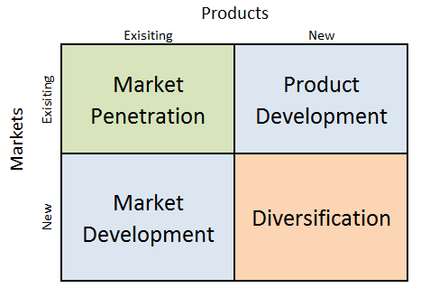
Diagram source: Business Research Methodology

Market Penetration
This method refers to selling existing products to already existent markets. Uber is involved in promotions available to its customers that they can enjoy such as promo codes for discounted trips and loyalty programs. These promos are created to attract customers and keep them loyal.
Product Development
When new products are introduced to the market that already existed, this is known as Product Development. From time to time, Uber introduces new range of services where customers can choose whichever meets their needs. Such services include UberX, Uber Green, Uber Comfort and Uber Executive.
Market Development
This can be described as looking for markets for products a business already has. Uber is always looking to expand its business to new regions and locations. It is currently located in over 10000 cities in the world. The organisation puts certain factors such as local culture into consideration before considering establishment in any new city.
Diversification
When Uber launched in 2010, it initially started as a taxi service. Today it has diversified into new products such as Uber Eats into the market for delivery of ordered food from restaurants.
Porter’s Five forces
This is an analytic tool developed by Michael E. Porter used for analysing industry structure and identification of forces that shape an industry and it can also be used to study the competitive environment of an organisation.
In other to understand the forces hindering Ubers growth due to the forces affecting it, an in-depth explanation of Porter’s five forces is hereby explained.
Diagrammatical illustration of Porter’s Five Forces
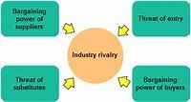Diagram source- Edrawsoft.com
The threat of new market entrants
Uber is big and popular in the transport and taxi industry. But they can not be allowed to monopolize the market. As a result, new organisations in the same industry are licenced by the regulatory body to compete in the market.
Competition is good because it drives down prices and it gives customers and consumers the opportunity to make a preferred choice.
In the USA, Lyft is a well-known competitor with Uber, in the UK, Bolt, Ola, Freenow are new entrants to the market that has been licenced by the regulatory body Transport for London. The threat of new entrants cannot be over emphasised, they drive down prices and reduce customer availability because customers that were only using Uber may now decide to use Bolt or Ola.
Threat of substitution
The availability of other taxi services has limited the dominance by Uber. In busy times when driver availability is limited, customer may have to wait longer to get a ride. In most cases they switch to alternative provider who can provide the same service for a lower cost.
When a customer request for a ride with Uber to a destination, they sometimes compare with other providers and eventually choose the cheaper option.
Supplier Power
Driver availability is a major player in this field. Uber does not own the vehicles its drivers drive but there are other service providers who drivers drive their vehicle and are contracted to work for them. These drivers only pick up customers for the vehicle owners whereas with Uber, drivers would normally pickup riders for providers with high request rate or with higher price.
Buyer Power
Bargaining power is great in the Taxi industry. Uber customers are price sensitive, so buyer power normally depends on how abundant the competition is in the industry. So for example if Uber decides to increase their cost to make profit, this may result in customers choosing alternative service provider.
The identity of Uber also matters in buyer bargaining power. Uber has a strong identity in the taxi industry thus customers tend to trust their service more due to its brand name.

Industry Rivalry
The rivalry in the taxi industry cannot be over emphasized. Uber has competitors all over the world. In London alone, it competes with the likes of Bolt, Ola, Freenow for customers. These competitors have the same business model with Uber.
The more competitors there are, the stiffer the competition to get customers. Rivalry also helps drive down prices on the positive side.
Covid-19 Effect
Before the pandemic broke out, Uber was very popular and dominated the taxi industry. Though it’s still popular it’s in recovery stage after being hit hard by the Covid-19 pandemic.
Uber relies on customers to request trips on its app to be in business and be profitable. When the pandemic broke out, various government announcements such as full lockdowns and encouraging people to work from had a huge impact on Uber. As a result, Uber service seemed to depend more on delivery services than the taxi service as more people were ordering food due to closure of restaurants.
In late 2019, Uber gave almost 2billion rides to customers which dropped significantly to 737million by mid-2020 as people were no longer prioritising their journeys using ride hailing services such as Uber.
Although in the UK the effect of Covid has significantly reduced and life is back to normal, there are other countries experiencing second and third waves of the pandemic, so the situation is different in every country.
During the pandemic, Uber hub in London was shut down to drivers with less staff working to attend to calls. Calls took much longer to answer as Uber staff were either self-isolating due to Covid infection or on some occasions, calls were not answered at all making it difficult for drivers and customers with issues to get the attention they needed.
Uber’s net revenue was not left out. Their net revenue was hit drastically to $1.9 billion from $3.9 billion in the second quarter of 2020 at the height of the pandemic.
In conclusion, the pandemic hit Uber drastically as a business, its impact is yet to be recovered from as the organisation is still recovering. The more the economy opens, and people are allowed to go back to their offices, shops open, Hospitality sector open, then the road to recovery will continue.

Task 2
As a result of the pandemic, Uber had to create a plan B to survive the pandemic due to spiralling revenue on the decline. This wasn’t an easy task as no one saw this coming and they were ill prepared for the task ahead.
Restaurants were not getting customers. The only way they could make a revenue was home delivery. Uber had to put in more resources to Uber Eats as more customers were ordering and not going out to eat outdoors.
In California, there was an unprecedented request on Uber Eat so Uber sent out emails to community operators for help with the surge in requests. More than 900 employees volunteered to help onboard restaurants so that customers could order food through Uber Eats. This way, Uber made the best use of the pandemic situation as there was a surge in the Uber Eat service. Uber Eats gross booking surged by 56%.
Another step taken by Uber to survive the situation was to cut down on its workforce slashing the customer support and recruitment team by 3700 staffs. This actions wer needed to reduce the business loses and to keep it afloat.
To keep drivers and customers safe, Uber distributed masks, hand gloves, hand sanitizers to drivers and made it mandatory to always wear during work.
Despite the pandemic being catastrophic to businesses, Uber made an unprecedented decision to give NHS staff 300,000 free rides and meals from its own pocket. A decision which was welcomed by customers as NHS staff were at the fore front of the pandemic working day and night to treat covid patients “We hope we can help in small way with meals and transportation as they work tirelessly day and night” said Uber CEO Dara Khosrowshahi.
Uber maintains some remarkable customer experience that makes them popular compared to other taxi services. When a customer request for a ride via the app from A to B, the customer knows in advance approximately what he/she is paying for the trip.
A customer can rate a trip driver included from 1 to 5 after every trip. If the customer rates the driver less than 5 star, the customer must put into writing the reason why the driver is rated less than 5 star and vice versa. This way Uber can monitor every trip and escalate issues they deem fit.
For customer’s peace of mind, whenever a customer orders a ride, the moment the customer is linked to a driver, the driver’s details pop up on the screen of the customer’s phone. Driver’s picture, vehicle registration, driver licence number with Transport for London are all seen by the customer to be sure they are entering the right vehicle and driven by the right driver.
Customer experience using the Uber app is seamless. Customers can easily navigate their way through the app from requesting for a ride, adding, or changing their destination and even viewing the trip route on their smart phones. Customers on Uber Eats enjoy the same experience though it’s a different app. They can choose a restaurant of their choice normally within the area, order food and in no time, the food is delivered to the customer.
Good customer relationship is important for every business and organisation. Customers can call Uber customer service from the app to make any complaints while they are readily available to attend to their needs. In some cases, due to experiencing a large call volume it may take time to get through to customer service. If this situation occurs, customers can send email which will be responded to as soon as possible.
According to a survey conducted by West Interactive Services on Uber customer preference, they were asked what they considered a good service, 77% said speed to resolution, 55% said convenience and 47% said transparency. Uber has worked hard to create a technology the connects customers to drivers via real time mapping accuracy which has help cut waiting time for customers to an average of 4 minutes and 10 seconds. This technology also helps drop off customer through the quickest routes available on the map.
The convenience of finding a ride is also an added advantage to a customer. The traditional taxicab, you must find and wave them down to get a ride, but with Uber, just a press of buttons on your phone brings a driver to you regardless of your location.
In conclusion, Uber has been able to survive the Covid 19 pandemic even though with losses and still achieve its business objects and at the same time maintain good customer relationship.

References
- ‘Uber swot analysis: uber strengths & weaknesses 2021’ (2019) Swot Analysis Template, 24 December. Available at: https://www.swotanalysistemplate.com/uber-swot-analysis/ (Accessed: 7 May 2022).
- Team, M.S. (no date) Uber pestle analysis, MBA Skool. Available at: https://www.mbaskool.com/pestle-analysis/companies/18032-uber.html (Accessed: 8 May 2022).
- Uber’ (2022) Wikipedia. Available at: https://en.wikipedia.org/w/index.php?title=Uber&oldid=1085715139 (Accessed: 2 May 2022).
- What has been the true impact of COVID-19 on Uber? - Business Leader News (2021) Business Leader. Available at: https://www.businessleader.co.uk/what-has-been-the-true-impact-of-covid-19-on-uber/ (Accessed: 9 May 2022).
- Nast, C. (no date) ‘How Uber plans to swerve its way out of the coronavirus crisis’, Wired UK. Available at: https://www.wired.co.uk/article/uber-coronavirus-chaos (Accessed: 9 May 2022).
- What is swot analysis? (no date). Available at: https://www.visual-paradigm.com/guide/strategic-analysis/what-is-swot-analysis/ (Accessed: 9 May 2022).
- The advantages of pestle analysis (2016). Available at: https://pestleanalysis.com/advantages-of-pestle-analysis/ (Accessed: 9 May 2022).
- Pocket-lint (2020) Uber offers 300,000 free rides and meals to NHS staff in UK. Available at: https://www.pocket-lint.com/apps/news/uber/151625-uber-offers-300-000-free-rides-and-meals-to-nhs-staff-in-uk (Accessed: 9 May 2022).
- McGovern, M. (2017) The 3 things customers want most (And lessons from uber on delivering them). Available at: https://www.customerexperienceinsight.com/the-3-things-customers-want-most-and-lessons-from-uber-on-delivering-them/ (Accessed: 9 May 2022).
- ‘Uber ansoff matrix’ (2021) Research-Methodology, 19 July. Available at: https://research-methodology.net/uber-ansoff-matrix-2/ (Accessed: 9 May 2022).

References

https://en.wikipedia.org/wiki/Uber

