How the role of an Assistant Therapy Practitioner can support with the Prevention and Management of Individuals with a Diagnosis of Osteoporosis.

Sian Jones - 2317727

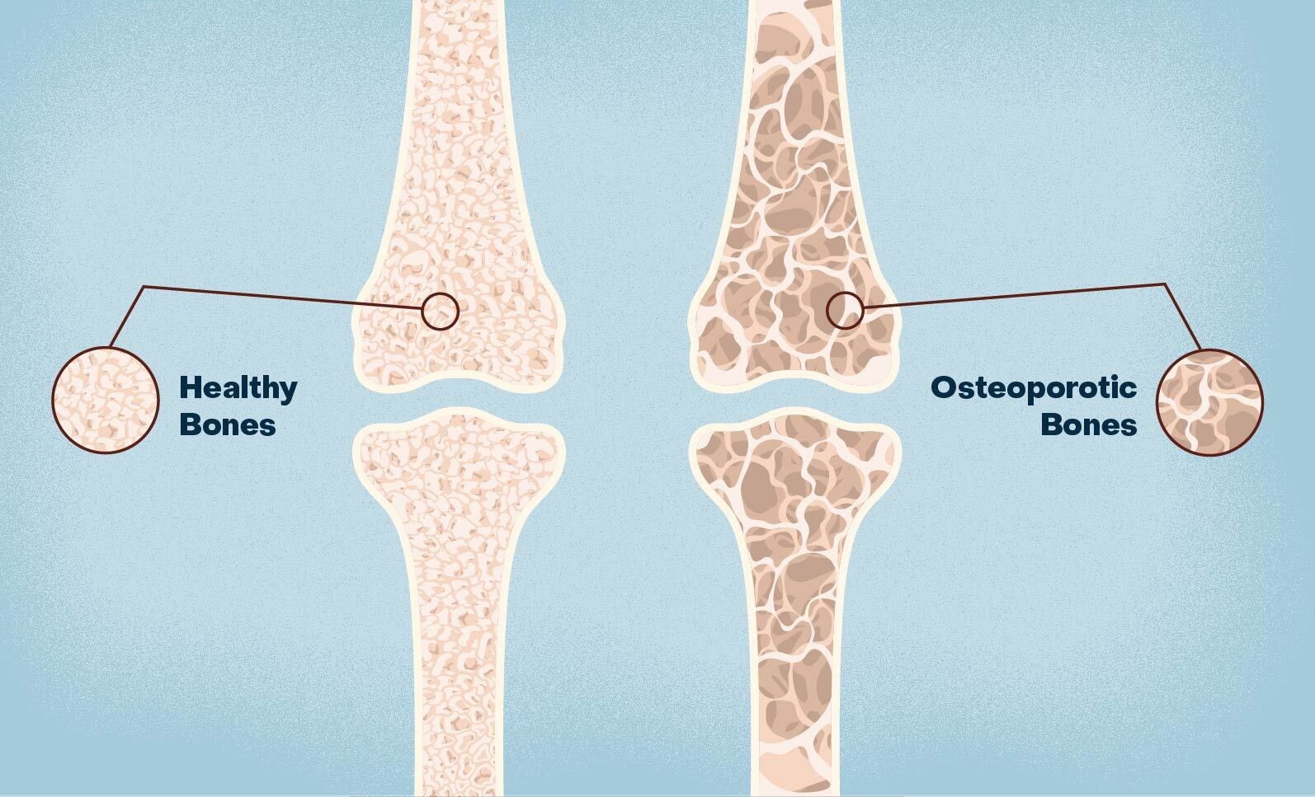
Contents Page

Introduction …………………………………………………………………………………………………………. Page 3
Case Study ……………………………………………………………………………………………………………. Page 3
Overview ……………………………………………………………………………………………………………… Page 4
Previous & Current Approaches to the Condition …………………………………………………. Page 5
Co-Production ……………………………………………………………………………………….……………… Page 6
Clinical Governance ………………………………………………………………………………………………. Page 7
Conclusion & Recommendations ………………………………………………………………………….. Page 8
Reference List ……………………………………………………………………………………………….………. Page 10
Appendix List ………………………………………………………………………………………………………… Page 14

Introduction
The following project will research osteoporosis and the involvement of an Assistant Therapy Practitioner (ATP) within a community therapy setting. Osteoporosis is a condition that weakens the bones and increases the risks of fragility fractures (Compston, McClung and Lesley; 2019) The Royal Osteoporosis Society state that “Over three and a half million people in the UK are living with osteoporosis” (2024). An ATP works within a variety of departments such as, Physiotherapy, Occupational Therapy, Podiatry, and Speech and Language Therapy to name a few (Apprenticeship Framework, 2019). The Apprenticeship Framework (2019) reports that ATPs work alongside the health care professionals within these departments to provide therapy to patients, by completing initial assessments, issuing equipment, creating exercise therapy plans and progressing patients to achieve their overall rehabilitation goals. Within this project, there will be a case study of a patient who had a recent fall which resulted in a fragility fracture, which then lead to the patient having a diagnosis of osteoporosis. A brief overview of osteoporosis will be discussed, leading to research of the previous and current approaches of the condition and how an ATP can be involved within these approaches and what the changes have been over the years. Co-Production within healthcare and clinical governance and supervision will also be referred to, and how these elements impact the ATP’s involvement within their role and how they can support the patient to ensure the best patient care is provided. With all of this, it is hopeful that the overall conclusion of the project will result in identifying how the role of the ATP can support in the management of patients pre and post a diagnosis of osteoporosis.

Case Study
The following case study will look into the role of an Assistant Therapy Practitioner (ATP) working in a Community Therapy setting. Community Therapy is a service that provides patients with therapy and rehabilitation in their own homes or nursing and residential homes and so the aim is to get the patients more independent and to allow them to remain in their home safely and to prevent any possible admissions. The ATP’s first visit following allocation generally consists of an initial assessment which involves finding out the full medical history, current medication, therapy goals and to create a therapy plan to achieve those goals. The case example will focus on a lady who was discharged home from hospital with a fractured neck of femur and then referred to the Community Therapy Team from the Home First service. Home First is a short-term service that supports patients who are discharged home from hospital to encourage them to build their skills and confidence and to regain independence in normal daily activities that they would normally be able to complete prior to admission (PTHB 2022). The lady involved with the case study will be given a pseudo name of Margaret to maintain confidentiality.
Margaret is a 68-year-old female who lives alone in a ground floor flat. She has had a recent fall leading to a long lie of 24 hours which resulted in a fractured neck of femur and her needing hip surgery to repair. As Margaret lives alone, she had no family members or visitors pop by to identify that she had fallen which was the reason for the 24 hour long lie as she was unable to get up off the floor independently to be able to call anyone for help. Margaret’s overall social situation is a positive one, she has a supportive family and friends who visit regularly as she was having difficulty before her fall with a bad back due to having osteoarthritis in her spine and therefore needed support with groceries and cleaning.
Margaret suffers from low blood pressure, Chronic Obstructive Pulmonary Disease (COPD) and also depression, the main cause identified of her depression was that she was struggling to access the outdoors prior to the fall due to poor mobility and weakness in her lower limbs. Margaret has been diagnosed with osteoporosis, which is a condition that weakens the bones, which causes the bones to be more fragile and therefore more prone to fractures (National Health Service, 2024).
Osteoporosis is a musculoskeletal disease which is known to lower bone density and the microstructure decline of bone tissue and therefore the consequence being weakened bones and therefore a higher risk of bone fractures (Compston, McClung and Lesley; 2019). Compston, McClung and Leslie (2019) continue to explain that osteoporosis is a chronic condition that requires long-term and occasionally lifelong management. According to Aibar-Almazán et al (2022) there are various management methods which can help the progression of osteoporosis for example, nutritional habits which include taking additional calcium and vitamin D, although it has been identified that there are new and other factors which support healthy bones.

Overview
It has been identified by Gregson et al (2022) that osteoporosis occurs predominantly in postmenopausal women and men over the age of fifty, he also continues to explain that “approximately one in two adult women and one in five men will sustain one or more fragility fractures”. Similarly, Lorentzon et al (2022) have also recognised that “In western societies, one in three women and one in five men will sustain an osteoporotic fracture in their remaining lifetime from the age of 50 years”.
In the UK, the average hospital stay following a hip fracture is 20 days, which is one of the most common fragility fractures, additionally fragility fractures cost the NHS more than £4.7 billion ever year (Gregson et al, 2022). Therefore, fractures caused by osteoporosis can have a major impact on the health service, between taking up bed space in hospitals and also the cost of fragility fractures per annum.
Family members often have to deal with the burden of individuals who have suffered an osteoporotic fracture, and therefore could cause a physical, emotional, and financial strain on them who are supporting or providing care to that patient (Borgström et al, 2020). According to Borgström et al (2020), the average yearly hours of care provided to patients by family members in the UK is 277 hours following a hip fracture (See appendix 1).
Lorentzon et al (2022) and Borgström et al (2020) both agree that osteoporotic fractures can cause functional decline, disability, reduced life quality, pain and an increase of ill health and mortality in individuals who have suffered a fall which resulted in a fracture.

Previous and Current Approaches
Many years ago, it was very difficult to differentiate the difference between osteoporosis and osteopenia with their normal attempt to diagnose the conditions by having a radiologist review a radiograph to identify the bone quality (Garn, Poznanski and Nagy, 1971), but as confirmed by Garn, Poznanski and Nagy (1971) there was no clear differences between osteoporosis and osteopenia when reviewing a radiograph making the diagnosis unreliable. Similarly in more recent years, the diagnosis of osteoporosis was made by either identifying that the bones were too thin, or following a fracture, which according to Raisz (1997) was “too inaccurate” and “too late”. Osteoporosis is still being identified as a “silent disease” which is only visibly diagnosed following a fracture (Anthamatten DNP, 2019, Akkawi & Zmerly, 2018), and therefore makes it extremely difficult to identify if an individual has the condition prior to having a fall or accident which results in a fracture. Anthamatten DNP (2019) suggests that individuals especially women over the age of fifty and individuals with a new fracture, should have an assessment to review bone health during their annual health check, as this will provide clinicians with better information to diagnose osteoporosis earlier. There is a fracture risk assessment tool (FRAX) available which was produced by the University of Sheffield to identify a fracture risk using clinical risk factors and bone mineral density (BMD) to calculate the risk (Osteoporosis Research Ltd, 2024).
In previous years there were various therapy and prevention approaches available for osteoporosis, for example a calcitonin nasal spray and bisphosphonates were used for patients (Raisz, 1997). A study was conducted by Saag et al (1998) to identify the effects of alendronate in a placebo-based study with 477 men and women. The study was completed over a two 48-week period for individuals receiving glucocorticoid therapy. The results were impressive, with a clear improvement in the bone density of individuals over the 48 week period and so it was identified that “Approximately 80 percent of the patients in the alendronate groups had increases in lumbar-spine bone mineral density” (Saag et al, 1998) (See appendix 2). Ayub et al (2021) agrees with Saag et al (1998) that bisphosphonates is the main pharmacological treatment choice for improving bone density and therefore reducing the fracture risk caused by osteoporosis in individuals which identifies that the treatment options have not developed greatly since the 90’s. Ayub et al (2021) also identified, similarly to Saag et al (1998) that there was “a 40% reduction in hip fracture risk” following the study and also that “Bisphosphonates are estimated to prevent 80–5000 fragility fractures for each atypical femur fracture possibly induced by treatment”.
Band 4 Assistant Therapy Practitioners (ATP) were known to be able to complete the following competencies: “completing initial assessments, highlighting problems and needs, completing mobility assessments, providing aids, completing functional assessments, onward referrals to social services as appropriate, leaving on home visits for simple cases” (Howard and Butcher, 2007) therefore, in previous years, it would be likely that the ATP would complete an initial assessment on a patient who had recently had a hip fracture, which could be impacted by the fact a patient has a diagnosis of osteoporosis, and then following this assessment they would support the patient by identifying problems and needs, and then issuing equipment and aids. In comparison to the current role of the ATP, the responsibilities for an ATP with a combined role of Occupational and Physiotherapy as stated by the Powys Teaching Health Board (2024) now also include (See appendix 3);
- Handover of caseload/patient to another member of staff, providing all the necessary information
- To demonstrate the ability to jointly set functional, achievable, rehabilitation goals with patients.
- To be able to carry out HOMEFAST assessments and establish an appropriate treatment plan.
- To be able to carry out Total Hip Replacement Pre-operative assessments and establish an appropriate treatment plan.
- Complete an accurate subjective assessment.
- Carry out a mobility assessment including the relevant outcome measures to establish the correct treatment plan.
- Be able to provide a suitable and safe walking aid and/or recognise when a mobility problem is complex and requires an assessment with a registered therapist.
- To be competent in the correct selection and progression of exercises e.g. from the Otago balance and strengthening programme
Therefore, the more current role of an ATP would be providing a broader service to the patient with a hip fracture potentially caused by a fall and the diagnosis of osteoporosis. Although there would be similarities between the current ATP role and the previous ATP role such as the initial assessment process and issuing appropriate equipment and aids to support at home, the updated and current role of the ATP would be involved in the mobility assessments, outcome measures, treatment plan and preventative measures to support the patient in reaching their goals, returning to baseline and prevent any falls in future which could result in any new fractures.

Co-Production
Co-Production is known to be a partnership between patient and healthcare services, which allows individuals to be provided with the best possible support that is relevant and appropriate to them (NHS England, 2024), in relation to this, the Welsh Government have an Evaluation of the Social Services and Well-being (Wales) Act 2014 which covers co-production, and they state that “The Act aims for people to be more involved in the design and provision of their care and support. It means organisations and professionals working with them and their family, friends and carers so their care and support is the best it can be”, additionally the National Health Service Act (2006) stated that “In exercising their respective functions NHS bodies (on the one hand) and local authorities (on the other) must co-operate with one another in order to secure and advance the health and welfare of the people of England and Wales”.
Duncan (2022) is clear that the initial assessment stage is a vital part of the process where details are collated about the patient, this information is necessary for the ATP to produce a plan for effective interventions. Prior to the initial assessment, the therapy team receive a referral from an out-source, whether that is the patient themselves, Home First, GP’s, hospitals, District Nurses, or social services. It is important that the ATP works together with other health care professionals (HCPs), such as the GP, Physiotherapists, Occupational Therapists, Dieticians, Pharmacists, amongst other HCPs to enable the best possible care to support in the preventative measures of falls and therefore fragility fractures in patients, as information like medical history and an up to date prescription list, could be vital information that is needed to support in the prevention of these fractures caused by osteoporosis.
Some barriers that may be encountered by the ATP could include;
- A patient being non-compliant or unmotivated to complete exercises, which affects their overall goals and not being able to achieve them, and so in this case the ATP could look to reassess the patient’s goals going forward.
- Poor communication between healthcare services, which could result in not having the appropriate information about the patient, leading to a lengthier assessment process, unnecessary discussions and even poor therapy planning as the patient may have a condition that the ATP is unaware of, which could cause discomfort or pain to the patient.
- Waiting lists for other services, such as Musculoskeletal Physiotherapy (MSK) which could impact the patient’s rehabilitation progress.
- Prescription lists not up-to-date and the patient not knowing what medication they are taking, or taking unnecessary medication, which could affect the patient’s mobility, cognition, balance, confusion, or illness.

Clinical Governance
All Public Health Wales staff, which includes the ATP have an obligation to complete statutory and mandatory training to fulfil their roles to the highest standards, which has been mandated by either the Welsh Government, NHS Wales, or Public Health Wales (Public Health Wales, 2024). In previous years, there have been several barriers in workforce training and so Ward and Wood (2001) state that “time, accessibility, financial issues, staff motivation and marketing/advertisement” were the main barriers. Similarly, Sanders and McLaughlin (2018) have a similar view with time and cost being a current barrier still, however as time has progressed there are also differences, with Sanders and McLaughlin (2018) also reporting that “quality, relevance, access and inclusion” are the most current barriers to training in healthcare. Most training available now is available online, which reduces the time constraints and accessibility, making it more readily available to healthcare staff.
Risk management is an essential pillar within clinical governance, which ensures the safety of patients and staff within any healthcare service. Reporting any risk is the responsibility of all staff within the NHS, including the ATPs and then reporting the risk onto Datix (Public Health Wales (2024). A specific policy within risk management includes ‘Lone Working’, and therefore when working in the community or in clinical settings, lone working is an often occurrence, and Public Health Wales (2024) state that “Public Health Wales has a duty of care to its lone working staff, both in the community and on its property”. Brennan (2014) produced a risk assessment tool for individuals working alone to identify any risks. Brennan (2014) breaks down the scoring system as “10-15 – low risk, 16-23 - medium risk, 24+ - high risk” (See Appendix 4), this system would be beneficial for the ATP along with all other health care professionals to use to ensure safety when working alone and therefore to carry out an effective risk assessment prior to a visit.
The Powys Teaching Health Board (PTHB) (2023) state that “The importance of clinical supervision for all therapy, health science, nursing, midwifery, mental health and supporting clinical staff is recognised as being central to safe and effective practice within a clinical governance framework”. Some of the benefits to completing clinical supervision for staff according to the PTHB, inclusive of the ATP’s are;
- Development of reflective clinical practice and evaluation skills.
- Identification and understanding of own development needs and how to address them.
- Learning and developing improved working practices, skills, knowledge, and values.
- Support and encouragement.
Clinical Supervision for an ATP allows them to raise any concerns to their supervisor of their clinical practice to ensure they receive support with their concerns or how to appropriately manage this in the next instance. Additionally, clinical supervision allows for an ATP to reflect on their practice and to identify any areas of improvement which may be needed to provide the best possible care for patients. It is important that ATPs receive regular six weekly supervision sessions to cover all aspects of their role which covers, goals, training, concerns, well-being discussions amongst many others (See Appendix 5).

Conclusion and Recommendations
The outcome of the research has been led to believe that from an osteoporosis perspective there is very little to none that can be done by the ATP to prevent osteoporosis in patients, although there are some methods that an ATP can support with the management of osteoporosis, such as reduce the risk of falls, and hopefully reduce the risk of fragility fractures caused by osteoporosis. These methods generally concentrate on preventative measures for falls which could result in fragility fractures, therefore overall strengthening for the patient, and improving an individual’s mobility whether that be aided or unaided, will generally support with the hopeful reduction of falls and therefore fragility fractures (PTHB, 2024).
Medication is heavily involved with the prevention of osteoporosis, and therefore the co-production of an ATP working alongside the GP and the pharmacist would be beneficial, as the ATP can offer preventative measures to fragility fractures, however the patient needs to be on the appropriate medication to manage other conditions that could increase the risk of falls, for example, low blood pressure, which would be the responsibility of the GP and pharmacist, however the ATP can relay any concerns or updates back to them if the patient’s condition changes
An ATP working in community therapy very often is lone working, and therefore needs to assure that a risk assessment is completed prior to attending a patient’s home alone. It would be beneficial for the ATP to use Brennan’s (2014) ‘Rapid Risk Assessment Tool’ (See Appendix 4) to identify any risks prior to completing a visit – this tool could also be very beneficial to the rest of the community therapy team to identify any risks, and act on those to ensure the safety of themselves, the patient and the rest of the team. Statutory and mandatory training is a vital part of the ATP’s role, as this allows the ATP’s competencies to be up to date and to provide therapy in the best possible and safest way (Public Health Wales, 2024), this also links to supervision in a way that the ATP is receiving the support they need to develop as a therapist and ensure their training is up to date (PTHB, 2024).

Reference List
Aibar-Almazán, A., Voltes-Martinez, A., Castellote-Caballero, Y., Afanador-Restrepo, D. F., Carcelén-Fraile, M. D., and López-Ruiz, E. (2022) ‘Current Status of the Diagnosis and Management of Osteoporosis’, International Journal of Molecular Sciences, 23(16), pp. 9465. Available at: https://doi.org/10.3390/ijms23169465

Akkawi, I., and Zmerly, H. (2018) ‘Osteoporosis: Current Concepts’, Joints, 7(4), pp. 122-127. Available at: https://www.thieme-connect.com/products/ejournals/pdf/10.1055/s-0038-1660790.pdf

Andrews, N., Calder, G., Blanluet, N., and Baker, R. (2023) ‘Co-Production’, Research to support the Final Report of the Evaluation of the Social Services and Wellbeing (Wales) Act 2014. Cardiff: Welsh Government.

Anthamatten, A. (2019) ‘Clinical Update on Osteoporosis’, Journal of Midwifery & Women’s Health, 64(3), pp. 265-275. Available at: https://onlinelibrary.wiley.com/doi/full/10.1111/jmwh.12954

Apprenticeship Framework (2019). Therapy Assistant Practitioner (Wales), (1) pp. 7-8. Available at: https://acwcerts.co.uk/web/wp-content/uploads/2019/11/Therapy_Assistant_Practit_Wales_FR04451_1.pdf

Ayub, N., Faraj, M., Ghatan, S., and Reijers, J. A. A., Napoli, N., and Oei, L. (2021) ‘The Treatment Gap in Osteoporosis’, Journal of Clinical Medicine, 10(3002), pp. 1-13. Available at: https://doi.org/10.3390/jcm10133002

Borgström, F., Karlsson, L., Ortsäter, G., Norton, N., Philippe, H., Cooper, C., Lorentzon, M., McCloskey, E. V., Harvey, N. C., Javaid, M. K., Kanis, J. A. (2020) ‘Fragility fractures in Europe: burden, management and opportunities’, Archives of Osteoporosis, 15(59), pp. 1-21. Available at: https://doi.org/10.1007/s11657-020-0706-y

Brennan, W. (2010) ‘Safer lone working: assessing the risk for professionals’, British Journals of Nursing, 19(22), pp. 1428 - 1430. Available at: https://www.magonlinelibrary.com/doi/pdf/10.12968/bjon.2010.19.22.1428
Butcher, E. and Howard, M. (2007) ‘The Developing Role of the Assistant Practitioner’, British Journal of Healthcare Assistants: Education and Training, 1(5), pp. 234-235. Available at: https://www.magonlinelibrary.com/doi/pdf/10.12968/bjha.2007.1.5.27212

Compston, J. E., McClung, M. R., and Leslie, W. D. (2019) ‘Osteoporosis’, The Lancet, 393(10169), pp. 364-376. Available at: https://www.clinicalkey.com/#!/content/playContent/1-s2.0-S0140673618321123?returnurl=null&referrer=null

Duncan, E. A. S. (2022) Skills for Practice in Occupational Therapy. 2nd Edition. Scotland: Bell and Pain LTD.

Garn, S., Poznanski, A., and Nagy, J. (1971) ‘Bone Measurement in the Differential Diagnosis of Osteopenia and Osteoporosis’, Diagnostic Radiology, 100, pp. 509-518. Available at: https://pubs.rsna.org/doi/pdf/10.1148/100.3.509

Gregson, C. L., Armstrong, D. J., Bowden, J., Cooper, C., Edwards, J., Gittoes, N. J. L., Harvey, N., Kanis, J., Leyland, S., Low, R., McCloskey, E., Moss, K., Parker, J., Paskins, Z., Poole, K., Reid, D. M., Stone, M., Thomson, J., Vine, N., Compston, J. (2022) ‘UK clinical guideline for the prevention and treatment of osteoporosis’, Archives of Osteoporosis, 17(58), pp. 1-46. Available at: https://doi.org/10.1007/s11657-022-01061-5

Lorentzon, M., Johansson, H., Harvey, N. C., Liu, E., Vandenput, E., McCloskey, V., and Kanis, J. A. (2022) ‘Osteoporosis and fractures in women: the burden of disease’, Climacteric, 25(1), pp. 4-10. Available at: https://doi.org/10.1080/13697137.2021.1951206

National Health Service (2024) Osteoporosis. Available at: https://www.nhs.uk/conditions/osteoporosis/ [Accessed on: 21st March 2024].

National Health Service Act 2006. (c41). [Online]. London: The Stationery Office. [Accessed 18 April 2024]. Available at: https://www.legislation.gov.uk/ukpga/2006/41/pdfs/ukpga_20060041_en.pdf

National Health Service England (2024) Co-production. Available at: https://www.england.nhs.uk/always-events/co-production/ [Accessed on 25th April 2024]

National Spine Health Foundation (2024) Osteoporosis And The Spine. Available at: https://spinehealth.org/article/osteoporosis/ [Available on 2nd May 2024]

Powys Teaching Health Board (2021). Powys Teaching Health Board Assistant Therapy Practitioner Support Worker Competencies. Bronglais: PTHB.

Powys Teaching Health Board (2022) Discharged to Recover & Assess: Powys Home First. Bronglais: PTHB.

Powys Teaching Health Board (2023) LINICAL SUPERVISION AND REFLECTIVE PRACTICE FOR THERAPY, HEALTH SCIENCES, MIDWIFERY, NURSING, SOCIAL WORK AND PSYCHOLOGY (EXCLUDING ALL MEDICAL STAFF). Bronglais: PTHB.

Powys Teaching Health Board (2024) Lone Working and Policy & Procedures. Bronglais: PTHB.

Public Health Wales (2023) Clinical Governance Framework. Cardiff.

Public Health Wales (2023) Learning and Development Policy. Cardiff.

Public Health Wales (2024) RISK MANAGEMENT PROCEDURE. Cardiff.

Raisz, L. (1997) ‘The Osteoporosis Revolution’, Annals of Internal Medicine, 126(6), pp. 458-462. Available at: https://oce.ovid.com/article/00000605-199703150-00007/HTML

Royal Osteoporosis Society (2024) Osteoporosis and bone health. Available at: https://theros.org.uk/ [Accessed on 2nd May 2024]

Saag, K., Emkey, R., Schnitzer, T.J., et al (1998) ‘Alendronate for the Prevention and Treatment of Glucocorticoid-Induced Osteoporosis’, The New England Journal of Medicine, 339(5), pp. 292-299. Available at: https://www.nejm.org/doi/pdf/10.1056/NEJM199807303390502

Sanders, K. and McLaughlin, D. (2018) Improving Mandatory Training: How reps can play their part. 1st Edition. London: Royal College of Nursing.

Vidal, M., Thibodaux, R. J., Neira, L. F. V., and Messina, O. D. (2019) ‘Osteoporosis: a clinical and pharmacological update’, Clinical Rheumatology, 38, pp. 385-395. Available at: https://link.springer.com/article/10.1007/s10067-018-4370-1

Ward, J. and Wood, C. (2000) ‘Education and training of healthcare staff: the barriers to its success’, European Journal of Cancer Care, 9(2), pp. 69-128. Available at: https://onlinelibrary.wiley.com/doi/epdf/10.1046/j.1365-2354.2000.00205.x

Appendix List
Appendix 1

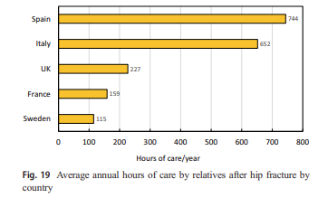

Appendix 2

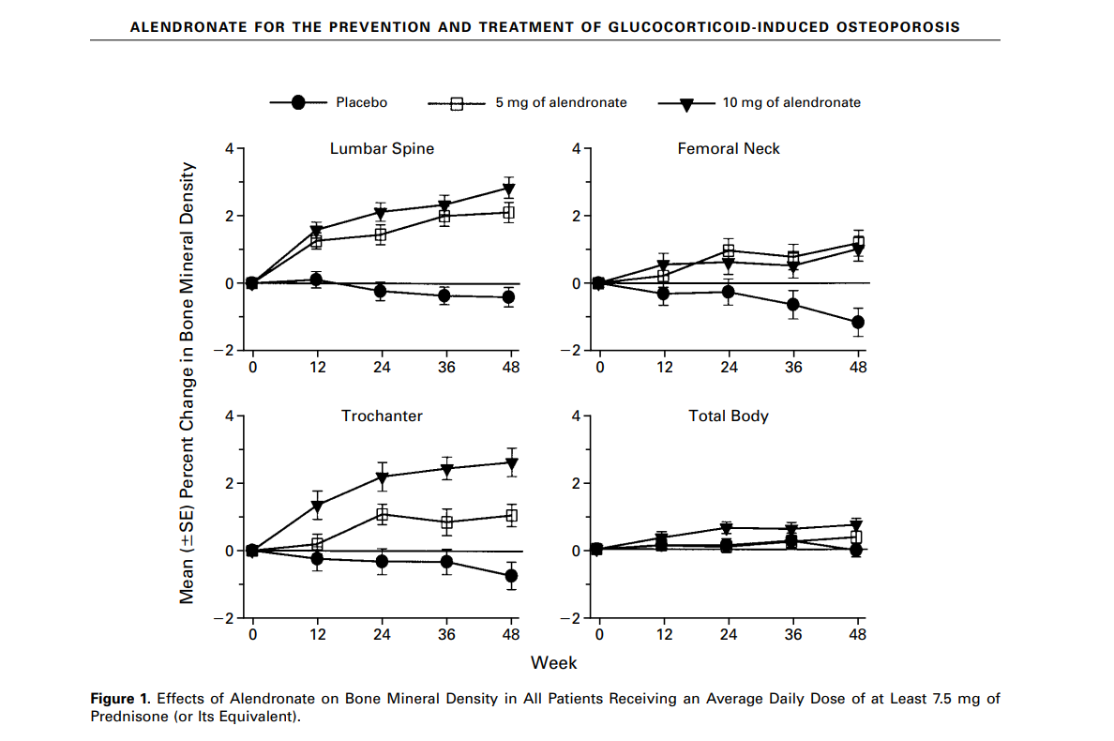

Appendix 3

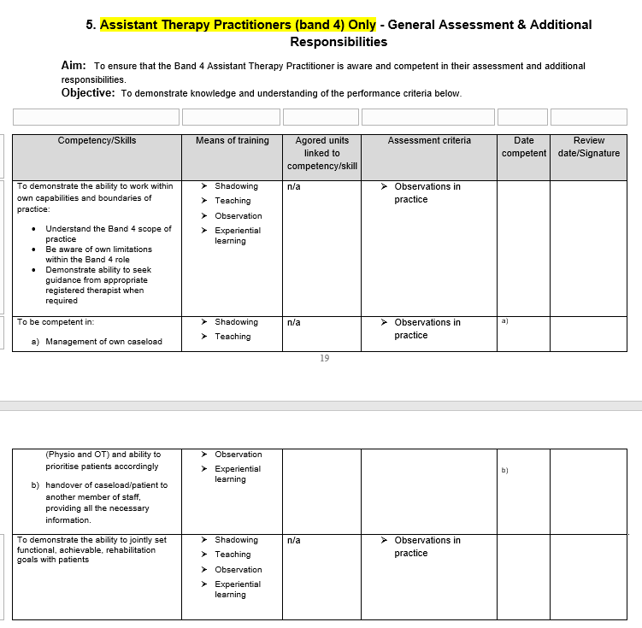

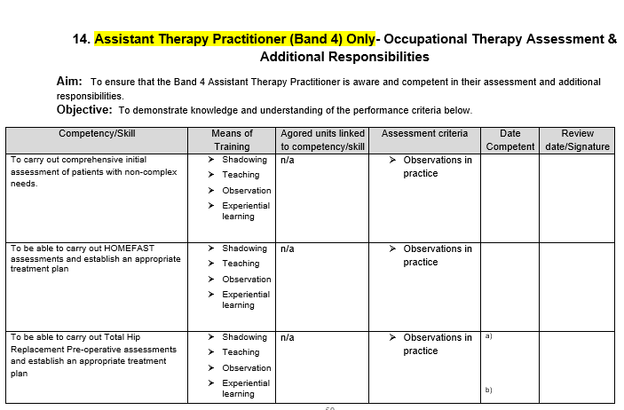
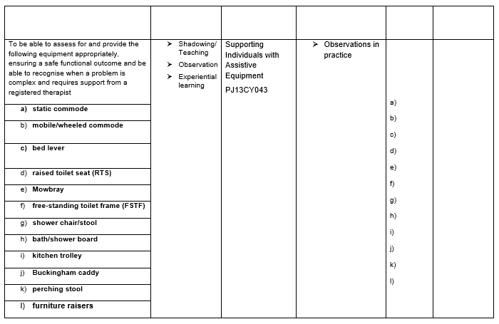

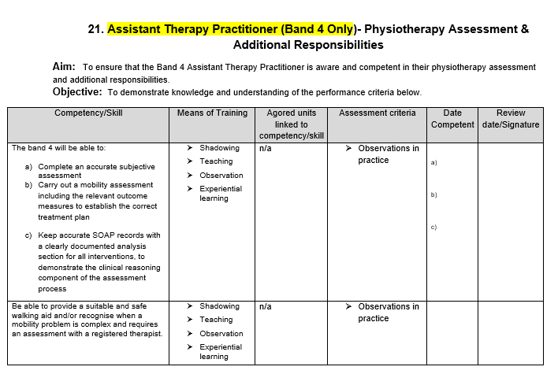
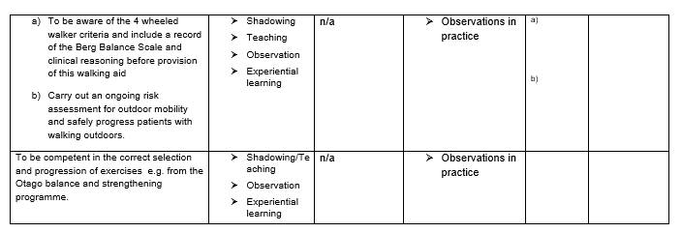

Appendix 4.
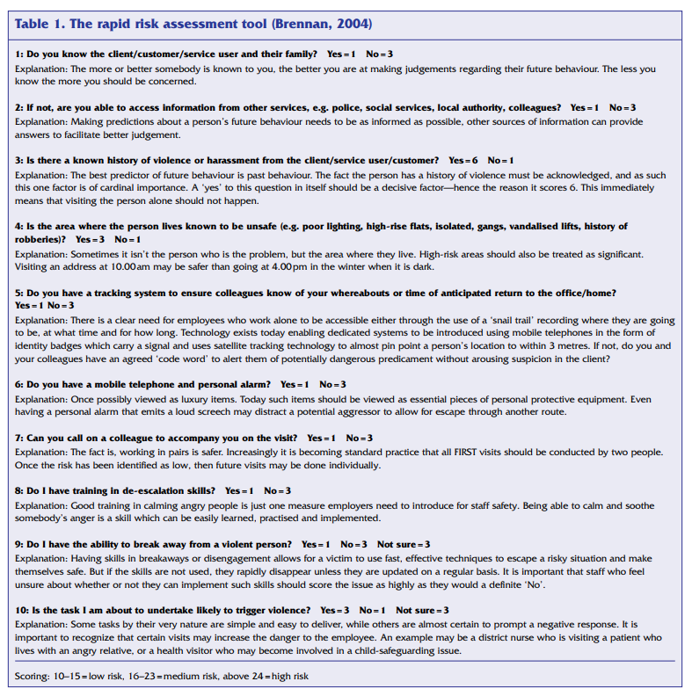

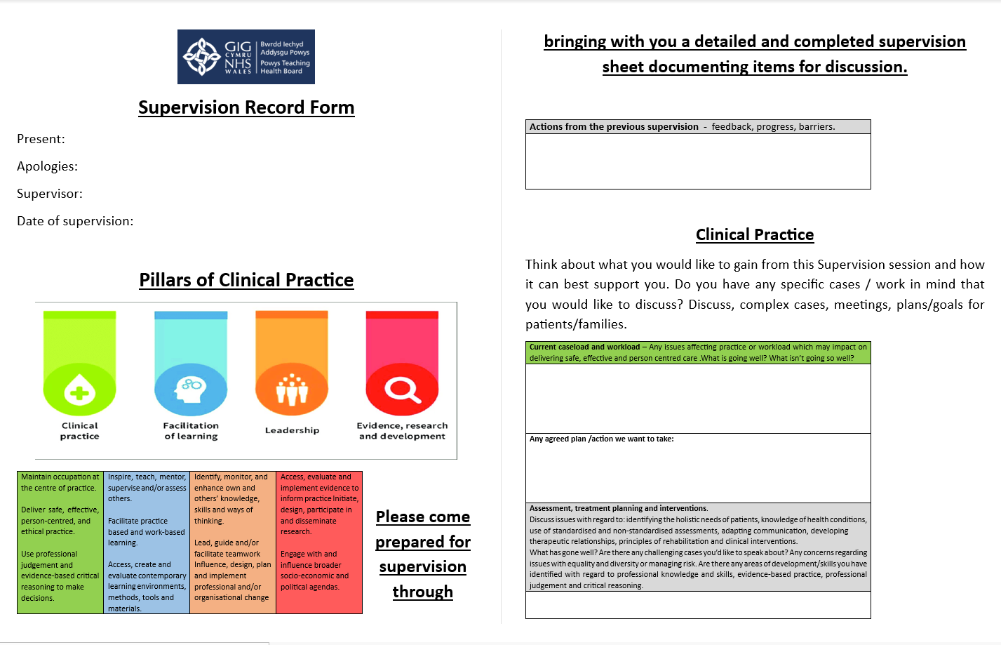
Appendix 5.

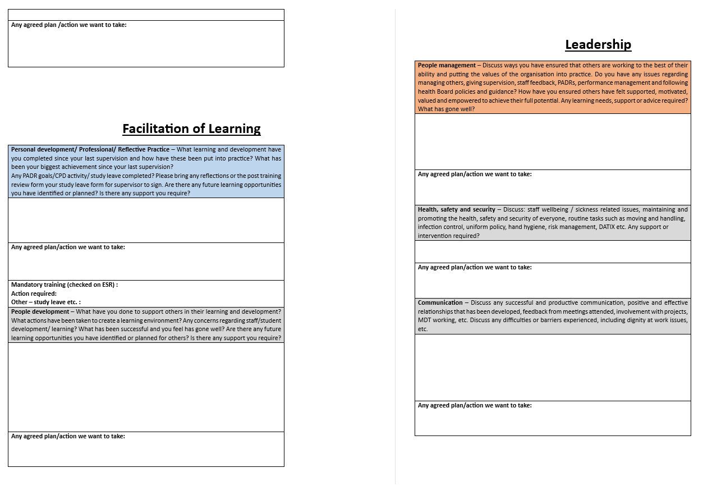
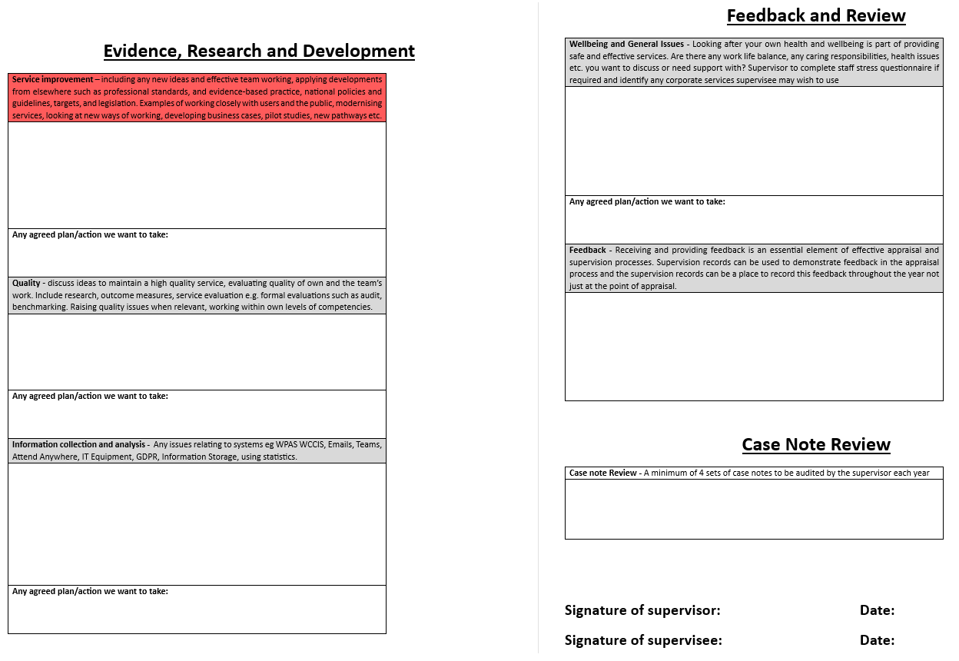


Appendix: 6 Critique check list
This Photo by Unknown Author is licensed under CC BY-NC

Article Title | Author(s) | Year of publication | Journal name | Abstract  (y or n) | Methods/  instruments used | Reliable  (y or n) | Validity  (y or n) | Ethical Considerations  (y or n) | Reference list  (y or n)
The Osteoporosis Revolution | Raisz, Lawrence G | 1997 | Annals of Internal Medicine | Y | Literature Review | Y | Y | N | Y
Clinical Update on Osteoporosis | Anthamatten, Angelina. | 2019 | Journal of Midwifery & Women’s Health | Y | Literature Review | Y | Y | N | Y
The Treatment Gap in Osteoporosis | Ayub, F., Faraj, M., Ghatan, S., Reijers, J., Napoli, N., & Oei,L. | 2021 | Journal of Clinical Medicine | Y | Literature Review | Y | Y | N | Y
Osteoporosis and fractures in women: the burden of disease | Lorentzon, M., Johansson, H., Harvey, N. C., Liu, E., Vandenput, E., McCloskey, V., and Kanis, J. A. | 2021 | Climacteric | Y | Literature Review | Y | Y | N | Y

