Student name: Layla White
Student number: 2016838
Module: Health, wellbeing & sustainable development. BMHP6021
Lecturer: Joanne Davies

Contents
Introduction.........................................................3
Introduction to concepts......................................4
Good health and well-being.................................6

Introduction
This report aims to examine the Sustainable Development Goals (SDG), exploring the efficiency of the goals on the public's health and wellbeing.
The SDGs are implemented in hope to make change to the world for the better, to protect our planet, our people and our future population. The fundamental principle of the SDG agenda is to ensure that no one is left behind and to unite as nations to make these goals a reality. Progress has been made since the 2030 agenda was blueprinted in 2015, nevertheless, a lot more development is to be made to hit the goals for 2030 (United Nations, 2023).

Introduction to concepts
Health and wellbeing
Wellbeing is a person's feelings about their life, although this can be described and measured in many ways and can differ depending on the person’s social construct and beliefs. Health and wellbeing are described to be the same, although wellbeing is focused on subjective assessment, meaning wellbeing is judged on how a person feels about their quality of life (Simons, G, 2021). Wellbeing is important as this affects a person physically, mentally, and socially. It is possible for a person to feel high levels of wellbeing while experiencing a mental or physical illness, as the person could still feel happy within themselves and rate their quality of life highly, although, people do say health is one of the main things that contribute to their wellbeing, furthermore, the Department of health state that good health is correlated with higher life satisfaction and improved physical outcomes such as slower disease progression, improved immune systems, improved cardiovascular health and high pain tolerance (Department of Health, 2014).
WHO (World Health Organisation) define health as a state of complete physical, mental and social well-being and not merely the absence of disease or infirmity, and detailed that every person has the right to the best possible health, regardless of their race, religion, political beliefs, or economic status (WHO, 2020).
Sustainable Development Goals.
In 2015, the United Nations established an agenda for sustainable development, within this there are 17 Sustainable Development Goals (SDG), and 169 targets. These goals are aimed at transforming the world, resolving the economic, environmental, and social problems that are imposed on the world, as well as ending poverty in all its forms. Each SDG has target strategies which the United Nations agreed upon for implementing these goals, these goals are intended to protect the planet, the people of the present, and the future generations to come. The SDGs officially came into force on January 1, 2016.
Sustainable development is a way of addressing the global environment and social challenges such as climate change, poverty, inequality and injustice, including living in a way that does not compromise our future societies. Some examples of this would be:
- Promoting a strong, healthy and just society, by meeting the unique requirements of all people. Promote personal well-being, social cohesion and inclusion, and equal opportunities for all members of the community, both current and future.
- To live with environmental limits, respecting the limits of our planet's environment and resources. Biodiversity aims to improve the environment and preserve natural resources for future generations.
- Creating a sustainable economy that benefits everyone and encourages efficient resource use.
- Promoting effective collaborative governance at all levels of society, using innovation, energy and diversity (Blewitt, J, 2008).

Goal 3 - Good health and well-being
SDG 3 is to promote good health and well-being to all people of all ages. The aim for 2030 is to promote health and well-being to everyone by improving maternal and child health, promoting mental health and well-being, reducing non-communicable diseases, and ending major communicable diseases. This goal is fundamental as the health and well-being of the population can affect other sustainable development goals too, for example, the health of workers and consumers will affect wealth development. The UN established 13 targets and 28 indicators for SDG3, aiming to track the progression of the targets, in the hope of reaching these goals by 2030. These targets are:
- To reduce the global maternal mortality ratio to less than 70 per 100,000 live births
- To end preventable deaths of newborns and children under 5 years of age, with all countries aiming to reduce neonatal mortality to at least as low as 12 per 1,000 live births and under‐5 mortality to at least as low as 25 per 1,000 live births
- To end the epidemics of AIDS, tuberculosis, malaria and neglected tropical diseases and combat hepatitis, water-borne diseases and other communicable diseases
- To reduce by one third premature mortality from non-communicable diseases through prevention and treatment and promote mental health and well-being
- To strengthen the prevention and treatment of substance abuse, including narcotic drug abuse and harmful use of alcohol
- To halve the number of global deaths and injuries from road traffic accidents
- To ensure universal access to sexual and reproductive health-care services, including family planning, information and education, and the integration of reproductive health into national strategies and programmes
- To achieve universal health coverage, including financial risk protection, access to quality essential healthcare services, and access to safe, effective, quality and affordable essential medicines and vaccines for all
- To substantially reduce the number of deaths and illnesses from hazardous chemicals and air, water and soil pollution and contamination
- To strengthen the implementation of the World Health Organization Framework Convention on Tobacco Control in all countries, as appropriate
- To support the research and development of vaccines and medicines for the communicable and non‐communicable diseases that primarily affect developing countries, provide access to affordable essential medicines and vaccines
- To substantially increase health financing and the recruitment, development, training and retention of the health workforce in developing countries, especially in least developed countries and small island developing States
- To strengthen the capacity of all countries, in particular developing countries, for early warning, risk reduction and management of national and global health risks (Sustainable Development Goals, 2015)
Healthcare workers play an important role in reaching these targets as promotion and awareness of healthy living, vaccine availability, and sufficient mental health support are crucial in achieving universal health coverage, meaning that all people have access to quality healthcare without facing financial hardship.
Covid-19 has shown to impact, not just in the UK but globally, the progress towards the health and well-being of the population and SDG 3. Early data suggests that the UK has cut up to 40% of its worldwide health spending, this includes 100% cut for the health partnership scheme which would have provided 78,000 healthcare professionals training by NHS staff, seeing benefits to more than 430,000 patients. Mental health projects and funding for water, sanitation, and hygiene also faced cuts of up to 80% (Bond, 2022). In addition to Covid 19 affecting the UK economically this has also shown a decrease in the amount of coverage for childhood immunisations, which will affect the sustainability on the UK’s future health of the population. The World Health Organisation has a target of 95% for early immunisation coverage of all children under the age of 5 in the UK, this has fell below this expected target in all available immunisations for early childhood, please see table below:
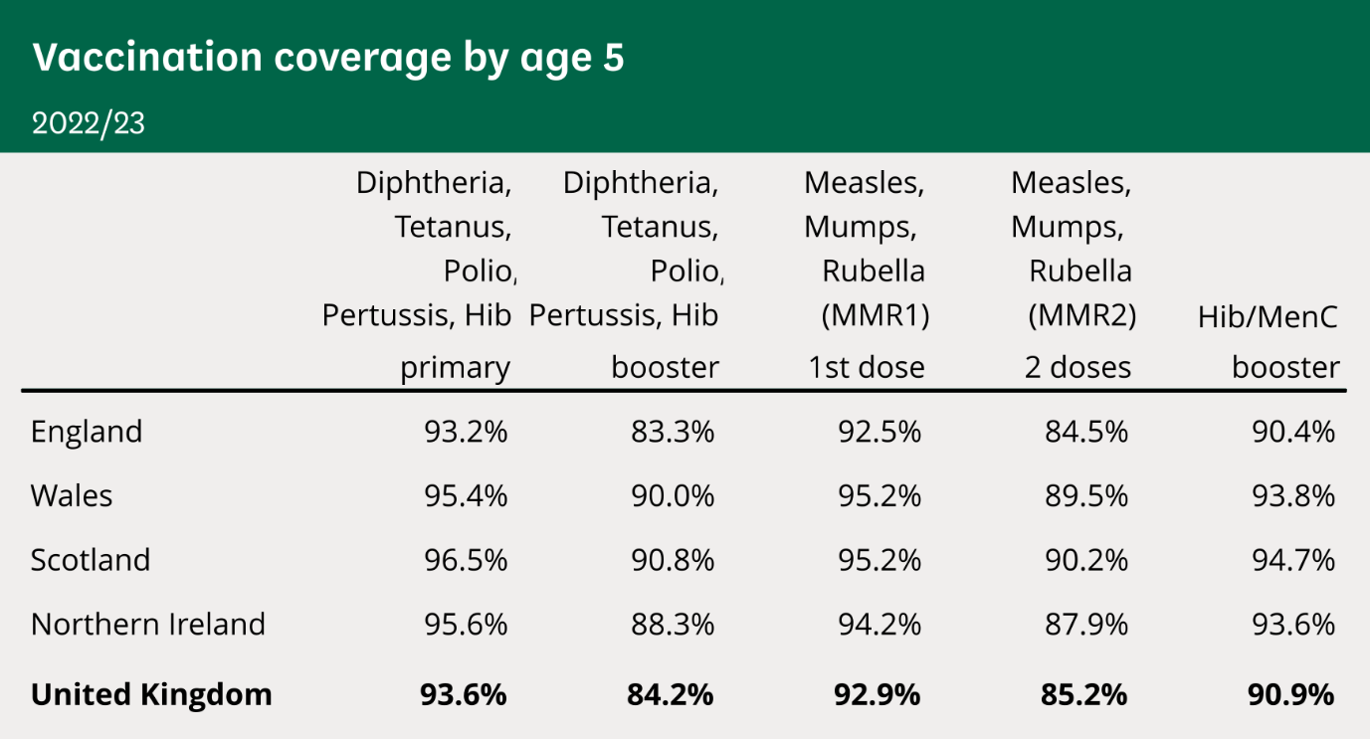(UK Parliament, 2024).
It would be recommended that there are more Campaigns for children’s vaccinations as there has been a decrease in children that receive their immunistaion, people may have forgotten about how serious these illnesses can be.

SDG 1 -

References
Blewitt, J (2008) Understanding sustainable development. London: Taylor & Francis Group Available at: https://doi.org/10.4324/9781849773645
Bond (2022) SDG 3 progress, gaps, and recommendations for the UK. Available at: https://www.bond.org.uk/wp-content/uploads/2022/09/sdg3.pdf (Accessed: 27 February 2024).
Department of health (2014) The relationship between wellbeing and health. Available at: https://assets.publishing.service.gov.uk/government/uploads/system/uploads/attachFebruaryment_data/file/295474/The_relationship_between_wellbeing_and_health.pdf (Accessed: 17 February 2024).
Simons, G and Baldwin, D. (2021) ‘A critical review of the definition of ‘wellbeing’ for doctors and their patients in a post Covid-19 era’. International Journal of Social Psychiatry. 67(8) 984–991. Available at: 10.1177/00207640211032259
Sustainable Development Goals (2015) Goal 3 – Good health and wellbeing. Available at: https://sdgdata.gov.uk/3/ (Accessed: 26 February 2024).
UK Parliament (2024) Childhood immunisation statistics. Available at: https://commonslibrary.parliament.uk/research-briefings/cbp-8556/ Accessed: 17 March 2024).
United Nations (2023) Halfway to 2030, world ‘nowhere near’ reaching Global Goals. Available at: https://news.un.org/en/story/2023/07/1138777 (Accessed: 17 February 2024).
WHO (2020) ‘Basic documents: forty-ninth edition’. Available at: https://apps.who.int/gb/bd/pdf_files/BD_49th-en.pdf (Accessed: 15 February 2024)

