Chapter 13

Flexible budgets and performance reporting
Seminar Questions

Questions

13-1 What is a static budget?

13-2 What is a flexible budget and how does it differ from a static budget?

13-3 Name three criteria that should be considered in choosing an activity base on which to construct a flexible budget.

Exercises

E13-1

An incomplete flexible budget is given below for Lavage Rapide, a Swiss company that owns and operates a large automatic carwash facility near Geneva. The Swiss currency is the Swiss franc, which is denoted by SFr.
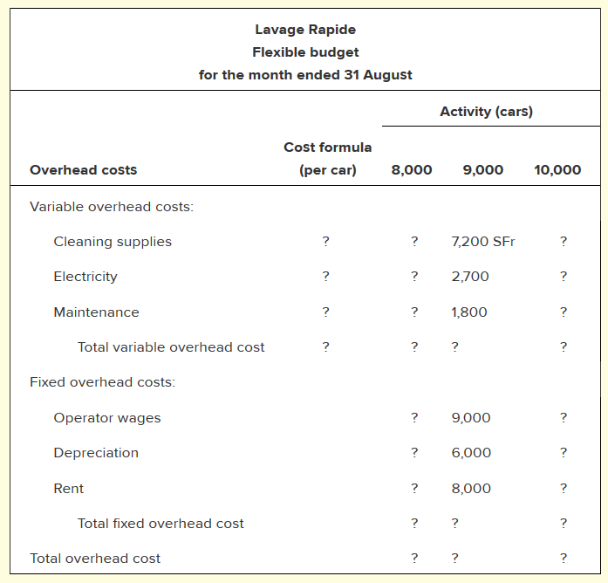

Required

Fill in the missing data.

Overhead Costs | Cost per car | 8000 | 9000 | 10,000
Variable overhead costs:
Cleaning supplies |  |  | 7200
Electricity |  |  | 2700
Maintenance |  |  | 1800
Total variable overhead costs |  |  | 11700
Fixed overhead costs:
Operator wages |  |  | 9000
Depreciation |  |  | 6000
Rent |  |  | 8000
Total fixed overhead costs |  |  | 23000
Total overhead costs |  |  | 34700

E13-2

The cost formulas for Emory Company’s manufacturing overhead costs are given below. These cost formulas cover a relevant range of 15,000 to 25,000 machine-hours each year.
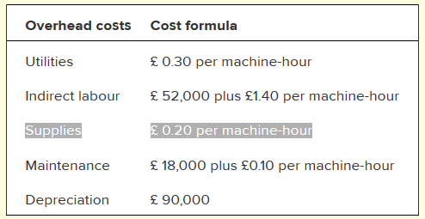

Required

Prepare a flexible budget in increments of 5,000 machine-hours. Include all costs in your budget.

E13-3

Operating at a normal level of 30,000 direct labour-hours, Lasser Company produces 10,000 units of product each period. The direct labour wage rate is £6 per hour. Two-and-a-half metres of direct materials go into each unit of product; the material costs £8.60 per metre. The flexible budget used to plan and control manufacturing overhead costs is given below (in condensed form):
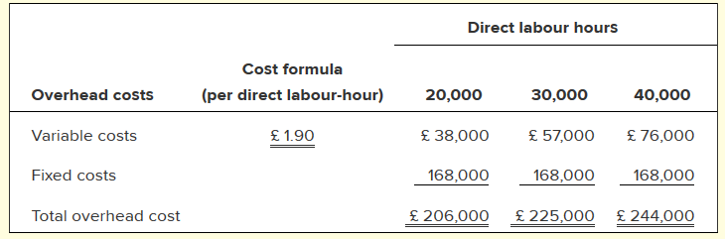

Required

- Using 30,000 direct labour-hours as the denominator activity, compute the predetermined overhead rate and break it down into variable and fixed elements.

- Complete the standard cost card below for one unit of product:

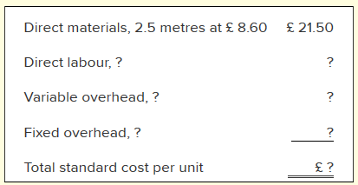

Variable overhead per unit /30000 =
Fixed overhead per unit /30000 =

Hours per unit
Direct materials
Direct labour
Variable overheads
Fixed overheads

