Can Stores of Tesco Withstand the Brunt of the Pandemic

Student Name: Ionut Petrisor Margareta
Student ID: 2131113
Tutor: Abdi Rahman

Contents
Introduction 3
Aim of the Research 4
Objectives of the Research 4
Questions of the Research 4
Methodology 5
Literature Review 6
Data Collection and Data Analysis 8
Research Outcome 9
Recommendations 12
Conclusion 13
References 14

Introduction
The pandemic has brought forth an unprecedented situation. The people never saw anything like this and as a result, didn’t know how to handle the situation. This has caused serious problems in almost every sector. Businesses have lost money left and right. People had lost their jobs and worried about how to feed their families. A huge number of businesses have shut down due to non-existent sales, and many will soon follow their trail. This report will tackle one such business. Tesco is a retail giant in the UK. It has countless locations and was generating a lot of revenue. However, the pandemic has also struck this business. Tesco has lost a lot of customer base in the pandemic and is looking to regain its footing. This report will discuss the very topic of whether Tesco can withstand the brunt of the pandemic or not. The report has been approved by the CEO of Tesco to find out how the business can survive the pandemic. The report will start with an introduction. The following sections will contain the aim and objective of the research. The literature review will follow the objective of the research. The findings of the report will be discussed in great detail in the subsequent parts. The report will end with a recommendation on how the business can do better and gain ground. The report has been conducted by following the approach known as the objectivist approach.

Aim of the Research
The research aims to find whether Tesco can handle the aftermath of the pandemic.

Objectives of the Research
- Evaluate how Tesco has handled the pandemic so far
- Analysing the consequences of the pandemic on the business of Tesco
- Recommendation on how Tesco can improve to survive the pandemic better

Questions of the Research
The research will be conducted based on a set of questions. The research will try hard to answer the following questions.
- What is the business practice for Tesco has been before the pandemic?
- How much did Tesco suffer during the pandemic?
- What has been the response of the customers?
- How is Tesco coping with the after-effects of the pandemic?
- How can the business survive the brunt of the pandemic and increase the rate of survivability?

Methodology
Two types of data can be seen in the research sector, which are primary and secondary data. Primary data is collected from the source and is unprocessed. Primary data cannot be used without further modification. However, primary data is reliable because it is collected straight from the source. Secondary data is not collected directly from the source of the incident. Rather, it is collected from the primary source by processing the primary data. Secondary data is unreliable because it is not collected directly. The reliability of secondary data depends solely on the source primary data. Quantitative and qualitative research technique is also widely used in research methodology. The quantitative method works with data with are quantitative, and as the name suggests qualitative method works with qualitative data.

Literature Review
The pandemic has radically changed our lifestyles. People are slowly but surely adapting to the new lifestyle forced by the pandemic. This new status quo has been dubbed the new normal. The lifestyle of the people is not the only that has changed in this pandemic. The operations of businesses have also changed drastically due to unforeseen situations. Due to the pandemic, there has been a lot of strain on the traditional supply chain. The countries closed their borders as soon as they understood the magnitude of the events. That’s why the supply chain was disrupted, and businesses couldn’t get their desired raw materials. It resulted in a severe shortage of goods in the market. The people were panicking and wondered whether they would get food in the future or not. So, people started to panic and buy and hoard goods. This caused further shortages in the market. However, as the vaccination rate went up, the country re-opened their borders once more, and things went back to normal. The pandemic has shown us the glaring mistakes with our traditional supply chains. Businesses cannot rely on foreign countries anymore for the supply of goods. They must move on to local and less complex supply chains to avoid these scenarios in the future. Many businesses have made their supply chain simpler following the pandemic (Chowdhury, et al. 2021). They opted for local producers even if the prices were a bit higher.
The supply chain is not the only thing that has changed during the pandemic. Another prominent thing that has also changed during the pandemic is the buying habit. Online services have become indispensable to our lives. Before the pandemic, consumers generally prefer to shop offline because they can verify the products. Moreover, shopping offline was more engaging than shopping online. This thing has completely changed. During the pandemic, there was a fear that people might encounter a highly contagious disease. That’s why people avoided public places and preferred to shop online. The habit has most likely stayed with people even after the pandemic has waned. People have become accustomed to shopping online, and this thing is not likely to change. Businesses must adapt to this changing behaviour. Many businesses have taken drastic steps to accustom to this new customer demand. Many businesses started to sell online along with offline. Existing online businesses bolstered their online presence by investing heavily. There have been notable changes in the retail industry (Ali, 2020). There has been an increased focus to sell products online to customers. Businesses will most likely adapt to these changes. Ventures that don’t adapt will most likely become extinct like a dinosaur.
There have also been other notable changes to the purchasing habits of customers other than the move online. Customers are less likely to spend on luxury items after the pandemic. People likely understood the value of money and the importance of savings during the pandemic. The levels of unemployment during the pandemic have not been seen for a long time. Many people went to extreme measures to feed their families. The rate of depression also skyrocketed due to unemployment. The suicide rate also increased significantly. In essence, people are starting to grasp the importance of money and are less inclined to spend it on frivolous things. That’s why many luxury businesses took a hit during the lockdown. The impact on the business of essential goods has also been significant but not as drastic as the luxury businesses (Kong,and Prinz, 2020). So, customers are willing to spend on the bare minimum only.
People had a lot of free time during the pandemic. Although a lot of that free time went into worrying about the future, there have been notable changes in the thinking pattern. Sustainability was a topic of contention even before the pandemic. However, the sustainability conversation has increased in number during and after the pandemic. The number of consumers pushing businesses to be sustainable has increased rapidly during the pandemic. Many people even thought the pandemic was a natural way of enacting revenge against us. Nonetheless, there has been increased clamouring for sustainable business practices, businesses cannot ignore it. They must put an increased focus on sustainability after the pandemic. The trend of customers boycotting businesses or supporting them has increased and will likely increase in the future. Businesses should be very wary of that. Ventures must also stay away from the practice of greenwashing. Greenwashing is the practice of appearing environmentally sustainable but engaging in environmentally damaging activities. Customers have a very keen eye and can immediately catch onto something fishy. Besides, words spread like wildfire thanks to social media and businesses don’t want to be at the receiving end of that fury (Obrenovic, et al. 2020).

Data Collection and Data Analysis
This report will use the quantitative method because of the subject matter. The research will deal with many numbers and statistics rather than people's opinions. This type of research works best when paired up with a quantitative method. For instance, the experimentation will require analysing the sales, profits, revenue, and many other similar things. These are all numerical data set and is very important for conducting the research. As the data set is numerical, the quantitative method must be used to reach any meaningful conclusion. The use of the qualitative method will bring no good to the research. The analysis of the data will also use quantitative techniques rather than qualitative techniques.

Research Outcome
The outcome can be best understood by looking at past performance. It will help us compare the pre-pandemic and post-pandemic performance of the company. It will also be easier for us to come to any conclusions.
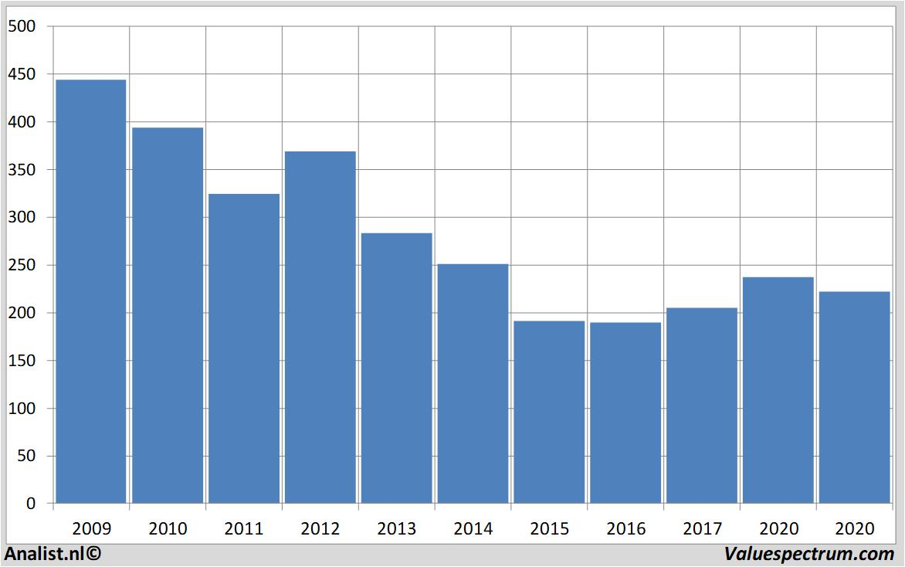

Figure 01: Tesco Revenues Over the Years
Source: (Valuespectrum.com, 2022)
The graph above shows the revenue of Tesco for around a decade. The revenue of Tesco peaked in 2009. After that, it has been a steady decline, and in 2020 the situation has not improved that much. Tesco has been suffering some problems even before the pandemic. The pandemic has exacerbated their problems and made their position even weaker. One major issue is the lack of skilled workers. The pandemic has worsened the financial condition of many businesses, including Tesco. That’s why the company had to take a strict decision and fire many employees. This has led to a shortage of skilled employees in the business. This situation is not only plaguing Tesco, but it is also plaguing the whole world. The graph below shows the employment situation in many countries before and during the pandemic.

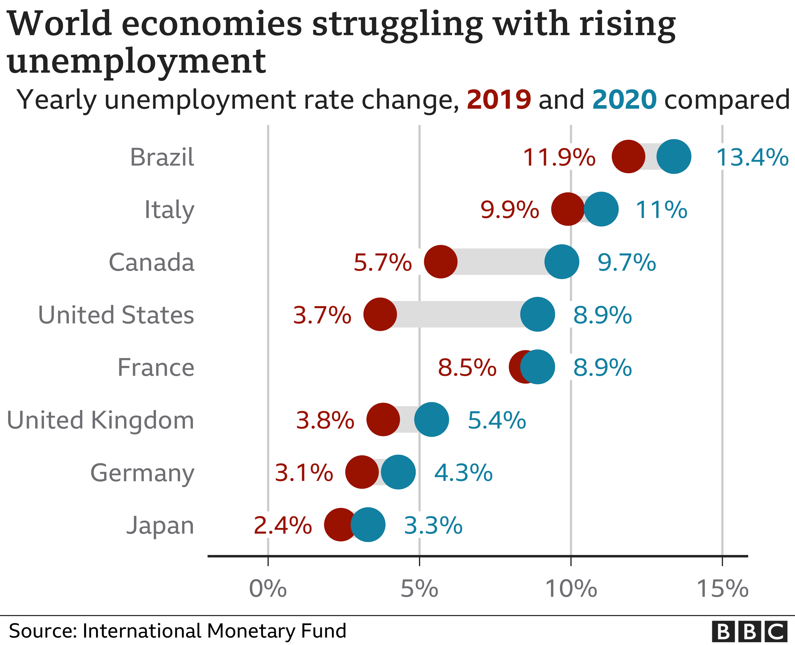

Figure 02: Employment Statistics Before and During the Pandemic
Source: (www.imf.org, 2022)
The graph above shows that many developed countries like the United States, the United Kingdom, and many more are facing an unemployment crisis. It led many businesses to shut off their stores and suffer a loss. However, it might not seem plausible, but there is some silver lining to the pandemic as well. The online business sector has experienced a massive boom during the pandemic. People's buying habits have changed drastically during the lockdown. People were frightened of catching the Covid. As a result, people avoided public places altogether. People might not go out, but need essential goods during the lockdown. That’s where online businesses come in. The online sector has experienced a rapid boom as more and more customers started ordering online. The habit of purchasing online has stuck with customers even after the pandemic. The habit is likely to stay as other isolated measures like working from home are getting more popular. A graph might be helpful to understand the extent that people are buying products online. The graph below shows a survey regarding the behaviour of people shopping online.

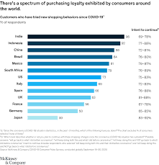

Figure 03: Survey of People Regarding Online Shopping
Source: (Koch, et al. 2020)
The survey shows the number of people that have tried online shopping and the number of people that intend to shop online after the pandemic. It is no surprise that the majority of the people have shopped online during the pandemic. The matter of interest is that most people intend to shop online even after the pandemic. The survey has ranged across countries from different continents. The similarity between the consumers is simply uncanny. The continents don’t matter, the thing that matters is that online shopping is likely going to be the future. Businesses know that and are acting on that. Businesses that previously didn’t have any online engagement, opened an online service. The majority of the businesses are serving products and services both online and offline. The shops that had previous online exposure are strengthening their online presence even more. Businesses that cannot adapt to the changing customer demand will not survive in the long run.

Recommendations
Like many other businesses, Tesco has been hit hard by the pandemic. The good news is Tesco is looking to fight back. Tesco needs the right recommendations to survive the brunt of the pandemic. The solutions to Tesco’s problems are simple, and sometimes the simple solution is the right solution. Tesco should increase its online presence. They already have an online store, but it needs to be updated to accommodate as many customers as possible. This will help them create a large customer base and recuperate the losses. Tesco should actively lure customers to their online service by providing incentives. One such incentive might be to give customers an online loyalty point. The points of the customers will increase every time they make a purchase. They can redeem the points for discounts. This will motivate the customers to come back frequently.

Conclusion
Many businesses are facing an existential crisis due to the pandemic. However, the key to success is to not give up. Proper planning and strategy can make businesses survive in the long run. Tesco is on the long list of businesses affected by the pandemic. It has suffered drastic losses in revenues and customer bases during the pandemic. However, the business is looking to regroup and fight back. The recommendation to Tesco would be to bolster its online presence. It should also incentivize the customers to become loyal to the online platform by employing a plethora of techniques.

References
Ali, B.J., 2020. Impact of COVID-19 on consumer buying behavior toward online shopping in Iraq. Ali, BJ (2020). Impact of COVID-19 on consumer buying behavior toward online shopping in Iraq. Economic Studies Journal, 18(42), pp.267-280.
Chowdhury, P., Paul, S.K., Kaisar, S. and Moktadir, M.A., 2021. COVID-19 pandemic related supply chain studies: A systematic review. Transportation Research Part E: Logistics and Transportation Review, 148, p.102271.
https://www.imf.org/en/Home. 2022. [online] Available at: <https://www.imf.org/en/Home> [Accessed 30 July 2022].
Koch, J., Frommeyer, B. and Schewe, G., 2020. Online shopping motives during the COVID-19 pandemic—lessons from the crisis. Sustainability, 12(24), p.10247.
Kong, E. and Prinz, D., 2020. The impact of shutdown policies on unemployment during a pandemic. Covid Economics, 17(13), pp.24-72.
Obrenovic, B., Du, J., Godinic, D., Tsoy, D., Khan, M.A.S. and Jakhongirov, I., 2020. Sustaining enterprise operations and productivity during the COVID-19 pandemic:“Enterprise Effectiveness and Sustainability Model”. Sustainability, 12(15), p.5981.
Valuespectrum.com. 2022. Analysts expect over 2020 rising revenue Tesco, quite high dividend | Valuespectrum.com. [online] Available at: <https://www.valuespectrum.com/news/409286-analysts-expect-over-2020-rising-revenue-tesco-quite-high-dividend> [Accessed 29 July 2022].

