

LCBB6000 DISSERTATION

BA (Hons) Business Management

Evaluating The Effectiveness Of Leadership In Managing Organisational Change In The Automotive Industry In The UK- A Case Study Of Bentley

Student name: Mirela Oprea
Student ID: 2107120
Supervisor: Alastair Moyes

Acknowledgements
I am eager to express my sincere gratitude to everyone who supported the research on “Evaluating The Effectiveness of Leadership In Managing Organisational Change In The Automotive Industry In The UK- A Case Study of Bentley’s.” I am deeply thankful to my supervisor for their invaluable guidance and academic insights throughout this process. I am keen to extend my appreciation to the authors of the secondary sources, academic journals, and industry reports for providing me with the foundation for this study. Finally, I am grateful to my colleagues and family for their unwavering support and encouragement in bringing this research to completion.

Declaration
I hereby declare that the overall research has been done by own understanding of the topic and critical evaluation of the information. My peers and mentors have helped to gather the information and statistical data from the relevant resources. The ethical standard are also been maintained by acknowledging the authors and maintaining the proper paraphrasing of the information. Hence the informative and structural pattern of the research has been maintained.

Abstract
The aim of this research is to evaluate the effectiveness of leadership in managing organisational change within the UK automotive industry. The research is important because it has highlighted different leadership practices followed by the automobile industry, considering Bentley Motors and how it manages organisational changes. The research has focused on analysing based on the existing sources to develop new information regarding the company, which can mitigate the issues within the organisation based on new strategic recommendations, which maintained its originality. The research is conducted through the use of secondary qualitative methods, where various online sources have been utilised. Based on the considered sources, thematic analysis has been developed that addresses the research objectives. It has been obtained from the research that significant leadership practices are essential for managing the changes within the organisation. The conclusion of the research has depicted that the leadership attributes play a significant role in enhancing the overall performance of firms during the change management and ensuring positive business outcomes. It has been identified that the current research upholds the updated information and real-life examples of automotive organisations with evidence that creates differences for the existing body of knowledge. It has been recommended that leaders should set a strong vision and anticipate and manage the resistance of employees during the implementation of the change process in automotive organisations. In terms of further study on the same topic, it can be recommended that the inclusion of a quantitative primary research method, including the conduct of a survey among managers and leaders of automotive firms, can be effective.

Table of Contents
Chapter 1: Introduction 8
1.1 Introduction 8
1.2 Background of the Study 8
1.3 Problem Statement 8
1.4 Aim, Objectives, Research Questions, Hypothesis, Propositions 8
1.5. Rationale Importance of the Research 9
1.6 Methodology 10
1.7 Scope of the Study/Demarcation 10
1.8 Structure of the Dissertation 11
1.9. Summary 11
Chapter 2: Literature Review 12
2.1 Introduction 12
2.2 Base theory of the sub-discipline and different background aspects of the concept 12
2.3 Theoretical frameworks, models, and related research issues 12
2.4 Previous studies and lessons learnt 15
2.6 Gaps identified to situate own research 18
2.7 Summary 18
Chapter 3: Research Methods and Methodologies 19
3.1 Introduction 19
3.2 Philosophical position of the research 19
3.3 Paradigm position of the research 19
3.4 Position of Research Approach 20
3.5 Methodological stance of the Research 20
3.6 Research Strategy and Design 21
3.7 Research Sample and Population 21
3.8 Data Collection and Data Analysis Tools 21
3.9 Ethical Consideration of the Research 22
3.10 Summary 22
Chapter 4: Data analysis and Discussion 23
4.1 Introduction 23
4.2 Analysis and Discussions of the Findings 23
4.3 Summary 31
Chapter 5: Conclusion, Limitations and Recommendations 32
5.1 Introduction 32
5.2 Conclusions on each research objective 32
5.3 Conclusions on the research problem 32
5.4 Summary of the research findings and outcomes 33
5.5 Original Contribution of the Research 33
5.6 Limitations of the Research 33
5.7 Recommendations 33
5.8 Summary 34
References 35
Terms of Glossary 44
Appendices 45

List of Tables
Table 1: Code generation for Theme 1 22
Table 2: Code generation for Theme 2 24
Table 3: Code generation for Theme 3 25

List of Figures
Figure 1: Dissertation structure 10
Figure 2: Lewin’s Change Management Model 12
Figure 3: McKinsey 7-S Framework 14
Figure 4: Conceptual Framework 16
Figure 6: Declining sales units of Vauxhall 25

Chapter 1: Introduction

1.1 Introduction
This chapter will focus on developing the foundation of the research by outlining the core reason behind the project. In order to complete this chapter, a complete evaluation of the study background, problem statement, aim, objective, research questions, hypothesis, rationale, and methodological introduction, scope of the study, dissertation structure, and summary of the chapter will be given.

1.2 Background of the Study
The automobile industry in the UK is considered a major contributor to the UK economy, with constant growth. This industry value in 2024 is £66.72 billion with 7.77% CAGR by 2035 (Spherical Insights, 2024). Bentley, which is a major operator in the automobile sector, has generated £1.21 billion in 2024 (Bentley Media, 2024). The company’s management practice is a major element that leads to its profitability. This company has been awarded for 15 consecutive years due to its excellent workplace culture. The leader, Christophe Georges, has fostered the culture of diversity, inclusion, equity, learning, development, and belonging for the employees to manage the organisational practices (Bentley Media, 2026).

1.3 Problem Statement
Leadership in the automobile sector infuses a compelling vision that encompasses a shared goal for managing organisational change (George, 2024). Bentley Motors has considered different employee management programs for fostering a growth culture; however, low wages are still a significant issue. In 2024, 86% of factory staff went on a strike regarding pay as they felt the company did not follow the terms and conditions (MhireLive, 2024). Thus, the problem statement is to understand the leadership issues of Bentley Motors and the strategies that they adapted to manage organisational change regarding employees.

1.4 Aim, Objectives, Research Questions, Hypothesis, Propositions
Aim
The research aims to evaluate the effectiveness of leadership in managing organisational change
in the automotive industry in the UK.
Objectives
- To discuss important leadership theories applicable in managing change in organisations
- To determine the impact of leadership styles on the change results of the automotive companies
- To identify challenges and barriers faced by leaders in implementing change in the automotive organisations
Research Questions
RQ1: What are the important leadership theories applicable in managing change in organisations?
RQ2: What is the impact of leadership styles on the change results of the automotive companies?
RQ3: What are the challenges and barriers faced by leaders in implementing change in the automotive organisations?
Hypotheses
H₀: Transformational leadership is a positive factor leading to successful organisational change in UK automotive companies.
H₁: The absence of adaptive leadership leads to employee resistance to organisational change.

1.5. Rationale Importance of the Research
The positive leadership practices in automobile companies like Bentley Motors brings positive changes in workplace practices and drive employee well-being and high-performance outcomes. The company is focusing on improving the digital skills of the workers, and 20% of workers already gained digital skills for Electronic Vehicles (EVs) in 2021 (Motor Trader, 2021). The problem of low wages in Bentley has impacted its management practice, which eventually reduced its growth. Bentley Motors has seen a 10% drop in its revenue in 2024 compared to 2023 (Reuters, 2025). This highlights that Bentley Motors is still needed to focus on improving leadership practice, which can foster a developed management system of the organisation. This study is important because it will derive sustainable strategies that can bring positive changes within Bentley.

1.6 Methodology
Sources: Online sources from different databases like online search, Google Scholar and ProQuest have been considered.
Sample: 15-20 sources have been used to complete the research.
Measuring instruments: Different peer-reviewed journals, authentic books, industrial sources, company websites, and others have been used as measuring instruments.
Data Collection: Secondary qualitative method has been used to collect adequate information. According to Cheong et al. (2023), secondary data provides deeper insight regarding a topic based on previously developed information.
Data Analysis: Thematic analysis has been done after collecting data from different sources. Codes will be developed based on different themes, which have been evaluated in Chapter 4.

1.7 Scope of the Study/Demarcation
The study provides the scope to understand different leadership practices that the automobile industry follows to manage organisational change. Focusing on a global automobile company can give international insights regarding the leadership practices. This study considers the UK automobile industry as a base, which discusses the national situation. The geographical demarcation involves different locations of the UK, including London, Birmingham, Manchester, Leeds, and other top cities.

1.8 Structure of the Dissertation
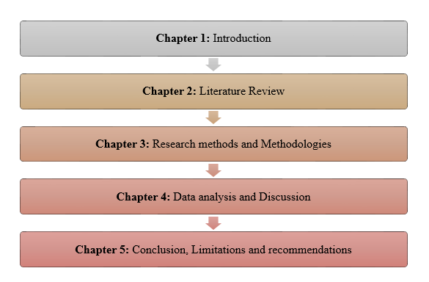

Figure 1: Dissertation structure
(Source: Self-developed)
Chapter 1 has considered the introduction of the dissertation. Chapter 2 has highlighted the previously developed information through a literature review. Chapter 3 discussed the methodologies of conducting the research. Chapter 4 has focused on analysing the objectives based on secondary research. Lastly, Chapter 5 has focused on drawing the conclusion and developing strategic recommendations.

1.9. Summary
This study summarised that Bentley Motors developed different leadership practices to manage positive organisational change. However, low wages are a crucial problem for the company, which is influencing its declining growth. Thus, secondary methodology has been considered for this study to drive more effective leadership strategies that can address the issues.

Chapter 2: Literature Review

2.1 Introduction
The chapter will emphasise the significance of leadership theories and change management models important for managing change in organisations. It will elaborate on the research's pre-set objectives using secondary sources. Furthermore, the chapter will identify a literature gap in the study. The conceptual framework is demonstrated at the end of this chapter.

2.2 Base theory of the sub-discipline and different background aspects of the concept
Transformational and Transactional Leadership Theories
The inclusion of leadership attributes within organisations plays a crucial role in the smooth functioning of brands and in ensuring effective change management. According to Kwan (2020), transformational leadership is a theory where leaders inspire, motivate, and empower followers to exceed expectations and foster positive change and innovation by aligning goals with a vision. It focuses on the high engagement, growth, adaptability, and long-term vision that contribute towards the organisational goals. In contrast, transactional leadership theory uses a structured and exchange-based system of rewards or punishments to manage tasks and ensure efficiency (Jensen et al. 2019). It emphasise on short-term goals, compliance and relies on extrinsic motivation that contributes towards consistent performances.
Situational Leadership Theory
The situational leadership theory states that no leadership theory or style is best suited and effective leaders must adapt their leadership style based on the requirements of followers, competence, and commitment towards the given task (Daniëls et al. 2019). It emphasises the flexibility, focuses on the development of employees, and combines the task behaviour. The key components of the theory enable organisations to facilitate change and manage the organisational operations of firms.

2.3 Theoretical frameworks, models, and related research issues
Lewin’s Three-Stage Model
The model is a foundational concept in change management that outlines three sequential phases for the transformation of organisations, including unfreeze, change and refreeze (Ellis, 2023). Unfreezing is the scenario before change, change is the new process, and refreezing is the process of stabilising the new change in the company. For example, Ford has positively integrated the components of the model into operational activities to implement a new process of restructuring the company and turn it into a centralised one. In this process, Ford broke down the existing structure and behaviours of employees and then integrated a new process as Ford 2000 and solidified the new process in the organisational structure and culture (Levinson, 2024). In contrast, the model failed to successfully implement the changes based on the process for General Motors, as the firm could not compete with the rising competition and was unable to refreeze the dedicated changes.
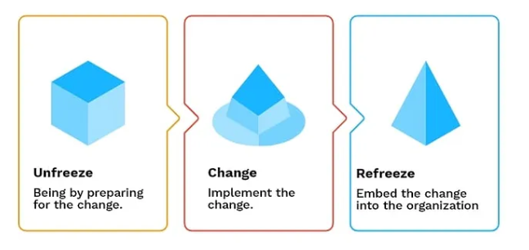

Figure 2: Lewin’s Change Management Model
(Source: Medium, 2025)
Kotter’s Eight-Step Change Model
As opined by Engmann et al. (2024), it is a structured framework designed to benefit organisations to successfully implement transformation by breaking the process of change into eight sequential steps. The eight steps in this model are to create a sense of urgency, build a coalition, form a strategic vision, communicate the vision, enable action, generate short-term wins, sustain acceleration, and lastly institute the change. For example, Jaguar Land Rover has positively implemented the model to reimagine its electrification strategy, which resulted in the successful brand rejuvenation and financial turnaround. The brand has invested around £15 billion in the successful implementation of the change and drives positive results for the company (Jaguar Landrover, 2023). As a result, the model helped the organisation to implement the organisational changes based on eight steps without fail. On the other hand, Nissan Motor Corporation has faced negative consequences for following the model in implementing change in eight steps in the firm. Nissan Motor Corporation failed to facilitate strategic growth and restructuring in certain lines and struggled to adapt the market changes frequently, such as EV and the Sunderland plant's future (Ozsevim, 2024).
McKinsey 7-S Framework
It is a strategic tool developed for analysing organisational effectiveness by aligning seven different internal and independent elements, including strategy, structure, systems, shared values, style, staff, and skills (Chmielewska et al. 2022). The framework is applied within the organisational operations to improve performance during the change, identify the influence of changes, align departments during a merger, and implement a new strategy. For example, Toyota Motor Corporation positively integrated the concerned framework into the business operation to ensure effective performance during the change and the merging of different departments of the company. The organisation has successfully used the hard elements of the framework including strategy, structure and system, in adapting the EV, localised the production to meet changing consumer demands, accelerated decision-making, and strengthened the supply chain resilience. Additionally, the brand successfully used soft elements including shared values, skills, staff and style through investing in training and development of employees, effective leadership style and facilitating continuous improvement (Toyota, 2021). On the contrary, McLaren Automotive could not use the framework successfully while implementing the changes regarding the electrification, organisational changes and struggled to turn around the process. The company faced a significant financial crisis and reduced its workforce by 25% due to financial constraints. McLaren Automotive failed to implement effective strategies based on the elements in the framework, resulting in the credit downgrades within the firm (CNBC, 2020). As a result, the firm could not successfully implement the changes as per the plans based on this framework and negatively influenced the organisational results.
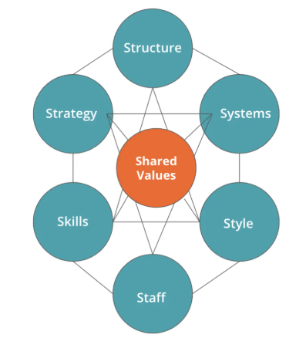

Figure 3: McKinsey 7-S Framework
(Source: CFI, 2025)

2.4 Previous studies and lessons learnt
Significance of leadership theories applicable in managing change in organisations
The attributions of leadership theories within organisations play a pivotal role in guiding employees and ensuring they are motivated to work willingly during the change. As stated by Dinibutun (2020), leadership theories provide a structured framework for organisations to reduce the resistance to change and align the cultural shifts with strategic goals. It empowers leaders to motivate staff and communicate the vision effectively during the change to ensure the successful transformation of the change. As supported by Wang et al. (2024), leadership theories such as situational and authentic enable leaders to instigate adaptability and maintain transparency during the complete change management that enhances the positive results. The incorporation of leadership theories enables organisations to make strategic decisions and set long-term goals, and drives better results. It benefits organisations to create a shared vision and encourage employees to achieve them without fail. For example, the leader of Lotus Cars, Matt Windle, follows a transformational and situational leadership theory to facilitate an adaptive and collaborative nature during the organisational change process and empower employees to make decisions. The organisation has executed several changes under the leadership style of Matt Windle, including technological and sustainability changes (Turner, 2025).
Impact of leadership styles on the change results of the automotive companies
The leadership style impacts the organisational results in multiple contexts and fluctuates the organisational results. Velasco (2019) described that the inclusion of transformational leadership styles encourages employees to commit, foster innovation, and align team members with the new vision of firms. Additionally, the democratic leadership style boosts the morale of employees, reduces the resistance to change, and makes employees participative in decision making. These leadership styles positively impact the organisational results of firms and support the organisational changes. As argued by Jensen et al. (2019), leadership styles like autocratic and bureaucratic limit employee input, lower morale, and focus on strict rules and regulations that disrupt the structural changes within firms. It creates confusion among employees during the change process and reduces productivity to a large extent. As a result, it negatively impacts the organisational changes and drives negative results. For example, the CEO of Aston Martin, Amedeo Felisa, follows a democratic and transformational leadership style that positively influences the restructure of the firm and strengthens the industrial and electrification expertise within the company (Aston Martin, 2023). Additionally, the leader of Caterham Cars, Bob Laishley, follows a bureaucratic leadership style and imposes strict rules during the change, which negatively influences the organisational performance of the company.
Challenges faced by leaders in implementing change in the automotive organisations
During the implementation of organisational changes in firms, leaders face several challenges that hinder the performance of firms and drive negative results. As depicted by Beaudet et al. (2020), automotive organisations face several challenges while implementing changes in firms, such as cultural resistance, supply chain complexities, leadership hurdles, and regulatory and policy inconsistency. These challenges makes it difficult for leaders to implement changes effectively within firms and restrict the organisational performances. As added by Shvetsova et al. (2021), balancing the costs and breaking down the barriers are some other challenges faced by leaders of automotive organisations that bring negative results. These challenges need concrete ways to implement the changes successfully and drive positive change. For instance, the regulatory uncertainty in the UK that set a 22% of EV sales target for 2024 brought significant challenges for the leaders of Nissan and Stellantis, who were facing fines for failing to meet the targets (McMillan, 2024). It negatively affects the leaders' ability to implement suitable changes within the company and mitigate the challenges in firms. Additionally, the leader of Ford faces cultural resistance during the change management process of EV transformations and reorganising the firm (Bloomberg, 2022).
2.5 Conceptual Framework
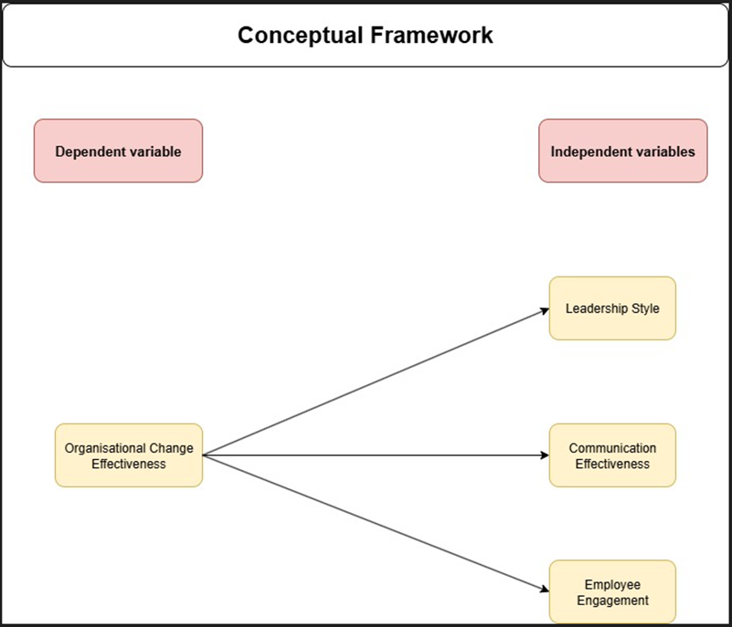

Figure 4: Conceptual Framework
(Source: Self-developed)
The conceptual framework demonstrates both the dependent and independent variables of the study. Organisational change effectiveness is the dependent factor in the study, which depends on some key independent variables, including leadership style, employee engagement and communication effectiveness. It shows the interrelationship between both the independent and dependent variables of the study.

2.6 Gaps identified to situate own research
The other existing literature based on the effectiveness of leadership style during the change management implementation in the automotive sector does not include real business examples. Additionally, other literature indicates that none of the leadership styles is suitable or effective during organisational change in firms. The current study includes real-world business examples from the automotive industry that comply with different leadership styles during the change management process in organisations. Moreover, the current study has evaluated enough information regarding the leadership aspects and its effectiveness in bringing organisational changes. However, the current study has lacked in gathering distinct information on how multiple leadership styles can be implemented by organisations to address the challenges efficiently.

2.7 Summary
The chapter has critically evaluated the theoretical concepts, models, and frameworks related to change management through leadership aspects in automotive firms. Furthermore, the significance of the leadership styles and its impact on the change management has been elaborated in this chapter. Some key challenges faced by the leaders while applying changes in firms have been identified in this chapter. The conceptual framework based on dependent and independent variables has been demonstrated in this chapter.

Chapter 3: Research Methods and Methodologies

3.1 Introduction
Research methodology provides a logical, structural, and ethical framework to complete the research. This chapter will highlight research philosophy, research paradigm, research approach, methodological stance, research strategy, research sample, data collection, data analysis, and ethical considerations of the research.

3.2 Philosophical position of the research
According to Bergmann (2023), Research philosophy refers to the assumptions about the nature of reality in research. There are four major types of research philosophies, which are positivism, Interpretivism, pragmatism, and realism. In this research, interpretivism research philosophy is considered to understand the valid experiences that have already been applied. Understanding the leadership approaches taken by Bentley Motors for managing the organisational changes have been evaluated through interpretivism philosophical position.
Justification
Adhering to a specific philosophy is essential because, in this process, the research is able to develop based on a suitable framework that can provide a valid result for research problems. Interpretivism philosophy is based on the information that has already been published and the validity of which has been checked by others. This subjective information of the company is suitable for the research because it evaluates the social phenomena, which is associated with the research.

3.3 Paradigm position of the research
Research paradigm is a foundational and comprehensive framework that guides researchers to execute specific approaches to get research outcomes (Panya and Nyarwath, 2022). There are different paradigms available, which are quantitative, qualitative, and mixed. In this study, the qualitative paradigm was used for conducting the research. This is because it focused on developing the relationship between independent and dependent variables.

Justification
A specific paradigm of research is important to consider because it provides an understanding of how the leadership practices of Bentley are influencing to manage organisational changes. The conceptual guide of the research process helps to provide a sustainable pathway for the researcher to complete the research successfully.

3.4 Position of Research Approach
The research approach focused on giving the overall direction of the research from philosophical assumption to data collection and analysis process. There are two major types of research approaches, which are inductive and deductive (Okoli, 2023). This research has considered an inductive research approach for completing the research. An inductive research approach is focused on developing new theories based on the conducted research. This approach is adapted as it explores the emerging issues in BentleyMotors and its impact on the leadership practices.
Justification
Considering a particular research approach is important because it highlights the patterns, trends, and changes in the management which can address the ongoing issue within the organisation. This has helped to solve the research problem by developing sustainable recommendations for the research.

3.5 Methodological stance of the Research
Methodological stance defines the systematic process to investigate a real-world problem, which derives the research outcome (Robson, 2024). In this research, a secondary qualitative method has been considered to complete the research on Bentley Motors leadership practices to manage organisational changes.
Justification
Considering a particular methodology for research is essential because it gives a complete direction to the research by highlighting a suitable data collection and analysis process, which can provide a strategic research outcome.

3.6 Research Strategy and Design
Research strategy is a comprehensive plan that gives ultimate effects by giving results based on research objectives. In this study, the secondary strategy method was considered reliant on the scholarly sources, case study, and government documents. On the other hand, research design highlights the overall strategy that is used to produce results. In this research, an exploratory research design is adopted to understand leadership effectiveness in change management. Exploratory design is suitable for evaluating complex social phenomena (Olawale et al., 2023).
Justification
Adherence to a particular research strategy and design is essential because it gives an outline plan and idea of how the positive research outcome can be achieved by the researchers. Here, the focus is on Bentley Motors’ leadership practices, which helped to manage organisational changes. Thus, exploring the in-depth issue of the company and how its current leadership practices are tackling those has been explored. Besides, the future strategies have been highlighted for completing the research successfully.

3.7 Research Sample and Population
The sampling method in secondary research is considered a subset of the existing data (Cheong et al., 2023). In this study, purposive sampling has been used to collect data from different secondary sources. For collecting relevant data, different peer-reviewed journals, authentic books, reports, industry publications, and company websites have been used.
Justification
Considering a particular sampling method for research is essential because it can provide a particular source for the research. This is crucial for data relevance, accuracy, and maintaining the credibility of the sources. In this research, purposive sampling is useful because the study has focused on a particular company from a particular industry. Thus, other industry information is not relevant. This sampling has helped to draw particular insight into leadership practices to manage organisational changes within Bentley.

3.8 Data Collection and Data Analysis Tools
In this research, a secondary data collection method has been endeavoured. As discussed by Taherdoost (2021), secondary data collection has been a systematic progression of collecting, measuring, and assessing appropriate information from different sources for answering the research questions. In terms of conducting the secondary data collection process for this specific research 10 journals (peer-reviewed) and books have been considered. Furthermore, for data analysis, a thematic analysis method has been undertaken as it favours nuanced exploration of qualification insights about leadership styles, barriers, and theories about the UK’s automotive industry. From the opinion of Christou (2022), applying thematic analysis on the qualitative data is suitable for providing high flexibility in identifying recurrent patterns. In this research, the thematic analysis process has been initiated with generating codes by highlighting particular phrases in the secondary data collected related to change resistance and leadership behaviour. Those codes are grouped in some specific themes and then interpreted for determining the effectiveness of leadership approach in directly influencing organisational change.

3.9 Ethical Consideration of the Research
In secondary research studies, ethical consideration has been mainly pivoted ensuing high data integrity. In addition, the researcher has focused on ensuring that the data sources are credible, properly cited and incorporated as per the academic protocols. This research has throughout focused on staying well adhered to the protocols defined in the GDPR. The GDPR on academic institutions shed immense light on handling data for research purposes (Halawi and Makwana, 2023). In addition, no proprietary data or confidential information has been disclosed in this research study. Also, data sensitivity has been maintained by ensuring that the proprietary information is anonymised.

3.10 Summary
This chapter summarises the methodological process of the research which has followed to conduct the study of Bentley’s leadership practices to manage changes. For completing the study, interpretivism philosophy, exploratory design, qualitative paradigm, and inductive approaches have been considered. Besides, a secondary qualitative method has been considered to develop a thematic analysis for the research.

Chapter 4: Data analysis and Discussion

4.1 Introduction
The effective UK automotive leadership requires transformational approaches to navigate EV transition, supply chain disruption, and skill gaps, ensuring sustainable, adaptive change (Obando et al. 2024). This chapter of the study will effectively analyse the importance of leadership theories which are effectively implemented in managing change within an organisation. Furthermore, this section of the study will examine the impact of leadership styles across the automotive industry. Along with the challenges that might be faced by an organisational leader while implementing the leadership strategies, this chapter will also be examined. Finally, this segment of the study will also include a summary of the conducted discussions.

4.2 Analysis and Discussions of the Findings
Analysis
Theme 1: Importance of leadership theories applicable in managing change in organisations

Table 1: Code generation for Theme 1
Objective | Key Words/Codes | Theme
To discuss important leadership theories applicable in managing change in organisations. | - Transformative change  - Organisational performance  - Leadership attributes  - High-performance culture | Importance of leadership theories applicable in managing change in organisations
The application of leadership theories within the operational strategies of organisations works as the backbone for firms to align, streamline, and sustain the operational process. As noted by Carvalho et al. (2021), the leadership theories in organisations benefit organisations in fostering operational excellence and ensuring transformative changes in firms. It enables organisations to improve employee engagement and facilitates strategic alignment without challenges. It has been found that 71% of people taking leadership roles positively contribute towards the stress levels that drive effective organisational performances (Quarterdeck, 2025). It highlights the effectiveness of the leadership attributions in organisations, which is beneficial for managing change in firms. For example, Bentley places a strong focus on the leadership style to drive high performance, employee engagement during the change and ensure business growth. The firm is recognised as a top employer due to its strategic and data-driven people strategies and is highly focused on the leadership attributions within the organisation (Bentley Media, 2026). Additionally, Rolls-Royce Motor prioritises the inclusion of leadership components within the firm, which positively contributes towards the streamlined operations of the firm and offers opportunities to expand globally. As a result, the brand could deliver 5,700 automobiles in 2024 and around 90% of finished vehicles exported out of the UK (Statista, 2025).
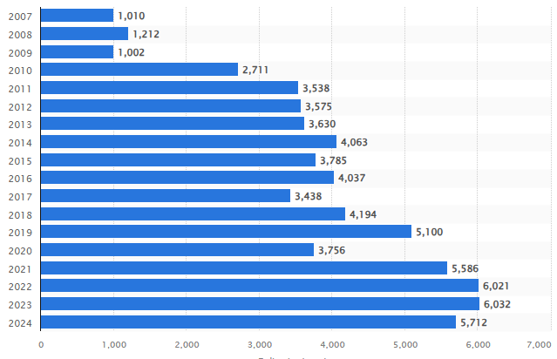
Figure 5: Global deliveries of Rolls-Royce automobiles
(Source: Statista, 2025)
As supported by Daniëls et al. (2019), the leadership theories enable organisations to foster a cohesive and high-performance culture during the change management process and achieve common goals. It has been found that 66% of organisations prioritise developing leaders to drive strategic change within organisations and 54% filling gaps in the leadership pipeline (Consultancy, 2026). It highlights the effectiveness of leadership contributions in organisations during the strategic changes within the organisations. The inclusion of leadership contributions enhances the adaptability among employees and leaders through situational leadership theory, as well as drives innovation through transformational leadership theory. As a result, the contribution of each leadership style works in different ways based on the change within firms [Refer to Appendix 1].
Theme 2: Examine the impact of leadership styles on the change results of the automotive firms

Table 2: Code generation for Theme 2
Objective | Key Words/Codes | Theme
To determine the impact of leadership styles on the change results of the automotive companies | - Employee engagement  - Inclusive leadership style  - Employee morale  - Organisational performance | Examine the impact of leadership styles on the change results of the automotive firms
Leadership styles are based on the behavioural patterns of leaders and focus on task-oriented and centralised power within organisations. It benefits organisations in building adaptability among employees and establishing employee engagement. Crede et al. (2019) depicted that the transformational leadership style is highly preferred by organisations to facilitate successful change management and align teams with the new technologies and change. Additionally, the inclusive leadership style positively promotes diversity and strengthens the innovation capabilities within teams to ensure smooth adaptation to organisational changes. For example, McLaren follows a transformational leadership style within organisations and embraces openness and continuous improvement within the company and empowers employees to make decisions for the change (Mclaren, 2026). Furthermore, Lotus Cars uses a transformational leadership style as a part of its Vision80 strategy, initiated in 2018 to emphasise the rapid cultural change, innovative changes, and ensure successful restructuring (Lotus Cars, 2022). As a result, it positively impacts the organisational performance of firms.
On the other hand, some key leadership approaches negatively influence the organisational performances by hindering the culture and restricting the change. The inputs of the autocratic leadership style result in lowering employee morale, engagement and slowing down the innovative processes in organisations (Modise, 2024). It leads to the poor performance of employees and poses a lack of direction for employees to achieve positive organisational results during a change. For instance, Vauxhall integrates bureaucratic leadership style within the organisation, and it impacts the willingness of employees to work and hinders their productivity. As a result, the sales of Vauxhall are continuously decreasing and reached 22,448 units in 2019, which is a decline from around 97,000 units (Statista, 2025).
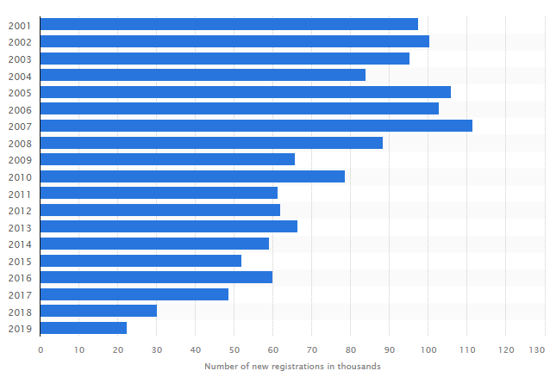

Figure 6: Declining sales units of Vauxhall
(Source: Statista, 2025)

Theme 3: Determine the challenges faced by leaders in implementing change in the automotive companies

Table 3: Code generation for Theme 3
Objective | Key Words/Codes | Theme
To identify challenges and barriers faced by leaders in implementing change in the  automotive organisations | - Traditional automotive  - Data-driven collaboration  - Upskilling employees  - Cost-cutting measures | Determine the challenges faced by leaders in implementing change in the automotive companies
In FY2025, the leaders across the automotive industry face multiple hindrances while navigating a fundamental transition from Internal Combustion Engines (ICE) to electric vehicles (EVs) and software-defined vehicles (SDVs) (IBM, 2025). The core challenges revolve around the aspects of managing high capital expenditure, intensifying competition, and necessary structural changes.
Ford has been observed to face a £14.33 billion write-down in the Q3 2025 as it scrapped its next-generation EV truck and three-row SUV programs. This results in the delay of the introduction of the electric pickup vans to 2028. This decision was taken by Ford to combat the loss of £96979.08 per sold EV in early 2024 (Reuters, 2025). Volkswagen is considering closing at least three German factories for the first time since its inception. This business has been identified to face a crunch of £8.08 billion (Raymunt, 2024). This issue is being mitigated by this business through the effective adoption of cost-cutting measures as its software unit delays stalled new model launches, leaving it to sell old technology to price-sensitive customers.
Sachan (2025) showcased that the traditional automotive command and control cultures are struggling to adapt to the fast-paced software development required for modern, connected vehicles. The author has also opined that the current automobile industry has been facing significant AI integration. Jaguar Land Rover has been identified to face challenges in the context of the automotive 3D Printing market, as it projects to reach about £3.90 billion in Q4 2026 and reach £8.64 billion by 2030 with a CAGR of 22% (Business Research Company, 2026).
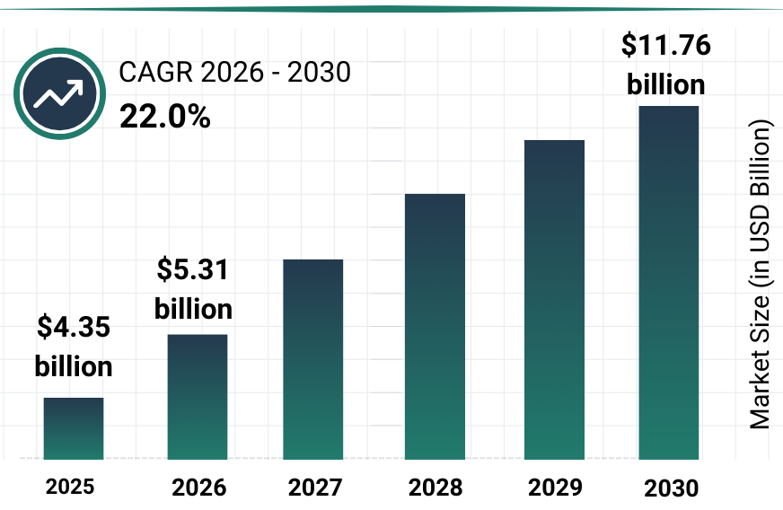
Figure 7: Automotive 3D printing Market Report.
(Source: Business Research Company, 2026)
Implementing AI for quality control and manufacturing requires shifting workforce mind-sets from legacy, compiled processes to agile, data-driven collaboration. Nearly 38% of the UK automobile sectors depict an insufficient expertise amongst the employees of the firms. This is a significant hindrance, where only 40% of the leaders feel the urge to conduct upskill, reskill and operational restructuring to be at par with the AI integration within this industry (Morandini et al. 2023).
Discussion
The examination of leadership theories express about no single approach is sufficient for organisations to maintain their operations. Adherence to a hybrid approach is observed to be necessary for navigating the complexities of manufacturing, sustainability and technological shifts (Wang et al. 2024). Transformational Leadership is widely considered the most effective for accelerating change, as it gives chances to innovation and aligns employee commitment with new strategic visions. However, in a traditional, high-precision manufacturing context like Bentley, an over-reliance on transformational leadership often lacks the procedural structure required for operational efficiency. Therefore, this must be balanced with Transactional Leadership, which is crucial for managing quality control, maintaining safety standards, and keeping production timelines during transitions (Carvalho et al. 2021). Moreover, Situational Leadership proves highly applicable within the UK automotive sector, allowing leaders to adapt their style from directive to supportive based on employee competence and the urgency of the change, such as transitioning to electric vehicle technology. For example, Matt Windle’s adaptive, collaborative leadership at Lotus drives organisational change through employee empowerment, fostering innovation and sustainable development. In the context of Bentley’s prestigious brand, Authentic Leadership is also found crucial for significantly balancing employee trust and motivation during turbulence (Turner, 2025). The compelling limitation in existing research is that while theories concentrate on top-down change, the success of transformation in UK automotive organisations is often impeded by inadequate middle-management buy-in and poor communication. In essence, effective leadership at Bentley demands proactively integrating transformational vision with transactional accountability and situational agility to successfully manage change.
The appropriate style in relation to leadership is considered the primary force of organisational change success within the UK automotive industry. The research significantly reveals transformational leadership by demonstrating the strongest positive impact on employee motivation, innovation, and adaptability during strategic shifts (Velasco, 2019). In the case of Bentley, effective leadership during turbulent periods such as supply chain disruptions and the shift to electric mobility (Beyond100 strategy) relied heavily on a blend of visionary leadership and strategic decision-making to maintain competitive advantage. For example, the CEO of Aston Martin, Amedeo Felisa, has followed a democratic and transformational leadership approach that allows the company to reach successful financial performance and carbon-neutral goals (Aston Martin, 2023). Conversely, the hierarchical structures are available where excessively autocratic styles were found to hinder adaptability, democratic and transformational approaches advocated better engagement and buy-in for change initiatives. Along with this, the observation highlights that the effectiveness of leadership is heavily contextual, requiring a shift toward new leadership styles that emphasise collaboration, open communication, and digital competence to manage technological transitions (Shvetsova et al. 2021). For Bentley, the ability to manage rapid changes, such as the substantial percentage of workforce expansion for the SUV launch, was contingent on leadership's capacity to balance operational efficiency (Transactional) with long-term strategic vision (Transformational). The study stated that to successfully manage change in the competitive UK automotive industry, leaders should move away from rigid, command-and-control methods, adopting instead a participatory, communicative approach that aligns employee behaviour with the organisation's strategic goals for sustainability and innovation.
As per the statement of Hayes (2025), change management is quite effective for corporate ventures to deal with diversification and adopt the changes within the market. It is quite effective for the ventures to ensure the future growth and financial stability within the market. However, it includes multiple issues, including cultural issues, technical issues, and talent management issues and so on.
Technical Issues- Considering the automobile industry of the UK is facing issues regarding the slow adaptation to technological innovations. It has negatively impacts on the innovation pace of the ventures. For instance, Jaguar Land Rover is currently facing cybersecurity issues that is hampering the overall brand image of the venture. It causes multiple operational disruptions for the entity, including computer system shutdowns like engineering software, CAD and the payment system of the supplier. As a result, the firm has faced a 310 million GBP loss that negatively impacts on its future growth aspect and overall financial performance (Bbc, 2025).
Talent Issues- The automobile industry of the UK is currently facing major issues in maintaining the digitalisation process towards EV due to poor employee skills and expertise. It hinders the diversification process along with the future growth probabilities of the automobile ventures. For instance, GSF Car Parts is facing high employee skill-gap issues that have been termed as an artificial straitjacket, which is hampering the brand image of the firm (Fleetnews, 2024). Additionally, it is facing operational disruptions in terms of increasing operational costs and poor organisational growth in the UK automobile market.

4.3 Summary
This chapter summarises the key findings from the three distinct themes to examine the importance and impact of the leadership theories in the context of the automobile industry across the UK. Furthermore, the issues faced by the current automobile industry have also been critically evaluated in this chapter. Every theme has been effectively backed up by proper data as well as critical viewpoints. It has been found that leadership attributions play a crucial role in enhancing the organisational performance of automotive firms.

Chapter 5: Conclusion, Limitations and Recommendations

5.1 Introduction
The final chapter of the study is going to conclude the findings of the study and summarise the key objectives of the study. Additionally, this chapter will conclude the research problem, original contributions of the study and demonstrate the outcomes of the study. The limitations of the study are identified in this chapter. Some suitable recommendations based on the challenges faced by leaders are depicted at the end of this chapter.

5.2 Conclusions on each research objective
Objective 1: The in-depth evaluation of the literature review on the first objective revealed that leadership theories play a crucial role in managing change within organisations and help organisations to align employees with organisational goals. It inspires, motivates, and empowers teams to foster a culture of agility and commitment to change in firms.
Objective 2: It has been determined that distinct leadership styles have both positive and negative impacts on the change management process within automotive organisations. It has been evaluated that transformational leadership style has a positive influence on organisational results, whereas autocratic leadership style has a negative influence on the change management process, as it lowers employee morale and brings negative results.
Objective 3: The other existing literature revealed that automotive companies face significant challenges in implementing change, such as AI integration, regulatory and policy inconsistency. Moreover, the resistance to change makes it difficult for automotive organisations to ensure positive business outcomes during the change process.

5.3 Conclusions on the research problem
The attribution of effective leadership in managing organisational changes in the automotive sector articulates several problems that hinder performance issues. It has been identified that low wages are one of the significant issues, and a large number of staff went on strike due to the payout issues, even during the change management process. As a result, it negatively affects the leadership attributions and hinders the overall performance during the change management process.

5.4 Summary of the research findings and outcomes
In the competitive business landscape, the contribution of leadership style works as the backbone for organisational success and implementing changes successfully. It has been found that leadership theories provide a structured framework to organisations for the application of changes sequentially. It has been analysed that Lewin’s Three-Stage Model provides three steps for change management, whereas Kotter’s Eight-Step Change Model offers eight different steps to implement the changes without fail. Furthermore, it has been identified that leadership styles have both positive and negative influences on the automotive companies that fluctuate the organisational results in multiple contexts. In conclusion, leaders face several challenges in implementing leadership style such as resistance to change and regulatory inconsistencies.

5.5 Original Contribution of the Research
The current study upholds the updated data and real-world examples of automotive organisations follows various leadership styles during the change management process in firms. In thi regard, the study positively contributes to scholars through the production of new knowledge and a credible source for them. The current study improves the accuracy of the academic work of scholars. Furthermore, the study also contributes to management through evidence-based decision-making, and organisations can gain more insight into the innovation and competitiveness in the market.

5.6 Limitations of the Research
The study only consists of the secondary qualitative method to investigate the predefined objectives, which is a limitation of the research. In this regard, the application of a quantitative research strategy would have been more effective in gaining valuable insights from the primary sources. The conduct of a survey among the managers and leaders of automotive organisations could give valuable results and more insight about their perspectives on the significance of leadership style during the change management process.

5.7 Recommendations
Establish active sponsorship and vision
The senior leaders of Bentley should establish active sponsorships and a vision to facilitate change within the organisation and include employees in the change process. Additionally, leaders should remove the obstacles that hinder progress towards the change and drive positive results. They can foster a sponsor coalition across different departments to ensure consistent messaging in the firm and eliminate the challenges.
Anticipate and Manage Resistance
The leaders of the company should proactively identify potential obstacles in the change management process and address employee concerns directly. Moreover, the organisation should conduct impact assessments based on the painpoints of employees and address them to enhance their willingness to do their best during the change management process. The firm can understand the current flexibility of the culture and eliminate the signs of disengagement to ensure a positive outcome.

5.8 Summary
This chapter has elaborated on the key findings of the study, along with the conclusion based on the research problem. The limitations of the study have been identified in this chapter. Some suitable recommendations based on the challenges faced by automotive organisations regarding the effectiveness of leadership during change management have been provided in this chapter.

References
Aston Martin (2023) Aston Martin strengthens industrial and electrification leadership with new senior appointments. Available at: https://www.astonmartin.com/en/our-world/news/2023/4/20/aston-martin-strengthens-industrial-and-electrification-leadership-with-new-senior-appointments [Accessed on: 12 February 2026].
Bbc (2025) Some JLR suppliers 'face bankruptcy' due to hack crisis. Available at: https://www.bbc.com/news/articles/czdjn0lv64ro [Accessed on: 9 February 2026].
Beaudet, A., Larouche, F., Amouzegar, K., Bouchard, P. and Zaghib, K. (2020) ‘Key challenges and opportunities for recycling electric vehicle battery materials’, Sustainability, 12(14), pp. 5837. Available at: https://www.mdpi.com/2071-1050/12/14/5837
Bentley Media (2024) Bentley announces its 2024 half-year financials. Available at: https://www.bentleymedia.com/en/newsitem/1612-bentley-announces-its-2024-half-year-financials [Accessed on: 10 February 2026].
Bentley Media (2026) Bentley Motors recognised by Top Employer for excellent workplace culture. Available at: https://www.bentleymedia.com/fr/newsitem/1766-bentley-motors-recognised-by-top-employer-for-excellent-workplace-culture [Accessed on: 10 February 2026].
Bergmann, J. (2023) Research philosophy, methodological implications, and research design. In At Risk of Deprivation: The Multidimensional Well-Being Impacts of Climate Migration and Immobility in Peru (pp. 57-89), Wiesbaden: Springer Fachmedien Wiesbaden. Available at: https://doi.org/10.1007/978-3-658-42298-1_3
Bloomberg (2022) Ford to Spend Up to $20 Billion Reorganizing for Shift to Electric Cars. Available at: https://www.bloomberg.com/news/articles/2022-02-01/ford-to-spend-up-to-20-billion-reorganizing-for-shift-to-evs [Accessed on: 12 February 2026].
Business Research Company (2026) Factors affecting adoption of 3D Printing: The case of Greater Manchester. Available at: https://www.thebusinessresearchcompany.com/report/automotive-3d-printing-global-market-report#:~:text=The%20automotive%203d%20printing%20market%20size%20has%20grown%20exponentially%20in,integration%20of%20additive%20manufacturing%20technologies [Accessed on: 12 February 2026].
Carvalho, A.M., Sampaio, P., Rebentisch, E., Carvalho, J.Á. and Saraiva, P. (2021) ‘The influence of operational excellence on the culture and agility of organizations: evidence from industry’, International Journal of Quality & Reliability Management, 38(7), pp. 1520-1549. Available at: https://www.emerald.com/ijqrm/article-abstract/38/7/1520/147806/The-influence-of-operational-excellence-on-the?redirectedFrom=fulltext
CFI (2025) McKinsey 7S Model. Available at: https://corporatefinanceinstitute.com/resources/management/mckinsey-7s-model/ [Accessed on: 11 February 2026].
Cheong, H.I., Lyons, A., Houghton, R. and Majumdar, A. (2023) ‘Secondary qualitative research methodology using online data within the context of social sciences’, International Journal of Qualitative Methods, 22, pp. 16094069231180160. Available at: https://doi.org/10.1177/16094069231180160
CheshireLive (2024) Bentley Motors staff at Crewe factory set to go on strike over pay. Available at: https://www.cheshire-live.co.uk/news/chester-cheshire-news/bentley-motors-staff-crewe-factory-29552352 [Accessed on: 10 February 2026].
Chmielewska, M., Stokwiszewski, J., Markowska, J. and Hermanowski, T. (2022) ‘Evaluating organizational performance of public hospitals using the McKinsey 7-S framework’, BMC health services research, 22(1), pp. 7. Available at: https://link.springer.com/article/10.1186/s12913-021-07402-3
Christou, P.A. (2022) ‘How to use thematic analysis in qualitative research’, Journal of Qualitative Research in Tourism, 3(2), pp. 79-95. Available at: https://www.academia.edu/download/104208431/How_to_use_thematic_analysis_in_qualitative_research.pdf
CNBC (2020) McLaren Group is laying off 25% of its workforce as coronavirus halts races, manufacturing and sales. Available at: https://www.cnbc.com/2020/05/26/mclaren-layoffs-1200.html#:~:text=The%20McLaren%20Group%2C%20which%20owns,2021%2C%20down%20from%20$175%20million [Accessed on: 11 February 2026].
Consultancy (2026) Transformational leadership needed to take businesses to new level. Available at: https://www.consultancy.uk/news/12869/transformational-leadership-needed-to-take-businesses-to-new-level [Accessed on: 13 February 2026].
Crede, M., Jong, J. and Harms, P. (2019) ‘The generalizability of transformational leadership across cultures: A meta-analysis’, Journal of Managerial Psychology, 34(3), pp. 139-155. Available at: https://www.emerald.com/jmp/article-abstract/34/3/139/241718/The-generalizability-of-transformational?redirectedFrom=fulltext
Daniëls, E., Hondeghem, A. and Dochy, F. (2019) ‘A review on leadership and leadership development in educational settings’, Educational research review, 27, pp. 110-125. Available at: https://doi.org/10.1016/j.edurev.2019.02.003
Dinibutun, S.R. (2020) ‘Leadership: A comprehensive review of literature, research and theoretical framework’, Research and Theoretical Framework. Available at: https://download.ssrn.com/20/01/17/ssrn_id3521205_code3070727.pdf?response-content-disposition=inline&X-Amz-Security-Token=
Ellis, P. (2023) ‘Managing change--the Lewin model 3: refreeze’, Wounds UK, 19(4). Available at: https://wounds-uk.com/journal-articles/managing-change-the-lewin-model-3-refreeze/
Engmann, A., Eluerkeh, E. and Ngwakwe, C. (2024) ‘Leading Change by Design-Integrating Design thinking with Kotter’s 8 Step Process’, HOLISTICA Journal of Business and Public Administration, 15(2), pp. 127-141. Available at: https://reference-global.com/download/article/10.2478/hjbpa-2024-0018.pdf
Fleetnews (2024) UK automotive industry facing “critical” skills gap. Available at: https://www.fleetnews.co.uk/news/uk-automotive-industry-facing-critical-skills-gap [Accessed on: 11 February 2026].
George, A.S. (2024) ‘The symbiotic relationship between visionary and pragmatic leadership in propelling organizational success’, Partners Universal International Innovation Journal, 2(3), pp. 57-79. Available at: https://doi.org/10.5281/zenodo.11411388
Halawi, L. and Makwana, A. (2023) ‘The GDPR and UK GDPR and its impact on US academic institutions’, Issues in Information Systems, 24(2). Available at: https://www.iacis.org/iis/2023/2_iis_2023_232-241.pdf
Hayes, J. (2025) The theory and practice of change management. Bloomsbury Publishing. Available at: https://books.google.co.in/books?hl=en&lr=&id=qdeIEQAAQBAJ&oi=fnd&pg=PP1&dq=+change+management+is+quite+effective+for+corporate+ventures+to+deal+with+diversification+and+adopt+the+changes+within+the+market.&ots=B2nNmTVeFI&sig=r-LetXcBAFHamjPixzh4lO-l7GA&redir_esc=y#v=onepage&q&f=false
IBM (2025) What is a software-defined vehicle?. Available at: https://www.ibm.com/think/topics/software-defined-vehicle [Accessed on: 13 February 2026].
Jaguar Landrover (2023) JLR TO INVEST £15 BILLION OVER NEXT FIVE YEARS AS ITS MODERN LUXURY ELECTRIC - FIRST FUTURE ACCELERATES. Available at: https://media.jaguarlandrover.com/en-us/news/2023/04/jlr-invest-ps15-billion-over-next-five-years-its-modern-luxury-electric-first-future [Accessed on: 10 February 2026].
Jensen, U.T., Andersen, L.B., Bro, L.L., Bøllingtoft, A., Eriksen, T.L.M., Holten, A.L., Jacobsen, C.B., Ladenburg, J., Nielsen, P.A., Salomonsen, H.H. and Westergård-Nielsen, N. (2019) ‘Conceptualizing and measuring transformational and transactional leadership’, Administration & Society, 51(1), pp. 3-33. Available at: https://journals.sagepub.com/doi/abs/10.1177/0095399716667157
Kwan, P. (2020) ‘Is transformational leadership theory passé? Revisiting the integrative effect of instructional leadership and transformational leadership on student outcomes’, Educational administration quarterly, 56(2), pp. 321-349. Available at: https://journals.sagepub.com/doi/abs/10.1177/0013161X19861137
Levinson, W.A. (2024) Henry Ford's lean vision: Enduring principles from the first Ford motor plant, CRC Press. Available at: https://books.google.co.in/books?hl=en&lr=&id=CfwqEQAAQBAJ&oi=fnd&pg=PP1&dq=Ford+chairman+was,+and+continues+to+be,+a+progress+chaser&ots=ooSeoRk2tQ&sig=IIwJNpsjdqv9F26yT60Az78Ok2s&redir_esc=y#v=onepage&q&f=false
Lotus Cars (2022) Lotus Tech Creative Centre: a new design hub to drive forward global transformation. Available at: https://www.lotuscars.com/en/press/news/lotus-tech-creative-centre-a-new-design-hub-to-drive-forward-global-transformation [Accessed on: 13 February 2026]
Mclaren (2026) HOW A FINE-TUNED CULTURE IS PLAYING A CENTRAL ROLE IN OUR IMPROVED PERFORMANCE. Available at: https://www.mclaren.com/racing/formula-1/2023/how-a-fine-tuned-culture-is-playing-a-central-role-in-our-improved-performance/ [Accessed on: 13 February 2026].
McMillan, A. (2024) How Supply Chain Constraints are Affecting EV Manufacturing. Available at: https://procurementmag.com/operations/how-supply-chain-constraints-are-affecting-ev-manufacturing [Accessed on: 12 February 2026].
Medium (2025) What is Change Management? Available at: https://medium.com/pensieve-by-philosophical-junkies/what-is-change-management-259c5300e744 [Accessed on: 11 February 2026].
Modise, J.M. (2024) ‘Assessing the impact of autocratic leadership styles on police department effectiveness and community relations’, International Journal of Innovative Science and Research Technology, 9(4), pp.3386-3397. Available at: https://www.researchgate.net/publication/382243607_Assessing_the_Impact_of_Autocratic_Leadership_Styles_on_Police_Department_Effectiveness_and_Community_Relations
Morandini, S., Fraboni, F., De Angelis, M., Puzzo, G., Giusino, D. and Pietrantoni, L. (2023) ‘The impact of artificial intelligence on workers’ skills: Upskilling and reskilling in organisations’, Informing Science, 26, pp. 39-68. Available at: https://doi.org/10.28945/5078
Motor Trader (2021) Bentley begins largest ever trainee intake, targeting 1/5 digital skills. Available at: https://www.motortrader.com/motor-trader-news/automotive-news/bentley-begins-largest-ever-trainee-intake-targeting-1-5-digital-skills-27-10-2021 [Accessed on: 10 February 2026].
Obando, B.A., Lee, H., Clark, A. and Zambrano, L.D.F. (2024) Empowering Innovation for the New Millennium: Business Leadership and Green Economic Growth in Electric Vehicle Production. Available at: https://d1wqtxts1xzle7.cloudfront.net/119362257/Henry_Lee._PDF_2024.-libre.pdf?1730761921=&response-content-disposition=inline%3B+filename%3DEmpowering_Innovation_for_the_New_Mille.pdf&Expires=1770983062&Signature=gzcM4wu~LPNjJ-xzNJP-l-qClc1zVCGKL9B7Lnf-oGS1IzWfxAiyLILeM8JmXXm5f48XkBP3HDcPtwssBng0I7AixarJyb2~TiWX4mQJzspwP6YN5Hth-efU3HwZ1Ylgc5rL1ky4BPf5HNi8Z2k6MlyD2NWM9TmsMVvcly7oKKeUJVqfNRTv7OuYXRBCptWh12xBoeN0UAa32nOUvR6aUNPBsRLl7sziUPhHAA-TrRJaDEjLXs0tYBbaos8KCNGYkq-X4sOQsO6oT0PEMJKd32dhZSSTHiERzRc7iS~taqXZrKgEiohHd6QWIwJFAdlUiHRIdD1GvjG1MUJCHyG4cw__&Key-Pair-Id=APKAJLOHF5GGSLRBV4ZA
Okoli, C. (2023) ‘Inductive, abductive and deductive theorising’, International Journal of Management Concepts and Philosophy, 16(3), pp. 302-316. Available at: https://doi.org/10.1504/IJMCP.2023.131769
Olawale, S.R., Chinagozi, O.G. and Joe, O.N. (2023) ‘Exploratory research design in management science: A review of literature on conduct and application’, International Journal of Research and Innovation in Social Science, 7(4), pp. 1384-1395. Available at: https://doi.org/10.47772/IJRISS.2023.7515
Ozsevim, I. (2024) Nissan’s Sunderland plant: Electric Vehicle hub or cost-cutting casualty amid global restructuring? Available at: https://www.automotivemanufacturingsolutions.com/oems/nissans-sunderland-plant-electric-vehicle-hub-or-cost-cutting-casualty-amid-global-restructuring/539337#:~:text=As%20CEO%20Makoto%20Uchida%20contends,restructuring%20effort%20to%20regain%20profitability [Accessed on: 11 February 2026].
Panya, K.O. and Nyarwath, O. (2022) ‘Demystifying philosophies and paradigms underpinning scientific research’, The Strategic Journal of Business & Change Management, 9(4), pp. 1367-1382. Available at: https://www.researchgate.net/profile/Kennedy-Panya/publication/365360270_DEMYSTIFYING_PHILOSOPHIES_AND_PARADIGMS_UNDERPINNING_SCIENTIFIC_RESEARCH/links/6371cd7f37878b3e87ac4b3d/DEMYSTIFYING-PHILOSOPHIES-AND-PARADIGMS-UNDERPINNING-SCIENTIFIC-RESEARCH.pdf
Quarterdeck (2025) Leadership Statistics 2025: Essential Data for Business Success. Available at: https://quarterdeck.co.uk/articles/leadership-statistics [Accessed on: 13 February 2026].
Raymunt, M. (2024) Amid competition & delays, Volkswagen faces another year without new EVs. Available at: https://www.business-standard.com/world-news/amid-competition-delays-volkswagen-faces-another-year-without-new-evs-125011500470_1.html [Accessed on: 12 February 2026].
Reuters (2025) Ford delays electric pickup, van to 2028 as it chases smaller, affordable options. Available at: https://www.reuters.com/business/autos-transportation/ford-delays-electric-pickup-van-2028-it-chases-smaller-affordable-options-2025-08-07/ [Accessed on: 13 February 2026].
Reuters (2025) In tough global market, Bentley posts lowest revenue since 2020. Available at: https://www.reuters.com/business/autos-transportation/tough-global-market-bentley-posts-lowest-revenue-since-2020-2025-03-19/ [Accessed on: 10 February 2026].
Robson, C. (2024) Real world research, John Wiley & Sons. Available at: https://books.google.com/books?hl=en&lr=&id=dIP8EAAAQBAJ&oi=fnd&pg=PA14&dq=Methodological+stance+defines+the+systematical+process+to+investigate+a+real-world+problem+which+derives+the+research+outcome&ots=sgJ9p7rLhY&sig=wIfLfx9bgmW5Tkhp7Zt5xNH-Fyw
Sachan, S. (2025) Human-Centric Logistics Leadership: Sills, Teams, and Continuous Improvement Culture, Wissira Research Lab. Available at: https://books.google.co.in/books?hl=en&lr=&id=puacEQAAQBAJ&oi=fnd&pg=PT8&dq=Traditional+automotive+%22command+and+control%22+cultures+are+struggling+to+adapt+to+the+fast-paced+software+development+required+for+modern,+connected+vehicles&ots=vyLKXz4DeI&sig=q5td4JTbxSeYenIxRCbFvT5g-5o&redir_esc=y#v=onepage&q&f=false
Shvetsova, O.A., Tanubamrungsuk, P. and Lee, S. (2021) ‘Organization leadership in the automobile industry: Knowledge management and intellectual capital’, The open transportation journal, 15(1), pp. 16-30. Available at: https://opentransportationjournal.com/contents/volumes/V15/TOTJ-15-16/TOTJ-15-16.pdf
Spherical Insights (2024) United Kingdom Automotive Industry Market Size, Share, and COVID-19 Impact Analysis, By Type (Commercial Vehicle, Passenger Car), By Propulsion (Electric, ICE), and United Kingdom Automotive Industry Market Insights, Industry Trend, Forecasts to 2035. Available at: https://www.sphericalinsights.com/reports/united-kingdom-automotive-industry-market [Accessed on: 10 February 2026].
Statista (2025) Global deliveries of Rolls-Royce automobiles from FY 2007 to FY 2024. Available at: https://www.statista.com/statistics/267243/worldwide-sales-volume-of-rolls-royce-automobiles/?srsltid=AfmBOopCvyh-UO-LoQh_FzKFGGyrBnlBJjy1icwtHraCZ8cD2G_4JArW [Accessed on: 13 February 2026].
Statista (2025) Number of Vauxhall Astra passenger cars registered for the first time in Great Britain from 2001 to 2019. Available at: https://www.statista.com/statistics/463155/vauxhall-astra-annual-sales-in-great-britain/?srsltid=AfmBOoruNPyHezU76pr6b8J8oKKKbclkg1yjMaWzQgie_W3mKroZXfhx [Accessed on: 13 February 2026]
Taherdoost, H. (2021) ‘Data collection methods and tools for research; a step-by-step guide to choose data collection technique for academic and business research projects’, International Journal of Academic Research in Management (IJARM), 10(1), pp. 10-38. Available at: https://hal.science/hal-03741847v1/file/Data%20Collection%20Methods%20and%20Tools%20for%20Research%20.pdf
Toyota (2021) TMC Announces Changes to Organizational Structure and Executive and Senior Professional/Senior Management. Available at: https://global.toyota/en/newsroom/corporate/35244752.html#:~:text=28%2C%202021-,TMC%20Announces%20Changes%20to%20Organizational%20Structure,and%20Senior%20Professional/Senior%20Management&text=Toyota%20City%2C%20Japan%2C%20April%2028,General%20Shareholders'%20Meeting%20in%20June [Accessed on: 11 February 2026].
Turner, A. (2025) Lotus CEO Matt Windle steps down after eight-year tenure. Available at: https://www.am-online.com/news/lotus-ceo-matt-windle-steps-down-after-eight-year-tenure#:~:text=In%202024%2C%20the%20company%20told,Manufacturer%20News [Accessed on: 11 February 2026].
Velasco, M. (2019) ‘Resistance to diversity and inclusion change initiatives: Strategies for transformational leaders’, Organization Development Journal, 37(3), pp. 9-20. Available at: https://beyondinclusiongroup.com/wp-content/uploads/2020/10/Resistance-in-Diversity-and-Inclusion-Change-Initiatives-OD-Journal.pdf
Wang, X., Liu, Y., Peng, Z., Li, B., Liang, Q., Liao, S. and Liu, M. (2024) ‘Situational leadership theory in nursing management: a scoping review’, BMC nursing, 23(1), pp. 930. Available at: https://link.springer.com/article/10.1186/s12912-024-02582-9

Terms of Glossary
EV - An electric vehicle refers to a vehicle that operates through electric motors using rechargeable batteries rather than relying on an internal combustion engine.
Internal Combustion Engines (ICE) - It is a heat engine that generates a mechanical power by burning fuel with an oxidiser inside the sealed chamber.
Software-defined vehicles (SDVs) - These vehicles are modern automobiles that manage the core functions, performances and users through software rather than hardware-dependent systems.
Chief Executive Officer (CEO) - The CEO in the organisation refers to the highest-ranking executive who is responsible for overall strategy and making major decisions.
Sport utility vehicle (SUV) - It is a versatile and high-performance passenger vehicle that combines the rugged and off-road capabilities of vehicles with comfort and has the features of a modern family car.

Appendices
Appendix 1
Most important leadership development priorities in organisations
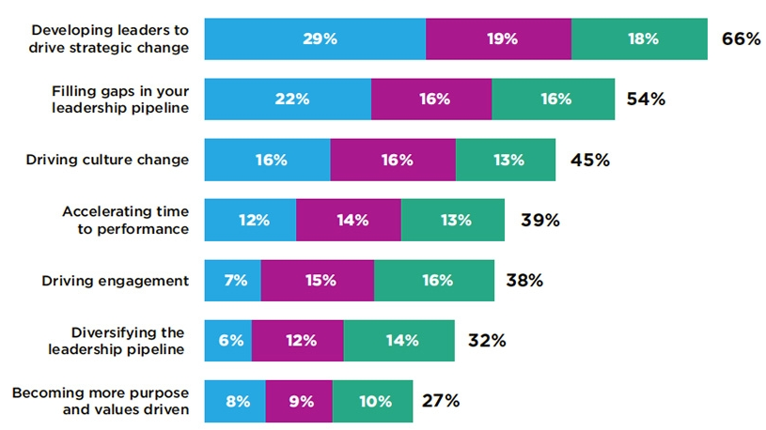
(Source: Consultancy, 2026)

