

Student name: Cynthia nelson-yeboah
Student ID: 2333272

Module name: Changemakers: Building your Personal Brand for Sustainable Employment
Module code: BMHP5015
Lecturer’s name: G1 Caroline Salami (module leader) G2 Christopher Mafuva
Assignment Title: Component 2: Assignment (Report)

Table of Contents
- Introduction…………………………………………………………...…………..….……….3
- Analyses of employability skills required………………..……………………………….…4
  - Job description and responsibilities………………………………………………..4
  - Key employability skills……………………………………………………………...4
  - Frameworks and Values…………………………………………………………….5
- Evaluation of my own skills………………..……………..………………………..………..5
  - Experience and learning…………………………………………………………….6
  - Skills Gap……………………………………………………………………...……..6
- Building a personal brand and professional identity………………………………………7
  - My values…………………………………………………………………………….7
  - My unique selling point (USP)………………………………………………………7
  - Promoting myself……………………………………………………………………7
  - Networking…………………………………………………………………………...7
  - Professional identity…………………………………………………………………7
- Action plan and timeline……………………………………………………………………..7
  - Short-term goals (0-1 year)………………………………………………………...7
  - Medium-term goals (1-3 years)………………………………………………….…8
  - Long-term goals (3-5 years)……………………………………………………..…8
  - SMART goal………………………………………………………………………….8
  - Resources needed…………………………………………………………………..8
  - Timeline table………………………………………………………………………..8
- Conclusion…………………………………………………………………………...……….9
- References………………………………………………………………………………….10

1.Introduction
This report examines the way social care workers function within the framework of the British healthcare system. Social care workers are professionals who help people that require assistance in their activities and lead a healthy lifestyle (Social Care Ireland (SCI), n.d). These individuals can be senior citizens, disabled people, and vulnerable individuals within society. Social care workers can work either in nursing homes, hospitals, or even people’s apartments. The main goal of social care workers is to provide assistance to people who wish to gain maximum independence while maintaining their dignity and wellbeing.
I chose this career path due to my passion to help other people and have a positive influence on their lives. Moreover, the chosen career gives many chances for my personal development within vulnerable groups of people. The career path directs me to my ideal professional field where I should interact with other people that require assistance.
This report will analyse the main employment competencies required by this job based on the standards established in Britain. It will also review my current professional skills and qualifications and also present my personal brand strategy and a clear timeline of events necessary to reach my goals as a future social care worker.
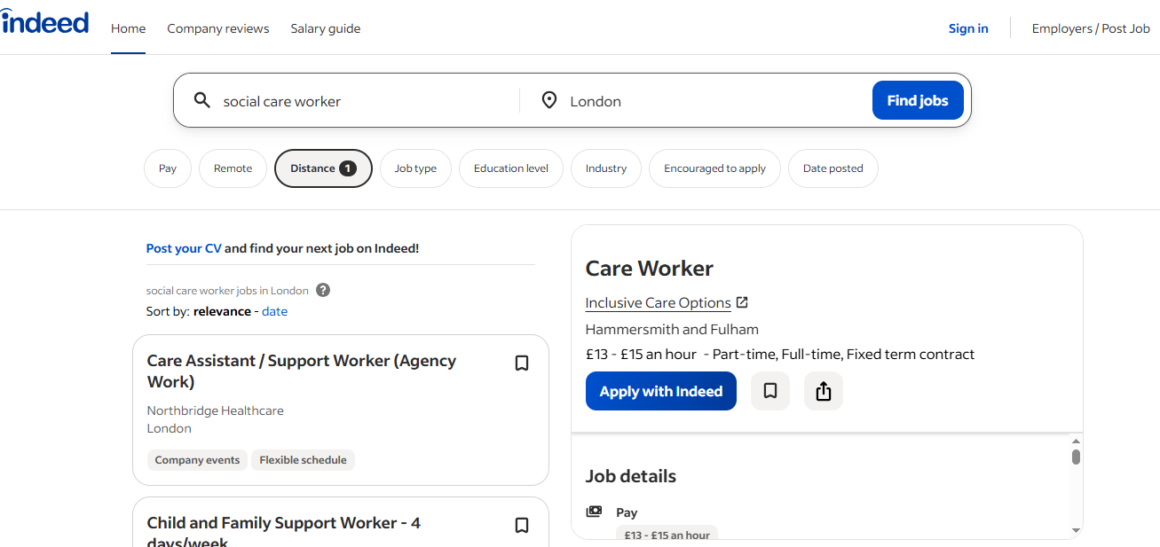
Fig 1: Social Care Worker Job Vacancy (Indeed, 2026)

2.Analyses of Employability Skills Required
A social care worker plays an important role in supporting individuals with their everyday needs, including personal care, emotional support, and helping them live independently (GOV.UK, 2025). The job requires workers to demonstrate practical abilities, personal attributes and professional conduct.
2.1. Job Description and Responsibilities
According to UK government guidance, social care workers support people with daily activities, promote independence, and provide person-centred care (GOV.UK, 2025). The staff members assist clients with various activities such as washing, dressing, eating, and social events while they monitor clients' health status and report any health-related issues.
2.2. Key Employability Skills
- Communication Skills: The field of social care identifies communication as its most essential skill (GOV.UK, 2025). Workers must listen carefully to service users while speaking clearly and understanding their needs. The process involves both spoken words and body language. Effective communication establishes trust between parties which leads to proper delivery of healthcare services.
- Empathy and Compassion: Social care workers need to possess three key personal qualities: kindness, caring nature and capacity to understand other people's emotions. Through compassion social workers provide help to people who experience hardship while maintaining their human dignity. These values function as fundamental requirements for social care job positions (GOV.UK, 2025).
- Teamwork: Social care workers need to collaborate with nurses, social workers and other professionals who work in their field. The ability to function effectively within a group system serves as a vital requirement which enables healthcare providers to deliver safe and efficient medical services.
- Problem-Solving Skills: Social workers need to have problem-solving skills because each person has unique needs. The workers must handle unexpected situations which arise when a service user's health condition suddenly changes.
- Resilience and Emotional Strength: The job requires workers to handle both physical and emotional challenges. The workers need to maintain composure during high-pressure situations while developing effective strategies to handle their stress. The ability to recover from tough situations becomes essential when people face difficult experiences.
- Organisation and Time Management: Social care workers need to handle their time effectively because they provide support to multiple people throughout their workday.
- Digital Skills: Workers in modern care roles need to use digital systems for their tasks which require electronic documentation of information. Basic IT skills are therefore essential (Skills for Care, n.d).
2.3. Frameworks and Values
The 6Cs of care which include Care, Compassion, Competence, Communication, Courage, and Commitment are widely used in the UK to guide how social care workers should behave in practice (Prospects, 2026). The situation requires that vulnerable people receive most compassionate support by using social care worker’s essential communication abilities.
The UK government established the Care Workforce Pathway to identify essential professional behaviours which include respect, accountability, adaptability, and a dedication to ongoing education. The two frameworks together establish a precise benchmark which organizations must follow to provide top-quality person-focused treatment (GOV.UK, 2025a; Prospects, 2026). For example, if a service user feels anxious or upset, a social care worker must use communication and empathy to calm them, while also working with other professionals to provide appropriate support.
3.Evaluation of My Own Skills
I used a SWOT analysis to evaluate my suitability for the social care worker position through a self-assessment process. The process helped me identify my current strengths, my needed areas of development together with the steps I must take for future growth.
- Strengths: My communication abilities serve as my primary strength. I can listen to others with full attention while I understand their different opinions and present information in a straightforward manner. Social care requires this ability because service users need information to be presented through peaceful and supportive explanations. I display empathy and patience when dealing with people. The need to help people makes me perfect for this job that entails helping others. From the group assignments I've done in school, I've developed skills in working with other people as well.
- Weaknesses: However, there are some areas that require development in spite of my strengths. Self-confidence is reduced in cases where I encounter difficult challenges that entail dealing with delicate issues. As far as social care goes, workers often have to deal with sensitive conversations, something that requires me to develop more confidence. My practical abilities are still inadequate since I have not worked in real social care environments. While I have theoretical knowledge from my studies, I have not yet had enough practical experience supporting clients. There is also a need for me to improve on my knowledge concerning safeguarding policies since they play an important role in protecting vulnerable persons.
- Opportunities: There are many opportunities where I can develop these skills. For instance, I can participate in voluntary work at care homes or other organizations to gain some practical knowledge. This will help me build my confidence and skills. I can also expand my knowledge by attending several training programs that cover topics like safeguarding and communication. The use of online learning sites and Skills for Care will enable me to understand the requirements of the job role more accurately.
- Threats: The social care sector presents its first challenge because the field requires strong competition for entry-level positions. Employers often look for candidates with experience, which means I need to work harder to build my profile. The job requires two main challenges which include both emotional and physical work requirements.
  - Experience and Learning
So far, my experience mainly comes from my academic work. Through my participation in group assignments, I improved my ability to work and communicate with team members while solving problems. I developed time management skills which allowed me to complete my work on time. I used Gibbs Reflective Cycle to reflect on a situation but didn’t speak up during the group discussion. After receiving feedback, I made an effort to speak more and share my ideas. This helped improve my confidence.
  - Skills Gap
It is clear that there are skill gaps when comparing the social care worker skills to mine. It is crucial for me to get some experience in working within the area of care, boost my confidence in dealing with difficult situations, and have more knowledge about safeguarding. However, the skill gaps I already have will not stay like this. I am convinced that with the help of training, work experience, and support, I will be able to master all the skills required for this job position in the future.

4.Buillding a Personal Brand and Professional Identity
Personal branding requires showing employers the unique aspects which make me valuable to their organization.
4.1. My Values
My personal values include kindness, respect, and helping others. These values match the expectations of a social care worker.
4.2. My Unique Selling Point (USP)
My Unique Selling Point (USP) consists of my ability to show deep empathy and my strong desire to acquire new knowledge. I welcome feedback from others while I seek out all available opportunities to enhance my personal development.
4.3. Promoting Myself
To build my professional identity I plan to:
- Create a professional CV that highlights my skills
- Develop a LinkedIn profile to showcase my achievements
- Maintain a record of my learning activities and personal experiences.
4.4. Networking
Networking develops essential connections in the social care field which I will pursue through professional social care networking, online community membership and workshop attendance. Social Capital Theory shows that relationship building leads to better career development opportunities which supports this idea (Seibert et al., 2001).
4.5. Professional Identity
My qualities of being caring, responsible and showing motivation will help me create a unique professional image that appeals to employers. My professional identity will strongly develop through my accumulated experiences and growing abilities.

5.Action Plan and Timeline
I have developed an action plan which will help me reach my objective of becoming a social care worker.
5.1. Short-Term Goals (0–1 year)
- I will finish my ongoing university programme
- I will begin my volunteer work at a care facility
- I will develop my communication skills while building my self-assurance
5.2. Medium-Term Goals (1–3 years)
- I will achieve my Health and Social Care qualification
- I will secure a part-time position in a healthcare setting
- I will participate in safeguarding and care training
5.3. Long-Term Goals (3–5 years)
- I will submit my application for a social care worker position
- I will continue to develop my skills through professional development activities
- I will advance my career by taking on higher-level positions
5.4. SMART Goal
- Specific: Volunteering in a care home
- Measurable: 5 hours per week
- Achievable: Apply within one month
- Relevant: This will build my experience
- Time-bound: Complete within 6 months
5.5. Resources Needed
- Training courses
- Financial support for education
- Guidance from mentors
5.6. Timeline Table
Time | Goal | Action
6 months | Gain experience | Volunteer
1 year | Improve skills | Training courses
3 years | Qualification | Complete university health and social care programme
5 years | Employment | Apply for jobs

6.Conclusion
The position of social care worker requires professionals to develop essential skills which include communication skills, empathy, teamwork, resilience and establishment of trustworthy connections. The required skills enable professionals to deliver exceptional care which focuses on individual needs while helping people maintain their security and independent living abilities. The position demands dedication to professional principles which include dignity, respect and compassion because these values form the foundation of successful healthcare and social work operations.
My self-assessment proved successful because I discovered my main abilities which include my capacity to understand other people's feelings, my ability to express myself and my talent for working with others. I need to develop my abilities through real-world practice while I build my self-assurance for difficult situations and learn more about how to keep people safe. The process of identifying these deficiencies showed me which actions I must take to advance my career.
The action plan I have developed provides a clear and realistic pathway for my career progression over the next few years. The report shows my plan to acquire new skills while I build my professional reputation. The process helped me understand my work better and it strengthened my desire to succeed as a future social care worker.

References
GOV.UK, 2025a. Care workforce pathway for adult social care: overview. [Online]
Available at: https://www.gov.uk/government/publications/care-workforce-pathway-for-adult-social-care/care-workforce-pathway-for-adult-social-care-overview
[Accessed 26th April 2026].
GOV.UK, 2025. Care or support worker' role category. [Online]
Available at: https://www.gov.uk/government/publications/care-workforce-pathway-for-adult-social-care/care-or-support-worker-role-category
[Accessed 26th April 2026].
Indeed, 2026. Find jobs. [Online]
Available at: https://uk.indeed.com/jobs?q=social+care+worker&l=London&from=careerguidejobsearch-box-GB&ctk=1jnetu4crghhnbh1&vjk=54dcfa74242081cb
[Accessed 26th April 2026].
Prospects, 2026. Overview of the social care sector. [Online]
Available at: https://www.prospects.ac.uk/jobs-and-work-experience/job-sectors/social-care/overview-of-the-social-care-sector
[Accessed 26th April 2026].
SCI, n.d. What is Social Care Work?. [Online]
Available at: https://socialcareireland.ie/what-is-social-care-work/
[Accessed 26th April 2026].
Seibert et al., 2001. A Social Capital Theory of Career Success. Academy of Management Journal, 44(2).
Skills for Care, n.d. Getting Started. [Online]
Available at: https://www.skillsforcare.org.uk/Careers-in-care/Getting-started/Getting-Started.aspx
[Accessed 26th April 2026].

