From Hope to Stalemate: Why Home Rule Failed in Ireland, 1885-1914

The repeated failure to implement Home Rule in Ireland between 1885 and 1914, was a result of complex socio-political dynamics. This involved British governance, Irish nationalist aspirations and deep-rooted sectarian divisions. Home rule was proposed to seek and grant Ireland its own Parliament, whilst remain under British sovereignty, which became a significant political issue during this period, championed by figures such as Charles Stewart Parnell, and later John Redmond. They led the Irish Parliamentary Party (IPP), which did gain traction within William Gladstones Liberal Party and eventually passed in the House the Commons, however Home Rule still faced substantial resistance, both within Britain and Ireland Itself. The opposition stemmed largely from the Conservative Party and the Ulster Unionists, who feared the implications of a self-governing Ireland dominated by Catholic influence. This led to significant political and social turmoil, culminating in the formation of paramilitary groups such as the Ulster Volunteer Force (UVF) in 1913. Additionally, the outbreak of World War I in 1914 provided a convenient reason to postpone the enactment of the Third Home Rule Bill indefinitely, highlighting the fragility of political solutions in the face of international crises. This essay will explore the major reasons behind the failure to implement Home Rule during this critical period, focusing on political opposition, the role of Ulster, and the impact of global events. By examining these factors, it will become clearer as to why Home Rule remained elusive for Ireland until the eventual partition in 1920.

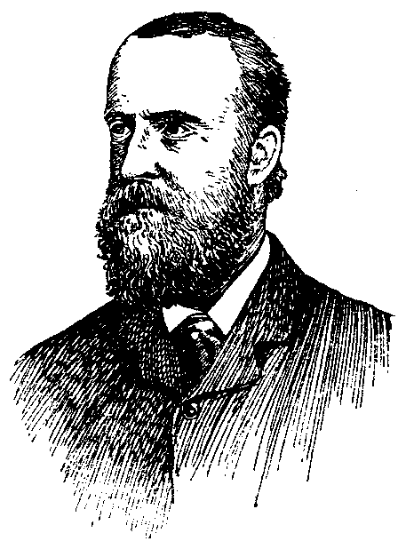
The origins of the Home Rule movement can be traced back to the growing dissatisfaction with direct British governance in Ireland during the 19th century. The economic distress caused by the Great Famine (1845-1852) and subsequent policies that many Irish saw as neglectful intensified the demand for greater autonomy. The IPP, founded in the 1870s and led by Charles Stewart Parnell, emerged as the primary political force advocating for legislative independence. Parnell was a charismatic leader who successfully garnered support both in Ireland and within segments of the British political establishment, making Home Rule a central issue in Anglo-Irish relations.

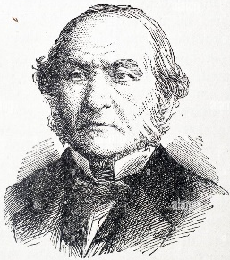
The First Home Rule Bill, introduced by Prime Minister William Gladstone in 1886, marked a significant turning point. Gladstone was convinced that a form of devolved governance would ease tensions in Ireland and bring stability to the United Kingdom. However, the bill failed due to strong opposition from the Conservative Party and dissenting members within the Liberal Party, who feared that granting Ireland a separate parliament would lead to the eventual dissolution of the union. The failure of this bill not only led to Gladstone's temporary political downfall but also highlighted the contentious nature of the issue, particularly among those who believed that Irish autonomy was incompatible with the integrity of the British state (Jackson, 2003).
A second attempt at Home Rule was made in 1893, passing the House of Commons but being blocked by the House of Lords. This underscored the resilience of the anti-Home Rule sentiment within the British establishment. During this time, the formation of the Irish Nationalist movement was paralleled by the strengthening of Unionist sentiments in the north, particularly in Ulster, where many Protestants feared that Home Rule would place them under the dominance of a predominantly Catholic parliament. These fears were fuelled by the belief that Home Rule would inevitably lead to discriminatory policies and economic disadvantages, given the agricultural character of southern Ireland versus the industrial economy of Ulster. The death of Parnell in 1891 left a leadership vacuum that weakened the Irish Parliamentary Party, but the movement for Home Rule did not dissipate. Instead, it experienced a resurgence under John Redmond, who managed to revitalize the IPP in the early 20th century and align with the Liberal Party, especially after the 1910 general election, which gave the Liberals a dependence on IPP votes for parliamentary support. This complex interplay between British political needs and Irish aspirations set the stage for a renewed push for Home Rule, culminating in the Third Home Rule Bill of 1912.

The Conservative Party, firmly committed to the maintenance of the United Kingdom’s unity, viewed the granting of legislative independence to Ireland as a direct threat to the cohesion of the empire. Their slogan, "Unionism," encapsulated a commitment to preventing any devolution of power that could lead to the fragmentation of the British state. The Conservative Party, led by figures such as Lord Salisbury, not only opposed the idea of an Irish parliament but also actively sought alliances with like-minded groups in Ireland, particularly the Ulster Unionists. Salisbury and other Conservatives articulated a narrative that Home Rule would lead to chaos, with a Catholic-dominated parliament threatening the rights and economic interests of the Protestant minority, particularly in the more industrialized and prosperous region of Ulster. The unionist movement found strong political and financial backing from the Conservatives, which allowed it to effectively mobilize against Home Rule, both in Westminster and on the ground in Ireland.

The Liberal Party, traditionally more sympathetic to Irish grievances, was itself divided over the Home Rule question. William Gladstone's enthusiastic advocacy for Irish Home Rule split his party, leading to the formation of the Liberal Unionists, who chose to ally themselves with the Conservatives. This faction, led by prominent figures like Joseph Chamberlain, argued that the dissolution of the Union between Britain and Ireland would lead to economic instability and weaken the empire's strategic position. The defection of the Liberal Unionists significantly weakened Gladstone’s efforts and highlighted the internal fractures within British politics regarding the Irish question. Moreover, the Ulster Unionists, led by influential leaders such as Edward Carson and James Craig, were instrumental in obstructing the Home Rule Bills. They campaigned vigorously against any measure that would subject them to what they perceived as a Catholic and nationalist-dominated Irish parliament in Dublin. Carson and the Ulster Unionists organized political rallies, signed petitions such as the Ulster Covenant in 1912, and ultimately formed the Ulster Volunteer Force (UVF) in 1913, a paramilitary group prepared to resist Home Rule by force if necessary. These developments significantly influenced British public opinion and demonstrated the potential for civil unrest, thereby making it politically unpalatable for any government to proceed with Home Rule without significant concessions.

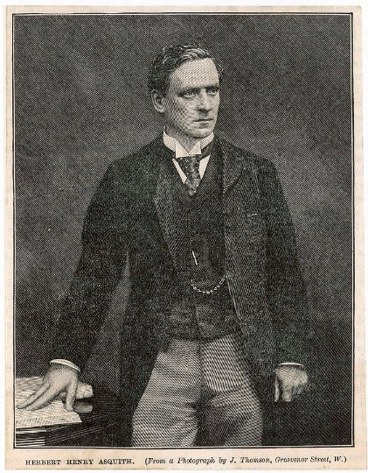
The Third Home Rule Bill, introduced in 1912 by the Liberal Prime Minister H. H. Asquith, faced resistance not only from the House of Commons but also from the House of Lords, which had traditionally been a bastion of Conservative power. The Parliament Act of 1911 had reduced the Lords' ability to permanently block legislation, allowing the bill to pass eventually, but the fierce resistance within both the Lords and the broader British political establishment underscored the deep divisions that made the implementation of Home Rule a seemingly insurmountable challenge. The Conservatives, aligned with the Unionist cause, warned of severe consequences, including civil conflict, should the bill be forced upon Ulster. The coordinated efforts of these opposition forces, Conservatives, Liberal Unionists, and Ulster Unionists created a formidable barrier to the implementation of Home Rule. This opposition was rooted in fears of economic instability, religious discrimination, and the broader imperial context, where the disintegration of the union with Ireland could set a dangerous precedent for other parts of the British Empire. These factors combined to ensure that any progress towards granting Ireland legislative autonomy would face nearly insurmountable political obstacles.

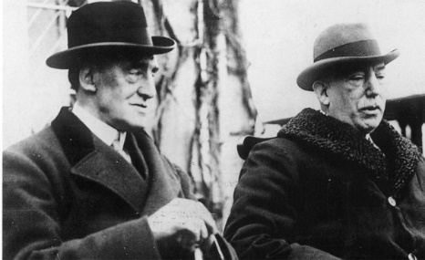
One of the most significant barriers to the implementation of Home Rule was the fierce opposition from Ulster Unionists, who feared that their economic and cultural identity would be jeopardized under a Dublin-centric government. Ulster, with its predominantly Protestant population, was economically distinct from the rest of Ireland due to its industrial character. Cities such as Belfast thrived on industries like shipbuilding and linen manufacturing, linking their prosperity closely to the broader British economy. Many Unionists believed that their economic success and Protestant values were threatened by the idea of a predominantly Catholic and nationalist parliament in Dublin. The fear of "Rome Rule" was a powerful motivator for Ulster Unionists, who worried that Home Rule would result in religious discrimination and the imposition of Catholic moral and social codes. This perception of cultural threat was heightened by the inflammatory rhetoric of Ulster leaders, such as Edward Carson and James Craig, who portrayed Home Rule as a fundamental assault on Protestant liberties. Carson emerged as a leading figure of the Unionist resistance, articulating the anxieties of Ulster’s Protestant community and fostering a united front against any measure that would grant political power to Dublin.

The campaign against Home Rule in Ulster reached a significant turning point with the signing of the Ulster Covenant in 1912, where nearly half a million men and women pledged to resist the establishment of a Home Rule parliament. The Covenant was a dramatic assertion of Unionist identity and determination to remain within the United Kingdom, even if it meant using extra-legal means. This mass mobilization of Unionists was both a political and social movement, as it extended beyond the upper echelons of society to include working-class Protestants, all of whom saw their way of life under threat. The formation of the Ulster Volunteer Force (UVF) in 1913 further escalated the situation. The UVF was established as an armed force to resist, by physical means, if necessary, the enforcement of Home Rule. This paramilitary dimension signalled a willingness to engage in violence and demonstrated the extent of Unionist resolve. The UVF's emergence not only increased tensions in Ireland but also significantly influenced British public opinion, with many in Britain sympathizing with Ulster's plight and fearing a potential civil war.

The British government's response to the Ulster crisis was cautious, reflecting the broader implications that a violent confrontation in Ireland could have for the stability of the United Kingdom. The Curragh Mutiny of 1914, where British officers stationed in Ireland indicated their unwillingness to enforce Home Rule in Ulster, highlighted the reluctance of the British military to act against the Unionists. This incident severely undermined the credibility of any potential government enforcement of Home Rule and reinforced the notion that Ulster was, effectively, beyond the reach of Dublin’s authority. The Unionist movement's appeal to both economic and religious identity ensured that it could draw upon widespread popular support, thereby posing a formidable challenge to nationalist aspirations. The success of the Ulster resistance demonstrated that the Home Rule project was not only a political matter but also deeply rooted in questions of identity, culture, and community divisions within Ireland.

The failure to implement Home Rule between 1885 and 1914 was significantly shaped by the shifting dynamics of British politics, particularly the Liberal Government’s reliance on the Irish Parliamentary Party (IPP) and the obstacles posed by the Conservative-dominated House of Lords. The 1910 general election resulted in a hung parliament, compelling the Liberals, under Prime Minister H. H. Asquith, to ally with John Redmond's IPP, promising to pursue Home Rule in exchange for political support. The Parliament Act of 1911, which limited the Lords' veto power, allowed the Liberals to push forward with Home Rule, culminating in the introduction of the Third Home Rule Bill in 1912. Despite these efforts, the Conservative Party’s influence in the Lords and their continued opposition made passing Home Rule politically fraught. Conservatives leveraged fears that Irish autonomy would destabilize the empire, using the House of Lords to delay and obstruct the process. The alliance between the Liberals and the IPP, while politically expedient, appeared fragile and opportunistic, leading many to question the sincerity of the government’s commitment to Irish self-governance.

The Ulster Unionists, strongly backed by the Conservatives, further complicated matters. Their organization of mass protests and the formation of the UVF underscored the potential for violence if Home Rule were enforced. This tension came to a head in the Curragh Incident of 1914, when British Army officers indicated their unwillingness to act against Ulster, revealing the government's limited control over its own military forces and highlighting the dangers of civil conflict. The outbreak of World War I in July 1914 suspended the implementation of Home Rule indefinitely. Although the Third Home Rule Bill had passed, its enforcement was postponed in favour of maintaining stability during the international crisis. Thus, the complexities of British political alliances, Conservative opposition, military reluctance, and the pressures of global conflict combined to ensure that Home Rule would not be realized during this period.

The failure to implement Home Rule in Ireland between 1885 and 1914 was the result of a complex interplay of political opposition, sectarian division, and global events. Strong resistance from the Conservative Party, the House of Lords, and the Ulster Unionists, coupled with the Liberal Government's hesitance and lack of control over the military, created insurmountable barriers to achieving Irish legislative autonomy. The outbreak of World War I in 1914 postponed the Third Home Rule Bill, highlighting how broader international crises could undermine domestic political reforms. The inability to implement Home Rule marked a significant turning point in Irish history, leading to rising radicalism and setting the stage for the eventual partition of Ireland and the pursuit of independence through different, more forceful means.

Reference list

- O’Day, A. (2004). Home Rule: An Irish History, 1800-2000. The English Historical Review, 119(482), 732–734. https://doi.org/10.1093/ehr/119.482.732
- Loughlin, J. (2004). The Ulster Question Since 1945. Red Globe Press.
- Lyons, F. S. L. (1973). Ireland Since the Famine. Fontana Press.
- Coleman, M. (2008). Ireland: the politics of enmity, 1789–2006. By Paul Bew. Pp xii, 613. Oxford: Oxford University Press. 2007.
- Jenkins, B. (2006). Irish nationalism and the British state: From repeal to revolutionary nationalism. Irish Nationalism and the British State: From Repeal to Revolutionary Nationalism. 1-428.
- O’Day, A. (1998). Irish Home Rule, 1867-1921. Manchester University Press.
- Bartlett, T. (2010). Ireland: A History. Cambridge University Press.
- Foster, R. F. (1989). Modern Ireland: 1600-1972. Penguin Books.
- Walker, Graham. A History of the Ulster Unionist Party: Protest, Pragmatism and Pessimism. Manchester University Press, 2004.
- Kenny, Kevin. The American Irish: A History. Longman, 2000.
- Hempton, David, and Hill, Myrtle. Evangelical Protestantism in Ulster Society 1740-1890. Routledge, 1992.
- Loughlin, James. Ulster Unionism and British National Identity Since 1885. Pinter, 1995.
- Stewart, A. T. Q. The Ulster Crisis: Resistance to Home Rule, 1912-14. Faber & Faber, 1997.
- Jackson, Alvin. Ireland, 1798-1998: Politics and War. Wiley-Blackwell, 2004.
- Jeffery, Keith. Field Marshal Sir Henry Wilson: A Political Soldier. Oxford University Press, 2006.
- Adelman, Paul. The Decline of the Liberal Party 1910-1931. Longman, 1984.
- Morgan, Kenneth O. The Age of Lloyd George: The Liberal Party and British Politics 1890-1929. George Allen & Unwin, 1986.
- Shannon, Catherine B. Home Rule and the Irish Question. Syracuse University Press, 1991.
- Jeffery, Keith. Field Marshal Sir Henry Wilson: A Political Soldier. Oxford University Press, 2006.
- Kiernan, V. G. The First World War and the European Revolutions of 1917-1923. Weidenfeld & Nicolson, 1972.

Jackson, Alvin. Home Rule: An Irish History, 1800-2000.
Loughlin, James. The Ulster Question since 1945.
Lyons, F. S. L. Ireland Since the Famine.
Bew, Paul. Ireland: The Politics of Enmity 1789-2006.
McCaffrey, Lawrence J. Irish Nationalism and the British State: From Repeal to Revolutionary Nationalism. Gill and Macmillan,
O'Day, Alan. Irish Home Rule, 1867-1921.
Bartlett, Thomas. Ireland: A History.
Foster, R. F. Modern Ireland: 1600-1972.
Walker, Graham. A History of the Ulster Unionist Party: Protest, Pragmatism and Pessimism.
Kenny, Kevin. The American Irish: A History.
Hempton, David, and Hill, Myrtle. Evangelical Protestantism in Ulster Society 1740-1890.
Loughlin, James. Ulster Unionism and British National Identity Since 1885.
Stewart, A. T. Q. The Ulster Crisis: Resistance to Home Rule, 1912-14.
Jackson, Alvin. Ireland, 1798-1998: Politics and War.
Jeffery, Keith. Field Marshal Sir Henry Wilson: A Political Soldier.
Adelman, Paul. The Decline of the Liberal Party 1910-1931.
Morgan, Kenneth O. The Age of Lloyd George: The Liberal Party and British Politics 1890-1929.
Shannon, Catherine B. Home Rule and the Irish Question.
Jeffery, Keith. Field Marshal Sir Henry Wilson: A Political Soldier. Oxford University Press, 2006.
Kiernan, V. G. The First World War and the European Revolutions of 1917-1923.

