INTERNATIONAL MARKETING- FERRARI
(ITALY & U.S.A)

BY: MOHAMMADJUNAID KHWAJA
STUDENT ID: 1711085
MODULE CODE: SBMA7108
ASSIGNMENT TITLE: INTERNATIONAL MARKETING
LECTURER: TUSHARA BALENDRAN
Table of Contents
Introduction 3
Background of the Company 3
PESTLE Analysis of Ferrari ---ITALY & U.S.A 4
Advantages and disadvantages of the Macro model 9
Analysis of Italy and American culture using Hofstede’s Theory 9
Porters 5 Forces Model 11
SWOT Analysis of Ferrari 13
Market segmentation, targeting and positioning 15
Segmentation 15
Demographic segmentation 15
Physchographic segmentation 16
Geographical segmentation 16
Targeting 16
Market Positioning 17
The 7Ps of marketing 18
Directional Development Strategy 21
Recommendations 22
Conclusion 23
References 24

Introduction
Ferrari is the car manufacturing company in Italy owned by Fiat that over the past few years had attained the leading position in its production and selling of luxury sports cars and road cars. Since 2013, this Maranello based company had attained the highest place among the powerful brands of the world performing ahead of other automobile companies such as BMW and Volkswagen. Ferrari stands in line with Google and Coca-Cola and operates in Italy, its home country, with subsidies in America and other countries. America’s technological advancements, Italy’s growing fashion, and designer trends facilitate the marketing of Ferrari’s models.

Background of the Company
Ferrari Company was founded by Enzo Ferrari and it built its first sports car in 1940. The company was initially headquartered in Modena and it was named as Scuderia Ferrari that manufactured Alfa Romeo racing cars that became a separate division later. In 1939, Enzo Ferrari established Auto Avio Costruzioni that produced tools and equipments and components for aircraft construction. The first Ferrari sports car, Tipo 815, was built in 1940 and was launched in the Mille Miglia race. A few years later, the Ferrari industry moved to Maranello from where it had operated permanently.
Ferrari was rated as the most powerful brand by Brand Finance in 2014 and its 1962 model Ferrari 250 GTO became the most expensive car. The company was taken in by Fiat S.p.A. that obtained about 50% of its stake in 1969 and expanded it to 90% after a few years. Later Fiat Chrysler Automobiles N.V. (FCA) owned most of Ferrari and divided Ferrari S.p.A from itself. In Netherlands, Ferrari N.V. became the new established company that held the Ferrari group.
The company had been recognized throughout history for its manufacturing of designed car models and coherent participation in many racing events. The racing team of Ferrari participated mainly in the Formula One racing and earned most of the championships besides producing the greatest number of champion drivers in the world. The road cars of Ferrari are also seen as a mark of comfort, wealth and luxury. Below figure shows the sales of Ferrari from FY2014 to FY2016, where there has been huge number of sales in the EMEA region in contrast to America and other APAC countries.

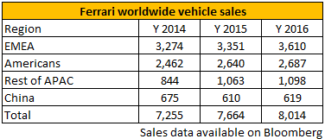
Figure 1: Sales data of Ferrari’s vehicles sales
(Source: Gilens and Page 2014)
Below figure also shows a drastic change where the soaring value of the Ferrari cars has increased huge. It shows a huge turbulence where the average value of the vintage Ferrari has tripled nearly in the last five years, as of 2015. This has showed high performance where there are new collection such as German Collectibles, American Muscle cars and British Collectibles.

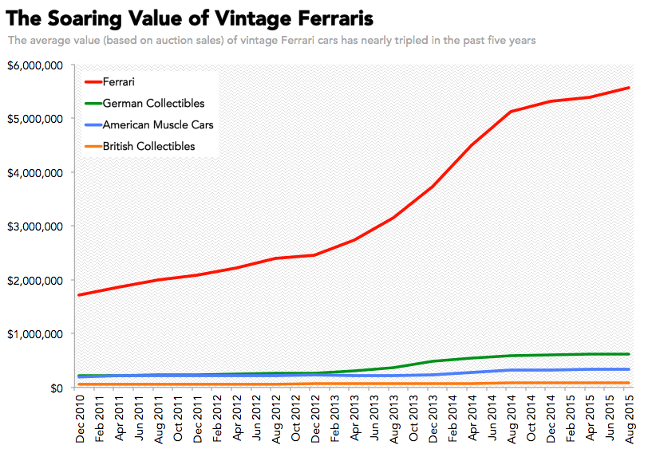
Figure 2: Average value of Ferrari vintage cars
(Source: Cantino et al. 2017)

PESTLE Analysis of Ferrari ---ITALY & U.S.A
This PESTLE analysis highlights the macro environment of Ferrari N.V. and the various factors it takes into consideration while marketing its luxury and sports car across the globe.
Political Factors- Favourable
A country’s political scenario affects any multinational countries in various ways. For an automobile industry the political factors tends to affect the market sales of the product. Ferrari operates as a car manufacturer in many countries and the political environment varies with each. The laws set by the government such as pricing and trade regulations had to be followed by Ferrari in order to establish the market in that country.
Italy influences foreign relations and is a strong supporter of the United Nations and the Organization for Economic Cooperation and Development and the country provides trade tariffs to organizations (Keukeleire and Delreux, 2014). In Italy, employees of Ferrari enjoy benefits and safety regulations provided by the industry.
America has a large and strong democracy with elections and business laws that are considered fair. As a policy maker, the country has the largest economic power and a steady political environment (Gilens and Page, 2014). It uses advanced technology, equipments, influences foreign direct investments and has been the primary choice for many multinational companies. While operating in America, Ferrari has advantage in the political stability of the automobile industry that occupies a major place in the country. It can also look into the legal structure for the imposition of a contract, the tax rates and allowances in car manufacturing and the trading benefits it can earn.
Economic Factors- Favourable
A country’s economy helps in the growth and expansion of a company. An automobile company will triumph under increased rates of exchange of the developed economy. However, an increase in the fuel price leads to an increase in price that affects the demand and purchasing of products (Gohari et al. 2018). Again, an economic crisis also affects the marketing strategy and profits of a company. This is favourable, as it has made a large market presence for operating with high profit structure in development of new cars.
Italy is a capitalist country where private companies own the production and hiring employees to do the central business tasks. The country has an innovative business sector and a competitive industrial sector for its quality and standard automobile and appliance design with the lowest unemployment rate (Cantino et al. 2017). These factors are quite favourable for Ferrari’s growth rate and hiring skilled workers with minimum labour and production costs. The company has used Italy’s competitive advantage and efficient markets for expansion. However, Italy is also the most corrupt among European countries and these might pose difficulties for Ferrari’s performance.
USA is regarded as the largest economy with respect to its GDP and it is from here companies such as McDonald’s, Microsoft and Apple have started to shape the other economies. The country provides talented employees for organizations and its economic growth rate and high consumer spending capabilities serve to be a suitable environment for Ferrari’s luxury cars. However, the country’s GDP has also estimated that there might be an economic recession in the future, as the global economy is rapidly rising and this could be a challenge for Ferrari (Chetty, 2017). Labour is not available for cheap in USA compared to other countries and Ferrari incurred considerable costs in this sector.
Social Factors- Favourable
These include a country’s changes in population and culture and the marketing strategies, product purchase decisions change accordingly. The population in UK is rapidly increasing alongside the living standards of the people. Italy has high-class citizens consisting of business managers, entrepreneurs and politicians. The luxury cars of Ferrari have helped in improving the living standards of people and the high purchasing power of these consumers favour the car sales (Gilens and Page, 2014). The negative side to this factor is that the aristocracy of Italy constitute only 10% of the population with the majority consisting of rural and urban working class people who are not skilled that affects the company’s selling power and production performance.
USA is the third most populated country drawing more talents and labour from other countries. Its education system helps people with knowledge and training, encourages entrepreneurship and the skilled population is growing rapidly (Berkman, Boersch-Supan and Avendano, 2015). Ferrari implements skilled employees easily in its American branch. Again, the country has more upper class people who can afford to buy luxury sports car and the age group who can buy such cars is the highest. However, USA has witnessed growing racial tensions that might hamper the corporate culture of Ferrari and the mindset of its employees.
Technological Factors- most Favourable
Technology is always evolving throughout the world. For an automobile industry, an advancement of technology makes their cars unique in quality and designs that result in increase in sales. According to a report by Research Services Group, Italy has 24 points more than the average world record in physics. Italy’s technology has seen a significant rise and has provided an opportunity for Ferrari to improve their product performance.
America is leading in science and technology with companies like Apple and Microsoft addressing the needs of its citizens properly (Collins and Halverson, 2018). Ferrari has the most favourable technological environment here that influenced its developing, launching and displaying of new models. Availability of quality materials is helping Ferrari increase its profit and meeting the consumer demands. The negative impact of technology is that it led to increase in price that had made many Americans disappointed. Global technological upsurge made America face challenges from China and Japan that increased the competition of Ferrari with other nations’ automobile companies. Again, implementing high technological equipments has the risk of increased operation costs that Ferrari faces on occasions that hampers its profit.
Legal Factors—Quite Favourable
National and international laws apply legal restrictions on cars emphasizing on the health and safety measures. This is quite favourable, as the automobile companies have to follow these laws to keep their brand name. While they can consider these factors in their production and selling methods, this might affect a company’s performance as it has to keep in mind all the conditions.
Italy offers a friendly climate for companies to invest and a stable economy to purchase capital. Ferrari’s cars are focused on the safety of the drivers and other factors that increased the company’s confidence in operating in Italy. Though the country has a complicated tax system, property tax reforms offer advantages such as discounts and value added tax (D’Attoma, 2018). Ferrari does not incur tax on capital gains, stocks or bonds and this favour the investors to maximize their investment returns.
The states of USA have their own individual government and legal procedures. Ferrari entered the American market by assessing the discrimination law and employment law. In USA, all the citizens are treated equally and there is no discrimination between nationals and foreigners. The employee law favours employees who do not face any biasness from the judicial system (Reisman, Kaplan and Gonzalez, 2016). This enables Ferrari to hire employees from other countries when skilled labour falls short. Further, the legal system guarantees the automobile company in the protection of its property.
Environmental Factors-Unfavourable
Pollution and global warming has forced companies to shift to producing more environmental friendly products. The increase in consumer awareness has brought a shift in their preferences allowing companies to concentrate on the changing demand patterns. Ferrari’s cars emit less fuel and its introduction of renewable energy resources reduced the carbon dioxide emission and pollution by 40 %.
Italy’s industrialized sector has faced big problems of air pollution with high carbon dioxide emissions (Carugno et al. 2016). There are also instances of poor land management and deforestation that led to ecological disasters. Ferrari is headquartered in Italy and these conditions are unfavourable to its operations. Climate change and waste management are important factors in the performance of Ferrari and Italy’s poor environment prevents its effective functionality.
There are diverse geographical locations in America and an approving climate that attracts companies to invest and employees to work in a healthy atmosphere. America has consistently drawn people to its companies and the chief reason is the safe environment. The opportunity to recycle its car products and the consumer demands of environmental friendly products has favored in the expansion of Ferrari. However, USA had also faced some extreme disasters and weather conditions with loss of property worth billions.

Advantages and disadvantages of the Macro model
Towards the macro-model, i.e. Pestel analysis of Ferrari, the advantage is that offers a simple ease to make the analysis. It helps to decrease the effects of the potential threat in organisation. While Pestel also aids development of strategic thinking in the organisation and that too enables to assess the implications of entering the new markets globally and nationally (Goldin and Katz, 2018). The major dis-advantage found is that the process has to be conducted regularly to make investment properly. However, Ferrari often restricts the process due to the cost and time considerations. Likewise, it is shown that few assumptions are been made in conjunction to making decisions based on subjective data.

Analysis of Italy and American culture using Hofstede’s Theory
Hofstede’s Theory points out six cultural dimensions that identify a country’s values and beliefs about each of these. The five dimensions of power distance, masculinity, uncertainty avoidance, individualism, long-term orientation and indulgence is used to look at the cross-cultural differences of Italy and USA.
The power distance index shows the range of inequality in power distribution and the less powerful citizens in a country accept this inequality (Beugelsdijk, Kostova and Roth, 2017). A higher degree of Index shows that there is a hierarchy maintained and a lower degree shows that the citizens question the existing authority and prefers equal power distribution. Italy has a score of 50 in its power index, as it prefers equality of power and decision-making while America has a score of 40 in this index as the comparison between the have and have-nots are growing larger.
The individualism index shows the extent to which the people in a country are united into groups. This index addresses the interdependence maintained by the citizens of a nation. America is a country having the most individualistic culture as it follows the notions of justice and liberty for every citizen. In most American companies including Ferrari, the supervisors are easily accessible and managers depend on both teams and individual workers for their knowledge and skills (Mazzalovo, 2016). The country’s self-reliability and its capability to interact with people earned it a score of 91. Italy also has an individualist culture where the people are mostly self-centered. However, in Southern Italy this attitude is less observed where family and friends form an important social feature thereby receiving a score of 76 in this index.
The masculinity index refers to the desires of heroism, achievement and success in a society. There is a recognized gap between men and women in terms of values and in such societies, men are more decisive and self-confident. Italy has a score of 70 due to the success-oriented nature of the people. This is visible in the working environment where the competitive nature among employees favors the operations of Ferrari. America, on the contrary has a score of 62 in this index for though the people have the drive towards achievement and success; this creates a degree of conflict leading to sharp divisions and cases.
The index of uncertainty avoidance shows the way a society estimates the future. It reflects the degree to which the people of a nation face complicated and unknown situations and in what way they try to avoid these (Beugelsdijk, Kostova and Roth, 2017). Italy has a score of 75, as they do not find comfort in complicated positions. The high degree of formality, civil codes and norms are complicated and the people do not always follow those (Hofstede Insights, 2015). America is willing to accept new innovative ideas, technology and quality products which Ferrari provides. Though it follows the freedom of expression, it is not dependent on a lot of norms and are less emotional for which it has a low score of 46.
Long-term orientation describes how societies maintain connections with the country’s past and use it to face present and future challenges. Societies that earn a high score are pragmatic and those with a low score view change with distrust. Italian culture is both realistic and practical where the people are factual believing that truth depends on a particular situation. The companies in Italy have a strong inclination to invest, adapt to the changing market conditions and are resolved to achieve results. Ferrari has successfully adapted its models to the changing designer trend of the times and has a score of 61 (Hofstede Insights, 2015). America, on the other hand, is far lower in this regard with just 26 points as the people are not as pragmatic as Italians are. Though Americans are practical, they assess any new change before deciding to adopt it (Hofstede Insights, 2015). The companies here strive for immediate results and measure product performance in a short period and issue quarterly statements of profit.
The final index is indulgence measuring the degree to which people try to resist their desires. If the resistance is weak, then it is called indulgence while a stronger control is restraint. Italy’s culture is very restrained thereby earning a very low score of 30 as the people control their desire fulfillment and do not spend time casually (Hofstede Insights, 2015). America has an indulgent society giving it a score of 68 and this broad-minded nature is favorable for Ferrari to launch new models.
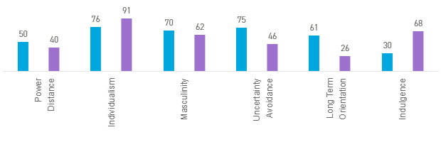
Figure 1: A comparison between Italy and America using Hofstede’s Theory
(Source: Hofstede Insights, 2015)

Porters 5 Forces Model
Porter’s Five Forces model is used here to analyse the competitive strength of Ferrari and the factors that shape this competition. The five forces that underlie industry competition are bargaining power of suppliers, bargaining power of customers, threats of new entrants in the industry, threat of substitute products and rivalry.
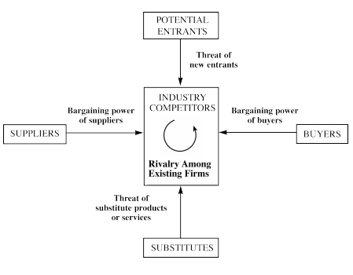
Figure 2: Porter’s Five Forces Model
(Source: Id.iit.edu, 2016)
Bargaining Power of Buyers-HIGH
The high power of the buyers is determined by the knowledge they have more than the suppliers and the order they give. If the buyers of a Ferrari sports car have a great bargaining power then it demonstrates the weakness of the suppliers. The buyer also has an advantage when they know a good brand name and when their high living standards enable them to price their products at a higher rate (Marino et al. 2015). This gives them an opportunity to bargain for their products at a lower rate from the suppliers. Again, if the Ferrari buyer is a celebrity with a high reputation they could also bargain at a lower price and demand incentives. The bargaining power and size of Ferrari consumers in America is much higher than those in Italy are.
Bargaining Power of Suppliers----MEDIUM
The suppliers of a Ferrari car have greater power when they can prove to their buyers that they can sell these cars at higher prices than others can. They could influence the consumers to buy at this higher price by efficient demonstrations of the quality and luxury the car holds. The greater size of the suppliers over the buyers and other brand manufacturers also increases their power.
New Entry Threats-----HIGH
Ferrari’s investment in a larger American capital carries high threats of new entrants then a comparatively smaller Italian market (Neese, Foxx and Eppler, 2018). The company’s market share is important which makes it dominant in its field of manufacturing. However, the entry of Ford Motors and Chevrolet in America and Lamborghini and Pagani in Italy provides a huge threat of Ferrari in the automobile market.
Threats of Substitutes----MEDIUM
Ferrari holds sports events and the closest competition it faces in the racing track is with Mercedes Benz GP and Mclaren Mercedes. Any sudden change in the market position of Ferrari could give these competitors an opportunity to overtake in the market. Ferrari must adjust itself to the shifting tastes of consumers to avoid any future threats from these equal substitutes.
Rivalry---HIGH
To expand its market, many companies maintain a proper coordination with existing companies. This can turn into rivalry if any of the companies break the coordination and dominate the market to prove its importance. The rivalry becomes intense if the other company responds with a similar counter attack. However, the major rivals of the firm are BMW, Bugatti, Lamborghini Porsch and Mercedes Benz
Names of the rivals: Mercedes, BMW, Audi, Lamborghini, Porsche

SWOT Analysis of Ferrari
The SWOT analysis of Ferrari and its operations in Italy and America is analysed to gather information about the potential success factors of the automobiles company and the drawbacks it retain so that these help in the later decision making process and improvise the manufacturing and marketing strategies.

- Strengths
Ferrari has a popular brand image in the production of sports cars and the unification of beauty and design has resulted in its grand performance in the market. America has the largest global market and invests in technology, research and development. The large economy is driven by its ever-increasing consumers and the technological systems include computer software, aerospace and mechanical equipments (Goldin, and Katz, 2018). The driving factors of Ferrari are innovation and technology and America offers facilities of research departments for the development of new models such as Ferrari California T, Ferrari GTC4 that are not sufficiently provided by Italy. Availability of flexible resources and plants motivate Ferrari to take on new challenges constantly.
Italy has a strong spirit of collaboration among workers that creates a sustainable and friendly environment among workers. Ferrari has inspired and satisfied employees who feel proud to work for it and this favourable environment gave it a status symbol in the country.
- Weaknesses
America has an increasing fiscal deficit that made it the largest country in debt and Ferrari’s investing in America has the risk of running into debt. Again, a considerable portion of workers lacks the education and training in skills required of them by companies (Ma and Schapira, 2017). Lack of proper skilled workforce can slow down Ferrari’s manufacturing of cars and create difficulties in the market. The economy also suffers from product shortages and steep prices that sometimes create unfavourable situations and the government control of the energy sector limits the freedom of operation.
In contrast, Italy does not impose limits on the business operations and Ferrari has more freedom in its home country (Anzuini, Rossi and Tommasino, 2017). However, Italy’s small ability to maintain new projects creates additional difficulties.
- Opportunities
Ferrari has opportunities for growth in the international market of sports cars in developing economies. It can enlarge the consumer base by entering new and popular markets of automobiles such as Japan. In America, the constant development of technology is opening up new environmental friendly regions where Ferrari can expand its industry. America has increased funding in the private sector and giving financial encouragement to both investors and consumers. Ferrari can use these advantages and be a part in initiating economical stability.
Italy, on the other hand, has surpassed America in the trend of fashion, designing and showcase. Fashion has become a central part in the country’s culture and cities like Venice, Florence and Milan produces luxury products such as jewellery and cosmetics (Cirella et al. 2016). Adhering to this design trend, Ferrari can develop the strategy of packaging and launch new sports car models to display new style and technology at racing events attracting consumers to radical designs. The features of style and exclusivity have been central to the company’s previous success and it can further exploit these aspects in their home market to increase the brand image.
- Threats
Ferrari manufactures cars that are environment friendly and emits less carbon dioxide. However policies related to automobile industries such as conditions of 130g/km carbon dioxide emission are being strictly enforced and Ferrari’s performance centered engines are finding it challenging to keep up to these norms. The American economic growth rate is estimated to increase at a lesser rate due to accommodations of the housing sector (Fernald and Jones, 2014). The export markets might suffer because of this and so might the profit power of Ferrari.
The growing economies in Asia and Europe are posing a threat to overtake the American market and unless Ferrari opens subsidies in these countries, the company might face steep competition from other companies. The threat of competition is looming in its home country with the Italian brand Lamborghini developing its market for high performing SUVs and sports cars. The brand Porsche is also rising after the success with its Cayenne Turbo model all over the world including India (Mazzalovo, 2016). There is also an increase in the level of poverty and unemployment in Italy and Ferrari is finding difficulties coping up with the market that is falling at times.

Market segmentation, targeting and positioning

Segmentation

Demographic segmentation
Ferrari mainly targets the high-level income earning age group of 30+ people, primarily the men. They target those because people fancy buying Ferrari cars at a certain age, and this drives their high-income reason to show richness of brand image. Ferrari also shows huge response to the rich premium personalities and to celebrities as well.

Physchographic segmentation
The company takes the different psychological factors of consumer buying behaviour to address their needs. Industries having a broad consumer field divide the market into segments of consumers according to certain shared aspects that helps the industries to reach the specific desires of consumers in each sector. Ferrari sells both sports and road cars for which it uses the strategies of psychographic segmentation (Sachdeva, Sachdeva and Sachdeva, 2015). Ferrari does not want every consumer to purchase its brand and its target consumers are mainly limited to famous celebrities, actors and sportsmen.

Geographical segmentation
Ferrari’s target consumers being mainly celebrities, their market are meant for the upper class with considerable buying power and Ferrari provide them with a comfortable driving experience. Both Italy and America have consumers who have a high income, who are luxury conscious, have a rich lifestyle and prefer fashionable cars and Ferrari divides them based on their purchasing power and cater to the demands of each sector (Shende, 2014). In America, every Ferrari owner has an annual income of USD one million or more and they consist of professionals, politicians and entrepreneurs.

Targeting
The activities, interests and secondary opinion also affect the buying behaviour of consumers. Many consumers like to buy automobiles of popular brands, but while some may like Ferrari, others may like Lamborghini. Ferrari changes its manufacturing techniques to retain its own target consumers. The wants and demands of consumers change with age. Even with the same product, the wants may vary according to the types and designs of the product. Ferrari targets consumers who are mainly of middle age group (Marino, 2015). The American market of Ferrari buyers consist of people who are belonging to the age group of 35 to 45 years sometimes extending to even 55 years. However, the Ferrari buyers in Italy extend up to 50 years maximum. As gender is another factor of market segmentation and preferences of cars are usually attributed to men. Ferrari’s target consumers in America have 98% male buyers and even half of these Ferrari buyers own more cars with more than 60% owning more than one Ferrari. In Italy, most of the buyers consist of men.

Market Positioning
Market position means the consumer’s ideas regarding a brand in relation to its competing brands. Companies need to position its brand image in a certain way so that consumers interpret it in a positive manner. Ferrari’s market positioning is mainly based on its design and car performance following which it surpassed many automobile brands (Mazzalovo, 2016). With respect to design, Ferrari attracts the Italian consumers more than Ferrari attracts the American consumers due to the increasing trend in fashion in Italy (Waller et al. 2015). On the other hand, the American consumers rely on the brand both from the perspectives of performance and design (Zeugner-Roth, Žabkar and Diamantopoulos, 2015). In the marketing strategy position, Ferrari faces steep competition from Lamborghini and Pagani in Italy. Though the brand emphasizes on the style and ease of consumers, it is behind the Jaguar and Mercedes brand in terms of comfort and Bugatti in terms of elegance.

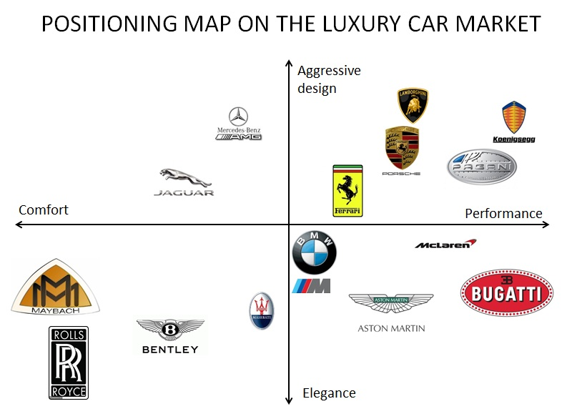
Figure 3: Market Positioning of Luxury Cars
(Source: SEGUY et al. 2018)

The 7Ps of marketing
The marketing mix consists of 7Ps that are regarded as the principle elements behind the marketing methods employed by a company for the development of its brand image. These seven elements include product, place, promotion, price, packaging, people and physical evidence.
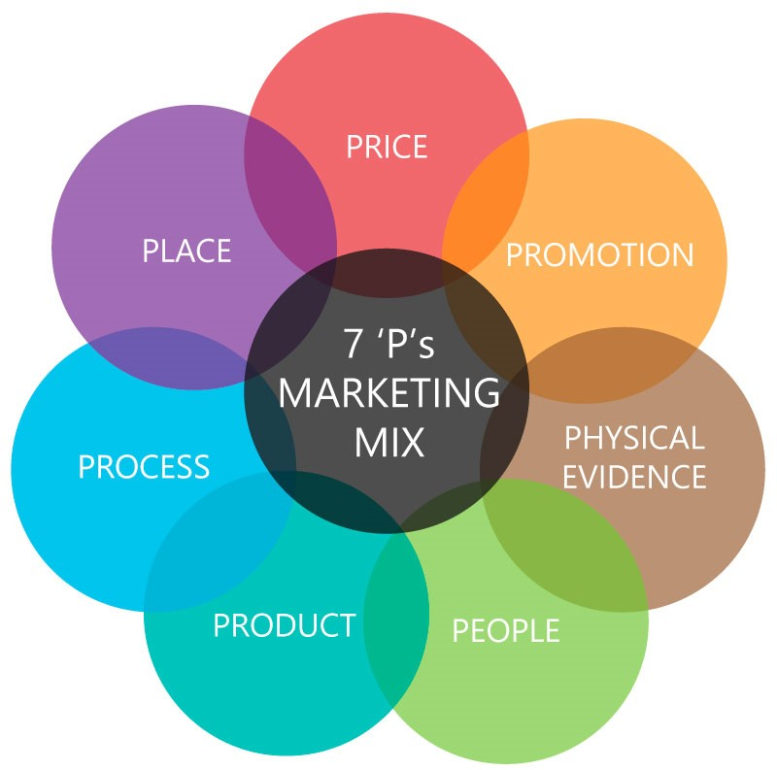
Figure 4: 7Ps of Marketing
(Source: Academy, 2017)
- Product
The product must be standardized and fit the consumer demands and expectations to influence their sale (Solomon et al. 2014). Ferrari manufactures high performance sports and road cars starting with the Ferrari 125 S in 1940 and its product strategy includes all the cars offered by the company, the latest being GTC4Lusso, Ferrari Aperta, Ferrari California T and others.
America, having the largest market, facilitates all types of product marketing based on design and standards. The sale of Ferrari models in America has been quite stable and the company had tried to maintain exclusivity in their sales. Consumers now prefer more safe and friendly products and Ferrari’s facilities of personalization give the drivers of the road car models a safe and unique experience (Mazzalovo, 2016). Though sales of the cars in America have increased more than the sales in Italy that has a comparatively smaller market, there has been a decrease in sales in America from 21% in 2016 to 19% in 2017.
Italy’s design and fashion hub is growing more than that of America and consumers prefer more fashionable and designer luxury brands. Ferrari’s cars are unique and its Formula 1 sports car and road car designs are attracting more consumers.
- Place
Consumers want places from where it is easier to purchase and Ferrari’s market has spread over more than 50 countries in Asia, Europe, America and the Middle East. The growing technological facilities have enabled Ferrari to sale their merchandise at various global stores and online (Neese, Foxx and Eppler, 2018). The Ferrari store in America reaches consumers by displaying its models in the renovated show room in Park Avenue. In Italy, the Marenello based company opened new stores and museum in Milan and Rome where it displayed clothing merchandise collections of their drivers to emphasize on their sporting spirit and values before consumers.
- Price
Company products should represent value for the money of consumers who are sometimes happy to pay more for a better quality product. Vintage Ferrari’s appreciate the value for which their cars are a prominent investment. In America, the company’s price starts around USD 170000 and the model Ferrari 485 GTB is priced at USD 280000 (MBA Skool-Study.Learn.Share, 2016). Though Vintage Ferrari models cost a lot, consumers are willing to pay for the brand value. In the market, Ferrari gives cars of premium prices that increase with more modifications.
The brand value of Ferrari is displayed in its merchandise stores in Rome and Milan. The models ensure low fuel emissions and safety of drivers for which luxury consumers prefer to buy these cars. In Italy, the Ferrari 458 Italia costs around 190000 euro and the price of other models range from 130000 euro to 260000 euro.
- Promotion
Digital advertising, personal selling and social media are the latest tools of promotions and communication for a company. When the company began, Ferrari started to manufacture Formula 1 racing cars where they gathered the maximum promotion all over the world (Marino et al. 2015). The promotion methods are different from other automobile industries. Ferrari offer driving courses in America where consumers are taught by professionals whereas in Italy, the company owns a club where events and meetings such as the CSAI regularity trial are organized and where the owners share their experiences. The merchandise stores in Milan and Rome has a big collection of clothing, perfumes and watches for all age groups that also plays an important role in promoting the models.
- People
Every organization relies on the employees and managers who are as important for the business as the consumers. Italy being their home country, the team spirit is much more here than America. The company trade unions are allowed to participate in decisions and important features of employment. A joint committee was formed and the management of Ferrari discussed issues related to employee job classification with the trade union (Marino, 2015). This approach led to strong participation between employees, trade unions and managers and the committee had a flexible impact on the performance of Ferrari. However, some employees complained that salaries could have been better and there was no yearly adjustment of salary.
The employees in the North American branch of Ferrari were satisfied with the working environment of Ferrari and the capability to learn much with also opportunities to drive the latest cars and participate in events. Some employees, on the other hand, find the working stressful and a challenging infrastructure (Reisman, Kaplan and Gonzalez, 2016). Employees are sometimes bereft of the financial data, as the technological systems are not user friendly.
- Process
In both Italy and America, Ferrari opened showrooms to launch and display their latest models before the consumers. The company offers different levels of service to consumers who enter these showrooms to decide their cars and place their orders (Sachdeva, Sachdeva and Sachdeva, 2015). Ferrari assures that the vehicle and its buyer receives standard treatment. For innovations, the company is largely dependent on its research and development department to adapt to the changing demands

- Physical Evidence
Ferrari besides highlighting its cars offers the consumers a comfortable and relaxing experience with their models by maintaining the lifestyle of their target consumers. Towards Ferrari’s website, it provides key information regarding photos, videos and the sports car with regard to the events and services. Ferrari also uses the cookies to guarantee the browsing experience to users for gathering information for the site (SEGUY et al. 2018). However, Ferrari’s market entry method is done mainly through market penetration where it could develop its base for product development. It also uses Joint venture in Asian and Foreign countries to develop its own product line.
Website:www.ferrari.com
Market entry methods

Directional Development Strategy
Every business plans to expand but this planning need to be done in the right direction. A preparation for the future involves having the correct knowledge of the market, the preferences of consumers externally while internally it involves the proper budgeting and planning with the company staff regarding the managers and employees (Solomon et al. 2014). A directional strategy guides a company both in times of success and in times of crisis and a company is kept focused while being consistent in the growth of revenue and quality of products offered to consumers.
The market objectives of Ferrari are:
- To attain 15% market share for Ferrari in the year 2018-2019, to target the consumers in a huge proportion
- To achieve sales by 25% so that the revenue can be gained higher than the fiscal year
The Ansoff matrix is used for strategic directional development as it gives companies a scope to market its products so that it can develop its products for the future market. The market penetration of Ferrari involves increasing the share of the market with the models already existing to stimulate consumer purchase (Zhou et al. 2015). An increase in the market share increases the bargaining power of the supplier. Besides modified products, Ferrari also delivers developed products to the existing markets. Along with the manufacturing development strategies of Ferrari, there is a need to develop the products so that consumer desires are properly fulfilled. Ferrari sponsors the Formula 1 racing competitions in an annual basis to display new technological advancements and innovative improvements.
- Diversification is another directional strategy that helps in market growth by taking the company away from its existing markets and products (Waller et al. 2015). Diversification helps Ferrari in gaining effectiveness by applying the already existing resources of the company to new markets and new products in a different country. In the west, Ferrari developed the market by moving to Canada and Mexico and these new geographical locations provide the company with new consumers and new marketing segments.
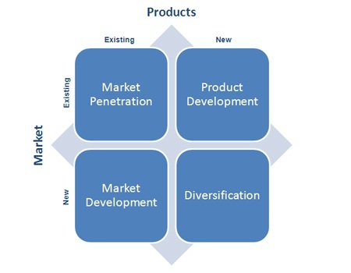
Figure 5: The Ansoff Matrix
(Source: MBA Skool-Study.Learn.Share, 2017)

Recommendations
It is recommended that Ferrari should gain competitive advantage because of its luxury and premium products targeted to customers. They value the essence of the brand, and should work with the well-known personalities to develop their exclusive luxury sports car. Even, the ideal market presence of the car is concentrated to few players that share characteristics like aesthetics, quality and the high degree of pricing. It is also recommended that Ferrari vehicles should have a niche target market where they can pay for a high price in owning products to brand and quality. Unlike, Ferrari marketing mix shows that premium priced cars increases with the rate of more individual customizations.

Conclusion
Ferrari is known for its Formula 1 sports cars and the new innovative models that it is launching throughout the globe and the engines, power and exhilaration that driver’s experience. Enzo Ferrari founded the company that at the start supplied car segments to racing teams and after the Second World War, the Ferrari S.p.A was founded from where the success story of the company began. Ferrari had since manufactured car for racing teams and consumers with quality, luxury, efficient and environmental friendly products. Its strategy of displaying models and promoting by holding events all contributed to its global success and winning the competition. However, a set of drawbacks have also been noted based on the complaints and reviews of buyers.
The turn signal indicators of Ferrari are usually on the steering wheel and the driver faces increasing difficulty to see the signals on the panel as the position of the steering wheel blocks it. Most of the recent Ferrari models such as the 458 model have the problem that needs to be solved. There is also the navigation problem as it appears in the panel behind the steering wheel. Ferrari’s market is still in the rise and the improvisation of its models by looking at these defects can give better advantages in the future. Ferrari should work on the economic instability and pressures from rival industries and focus more on diversifying its business to generate more revenue.

References
Academy, P. (2017). Marketing Theories - The 7Ps of the Marketing Mix. [online] Professionalacademy.com. Available at: https://www.professionalacademy.com/blogs-and-advice/marketing-theories---the-marketing-mix---from-4-p-s-to-7-p-s [Accessed 3 Aug. 2018].
Anzuini, A., Rossi, L. and Tommasino, P., 2017. Fiscal policy uncertainty and the business cycle: time series evidence from Italy. https://www.bancaditalia.it/pubblicazioni/temi-discussione/2017/2017-1151/en_tema_1151.pdf
Berkman, L.F., Boersch-Supan, A. and Avendano, M., 2015. Labor-force participation, policies & practices in an aging America: Adaptation essential for a healthy & resilient population. Daedalus, 144(2), pp.41-54. https://www.ncbi.nlm.nih.gov/pmc/articles/PMC5193486/
Beugelsdijk, S., Kostova, T. and Roth, K., 2017. An overview of Hofstede-inspired country-level culture research in international business since 2006. Journal of International Business Studies, 48(1), pp.30-47. https://link.springer.com/article/10.1057/s41267-016-0038-8
Cantino, V., Hanić, H., Dutto, G., Adame, M.A., Erić, D., Brnjas, Z., Dedeić, P., Ćulahović, B. and Redžepagić, S., 2017. Business Opportunities in Serbia: the Case of Italian Business Sector and Role of Management Education. Tematski zbornici, pp.315-315. http://www.library.ien.bg.ac.rs/index.php/zb/article/download/461/412
Carugno, M., Consonni, D., Randi, G., Catelan, D., Grisotto, L., Bertazzi, P.A., Biggeri, A. and Baccini, M., 2016. Air pollution exposure, cause-specific deaths and hospitalizations in a highly polluted Italian region. Environmental research, 147, pp.415-424. https://www.sciencedirect.com/science/article/pii/S0013935116300834
Chetty, R., Grusky, D., Hell, M., Hendren, N., Manduca, R. and Narang, J., 2017. The fading American dream: Trends in absolute income mobility since 1940. Science, 356(6336), pp.398-406. http://www.equality-of-opportunity.org/papers/abs_mobility_paper.pdf
Cirella, S., Canterino, F., Guerci, M. and Shani, A.B., 2016. Organizational learning mechanisms and creative climate: Insights from an Italian fashion design company. Creativity and Innovation Management, 25(2), pp.211-222. http://repository.essex.ac.uk/16312/
Collins, A. and Halverson, R., 2018. Rethinking education in the age of technology: The digital revolution and schooling in America. Teachers College Press. https://www.researchgate.net/profile/Richard_Halverson/publication/264869053_Rethinking_education_in_the_age_of_technology_the_digital_revolution_and_the_schools/links/58343bb608aef19cb81f4ea7/Rethinking-education-in-the-age-of-technology-the-digital-revolution-and-the-schools.pdf
D’Attoma, J., 2018. What explains the North–South divide in Italian tax compliance? An experimental analysis. Acta Politica, pp.1-20. https://www.researchgate.net/profile/John_Dattoma/publication/322724545_What_explains_the_North-South_divide_in_Italian_tax_compliance_An_experimental_analysis/links/5a7092bd458515015e63db57/What-explains-the-North-South-divide-in-Italian-tax-compliance-An-experimental-analysis.pdf
Fernald, J.G. and Jones, C.I., 2014. The future of US economic growth. American economic review, 104(5), pp.44-49. http://citeseerx.ist.psu.edu/viewdoc/download?doi=10.1.1.683.2647&rep=rep1&type=pdf
Gilens, M. and Page, B.I., 2014. Testing theories of American politics: Elites, interest groups, and average citizens. Perspectives on politics, 12(3), pp.564-581. http://amadorcountynews.org/2014-04/American%20Politics%20-%20Elites,%20Interest%20Groups,%20and%20Average%20Citizens.pdf
Gohari, A., Matori, N., Yusof, K.W., Toloue, I. and Myint, K.C., 2018. Effects of the Fuel Price Increase on the Operating Cost of Freight Transport Vehicles. In E3S Web of Conferences(Vol. 34, p. 01022). EDP Sciences. https://www.e3s-conferences.org/articles/e3sconf/pdf/2018/09/e3sconf_cenviron2018_01022.pdf
Goldin, C. and Katz, L.F., 2018. The race between education and technology. In Inequality in the 21st Century (pp. 49-54). Routledge. http://epa.uz.ua/00000/00017/00169/pdf/06toth.pdf
Hofstede Insights. (2015). Country Comparison - Hofstede Insights. [online] Available at: https://www.hofstede-insights.com/country-comparison/the-usa/ [Accessed 18 Mar. 2015].
Id.iit.edu. (2016). 5 Forces | Models for design planning. [online] Available at: https://www.id.iit.edu/models/5-forces [Accessed 3 Sep. 2016].
Keukeleire, S. and Delreux, T., 2014. The foreign policy of the European Union. Macmillan International Higher Education. https://www.macmillanihe.com/page/detail/the-foreign-policy-of-the-european-union-stephan-keukeleire/?sf1=barcode&st1=9781137025746
Ma, C. and Schapira, M., 2017. The bell curve: Intelligence and class structure in American life. Macat Library. http://academic.sun.ac.za/mathed/174/NatureNurture/Wikipedia.pdf
Marino, A., Aversa, P., Mesquita, L. and Anand, J., 2015. Driving performance via exploration in changing environments: Evidence from formula one racing. Organization Science, 26(4), pp.1079-1100. https://pubsonline.informs.org/doi/pdf/10.1287/orsc.2015.0984
Marino, S., 2015. Trade unions, special structures and the inclusion of migrant workers: on the role of union democracy. Work, employment and society, 29(5), pp.826-842. http://citeseerx.ist.psu.edu/viewdoc/download?doi=10.1.1.955.4676&rep=rep1&type=pdf
Mazzalovo, G., 2016. Resolving Tensions among Creative Departments through Brand Identity Definition: The Case Study of Pininfarina. Business and Management Studies, 2(1), pp.111-124. http://redfame.com/journal/index.php/bms/article/download/1414/1397
MBA Skool-Study.Learn.Share. (2016). Ferrari Marketing Mix (4Ps) Strategy | MBA Skool-Study.Learn.Share.. [online] Available at: https://www.mbaskool.com/marketing-mix/products/16830-ferrari.html [Accessed 7 Jun. 2016].
MBA Skool-Study.Learn.Share. (2017). Ansoff Matrix Definition | Marketing Dictionary | MBA Skool-Study.Learn.Share.. [online] Available at: https://www.mbaskool.com/business-concepts/marketing-and-strategy-terms/2550-ansoff-matrix.html [Accessed 17 Nov. 2017].
Neese, W.T., Foxx, W. and Eppler, D.B., 2018. The influence of industry-specific personal characteristics on consumer reactions to domestic vs. foreign comparative advertising in the American automobile market. Cogent Business & Management, 5(1), p.1444329. https://www.tandfonline.com/doi/pdf/10.1080/23311975.2018.1444329
Reisman, N.R., Kaplan, G.F. and Gonzalez, S.M., 2016. The American Legal System. In International Textbook of Aesthetic Surgery (pp. 89-113). Springer, Berlin, Heidelberg. Reisman, N.R., Kaplan, G.F. and Gonzalez, S.M., 2016. The American Legal System. In International Textbook of Aesthetic Surgery (pp. 89-113). Springer, Berlin, Heidelberg. https://www.coursehero.com/file/pg2ff3/Court-system-The-court-system-is-divided-into-three-distinct-categories-namely/
Sachdeva, S., Sachdeva, R. and Sachdeva, A.K., 2015. A Case Study on the Emerging Market for Leading Premium Sports Luxury Car Manufacturers in India. IITM Journal of Management and IT, 6(2), pp.20-27. http://iitmjanakpuri.com/journals-pics/Volume%206%20Issue%202%20July-December%202015.pdf#page=20
SEGUY, B., Segol, M., SEGUY, B. and Segol, M. (2018). THE CAR INDUSTRY AT ITS ABSOLUTE FINEST. [online] Lamboandrollsaudit.blogspot.com. Available at: http://lamboandrollsaudit.blogspot.com/2012/11/ [Accessed 15 Jul. 2017].
Shende, V., 2014. Analysis of research in consumer behavior of automobile passenger car customer. International Journal of Scientific and Research Publications, 4(2), p.1. http://www.academia.edu/download/36979028/ijsrp-p2670.pdf
Solomon, M.R., Dahl, D.W., White, K., Zaichkowsky, J.L. and Polegato, R., 2014. Consumer behavior: Buying, having, and being (Vol. 10). London: Pearson. http://www.semesteratsea.org/wp-content/uploads/2015/03/Trittipo_SEMS-3500_Consumer-Behavior3.pdf
Waller, S., Bradley, M., Hosking, I. and Clarkson, P.J., 2015. Making the case for inclusive design. Applied ergonomics, 46, pp.297-303. https://www.repository.cam.ac.uk/bitstream/handle/1810/251415/1-s2.0-S0003687013000513-main.pdf?sequence=5
Zeugner-Roth, K.P., Žabkar, V. and Diamantopoulos, A., 2015. Consumer ethnocentrism, national identity, and consumer cosmopolitanism as drivers of consumer behavior: A social identity theory perspective. Journal of international marketing, 23(2), pp.25-54. https://www.researchgate.net/profile/Adamantios_Diamantopoulos/publication/276656210_Consumer_Ethnocentrism_National_Identity_and_Consumer_Cosmopolitanism_as_Drivers_of_Consumer_Behavior_A_Social_Identity_Theory_Perspective/links/5aa6358f45851543e641716f/Consumer-Ethnocentrism-National-Identity-and-Consumer-Cosmopolitanism-as-Drivers-of-Consumer-Behavior-A-Social-Identity-Theory-Perspective.pdf
Zhou, Y., Wang, M., Hao, H., Johnson, L. and Wang, H., 2015. Plug-in electric vehicle market penetration and incentives: a global review. Mitigation and Adaptation Strategies for Global Change, 20(5), pp.777-795. https://www.researchgate.net/profile/Hewu_Wang/publication/276481714_Plug-in_electric_vehicle_market_penetration_and_incentives_a_global_review/links/55a3722108aeaefdb97bb827.pdf

