
Data Mining
Student Performance Analysis — Maths and Portuguese (UCI)

14 November 2025
Sobia Tabassam-2222632
ACCA6026-Dr Mobolanle Bello

Contents
Introduction 2
1.1 Purpose and practice of data mining 3
1.2 Dataset description and data exploration 4
Mathematics Dataset – Exploration (student.mat) 5
Portuguese Dataset - Exploration (student-por) 8
1.3 Data Pre-processing and Post-processing 10
1.4 Analysis, Methods, and Results 12
Prediction Results – student.por Dataset 13
Prediction Results – student.mat Dataset 17
Clustering – student.mat Dataset 24
Clustering – student.por Dataset 27
1.5 Business recommendations 28
1.6 Reflection 28
Conclusion 30
References 31

Introduction
This report analyses student performance data from two Portuguese secondary schools (Mathematics and Portuguese datasets) obtained from the UCI Machine Learning Repository [11]–[13]. The study explores how academic, behavioural, and demographic factors—such as studytime, family support, absenteeism, alcohol consumption, and parental education—affect student outcomes. The primary goal is to identify key predictors of success and uncover patterns to support targeted interventions.
Data mining techniques were applied, including predictive modelling (classification and regression) for grade estimation and unsupervised clustering for student segmentation. Tableau visualisations were used to enhance interpretability. Figure 1 illustrates the structured data-mining workflow, encompassing data understanding, preprocessing, modelling, evaluation, and recommendations [1].

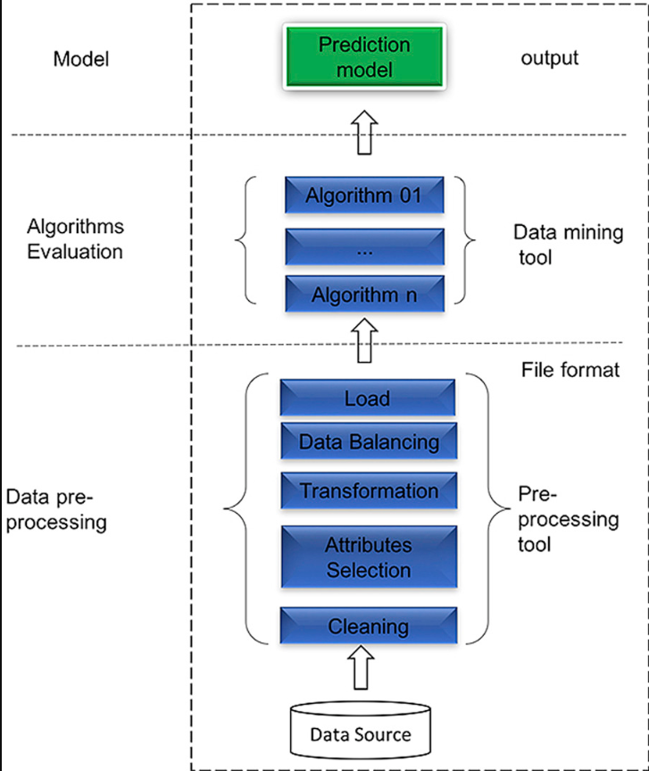
Figure 1. Data-mining workflow applied to the student performance analysis [1].

The report is organised to lead the reader from initial data exploration and preprocessing, through analytical methods and results, to practical recommendations and reflective insights, providing a comprehensive view of the factors influencing student performance.

1.1 Purpose and practice of data mining
Data mining is the systematic process of discovering meaningful patterns, correlations, and trends within large datasets using statistical analysis, artificial intelligence, and machine learning techniques [2] - [4]. Its purpose is to transform raw data into actionable insights that support evidence-based decision-making and strategic planning [5]. By revealing hidden relationships, organisations can enhance efficiency, forecast outcomes, and make informed choices across various sectors [6].
The interdisciplinary nature of data mining, shown in Figure 2, highlights its foundations in statistics, artificial intelligence, and machine learning. These domains provide complementary approaches: statistical inference for identifying patterns, machine learning for predictive modelling, and artificial intelligence for adaptive automation [7] –[10].

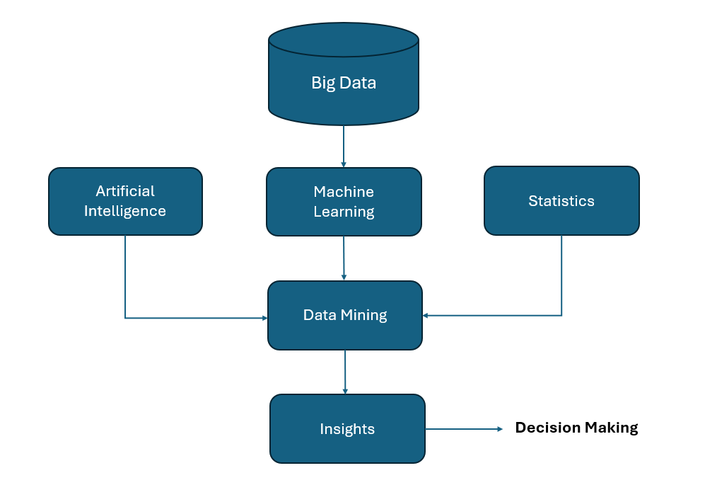
Fig. 2. Core domains contributing to data mining: statistics, artificial intelligence, and machine learning

Common techniques include classification, regression, and clustering. Classification predicts discrete outcomes such as pass or fail [5], [6]; regression estimates continuous variables like grades [6]; and clustering groups individuals with similar characteristics to uncover natural patterns [7], [8]. Combined, these methods offer a multidimensional view of data behaviour [9], [10]. Figure 3 summarises how data mining techniques are organised into descriptive and predictive categories.

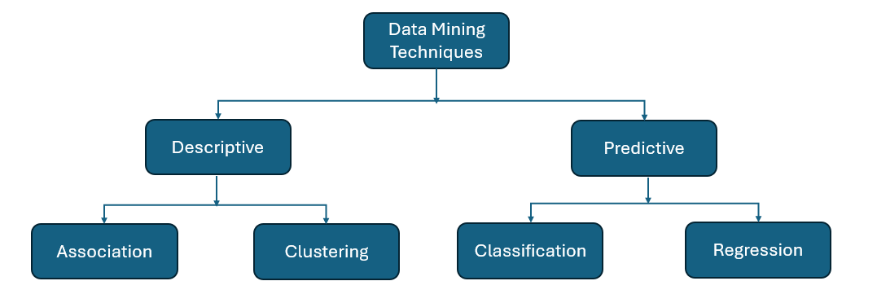
Figure 3. Data mining techniques are classified into descriptive and predictive categories.

In education, data mining enhances student achievement through predictive modelling and performance analysis [1], [5]. Predictive models flag at-risk learners for timely intervention, while clustering students into segments for personalised learning [6], [7]. For performance prediction, classification identifies students at risk of failure, regression estimates final grades, and clustering reveals learning profiles, supporting proactive, data-driven decisions and resource optimisation [5], [6], [10]. Techniques were chosen for interpretability and integration with Tableau dashboards, connecting theory to visual analysis [5], [7].

1.2 Dataset description and data exploration
The datasets for this study were obtained from the UCI Machine Learning Repository [11] and contain student records from two Portuguese secondary schools. Separate files exist for Mathematics (student-mat, 395 records, 33 attributes) and Portuguese (student-por, 649 records, same structure). Each record describes demographic, family, behavioural, lifestyle, and academic factors. Variables include school, sex, age, address, famsize, Pstatus, Medu, Fedu, Mjob, Fjob, reason, guardian, studytime, traveltime, failures, schoolsup, famsup, paid, activities, nursery, higher, internet, romantic, famrel, freetime, goout, Dalc, Walc, health, and absences, with academic performance represented by G1, G2, and G3 [12], [13].
This rich structure enables detailed analysis of how personal, family, and lifestyle factors influence student outcomes over time [12]-[14]. Initial inspection revealed minor formatting inconsistencies, such as stray quotation marks, which were corrected to ensure consistent data types and reliable numeric parsing. After cleaning, no missing values remained among key variables. These preprocessing steps align with best practices in educational data mining [12], [13], ensuring data quality, accuracy, and interpretability for subsequent exploration and modelling.
Following data preparation, initial exploratory visualisations were conducted to examine key relationships among academic and behavioural factors.

Mathematics Dataset – Exploration (student.mat)

Studytime vs G1 – Effect of Study Effort on Early Grades

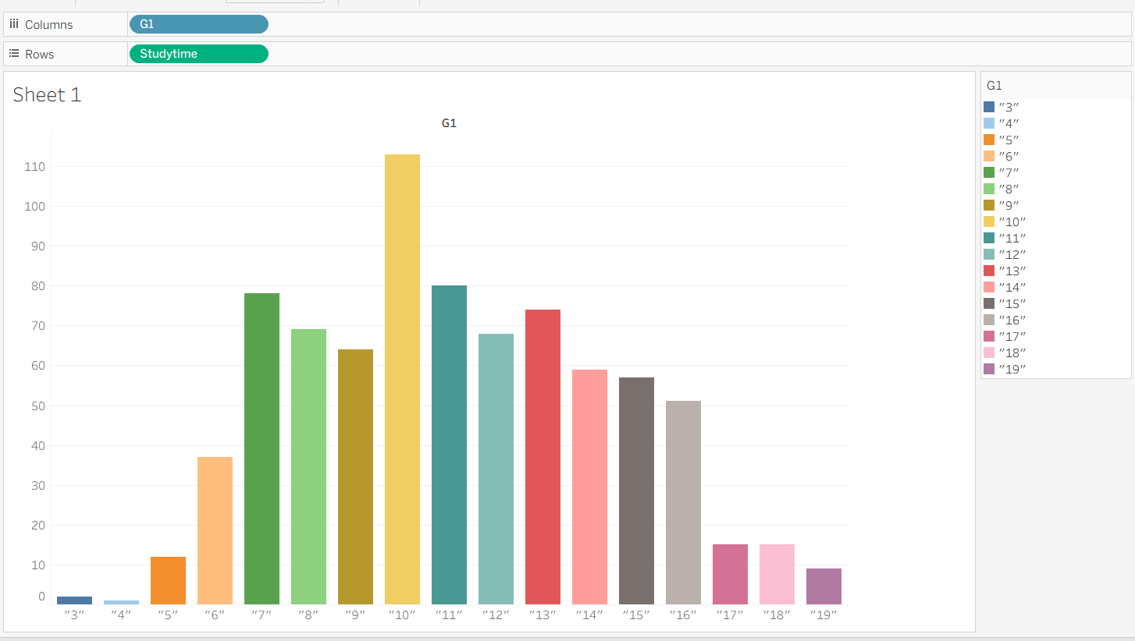

Students with moderate to high studytime (levels 2–4) generally achieve grades between 10 and 14, while those studying minimally (level 1) often fall below passing, highlighting the positive effect of consistent study habits.

Absences vs G1 – Impact of Attendance on Performance

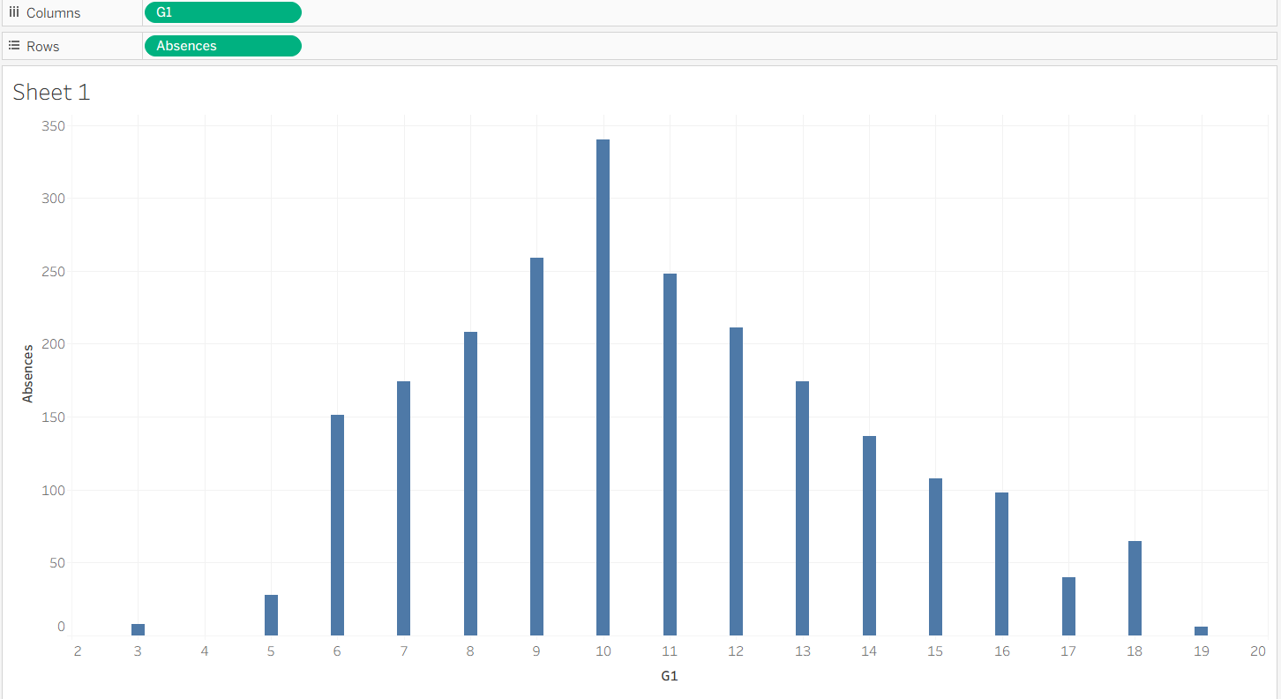

Lower G1 grades correspond to higher absence rates, showing that frequent absenteeism negatively affects early performance and indicating a need for attendance-based interventions.

Weekend Alcohol Consumption vs G3 – Influence of Wellbeing Behaviours

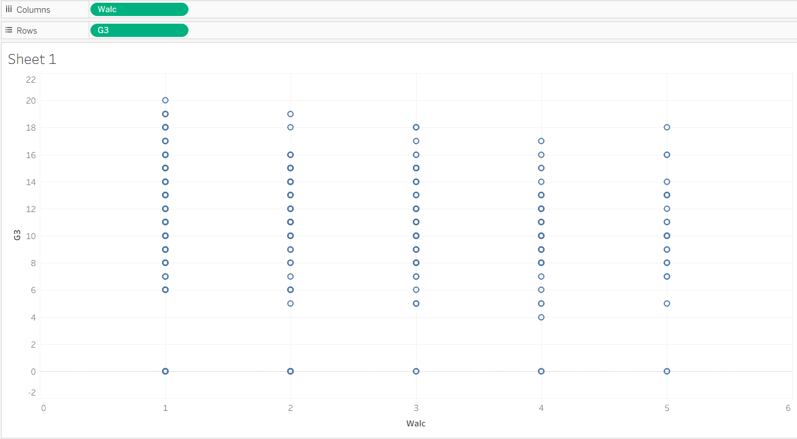

Higher weekend alcohol use (Walc 4–5) is associated with lower G3 scores, suggesting that wellbeing behaviours influence academic outcomes.

School Support vs G1 – Role of Support Programmes

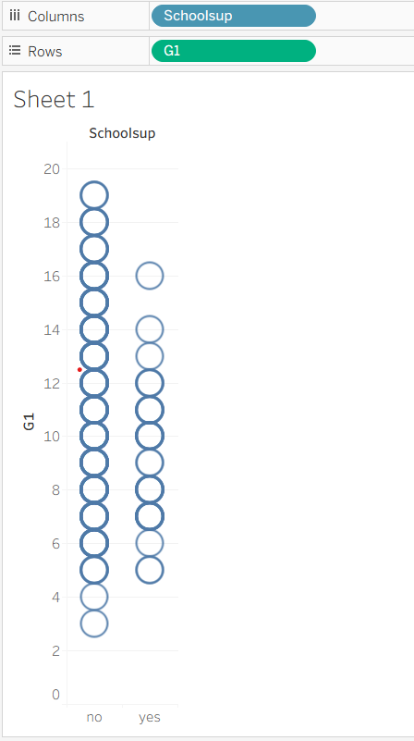

Students without school support often achieve higher G1 grades, indicating that support programmes primarily target struggling learners rather than causing lower performance.

Portuguese Dataset - Exploration (student-por)

Early Grades vs Failures – Early Performance as a Predictor of Risk

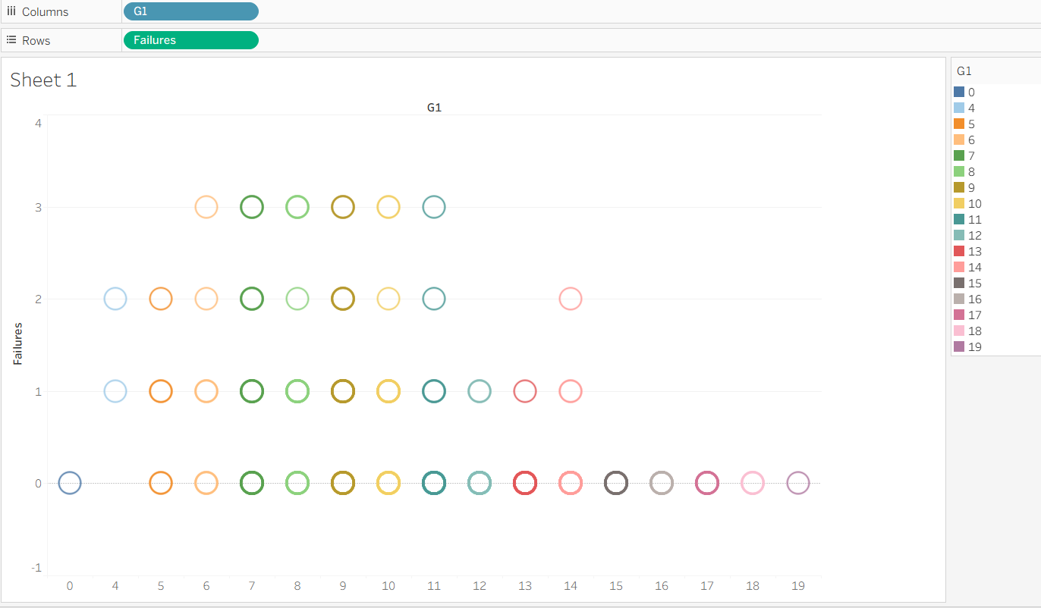

Low G1 scores (1–5) correlate with multiple failures, confirming that early-term performance is a strong predictor of academic risk.

Studytime, Family Support, and Academic Progression – Combined Effects of Study and Parental Support
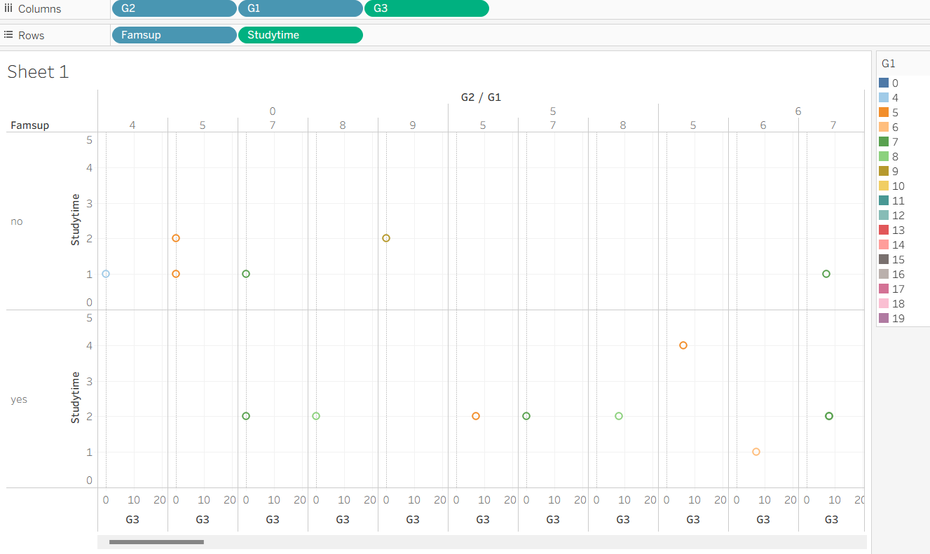
Family support enhances the benefits of studytime: supported students achieve consistently higher G1–G3 grades, underscoring the importance of parental involvement.
Maternal Education vs G3 – Parental Education and Student Success

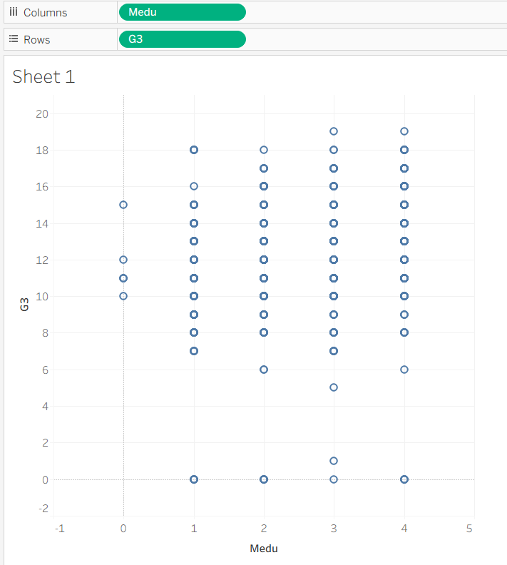
Higher maternal education (Medu) is associated with stronger and more stable G3 grades, indicating parental education as a key success factor.

G3 vs Studytime, Absences, and Failures – Academic Habits and Historical Performance
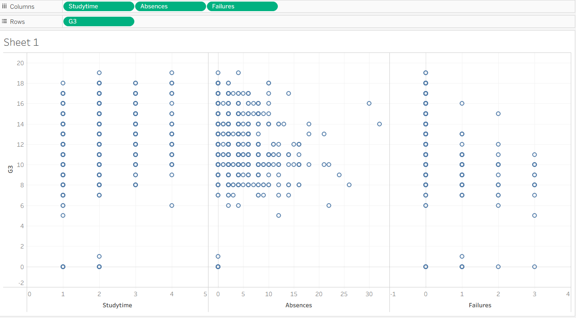

Greater studytime and regular attendance improve G3 scores, whereas absences and prior failures reduce performance, emphasising the role of academic habits and history.

These visual patterns identified the most relevant features for predictive modelling and clustering, supporting transparent, data-driven educational insights [3], [4]. Overall, the exploration reveals consistent trends across both datasets: studytime and family support improve outcomes, while absences, alcohol use, and prior failures reduce performance. These findings provide a robust foundation for subsequent predictive analysis and targeted intervention design.

1.3 Data Pre-processing and Post-processing
Data pre-processing refers to the set of methods used to clean, standardise, and transform raw datasets so they are suitable for analysis [15]. As described by Denodo [1], these steps ensure accuracy, consistency, and completeness, qualities necessary for any machine learning or analytical workflow. CRISP-DM methodology also emphasises thorough data preparation as a critical early stage of analytics [16], [17].
Primary Preprocessing
Primary preprocessing forms the initial stage of preparing the Mathematics (student-mat) and Portuguese (student-por) datasets, aiming to correct errors, resolve inconsistencies, and ensure the data structure is suitable for further analysis. In this project, the datasets were first cleaned to make them usable in Tableau. This included addressing formatting issues such as stray quotation marks, inconsistent spacing, and mis-typed categorical values, as well as adjusting rows to improve clarity and readability so that each record was well-structured and easy to interpret. Variables were verified to have the correct data type, particularly where numeric fields could be misinterpreted as text. Missing values were assessed for key academic (G1, G2, G3), behavioural (studytime, absences), and demographic variables; no gaps were identified, so imputation or row removal was unnecessary [4]. This stage ensured that the datasets were clean, reliable, and ready for subsequent analyses and Tableau visualisations [15], [18].

Secondary Preprocessing
Secondary preprocessing for Tableau focuses on transforming the cleaned dataset to improve interpretability and facilitate visualisation rather than preparing it for machine-learning models [19], [20]. This includes creating derived variables, organising data for clarity, and formatting fields to make visual analysis easier.
For both datasets, new variables were created to enhance visual insights. Examples include grouped studytime categories (low, medium, high), performance bands for grades, and combined weekday and weekend alcohol measures. Categorical variables, such as family support (famsup), school support (schoolsup), parental occupations (Mjob, Fjob), and alcohol use (Dalc, Walc), were kept in text form, as Tableau can process categories directly. No numeric encoding or scaling was required [19], [20].
These steps ensured the datasets were structured, interpretable, and ready for visual analysis, allowing exploration of relationships between study habits, family and school support, lifestyle behaviours, and academic performance.

Data Preparation for Tableau
For Tableau visualisation, only selected aspects of preprocessing were required. The dataset needed to be clean, consistent, and well-structured, with correct data types and descriptive column names. Irrelevant fields were removed to simplify the workspace, and calculated or derived features—such as grouped studytime levels, grade performance bands, or total alcohol consumption measures—were created to improve visual interpretation [2].
Unlike machine-learning models, Tableau does not require scaling of numerical variables or encoding of categorical data into numeric formats, as it can process text categories directly. These steps ensured that the data could be smoothly imported into Tableau and that visualisations clearly displayed patterns and relationships across academic, behavioural, and demographic dimensions.
Data Post-processing
Data post-processing refers to the procedures performed after analysis to interpret, summarise, and present results in a clear and usable format [22]. This stage ensures that analytical outputs are organised, formatted, and prepared for effective reporting.
In this report, visual outputs created in Tableau, including scatterplots, regression lines, prediction curves, and cluster diagrams, were captured as screenshots and inserted directly into the written report. Headings, captions, and brief descriptions were added to emphasise key insights, such as the effects of studytime, absences, and alcohol consumption on academic performance. Analytical findings and metrics were explained in accessible language to ensure clarity for non-technical audiences. This stage ensured that the results were communicated clearly, visually effectively, and in a manner that supported meaningful interpretation of the data.
All stages, from initial cleaning through transformation and visualisation, were fully documented to ensure transparency, reproducibility, and traceability. The overall workflow followed the CRISP-DM (Cross-Industry Standard Process for Data Mining) framework, ensuring a systematic and interpretable approach to analysis [16], [17]. This structured preparation established a solid foundation for predictive and exploratory modelling, combining analytical rigour with practical usability across all phases of the student-performance study.

1.4 Analysis, Methods, and Results
This section presents the analytical methods and findings for both prediction and clustering applied to the student.mat (Mathematics) and student.por (Portuguese) datasets. The analysis aims to understand key behavioural, demographic, and academic factors influencing student performance and to identify meaningful student groups for targeted academic and well-being interventions [23], [24].

Prediction uses supervised learning to estimate unknown outcomes from labelled data by identifying relationships between input variables and targets [2]. In this study, it was applied to forecast student grades (G1, G2, G3) based on factors like studytime, alcohol use, family support, parental education, absences, and lifestyle, with predictions compared to actual grades to evaluate model accuracy and factor influence.

Prediction Results – student.por Dataset

Studytime and Father’s Education (Fedu)

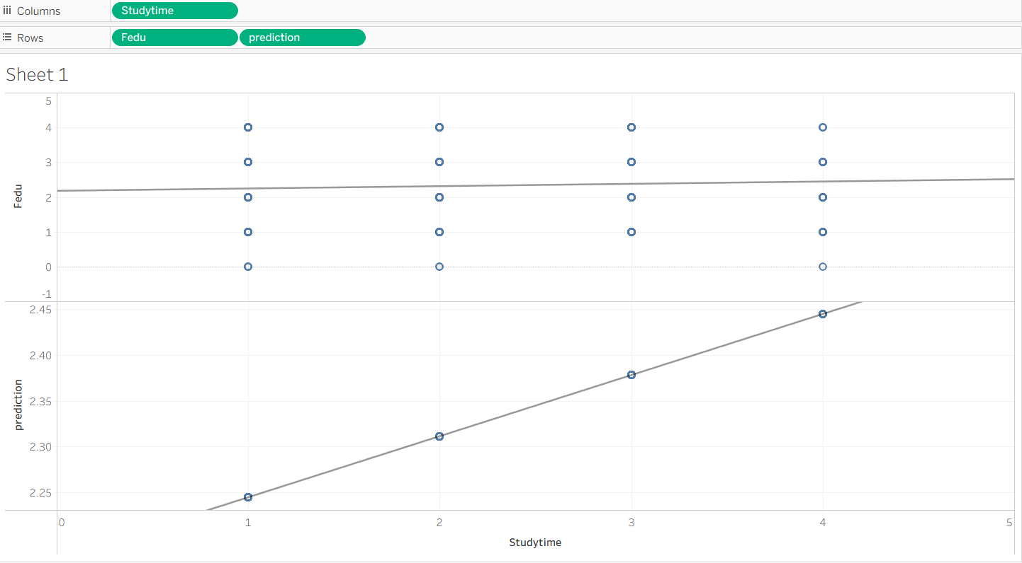

Predicted performance increased with studytime, while father’s education showed no meaningful influence, indicating that studytime is the stronger predictor of achievement in this dataset [28].

Maternal Education (Medu) and G1 Performance

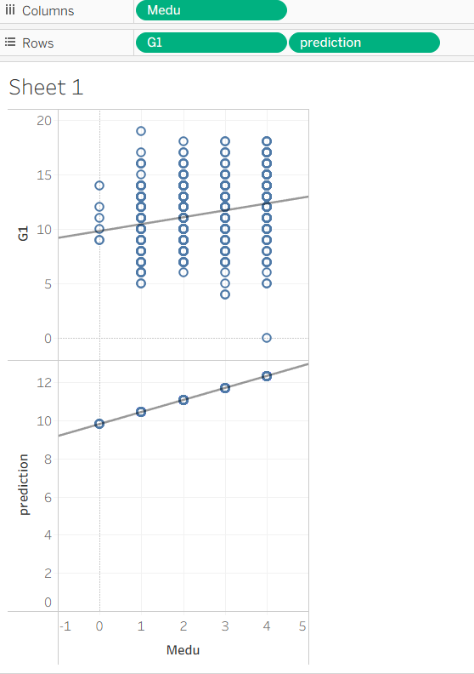

Maternal education showed a noticeably stronger effect on academic performance, with higher Medu levels consistently associated with higher actual and predicted G1 grades. The close alignment between predicted and real values indicates a reliable model fit. Overall, Medu appears to be a more influential and meaningful socio-demographic predictor of student achievement than father’s education [28].

Weekend Alcohol Use (Walc) and Final Grades (G3)

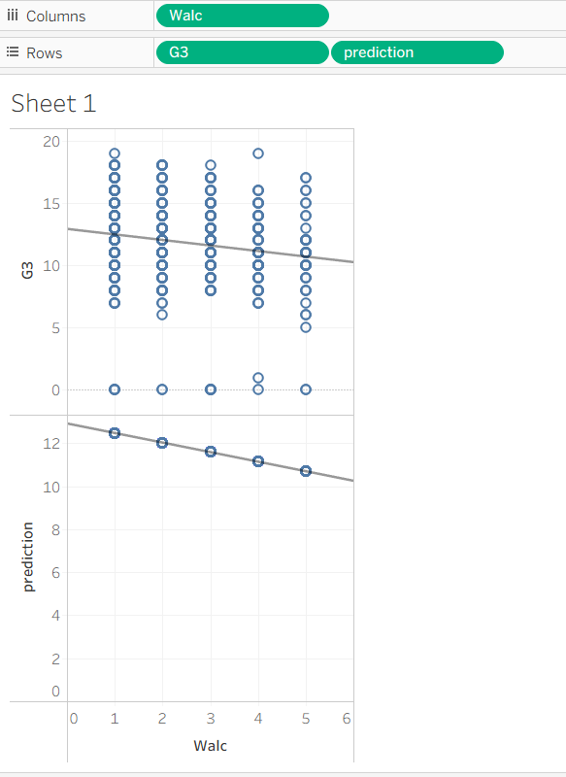

The relationship between weekend alcohol consumption (Walc) and performance showed a clear negative pattern, with both actual and predicted G3 grades declining as Walc increased. The prediction model closely followed this downward trend, confirming that higher weekend alcohol use is a meaningful behavioural risk factor linked to reduced academic achievement [28].

Absences and G2 Prediction Accuracy

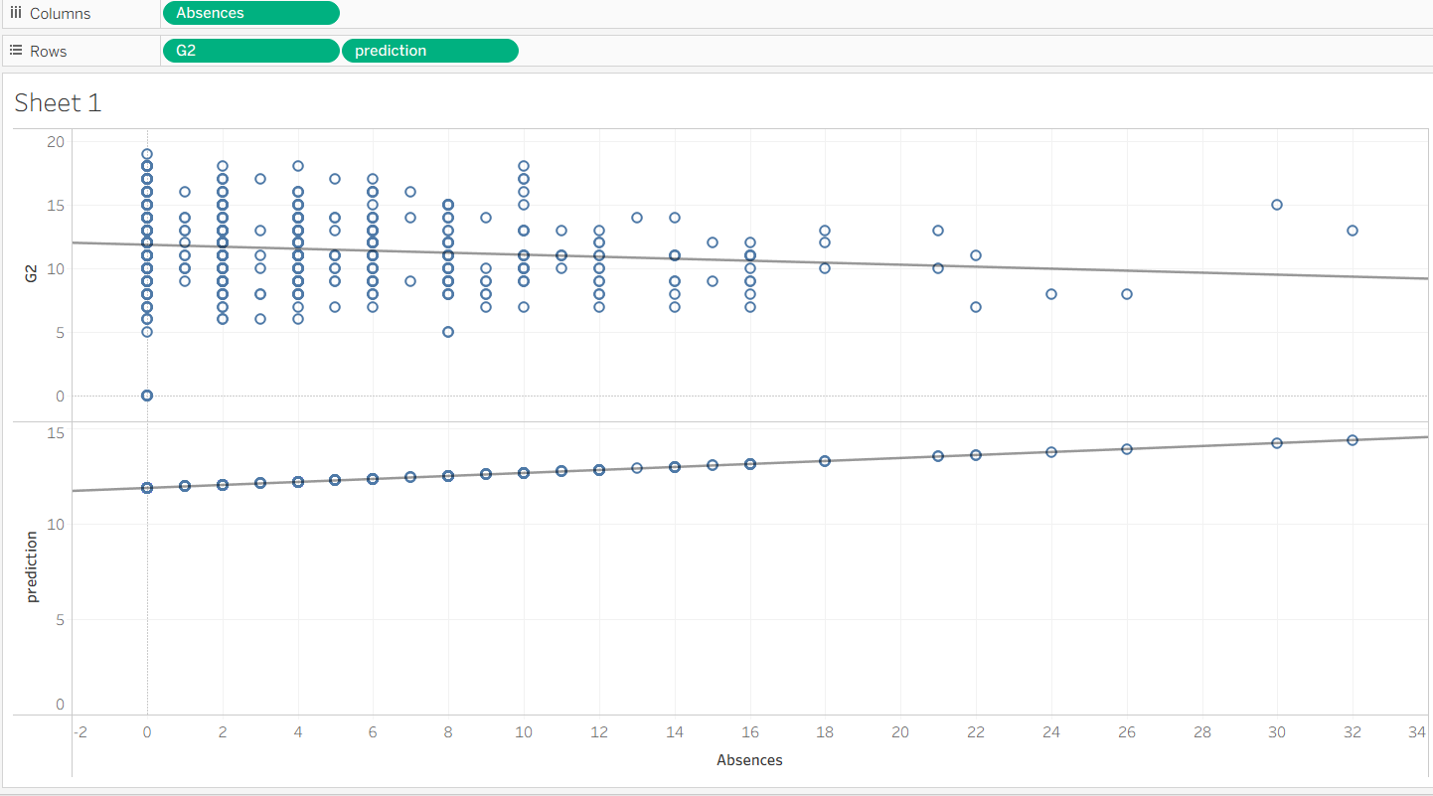

Absences demonstrated a clear linear relationship with academic performance, as higher absence levels were consistently associated with lower predicted G2 grades. The model closely mirrored this downward trend, indicating strong predictive reliability. Overall, attendance emerges as an important and interpretable indicator of student academic risk [28].

Prediction Results – student.mat Dataset

Daily Alcohol Use (Dalc) and Final Grades

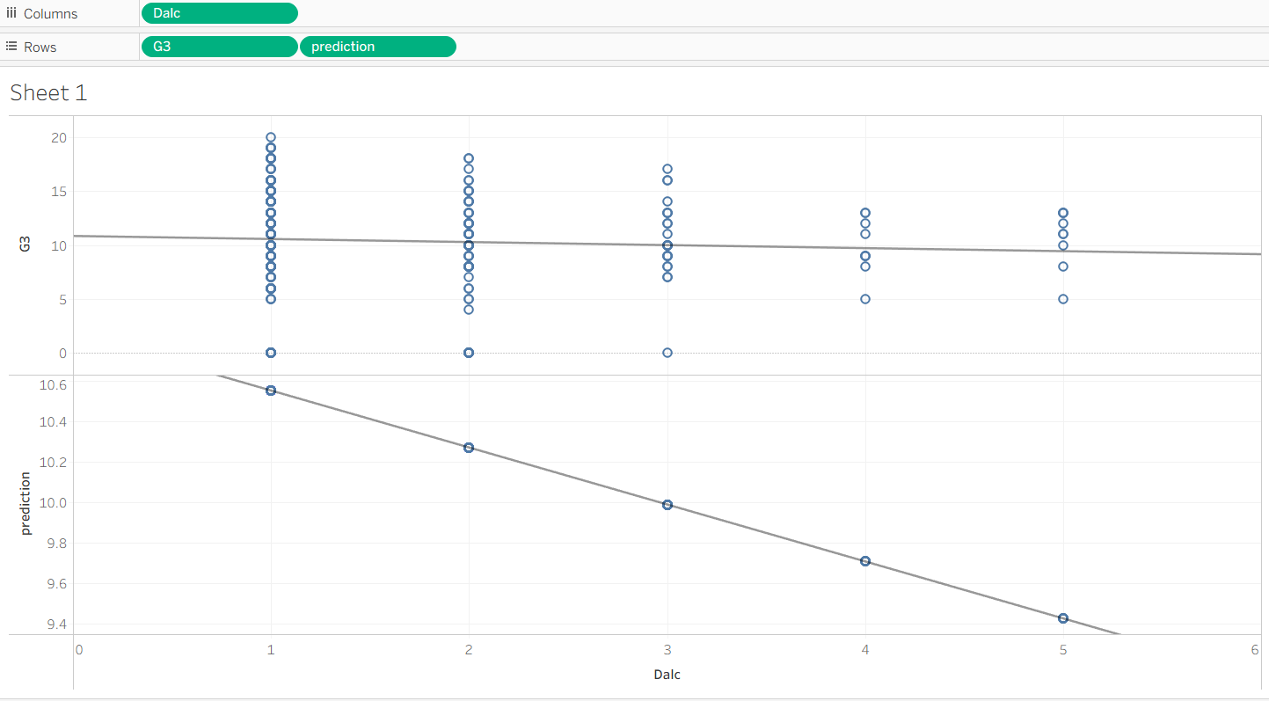

Daily alcohol consumption (Dalc) shows a clear negative relationship with final grades (G3), with both actual and predicted values declining as Dalc increases. The model reflects an even steeper decrease, highlighting its sensitivity and confirming Dalc as a key behavioural factor for identifying students at academic risk [28].

Family Relationship Quality (Famrel) and G1

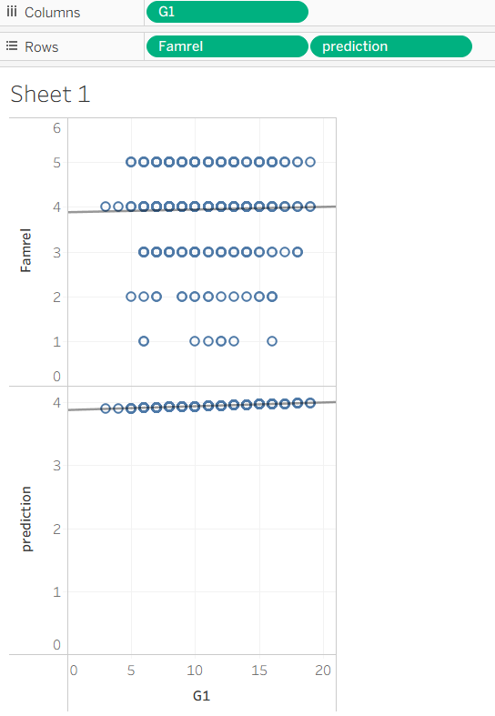

Family relationship quality (Famrel) shows a mild positive correlation with G1 grades, with predicted values reflecting a similar trend. While supportive family relationships may contribute to academic performance, their impact is smaller compared with factors such as studytime or alcohol consumption [28].

Failures and Prediction Misalignment

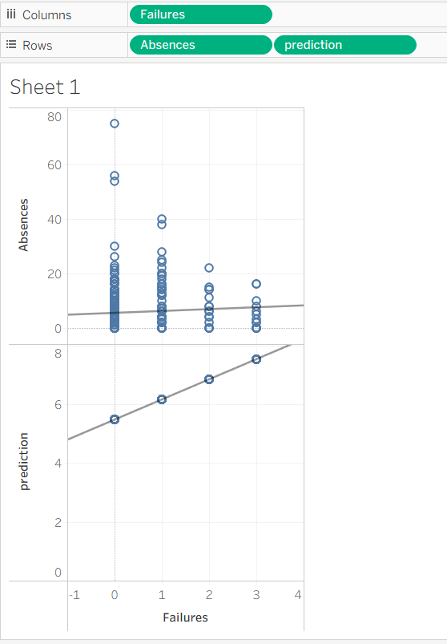

The analysis of academic failures revealed no consistent relationship with absences, and predicted grades unexpectedly increased as failures rose, indicating model miscalibration. This suggests that failure history was not effectively incorporated and highlights the need for improved handling of this variable in future modelling [28].

Social Activity (Goout) and G1

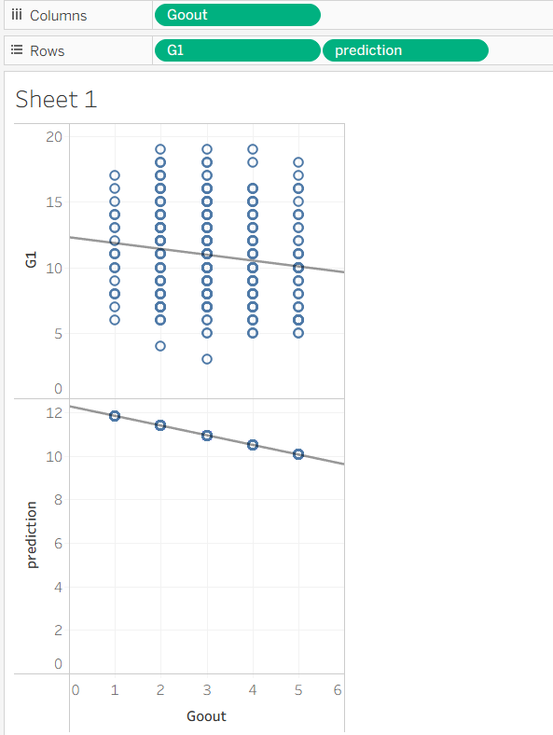

Increased social activity (Goout) is associated with a slight decrease in actual G1 grades, while predicted values show a steeper decline. This indicates that the model may overstate the negative impact of socialising, although the general downward trend in the data is consistent with reduced academic performance.

Studytime, Family Support, and G3

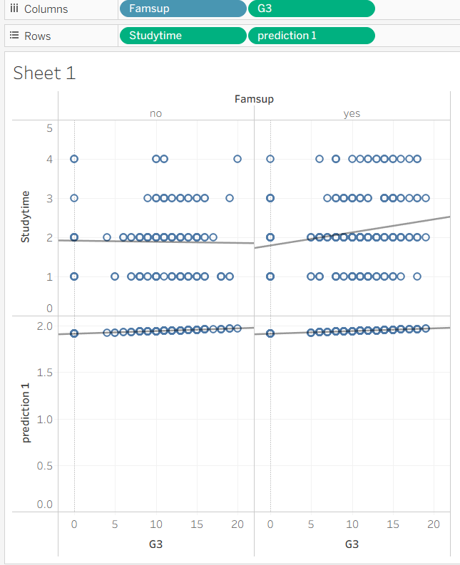

The combined analysis of studytime and family support indicates that higher studytime leads to significantly better G3 performance when family support is present, whereas the relationship is weaker and more variable without support. This suggests that studytime is most effective in the context of a supportive home environment [28].

Studytime Alone and Prediction Accuracy

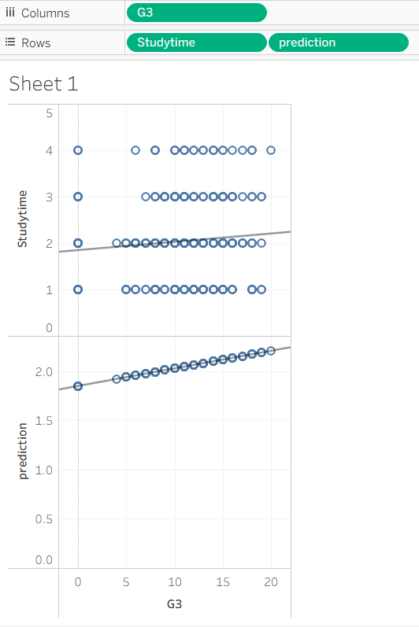

Studytime alone shows a generally positive impact on G3, though with variation.
Predicted values closely align with the real data, indicating a well-fitted model capturing studytime-dependent performance accurately.

Daily Alcohol Use and Absences

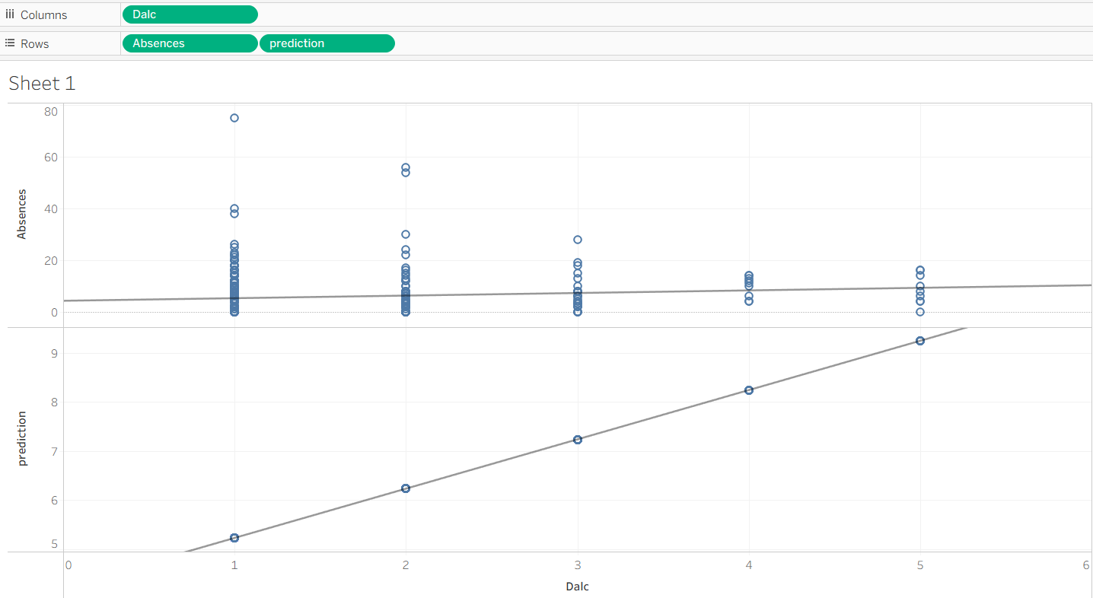

A slight positive correlation was observed between daily alcohol consumption (Dalc) and student absences, with higher Dalc generally associated with increased absenteeism. However, variability in the data indicates that other factors also play a role, making alcohol consumption one of several contributors to attendance patterns.

Prediction was appropriate for this analysis because the target outcomes (G1, G2, G3) were known and labelled, allowing a supervised approach to quantify the influence of each variable on student performance. Using Tableau for visualisation enabled clear observation of these patterns, supporting the interpretability and transparency of the results.
Clustering is an unsupervised method that groups data points by feature similarity without predefined outcomes [2]. In this study, it was used on both datasets to identify student groups with similar behavioural and academic profiles, revealing performance patterns and informing strategies for academic support, wellbeing, and enrichment programs.

Clustering – student.mat Dataset

Clusters Based on G3 and Predicted Outputs
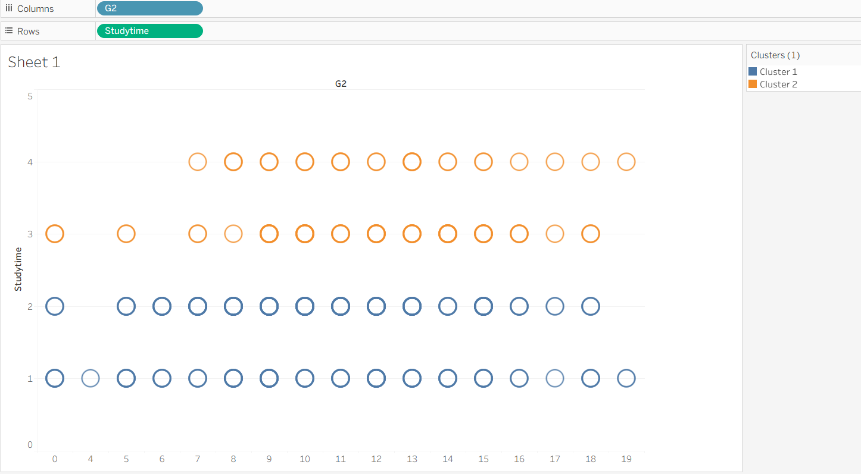

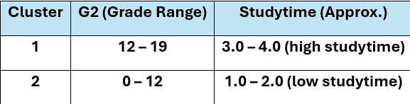

Clustering based on G3 and predicted outputs revealed clear alignment between actual and predicted performance, with low-performing students grouped and high-performing students forming a separate cluster. This demonstrates that the prediction model accurately reflects academic outcomes across performance levels.

Clusters Based on Health and Studytime

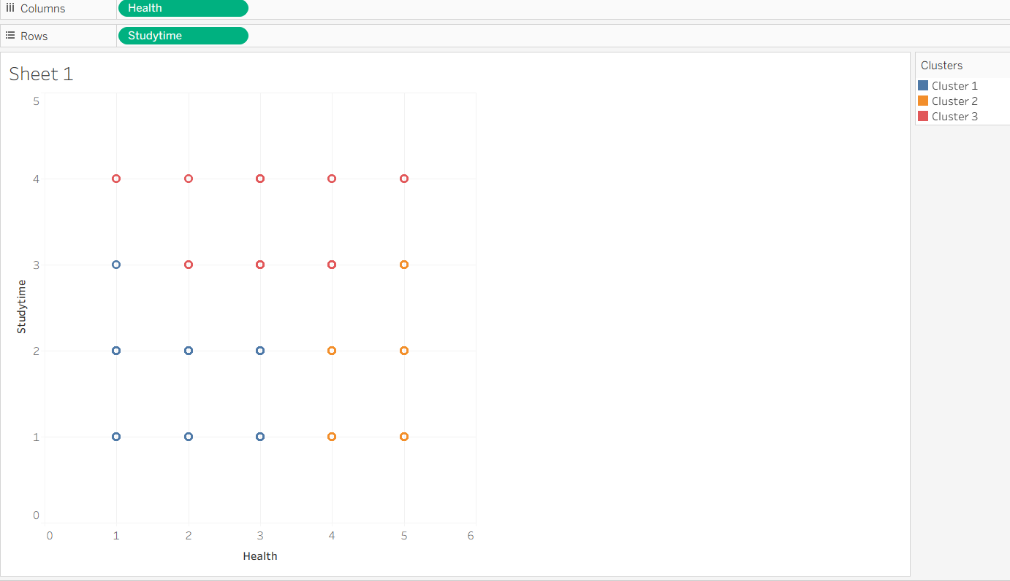

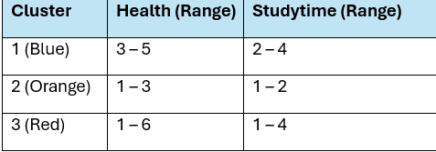

Three distinct clusters were identified based on health and studytime. Cluster 1 (Blue) included students with good health and high studytime, indicating stable academic performance. Cluster 2 (Orange) comprised students with lower health and studytime, highlighting those in need of support, while Cluster 3 (Red) displayed mixed health and studytime, reflecting diverse needs. These groupings offer valuable insights for tailoring wellbeing-focused academic interventions.

Student Performance Clusters Based on Weekend Alcohol Use and Final Grades

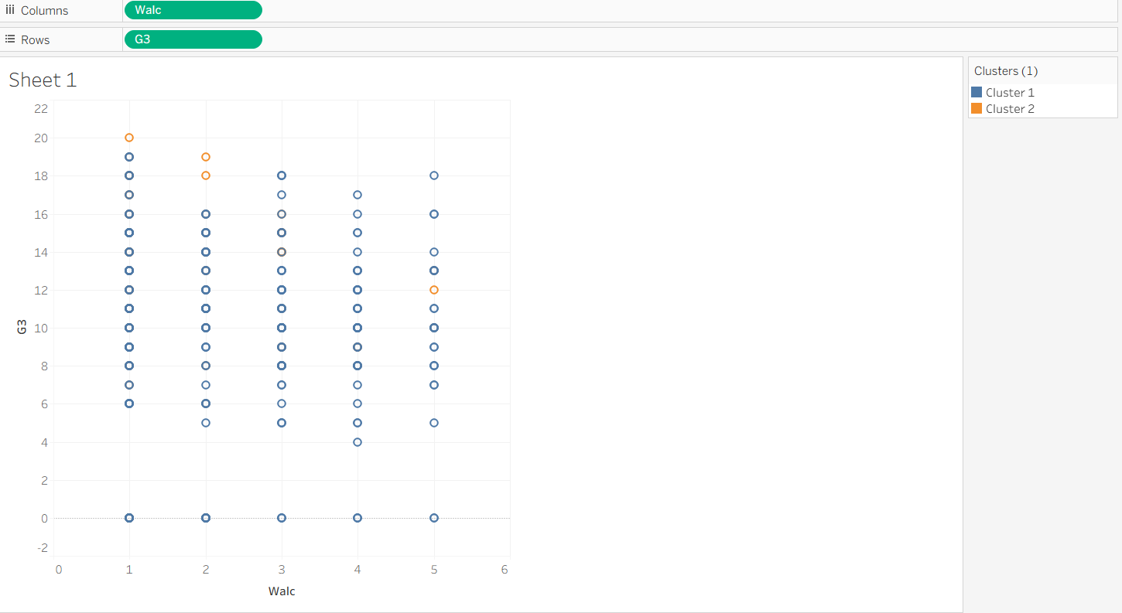

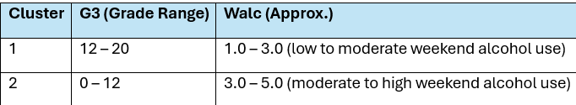

Clustering based on weekend alcohol consumption (Walc) and final grades (G3) revealed two clear groups: students with low-to-moderate Walc showed strong academic performance, while those with moderate-to-high Walc had weaker grades. This highlights the negative impact of weekend drinking on academic outcomes.

Clustering – student.por Dataset

Weekday Alcohol Use (Dalc) and Final Performance

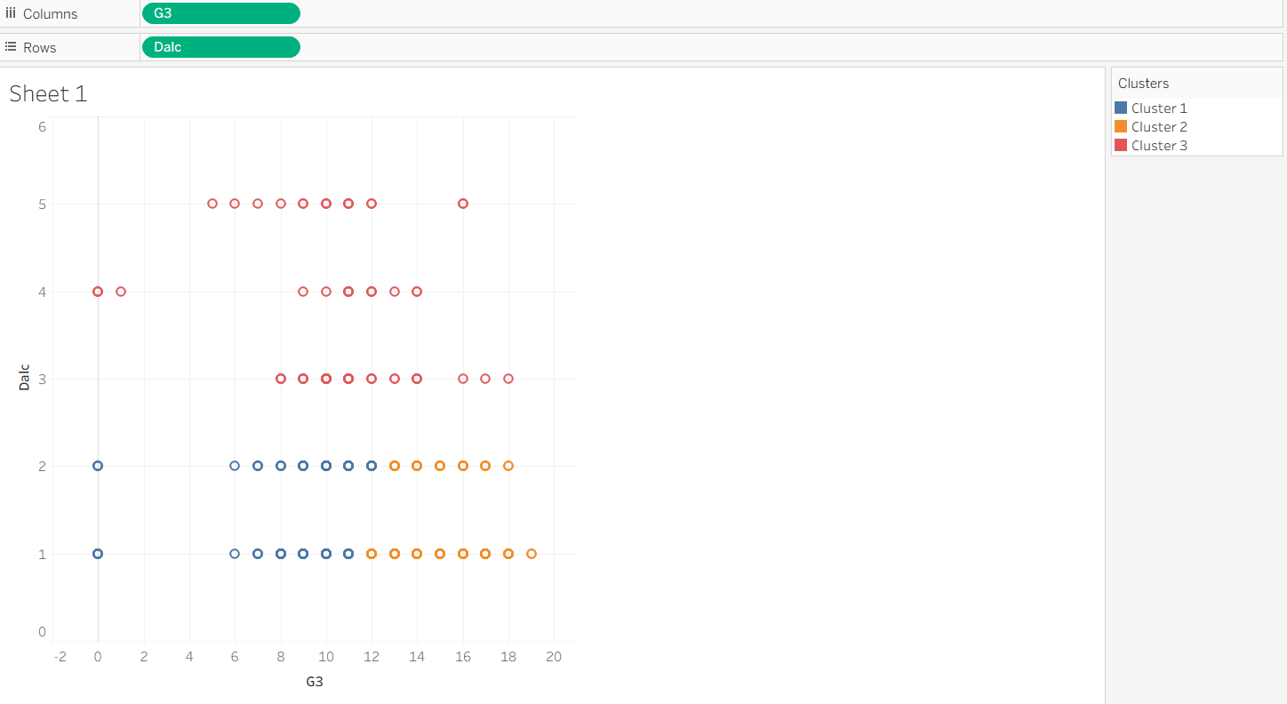

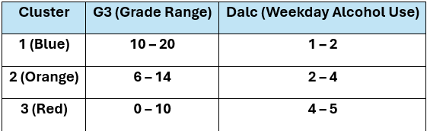

The clustering shows three student groups: high grades with low alcohol use, moderate performance with moderate use, and low grades with high alcohol use. These patterns support tailored wellbeing strategies, from enrichment to intervention.

Clustering was selected because it enables the identification of high-risk or distinctive behavioural groups without relying on predefined labels. This unsupervised approach complements prediction, which estimates individual outcomes, by revealing broader patterns and natural groupings that can inform tailored interventions [24], [25], [28].

Across both datasets, studytime positively influenced performance, while alcohol use negatively impacted it; family support, maternal education, and attendance also played roles. Clustering highlighted high-risk groups, and combined with prediction, these analyses, visualised in Tableau, provide clear, actionable insights for targeted academic and behavioural interventions.

1.5 Business recommendations
Analysis of the student.mat and student.por datasets provide actionable insights for schools. Studytime was identified as the most significant positive factor for academic performance, while weekday and weekend alcohol use were strongly linked to lower grades. Maternal education and family support also improved outcomes, and absenteeism remained a reliable indicator of academic risk. Clustering identified high-risk student groups with low studytime, poor attendance, higher alcohol use, and weaker performance [29], [34].
To address these factors, schools should promote effective study habits, improve attendance, and offer structured programs such as tutoring, mentoring, and homework monitoring. Early identification of at-risk students using predictive models enables timely interventions, including academic support, counselling, and parental engagement. Integrating predictive analysis with behavioural clustering provides a framework for evidence-based strategies that enhance student achievement, support wellbeing, and inform broader educational policies [29], [34].

1.6 Reflection
The analysis of the student.mat and student.por datasets using predictive modelling and clustering revealed key behavioural and academic factors affecting student performance. Studytime and maternal education were the strongest predictors of grades (G1, G2, G3), while Tableau visualisations improved interpretability. Clustering identified high-risk student groups, supporting targeted interventions. Combining supervised and unsupervised methods allowed both individual-level assessment and detection of broader patterns, with results accessible to non-technical stakeholders. Limitations included incomplete use of variables like prior failures, dataset specificity, and simplified categorical factors. Future work could incorporate socio-economic, psychological, and extracurricular variables, advanced machine learning techniques, and longitudinal tracking to enhance predictions and interventions. Overall, the study highlights the complementary value of prediction and clustering for improving student achievement.
Conclusion
The analyses show that commonly available student data can be leveraged to develop effective early-warning systems and to identify distinct student groups for targeted academic and well-being support. Key predictors, such as attendance, studytime, maternal education, and prior failures, consistently informed actionable insights across both Mathematics and Portuguese datasets. Implementing a phased approach, beginning with a pilot that combines weekly risk scoring with cluster-based interventions, ensures a balance between timely support and careful assessment. Through transparent reporting, ongoing evaluation, and fairness monitoring, this analytics framework can help schools optimise resource allocation, provide personalised support, and ultimately enhance student achievement and overall learning outcomes.

References
[1] E. B. Costa, B. Fonseca, M. A. Santana, F. F. de Araújo, and J. Rego, “Evaluating the effectiveness of educational data mining techniques for early prediction of students likely to fail,” Computers in Human Behavior, vol. 73, pp. 247–256, 2017.
[2] C. Clifton and Britannica Editors, “Data mining,” Encyclopaedia Britannica, Oct. 8, 2025. [Online]. Available: https://www.britannica.com/technology/data-mining?utm_source=chatgpt.com.
[3] A. Morris, “What is data mining? How it works, techniques & examples,” NetSuite, Jul. 9, 2021. [Online]. Available: https://www.netsuite.com/portal/resource/articles/data-warehouse/data-mining.shtml?utm
[4] SAS, “Data Mining: What It Is & Why It Matters.” [Online]. Available: https://www.sas.com/en_gb/insights/analytics/data-mining.html.
[5] M. Yağcı, “Educational data mining: prediction of students’ academic performance using machine learning algorithms,” Smart Learning Environments, vol. 9, art. 11, 2022.
[6] A. Khan and S. K. Ghosh, “Student performance analysis and prediction in classroom learning: A review of educational data mining studies,” Education and Information Technologies, vol. 26, no. 1, pp. 205–240, 2021.
[7] Amin, Noornajwa Md, et al. "The Development of Student Academic Performance Prediction System for UPTM using RepTree Algorithm."
[8] A. Ashraf, S. Anwer and M. G. Khan, “A Comparative Study of Predicting Student’s Performance by use of Data Mining Techniques,” ASRJETS Journal, vol. XX, 2023.
[9] Patel, Vinod Kumar, Mahesh Pawar, and Sachin Goyal. "Predicting Student‘s Performance Using Data Mining Techniques: A Survey From 2002 To 2020." network 27 (2020): 26.
[10] Ünal, Ferda. "Data Mining for Student." Data Mining: Methods, Applications and Systems (2021): 153.
[11] PP, Padilha Thereza, Gernel Lumacad, and Richard Catrambone. "Predicting student performance using feature selection algorithms for deep learning models." 2021 XVI Latin American Conference on Learning Technologies (LACLO). IEEE, 2021.
[12] Yağcı, Mustafa. "Educational data mining: prediction of students' academic performance using machine learning algorithms." Smart Learning Environments 9.1 (2022): 11.
[13] E. Kalita, S. S. Oyelere, S. Gaftandzhieva et al., “Educational data mining: A 10-year review,” Discover Computing, vol. 28, art. 81, 2025.
[14] C. Romero and S. Ventura, “Educational data mining and learning analytics: An updated survey,” arXiv preprint arXiv:2402.07956, 2024.
[15] R. Sharma, “CRISP-DM Explained: A Proven Data Mining Methodology,” Udacity Blog – Data Science, Mar. 13, 2025.
[16] J. Brzozowska et al., “Data engineering in CRISP-DM process production data – case study,” Applied Computer Science, vol. 19, no. 3, pp. 83–95, 2023.
[17] V. J. Patil, “A survey on missing data in machine learning,” Journal of Big Data, vol. 8, no. 26, 2021.
[18] F. F. Prado and L. A. Digiampietri, “A systematic review of automated feature engineering solutions in machine learning problems,” Proc. SBSI’20, Nov. 2020.
[19] S. A. K. M. Alhassan Mumuni and F. Mumuni, “Automated data processing and feature engineering for deep learning and big data applications: a survey,” arXiv:2403.11395, 2024.
[20] L. Paulsen and E. Lindsay, “Learning analytics dashboards are increasingly becoming about learning and not just analytics – a systematic review,” Education and Information Technologies, vol. 29, no. 11, pp. 14279–14308, 2024.
[21] SBG Systems, “Post-Processing Data (PPK): Definition,” SBG Systems Glossary, 2025.
[22] J. Han, M. Kamber, and J. Pei, Data Mining: Concepts and Techniques, 4th ed., Morgan Kaufmann, 2022.
[23] C. Aggarwal and C. Reddy, Data Clustering: Algorithms and Applications, 2nd ed., CRC Press, 2023.
[24] R. Romero and S. Ventura, “Educational Data Mining: A Review of the State of the Art,” IEEE Trans. Syst., Man, Cybern. C, vol. 40, no. 6, pp. 601–618, 2020.
[25] M. Kuhn and K. Johnson, Applied Predictive Modeling, Springer, 2021.
[26] A. Géron, Hands-On Machine Learning with Scikit-Learn, Keras & TensorFlow, 3rd ed., O’Reilly Media, 2023.
[27] D. Tempelaar, B. Rienties, and H. Nguyen, “Student profiling in learning analytics: The role of study behaviour and self-regulation,” Computers in Human Behavior, vol. 131, 2022.
[28] Utamachant, Piriya, Chutiporn Anutariya, and Suporn Pongnumkul. "i-Ntervene: applying an evidence-based learning analytics intervention to support computer programming instruction." Smart Learning Environments 10.1 (2023): 37.[29] U.S. Department of Education, Institute of Education Sciences, “Chronic Absenteeism,” Supporting Academic Learning and Development through Evidence-Based Practices.
[30] A. Delavande, E. Del Bono, A. Holford and K. Williams, “Timetables, Attendance and Academic Achievement in Higher Education,” IZA Discussion Paper No. 17979, July 2025.
[31] S. Büchele, "Evaluating the link between attendance and performance in higher education: The role of classroom engagement dimensions," Assessment & Evaluation in Higher Education, vol. 46, no. 1, pp. 132–150, 2021.
[32] E. M. Walck-Shannon, S. F. Rowell, and R. F. Frey, "To what extent do study habits relate to performance?," CBE, Life Sciences Education, vol. 20, no. 1, 2021.
[33] D. T. Marshall, "Student Attendance Patterns as Actionable Early Warning Indicators of High School Graduation Outcomes: Findings from an Urban Alternative Charter School," Urban Science, vol. 8, no. 3, 2024, pp. 78.
[34] Sones, James A. "Understanding Change Factors in Missouri Secondary Social Studies Curriculum for Anticipating Future Trends, Challenges, and Opportunities." (2024).

