Student Number: 1300078
Student name: Ryan Maynard
Module: Living Well: A Life-course Approach to Health and Wellbeing (BMNS4014)
Assignment: Research Report
Module lecturer: Dr Ben Duxberry
Submission date: 01/05/2026
Word count: 1595

The life course approach to health and wellbeing: A critical analysis.

Abstract
This report critically examines the life course approach to health and wellbeing, focusing on how biological, social and economic and environmental determinants shape health outcomes across the lifespan. Drawing on theoretical models like the critical period, which highlights how certain times in someone’s life can have a greater effect on how someone’s life trajectory will continue. The analysis in this report will demonstrate how factors such as poverty, education, employment and housing all interact to influence health trajectories from preconception to older age and beyond.
This report evaluates the appropriateness and effectiveness of life course interventions across different stages including early years, school-based initiatives, workplace policies and interventions that target the older population. Whilst evidence suggests that early intervention and prevention strategies can yield significant long-term benefits, many current studies emphasise that individual behaviours can change rather than structured determinants.

Contents
- Title page 1
- Abstract 2
- Contents 3
- Introduction 4
- Biological factors 5
- Social and economic factors 7
- Environmental factors 9
- Conclusions 10
- Appendices 11
- Reference list 12

Introduction
The life course approach provides a framework for understanding how health and wellbeing are shaped by a combination of biological, social, economic and environmental factors across an individual’s lifespan (Public Health England, 2019). Rather than viewing health outcomes as isolated events, this perspective emphasises trajectories, transitions and increased exposure from preconception through to old age and even post death influences.
World Health Organisation (2025) states “A life course approach includes a good start to life, optimal development (of infants, children, adolescents and youth), adult health and well-being, healthy ageing and a dignified death at any age.”
The approach outlines the importance of using a holistic approach when analysing an individual’s health and wellbeing status (Piccarreta and Studer, 2019).
The life course approach differs from other health models as it is it a model that is a longitudinal study, meaning that it measures someone’s health over the timespan of their life rather than at single life events (Haas, Oi and Zhou, 2017).
This report critically examines how social, economic and environmental determinants influence health across the life course, evaluates the effectiveness of key interventions and offers recommendations for future development in research, policy and practice.

Biological factors
Biological factors in the life course approach refer to the physiological and genetic processes that influence health and development from an early age through to old age (Kuh et al., 2014).
At the earliest stage of the life course approach, genetics and epigenetics play a key role, as what they inherit genetically from their parents can influence their health. This is why the life course approach often looks at pre-conception as the starting point of the model due to the parent’s health playing a factor. Prenatal and early childhood development are especially critical. Maternal health, nutrition, stress levels and exposure to harmful substances (e.g., smoking and alcohol) can affect foetal growth and organ development (Mishra, Cooper and Kuh, 2010). Low birth weight, for example, is associated with increased risk of chronic diseases in adulthood, supporting how critical this period is.
Across childhood and adolescence, growth, hormonal changes and brain development influence both physical and mental health (Tomlinson et al., 2021). Adolescence is seen as the second largest change in rapidity of growth, only second to foetal and can carry some of the largest biological changes, such as puberty (Viner et al., 2015).
In adulthood, biological ageing and physiological wear and tear, reflect the cumulative impact of chronic stress and adverse conditions on the body’s systems These can often lead to higher amounts of comorbidities and mental health issues being present later in life (Liu et al., 2023). Degenerative processes become more prominent, including reduced mobility, cognitive decline and increased susceptibility to illness (Papa and Scherer, 2023).
Due to the United Kingdom having an ageing population, this has produced a strain on healthcare systems due to the population of the United Kingdom needing more healthcare services to manage the higher number of ailments they have (McKee et al., 2021). With 18.6% of the total population aged 65 and over, this figure has increased from the previous intake of statistics, proving that the population is ageing and the strains that brings on society and public services being increasingly prevalent (ONS, 2022).
All these factors are evidence on how maintaining a positive balance between physical and mental health can influence someone’s trajectory across their own life course. Making good use of the services available whether it be accessing help through the healthcare system (e.g., GP surgery, midwife, Accident and Emergency Services) or seeking support from your local community and social circle who can offer their help.
Crucially, biological factors do not function by themselves, they interact continuously with social and economic factors, shaping the trajectory of someone’s health over time.

Social and economic factors
In the life course approach, social and economic factors are the central determinants of health because they shape the conditions in which people are born, grow, live, work and age. These factors influence opportunities, exposure and behaviours across the lifespan, often creating patterned inequalities in health outcomes (Carpentieri, Carter and Jeppesen, 2023).
Social factors relate to the relationships, structures, and cultural contexts that influence an individual’s life, such as family environment and early year relationships. Early attachment, parenting quality, and exposure to adversity (e.g., neglect or conflict, also knows as Adverse Childhood Experiences or ACEs) can affect emotional development, stress responses, and long -term mental and physical health (Stannard et al., 2023).
Educational achievement strongly influences life chances. It affects health literacy, employment opportunities, and the ability to make informed health decisions (Jackson, 2010). Poor educational outcomes are linked to worse health across the life course (Han and Zhou, 2026).
Strong social connections can protect against stress, improve mental wellbeing, and even reduce mortality risk (Kelly-Irving and Vineis, 2019). Opposingly, social isolation (especially in older adults) is associated with poorer health outcomes (Umberson, Lin and Cha, 2022).
Social norms around diet, physical activity, substance use, and help-seeking behaviours shape health behaviours over time (Umberson, Crosnoe and Reczek, 2010).
Experiences of racism, stigma or marginalisation can lead to chronic stress and reduced access to opportunities, contributing to health inequalities (Siersbaek et al., 2023).
Economic factors determine access to material resources necessary for health, such as a person’s income and poverty levels. Income affects the ability to afford nutritious food, safe housing, healthcare and other essentials (Corna, 2013) Whereas persistent poverty is linked to worse health outcomes and shorter life expectancy (Mikkelsen et al., 2019).
Employment and working conditions can be crucial to a person’s wellbeing during the adulthood period of the life course. Factors such as job security, wages and working environments influence both physical and mental health (Di Gessa et al., 2016). Studies then show that hazardous or unsafe work increases stress and risk of illness (Balogh et al., 2024). Housing issues such as poor-quality and overcrowded housing is associated with respiratory illness, accidents and mental health problems (Marsh et al., 2000).
Economic disadvantage can limit access to healthcare, education, transport, and social services, particularly over time. Wealth inequality, not just poverty, but the gap between rich and poor, has been shown to affect population health through social cohesion and stress pathways (Oris, Baeriswyl and Ihle, 2021).
Socioeconomic factors in the life course approach include education. Family environment, social support, income, employment and living conditions. Together they shape health trajectories over time by influencing both opportunities and risks at different stages of life. These factors coincide with environmental factors that someone experiences across the life course.

Environmental factors
In the life course approach, environmental factors refer to the physical surroundings in which people live and how these conditions influence health and wellbeing overtime. These factors operate from before birth through to old age and interact with social and economic conditions to long-term health trajectories.
Housing and living conditions that highlight the quality, safety and stability of housing are fundamental to someone’s health and wellbeing (Calloo et al., 2026). Damp, mould and poor ventilation are linked to respiratory diseases. Overcrowding in housing can increase the risk of infections and stress. Additionally, unsafe housing raises the likelihood of injuries (Leicestershire & Rutland Statistics & Research, 2016).
Assessing someone’s neighbourhood and built environment, i.e. the wider environment influences daily life and behaviour. Something often taken for granted is access to open green spaces, this encourages physical activity and support with mental wellbeing (Jivraj et al., 2024). In certain areas, the availability of safe walking routes recreational facilities affect activity levels. Also, high crime numbers in areas can lead to chronic stress and reduced outdoor activity, which directly links to the socio-economic factor of social isolation (Klose and Gordon, 2022).
Environmental pollution and exposure to harmful substances have both immediate and long-term effects. Air pollution is linked to asthma, cardiovascular disease and reduced life expectancy (Baranyi et al., 2025). Water and soil contamination can lead to infections and chronic illnesses (Campbell et al., 2014).
Environmental factors in the life course approach include housing quality, neighbourhood conditions, pollution, climate and workplace environments. These factors shape health across the lifespan, particularly when exposes occur during sensitive life events and periods.

Conclusion
Recommendations for the life course approach should focus on strengthening prevention, reducing inequalities, and ensuring that health and wellbeing is supported at every stage of life. By prioritising intervention in the early years, it highlights the critical period model. To tackle social and economic inequalities, addressing the root cause of the problem is crucial to report the accumulation of disadvantage over time. Providing universal services, but focusing on those most in need, will help reduce the social gradient in health. Strengthening cross-sector collaboration shows that health is not just influenced by healthcare but multiple sectors that reflect the connected nature of the determinants of health. Creating healthier physical environments for all the population with reduce long-term exposure risks accumulate and affect across the life course. Shifting the focus from treatment to prevention will reduce long-term strains on the healthcare system, thus promoting healthy ageing and recognising that the life course approach continues into later life, not just highlighting the early years.
The life course approach offers a powerful framework for understanding how health inequalities develop and persist. Biological, social, economic and environmental factors interact dynamically across the lifespan, shaping health trajectories in profound ways. While interventions at different stages can be effective, their impact is often limited by insufficient attention to structural determinants.
Future progress depends on long-term integrated, and equality-focused strategies that address the root cause of health inequalities. By embedding life course principles into policy and practice, there is significant potential to improve population health and reduce inequalities across generations.

Appendices

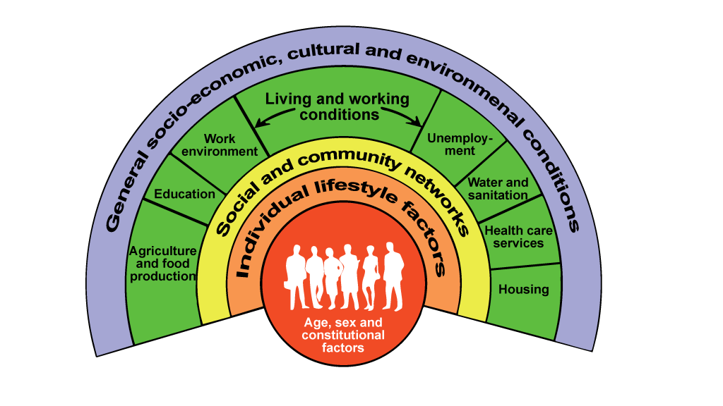
Social determinants of health, Dahlgren and Whitehead, 1991

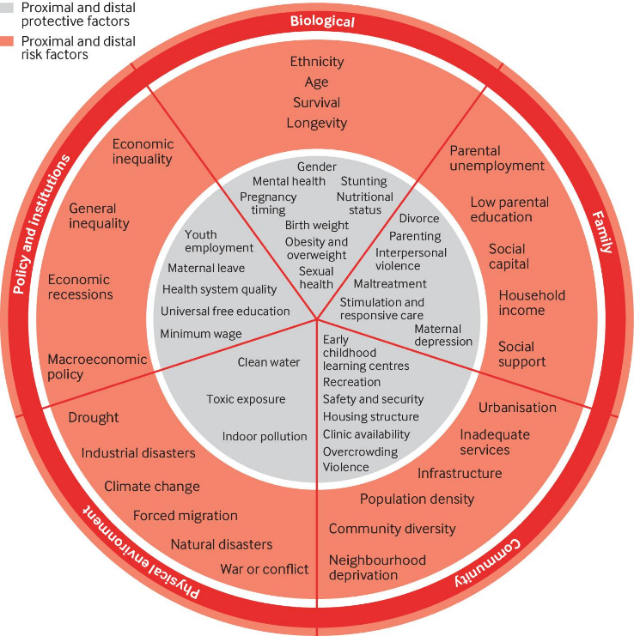

Proximal and distal risk factors in a life course ecological approach (Tomlinson et al., 2022)

Reference list
Leicester-Shire & Rutland Statistics & Research (2016). Inadequate Housing. [online] www.lsr-online.org. Available at: https://www.lsr-online.org/inadequate-housing.
and, A. (2025). Framework to implement a life course approach in practice. [online] Who.int. World Health Organization. Available at: https://www.who.int/publications/i/item/9789240112575.
Balogh, R., Gadeyne, S., Christophe Vanroelen and Warhurst, C. (2024). Multidimensional employment trajectories and dynamic links with mental health: Evidence from the UK Household Longitudinal Study. Scandinavian Journal of Work Environment & Health. doi:https://doi.org/10.5271/sjweh.4193.
Baranyi, G., Harron, K., Shen, Y., de Hoogh, K. and Fitzsimons, E. (2025). The relationship between early life course air pollution exposure and general health in adolescence in the United Kingdom. Scientific Reports, [online] 15(1). doi:https://doi.org/10.1038/s41598-025-94107-w.
Calloo, G.V., Odei Boateng, M., Agbe, E.A. and Boateng, G.O. (2026). Shelter to Survival: Unpacking the Health Impacts of Housing Insecurity Across the Life Course. International Journal of Environmental Research and Public Health, 23(1), p.91. doi:https://doi.org/10.3390/ijerph23010091.
Campbell, O.M.R., Benova, L., Gon, G., Afsana, K. and Cumming, O. (2014). Getting the basic rights - the role of water, sanitation and hygiene in maternal and reproductive health: a conceptual framework. Tropical Medicine & International Health, 20(3), pp.252–267. doi:https://doi.org/10.1111/tmi.12439.
Carpentieri, J., Carter, L. and Jeppesen, C. (2023). Between life course research and social history: new approaches to qualitative data in the British birth cohort studies. International Journal of Social Research Methodology, 27(5), pp.1–28. doi:https://doi.org/10.1080/13645579.2023.2218234.
Corna, L.M. (2013). A life course perspective on socioeconomic inequalities in health: A critical review of conceptual frameworks. Advances in Life Course Research, 18(2), pp.150–159. doi:https://doi.org/10.1016/j.alcr.2013.01.002.
Di Gessa, G., Corna, L.M., Platts, L.G., Worts, D., McDonough, P., Sacker, A., Price, D. and Glaser, K. (2016). Is being in paid work beyond state pension age beneficial for health? Evidence from England using a life-course approach. Journal of Epidemiology and Community Health, 71(5), pp.431–438. doi:https://doi.org/10.1136/jech-2016-208086.
Haas, S.A., Oi, K. and Zhou, Z. (2017). The Life Course, Cohort Dynamics, and International Differences in Aging Trajectories. Demography, 54(6), pp.2043–2071. doi:https://doi.org/10.1007/s13524-017-0624-9.
Han, C. and Zhou, N. (2026). Life-Course Neighborhood Contexts, Social Engagement, and Cognitive Health in Later Adulthood. Social Science & Medicine, [online] 398, p.119103. doi:https://doi.org/10.1016/j.socscimed.2026.119103.
Jackson, M.I. (2010). A Life Course Perspective on Child Health, Cognition and Occupational Skill Qualifications in Adulthood: Evidence from a British Cohort. Social Forces, [online] 89(1), pp.89–116. doi:https://doi.org/10.1353/sof.2010.0101.
Jivraj, S., Nicholas, O., Murray, E.T. and Norman, P. (2024). Life Course Neighbourhood Deprivation and Self-Rated Health: Does It Matter Where You Lived in Adolescence and Do Neighbourhood Effects Build Up over Life? [online] Nih.gov. Available at: https://pmc.ncbi.nlm.nih.gov/articles/PMC8508077/ [Accessed 1 May 2026].
Kelly-Irving, M. and Vineis, P. (2019). Life-course approach: from socioeconomic determinants to biological embodiment. [online] PubMed. Available at: https://www.ncbi.nlm.nih.gov/books/NBK566177/ [Accessed 11 May 2023].
Klose, H. and Gordon, F. (2022). Public health approaches to youth involvement in violence: Examining stakeholders’ perspectives in Australia and the United Kingdom. Journal of Criminology, 56(1), p.263380762211353. doi:https://doi.org/10.1177/26338076221135340.
Kuh, D., Karunananthan, S., Bergman, H. and Cooper, R. (2014). A life-course approach to healthy ageing: maintaining physical capability. Proceedings of the Nutrition Society, [online] 73(2), pp.237–248. doi:https://doi.org/10.1017/s0029665113003923.
Liu, Y., Hatch, S.L., Praveetha Patalay, Schott, J.M. and Richards, M. (2023). A lifecourse approach in examining the association between accumulation of adversity and mental health in older adulthood. Journal of Affective Disorders, 339, pp.211–218. doi:https://doi.org/10.1016/j.jad.2023.07.001.
Marsh, A., Gordon, D., Heslop, P. and Pantazis, C. (2000). Housing Deprivation and Health: A Longitudinal Analysis. Housing Studies, 15(3), pp.411–428. doi:https://doi.org/10.1080/02673030050009258.
McKee, M., Dunnell, K., Anderson, M., Brayne, C., Charlesworth, A., Johnston-Webber, C., Knapp, M., McGuire, A., Newton, J.N., Taylor, D. and Watt, R.G. (2021). The changing health needs of the UK population. The Lancet, 397(10288), pp.1979–1991.
Mikkelsen, B., Williams, J., Rakovac, I., Wickramasinghe, K., Hennis, A., Shin, H.-R., Farmer, M., Weber, M., Berdzuli, N., Borges, C., Huber, M. and Breda, J. (2019). Life course approach to prevention and control of non-communicable diseases. BMJ, [online] 364, p.l257. doi:https://doi.org/10.1136/bmj.l257.
Mishra, G.D., Cooper, R. and Kuh, D. (2010). A life course approach to reproductive health: Theory and methods. Maturitas, 65(2), pp.92–97. doi:https://doi.org/10.1016/j.maturitas.2009.12.009.
ONS (2022). Voices of our ageing population - Office for National Statistics. [online] www.ons.gov.uk. Available at: https://www.ons.gov.uk/peoplepopulationandcommunity/birthsdeathsandmarriages/ageing/articles/voicesofourageingpopulation/livinglongerlives.
Oris, M., Baeriswyl, M. and Ihle, A. (2021). The Life Course Construction of Inequalities in Health and Wealth in Old Age. International handbooks of quality-of-life, pp.97–109. doi:https://doi.org/10.1007/978-3-030-58031-5_5.
Papa, R. and Scherer, S. (2023). Routes to healthy ageing: the role of lifecourse patterns. Ageing & Society, [online] pp.1–28. doi:https://doi.org/10.1017/S0144686X23000521.
Piccarreta, R. and Studer, M. (2019). Holistic analysis of the life course: Methodological challenges and new perspectives. Advances in Life Course Research, 41, p.100251. doi:https://doi.org/10.1016/j.alcr.2018.10.004.
Public Health England (2019). Health matters: Prevention - a Life Course Approach. [online] GOV.UK. Available at: https://www.gov.uk/government/publications/health-matters-life-course-approach-to-prevention/health-matters-prevention-a-life-course-approach.
Siersbaek, R., O’Donnell, C., Parker, S., Ford, J., Burke, S. and Ní Cheallaigh, C. (2023). Social exclusion and its impact on health over the life course: A realist review protocol. HRB Open Research, 6, pp.34–34. doi:https://doi.org/10.12688/hrbopenres.13746.2.
Stannard, S., Berrington, A., Shantini Paranjothy, Owen, R., Fraser, S., Hoyle, R.B., Boniface, M., Wilkinson, B., Akbari, A., Batchelor, S., W. Schuyler Jones, Ashworth, M., Welch, J., Mair, F.S. and Alwan, N.A. (2023). A conceptual framework for characterising lifecourse determinants of multiple long-term condition multimorbidity. Journal of multimorbidity and comorbidity, 13. doi:https://doi.org/10.1177/26335565231193951.
Tomlinson, M., Hunt, X., Daelmans, B., Rollins, N., Ross, D. and Oberklaid, F. (2021). Optimising child and adolescent health and development through an integrated ecological life course approach. BMJ, (372), p.m4784. doi:https://doi.org/10.1136/bmj.m4784.
Umberson, D., Crosnoe, R. and Reczek, C. (2010). Social Relationships and Health Behavior Across the Life Course. Annual Review of Sociology, 36(1), pp.139–157. doi:https://doi.org/10.1146/annurev-soc-070308-120011.
Umberson, D., Lin, Z. and Cha, H. (2022). Gender and Social Isolation across the Life Course. Journal of Health and Social Behavior, 63(3), pp.319–335. doi:https://doi.org/10.1177/00221465221109634.
Viner, R.M., Ross, D., Hardy, R., Kuh, D., Power, C., Johnson, A., Wellings, K., McCambridge, J., Cole, T.J., Kelly, Y. and Batty, G.D. (2015). Life course epidemiology: recognising the importance of adolescence. Journal of Epidemiology and Community Health, [online] 69(8), pp.719–720. doi:https://doi.org/10.1136/jech-2014-205300.

