Student name: Lewis Parry
P Number: 2206670
Program of study: product and furniture design
Module: ADAD4018 Ways of Thinking

Tasks in the order I received them: Task One: Manifesto - 489
Task Two: Semiotic Analysis Manifesto - 523
Task Three: Practice-based writing - 498

Task One: Manifesto
- Nothing is truly original.
- Inspiration comes from unseen things.
- Beauty is created from pain, like joy is created from sadness.
- Failure creates the foundation for success.
- Discipline and hard work will out way un- nurtured natural talent.
- Being right sometimes mean you’ll be wrong to everyone else.
- patience and consistency will outlast instant and quick.
- Time and tide wait for no man.

Nothing is truly original.
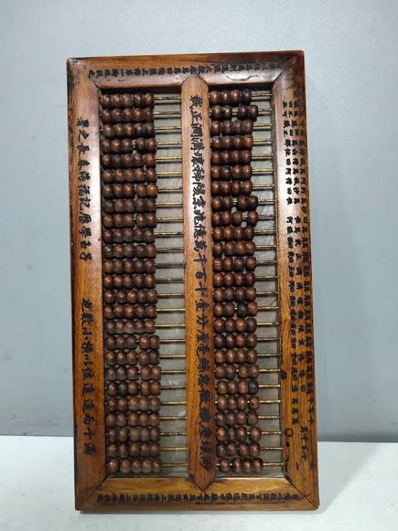
(Fig 1 - An abacus)
This comes from a designer who wants to be original as it is a mark of a creative genius. However, products and furnishings are always inspired by something. Whether it is a desire to make something better or trying to create something new. For example, computers came about in “1822” (Luoma, G, 2022) as a way of doing mathematical calculations quicker and with less mistakes than human beings. Before that a “basic calculator was invented in 1812” (Gregersen. E. 2022). Then before that “the abacuses was invented 2700 to 2300 B.C.E.”(Helper .R. 2021) if you go far enough back, we probably used to count with stones and sticks. It was a need to keep track of a calculation that’s why someone created the abacuses. which led to the calculator, which lead to the computer, which lead to the modern-day mobile phone/laptop. Good design comes from using what we know and taking components/inspiration from it.

Beauty is created from pain, like joy is created from sadness.

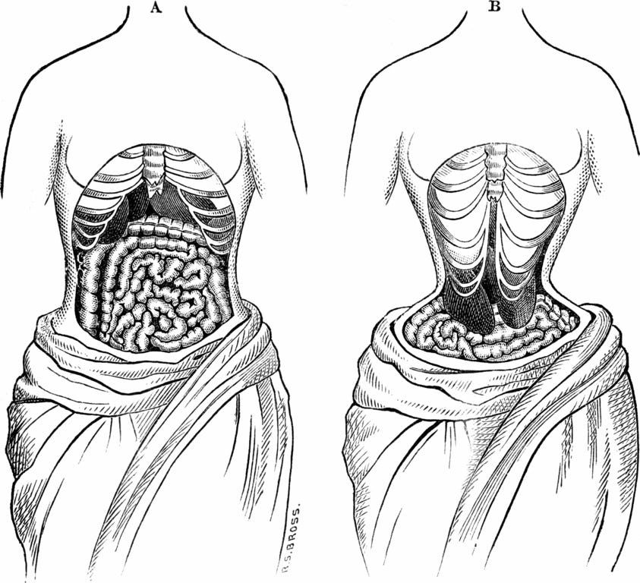
(Fig 2 – corset damage over time)
This has two meanings to me. A real-world meaning and a philosophical interpretation. The original phrase of beauty is created from pain. Comes from the French saying “Il faut souffrir pour être belle.”(Barreau, H. 2004)which translates to “you must suffer to be beautiful”. It comes from the start of French fashion world, when the corset was coming into fashion between “1500s and 1600s” (Lane. L. 2021). It would be hard/painful to put on a corset. So much so that often people passed out as they were tied in so tight. “They would often suffer major internal damage from extensive use” (Isaac. S. 2017).
The other meaning is more philosophical. The French philosopher Louis Lavelle, philosophize there is “no light without dark”, “there is no joy without sadness” and “there is no beauty without pain.” (Barreau, H. 2004) What these remarks are saying is one cannot exist without the other. Would you be about to experience joy without sadness. As if you would be joyful all the time you would not know what joy is. It is sadness which creates the moments of joy. Life would be truly boring without this constant battle of emotions.

Time and tide wait for no man.

(Fig 3 – Time & Tide)
“The original proverb is recorded as early as 1225,” (Time waits for no man, 2022) and is “reputedly a quote from Saint Mahrer” (Time waits for no man, 2022). It’s meaning is a story of time, in that there are only two constants in the world. Time will always move forward and the tide will always come in and out. It’s the two things man cannot control or buy. We are merely gests in their world.
It also talks about the importance of trying stuff and getting up and doing the thing you want to do. But also, the importance of spending time with the people you love. As like you they will pass and the cycle will still go on, time will still move forward and tide will keep coming in and out.

Bibliography
Cullinane, K. (2013) The Original Paradox. Available at: https://designobserver.com/feature/the-original-paradox/37733/
Luoma, G. (2022) 10 Reasons Why the Computer Was Invented. Available at: https://zipitclean.com/invention-news/why-was-the-computer-invented/#:~:text=Why%20was%20the%20computer%20invented,%E2%80%9Cfather%E2%80%9D%20of%20the%20computer.
Gregersen, E. (2022) Charles Babbage British inventor and mathematician. Available at: https://www.britannica.com/biography/Charles-Babbage
Helper .R. (2021) What is Abacus? Available at: https://study.com/learn/lesson/abacus-invention-history-architecture.html#:~:text=The%20invention%20of%20the%20Abacus,Japanese%20soroban
Lane. L. (2021) The Changing Silhouette of Victorian Women’s Fashions – The History of the Corset. Available at: https://www.eriehistory.org/blog/the-changing-silhouette-of-victorian-womens-fashions-the-history-of-the-corset#:~:text=During%20the%201500s%20and%201600s,of%20the%20skirts%20and%20chest.
Isaac. S. (2017) The dangers of tight lacing: the effects of the corset. Available at: https://www.rcseng.ac.uk/library-and-publications/library/blog/effects-of-the-corset/#:~:text=Women%20were%20often%20laced%20so,the%20rib%20cage%20becoming%20deformed.
Barreau, H (2004) ' Louis Lavelle, philosopher of evil and suffering, Revue des sciences philosophiques et théologiques, Issue information, page 281. Available at: https://www.cairn.info/revue-des-sciences-philosophiques-et-theologiques-2004-2-page-281.htm
Time waits for no man (2022) Available at: https://grammarist.com/proverb/time-waits-for-no-man/#:~:text=The%20proverb%20is%20recorded%20as,no%20man%20is%20much%20older.&text=Help%20Us%20Improve (Accessed: 2022).

Task tow Semiotic Analysis
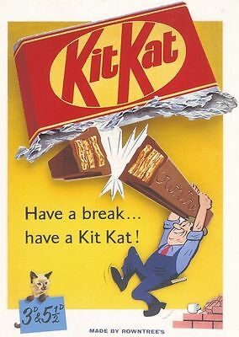
(Fig 4 –KitKat poster)
This advertisement is a 1950 - 1960 advert for KitKat. It is verry much depicting the working man (a brick layer). What the advertisers want us to feel is that on a hard day's work, take some time out for yourself, "Have a break... have a KitKat”. As we know there are more middle- and working-class people in the world, then the higher and upper class. Thus, a grater target audience.
Post war Britan and the 1950’s
After World War 2, Britan was rationing. what is rationing? “The British government introduced food rationing. The scheme was designed to ensure fair shares for all at a time of national shortage” (Imperial War Museum, 2023). Why am I taking about rationing? “Rationing ended in 1954” (Minney, N.2022), “but the sweet and chocolate rating ended in 1953” (The National Archives, 2023) This opened up the market again as restrictions lifted.
This marked a new age in Britan. As peoples living/working and transport conditions improved. With those improvements wadges started to increase which meant people in the working and lower classes had disposable income and could afford a small treat. Rowntree the original makers of the KitKat wanted to profit.
The Cat
The cat was known as “Kitty the Kat”. Kitty the kat was intruded at the start of Rowntree’s advertising. It was to emphasize the creamy richness of the taste of the KitKat bar. That’s what people associated with good/luxury and quality.
The snap
The snap was one huge selling point. It showed Kit Kats crisp wafer. Much like in this image snapping in the middle of the bar, almost as a lunch time bell to the worker. It has become an iconic mark of the chocolate bar.
The packaging and foil
The packaging of the KitKat used to be wrapped in foil, as we can see in this image. The KitKat is bursting out the foil like someone couldn't wait to get in it. “The KitKat has been wrapped in foil since its creation in 1935.” (Reporter .BP, 2022) But as of “2022 Nestlé announced that they will stop wrapping KitKat’s in the foil. They will now be raped in a eco-friendly and sustainable substitutes.”(Reporter .BP. 2022)
The cup of tea
“The cup of tea is a quintessential British symbol.” (Singhal. M. 2022) It is the symbol of having 5 minuets to make and enjoy a cup of tea on a break. It comes across as the KitKat is the perfect company to have on your lunch/tea break. Its association is with relaxing.
The slogan
Have a brake have a KitKat has been part of the British psyche since its invention in “1935” (Gilles. D. 2022) and has lasted 87 years. It is still one of Britan's bestselling chocolate bars. The slogan itself suggest that you should take time to enjoy it. It also describes how the chocolate bar works. As its breakable in to smaller chunks. You can “have a brake” also has two meanings, one meaning is stop what you're doing. The other describes the chocolate bar itself.
The KitKat chocolate bar is a British icon and has survived countless events in world history. The advert is merely a moment in time, we can look back on!

Bibliography
Minney, N. (2022) How did rationing work in the second world war?. Available at: https://merl.reading.ac.uk/news-and-views/2022/05/everything-you-wanted-to-know-ration-books/#:~:text=The%20end%20of%20rationing&text=Meat%20was%20the%20last%20item,war%20to%20stop%20rationing%20food.
Imperial War Museum (2023) What You Need To Know About Rationing In The Second World War. Available at: https://www.iwm.org.uk/history/what-you-need-to-know-about-rationing-in-the-second-world-war (Accessed: 2022).
The National Archives (2023) Life in 1950s Britain. Available at: https://www.nationalarchives.gov.uk/education/resources/platinum-jubilee/life-in-1950s-britain/ (Accessed: 2022).
Campaign (2002) GREAT BRITISH BRANDS: Kit Kat - Britain's favorite chocolate bar since before World War II, Kit Kat has spent the past few years trying to diversify. Available at: https://www.campaignlive.co.uk/article/great-british-brands-kit-kat-britains-favourite-chocolate-bar-world-war-ii-kit-kat-spent-past-few-years-trying-diversify/154770 (Accessed: 2022).
Reporter .BP. (2022) Nestlé Bids Farewell To Iconic KitKat Wrapper? Available at: https://businessplus.ie/industry-type/sustainability/nestle-bids-farewell-to-iconic-kitkat-wrapper/#:~:text=Nestl%C3%A9%20has%20scrapped%20the%20iconic,for%20its%20Quality%20Street%20sweets.
Singhal. M. (2022) Why do British people like to drink tea? Available at: British Tea Culture : Why Do British People Like To Drink Tea? (teafloor.com)
Gilles. D. (2022) 06. Kit Kat (1957) – Have a Break Have a Kit Kat Available at: The history of Have a Break Have a Kit Kat – Creative Review

Practice-based writing
Sofa + civilization
A-B Sofas and civilizations have been around together for hundreds of years. But with different names the word. The first record of the first use of the word was by “Jay Wellingdon Couch in 1895.” (Frank. J. 2021)
• A-C The sofa has existed together with civilizations for hundreds of years but the name has changed. “It originally came from the French word “Couch,” around 1300’s which meant “bed” for most of history.” (Kellerman. S. 2019) “Which then developed into the chaise-longue which then translates to English as a “long chair”.”(Hunt. F. 2016)
• A-D The sofa didn’t just come into being. It was developed over years and different civilization “going as far back as ancient Egypyt around 3000BC.” (Hunt. F. 2016) Its existences as a luxury item has surpassed multiple civilization including, the Ancient Greece and the Roman Empire to modern times.
• B-A The relationship between furniture design and the development of the sofa. Is the same as civilizations and their evolution. As a designer I pick and take elements from the past. The same way the “Ancient Greeks built their monuments to the god’s. In the same why the Ancient Egyptians did years earlier.” (Chrissy. A. 2021) As ideas travel some times more than people. civilization and over time the chaise-longue were invented which turned into the sofa.
• B-D The sofa was developed as a luxury item buy skilled designers and makers. which originated form the chaise-longue. People have wanted a comfortable place to sit for years and the makers and designers made that for them.
C-A crafts men who build and design the most amazing things. Can create and over time develop an affordable item that most people own and can afford. But ideas can out last the civilization the where created in.
• C-B research tells us, that much like “evolution” (Millstein. R. 2022). Different craftsmen make small tweaks to one main idea. But what they referenced has changed, so the next craftsmen's idea is inspired by your idea. Just like evolution.
• C-D the relationship between the evolution of the ancient civilization and the sofa is that it’s a development over time it’s a “passing of the baton.”(Web. O. 2016) So, the ancient Egyptians led to the Romans etc. the same way the chair led to the chaise-longue which led to the sofa.
• D-A the reader wants to know how the sofa came into being, and how that is related to the different civilization that have appeared and disappeared.
• D-B the relationship between my practices is that it is woven through the tapestries of great civilization’s, To the modern day of sofas and furniture.
• D-C the reader wants to know how the sofa came into being. But to understand that we have to look far back to grate civilizations. It gives context to the craftsmanship and the test of time of ideas have effects on the world today. People say the world goes in cycles it’s the same with furniture and civilizations.

Bibliography
Frank. J. (2021) Who was the inventor of the sofa? Available at: https://insidersguidetofurniture.com/sofa-inventor/#:~:text=The%20couch%20was%20invented%20by,that%20was%20called%20a%20canape.
Kellerman. S. (2019) Period furniture. Available at: https://www.grammarphobia.com/blog/2019/09/period-furniture.html
Hunt. F. (2016) The history of the chaise longue Available at: https://www.franceshunt.co.uk/news/2016/07/history-of-the-chaise-longue/
World Civilization. Temples Available at: - https://courses.lumenlearning.com/suny-hccc-worldcivilization/chapter/ancient-egyptian-monuments/
Chrissy. A. (2021) Ancient Greek Temples Available at: https://greecetravelideas.com/ancient-greek-temples/#:~:text=The%20ancient%20Greek%20were%20no,the%20majesty%20of%20their%20gods.
Web. O. (2016) Furniture Design History Available at: https://www.onlinedesignteacher.com/2016/02/furniture-design-history.html
Millstein. R. (2022) Stanford Encyclopedia of Philosophy Available at: https://plato.stanford.edu/entries/evolution/

