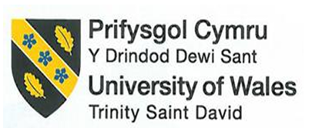

Student name: Florin Ionut Nitu
Student number: 2240772
Module: Management and Organisational Behaviour
Module code: BMIH5004
Lecturer: Antoinette Milne
Assessment Component 2
Assignment Title: Title: Report

I confirm that I have not used any AI tools in the research and creation of this assignment. I confirm that I have not presented any AI generated materials as my own work. I confirm I have copies of my drafts, notes, and other resources I used, which I may be asked to provide in evidence.

Table of Contents

Introduction 4
Organisation Structure, Culture, and Goals 4
Organisational Structure 4
Corporate Culture 5
Organisational Goals 6
Strategic Direction 6
Analyse the organisation's strategic direction 6
Analyse the Strategies Implemented to Achieve Their Long-Term Objectives 7
Recent Change Initiatives 8
Change initiatives undertaken by the organisation 8
Impact of these change initiatives on the organisation 10
Evaluation of the change management 10
Recommendations 11
Conclusion 12
References 13

Executive Summary
Marriott International uses a matrix organizational structure which connects worldwide standardization to individual location flexibility. The company directs its strategy toward downloading growth while advancing technology along with sustainable practices. Marriott International executes its business strategy through strategic acquisitions smart technology investments together with environmental program implementation. The combination of creating a consolidated corporate culture with excellent customer service positions Marriott as an industry leader in hospitality. The report has examined the impacts of diverse change strategies such as sustainability programs, digital transformation and post-pandemic recovery strategies and their impacts and the way the organization has managed it by using Lewin’s Chang Management Model. The report has assessed the necessity of actionable recommendations that highlight further opportunities for Marriot International to strengthen employee engagement.

Introduction
Marriott International is one of the leading global hospitality companies that offers a diverse portfolio of world-class accommodations and unique services. It was founded in 1927 and as a brand leader, provides more than 30 leading brands in nearly 9,100 properties over 142 countries globally (marriott.com, 2024). The report aims to evaluate the organisational structure, culture and goals of the company and their influences on the operations. It will also assess recent change initiatives, their impacts and their effectiveness on management. The strategic direction and its analysis help to achieve long-term objectives and it will further consider suitable recommendations to enhance its position within the hotel and hospitality industry.
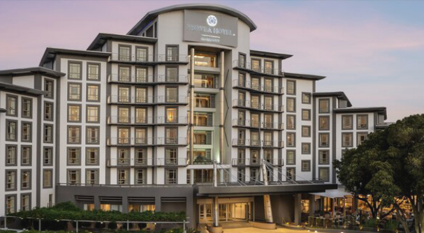
Figure: A brunch of Marriott International
(Source: marriott.com, 2021)

Organisation Structure, Culture, and Goals

Organisational Structure
As an organisational structure, Marriott International uses matrix governance which integrates geographic areas with business units alongside functional divisions. The organisational structure brings worldwide standardisation of service initiatives and maintains adaptability for local market requirements. The company divides its worldwide operations into three main regions named Americas Europe and Asia-Pacific which then separate into luxury premium and select service brands categories (Marriott, 2025). Through market-specific decision-making authority, corporate managers foster both agility and market responsiveness. Every department from operations to marketing and IT must collaborate with each other to become operationally efficient and continuously innovative. The organisational framework provides a smooth information flow between different levels to resolve both strategic needs and operational problems successfully.
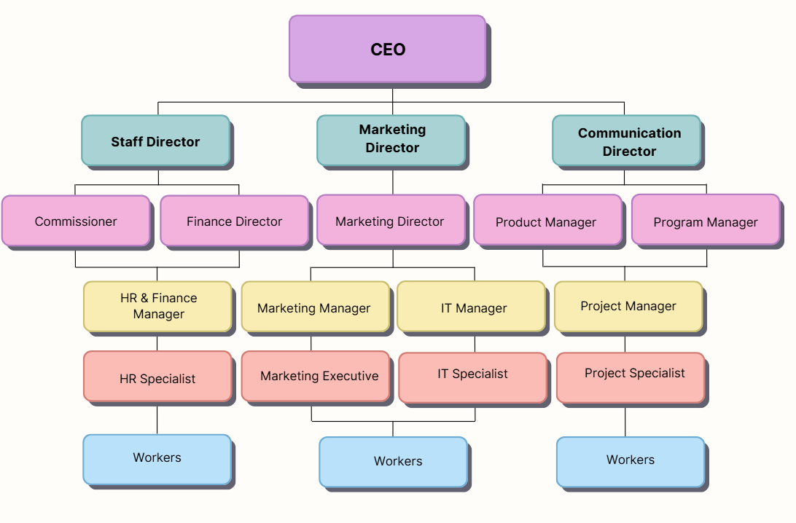
Figure: Organisational Structure of Marriott
(Source: Learner)

Corporate Culture
Marriott bases its organisational culture on the core belief of "Putting People First" which ensures welfare conditions for staff and visitors along with community support systems. The company maintains a supportive workplace through its "TakeCare" initiative which dedicates efforts toward mental health improvement together with physical fitness and career advancement (Marriott, 2025). This technique promotes increased employee engagement, leading to better customer service delivery. Amongst dedicated programs such as Women Leadership Development and multicultural networking events, the company wants to encourage diversity. Marriott essentially encourages innovation among its workforce by using progressive technological solutions such as mobile apps and AI personalisation features as well as green operational practices. Employees at Marriott experience a culture of value where they display loyalty and deliver exceptional guest experiences according to the hotel company's worldwide reputation standards.

Organisational Goals
Marriott’s mission is to be the world’s favourite travel company, and such goals fit right in. These goals at the corporate level comprise sustainable growth, customer satisfaction and shareholder value. Actions such as reaching zero food waste, halving water use and overall energy use, and removing two million disposable plastic straws and others, support Marriott’s efforts to reduce its environmental footprint (Marriott, 2025). Goals at the level of the individual property are tailored to local markets. These include hotels in urban areas which will focus on technology integration and business traveler satisfaction, and resorts on the other hand will focus on personalised guest experiences and community engagement. Multilevel goals such as these keep Marriott in the competitive circle because the company takes the global strategic approaches and the local execution but all that results in outstanding performance with consistency.

Strategic Direction

Analyse the organisation's strategic direction
Marriott International guides its strategic development using a plan to lead the global tourism industry through the expansion of its digital presence and sustainable practices. As a vital element of its strategy Marriott International deploys its business expansion to high-demand regions including Asia-Pacific together with Africa and the Middle East because these territories manifest notable expansion potential in hospitality (Marriott, 2025). Throughout its operations, Marriott maintains a broad reach across all segments by regularly expanding its property collection while adding new brands to serve premium luxury to budget market needs. Customer experience enhancements are a key focus as the company conducts digital transformation initiatives. The company uses artificial intelligence mobile apps and personalised marketing strategies to build seamless memorable guest experiences during hotel stays. Sustainability stands central to Marriott's plans for enduring growth. Marriott has established 2025 sustainability targets which focus on decreasing carbon outputs minimising water utilisation and establishing zero waste processes (Marriott, 2025). The company supports community growth by forming strategic partnerships that match the expectations of socially aware travellers. Strategies developed by Marriott aim to preserve its market leadership position through timely responses to emerging customer trends as well as environmental conservation and technological integration concepts.
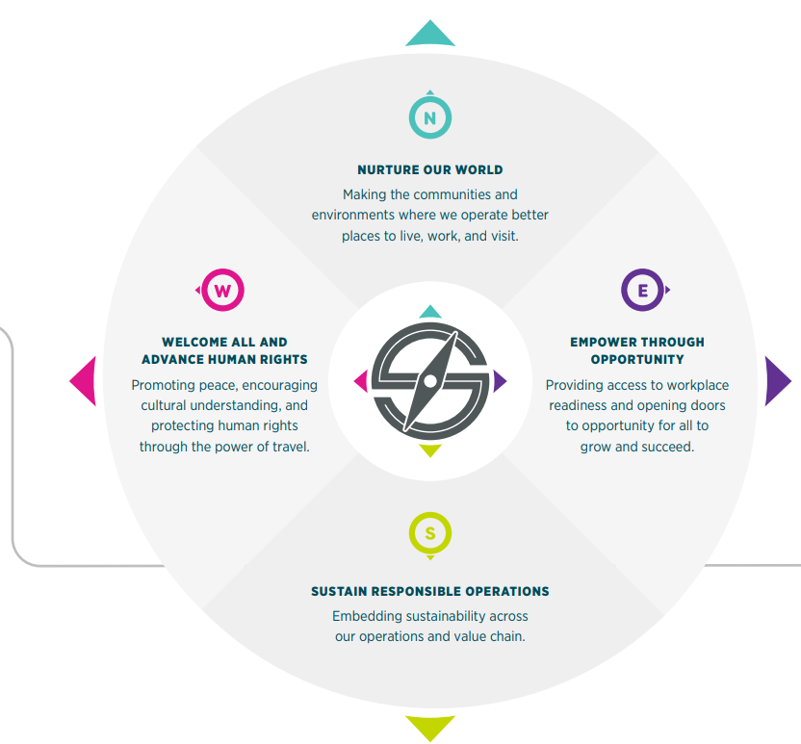
Figure: Sustainability Goals of Marriott
(Source: Marriott, 2025)

Analyse the Strategies Implemented to Achieve Their Long-Term Objectives
Marriott International has developed multiple strategic initiatives to carry out its future-focused goals for worldwide expansion and technological advantage with environmental sustainability. A prime element of its operational strategy rests on strategic acquisitions specifically the 2016 acquisition of Starwood Hotels & Resorts stands out as a main example. Through this acquisition, Marriott broadened its brand collection to over 30 types and achieved greater market penetration in luxurious residences while expanding to more than 150 planetary territories (Marriott, 2025). Through acquisitions Marriott both extends its branding selection as well as builds up its market leadership through specialised customer solutions for different market segments.
Marriott invests in technological innovation through the development of automated guest interactions that provide individualised and streamlined experiences. The Marriott Bonvoy app serves as an excellent illustration of customised guest experiences through which users can redeem loyalty rewards and control bookings to fulfil their stay preferences (Forbes, 2019). Through the use of artificial intelligence together with data analytics Marriott can predict guest needs which enables customised recommendations to increase guest satisfaction. Through smart technologies including contactless check-ins mobile room keys and voice-activated room controls Marriott demonstrates how they combine cutting-edge solutions with convenience features.
Sustainability represents a central priority in Marriott's business approach. Marriott targets a 30% reduction in carbon emissions alongside water conservation and complete eradication of food waste before 2025 (Forbes, 2021). Effective power efficiency tools have been deployed throughout Marriott's properties through computerised heating and ventilation systems combined with LED illumination systems. Through active engagement, Marriott supports local communities by choosing local supply partners which helps create jobs as well as providing training programs designed to maximise employee and partner potential.
A resilient corporate culture at Marriott produces engaged employees who provide superior service delivery because these factors are essential for enduring result achievement. Guest experiences at Marriott excel because the company places people at the centre of its operations through targeted diversity programs which ignite employee motivation (Marriott, 2025). Through integrated approaches, Marriott maintains its industry leadership position through growth combined with innovation while supporting sustainability which leads to enduring business success.

Recent Change Initiatives

Change initiatives undertaken by the organisation
As a global hospitality brand, Marriot International evolves continuously to address changing market demands, consumer preferences and operational challenges. The major change initiatives include sustainability programs, digital transformation, post-pandemic recovery strategies and so on.
Sustainability programs- Increasing global sustainability trends and environment-conscious customers seeking responsible business practices. Marriot International has launched its “Serve 360” initiatives that are committed to meeting the SDGs including myelinating single-use plastics, reducing carbon footprints and achieving net zero emissions by 2050 (marriott.com, 2024). These efforts of the organization help to meet consumers' and other stakeholders' expectations considering CSR.
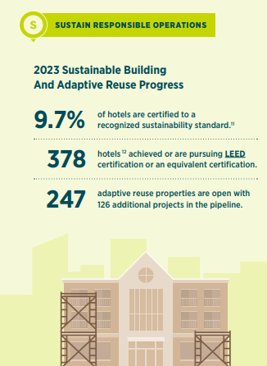
Figure: Sustainable operations at Marriott
(Source: marriott.com, 2024)
Digital transformation- Marriott has alleviated its digital innovation approach to improve guest experiences and operation streamlining. The company has employed a tailored mobile app with digital keys and check-ins, personalised communication, digital keys and integration of AI-driven analytics for better customer insights. The company invested $1.5 billion in annual ICT in 2023 and in January 2024, Marriot selected Oracle Hospitality OPERA Cloud Property Management Systems (PMS) for sales and event management (globaldata.com, 2024).
Post-pandemic recovery- The pandemic outbreak has facilitated some operational changes that include flexible booking policies, cleaning protocol and hybrid event solutions. In response to the pandemic, the company considered earth protection action and in 2021 it planned to combat climate change with science-based targets and also launch Marriot Bonvoy and flexible working situations (marriott.com, 2021).

Impact of these change initiatives on the organisation
Sustainability initiatives have strengthened the brand's reputation while attracting conscious travellers as well as investors. This allows the company to lead partnerships with organisations such as WWF for sourcing sustainable seafood (Ruiz Molina et al., 2022). Investments in green technologies including efficiency systems and waste management improved high upfront costs through long-term savings. This resulted in a restructured supply chain and tailored staff training which caused temporary workforce disruptions. The company has improved the usage of digital tools for enhancing IoT technology and predictive maintenance. Digital initiatives have improved seamless communication with loyalty and customer satisfaction. The loyalty programs of Marriot, and Marriot Bonvoy have integrated digital tools which have resulted in a growing number of 196 million (marriott.gcs-web.com, 2023). The company has encountered resistance initially from the employees due to unfamiliar technological advancements that highlight the need for further training and improvements. Flexible booking policies and innovative hybrid solutions have supported the global revenue recovery of the company with improved health and safety protocols during the pandemic.

Evaluation of the change management
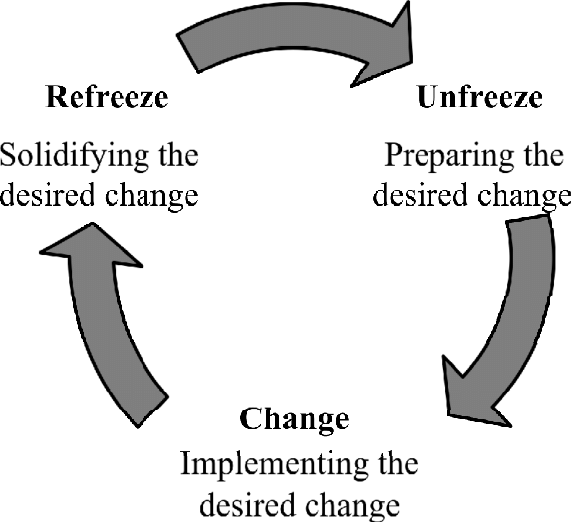
Figure: Lewin’s Change Management Model
(Source: Dissanayake and Rajapakse, 2020)
The effectiveness of the Marriots’ change management can be well-evaluated by using Lewin’s Change Management Model. In the unfreezing stages, Marriott has highlighted financial and environmental imperatives for sustainability along with identifying the need for digitalization to remain competitive in the technology-driven hospitality sector. Communication campaigns along with rapid assessments of customer and employee concerns in the pandemic state have emphasised the need for adaptability and emotional intelligence. In the Change stage, incremental changes of lowering climate concerns offer publicized progress to build better engagement of the customers of Marriot (Menegaki, 2025). User-friendly apps and training programs empower employees for broad action that helps to overcome resistance and flexible booking and cleaning protocols leveraging guidance for effective change in the stage. In the final and refreezing stages, Marriot includes sustainable practices in the core CSR programs with a long-term commitment, institutionalises daily operations through continuous feedback mechanisms for digital operations and employs safety measures for hybrid event offerings to ensure future disruptions.

Recommendations
Marriot International has improved its strategic focus for better global expansion and improved customer satisfaction, however, the company can further improve its strategic approach and operational practices including strengthening localized strategies, improving employee training and focusing on tech-driven sustainable measures as well. Marriot has customized its service to regional markets to cater to diverse customer preferences. Regional managers can improve the localized strategies annually within key growth markets (Coe et al., 2017). It can enhance guest satisfaction and market penetration by leveraging data analytics for insights that enhance the market-specific approach of Marriot. The company can enhance employee training by investing in robust training programs to address gaps in technology adoption and sustainability practices. The HR and training teams can employ quarterly training plans across all properties to improve service quality and consistency. The company can leverage e-learning platforms and best practices from the digital training programs. The focus of tech-driven sustainability can improve waste reduction and energy efficiency can be facilitated by the sustainability teams for immediate results to meet ESG goals by partnering with the green tech providers.

Conclusion
Thus, it can be concluded that Marriot International has facilitated diverse change activities that align with its culture, structure and organizational operations the change initiatives include sustainable measures, digital transformation and post-pandemic recovery which have strengthened its global positions and operational efficiency. The long-term objectives focus on expanding into the high-demand markets to achieve environmental sustainability through programs such as “Serve 360”. There are multiple challenges that the company countered and it should include robust strategies such as consistent adoption of technology, training programs and so on which can help in maintaining a competitive edge with long-term success and market position.

References
Coe, N.M., Hess, M., Yeungt, H.W.C., Dicken, P. and Henderson, J., 2017. ‘Globalizing’regional development: a global production networks perspective. In Economy (pp. 199-215). Routledge.
Dissanayake, K. and Rajapakse, B., 2020. Environmental Management Accounting for Corporate Sustainability: A Case from a Sri Lankan Automobile Company. International Journal of Auditing and Accounting Studies, 2(1), pp.41-65.
Forbes, 2019. Marriott’s Program Changes Have Officially Been Announced﻿, Forbes. Forbes Magazine. Available at: https://www.forbes.com/sites/geoffwhitmore/2019/01/29/marriotts-program-changes-have-officially-been-announced%EF%BB%BF/ (Accessed: 27 January 2025).
Forbes, 2021. Marriott CEO On Net-Zero Emissions: ‘It Is An Imperative That We Do This’, Forbes. Forbes Magazine. Available at: https://www.forbes.com/sites/jenniferleighparker/2021/10/11/marriott-ceo-on-net-zero-emissions-it-is-an-imperative-that-we-do-this/ (Accessed: 27 January 2025).
globaldata.com (2024) Market Research Reports & Consulting | GlobalData UK Ltd. Available at: https://www.globaldata.com/store/report/marriott-international-enterprise-tech-analysis/ (Accessed: 27 January 2025).
Marriott, 2025. Core Values & Heritage. Available at: https://www.marriott.com/culture-and-values/core-values.mi (Accessed: 27 January 2025).
Marriott, 2025. FOOD WASTE MANAGEMENT PROGRAM ANNUAL REPORT. Available at: https://www.marriott.com/marriottassets/marriott/BKKCY/PDF/BKKCY_Food_Waste_Management.pdf (Accessed: 27 January 2025).
Marriott, 2025. Marriott International Announces Organizational Structure and Executive Appointments, Marriott News Center. Available at: https://news.marriott.com/news/2023/02/24/marriott-international-announces-organizational-structure-and-executive-appointments (Accessed: 27 January 2025).
Marriott, 2025. Marriott International Announces Record Year of Global Signings and Strong Net Rooms Growth_Marriott International. Available at: https://marriott.gcs-web.com/news-releases/news-release-details/marriott-international-announces-record-year-global-signings-and (Accessed: 27 January 2025).
Marriott, 2025. Our Story_Marriott International. Available at: https://www.marriott.com/about/culture-and-values/history.mi (Accessed: 27 January 2025).
Marriott, 2025. Sustain - CSR Marriott. Available at: https://serve360.marriott.com/sustain/ (Accessed: 27 January 2025).
marriott.com (2021). Available at: https://serve360.marriott.com/wp-content/uploads/2021/09/2021_Serve_360_Report.pdf (Accessed: 27 January 2025).
marriott.com (2024) About Marriott International | Corporate Information. Available at: https://www.marriott.com/marriott/aboutmarriott.mi (Accessed: 27 January 2025).
marriott.com (2024). Available at: https://serve360.marriott.com/wp-content/uploads/2024/07/2024ESGProgress.pdf (Accessed: 27 January 2025).
marriott.gcs-web.com (2023). Available at: https://marriott.gcs-web.com/static-files/b82978a6-9d28-4e38-9855-fc4ae2cebe11 (Accessed: 27 January 2025).
Menegaki, A.N., 2025. Powering Down Hospitality Through a Policy-Driven, Case-Based and Scenario Approach. Energies, 18(2), pp.1-36.
Ruiz Molina, M.E., Belda-Miquel, S., Hytti, A. and Gil-Saura, I., 2022. Addressing sustainable food management in hotels: proposing a framework and examining hotel groups. British Food Journal, 124(2), pp.462-492.

