BMSP5007
Business inquiry and research
Assignment 1Part 1 and Part 2 -- Business Example
Dr. Roisin Mullins
University of Wales: Trinity Saint David
Table of Contents Part 1
Introduction 3
Literature Research 3
Procedure 4
Data Analysis Techniques 5
Data Presentation and Findings 6
Conclusion/Reflection 8
References ………………………………………………………………………………...9

Introduction
This qualitative study aims to understand the participants’ experience of domestic food waste. The data was collected from face to face semi structured interviews with three participants. Participants were selected through a convenience sampling process to demonstrate a range of demographics. This field of study is particularly important to me, and I refer to my positionality where I am currently a student studying business with sustainability as the lens through which business issues are considered (Bourke, B. 2014). The topic is important because of the economic impact of wasting resources and the moral impact of excess consumption when other people around the world are struggling to access food. 66 tonnes of food is thrown away every second globally and this is predicted to rise in the future. This is whilst 10% of the population (815million people) are chronically undernourished (Ratcliffe, R. (2018). During the interviews, the participants’ experiences of purchasing and disposing of food will be examined and their perceptions of the impact of this waste. Results will then be analysed using a thematic framework method.

Literature Research
A qualitative approach was chosen for the study rather than a quantitative one because it was important to find out the participants views on waste and have insight in to their shopping habits. Qualitative research methods were developed in the field of social sciences and they enable researchers to find trends within data to identify social and cultural phenomena (Ernst, A. (2003). Interviewing is an effective way of gaining qualitative data as it can allow the participants to tell stories and reveal feelings and beliefs shaped by their own experience which in turn allows more understanding of human behaviour and the social world (Silverman, D. (2010). The sample groups were selected through purposive sampling which is a non-probability judgmental selection of participants. Typical case sampling could be used as food wastage is something that the average person within the population has experienced (Ray, A. (2012).

In 2007 Groenewald described paradigms as an action of submitting to an opinion and research paradigms as a set of basic principles to help us make the next steps. Qualitative research paradigms are concerned with deriving meaning from details and are naturistic, inductive in approach and seek pluralism. A ‘phenomenology method’ will be used as the primary research approach. Phenomenology is a qualitative research method using the personal experiences of someone who has actually lived through a situation connected to the subject of interest. This research method usually uses small sample groups and tries to focus solely on the participants experience rather than preconceived ideas (Moustakas, C. (1994). The phenomenon chosen was “participant’s experiences with food wastage within their own household.”

Procedure
Once the phenomenon framework (thematic) and methodology were chosen, a semi structured interview process was selected as the most effective method of collecting the qualitative data. The following process was carried out to ensure accurate and ethical results:
- Questions were chosen that would define themes within the topic of food waste. A combination of open and closed questions were devised to provide information of sufficient detail for analysis.
- A sample group of participants were selected with different demographics to enable a diverse set of results. The sampling techniques used were convenience sampling which is a form of non-probability sampling.
- A semi structured interview technique was undertaken because it combines fixed questions with opportunities for some open comments. Fixed questions enable a consistent analysis of data because all the participants have been asked the same questions. However the opportunity for open comments within an interview is also useful for expanding on topics and ensuring that the process is not overly formal or restrictive as there is the chance for participants to express their views. Practical arrangements were made with the participants of the study and the process and rationale clearly explained, prior to them signing the ethics agreement.
- The semi structured interviews took place individually in the same quiet, distraction free room. The interviewer asked all the questions in the same tone and manner. Each interview took from 20-30 minutes to complete.
- Responses were transcribed on to a word document for analysis. All the transcriptions complied to the ethical agreement and privacy rules with no names or identifiable details recorded.

Data Analysis Techniques
Any comments not relevant to the subject of food wastage or repetitions were removed from the transcribed word document. A table was compiled from the data with three columns (see table below). The first column was collated from the participants answers, the middle was the researchers’ impressions of the data and the last column identified recurring themes. Groups identifying different themes were created but when a new opinion was expressed that did not fall under a previous category, a new group was created. The themes were then condensed and conclusions were made from this data.
A focus group would have been another method of data collection but the logistics of grouping participants together was difficult and extroverted people can dominate a group making the data disproportionate between interviewees (Harrell, M., & Bradley, M. (2009).

Data Presentation and Findings
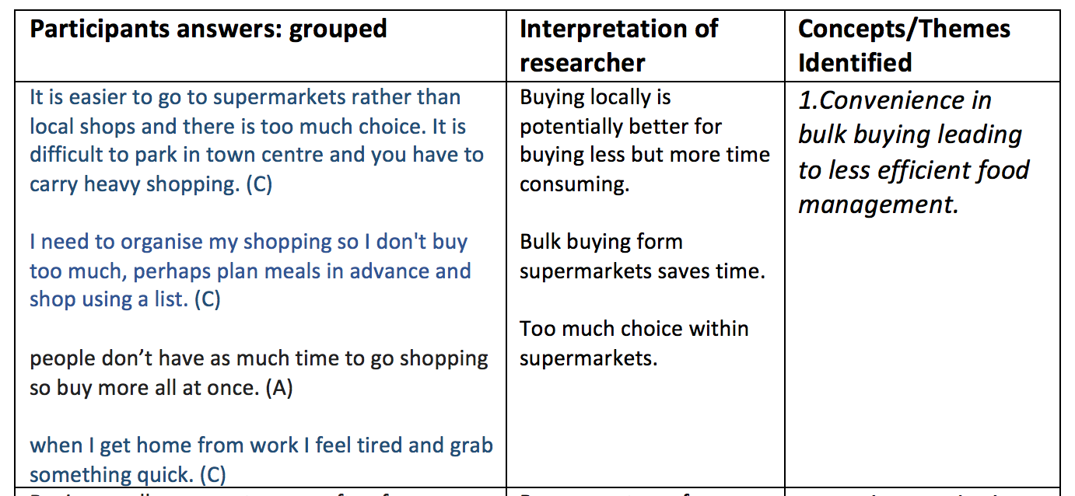
Here is the table created to display the qualitative analysis showing the grouped participants answers researchers interpretations and then concepts identifies within the transcript.

The first theme identified was convenience in bulk buying leading to poor food management. The participants were busy and did not have the time to shop around locally in independent shops for specific items. They chose the convenience of supermarkets. The temptation is then to buy greater amounts of food which is more challenging to organise and to judge exactly how much is needed. The efficiency and choice that supermarkets offer combined with the busy lifestyles are central to this theme and contribute the food waste issue.

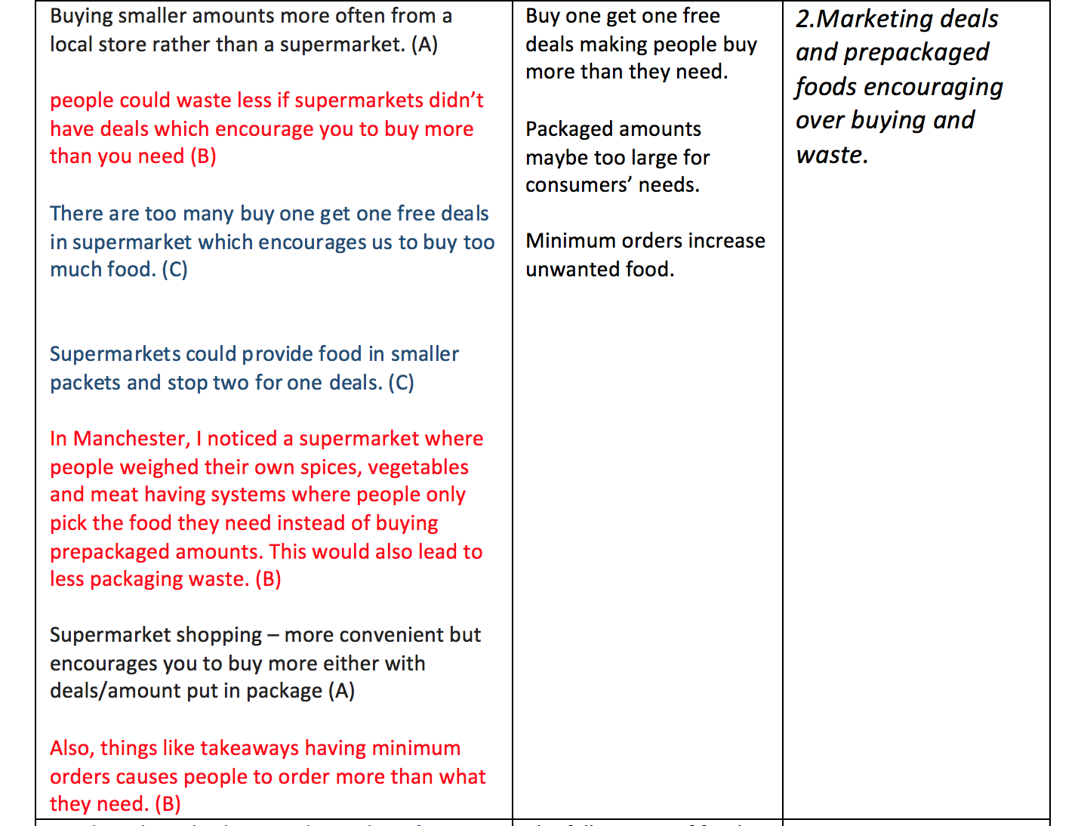

The second theme identified from the data was that marketing deals and prepackaged foods encourage excess buying and waste. This was the most frequent comment within the interviewees data. All the participants expressed the view that promotions such as ‘buy one get one free’ and minimum spends for free delivery encouraged them to buy more than they needed. The interviewees also commented that package sizes were often too big for their own use. Participant B highlighted an experience they had in a different kind of supermarket where customers weighed out exactly the amount they needed, leading to less food waste and less packaging. The need for supermarkets to keep profits high and to turn over stock rapidly has contributed to the issue of excess food waste.
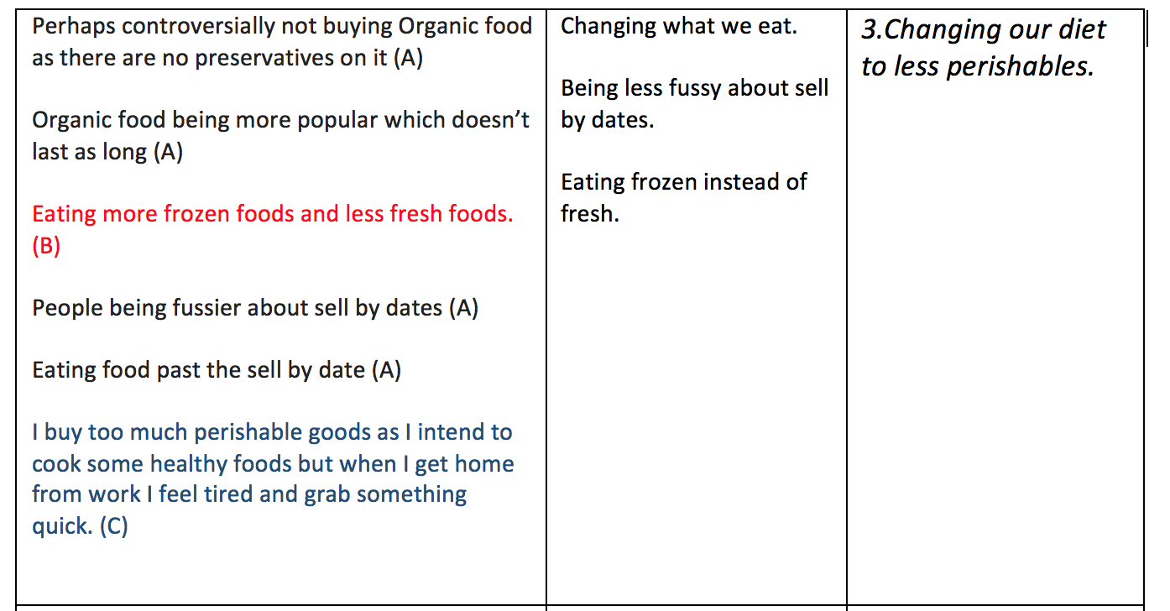
The third concept discovered was changing our diet to less perishables. A participant had experiences with organic foods which use no preservatives go off faster and therefore are more like to be thrown. I draw they felt that this was a controversial statement as usually organic foods are usually considered superior. I interpenetrated that consumers buying habits are slowly changing towards a fresher, organic and health conscious diet. However these foods are usually more perishable than processed, tinned and frozen ones. The mix of more fresh foods and a busy lifestyle actually leads to even more food wastage.

Conclusion/Reflection
Data collection was restricted to only three participants which means that drawing conclusions to wider society is not possible because of the small sample size. A larger sample would be more representative and offer more robust data. The interviewees had a western perspective on food wastage which would be very different to people from a third world country or very poor communities. Using different data collection methods such as focus groups and observational research and combining all three for analysis would have produced more diverse data.
The studies strengths came from the way that the main themes could be extrapolated from the semi structured interview data showing that the questions were both reliable and valid. The pre hand planning of relevant questions. Possible ethics issues and interviewing techniques had been established and participants briefs before starting. I found that using qualitative techniques like phenomenology with a thematic framework allowed for compelling answers and for the participant to tell a story and not just answer in predictable fashions like in quantitative data. The themes gave insight in to levels of domestic food waste, reasons for waste and offered solutions for reducing waste.
I draw from this study that food habits are slowly adapting. The power of supermarkets and big food brands is creating a culture of waste and the availability and cheapness of food has altered consumer’s perceptions. Even the adoption of a fresh and organic diet may not help consumer’s battle wastage. All the participants pointed strongly to the relationship between super markets and consumers as one of the main contributors to wastage. The data provided an insight in to the important topic of food waste which is becoming increasingly relevant in a world of inequality and social conscience. There is a desire to conserve resources for future generations and to stop excessive waste of all kinds which is now being viewed as morally indefensible.

REFRENCES

Bourke, B. (2014). Positionality: Reflecting on the Research Process. Qualitative Report. Vol. 19 Issue 33, p1-9.

Ernst, A. (2003). Comparison of Qualitative and Quantitative Research. Munich: GRIN Verlag GmbH.

Groenewald, T. (2004). A phenomenological research design illustrated. International Journal
Of Qualitative Methods, 3. Article 4. http://www.ualberta.ca/~iiqm/backissues/3_1/pdf/groenewald.pdf

Harrell, M., & Bradley, M. (2009. Data collection methods. Santa Monica, CA: RAND.

Moustakas, C. (1994). Phenomenological research methods. London, Sage.

Ratcliffe, R. (2018). Food waste: alarming rise will see 66 tonnes thrown away every second. The Guardian. https://www.theguardian.com/global-development/2018/aug/20/food-waste-alarming-rise-will-see-66-tonnes-thrown-away-every-second

Ray, A. (2012). The Methodoloy of Sampling and Purposive Sampling. Munich: GRIN Verlag.

Silverman, D. (2010). Qualitative research. Los Angeles: SAGE.

Tong, A., Sainsbury, P. & Carig, J. (2007). Consolidating criteria for reporting qualitative research. International Journal of Quality in Health Care, Volume 19, Issue 6.

Table of Contents Part 2
Introduction 3
Data Collection 3
Analysis Approach 4
Procedure 4
Analytical Procedure. 5
Data Presentation and Findings 6
Cross tabulation of results. 12
Limitations of the data. 13
Conclusion 14
References ……………………………………………………………………………….26

Introduction
This report aims to examine the consumer buying habits of clothing. Studies show that the textiles industry is a significant contributor to the environmental issues being the second largest polluter of water globally, after farming (Perry, P. (2018) and a source of global repression of workers. Recycling clothes is possible but unfortunately the industry is more disposable than ever. The quantitative research in this report will give insights in to consumers’ attitudes towards buying, disposing and recycling clothing. This topic associates well with ‘the globally responsive Wales’ section of the Future Generations Act (Future Generations Commissioner. (2019).
The study area was chosen because of personal experience in the second-hand clothing industry and the impact that changes in attitudes towards clothing has on consumerism and the planet. Factors may be the increasing use of synthetic materials that contribute to global warming or with connections to child labour in third world economies.

Data Collection
Data was collected in a quantitative survey method to explain the chosen phenomenon (Muijs, Daniel. (2010). The data collection method was an online questionnaire. The survey method was chosen because of low cost and ease of accessibility. Non-probability convenience sampling was used ensuring the sample was large and diverse enough in opinions to secure a valid range of results (Ray, A. (2012).

Analysis Approach
Quantitative data is information that is in or can be converted into numbers so it can be analysed in a mathematical calculation and used to create statistics (Williams, C. (2007). Types of quantitative data include counter, sensory calculation and quantification of qualitative information.
Cross tabulation is a method of analysing relationships between multiple variables. This method works best on categorical data which is data that can be divided into mutually exclusive groups i.e. cannot be in more than one category at once. Cross tabulation method can minimise errors in analysis by grouping the variables in to clear groups. Correlations in the data are then analysed and emerging themes are noted.

Procedure
A survey data collection method was used in a cross-sectional observational study. This is where the natural environment of the participants is not manipulated. This was chosen over a longitudinal study method because it is time efficient and multiple variables can be studied at one given time (Cross-Sectional Study Vs Longitudinal Study. (2019).
An online questionnaire was the data collection method because of its ease of distribution. Survey Monkey, an online survey development software, was used to create the questionnaire (SurveyMonkey. (2019). This software is cloud based so it can be assessed and edited from any location.
The questions were developed with the aim of gaining information on the clothing habits of participants in connection to sustainability, the use of second hand recycled clothing and personal buying habits. The questionnaire comprised of a combination of closed ended questions, nominal questions such as gender selection and ordinal questions such as likelihood to purchase second hand clothing. Interval and ratio measurement scales were used (Trochim, W., Donnelly, J., & Arora, K. (2015). The first three questions provided information on the demographics of the participants which linked themes to groups in the analysis. There was a range of response methods including multiple choice, level of measurement, contingency and dichotomous (Trochim, W. (2006).
The survey was distributed to a wide range of participants online. This method means that distance and time was not an issue as the survey takers could fill out the questionnaire in a time and place that suited them. Ten participants took part in the online survey

Analytical Procedure.
The IBM Statistical Package for Social Sciences (SPSS) and Survey Monkey analysis for graphs was used to process the data and identify trends from within the data. An ID was assigned to all participants so there was no breach of confidentiality. A coding frame was created where labels were given corresponding to multiple choice answers. Variables were entered and made to be either nominal, scale or ordinal.
The survey results were imported into SPSS. Some variables were entered in numeric form to aid analytics and to match the labels assigned. The data was cleaned making ensuring there were no errors in the findings.

Data Presentation and Findings

Q1. What gender do you identify by?
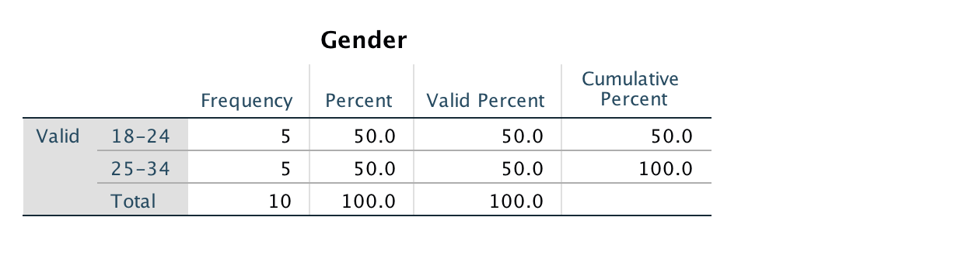
The data from the question shows and even men to women ratio. This makes for a fair representation of the general population.
Q2. What age group are you?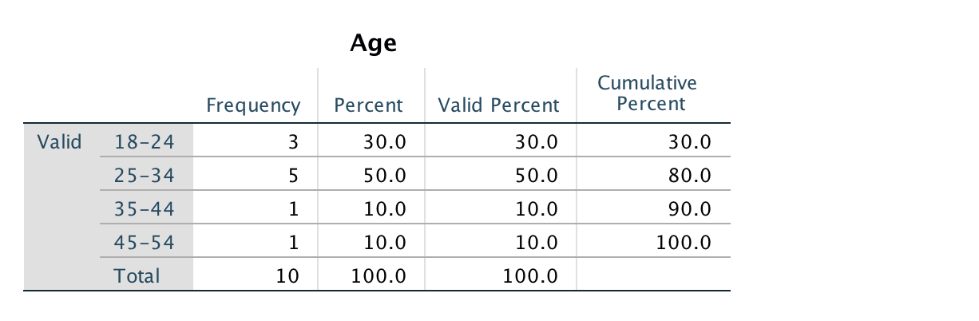
This table shows the age distribution of participants. The majority are 25-34 years of age but there is representation in every age range sampled.

Q3. What do you do as a profession?
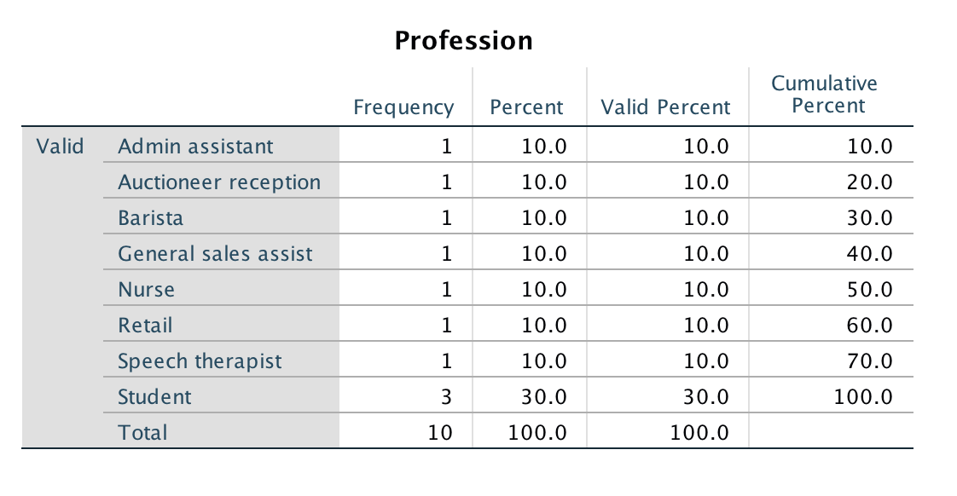
The majority of the participants were students. This was because of the convenience sample used but there is a range of occupations reflecting the general population.

Q4. Where would you normally shop?
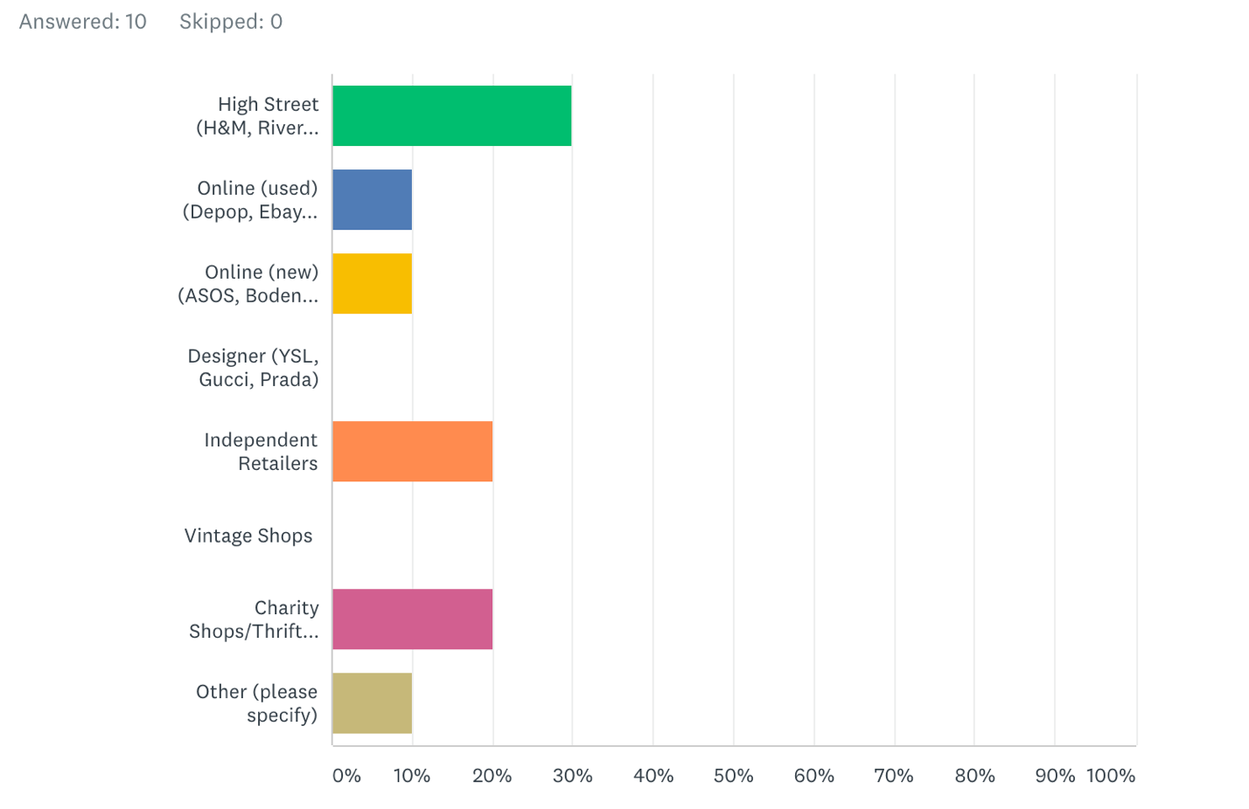
The High Street was the most popular purchase destination with thirty percent selecting this as their main place to buy clothing. Independent retailers were the next most popular and charity shops. This may reflect the fact that the participants were mainly young and students. Online shopping scored the least which was surprising because there is a media perception that this is a growing trend with a detrimental effect on the High Street.

Q5. How often do you buy new clothing?
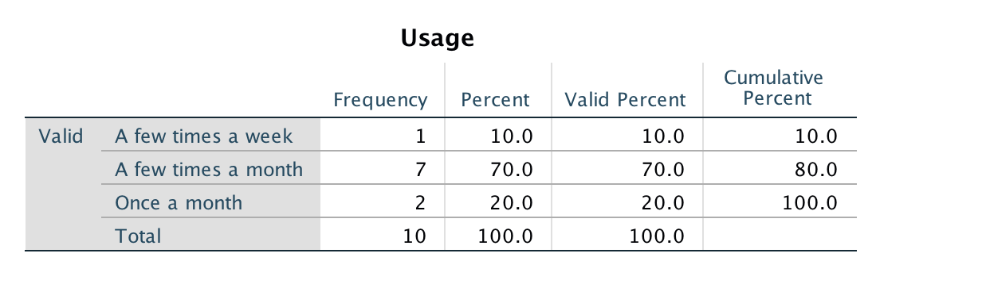
Seventy percent of participants bought clothing a few times a month. This gives data on the volume of clothing that participants purchase monthly and over a year there will This matches with findings that suggest that British citizens now own four times as much clothing than in the 1980s (Bain, M. (2015).

Q6. How likely are you to buy second hand?
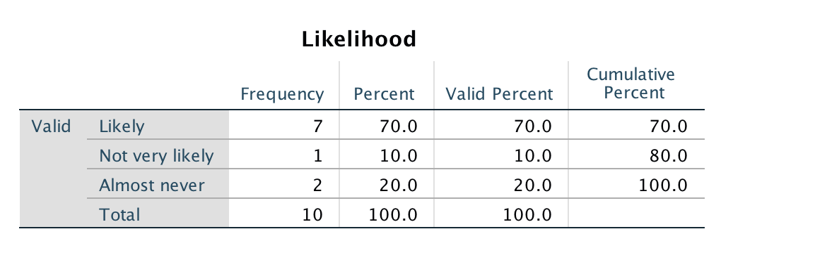
The above results show that most consumers are willing to buy second hand clothing but twenty percent said they would almost never do so. It can be concluded from the data that consumers are not opposed to buying used garments. This can be a good way of improving the lifecycle of clothing and reducing the environmental impact of the clothing industry.

Q7. What would put you off buying second hand clothes?
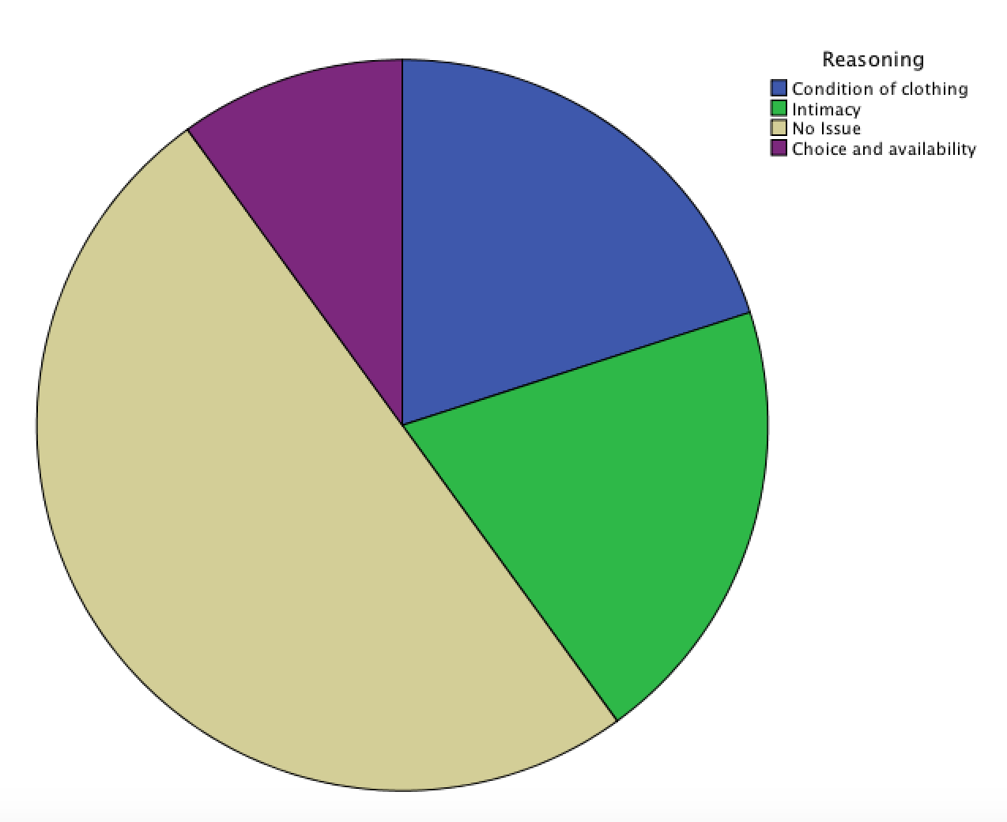
The results were collected in a short answer format which was then converted from qualitative to quantitative by grouping similar responses into four main categories which were assigned corresponding numbers. Although most of the sample had no problem with buying second hand clothing, the condition, availability and not wanting to wear garments that have been worn by someone else were barriers to some consumers.

Q8. How long do items of clothing last you?
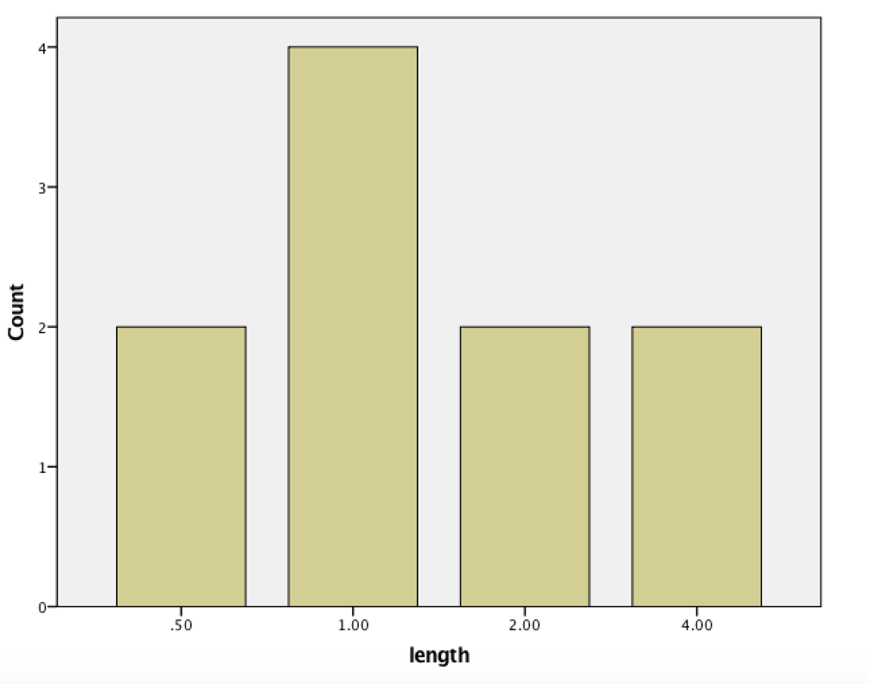
The results for the length of time items of clothing lasted were converted into a scale where 1.0 meant one year and 0.5 represented 6 months. It can be concluded that the average lifetime of a garment is one year.

Q9. How do you dispose of unwanted clothing?
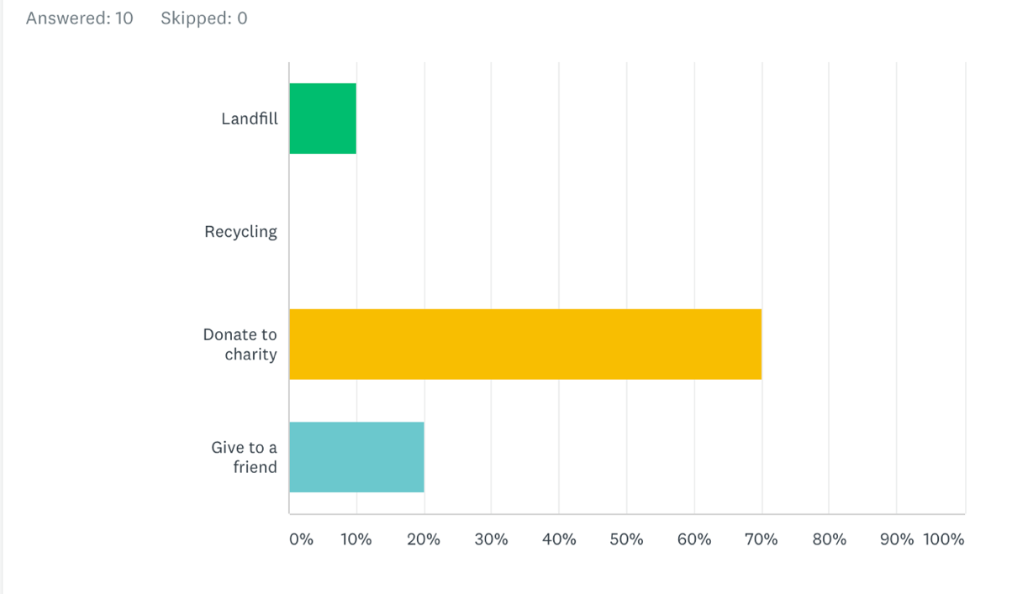
The graph shows the patterns in disposal of unwanted clothing. The majority is donated to charity so this is a good indicator of changes in disposal habits towards a more environmental friendly and circular lifespan of clothing.

Q10. Would you pay more for ethically sourced clothing?
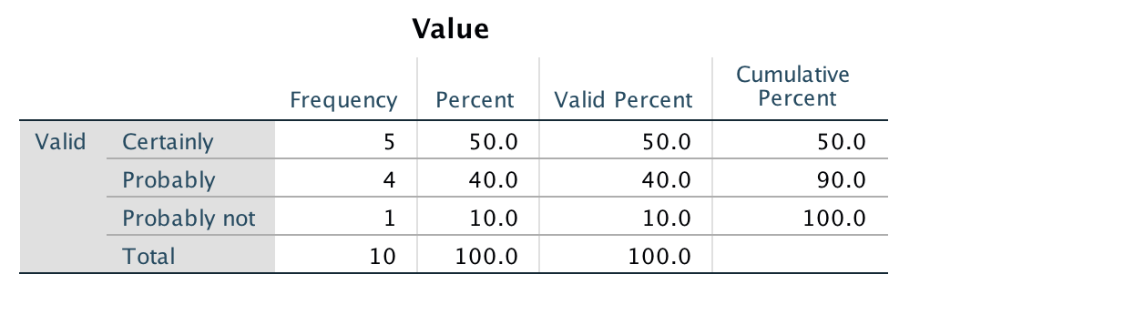
The majority of the sample group responded positively to paying more for ethically sourced clothing. However, the question only gives information on an intention rather than the actual buying behaviour.

Cross tabulation of results.
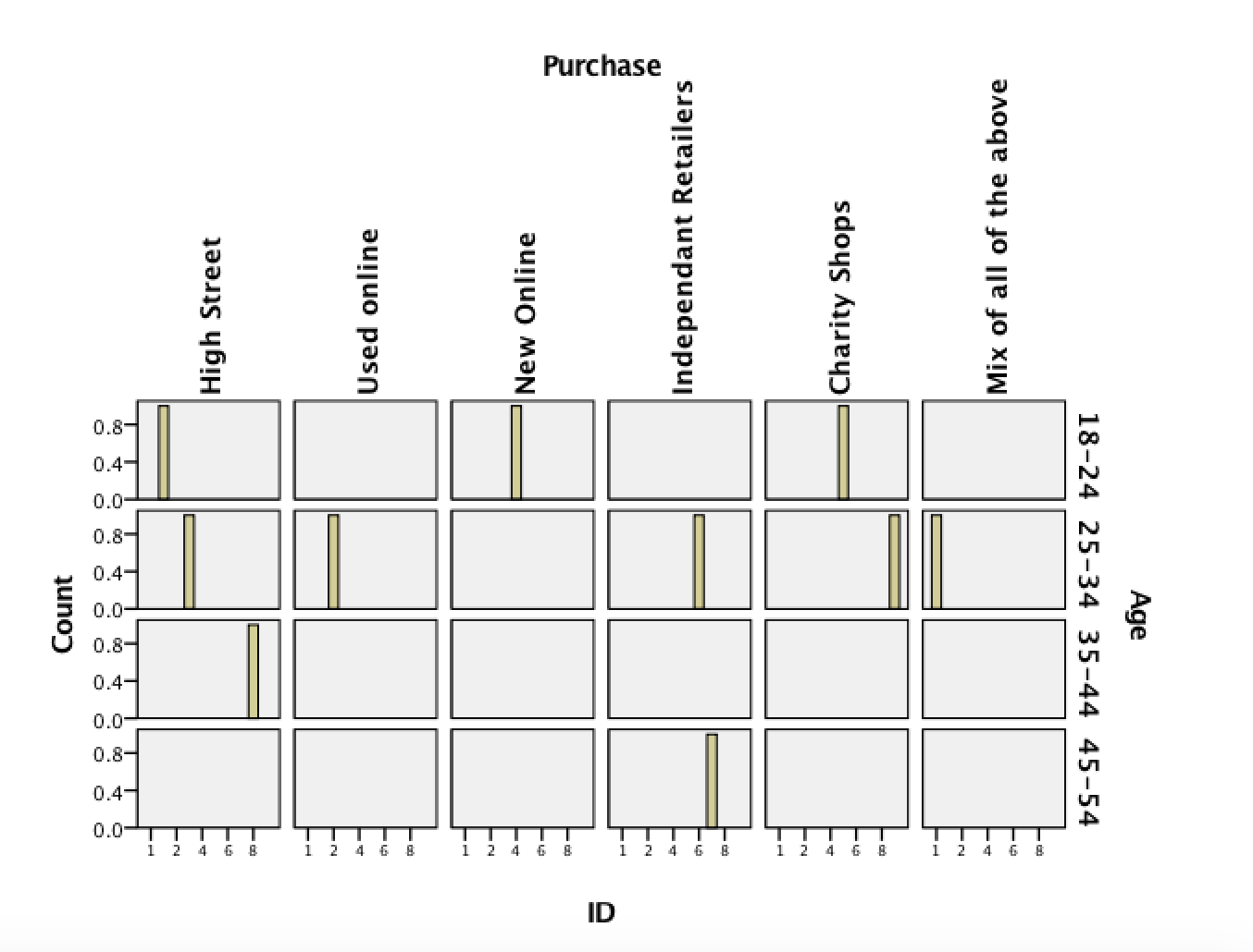
The graph above shows age and purchasing place. High street shops are popular throughout a wide range of age groups. Online methods appeal more to the younger generations. This may be because these generations have grown up using technology.

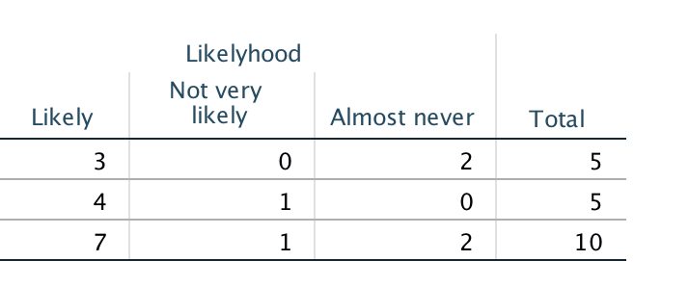

Male
Female

The above table shows a cross tabulation between gender and likelihood to purchase second hand clothing. Males are less likely to purchase second hand items than females. This is possibly because there is less variety of male garments in second hand shops.

Limitations of the data.
The small sample size is a limiting factor as it means that caution needs to be taken before generalising the results to a wider population. The convenience sampling method had similar limitations because of the restricted range of participants. A more random probability sampling method would have led to a more varied set of findings. An ‘other’ multiple choice option could have been added to the gender question to represent any participants who did not identify as either male or female.
Future research would need a larger sample group, more robust sampling techniques and longitudinal follow up to examine buying habits over time. It would be interesting to look at the amount of money spent in each sector and whether people are willing to pay more for ethical fashion. The methods of recycling garments are currently not diverse and there may be new ways of recycling in the future.

Conclusion
To conclude, there is now a growing awareness of the effects of a disposable fashion system. The clothing industry however has an interest in turning over cheap and disposable garments to increase profits. Changing fashions, cheaper production of clothing, social influences and media all contribute to the newly found perception that clothing is meant to be thrown away. The consequences are detrimental to the planet and unstainable. Possible future solutions include changing consumers buying habits, extended life cycles of clothing and recycling fabrics more effectively. The current practice is wasteful and imaginative solutions to meeting consumer, business and global needs must be found to ensure sustainability and protect the environment.
REFRENCES
Babbie, E. (2010). The Practice of Social Research. 12th ed. Belmont: Wadsworth Cengage.

Bain, M. (2015). Consumer culture has found its perfect match in our mobile-first, fast-fashion lifestyles. Quartz. https://qz.com/359040/the-internet-and-cheap-clothes-have-made-us-sport-shoppers/

Cross-Sectional Study Vs Longitudinal Study. (2019). https://www.questionpro.com/blog/cross-sectional-study-vs-longitudinal-study/

Ernst, A. (2003). Comparison of Qualitative and Quantitative Research. Munich: GRIN Verlag GmbH.

Future Generations Commissioner. (2019). A Globally Responsible Wales Archives. https://futuregenerations.wales/aotp/global-resonsibility/

Harrell, M., & Bradley, M. (2009. Data collection methods. Santa Monica, CA: RAND.

Muijs, Daniel. (2010). Doing Quantitative Research in Education with SPSS. 2nd edition. London: SAGE Publications.

Perry, P. (2018). The environmental costs of fast fashion. The Independent.
https://www.independent.co.uk/life-style/fashion/environment-costs-fast-fashion-pollution-waste-sustainability-a8139386.html

Ray, A. (2012). The Methodoloy of Sampling and Purposive Sampling. Munich: GRIN Verlag.

SurveyMonkey. (2019). It's All About Powering the Curious. https://www.surveymonkey.com/mp/aboutus/

Trochim, W. (2006). Social Research Methods - Knowledge Base - Types Of Questions. Retrieved from http://www.socialresearchmethods.net/kb/questype.php

Trochim, W., Donnelly, J., & Arora, K. (2015). Research methods. Ontario: Nelson Education.

Williams, C. (2007). Research Methods. Journal of Business & Economics Research (JBER), 5(3). https://doi.org/10.19030/jber.v5i3.2532

