Student Name: Alexandra Viorela Gjoka  Student ID: 2224326  Module Title: Foreign languages & Cultural Awareness  Module Code: BMIH5003  Lecturer: Lisa Bassler  Date: 09/02/2024 |  |  | 
ASSIGNMENT 1: PORTFOLIO
(4 Components)

Component 1: Professional Reflection (500 words +/- 10%)

Weighting: 25%

Component 1: Professional Reflection

Introduction
Premier Inn is the biggest hotel company in the United Kingdom with more than 800 locations and roughly 72,000 rooms. Premier Inn fosters an inclusive work environment by hiring employees from a variety of backgrounds. However, staff and guests frequently encounter language barriers as a result of cultural differences. I have seen similar situations in my role as restaurant manager within the establishment. This reflection will describe the encounters with cultural obstacles and provide strategies for overcoming them.

Discussion
I was working as an assistant general manager at Premier Inn Leicester Fosse Park Hotel. Cultural awareness and some knowledge of diverse languages are important for a hospitality business, the conflicts that occur due the cultural misunderstandings can reduce the company's image. I was recently confronted with an incident that highlighted the possibility of cultural misinterpretations within the food and beverage industry. A similar incident happened in the hotel restaurant during dinner service a few months ago. Due to the F&B staff's limited command of English, it was challenging to comprehend the guest's dietary requirements (Christiansen et al., 2020). Due to their varied cultural backgrounds, the guests had certain dietary needs because of their cultural beliefs. The guests made constant attempts to communicate their dietary requirements, but there was a great deal of confusion due to the language barrier. An avoidance of high uncertainty culture can be exemplified by the guest's particular dietary requirements based on their faith. Thus, it becomes essential to maintain precise guidelines and steer clear of complexity. Our restaurant staff's possible lower background in uncertainty avoidance may have caused confusion and caused them to disregard the guest's strict dietary requirements (Maheshkar and Sharma, 2018). Furthermore, linguistic nuances may give rise to cultural misinterpretations between patrons and staff in our restaurants. In this case, language barriers contributed to the already dire situation in addition to cultural unfamiliarity. I also discovered that it's critical to raise awareness and facilitate cross-cultural communication in our restaurant. I will need to improve the F&B staff at Premier Inn's communication skills to prevent similar incidents in the future. To improve the English proficiency of employees from different cultures, language training sessions must be offered. In addition, it is imperative to offer training in cultural sensitivity to foster respect and comprehension of customs and practices that affect visitors. I must set an example as the restaurant's manager. I must implement some strategic improvements that can help evaluate leadership abilities. In my opinion, the manner F&B department of Premier Inn Leicester can prevent cultural misunderstandings (Deresky, 2017).

Conclusion
The above discussion has concluded that knowledge of various languages and cultural awareness is important for the hospitality business. However, by this reflection, a common but important incident has been brought forward which can help in mitigating the issues by the organisational heads and its employees. Apart from that skills by which this kind of occurrence can be tackled have also been identified.

References
Christiansen, B., Branch, J.D. and Karmowska, J. (2020) Cultural Factors and Performance in 21st Century Businesses. Hershey : IGI Global.
Maheshkar, C. and Sharma, V. (2018) Handbook of Research on Cross-Cultural Business Education. Hershey: IGI Global. Deresky, H. (2017) International Management: Managing Across Borders and Cultures: Text and Cases. 9th Ed. Harlow: Pearson Education Ltd.
Component 2: Training Plan (500 words +/- 10%)

Identified cultural misunderstanding (in a few words) :
Cultural misunderstanding occurs due to personality and behavioural differences such as language, gestures, communication and many others. Moreover, cultural misunderstanding can occur when people speak more than one or two languages. The misunderstanding in culture can be mitigated by a training plan that is mentioned below.

Training plan (Why/What//Who/Where/When):
Skills to be improved | Training format | Important stakeholders |  | Training partner | Allocated budget
Enhancing English and other languages for the staff | 1. Employees who have less knowledge in English or other languages can be improved by providing some English or other language training classes.  2. Other than that active listening has the power to improve in a language and cross-cultural interactions.  3. The training can be provided from the speaker's viewpoint rather than simply a response on hearing (Abramson and Moran, 2018). | Staff who are native in non-English languages or in modern European languages can train other employees. |  | Other than that professionals in language training can also be provided by the organisation to decrease language barrier. | £ 6000
Cross-cultural communication | 1. Some resources such as video tutorials, and examples of real life appear to be beneficial in this case.  2. Some practice sessions of language discussion are also helpful in cross-cultural communication.  3. Rather than that, training session can also be provided in order to increase cross-cultural communication. | The HR department, management and F&B staff of the respected hotel, |  | Consultant in cultural languages or teachers that are hired for the discussion | £ 5000
Inclusive leadership | 1. Being an assistant general manager, it was my responsibility to enhance my leadership skills as this kind of incident never happened again.  2. Gaining comprehensive knowledge is helpful for me and by their possible impact inclusive decision-making procedures can be improved.  3. Additionally, taking workshops from the leaders is also beneficial for me (Hofstede et al., 2010). | Main stakeholder of this is the general manager of the Premier Inn. other than Supervisor along with the management team can be the stakeholder. |  | Expert leaders will be hired who can provide seminars to mitigate this issue. | £ 7000
Knowledge in diverse customs | 1. Some workshops can discuss the diverse rituals and habits by knowing which staff of the organisation can grab the attention of the customers having diverse cultures.  2. Staff at the Premier Inn also can be encouraged by organising and showcasing diversity along with its importance in the workplace.  3. Creating an open platform can also be crucial in this case and this also can provide cultural awareness to the staff (Hampden-Turner and Trompenaars, 2020). | Entire F&B Sector, guest lecturers, HR professionals along with training personnels. |  | Some leadership experts can be called from the nearby universities who have the ability to provide lessons in this case that are helpful for mitigating cultural awareness. | £ 8000
References:
Abramson, N.R. and Moran, R. (2018) Managing Cultural Differences: Global Leadership for the 21st Century. 10th Ed. Abingdon: Routledge.
Hampden-Turner, C. and Trompenaars, F. (2020) Riding the Waves of Culture. 4th Ed. London: John Murray Press.
Hofstede, G., Hofstede, G.J. and Minkov, M. (2010) Cultures and organizations: software of the mind. 3rd Ed. New York: McGraw-Hill.
Component 3: Student Self-Reflection (500 words +/- 10%)

Weighting: 25%

Description
While choosing the hospitality sector as my career path I did have not any proper knowledge about cultural awareness. On the other hand, my main focus is to provide excellent services to the customers without any cultural consequences. As the day passed, I came to know about cultural awareness and its negative impact as the knowledge is not adequate in the staff. I also acknowledged the diverse culture among guests, but I also did not pay attention to the impact of daily operations within the organisation (Dr Nicole Brown, 2024). However, it wasn't until after one particular incident in the eatery of the Premier Inn, my Level 4 position hotel, that I began to realise how crucial cultural sensitivity is to providing a better guest experience. It was confusion between a member of the restaurant's food and beverage staff and a customer who didn't speak the same language as him and wasn't able to express his dietary preferences.

Feelings
During that time when the guest shouted at the F&B staff as some ingredients were present in his meal, he was completely restricted by his physician. It was a surprising condition and I also felt uncomfortable at that time. Afterwards, I was a bit curious to understand the incident and I wanted to know what I should do to mitigate this (Pieper et al., 2021).

Evaluation
Upon analysing the incident that transpired at the eatery, I became immediately aware of the impact that cultural sensitivity could have on patron satisfaction and retention. It thus helped me to understand how neglecting the traditions and customs of other cultures could damage Premier Inn Leicester's reputation as a whole. My viewpoint quickly changed, and I began to see cultural sensitivity as an essential part of providing first-rate hospitality services.

Analysis
While analysing further, I came to know the importance of detailed training in cross-cultural interactions. It is also important for the hospitality industry to create an inclusive environment along with the preferences of the customers. The guests should feel heard, seen and respected or the cultural inclusivity remains to be unscored and disrupted long-term reputation to enhance guests satisfaction (Markkanen et al., 2020).

Conclusion
The cultural misunderstanding that transpired in the restaurant where I was placed served as a spur to my dedication to self-improvement in the area of cultural sensitivity. As a result, I started training programmes aimed at helping the F&B staff at the Premier Inn restaurant develop cross-cultural communication skills, language fluency, and understanding of customs. This proactive strategy was required to prevent any such cross-cultural confusion that might damage the hotel chain's reputation. As a result, there was a noticeable improvement in the team's dynamics as employees became more comfortable dealing with various kinds of visitors.

Action plan
After concluding the whole incident I need to implement some action plans that are important in order to mitigate cultural awareness within the organisation. A detailed training plan has also been provided in the above section. This gives a clear instance of what I should apply in my leadership operations in order to mitigate these problems. I have committed to some ongoing training processes and also participate in external workshops that help my staff to be confident enough while speaking in other languages (Nedelko et al., 2020).
References:
Dr Nicole Brown, (2024). Reflective model according to Gibbs. [Online] Available at: https://www.nicole-brown.co.uk/reflective-model-according-to-gibbs/ [Accessed 22 January 2024].
Nedelko, Z. and Brzozowski, M. (eds) ‘Recent advances in the roles of cultural and personal values in organizational behavior’ in Ordóñez de Pablo, P. (2020) Advances in Human Resources Management and Organizational Development Book Series. Hershey: IGI Global.
Markkanen, P., Välimäki, M., Anttila, M. and Kuuskorpi, M., (2020). A reflective cycle: Understanding challenging situations in a school setting. Educational Research, 62(1), pp.46-62.
Pieper, M., Roelle, J., vom Hofe, R., Salle, A. and Berthold, K., (2021). Feedback in reflective journals fosters reflection skills of student teachers. Psychology Learning & Teaching, 20(1), pp.107-127.
Component 4: Training Presentation (6 Slides)

Weighting: 25%
Slide
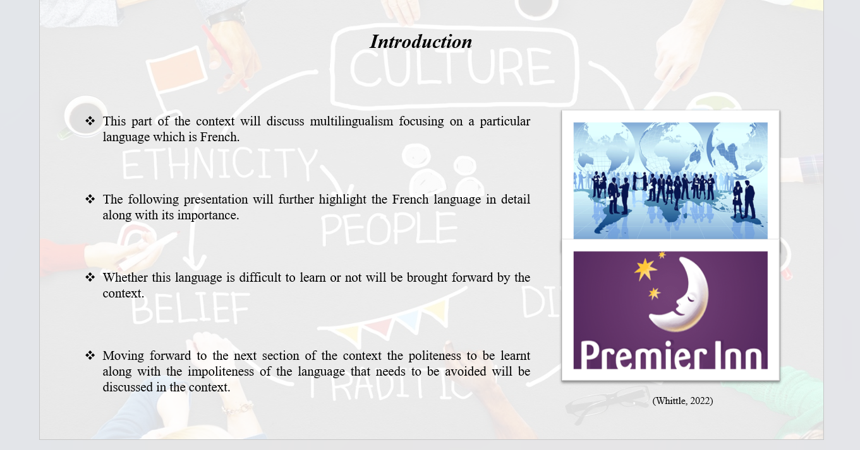
Notes

Introduction
This part of the context will discuss multilingualism focusing on a particular language which is French. The following presentation will further highlight the French language in detail along with its importance. Whether this language is difficult to learn or not will be brought forward by the context. Moving forward to the next section of the context the politeness to be learnt along with the impoliteness of the language that needs to be avoided will be discussed in the context.
Slide
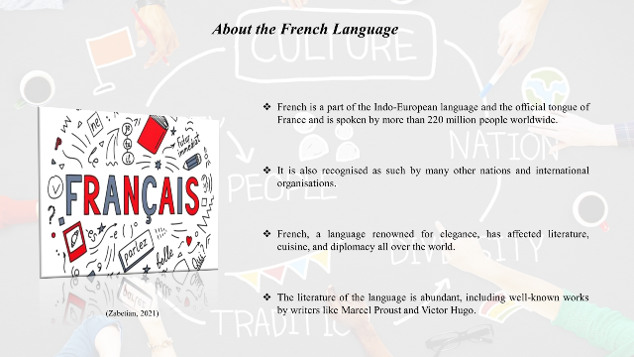
Notes

About the French Language
French is a part of the Indo-European language and the official tongue of France and is spoken by more than 220 million people worldwide. It is also recognised as such by many other nations and international organisations. French, a language renowned for elegance, has affected literature, cuisine, and diplomacy all over the world. Pronouncing words in French can be difficult because of liaisons and a nasal sound. The literature of the language is abundant, including well-known works by writers like Marcel Proust and Victor Hugo. Gaining access to a variety of cultures through learning French makes it an invaluable ability for travel, work, and academic endeavours (BBC, 2024).
Slide
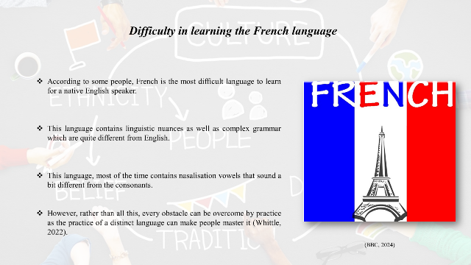
Notes

Difficulty in learning the French language
According to some people, French is the most difficult language to learn for a native English speaker. This language contains linguistic nuances as well as complex grammar which are quite different from English. Apart from that this language also has different sentence work order, which mostly depends on whether the speaker is focused on the sentence or not. This language, most of the time contains nasalisation vowels that sound a bit different from the consonants. This language has the greatest number of vowels and is so stressed from the English language. However, rather than all this, every obstacle can be overcome by practice as the practice of a distinct language can make people master it (Whittle, 2022).
Slide
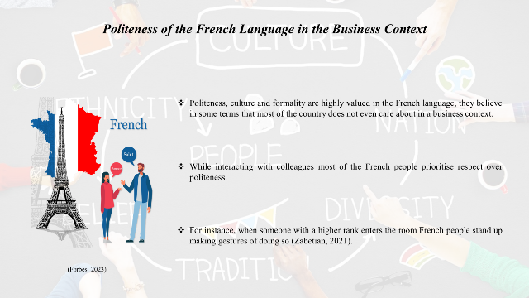
Notes

Politeness of the French Language in the Business Context
Politeness, culture and formality are highly valued in the French language, they believe in some terms that most of the country does not even care about in a business context. While interacting with colleagues most of the French people prioritise respect over politeness. For instance, when someone with a higher rank enters the room French people stand up making gestures of doing so (Zabetian, 2021).
Slide
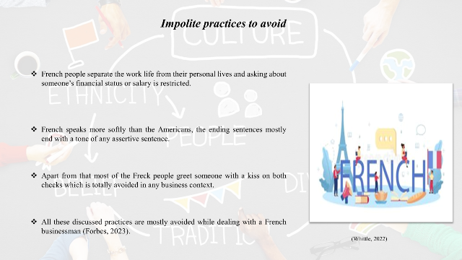
Notes

Impolite practices to avoid
French people separate the work life from their personal lives and asking about someone’s financial status or salary is restricted. French speaks more softly than the Americans, the ending sentences mostly end with a tone of any assertive sentence. Apart from that most of the Freck people greet someone with a kiss on both cheeks which is totally avoided in any business context. All these discussed practices are mostly avoided while dealing with a French businessman (Forbes, 2023).
Slide
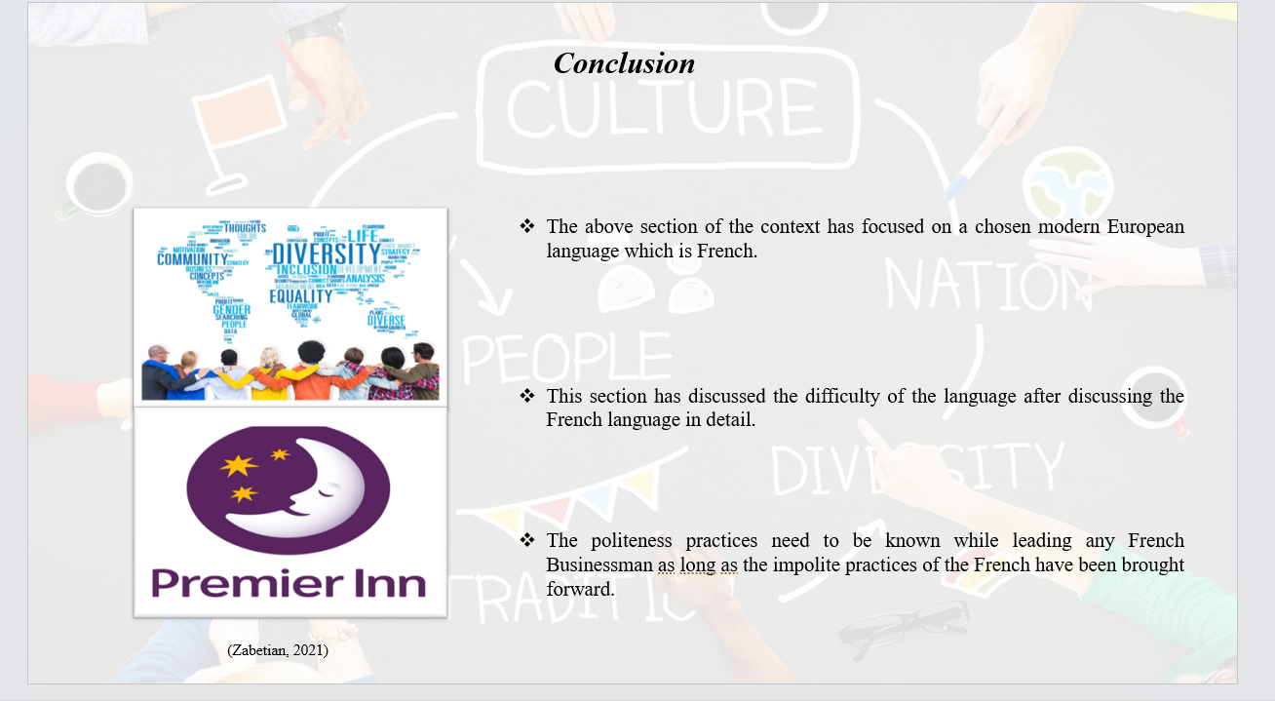
Notes

Conclusion
The above section of the context has focused on a chosen modern European language which is French. This section has discussed the difficulty of the language after discussing the French language in detail. The politeness practices need to be known while leading any French Businessman as long as the impolite practices of the French have been brought forward.
References
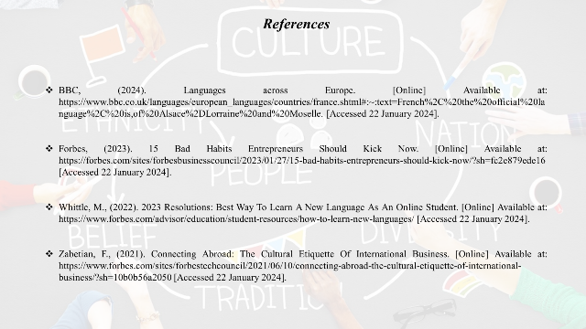
References
BBC, (2024). Languages across Europe. [Online] Available at: https://www.bbc.co.uk/languages/european_languages/countries/france.shtml#:~:text=French%2C%20the%20official%20language%2C%20is,of%20Alsace%2DLorraine%20and%20Moselle. [Accessed 22 January 2024].
Forbes, (2023). 15 Bad Habits Entrepreneurs Should Kick Now. [Online] Available at: https://forbes.com/sites/forbesbusinesscouncil/2023/01/27/15-bad-habits-entrepreneurs-should-kick-now/?sh=fc2e879ede16 [Accessed 22 January 2024].
Whittle, M., (2022). 2023 Resolutions: Best Way To Learn A New Language As An Online Student. [Online] Available at: https://www.forbes.com/advisor/education/student-resources/how-to-learn-new-languages/ [Accessed 22 January 2024].
Zabetian, F., (2021). Connecting Abroad: The Cultural Etiquette Of International Business. [Online] Available at: https://www.forbes.com/sites/forbestechcouncil/2021/06/10/connecting-abroad-the-cultural-etiquette-of-international-business/?sh=10b0b56a2050 [Accessed 22 January 2024].

