
2019
Matthew Howells
University of Wales Trinity Saint David
11/30/2019

Matthew Howells (1702520)
Project Management and Research Methods (ACCA5004)
Individual Project Report
(FACE)
Sue Maw

Tuesday 14th January 2019 3pm

Managing a Hardware/Software Project
Table Of Contents

1. Introduction: 2
2. Risk Management 3
2.1. Risk Evaluation Matrix: 3
2.1.1. What Is A Risk Evaluation Matrix? 3
2.1.2. Why Use A Risk Evaluation Matrix? 3
3. Identifying and Analysing Risks for project 4
4. Code of Practice 7
4.1. Sustainability Issues 7
5. Sustainability Issues of The Smart Brain Project 7
5.1. Using Software and hardware Duplicates 7
7. Ethical and Legal issues for the project 10
7.1.1. British Computer Society Code of Conduct 10
7.1.2. IET Code of Conduct. 10
8. General Data Protection 10
9. Quality Assurance Issues 10
9.1. Appropriate quality metrics. 10
10. References 11
11. Appendix 12

Introduction:

This document is a report built on a Group Project known as “Smart Brain”. The objective of the Smart Brain project is to attempt to plan and implement a software application which can be used as a way of assisting elderly individuals and dementia sufferers 24 hours a day. It is a fact that as lifestyles move on individuals start developing certain amounts of difficulties throughout their daily lifestyle. This means more support must always be made available. The planned application shall have the ability of providing essential everyday services which can be controlled by family or carers as well as streaming information through an earphone device.
This earphone shall be controlled using the implemented app which can be accessed through a selection of technology devices. The use of technology and mobile phones has become a popular part of individuals everyday life and certainly used more than computers. This is the most ideal way to communicate information using applications. Some Examples of the embedded services include carers information, Family contacts and Photographs, medical information plus other important materials. Unfortunately, the need for support is increasing as illnesses continues to escalate in families. We believe Smart Brains services may help make those lives easier.

Risk Management

2.1. Risk Evaluation Matrix:

2.1.1. What Is A Risk Evaluation Matrix?

A Risk Evaluation Matrix is a common style of grid used during a risk assessment stage. This breakdown can be extremely useful especially while planning to analyse hazards. The grid can be created by using a 4x4 dimension. This can be used to break down, analyse and assess different levels of risks. This matrix aims to split each risk into suitable sections while predicting possible impacts that could apply while working on different projects.

2.1.2. Why Use A Risk Evaluation Matrix?

People may choose to use this method due to the fact it is useful while trying to categorise different risks. This method reflects different ways of categorising due to the fact the methods are based on the probability of the risk occurring. By identifying potential risks project leaders can prioritise and improve team actions in order to prevent further problems along the way. It is always ideal to control risks beforehand.
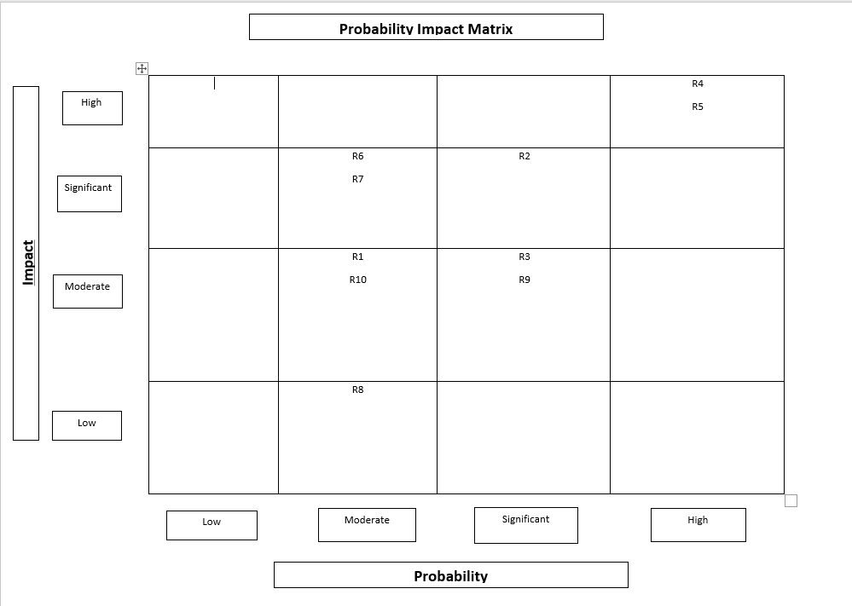

Identifying and Analysing Risks for project

Every project continuously transports a selection of risks. This project report identifies and reviews how risks has an overall effect on projects. The objective is to recognise exactly how risks can be analysed by using a selection of different methods. This can successfully lead to expanding certain skills within a team. In order to succeed we must explore how embracing identified risks can lead to becoming successful.

  - Change of team Management – R1

As time develops every company requires certain amounts of transformations in order to survive. All company transformations and progression should be annually reviewed in order to maintain a strong relevant structure for the business. Businesses must plan beforehand by using a coordinated business plan before executing any team changes [1].

  - Stakeholders – R2

Stakeholders express an interest in the involvement of any project. The most important part of any project is the role and management of stakeholders, and just how the use of communication is enforced during the process. While conducting risk management, it is always perfect to have a selection of stakeholders who intend to fully approve and support the project. In order to support stake holders, it seems ideal to address the use of Stake holder Management techniques [2]. This technique splits the positive impacts and minimises the effect of the negative effects on an overall project. The management techniques can be identified as: -
- Identifying potential stakeholders;
- Assess stakeholders’ interest and influence within a project;
- Develop communication strategies within the team;
- Involvement and influence of stakeholders within future proposals.

  - Financial Costs – R3

While implementing a project the amount of financial facts can always cause a disruption on how a development intends to go forward. The risk of financial, costs, such as, cost estimations can easily become underestimated unfortunately leading to overspends. This can be prevented by producing and maintaining a finance Document containing expected expenses in a spreadsheet based on the entire project. This remains crucial as this is where the actual project costs are maintained considering a set budget allowance linked to project. Ideally, a dedicated team member could hold full responsibility controlling any flow of financial costs. Any crucial financial matters must be professionally investigated, discussed and fixed with the full team.

  - Health and Safety – R4

Health and safety is a critical category that requires fully accurate and professional arrangements within any organisation or business industry. As the senior represented the teams dedicated project manager remains the most responsible for addressing this point ensuring everything is fully considered. As expected, this happens to be critical in any industry, especially while conducting any team experiments. For all team members to work safely within a healthy and suitable environment a formal risk assessment addressing any external hazards must always be produced and followed. This can include first aid as a precaution to treat any injuries’ during the process.

  - Timescales – R5

In order to carry out a successful group project, as expected group members must identify any timescales for performing each task professionally, as well as, the amount of time required. A timescale can be a planning schedule breaking down the amount of time each member must spend implementing each task. Timescales are flexible due to the fact Individuals could easily underestimate the amount of time required for a task. Schedules can usually be adjusted by possibly granting additional time which can be sensibly used in order to allow members to get back on track.

  - Feasibility – R6

Feasibility can help determine whether a project has the possibility of having a space within the industry and how the business idea has the possibility of performing, based on a certain financial budget. Potentially, some business ideas may not be suitable for purpose or possibly may have already been developed. In order to avoid these circumstances, it is always ideal to conduct further marketing research on any business ideas before commencing to write any planning documents. This is known as a Feasibility Study in market management [3].

  - Quality – R7

The quality of an implemented project can always be challenging due to the fact a planned prototype may not completely match an original or expected idea. This can lead to potential losses within projects as nobody may wish to purchase the product if an improved version is available. Potentially, customers expect high quality products to suit their sufficiency [4].

  - Suppliers – R8

Businesses may rely on certain suppliers to deliver technical equipment in order to implement a product idea. Unfortunately, products could arrive late leading to disruptions to schedules. While purchasing technology it is always wise to use reliable suppliers in order to avoid delays in services [5].

  - Skills – R9

In order to carry out a successful development within the business industry each associate within a team must hold a high quantity of skills. These skills and capacities could be useful and developed further. As technology develops further resources are produced opening new opportunities for enterprise environments [6]. For businesses to understand further developments certain skills must be redeveloped further. It is always ideal to research further skills in order to continue learning while aiming to develop a successful organisation.

  - User Acceptance – R10

While carrying out any type of project; user acceptance members shall, ideally, make use of member acceptance training [7]. This strategy can helps settle any problems along the line while seeing how certain individuals interact overall.

Code of Practice

Sustainability Issues

Project managers seek to establish a relationship by combination between project management and sustainability methods. As expected within project organisation Sustainability is one of the most important points within project management. It is a fact that sustainability needs to be assessed and considered on a few occasions. This can be identified as the environment, local economy, and society in general. Based on national changes, there has been an immense increase in sustainability policies for selected reasons. For this reason, there is a huge importance to understand the topic of sustainability and how small changes can make. Difference.

Sustainability Issues of The Smart Brain Project

Using Software, hardware Duplicates

As society matures further software changes must be implemented going along with society. Overtime hardware will begin to change to a certain extent. Unfortunately, this can always lead to former versions to become redundant. This leads to components demanding overpriced upgrades in order to keep supporting software or the installation of new parts. This computer technology that allows us to keep reusing software on multiple systems helping cut down on pollution as well as financial costs. This can help avoid wastage on unused parts and machinery. Project managers can also ask: -
- Are the resource manufactures efficient?
- Can any Recycled Components be reused?

  - Community

A successful project manager should always pursue to engage with members of the team. In order to have a positive and helpful influence on team members it is always ideal to consider the amount of sustainable methods throughout the community during the construction of any prototypes. This can encourage students to work together in order to work towards cutting down on pollution rather than working individually. As a team everybody must work together in order to establish and complete the assigned tasks correctly.

  - Policies

As time moves on companies are establishing and engaging with a selection of policies. Policies define the context for management practices on individual levels. Sustainability Policies can help companies make their products much more marketable. These policies can have a positive influence on companies encouraging them to change how they run businesses. This can help cut down on budgeting in order to save money and balance additional funding. This point addresses that companies can be much more sustainable if they address a sustainable policy within their final product.

  - Product lifecycle

The Product lifecycle is an important method taken toward dealing and maintaining the steps towards the existence of a product while taking sustainability into account. This is to guarantee that any damaging impacts on the environment is minimized as much as possible. This can help to evaluate the environmental impacts of a product or a service throughout its full life cycle.

  - Business continuity

Business continuity is approximately known as having a backup strategy to deal with tough circumstances. This ensures that organizations can continue to function with as little disruption. An example could a power cut where certain information could unfortunately get lost or corrupted. By having a backup in place administrators can still offer their data in order to resume. Unfortunately, most automatic back up methods require the use of power.

  - Project legislation

Project legislation is known as Recognising the current legislation laws, rules and regulations, while searching to comply with them while creating a project. In order not to come to be into trouble full investigation must be carried out in order to prove the set rules.

  - Pollution

Pollution could be common problem within this project due to a certain quantity and factors. As this project requires a high amounts of electrical features certain alterations would be essential in order to help cut down on pollution. This can be completed by asking What exactly is the Power usage of this project and how can power be cut down in order to save energy.

- Possible Requirements affecting sustainability

Database Designer | Software Developer | Electronic Engineer
Data centres can request the use of cooling features while generating their data. This still uses power which can have an impact by giving off air pollution. | Software Developers rely on working hardware to produce the correct software for companies | Electronic engineers require plenty of power resources
Data analysers use Cloud storage in order to store data which is not green. | Developers can establish connectivity to a database provided by Data Analysers | Electronic Engineers Occasionally require the Use of Batteries
A High amount of Power Availability is required in order to generate and store people’s data. | Developers rely on Top quality software in order to program pieces of software | High quality Electronics could Possibly lead to the Overload of any computer systems
A large amount of data required in order for app to communicate |  | Requires a High amount of availability of power resources. This can include energy efficient lights, motors, appliances, and heating and cooling systems.
Continuous involvement within people’s daily lives |  | Use of Planning documents which unfortunately are usually printed on paper.

- First, second and third order sustainability issues for the project.

  - First order sustainability issues for the project

First order sustainability issues focus on individuals that benefit from the existence of the Smart Brain Project and the process of making the application available to assist vulnerable individuals at sensible rates. For example, various people must be trained using different pieces of hardware in order to implement the outcome. This can include involved manufactures and developers who may focus on the production of the implementation.

  - Second order sustainability issues for the project

Positive Consequences | Why should the project happen? | What will be pursued?
Teams can conduct meetings online instead of travelling to the university campus | Aims to deliver outstanding care
 | Provide Jobs for others
 | Allow further communication with others

- What changes can be made for the company to conduct themselves

7.3. Third order sustainability issues for the project

- long term changes of society as a result if people change how they work
- long term impacts

Ethical and Legal issues for the project

British Computer Society Code of Conduct

IET Code of Conduct.

General Data Protection

Quality Assurance Issues

Appropriate quality metrics.

References

[1] | A. Phillips, “How to Lead Your Team Through Change,” Entrepreneur Europe, 1st August 2014. [Online]. Available: https://www.entrepreneur.com/article/235832. [Accessed 30th Janurary 2020].
[2] | E. Verzuh, “Stakeholder management strategies,” Project Management Institute, 13 September 2005. [Online]. Available: https://www.pmi.org/learning/library/stakeholder-management-strategies-applying-risk-management-7479. [Accessed 31 Janurary 2020].
[3] | “What Is a Feasibility Study in Project Management?,” wrike.com, 19 Jan 2006. [Online]. Available: https://www.wrike.com/project-management-guide/faq/what-is-a-feasibility-study-in-project-management/. [Accessed 20 Jan 2020].
[4] | D. Greenblatt, “5 Steps to Improve Quality,” www.inc.com, 22nd Jan 2014. [Online]. Available: https://www.inc.com/drew-greenblatt/5-steps-to-improve-quality.html. [Accessed 30th 01 2020].
[5] | K. Corrigan, “Supplier,” Oberlo, 18 Oct 2018. [Online]. Available: https://www.oberlo.co.uk/ecommerce-wiki/supplier. [Accessed 20 Jan 2020].
[6] | E. Klein, “Technology is changing how we live, but it needs to change how we work,” vox, [Online]. Available: https://www.vox.com/a/new-economy-future/technology-productivity. [Accessed 31 jan 2020].
[7] | G. Contributor, “Understanding User Acceptance Testing in a Project,” Project Management Works, 8 May 2015. [Online]. Available: http://www.projectmanagementworks.co.uk/understanding-user-acceptance-testing-project/. [Accessed 30 Jan 2020].

Appendix

