EFFECTS OF STAFF SHORTAGES ON EMPLOYEE MOTIVATION, RETENTION, AND RECRUITMENT STRATEGIES: A CASE STUDY OF IBIS LONDON CANNING TOWN

Name: Patricia Menendez Hernandez
Student Number: 2111630
Module Name: Hotel Placement Research Project
Module Lead: Ernest Balutie Wavei.

AI Acknowledgement
I confirm that I have not presented any AI-generated text as my own work. I confirm I have copies of my drafts, notes, and other resources I used before and after using AI tools, which I may be asked to provide in evidence.
Executive Summary
This report discusses the effect of staff shortages on motivation, retention, and recruitment strategies in the hospitality industry concerning Ibis London Canning Town. The main objective is to examine the present staffing problem and its impact on the morale and job satisfaction of its employees and the ability of the hotel to recruit and maintain competent staff. The first section gives a background of the Ibis London Canning Town with regard to operations and a snapshot of the staffing problems faced. Analysis of current literature gives insight into patterns of issues, including staffing in hospitality businesses, which lead to insights that have bearings on employee motivations and turnover and changes in recruitment practice. Part of the research evidences the internal challenges at Ibis London Canning Town, such as the hotel's reliance on minimum wage pay, the lack of career development opportunities, and insufficient training programs—all these factors culminate in low morale among the employees, high staff turnover rates, and difficulties in retaining skilled workers. PEST and SWOT analyses will be conducted with a focus on the internal and external factors affecting staffing levels and, in particular, how changes in the labour market, especially post-COVID and Brexit, have exacerbated the shortfall in staffing. The report concludes with some recommendations on how to increase staff motivation and retention at the Ibis London Canning Town. Recommendations include better provision for training and progression opportunities, a review of the wage structure, and improvement in recruitment strategies. These are the areas that are not only important for smooth hotel operations but also for having motivated and stable employees. These results, therefore, point out the urgency for action to be taken within employee development and compensation to successfully battle the ongoing challenges of staff shortages in the hospitality industry.

Contents
Introduction 5
Literature Review 6
Causes and Impact of Staff Shortages in the Hospitality Industry 6
Employee Motivation and Job Satisfaction in Hospitality 7
Employee Retention Strategies Amidst Staff Shortages 8
Recruitment Challenges and Strategies in the Hotel Industry 9
Research Gaps and Future Directions 10
Methods 10
Case Study Approach 10
Data Collection Techniques 11
Reflective Writing and Netnography 12
Data Analysis 12
Limitations 13
Case Study Discussion 13
Overview of Ibis London Canning Town 13
SWOT Analysis 15
Strengths 15
Weaknesses 16
Opportunities 16
Threats 17
PEST Analysis 18
Political Factors 18
Economic Factors 19
Social Factors 19
Technological Factors 20
Competitor Analysis: Price vs Quality 21
Comparing the Price and Quality Ratings 23
Netnography 23
Theme Exploration 24
Staff Shortages and Their Impact on Employee Motivation 24
The Role of Employee Retention in Combating Staff Shortages 25
The Challenges of Recruitment in Times of Staff Shortages 26
Areas for Development and Improvement 28
Conclusions and Recommendations 29
Conclusion 29
Recommendations 29
Increase Employee Wages and Benefits 29
Invest in Career Development and Training Programs 30
Adopt Flexible Working Hours and Part-Time Options 30
Leverage Technology for Recruitment and Staff Management 30
Improve Employee Engagement through Recognition and Feedback 31
Reflective Account 31
References List 35

EFFECTS OF STAFF SHORTAGES ON EMPLOYEE MOTIVATION, RETENTION, AND RECRUITMENT STRATEGIES: A CASE STUDY OF IBIS LONDON CANNING TOWN

Introduction
Working in the hospitality industry can be one of the challenging tasks at the best of times; however, during the prolonged post-pandemic period, where staff shortages and turnover are at historically high levels, working in a service role is tougher than ever. Fourth (2022) report suggests that an average of 6% of hospitality workers leave their jobs every month. As companies look for suitable replacements, this puts further pressure on those staff left behind. But with the industry still finding its feet in a post-pandemic world, what is currently driving these shortages in hospitality? These problems are particularly visible in hotel operations, where high employee turnover, serious recruitment difficulties, and poor employee motivation become increasingly troubling. Ibis London Canning Town is part of the Ibis hotel brand, a globally recognised budget hotel chain operating under high demand in East London, serving business and leisure travellers (Sylvestre, 2022). However, despite the hotel's strong brand reputation, it has been facing huge staffing challenges that have led to high employee turnover, particularly in front-line roles. While these are not problems isolated to Ibis London Canning Town, the general hospitality industry has been suffering from staff shortages in part due to post-pandemic changes in the labour market and the economic impacts of Brexit. The dependence of the hotel industry on minimum wage labour, coupled with few opportunities for career progression, has exacerbated this further. This report will aim to achieve the following objectives:
- To investigate the effect of staffing shortages on the motivation, retention, and job satisfaction of Ibis London Canning Town employees.
- Review the effectiveness of the hotel's existing recruitment and retention strategies and recommend areas for improvement.
- To provide actionable recommendations for enhancing employee motivation and retention in light of the ongoing staffing challenges.
This paper will seek to solidify further the impact of work-life balance, compensation, and job security on turnover among hospitality industry employees (Grigoryan, 2024), hence serving the wider hospitality industry staff retention strategies (Dogonyaro, 2021). Using the case study of Ibis London Canning Town, the report will shed light on how hotels can adapt their human resource strategies in response to these persistent staffing issues.

Literature Review
This section critically reviews the causes and effects of staff shortages within the hospitality industry, focusing on employees' motivation, retention, and recruitment strategies. It considers how understaffing impacts workforce stability, especially in budget hotels. Moreover, it will review current retention strategies and their efficacy in identifying gaps in research about talent retention and workforce sustainability within the budget hotel setting.

Causes and Impact of Staff Shortages in the Hospitality Industry
The main drivers of staff shortages in the hospitality sector include low wages, inadequate career progression, and post-pandemic labour market changes. According to Marketing (2024), high employee turnover rates have been very common in the hospitality industry, while COVID-19 has resulted in many employees losing their jobs and others not returning to work in the industry. Brexit has also worsened the situation in the UK by reducing the supply of EU workers, who were a great source of workers for a long time (Wong et al., 2021). Poor working conditions, long hours, and perceived instability also make hospitality jobs unattractive to workers and cause chronic short-staffing (Helloshift, 2023).
The effects of staff shortages have been wide-ranging. Operational efficiency falls as it becomes difficult for hotels to maintain service quality when remaining employees are overworked and make longer shifts to compensate (Waller, 2021). Thus, this leads to burnout, dissatisfaction with jobs, and further quitting, thus starting a cycle of attrition (Alonso et al., 2020). Customer experience also suffers as service delays and overworking of employees lead to poor reviews and reduced guest satisfaction (Jobs, 2023). Furthermore, businesses are exposed to more recruitment challenges, where poor job conditions and lack of career development opportunities deter potential candidates from the industry (Undefined, 2022). These require structural changes in terms of better wages, career progression schemes, and improved working conditions to increase staff retention and the industry's attractiveness.

Employee Motivation and Job Satisfaction in Hospitality
The issues of motivation and job satisfaction are instrumental in addressing the staff shortages and the rate at which staff leave the hospitality industry. Motivated work will ensure quality delivery of services to minimise turnover (Chung et al., 2021). However, hospitality has been severely criticised for presenting very few opportunities for career advancement, with poor wages and demanding working conditions. All this results in poor motivation and job dissatisfaction among employees within the hospitality industry (Giousmpasoglou and Marinakou, 2024). According to Dayour and Adam (2021), work-life balance, employee compensation, and training and development potential mean the most job satisfaction in the hospitality industry. Most hotels worldwide, including the Ibis London Canning Town, tend to under-invest in providing career development opportunities or required training to their staff to keep them motivated for the job. Irabor and Okolie (2019) found that staff will always feel stuck in their positions, leading to job dissatisfaction and increased potential for quitting.
In terms of retention, Almeria (2023) posits that a strong organisational culture can noticeably influence the level of motivation in employees and, thus, job satisfaction. Eladawi (2024) posits that a positive workplace where individuals feel valued and supported would help offset the prevailing staff shortages in that it will make employees not easily leave organisations. However, according to Chopra et al. (2023), for those hotels paying minimum wages with minimal training available to the employees, such as Ibis London Canning Town, building a positive culture and motivating employees is a big challenge.

Employee Retention Strategies Amidst Staff Shortages
It is becoming increasingly difficult to retain staff in the hospitality industry, especially in the budget hotel segment, in the face of chronic staff shortages and poor working conditions. Heavy workloads, low salaries, and poor prospects for professional growth cause high turnover rates and intensify operational instability (Staff, 2024). According to Ghani et al. (2022), retention strategies should address these underlying issues and not merely offer short-term incentives. For example, competitive wages alone are inadequate if workers have no job security or professional growth prospects.
Work engagement may be one of the most pivotal factors that might decrease turnover since Green HRM practices increase employees' commitment via an ethical work environment and sustainable business models (Al-Hajri, 2020). Much of this revolves around budget hotels, where the budget controls often focus more on short-term profitability than long-term retention (Leahy, 2024). Moreover, Done (2024) indicates that employers who do not improve retention worsen the staff shortage problem since constant turnover increases costs related to recruitment and decreases service quality. Staff shortages will continue without structured career development, fair compensation, and improved working conditions, creating a cycle of disengagement and high attrition.

Recruitment Challenges and Strategies in the Hotel Industry
While recruiting staff in hospitality businesses is usually complex, it is even more challenging due to staff shortages filling new hotel positions. As Al-Suraihi et al. (2021) mentioned, low wages associated with most hospitality positions discourage potential employees from participating in the sector. When compounded by the low-wage job stigma, this makes it rather difficult for these hotels to find good candidates for such positions—especially frontline staff (Banyeva, 2023).
Still, against the backdrop of challenges in recruitment, many hotels have adopted innovative strategies in recruitment, including digital platforms, social media, and employee referral programs (Chopra et al., 2023). Still, these may attract candidates but never solve the real problems of low wages, poor job satisfaction, and a lack of career progression that are, in turn, the cause of high staff turnover. Ujji (2023) further argues that hotels need to concentrate less on trying to get people and more on improving experiences for their present workers through competitive wages, opportunities for career growth, and a great workplace environment if they want to overcome all recruitment challenges. Such difficulties in recruiting hit harder when there is a staff shortage. Amadhila (2022) outlines that understaffing leads to delays in services and a decline in customer satisfaction while increasing the load on other existing employees, further increasing turnover. Sonmez, Liu and Mistry (2023) also discovered a vicious circle in which high turnover worsens the staff shortage, making it increasingly difficult for hotels to recruit and retain new ones.

Research Gaps and Future Directions
Several insights have emerged concerning the issue of staff shortages and employee retention in the hospitality industry; however, much of this research has overlooked the peculiar challenges that independently operated budget hotels—like Ibis London Canning Town—have to face in terms of strategies for recruitment and retention. A related area needing further research is how shortages impact motivation among the lowest-paid, highly turned-over staff to seek further career development or better work-life balance (Michael and Fotiadis, 2022). Longitudinal analyses of retention programs should be at the core of future research, and the extent to which technology can support efforts to mitigate staffing shortages without undermining employee well-being needs to be examined.

Methods
This section discusses the methodology to be used in the analysis of staff shortage issues in relation to the hospitality industry as applied to Ibis London Canning Town. It reflects on the discussion of the case study approach, data collection methods, and analysis techniques in understanding causes, effects, and possible solutions to the challenges of staffing for the hotel. Further, this section discusses the use of reflective writing and netnography in a complementary manner, so as to ensure comprehensiveness in relation to the research topic.

Case Study Approach
The research adopted a case study approach. It was based on Ibis Canning Town, the company's flagship property within Accor. The Accor Company majors in middle-scale hotels. It meets customers' highest expectations with moderate operation costs at lower prices (Accor, 2022). In keeping with this, the selection of Ibis Canning Town will research on-ground the challenges faced in the hotel's operation and staffing and their implication in the broader hospitality industry trends. According to Yin (2003), a case study is appropriate for exploring complex issues in a given context because it allows the researcher to delve into depth regarding the problem under investigation.
The approach also offers valuable lessons in the direct impact of staff shortages on operational efficiency, service quality, and employee turnover rates. Yin (2003) argues that, as a strategy, case studies offer 'rich, contextual analysis' that is particularly appropriate to exploring issues such as staffing within the specific context of Ibis Canning Town. Concurrently, this presents limitations about the generalisability of the study. Also, findings from one location may not be generalised to the rest of the hotels in other regions because of huge variations in organisational culture, employee demographics, and managerial practices (Saunders et al., 2012). Through the case study method, factors likely to affect staff shortages at the Ibis in Canning Town could be researched in detail to establish generalities in improving practices that could apply throughout the industry.

Data Collection Techniques
Qualitative and quantitative data-gathering methods must be considered to have a holistic view of the staffing issues at Ibis Canning Town. According to Yin (2003), case studies use triangulation, which is more than one source of information, to enhance the validity and reliability of the findings. Semi-structured in-depth interviews were conducted with key stakeholders such as front desk staff, management and human resource personnel (Tiwari, Srivastava and Kumar, 2019). This allowed us to probe their views on staff shortages, how they affected daily operations, and how they would tackle such a problem. The work of Marshall and Rossman (2015) informs these interviews as they describe the value of semi-structured interviews in obtaining detailed and nuanced responses.

Reflective Writing and Netnography
Additionally, this paper used reflective writing to document the personal experiences and observations of the researcher during the study apart from case study and data collection approaches. Since reflective writing is strongly suggested as an instrument in qualitative research improvement, it gives researchers the ability to explore their biases, emotions and multiple insights into the subject matter (Heinonen and Medberg, 2018). Such a practice allowed for the subjective lens through which to view organisational dynamics and an emotional impact on employees and guests due to staffing shortages. Such reflection served me well in more fully grasping the nuance of an issue otherwise explored via more structured methods of data gathering. Besides, netnography was used to search online forums and reviews by employees and guests, sharing experiences regarding the hotel's staffing practices and service quality (Pell, 2023). This helps especially in capturing the voices of employees who may not be so forthcoming in a formal interview setup; it also becomes essential to gain insight into the customers' perceptions of how the hotel works (Grbich, 2013). Furthermore, through netnography—that is, analysing comments and discussions on social media and review websites—further insights were brought to light on the reputation of the hotel, its staff management practices, and customer satisfaction.

Data Analysis
This study carried out data analysis using both thematic and statistical techniques. First, the qualitative data from the semi-structured interviews and online reviews are analysed using the thematic analysis technique guided by Lochmiller (2021), which helps identify repeated themes related to staff shortages, employee satisfaction levels, and different management practices. This approach might expose key factors contributing to staff turnover and operational inefficiencies at Ibis Canning Town through coding data and identification of essential patterns. Quantitative data was analysed by statistical methods to scrutinise some of the most important operational metrics, which included turnover rates, absenteeism, and workload distribution. The mentioned data was analysed to establish whether there was a statistically significant relationship between staffing shortages and operational inefficiencies. Besides this, the effectiveness of any retention strategies implemented was also assessed. According to Noyes et al. (2019), the combination of both qualitative and quantitative approaches gives a much more holistic view of the issue, allowing for strong analysis accounting for numerical patterns and the experiences of people.

Limitations
The major limitation lies in the generalisability of the findings. As Yin (2003) points out, case studies are context-specific, and hence, their findings may not apply to other hotels or regions, particularly those with different operational strategies, staffing models, or organisational cultures. This is strengthened by the fact that it involves both qualitative and quantitative data. On the negative side, being based on self-reported data—particularly from the employees—introduces bias. Employees might feel obliged to give answers that would please an organisation since such responses have the potential to skew results. According to Wowor et al. (2022), guests may have biased responses due to experiences which are exceptionally good or bad.

Case Study Discussion

Overview of Ibis London Canning Town
Ibis London Canning Town is a midscale hotel located in East London and is part of the Accor Group (2021), the world's largest hotel chain. The Ibis chain provides simple, low-cost stays without skimping on comfort for business and leisure travellers on a budget who do not want to pay premium prices. This makes the Canning Town branch very versatile, with approximately 150 rooms, catering to a wide range of clientele from city tourists to corporate guests attending Excel London Exhibition Centre (IBIS n.d). Probably one of the strongest selling points of this hotel is its accessibility, as it lies close to major transport links such as the Jubilee Line and London City Airport, hence easily placing central London and the areas around it at the guests' disposal.
The hotel features a relatively small number of employees, as there are roughly 30 staff members within the key front office departments, housekeeping, and maintenance. This number of staff usually suffices for normal operations (Tripadvisor, n.d). However, during periods of high occupancy, such as big local events and high seasons, it becomes a big challenge for the hotel staff to cope with increased demand by the guests for the maintenance of quality of service and perhaps even the well-being of employees. Meanwhile, given the average occupancy rate of 75% annually, the increased demand for events around venues such as festivals and conferences will make staffing pressures inevitable and thus lead to stressful working conditions for the employees.
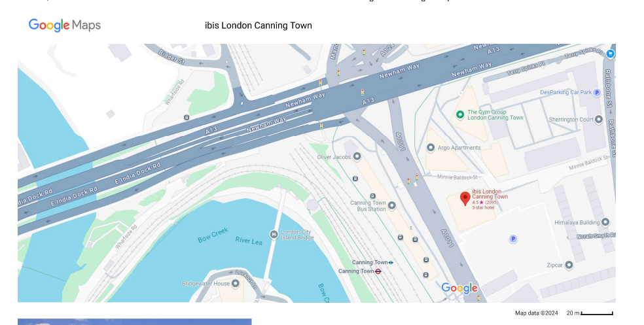
Google map Location for Ibis London Canning Town Hotel. Accessed at https://maps.app.goo.gl/cWgjeQzA2zZqVYwj7

SWOT Analysis

Strengths
Ibis London Canning Town is a midscale hotel in East London and part of the Accor Group, the world's largest hotel chain. The Ibis chain offers simple, low-cost stays without skimping on comfort for business and leisure travellers on a budget who do not want to pay premium prices (Malony, 2011). This makes the Canning Town branch very adaptable, with a projected 150 rooms that should accommodate a range of guests, from city tourists to business visitors accessing the Excel London Exhibition Centre. The location is one of the strongest selling points of this hotel, as it lies close to major transport links, including the Jubilee Line and London City Airport. Hence, it is easy for guests to place central London and the areas around it at their disposal. The hotel runs under the umbrella of the Accor Group (Accor Live Limitless, n.d.).
The hotel has a rather small staff of employees, with 30 members in the main departments like front office, housekeeping, and maintenance. This number is normally adequate for routine operations. However, during periods of high occupancy, such as big local events and high seasons, it indeed becomes a big challenge for the hotel staff to cope with increased demand by the guests for the maintenance of quality of service and perhaps even the well-being of employees (Liu and Hung, 2020). Meanwhile, with an average occupancy rate of 75% annually, increased demand for events around the venues in festivals and conferences will make staffing pressures inevitable and, hence, a stressful working environment for the staff (Hague, 2020).

Weaknesses
However, IBIS London Canning Town suffers greatly from large staffing shortages, which is the greatest weakness affecting the organisation's running. Indeed, the staff turnover rate is extremely high, and Ibis is no exception to this trend. Zhang (2022) notes that it becomes very problematic to find adequate replacements for skilled labour in certain positions, especially housekeepers. This problem is compounded by changes in the labour market since Brexit, restricting the availability of workers coming from the EU—among the most important sources for the hospitality sector. Another weakness is the non-existence of career development for hotel employees. Low job engagement and motivation would emanate from almost a total lack of formal training, well-defined career paths, or progressions that lead to stagnant work life. Consequently, Yousuf and Siddiqui (2018) posit that unmotivated staff become turnover-prone. Furthermore, low wages at Ibis, which are common in budget hotels, discourage employees from staying for long periods, making it very difficult for the hotel to develop a stable workforce.

Opportunities
Despite the staffing shortages that Ibis London Canning Town currently faces, there are several opportunities that it can capitalize on to overcome its staffing challenges and enhance its operations. The most significant opportunity is in terms of investment in recruitment and retention strategies such as providing competitive wages, better benefits and career development programs (Al-Suraihi et al., 2021). Addressing these issues will help the hotel to increase motivation, reduce staff turnover, and have a workforce that is much more engaged and loyal.

Threats
Externally, there are a lot of threats facing Ibis London Canning Town, especially those propagated by Brexit and its implications on the labour market. According to Grenside (2024), tightening the immigration rules has made it very difficult for the hotel to fill job positions with skilled workers from the EU, hence aggravating the shortage of staff and dependence on either temporary workers or local talent that usually falls short of meeting demand at peak times (Grigoryan, 2024). This has put more pressure on the remaining staff, resulting in low morale and dissatisfaction among the employees. Looking at the wider labour shortage across hospitality, this becomes a massive threat—far more demand than supply. This means there would be even more competition for talent, making recruitment harder and driving up expectations of wage levels even further (Sylvestre, 2022). The retention strategies are challenged even further as staff look elsewhere for better pay and conditions. This continued strife in the attraction and retention of workers means increased turnover and affects the stability and motivation of the existing team.

Summary of SWOT Analysis
Strengths | Weaknesses
Strong brand recognition within Accor Group (Accor, 2022) | High staff turnover and recruitment challenges (Kumar,/ 2022)
Strategic location with good transport links | Limited career progression and training opportunities (Yousuf and Siddiqui, 2018)
Operational efficiency and streamlined procedures | Low wages leading to low employee retention

Opportunities | Threats
Enhanced recruitment and retention strategies (Al-Suraihi et al., 2021) | Brexit and post-Brexit immigration restrictions
Leveraging technology to improve efficiency (Cottrell, 2014) | Industry-wide labor shortages and competition for talent
 | Rising customer expectations and pressure on service quality

PEST Analysis

Political Factors
The issues affecting staffing at Ibis London Canning Town are highly influenced by the political environment. Brexit directly hits the probability of the hotel's recruitment of staff from within the EU for crucial positions like housekeeping and front-desk staff. Immigration policies post-Brexit have drastically reduced potential workers within the EU, increasing shortages (Reeves and Bristow, 2024). Consequently, the hotel has had to rely more heavily on local talent; however, the highly competitive London labour market and relatively low Ibis wages make staffing difficult. That affects employee retention since local candidates seek better-paying offers from other places. Added to these are the minimum wage laws and labour rights policies, which bring about further constraints (Hall, 2020). Though it has to abide by such laws, Ibis often fails to offer competitive wages and, as a result, faces high turnover and failure to motivate its employees towards better performance.

Economic Factors
Coupled with the high cost of living in London, low wages in the hospitality sector further exacerbate staff shortages at Ibis. According to Michael and Fotiadis (2022), if wages do not keep up with increased costs of living, employees are likely to quit to find better-paying positions, which leads to high turnover. This also caused a decline in tourism due to the economic downturn and COVID-19 aftermath (Sanabria-Díaz et al., 2021). This, in turn, caused financial strain on Ibis and reduced its potential to offer competitive pay or to reinvest in programs for employee retention. All these factors influence recruitment, as Ibis struggles to attract skilled workers into a competitive market.

Social Factors
The other big influence on the staffing shortages at Ibis London Canning Town emanates from social factors. Changing workforce expectations have demanded better work-life balance, career development opportunities, and increased wages. As employees, particularly young workers, increasingly place greater importance on job satisfaction and career progression, hotels like Ibis have to adjust to these expectations in order to improve employee retention (Al-Suraihi et al., 2021). Public perception of the hospitality industry also impacts recruitment. Much of the general public views hospitality work as low in status and low in rewards, and this discourages many potential workers from entering this field. This is further compounded by the physical nature of the work, especially for jobs like housekeeping, which proves unattractive to potential employees (Marinakou and Giousmpasoglou, 2019).

Technological Factors
Technological advancement brings opportunities and challenges to Ibis London Canning Town. For example, automation tools, such as self-service check-in kiosks and mobile apps, could cut down the volume of work for thinly spread teams and possibly ease some pressure of staff shortages (Cottrell, 2014). At the same time, the technology requires a lot of investment, and the staff training adds even more pressure on an already understaffed team. According to Unifocus (2024), technological solutions must be reliable to avoid problems that could put more demands on employees, increasing stress and impacting employee motivation.

Summary of PEST Analysis
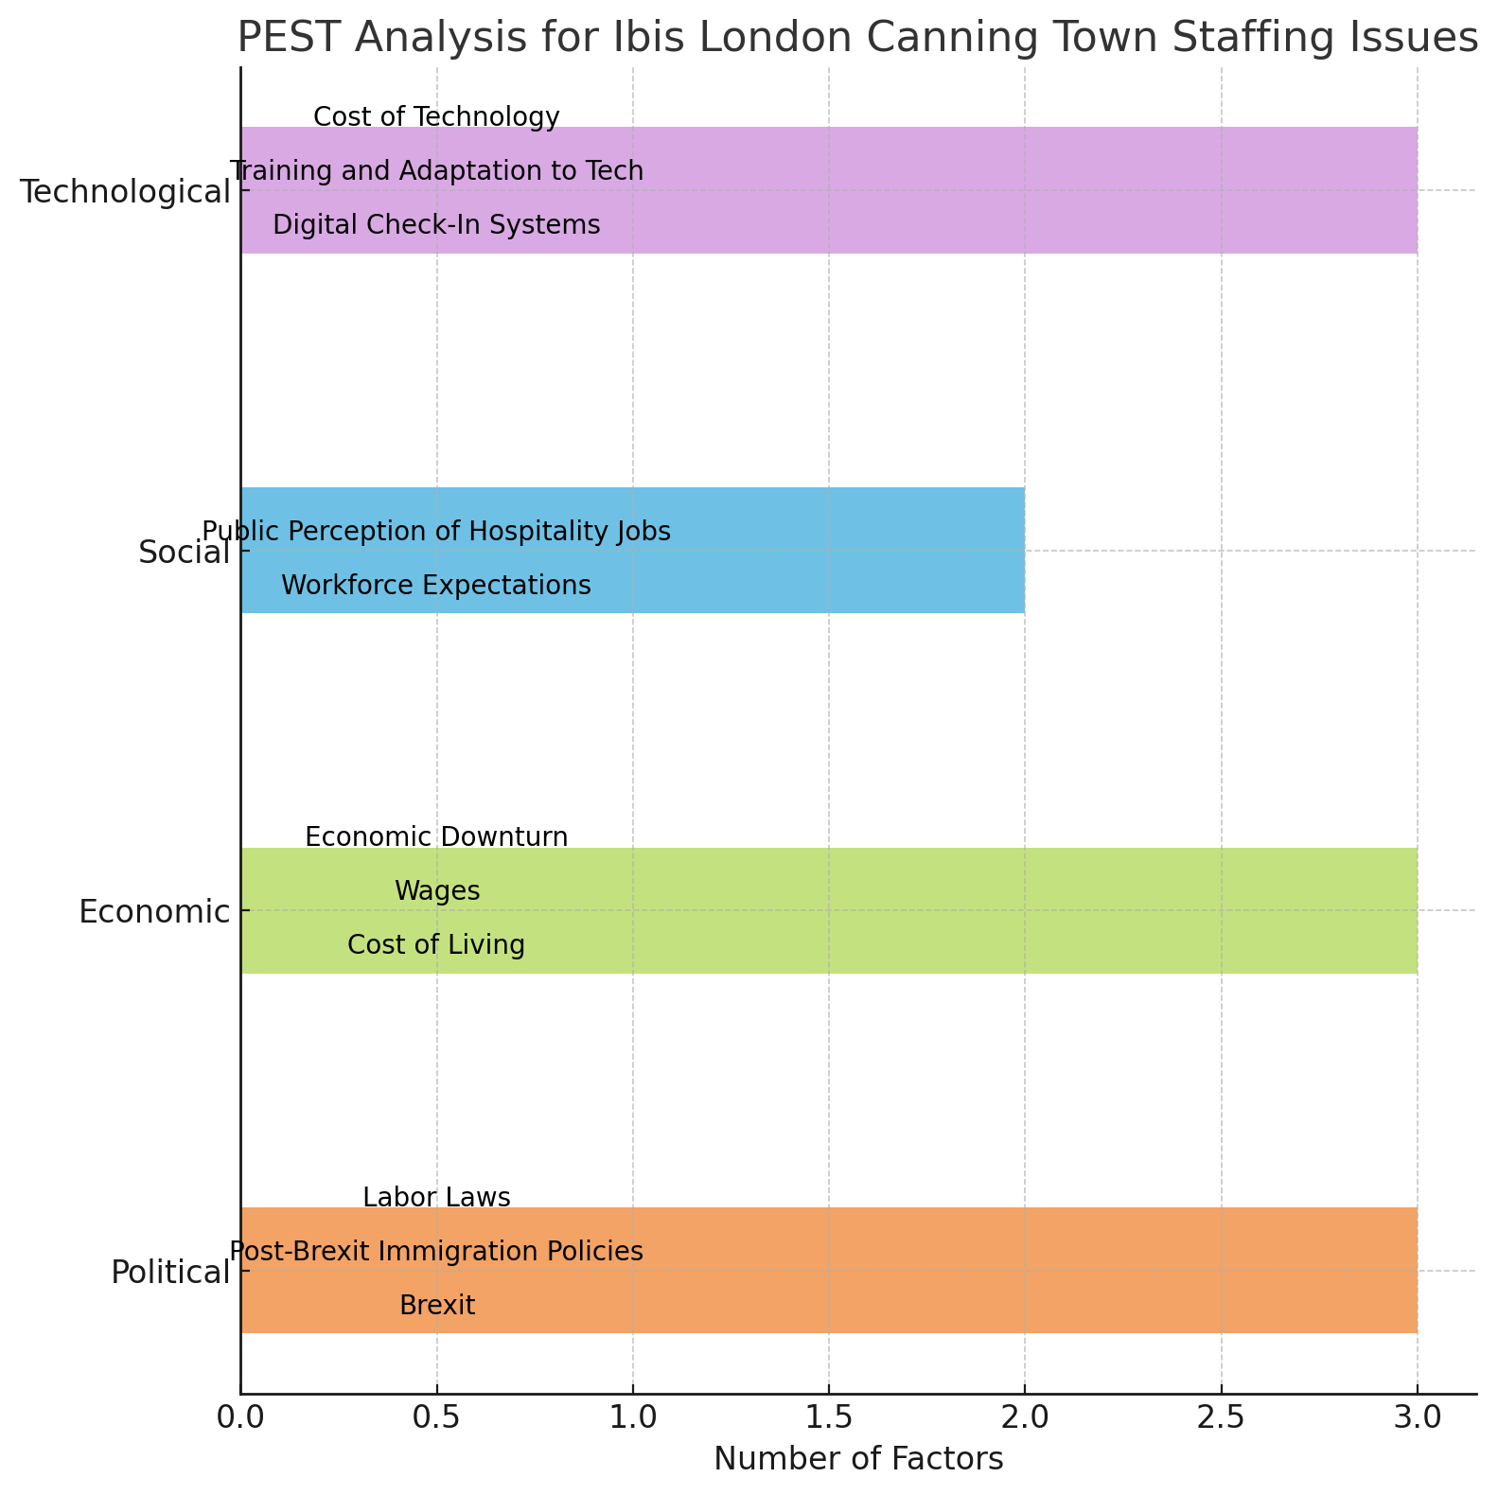

Competitor Analysis: Price vs Quality
IBIS London Canning Town belongs to the budget hotel industry, where price is very significant and closely relates to quality to attract and keep customers. Compared with major rivals such as Premier Inn and Travelodge, there is evidence that Ibis positioned itself to offer cheap solutions to business and leisure travellers (Held, 2023). However, the relationship between price and quality at Ibis is a double-edged sword, where the brand offers lower rates at the expense of some aspects of service quality. For Ibis Hotel, with a 3/5 average price rating on a scale where five is the most expensive, Ibis competes primarily on price. This lower price often comes at the expense of quality, with guests citing staff shortages and thus dissatisfaction, as well as erratic services (Bargavi, 2023). Also, it maintains its appeal with a view of the convenient locations and simple, functional accommodations.
On the other hand, Premier Inn is a bit pricier with a 4/5 rating, but it has better quality service. The quality is evidenced by consistent guest satisfaction levels and more stability of its workforce, perhaps due to improved employee retention and competitive salary scales. Many visitors will comment on how they have found a far higher standard of service when busy, bearing in mind they pay that little bit more for the privilege (Tripadvisor, n.d). The price rating of Travelodge is also 3.5/5, which means it can balance between price and quality. Like Ibis, the prices are very low, although it shares some of the same staff turnover and erratic service problems. On the plus side, Travelodge does have good staff benefits, which helps make it attractive in terms of recruitment and retention. That only serves to compound challenges for Ibis regarding matching the quality in relation to affordability. Along these lines, improving the recruitment and retention strategies by Ibis is indispensable in order not to prevent the already existing staff from being further inclined in guest satisfaction due to a situation already suffering from being understaffed. Below is a chart showing comparative price/quality ratings among Ibis, Premier Inn, and Travelodge in order to evaluate the trade between low prices and good service rendered per hotel brand.

Comparing the Price and Quality Ratings
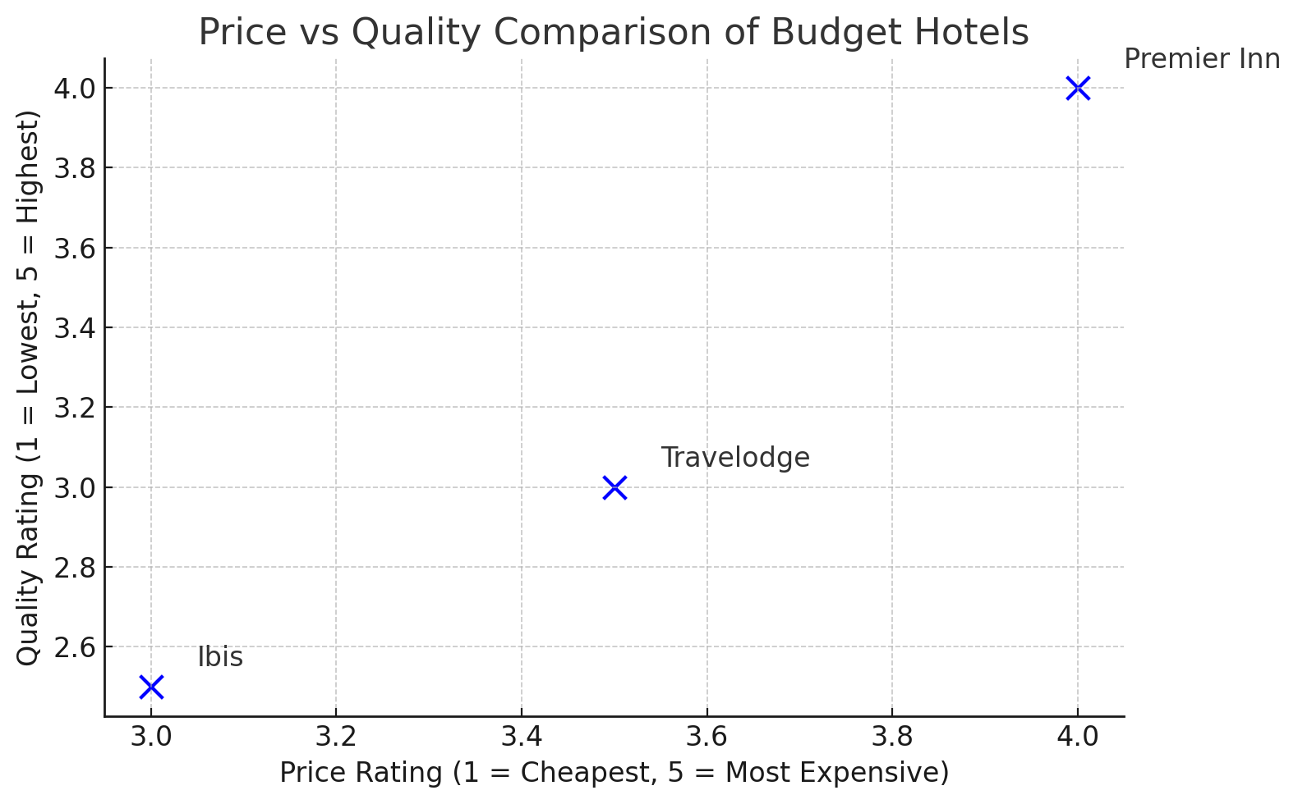

Netnography
Based on online reviews and community discussions, netnography is a study that offers critical insight into how staff shortages impact customer satisfaction and employees' perception of Ibis London Canning Town. From the feedback on sites like Tripadvisor and Google Reviews, one could easily note that feelings and perceptions developed through a staff shortage include long wait times, delays in service, and perceived indifference among employees. Long waits and an attitude of indifference are common in negative reviews during peak periods when the hotel is understaffed. Online forums show employee discussions that reveal, along with customer feedback, grievances about low wages, job dissatisfaction, and a lack of career opportunities—industry-specific. These cause high staff turnover rates—a very direct symptom—that parallelly mirror the lower levels of morale and motivation among its members (Islam et al., 2017). The interaction of these customer concerns with the dissatisfaction of employees sends an urgent need for Ibis to address the staff level and increase employee engagement to raise the overall service quality and retention.

Theme Exploration
The hospitality industry has generally been plagued by staff shortages, which have been an influential factor in operational efficiency and service quality at hotels. The Ibis London Canning Town hotel is no exception to these general industry issues and forms part of the greater Accor Group. This section is a critical review of the impact of staff shortages on motivation, retention, and recruitment strategies of Ibis London Canning Town employees, hence serving to provide insights into operational difficulties faced by the hotel and areas for improvement.

Staff Shortages and Their Impact on Employee Motivation
Staff shortages have a serious effect on the motivation of employees, mostly in the hospitality industry, since the quality of service depends so much on the performance of its front-line staff. Employees at the Ibis London Canning Town are often burdened with extra workload because of inadequate staff strength, especially during peak periods. As Ramuni (2021) states, the impact of shortages on motivation is closely linked with the increased pressure put on employees to take on several roles, resulting in job dissatisfaction and, consequently, burnout. Employees who were already overstretched tended to report higher stress levels, which had severely affected their motivation. Drawing from Herzberg's Two-Factor Theory (Holston-Okae and Mushi, 2018), it can be established that hygiene factors, including working conditions, pay, and job security, are in place to avert dissatisfaction.
At Ibis London Canning Town, the staff often work for long hours and receive low wages with no support during busy periods, which thereby decreases job satisfaction and motivation. Herzberg goes on to suggest that these are not motivational factors that encourage employees to strive for excellence. However, their absence could lead to job dissatisfaction, as witnessed at Ibis London, where the staff shortage increases the workload on the remaining staff. Further, basing this argument on Maslow's Hierarchy of Needs, Ruiter (2021) explains how staff shortages at Ibis are related to the motivation of the employees.
As outlined by Maslow, basic needs like safety and job security must be met before people can feel motivated toward more engagement in work. The staff shortage at Ibis undermined these, leaving employees uncertain of what their workload would be or even about their job security (Lundberg, Gudmundson, and Andersson, 2019). Also, there is a resultant fall in motivation, especially among the junior staff, who felt that their input was neither appreciated nor rewarded. This staffing gap deprives the employees of opportunities to satisfy higher-order needs associated with self-esteem and self-actualisation, which are important for motivational retention over time. In light of such challenges, it is clear that staff shortages not only help reduce motivation among employees but also initiate a vicious circle of dissatisfaction, leading to further turnover (Silver, 2024). This indicates that, for Ibīs to surmount these challenges, it needs to work on adequate staff levels, competitive wages, and resources for the employees to retain their employees.

The Role of Employee Retention in Combating Staff Shortages
One of the critical strategies in dealing with the impacts brought about by staff shortages is employee retention—mostly for a budget hotel like Ibis London Canning Town, given that costs linked to recruitment and training could be very high. High levels of turnover—especially among low-level hospitality workers—are exacerbated by staff shortages that place even greater pressure on already employed workers. According to Kieckhaefer (2024), turnover is mostly bound to a lack of job satisfaction emanating from poor working conditions, low compensation, and poor career development opportunities. These have been the causes of high turnovers in most departments at Ibis, especially in front desk and housekeeping roles. Mann, Ramirez, and Straus (2023) say poor development opportunities and proper training also contribute to poor employee retention. The staff working in the low-wage areas of Ibis London Canning Town do not have career progression lines; hence, they change to better-paying jobs or those with greater possibility of progression. The lack of structured training programs or mentoring opportunities has given them a sense of stagnation and further aggravated the problem of retention.
Ibis Hotel should bring improvement in the area of retention with better training and career development programs. According to Ruiter (2021), there is a need for humanization in the HRM process in hospitality, given the resilience and engagement of the employees. Moreover, it could allow Ibis to reduce turnover because it will increase employees' job satisfaction through learning and growth within the company. Additionally, the hotel should be concerned and create an environment that makes the employees feel valued and allows nurturing their aspirations in their respective careers (Kim, Lee and Kim, 2019). Through reinvestment in the development of employees, offering competitive pay, and ensuring clear pathways for career advancement, IBIS London Canning Town will not only reduce turnover rates but also increase the engagement and motivation of its employees. This would then decrease operational disruption brought about by the lack of staff and increase the quality of services.

The Challenges of Recruitment in Times of Staff Shortages
One of the areas greatly affected by the shortage of staff is recruitment; this is worse when the hotel is at the height of the turnover. Attracting good staff and holding onto them, IBIS London Canning Town, is very hard because of low wages and competition for highly placed housekeeping and front-desk staff. The post-Brexit labour market, according to Howson (2020), made it more difficult to bring new staff in from the EU countries, increasing stress on the recruitment process for the hotel. Budget hotels often have less competitive wages and benefits than those offered by bigger, more luxurious brands within the hotel industry, making the quest to attract qualified candidates rather tough. As noted by Ye (2022), it would also mean that the recruitment efforts should not just focus on luring candidates but also on humanizing the recruitment process to appeal to candidates who want something more than just a paycheck. In the case of Ibis London Canning Town, the recruitment strategies should be strengthened by offering flexible work hours and part-time jobs with better pay for the front-line workers (Pendell, 2025). This will attract a diverse pool of candidates, especially from underrepresented groups or those who would not have traditionally considered the hospitality industry, as Bajrami et al. (2020) stated.
Additionally, according to Khan and Fatma (2022), using netnography means that digital platforms and social media may be a good way to reach a wider talent pool. Ibis can offer people looking for flexibility and perhaps open to non-traditional work arrangements online platforms such as LinkedIn and Glassdoor to attract them. Additionally, digital recruitment tools also facilitate building a strong employer brand and attracting employees with the same values and mission as the hotel. For Ibis London Canning Town to better its recruitment, it needs to work on a strong employer brand that appeals to the candidates. Competitive compensation, flexible work arrangements, and a supportive work environment will also help the hotel recruit staff who will be motivated to stay and be productive within the company.

Areas for Development and Improvement
The staffing shortages at Ibis London Canning Town will be addressed by strategically focusing on employee motivation, retention, and recruitment. Much can be achieved by adopting wide-ranging training and development programs that would empower the employees with the necessary skills and knowledge, creating a feeling of competence and confidence in handling their job roles. Further, studies indicate ample training discourages turnover because staff feels satisfied and ready for future development (Gazija, 2024). Moreover, the fact that it provides career development opportunities describes a willingness for the growth of the employees; hence, this affects their retention dramatically. The clear career progression pathways are among the things that, according to Johansson (2024), are quintessential in the hospitality industry for keeping talent.
Moreover, adopting flexible work arrangements increases job satisfaction and attracts a wider pool of candidates. This has been the case in hospitality with the introduction of such practices as they help achieve a positive work-life balance, which increases the morale and retention rate of employees within the industry. Motivation and loyalty may also be increased through the delivery of recognition schemes that target recognition of accomplishments and contributions. According to Ghorbani (2022), recognition and reward of employee efforts result in engagement and retention. By focusing on these areas, IBIS can bring out an environment of work that is much more supportive and engaging to surmount the challenges associated with staff shortages.

Conclusions and Recommendations

Conclusion
Staff shortages have been quite challenging in terms of operational efficiency and satisfaction amongst the employees of Ibis London Canning Town. Research has shown that poor staff levels affect motivation, increase staff turnover, and complicate recruitment. Several factors have been attributed to low motivation, hence a cycle of dissatisfaction and attrition amongst employees. The shortfall has been increased by external factors such as Brexit and post-pandemic changes to the labour market, which have reduced the supply of available workers from the EU. From a human resource management view, improper staffing results in overloading the employees, especially frontline employees who are under more pressure and workload during peak occupancy. This is not a good situation and, therefore, reduces their morale and their level of satisfaction with the jobs they perform. However, lack of recruitment and high staff turnover have caused the current concession to have more severe shortages of employees than other such hotels. In this regard, Ibis London Canning Town has to effectively address the issues of retention of employees, how to secure the best talent from the market and how to remunerate employees adequately. The solution lies in an investment involving employees' welfare, training, and development, which is central to enhancing engagement levels and thus alleviating staff shortages. The case study ends with Ibis overcoming its most common problems by using an integrated solution of strategic compensation, development, and flexible staffing.

Recommendations

Increase Employee Wages and Benefits
Ibis London Canning Town has to pay competitive salaries and other incentives to its workers to attract and maintain competent staff. Higher wages make employees more satisfied with their jobs and reduce employee turnover, mostly in low-paid jobs (Sergiomistretta, 2024). Offering better pay can, therefore, make Ibis's job positions more attractive in a competitive market to retain staff.

Invest in Career Development and Training Programs
One of the major causes of high turnover is the lack of career progression. To tackle this, Ibis needs to adopt systematic training programs with defined career paths. Zaki (2024) found that employees whose work is not growing are likely to quit, especially in those roles where there is little or no chance of career advancement. That would make the employees feel more invested in their roles.

Adopt Flexible Working Hours and Part-Time Options
The flexible working hours and part-time positions will reduce the rate of staff turnover and make Ibis more attractive to employees with diverse backgrounds. With this flexibility, employees can easily balance their personal and work life, resulting in less stress and more job satisfaction. According to Lee, Chong and Ojo (2024), one of the strongest factors for employee retention is flexibility in work scheduling, especially when workers have other commitments to family or education.

Leverage Technology for Recruitment and Staff Management
With the help of digital platforms, Ibis can enhance its recruitment practices by using LinkedIn, Indeed, and Glassdoor to reach a much larger pool of potential candidates. According to Khan and Fatma (2022), online recruitment tools are quite effective at attracting candidates, especially passive job seekers who do not actively seek work but may be interested in new opportunities should they arise. Hence, Ibis can access a better pool of diverse applicants by expanding its digital presence.

Improve Employee Engagement through Recognition and Feedback
Another recommendation is to institute regular feedback and recognition programs, which will go a long way in increasing staff engagement and improving staff retention. As revealed by Shaban et al. (2017), employees who feel recognized for their hard work are more inclined to stay with an organization. Ibis should concentrate on building systems that will formally and informally regularly acknowledge contributions by its employees.

Reflective Account
During my placement at Ibis London Canning Town, I have been able to observe and participate in the direct effects of staff shortages on motivation, retention, and recruitment strategies within the hotel. Part of the Accor Group, Ibis has gained a reputation for offering cheap, comfortable lodging. Still, the hotel, like many others, has been under immense pressure because of severe staff shortages exacerbated by post-Brexit labour shortages and COVID-19 disruptions. I could appreciate the critical insights into how these staffing issues hit the operational dynamics of the hotel regarding human resources with firsthand experience.
The biggest reflection area for me in this regard is how staff shortages affect employee morale, staff retention, and employee recruitment processes at Ibis London Canning Town. I also reflect on direct observations I made on the strategies applied by the hotel to face challenges, together with potential solutions that could be useful in reducing the effects of the shortages. This opportunity will offer me a chance to review critically the current HR practices at Ibis and how these can be adapted in order to drive employee motivation, retention, and recruitment.
The most immediate and visible effect of the staff shortage in Ibis London Canning Town was employee motivation. As observed during the placement, employees were under severe stress due to high job demand and not having enough team members to meet demand, mainly in housekeeping and front desk roles. This often meant staff had to work longer hours and take on multiple roles, leading to feelings of fatigue, stress, and general dissatisfaction among staff.
Studies indicate that in a setting like hospitality, where expectations of quality service are high, and resources are low, an increased workload and, therefore, an increase in stress lead to lowered motivation and increased job dissatisfaction. At Ibis London Canning Town, staff became increasingly overburdened, especially during peak hours when there would be an influx of guests. One would always see the staff running from one thing to another, unable to give each guest sufficient time, leading to a loss of confidence in their work. Still, no one recognized or rewarded this over time; hence, motivation was very low.
From Herzberg's Two-Factor Theory perspective, these hygiene factors, such as the lack of job satisfaction, poor working conditions, and lack of recognition, were at the root of the decline in employee motivation. While employees were certainly motivated to work hard, the absence of key motivational factors, like career development opportunities or fair compensation, left them feeling disengaged. Herzberg underscores that as long as these hygiene factors are not resolved, motivation will "ebb away despite an inner wish of workers to work".
Another challenge fueled by the staff shortage at Ibis London Canning Town is staff retention. Throughout my placement, staff turnover was quite high, with most leaving within a short period of joining, mostly from the low-wage, high-turnover section of workers. As Niroula, Upadhyay and Singh (2024) note, hospitality staff retention hinges on job satisfaction, career development, and work culture. There were widespread complaints about poor career growth prospects at Ibis. With few opportunities for employees to progress and inadequate training programs, employee skills began to stagnate as they found much better prospects outside.
One main reason behind low job retention was that job security was threatened only during the busy seasons. There was considerable uncertainty regarding whether employees at the front desks were stable, particularly the temporary workforce. Maslow's Hierarchy of Needs substantiates the claim that if employees' basic needs concerning security and job satisfaction are not met, they will be less inclined to show loyalty to an employer (Gómez, 2022). I found out that many left not because they were not passionate about the job but because they could not see any long-term prospects at Ibis since there were no clear career paths or growth opportunities.
This consequently led to a high turnover, which resulted in a constant need for recruitment and further exacerbated the cycle of staff shortages. Most issues regarding retention stem from a lack of proper engagement and an inability to satisfy the needs of the employee concerning personal and professional growth. In this scenario, Ibis London Canning Town seemed to fail to provide such support. From this experience, I understood that a strategic shift in the approach towards HR practices at Ibis London Canning Town is needed to address staff shortages. If the hotel is to break the high turnover and low retention cycle, then it needs to focus on employee well-being, engagement, and career development. One of the most relevant employee retention drivers is the possibility of growth and career advancement. I have observed many staff looking for roles where they can progress, which was not possible in Ibis, as there are no structured training programs or career pathways.
Overall, the experience was great and enriched with the need for a general overview of how staff shortages affect motivation, retention, and operational efficiency at Ibis London Canning Town. Firsthand observations of the problems created by high turnover, excessive workload, and limited career growth opportunities have taught lessons that can be learned from the difficulties faced by budget hotels. The experience only cemented the need for structured employee retention strategies, including fair compensation, career development programs, and a supportive work culture. Unless these core issues are addressed, staff shortages will continue to compromise service quality and increase recruitment pressures. This reflection has deepened my understanding of how strategic HR practices can improve employee engagement and reduce turnover for better workforce stability and business performance.

References List
Accor (2022) The Staying Power of Accor’s Midscale and Economy Brands: How Favorites such as Novotel, Mercure and ibis are Stronger Global Names Than Ever. https://group.accor.com/en/Actualites/2022/05/midscale-economy-brands-novotel-mercure-ibis
Accor Group (2021) Discover all our Hotels. https://all.accor.com/a/en/brands.html.
Accor Live Limitless (no date) ibis London Canning Town. https://all.accor.com/hotel/A070/index.en.shtml.
Al-Hajri, S.A. (2020) 'Employee Retention in Light of Green HRM Practices through the Intervening Role of Work Engagement,' Annals of Contemporary Developments in Management and HR, 2(4), pp. 10–19. https://doi.org/10.33166/acdmhr.2020.04.002.
Aljohi, A. S., Alzaabi, S. S., Almahri, R. S., Tsaramirsis, G., and Hamid, O. H. (2024) Navigating the Divide: Digital Kiosks and Mobile Apps as Complementary Human-Centered Self-Service Technologies. RAiSE-2023, 162. https://doi.org/10.3390/engproc2023059162
Almerri, H.S.H. (2023) Investigating the Impact of Organizational Culture on Employee Retention: Moderating Role of Employee Engagement. Journal of System and Management Sciences, 13(4), pp.488-507. https://doi.org/10.33168/jsms.2023.0429
Alonso, D A., Kok, S. K., Bressan, A., O’Shea, M., Sakellarios, N., Koresis, A., Buitrago Solis, M. A., and Santoni, L. J. (2020) 'COVID-19, Aftermath, Impacts, and Hospitality Firms: An International Perspective,' International Journal of Hospitality Management, 91, p. 102654. https://doi.org/10.1016/j.ijhm.2020.102654.
Al-Suraihi, W. A., Samikon, S. A., Al-Suraihi, A. A., and Ibrahim, I. (2021) 'Employee Turnover: Causes, Importance and Retention Strategies,' European Journal of Business Management and Research, 6(3), pp. 1–10. https://doi.org/10.24018/ejbmr.2021.6.3.893.
Amadhila, O. (2022) Examining the Effects of Understaffing on Employee Performance at the Forensic Pathology Division, Namibia Police Force (Doctoral dissertation, University of Namibia).
Banyeva, I. (2023) Quality Management Strategies in the Hotel and Restaurant Industry: Best Practices and Challenges. Economic Affairs, 68(3). https://doi.org/10.46852/0424-2513.3.2023.30
Bargavi, N., Roy, A., Kumar, V., Shrivastava, G., Varma, R. A., and Shrivastava, A. (2023) An Empirical Study on Employee Turnover and Job Satisfaction in Human Resource Management Practices. E3S Web of Conferences, 399, 07001. https://doi.org/10.1051/e3sconf/202339907001
Chopra, A., Sahoo, C.K. and Patel, G. (2023) 'Exploring the Relationship between Employer Branding and Talent Retention: the Mediation Effect of Employee Engagement,' International Journal of Organizational Analysis, 32(4), pp. 702–720. https://doi.org/10.1108/ijoa-02-2023-3638.
Chung, H., Quan, W., Koo, B., Ariza-Montes, A., Vega-Muñoz, A., Giorgi, G., and Han, H. (2021) 'A Threat of Customer Incivility and Job Stress to Hotel Employee Retention: Do Supervisor and Co-Worker Supports Reduce Turnover Rates?,' International Journal of Environmental Research and Public Health, 18(12), p. 6616. https://doi.org/10.3390/ijerph18126616.
Cottrell, S. (2014) Dissertations and Project Reports: A Step by Step Guide 9781137364265 - DOKUMEN.PUB. https://dokumen.pub/dissertations-and-project-reports-a-step-by-step-guide-9781137364265.html.
Dayour, F. and Adam, I. (2021) 'Entrepreneurial Motivations Among COVID-19 Induced Redundant Employees in the Hospitality and Tourism Industry,' Journal of Human Resources in Hospitality and Tourism, 21(1), pp. 130–155. https://doi.org/10.1080/15332845.2022.2015239.
Done, P. (2024) 'How Do Staff Retention and Recruitment Strategies Hold Up in 2024?,' Forbes, 13 August. https://www.forbes.com/councils/forbesbusinesscouncil/2024/03/06/how-do-staff-retention-and-recruitment-strategies-hold-up-in-2024/.
Eladawi, F. M., Elnaggar, M. K., Hashad, M. E., Awad, A. H., and Abd El-Halim, A. A. (2024) Effect of Green Inclusive Leadership on Employees' Green Work Engagement in Hotels and Travel Agencies: The Role of Green Intrinsic Motivation. GeoJournal of Tourism and Geosites, 54(2 supplement), 885-895. https://doi.org/10.30892/gtg.542spl12-1263.
Fourth. (2022) Hospitality Headcount Hits Two Year High – But Leaver Rate Remains Major Cause for Concern. https://uk.fourth.com/press-room/hospitality-headcount-hits-two-year-high-but-leaver-rate-remains-major-cause-for-concern/.
Gazija, MSc.A. (2024) 'Importance of Staff Training in Hotel Industry Case Study: Hotel Dukagjini,' ILIRIA International Review, 1(2). https://doi.org/10.21113/iir.v1i2.191.
Ghani, B, Zada, M, Memon, Kr and Araya-Castillo, L (2022) “Challenges and Strategies for Employee Retention in the Hospitality Industry: A Review,” ResearchGate, https://www.researchgate.net/publication/362013886_Challenges_and_Strategies_for_Employee_Retention_in_the_Hospitality_Industry_A_Review.
Ghorbani, A. (2022) 'International Journal of Contemporary Hospitality,' ResearchGate [Preprint]. https://www.researchgate.net/publication/359426459_International_journal_of_contemporary_hospitality.
Giousmpasoglou, C. and Marinakou, E. (2024) 'Human Resources Management in Hotels,' in Springer eBooks, pp. 129–158. https://doi.org/10.1007/978-3-031-52803-3_6.
Grbich, C. (2013) Qualitative Data Analysis: An Introduction. https://doi.org/10.4135/9781529799606.
Grigoryan, K. (2024) 'Labor Shortages in the Hospitality Industry: The Effects of Work-Life Balance, Employee Compensation, Government-Issued Unemployment Benefits and Job Insecurity on Employees’ Turnover Intentions,' Westcliff International Journal of Applied Research, 8(1), pp. 59–73. https://doi.org/10.47670/wuwijar202481kg.
Hague, J. (2020) Addressing Staffing Shortages Requires Creative Thinking by Hotel Operators. Hotelier Magazine. Available at: https://www.hoteliermagazine.com/addressing-staffing-shortages-requires-creative-thinking-by-hotel-operators/
Hall, M. (2020) Brexit and Its Consequences for the UK Hospitality Sector. Journal of Tourism Management, 75, 128-139.
Heinonen, K. and Medberg, G. (2018) 'Netnography as a Tool for Understanding Customers: Implications for Service Research and Practice,' Journal of Services Marketing, 32(6), pp. 657–679. https://doi.org/10.1108/jsm-08-2017-0294.
Held, J.S. (2023) Competitive Intelligence Consulting Services. https://www.jsheld.com/areas-of-expertise/strategic-advisory/business-intelligence/competitor-intelligence?gad_source=1andgclid=Cj0KCQiA19e8BhCVARIsALpFMgHsUw05xAhbbEni1J46HsijVm4Zx7aM4UJAgdFtkcsia41DXapH9bgaAvxsEALw_wcB
Holston-Okae, B. L., and Mushi, R. J. (2018) Employee Turnover in the Hospitality Industry Using Herzberg’s Two-Factor Motivation-Hygiene Theory. International Journal of Academic Research in Business and Social Sciences, 8(1). https://doi.org/10.6007/ijarbss/v8-i1/3805
Howson, J. (2020) Shortages, What Shortages? Exploring School Workforce Supply in England. Exploring Teacher Recruitment and Retention, 9-21. https://doi.org/10.4324/9780429021824-3
IBIS (no date) The Best Cheap Hotels in London | Ibis Hotels. https://ibis.accor.com/en/destination/city/hotels-london-v2352.html.
Irabor, I.E. and Okolie, U.C. (2019) 'A Review of Employees’ Job Satisfaction and Its Affect on Their Retention,' Annals of Spiru Haret University Economic Series, 19(2), pp. 93–114. https://doi.org/10.26458/1924.
Islam, Md.R. (2017) Motivating Front Level Employees in the Services Organisation: Theoretical Analysis and Implications | International Journal of Business Process Integration and Management. https://www.inderscienceonline.com/doi/abs/10.1504/IJBPIM.2017.085398.
Johansson, A. (2022) Benefits and Challenges in Forecasting Hotel Demand, Demand Calendar - Profit-Oriented Total Revenue Management. Demand Calendar AB. Available at: https://www.demandcalendar.com/blog/benefits-and-challenges-in-forecasting-hotel-demand
Kieckhaefer, G. (2024) What Is Employee Retention? Importance, Benefits, and Calculation. https://www.oracle.com/ke/human-capital-management/employee-retention/.
Kim, M., Lee, J. and Kim, J. (2019) 'The Role of Grit in Enhancing Job Performance of Frontline Employees: The Moderating Role of Organizational Tenure,' in Advances in Hospitality and Leisure, pp. 61–84. https://doi.org/10.1108/s1745-354220190000015004.
Kumar, S. (2021) 'The Impact of Talent Management Practices on Employee Turnover and Retention Intentions,' Global Business and Organizational Excellence, 41(2), pp. 21–34. https://doi.org/10.1002/joe.22130.
Leahy, S. (2024) Overcoming Staffing Shortages: How Agencies Improve Retention. https://www.gothamcompanies.com/2024/11/13/overcoming-staffing-shortages-how-agencies-improve-retention/.
Lee, S.H., Chong, C.W. and Ojo, A.O. (2024) 'Influence of Workplace Flexibility on Employee Engagement Among Young Generation,' Cogent Business and Management, 11(1). https://doi.org/10.1080/23311975.2024.2309705.
Liu, C. and Hung, K. (2020) Self-Service Technology Preference During Hotel Service Delivery: A Comparison of Hoteliers and Customers. In Information and Communication Technologies in Tourism 2020: Proceedings of the International Conference in Surrey, United Kingdom, January 08–10, 2020 (pp. 267-279). Springer International Publishing. https://www.emerald.com/insight/content/doi/10.1108/978-1-78756-687-320191003/full/html
Liu, Y. and Hung, C. (2020) The Impact of Seasonal Staffing on Hotel Operations and Employee Well-Being. International Journal of Hospitality Management. Available at: https://www.sciencedirect.com/science/article/pii/S0278431920301132
Lochmiller, C.R. (2021) Conducting Thematic Analysis with Qualitative Data. The Qualitative Report, 26(6), pp. 2029-2044. https://pdfs.semanticscholar.org/271f/61ca8c699d5f41436fd70b8da1bd321a0ad9.pdf
Lundberg, C., Gudmundson, A. and Andersson, T.D. (2019) 'Herzberg’s Two-Factor Theory of Work Motivation Tested Empirically on Seasonal Workers in Hospitality and Tourism,' Tourism Management, 30(6), pp. 890–899. https://doi.org/10.1016/j.tourman.2008.12.003.
Malony, R. J. (2011) Analysis of Staff Scheduling Effect on Hospitality Staffing Service Efficiency During High-Occupancy Conditions Using Discrete Event Simulation (DES). Embry-Riddle Aeronautical University. https://commons.erau.edu/edt/99
Marinakou, E. and Giousmpasoglou, C. (2019) 'Talent Management and Retention Strategies in Luxury Hotels: Evidence from Four Countries,' International Journal of Contemporary Hospitality Management, 31(10), pp. 3855–3878. https://doi.org/10.1108/ijchm-10-2018-0862.
Marketing (2024) 'Labor Shortage in Hospitality Industry: Addressing Challenges,' Epos Now, 8 March. https://www.eposnow.com/au/resources/labor-shortage-in-hospitality-industry/
Marshall, C., and Rossman, G. B. (2015) Designing Qualitative Research. London: SAGE Publication. - References - Scientific Research Publishing (no date). https://www.scirp.org/reference/referencespapers?referenceid=2597612.
Michael, N. and Fotiadis, A. (2022) 'Employee Turnover: The Hotel Industry Perspective,' Zenodo (CERN European Organization for Nuclear Research) [Preprint]. https://doi.org/10.5281/zenodo.6583698.
Niroula, B., Upadhyay, J.P. and Singh, S.K. (2024) 'Employee Turnover and Their Impact on the Organizational Performance of the Hospitality Industries of Nepal,' International Journal of Professional Business Review, 9(5), p. e04509. https://doi.org/10.26668/businessreview/2024.v9i5.4509.
Noyes, J., Booth, A., Moore, G., Flemming, K., Tunçalp, Ö., and Shakibazadeh, E. (2019) 'Synthesising Quantitative and Qualitative Evidence to Inform Guidelines on Complex Interventions: Clarifying the Purposes, Designs and Outlining Some Methods,' BMJ Global Health, 4(Suppl 1), p. e000893. https://doi.org/10.1136/bmjgh-2018-000893. e000893. https://doi.org/10.1136/bmjgh-2018-000893.
Pell, G.R. (2023) Tearing Down and Building Up in the Contemporary Workplace: How Reflective Writing Inspires Workplace Learning and Well-Being - ProQuest. https://www.proquest.com/openview/efb9430fd8bcd32373a0902ac37dde1b/1?pq-origsite=gscholarandcbl=18750anddiss=y.
Pendell, B.R. (2025) 'Frontline workers want flexibility too,' Gallup.com, 10 January. https://www.gallup.com/workplace/544775/front-line-workers-flexibility.aspx.
Ramuni, L. (2021) Coronavirus and Its Impact on UK Hospitality - Office for National Statistics. https://www.ons.gov.uk/businessindustryandtrade/business/activitysizeandlocation/articles/coronavirusanditsimpactonukhospitality/january2020tojune2021.
Reeves, L.J. and Bristow, A. (2024) 'Political Organisational Silence and the Ethics of Care: EU Migrant Restaurant Workers in Brexit Britain,' Journal of Business Ethics, 194(4), pp. 825–844. https://doi.org/10.1007/s10551-024-05772-2.
Ruiter, V.N. (2021) Humanizing Hospitality Industry Human Resources Management to Improve Recruitment and Retention of Resilient Hospitable Talents in the Sector. University of Derby. Available at: https://www.derby.ac.uk/research/reports/career-development.
Sanabria-Díaz, J.M., Aguiar-Quintana, T. and Araujo-Cabrera, Y. (2021) 'Public Strategies to Rescue the Hospitality Industry Following the Impact of COVID-19: A Case Study of the European Union,' International Journal of Hospitality Management, 97, p. 102988. https://doi.org/10.1016/j.ijhm.2021.102988.
Saunders, M., Lewis, P. and Thornhill, A. (2012) Research Methods for Business Students. Pearson Education Ltd., Harlow. - References - Scientific Research Publishing (no date). https://www.scirp.org/reference/referencespapers?referenceid=1353990.
Sergiomistretta (2024) Employee Retention in Times of Staff Shortages. https://ch.gigroup.com/blog/employee-retention-in-times-of-staff-shortages/.
Shaban, O. S., Al-Zubi, Z., Ali, N., and Alqotaish, A. (2017) 'The Effect of Low Morale and Motivation on Employees’ Productivity and Competitiveness in Jordanian Industrial Companies,' International Business Research, 10(7), p. 1. https://doi.org/10.5539/ibr.v10n7p1.
Silver, S. (2024) Rates Refuse to Fall: Hotel Industry Faces Uncertainty as Global and Domestic Pressures Build. https://lodgingmagazine.com/rates-refuse-to-fall-hotel-industry-faces-uncertainty-as-global-and-domestic-pressures-build/.
Sonmez, D., Liu, L. and Mistry, T. (2023) 'Recruitment Issues in the Hospitality Industry,' Journal of Hospitality and Tourism Cases, 11(1), pp. 23–30. https://doi.org/10.1177/21649987231208837.
Staff, C. (2024) The Average UK Salary and Factors Influencing Your Earning Potential. https://www.coursera.org/gb/articles/average-uk-salary.
Sylvestre, L. (2022) The Impact of Brexit and Covid on the UK Hospitality Workforce | Caterer.com. https://www.caterer.com/recruiter-advice/the-impact-of-brexit-and-covid-on-the-uk-hospitality-workforce.
Tiwari, V., Srivastava, S. and Kumar, Dr. P. (2019) Adoption of HRM Practices: A Practical Model - Case Study of a Hotel. https://papers.ssrn.com/sol3/papers.cfm?abstract_id=3379586.
Tripadvisor. (n.d.) Go to a Premier Inn or Travelodge Instead. https://www.tripadvisor.com/ShowUserReviews-g186338-d192139-r812018845-Ibis_London_Earls_Court-London_England.html.
Ujji (2023) Creating a Positive Work Environment: Key to Employee Retention — Ujji. https://www.ujji.io/posts/creating-a-positive-work-environment-key-to-employee-retention.
Undefined (2022) Undefined. https://botshot.ai/resources/blog/hospitality-workforce-shortage
Unifocus (2024) How to Solve Hotel Staffing Challenges: The Role of Technology in Hospitality’s Future. Unifocus. Available at: https://www.unifocus.com/blog/how-to-solve-hotel-staffing-challenges-the-role-of-technology-in-hospitalitys-future
Waller, G. (2021) The Economic Impacts of Covid-19 on 4-Star Hotels in London and Stockholm in 2020. https://www.diva-portal.org/smash/record.jsf?pid=diva2%3A1571251anddswid=-8840.
Wong, A. K., Kim, S., Kim, J., and Han, H. (2020) 'How the COVID-19 Pandemic Affected Hotel Employee Stress: Employee Perceptions of Occupational Stressors and Their Consequences,' International Journal of Hospitality Management, 93, p. 102798. https://doi.org/10.1016/j.ijhm.2020.102798.
Wowor, N.M.C., Deske W. Mandagi, Benny Lule, and Shapely S. Ambalao. (2022) 'The Role of Social Media in Employee Recruitment: A Systematic Literature Review,' Jurnal Multidisiplin Madani, 2(12), pp. 4118–4125. https://doi.org/10.55927/mudima.v2i12.1957.
Ye, G. (2022) 'Critically Discuss Challenges and Recommendations in Recruitment and Selection,' Advances in Economics, Business and Management Research/Advances in Economics, Business and Management Research [Preprint]. https://doi.org/10.2991/aebmr.k.220307.043.
Yin, R.K. (2003) Case Study Research. https://books.google.co.ke/books/about/Case_Study_Research.html?id=k0WrN3rBz_sCandredir_esc=y.
Yousuf, S. and Siddiqui, D. (2018) Factors Influencing Employee Retention: A Karachi Based Comparative Study on IT and Banking Industry. https://www.semanticscholar.org/paper/Factors-Influencing-Employee-Retention%3A-A-Karachi-Yousuf-Siddiqui/b0375f77eb61fc73e68d481b9e3f1e23d282130d.
Zaki, A. (2024) '46% of Employees Say They Lack Career Support from Managers,' CFO.com, 13 February. https://www.cfo.com/news/manager-employee-career-development-workplace-intelligence/707343/.

