

Topic: Tesco SmartCart: Shop Smarter. Faster. Easier.

Programme: Master of Business Administration

Module: Marketing Management

Module code: LCMB7024

Student Name: Shubham Karanwal

Student ID: 2504766

Table of Contents
Element 1: STDP Analysis 3
1. Introduction to Tesco and the New Brand Concept 3
2. The Concept Appeal and Market Rationale 3
3. Segmentation 3
4. Targeting 4
5. Differentiation 5
6. Positioning 6
Element 2: Marketing Mix 6
1. Product 6
2. Price 6
3. Place 7
4. Promotion 7
5. People 7
6. Process 8
7. Physical Evidence 8
Element 3: Marketing Strategy Pitch 10
Element 4: Reflection 11
1. Introduction 11
2. Reflection on Brand Concept Development 11
3. Reflection on Strategy Creation 11
4. Reflection on Pitch Preparation & Delivery 12
5. Conclusion & Future Improvement 12
References 13

Element 1: STDP Analysis

1. Introduction to Tesco and the New Brand Concept
The Tesco brand is one of the largest and most reputable UK retail brands, with a reputation for ensuring quality, value, and customer satisfaction. Since its founding in 1919, Tesco has continuously developed with the use of innovation, growing not only in terms of groceries but also in a whole set of services, online and offline (Tesco PLC, 2025). The company has a mission statement, which is Every little helps which makes it committed to making shopping convenient and making the process better. Following the same ideology, Tesco SmartCart proposes an intelligent trolley cart with an AI platform that allows real-time billing, automatic scanning of products, and a checkout-free payment system.

2. The Concept Appeal and Market Rationale
The contemporary consumers are demanding more speedy, convenient, and transparent shopping experiences. But then, long lines, paper scanning, and a lack of cost transparency usually cause irritation and loss of time. As lifestyles evolve and people begin embracing digital power, they are now finding themselves attracted to convenient technology-based shopping processes that make life easier (Stecuła, 2023, p4). The Tesco SmartCart is the direct response to these issues by eradicating the checkout delays, providing real-time spending information, and instant payments with the Tesco app. The innovation is within the emerging trends of smart retail and contactless technology and complies with the expectation of efficiency and personalization by consumers.

3. Segmentation
Tesco SmartCart is focused on well-defined market segments based on demographic, psychographic, behavioural, and geographic characteristics. In terms of demographics, it targets young professionals, technologically inclined families, and urbanites who perceive the value in being in a hurry. These consumers are psychographically advanced; they value innovation, are digitally enabled, and like the paperless, sustainable shopping solutions (Šálková, 2023, p5). Geographically, they shop as regulars at Tesco stores, are Tesco Clubcard members, and frequent users of Tesco mobile.
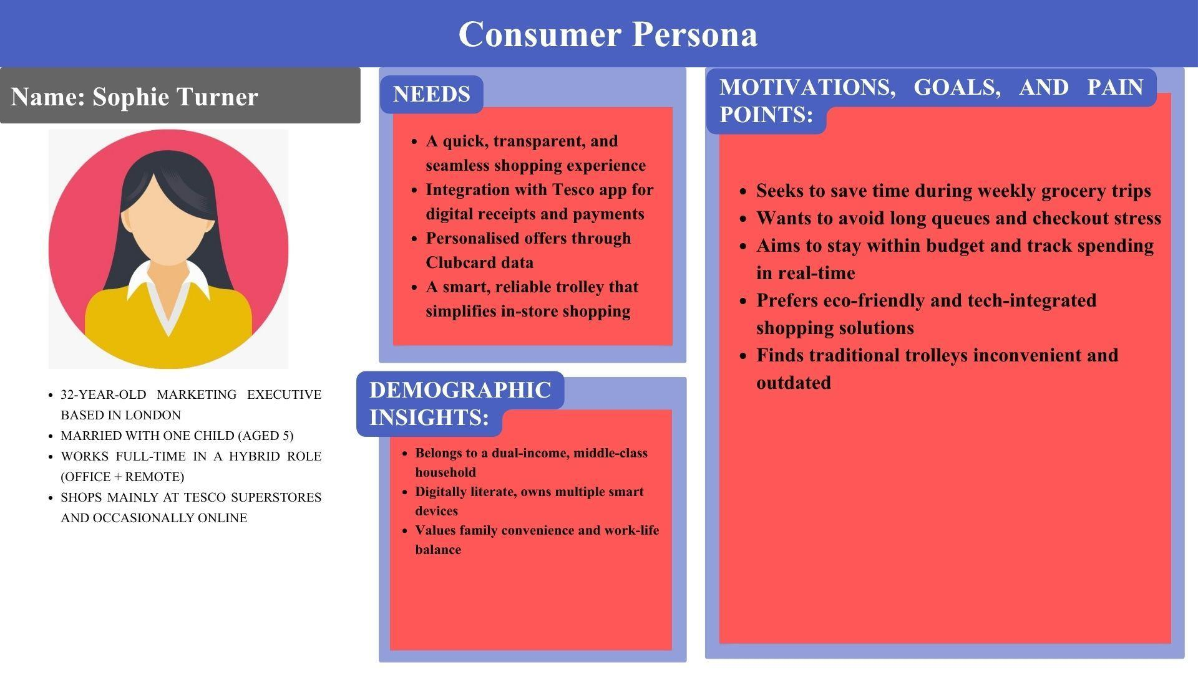
Figure 1: Consumer Persona
(Source: Self-Made)
Sophie Turner is a London-based 32-year-old marketing executive who is married and has one child. She has a hectic working schedule and a family to take care of, so her time is of the essence in most activities. Sophie is a typical Tesco customer, an owner of a Clubcard, who wants to enjoy quicker, stress-free shopping without having to wait in long queues. She desires to control her domestic budget with the help of real-time visibility of costs and is interested in ecologically friendly and technologically oriented solutions. Being a digitally mature generation professional in a two-income family, she is innovative and demanding, both the physical and digital worlds to integrate perfectly. Tesco SmartCart is exactly what she wants in her smart, fast, and transparent shopping with the help of technology.

4. Targeting
The Tesco SmartCart is aimed mostly at busy, tech-savvy families and working professionals between the ages of 25-45, including the personification in the form of Sophie Turner, who are conscious of convenience, speed, and computer connectivity in their shopping habits. Having more than 90 percent smartphone penetration in the UK, and being more willing to use cashless technologies that are contactless in their retail, this group easily embraces smart technologies, which make everyday life easier. The second target is the older generation of customers who want to have easy navigation and quicker checkout services.

5. Differentiation
Tesco SmartCart is an exception in a competitive market of Amazon Dash Carts, Sainsbury SmartShop, and Aldi Scan and Go. In contrast to these, SmartCart is a combination of real-time cost visibility, an integrated Tesco app, and immediate checkout, which will provide a full in-store digital experience. It also provides personalised promotion using Clubcard information, which contributes to improved loyalty and satisfaction. Whereas the competitors tend to spend more on self-scanners or applications, Tesco has been incorporating innovation into the trolley, making shopping as easy and clear as possible.
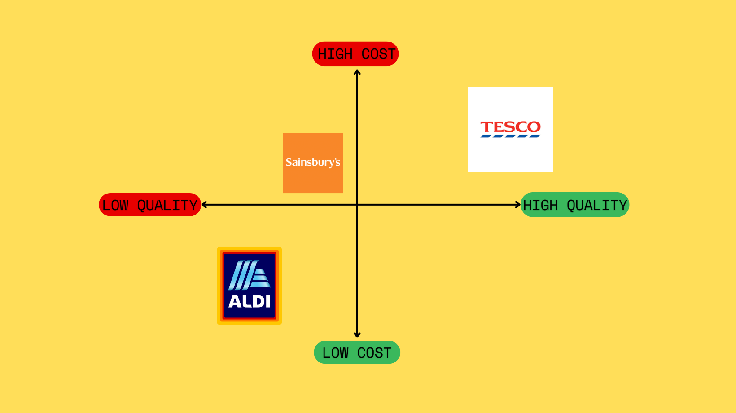
Figure 2: Consumer Persona
(Source: Self-Made)
Tesco SmartCart offers itself as a high-quality but affordable innovation, a mixture of stunning technology and daily availability. Amazon Dash Cart is positioned in the high quality and high cost zone on the brand positioning map, as it has limited coverage and a premium technology (Dubé, 2024, p14). Sainsbury SmartShop and Aldi Scan and Go lie in the medium-quality spectrum, but with prices of different degrees due to their less complex app-based platforms. Low-cost and low-quality traditional trolleys and self-checkouts are due to the lack of innovation.

6. Positioning
Tesco SmartCart will be the final high-convenience, high-technology product that will allow modern consumers to feel efficient and to be in control. Positioning statement: Tesco SmartCart provides a convenient, AI-powered shopping experience that is both time-saving and more transparent, and makes the process of shopping for groceries easier in the everyday life of busy, tech-savvy customers (Arachchi and Samarasinghe, 2023, p4). This technology strengthens the Tesco brand as a technology-oriented retailer that cares about its customers. Its value proposition of effortless, intelligent shopping is encompassed in the value proposition, which is called Smart, Fast, Easy.

Element 2: Marketing Mix

1. Product
Tesco SmartCart is an artificial intelligence-based trolley that will transform the way people shop in the store. It has barcode scanners, weight sensors, and digital touch screens that enable customers to see their total bill as they shop. The SmartCart is connected to the Tesco app, which allows paying immediately, having an e-receipt, and receiving a personal offer after reviewing the transaction history. This also does not require manual scanning or a checkout queue and saves the customers' precious time. On the environmental aspect, it ensures that it is sustainable, and paperless transactions and resource use are minimized. The service aspect of the product entails the use of the app to provide support, software updates, and in-store technical support to make the product reliable (Pathan et al. 2025, p62).

2. Price
Tesco adheres to a competitive pricing policy in order to make SmartCart affordable to every customer and support its affordable offer. Members and employees of Tesco Clubcard and employees will have access to the service free of charge, which provokes loyalty and recurring purchases. The non-members will utilize SmartCart with a modest rental/deposit fee, which would be in line with a freemium business concept that facilitates mass usage. Frequent users are attracted and retained using promotional incentives like exclusive Clubcard discounts, loyalty points, and gift card offers. Tesco uses a value-based pricing strategy, which involves a perception of convenience, time saving, and technology as worthwhile investments (Kukard, 2023, p25).

3. Place
Tesco SmartCart will be initially introduced in the high-traffic Tesco Extra and Superstores in the big cities of the UK, like London, Manchester, and Birmingham. These places are characterized by a large number of customers and are the right places to implement new retailing technology. The SmartCart stations will be located in front of the stores with specific parking and charging bays, as they will be accessible. The Tesco app also benefits the in-store experience through integration to enable the shopper to plan the shopping list, find products, and pay without any issues (Wolniak, 2024, p10). SmartCarts also connect to self-service zones, which is also convenient. In the long run, Tesco will roll out to Tesco Express outlets and suburbs as the adoption increases.

4. Promotion
The promotion plan of Tesco's SmartCart is aimed at generating excitement and awareness via Integrated Marketing Communications (IMC). Online campaigns will consist of social media previews, influencer partnerships, in-app messages, and YouTube tutorials on how SmartCart makes shopping easier. Promotions in stores include the use of demo kiosks, trained personnel, and good displays with the slogan of “Shop Smarter. Faster. Easier." Press releases, interviews, and media coverage are part of the PR activities that will focus on making Tesco known as a company that is dedicated to technology, sustainability, and convenience to its customers. Loyalty-based promotions will also be conducted by the company with exclusive Clubcard benefits to SmartCart users (Chen and Cui, 2025, p5). There will be eco-friendly advantages of using e-receipts and paperless transactions that will be emphasized through sustainability messaging.

5. People
Tesco understands that the success of SmartCart will rely on the highly qualified and customer-oriented staff. The employees of the store will be trained on how to help customers use SmartCarts, how to work with technical difficulties, and how to get through the shopping experience easily (Ylilehto, 2021, p663). The trolleys will have dedicated tech support teams that will monitor the maintenance, charging, and software functionality of the trolleys. Quick troubleshooting and real-time customer assistance will be availed in customer service desks and using chat apps. Employees will be advised to market the use of SmartCart so that first-time users can easily adjust. This people philosophy is consistent with the Tesco brand philosophy, Every little helps. The involvement of employees contributes to the provision of convenience, friendliness, and professionalism to increase trust and satisfaction.

6. Process
The Tesco SmartCart is a process that will provide a fast, effortless, and hassle-free shopping process. The customer then opens their Tesco app and is automatically linked to the SmartCart when a QR code is scanned. When customers select products, AI-powered scanners and sensors automatically save product information, prices, and their accumulated costs in the digital display on the cart. Once a customer is done with his or her shopping, he or she can check out immediately through the application using saved payment methods, which will offer a completely non-contact transaction (Zhong and Moon, 2022, p3). E-receipts are produced automatically, thus making it easy to give back or exchange. The whole system does away with queues and manual scanning, which improves operational efficiency. Onboarding of customers is made simple through video tutorials and guided instructions with staff support on entry points.

7. Physical Evidence
The Tesco SmartCart has a physical design that brings out the modern and customer-focused nature of the brand. The trolleys will be sleekly designed with a unique brand of Tesco in blue and red and a digital touchscreen interface indicating live prices and offers. The visibility and convenience of charging stations and SmartCart zones in the stores. In-store SmartCart signage, demo areas, and promotion displays are added, to which the innovation story is committed. Electronic receipts and transaction records on apps can be viewed as real manifestations of the neo-liberal enterprise, and Tesco and its sustainable practices to lessen the amount of waste paper. A similar brand image is ensured using staff uniforms, kiosks, and the appearance of apps (Aslan, 2025, p9). The physical appearance of SmartCart, both at the design level and in its integration with the store, creates an atmosphere of customer confidence and engagement, relying on the use of technology.

Element 3: Marketing Strategy Pitch
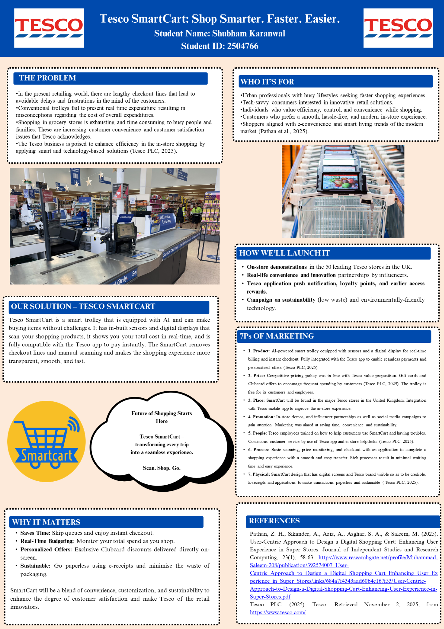

Element 4: Reflection

1. Introduction
This reflection is an analysis of the learning experience that was experienced in the development and marketing of the Tesco SmartCart concept. The project was intended to design an AI-based trolley that would provide convenience and innovation in the retail sector. It puts emphasis on the major learnings during the process, leading to creative ideas through to strategy planning and delivery, issues related, skill building, and self-development.

2. Reflection on Brand Concept Development
The idea of the brand was born out of the realisation of the need of modern customers to be able to shop fast, conveniently, and with the incorporation of technology in their shopping. The product of my analysis of the market trend and Tesco's digital capabilities allowed me to develop an innovation that met customer requirements and brand image. This stage increased my creativity and problem-solving ability because I acquired the ability to balance feasibility with originality (Adeoye and Jimoh, 2023, p54). The study of AI applications and sustainability programs in the field of retail enriched my critical thinking and tactical consciousness. I also learned some important lessons about consumer psychology, specifically, how solutions developed through the use of technology can be used to build trust, satisfaction, and long-term loyalty.

3. Reflection on Strategy Creation
The formulation of marketing strategy enhanced my knowledge of some of the frameworks, such as the STDP and the 7Ps. The use of the principles of segmentation and targeting assisted in defining tech-savvy and time-conscious shoppers as the target audience. Writing, positioning, and promotional strategies helped me to combine both digital and traditional marketing strategies in a comprehensive manner. Carrying out independent research sharpened my skills in critical thinking and interpretation of data. Besides, I was able to understand the methods of creating marketing messages that would help in building brand differentiation. This process emphasized the need to integrate all the marketing components of pricing to physical evidence with the total brand promise.

4. Reflection on Pitch Preparation & Delivery
The pitch development and presentation helped me to refine my communication and persuasion skills. I also got to know how to make complicated concepts simple with concise and interesting messages that can be understood by various audiences. In the process of preparing the narration, my time management and confidence in presentation were enhanced. The visual storytelling and the customer-based narratives enhanced the engagement of the audience (Koerich da Silveira, 2024, p12). This stage especially increased my professional preparedness through improved verbal fluency, structure of slides, and fluency in delivery with little time pressure.

5. Conclusion & Future Improvement
Comprehensively, the project enhanced my marketing knowledge, creativity, as well as, strategic planning skills. I have become certain that I can combine practice and theory in the process of creating innovative brand solutions. I would also like to further the process of making data-driven decisions and designing in future projects to raise the level of analytic accuracy. This has equipped me adequately for dynamic and real-world marketing environments.

References
Adeoye, M. A., and Jimoh, H. A. (2023). Problem-solving skills among 21st-century learners toward creativity and innovation ideas. Thinking Skills and Creativity Journal, 6(1), 52-58.
Arachchi, H. D. M., and Samarasinghe, G. D. (2023). Impulse purchase intention in an AI-mediated retail environment: Extending the TAM with attitudes towards technology and innovativeness. Global Business Review, 09721509231197721.
Aslan, M., Güngör, H., and Önler, B. (2025). The effect of the uniforms and attitudes of the flight attendants on passenger repurchase intention, and the mediating role of brand imagery and brand perception. Cogent Business & Management, 12(1), 2485409.
Chen, B., and Cui, W. (2025). Data-driven power marketing strategy optimization and customer loyalty promotion. Energy Informatics, 8(1), 53.
Dubé, J. P. (2024). AMAZON PRIVATE BRANDS: SELF-PREFERENCING VERSUS TRADITIONAL RETAILING. Antitrust Law Journal, 86(1), 115-148.
Kukard, W. A. (2023). Transforming an industry: Leveraging emerging technologies in the smart home environment to create value for the FMCG industry.
Pathan, Z. H., Sikander, A., Aziz, A., Asghar, S. A., and Saleem, M. (2025). User-Centric Approach to Design a Digital Shopping Cart: Enhancing User Experience in Super Stores. Journal of Independent Studies and Research Computing, 23(1), 58-63.
Šálková, D., Hes, A., and Kučera, P. (2023). Sustainable consumer behavior: The driving force of innovation in retail. Sustainability, 15(24), 16648.
Stecuła, K., Wolniak, R., and Aydın, B. (2024). Technology development in online grocery shopping—from shopping services to virtual reality, metaverse, and smart devices: a review. Foods, 13(23), 3959.
Tesco PLC. (2025). Tesco. Retrieved November 2, 2025, from https://www.tesco.com/
Wolniak, R., Stecuła, K., and Aydın, B. (2024). Digital transformation of grocery in-store shopping-scanners, artificial intelligence, augmented reality and beyond: A review. Foods, 13(18), 2948.
Ylilehto, M., Komulainen, H., and Ulkuniemi, P. (2021). The critical factors shaping customer shopping experiences with innovative technologies. Baltic Journal of Management, 16(5), 661-680.
Zhong, Y., and Moon, H. C. (2022). Investigating customer behavior of using contactless payment in China: A comparative study of facial recognition payment and mobile QR-code payment. Sustainability, 14(12), 7150.

