4/20/2026
Assessment 2
Practical and Professional Development of the Proposed Project

Module NaMe: Changemakers, Creativity and Value creation
Module Code: ACCA 5033
Student NAME:Mohamad bagher ghotbi karimi
Student ID: 2422377
Lecturer: Dr. fahad ahmed
Trinity saint david University of Wales (London Campus)

Mohamad Bagher Ghotbi Karimi (2422377)
Table of Contents
Introduction: 1
Main Body 2
Task 1 2
Task 2 6
Task 3 10
Reference 11
Appendices 11

Introduction:
Artificial intelligence (AI) is increasingly transforming the education sector by enabling more personalised, accessible, and efficient learning experiences. One significant application of AI is intelligent tutoring systems, which provide students with immediate feedback, structured explanations, and adaptive learning support. These systems have the potential to enhance independent learning and improve academic performance; however, their effectiveness is influenced by challenges such as reliability, ethical considerations, data quality, and user trust.

This project explores the conceptual development of a Smart AI Homework Assistant designed to support students in completing homework tasks through natural language processing (NLP). The system aims to provide clear explanations and step-by-step guidance, encouraging independent learning while improving engagement and accessibility. By addressing common learning challenges, the project demonstrates how AI technologies can be applied to create more supportive and inclusive educational environments.

This assignment focuses on project planning, system design, and innovation analysis, rather than full prototype implementation, in order to provide a structured and critical evaluation of the proposed system. Task 1 examines the project planning and design process, including scope definition, constraints, development approach, and key design artefacts. Task 2 evaluates the enterprise and innovation context using frameworks such as PEST and SWOT, alongside the innovation lifecycle to assess external influences and strategic positioning. Task 3 provides a reflective evaluation of the project, focusing on skills development, potential societal impact, and key risks and challenges.

Overall, this report aims to demonstrate a comprehensive and critical understanding of AI-driven educational solutions by integrating theoretical knowledge with practical design considerations. It emphasises the importance of balancing technological innovation with ethical responsibility, user needs, and system reliability. Through this structured approach, the report highlights how effective planning, thoughtful design, and continuous evaluation contribute to the development of realistic, scalable, and responsible AI systems within the education sectors.

Task 1
Question 1: Project Management & Planning
Project Scope and Proposed Solution
The project focuses on the conceptual development of a Smart AI Homework Assistant designed to support students through personalised explanations and step-by-step guidance. Many learners face difficulties in understanding homework independently, and AI-based systems can help address this gap by providing immediate academic support. However, the effectiveness of such systems depends on the accuracy and reliability of generated responses, which remains a key limitation in AI-supported education [1], [3]. Therefore, the project scope is limited to planning and design rather than full implementation.

The project requires natural language processing (NLP) to interpret user input and generate appropriate responses. Research highlights that NLP is essential in enabling personalised learning and simulating intelligent tutoring systems [1], [3]. In addition, user interface design plays an important role in ensuring accessibility and usability, as effective human–AI interaction can significantly influence user engagement and learning outcomes [4]. Design tools such as Figma and draw.io are used to visualise system functionality and user interaction. As this is a student-led project, resources are limited to a single developer, which restricts technical complexity but ensures focused development.

A structured five-week timeline was adopted, covering research, planning, design, and evaluation stages. This approach improves organisation and ensures logical progression. However, short academic timeframes limit opportunities for iterative refinement, which is an important factor in improving AI system performance [5]. Key constraints include limited time, technical skills, and restricted access to high-quality datasets, which may affect system reliability and scalability [3].

An Agile-inspired development approach was selected due to its flexibility and suitability for evolving project requirements. Agile supports iterative development and continuous feedback, which are important for improving intelligent tutoring systems [2], [5]. However, its effectiveness is limited in short academic projects due to restricted iteration cycles. Therefore, a simplified Agile approach was adopted to balance flexibility with practical constraints. Overall, the project combines structured planning with limited iteration to ensure a realistic and manageable development process

Gantt Chart
Figure 1:
Gantt Chart showing the project timeline for the Smart AI Homework Assistant
The Gantt chart was structured to reflect clear task dependencies and efficient use of limited project time. Research and planning were scheduled first to define requirements and constraints before moving to design activities. Design outputs then informed prototype development and feedback collection, reducing the risk of rework. This sequencing supports an iterative project management approach, where each stage builds logically on the previous one and enables controlled progress within an academic timeframe [6], [7].

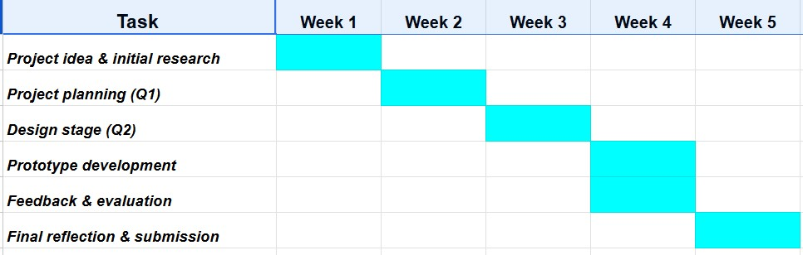

The timeline was structured to prioritise research and planning in the early stages, ensuring a strong foundation before design development. This sequential approach reduces the risk of design inconsistencies and supports efficient time management. However, the limited timeframe restricts opportunities for iteration, which may impact the refinement of the system design.

Question 2: Project Design
This section presents key design artefacts for the Smart AI Homework Assistant, including a requirements specification and a system flowchart. These artefacts translate the project concept into a structured design and support understanding prior to implementation.

The requirements specification defines both functional and non-functional requirements. Functionally, the system enables users to input homework questions, which are processed using natural language processing (NLP) to generate clear explanations and optional step-by-step guidance. This approach aligns with research on intelligent tutoring systems, where structured explanations improve learning outcomes and support independent study [1], [2]. Non-functional requirements focus on usability, accessibility, and response speed, which are essential for maintaining user engagement. However, defining requirements at an early stage may reduce flexibility, particularly in AI-based systems where user needs and system behaviour can evolve over time.

A system flowchart was developed to represent the interaction between the user and the AI system, including input, processing, and output stages. This visual representation improves communication of system logic to both technical and non-technical stakeholders and supports clarity in system design [4]. However, flowcharts simplify system behaviour and may not fully capture the adaptive and dynamic nature of AI systems, particularly those that rely on continuous learning.

In addition, a UML use case diagram was created to illustrate how users interact with the system, ensuring that core functionalities are clearly defined. Visual artefacts such as wireframes further support interface design, which plays a significant role in user engagement and overall usability [4].

Implementation Plan
A brief implementation plan was considered to outline how the system could be developed in practice, including NLP processing and user interaction features. However, due to the conceptual nature of this project, the focus remains on design rather than full implementation.
Overall, these design artefacts provide a clear and structured foundation for the project. While they support planning and communication, they remain conceptual and do not fully represent real-world AI system complexity [3],[5]

Flowchart
Figure 2:
Flowchart illustrating the operation of the Smart AI Homework Assistant

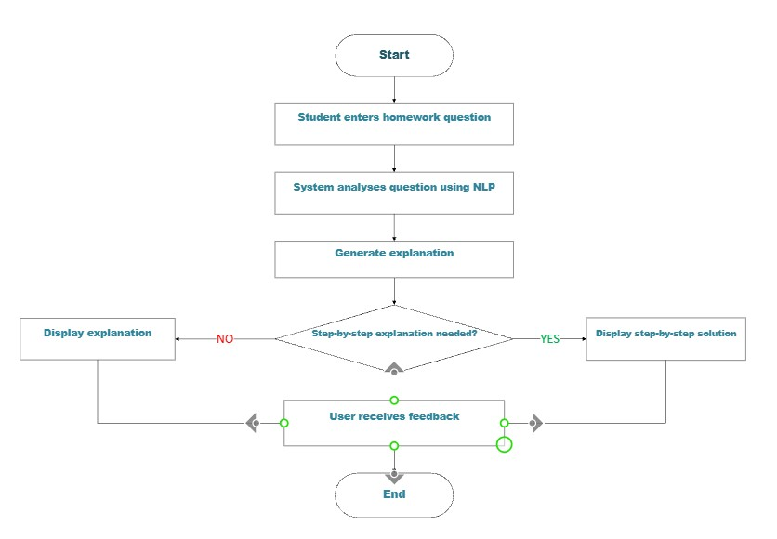
A system flowchart was designed to visually represent how the Smart AI Homework Assistant would operate. This diagram shows the logical flow of interaction between the user and the AI system.
The flowchart follows these main steps:
- The user enters a homework question.
- The system receives and processes the input.
- The AI component analyses the question using natural language processing.
- The system generates an explanation and optional step-by-step response.
- The response is displayed to the user.

This flowchart helps illustrate the internal logic of the system in a simple and understandable way. It is especially useful for explaining system behaviour to non-technical stakeholders and supports clear communication of the project concept. This flow structure was intentionally designed to ensure a clear and logical progression from user input to AI processing and final output, reducing ambiguity in how the system operates. A linear sequence was selected rather than a more complex branching structure in order to maintain simplicity and usability, particularly for first-time users who require an intuitive interaction process. This design decision supports accessibility and ensures that users can easily understand how the system responds to their queries. However, this simplified flow may limit the system’s ability to handle more complex or multi-layered queries, as it does not fully represent adaptive or iterative processing. This highlights a potential limitation and an area for future development in more advanced versions of the system.
Design Summary
The two design artefacts presented in this section support the transition from project planning to later prototype development. The requirements specification defines what the system should achieve, while the system flowchart explains how the system operates. Together, these design elements help ensure that the project is well-structured and ready for the next stage of development.

UML Diagram
Figure 3:
Use Case Diagram for the Smart AI Homework Assistant

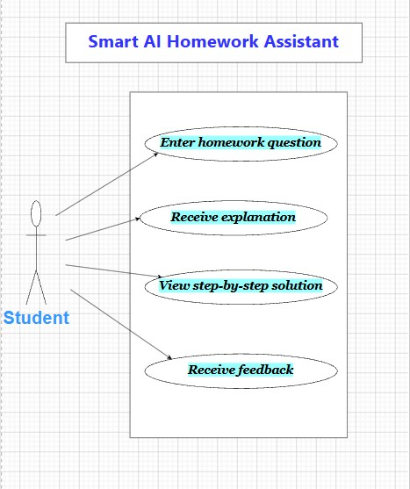

The use case diagram was developed to represent the key interactions between the user and the system in a clear and structured way. It focuses on essential functionalities such as submitting a question and receiving a response, ensuring that the core purpose of the system is clearly defined. This simplified interaction model was chosen to improve clarity and make the system design accessible to both technical and non-technical audiences. However, the diagram does not capture more advanced interactions, such as personalised feedback loops, adaptive learning behaviour, or system evolution over time. As a result, while the diagram is effective for initial design representation, it may not fully reflect the complexity of a fully developed AI-based learning system.

Task 2
Question 1:
PEST Analysis
The following PEST analysis evaluates external factors influencing the potential implementation of the Smart AI Homework Assistant within the education technology sector.
Political & Legal
Compliance with data protection regulations such as GDPR is essential, particularly when handling student data. These regulations influence system design by requiring secure data storage, transparency, and user consent mechanisms [8].
- Ethical governance of AI systems is increasingly important, as organisations must ensure fairness, accountability, and transparency in AI decision-making [8].
- While regulations may limit data usage, they also increase user trust and institutional acceptance, supporting long-term adoption.
Economic
The cost of cloud infrastructure, AI model training, and system maintenance can impact scalability, particularly in early-stage deployment [6].
- Large organisations may benefit from economies of scale, but smaller start-ups may face financial constraints when developing AI-driven systems.
- However, long-term investment in AI-based education can create value through improved learning efficiency and reduced reliance on traditional support systems [7]. Social
User trust and acceptance are critical, as students and educators may be concerned about over-reliance on AI technologies [9].
- There is increasing demand for personalised and accessible learning solutions, which creates opportunities for AI-based educational tools.
- However, concerns about reduced human interaction and dependency on technology may limit adoption if not addressed effectively [8], [9].
Technological
Advances in natural language processing enable scalable and personalised learning support, forming the foundation of the proposed system [6].
- However, AI systems are subject to risks such as bias, inaccuracy, and lack of explainability, which require continuous monitoring and improvement [10].
- Rapid technological change also means systems must be designed to evolve over time, rather than remain static.

SWOT Analysis
The following SWOT analysis evaluates internal strengths and weaknesses, as well as external opportunities and threats..
Strengths
- Ability to provide personalised, step-by-step explanations enhances independent learning and user engagement [6].
- Scalable AI-based design allows the system to support a large number of users simultaneously.
- Aligns with current trends in digital education and AI integration.
Weaknesses
- Dependence on data quality and model accuracy may affect reliability and trust in the system [6].
- Limited technical resources and lack of real-world testing reduce system validation.
- AI-generated responses may lack contextual understanding compared to human tutors.
Opportunities
- Growing demand for personalised and digital learning solutions creates strong market potential [9].
- Opportunities for expansion include multilingual support, adaptive learning, and accessibility features.
- Integration into existing educational platforms could increase adoption and scalability [7]
Threats
Regulatory restrictions and ethical concerns may limit system deployment if not properly addressed [8].
- Competition from existing AI-based educational platforms may reduce market share.
- Risks related to bias, misinformation, and system errors may negatively impact user trust and adoption [10].

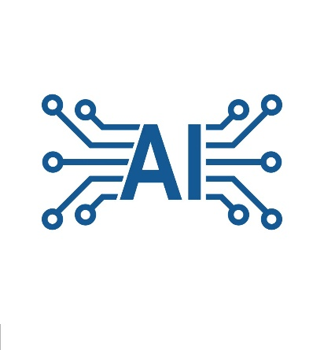
Question 2:
Innovation Lifecycle
The development of the Smart AI Homework Assistant can be understood through an innovation lifecycle consisting of development, deployment, maintenance, and evolution stages.
- Development:
Focuses on defining user requirements and selecting appropriate NLP models. Emphasis is placed on clarity and explainability to support learning outcomes [6].
- Deployment:
The system could be implemented as a cloud-based platform integrated into educational environments. A phased rollout allows testing and reduces operational risks [7].
- Maintenance:
Continuous monitoring and updating of datasets are required to ensure system accuracy and relevance over time. AI systems require ongoing evaluation rather than one-time deployment [6].
- Evolution:
Future development may include adaptive learning, accessibility improvements, and new features. However, innovation must remain aligned with ethical and regulatory requirements [10].

Overall, managing the innovation lifecycle effectively ensures that the system remains relevant, scalable, and aligned with both user needs and organisational objective

Task 3
Project Reflection
Development of new skills
This project provided an opportunity to develop both academic and practical skills. One of the key skills developed was critical thinking, particularly when analysing literature related to artificial intelligence, innovation, and ethics. Evaluating different perspectives helped in understanding how AI systems function beyond technical performance, especially in terms of reliability and ethical considerations [8].

In addition, project management skills were developed through planning, structuring tasks, and managing time effectively. The use of a staged approach, including planning, design, and evaluation, reflects real-world project practices and supports structured problem-solving [7].

The project also contributed to the development of technical awareness, particularly in understanding how natural language processing (NLP) supports educational tools. Although the system was not fully implemented, analysing AI system design helped build foundational knowledge of how such systems are developed and maintained [6].
In the future, these skills can be further developed by gaining practical experience in AI development and user interface design, which would support the transition from conceptual design to real-world application.
This reflective discussion supports the idea of creating value through innovation, as discussed in Unit 2 Topic 4: Creating Value.
One challenge I faced during the project was defining realistic system requirements within limited time constraints, which required balancing technical ambition with practical feasibility.

Positive Social Impact and Value Creation
The Smart AI Homework Assistant has the potential to create positive social impact by improving access to personalised learning support. Many students struggle with independent learning, and AI-based tools can help reduce this gap by providing clear explanations and structured guidance.

From a societal perspective, responsible AI innovation should support human learning rather than replace it. This project aligns with human-centred AI principles, ensuring that the system acts as a support tool for students rather than a substitute for teachers [8]. This approach helps maintain the importance of human interaction while enhancing learning efficiency.

In addition, the project supports inclusivity by providing accessible learning support, particularly for students who may not have access to additional educational resources. However, it is important to recognise that over-reliance on AI systems may reduce critical thinking skills if not used appropriately [9]. Therefore, the system must be designed to encourage learning rather than dependency.

Risks, Challenges, and Mitigation Strategies
One of the main challenges of the project is data quality and bias, which can affect the accuracy and fairness of AI-generated responses. Poor-quality data may result in incorrect or misleading explanations. To reduce this risk, datasets should be carefully selected and regularly updated to maintain system reliability [6], [10].

Another challenge is user trust and acceptance. Students and educators may be hesitant to rely on AI-based systems due to concerns about accuracy and ethical use. This risk can be addressed by ensuring transparency in how responses are generated and by maintaining human oversight in the learning process [8].

Technical limitations also present a challenge, particularly in a student-led project with limited time and resources. Full system implementation is not feasible within the project scope. This can be managed by focusing on core features and adopting an iterative development approach, allowing gradual improvement over time [7].

Overall, while the project faces several challenges, appropriate planning and ethical considerations can reduce risks and support the development of a reliable and effective AI-based learning tool.

Conclusion:
This report has demonstrated the structured development of the Smart AI Homework Assistant through project management, design, innovation analysis, and reflective evaluation. In Task 1, the project was effectively planned using a defined scope, appropriate technologies, and a structured timeline, supported by an Agile-inspired approach. The inclusion of design artefacts such as requirements specification, flowcharts, and UML diagrams provided a clear representation of system functionality and user interaction.

In Task 2, the enterprise and innovation aspects of the project were critically analysed through PEST and SWOT frameworks, highlighting both opportunities and challenges within the education technology sector. The analysis emphasised the importance of ethical considerations, regulatory compliance, and technological adaptability in the successful implementation of AI-based systems. Furthermore, the innovation lifecycle demonstrated how the project could evolve within a real-world organisational context.

Task 3 provided a reflective evaluation of the project, identifying key skills developed, including critical thinking, project planning, and understanding of AI systems. It also highlighted the potential positive impact of the project in supporting inclusive and personalised learning, while recognising risks such as data bias, user trust, and technical limitations.

Overall, the project demonstrates that the Smart AI Homework Assistant is a feasible and valuable concept with the potential to enhance learning experiences. However, its success depends on careful design, continuous evaluation, and responsible implementation. This report reflects a balanced understanding of both the opportunities and limitations of AI-driven educational innovation.

References:
[1] O. Sychev, N. Penskoy, A. Anikin, and M. Denisov, “Artificial Intelligence in Education: Tools and Impact,” Education Sciences, 2021.
[2] S. A. Nikou and M. Chang, “Intelligent Tutoring Systems and Student Support,” International Conference on Intelligent Tutoring Systems, 2023.
[3] E. Kochmar, D. D. Vu, R. Belfer, V. Gupta, et al., “AI based Tools for Educational Support,” International Journal of Artificial Intelligence in Education, 2022.
[4] H. Y. Durak and A. Onan, “Human–AI Interaction and User Experience in Educational Technologies,” Journal of Computational Social Science, 2025.
[5] R. Ren, M. Zapata, J. W. Castro, and O. Dieste, “Evaluation of AI Driven Learning Systems,” IEEE Access, 2022.
[6] G. Milossi, A. Forti, M. Naldi, and L. Piroddi, “Artificial intelligence systems lifecycle: A systematic engineering perspective,” IEEE Access, vol. 9, pp. 150123–150139, 2021.
[7] A. Koley, S. Mukherjee, and P. K. Dan, “Lifecycle-aware innovation management for AI-driven systems,” Systems Engineering, Wiley, vol. 28, no. 1, pp. 45–61, 2025.
[8] H. Roberts, J. Cowls, S. Morley, M. Taddeo, and L. Floridi, “Governing artificial intelligence: Ethical, legal and technical opportunities and challenges,” Internet Policy Review, vol. 12, no. 2, 2023.
[9] D. Helbing, Towards Digital Enlightenment: Essays on the Dark and Light Sides of the Digital Revolution, Springer, Cham, Switzerland, 2018.
[10] I. Tsirigotis, Product Lifecycle Management in the Digital and AI Era, Springer, Cham, Switzerland, 2024.
[11] Design.com, “AI Logo Generator,” [Online]. Available: https://www.design.com. Accessed: Apr. 2026.

Appendices:


