Networking and Cyber Security
Module: Computer Forensics
Student Name: Oskar Kazimierski
Student ID: 2212605

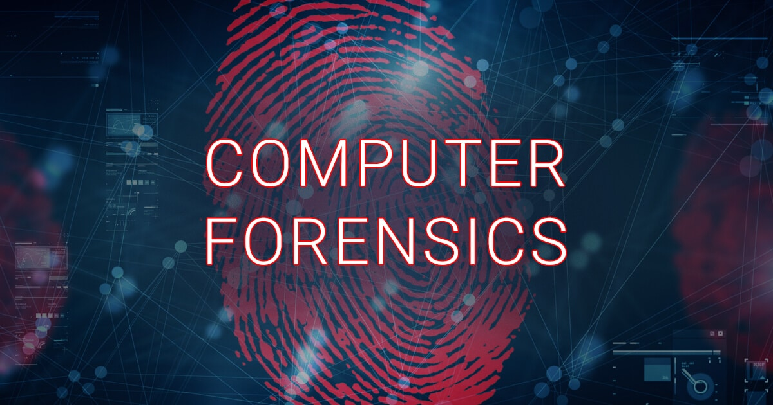

Coursework Overview 3
Task 1 – Research and Report 3
Task 3 – Forensic Report 4
Overview of the forensic investigation 4
Investigation methodology 4
Chain of Custody 7
Investigation findings 8
Figure 1 8
Figure 2 8
Figure 3 9
Figure 4 9
Figure 5 10
Figure 6 10
Figure 7 11
Figure 8 11
Figure 9 12
Figure 10 12
Investigation Analysis 13
Figure 1 - analysis 13
Figure 2 and figure 3 – analysis 13
Figure 4 and figure 5 - analysis 13
Figure 6 - analysis 14
Figure 7 and figure 8 - analysis 14
Figure 9 - analysis 14
Figure 10 – analysis 14
Conclusion 14
References 15

Coursework Overview
Within this coursework, I have been set 3 different tasks which need to be complete. The first task is to conduct research in the computer forensics area and then report my findings. The second task that I have been set is to research, critically analyse and present. This task involves in me creating a presentation which shouldn't be longer than 15 minutes and it should also consist of practical implementations. The final task is to investigate a computer forensic case and I also should report all my findings. Each task must follow the IEEE reverencing standard.

Task 1 – Research and Report
To begin with, computer forensics consists of many varied factors, and this includes an investigation process and analysis techniques. These are used to both gather and preserve evidence from a crime which is found on a device. The evidence is required to be suitable for a presentation in the court of law. The main goal of computer forensics is to investigate and maintain a fully documented chain of evidence. It's essential that the evidence collected maintains its full integrity and there must not be any changes or modifications to the evidence. This will show in court who is responsible for the crime, and it will show the court exactly what happened. [1] “Computer forensics is the application of investigation and analysis techniques to gather and preserve evidence from a particular computing device in a way that is suitable for presentation in a court of law.”
On the other hand, digital forensics is different when compared to computer forensics. Digital forensics focuses on the recovery and investigation of material which is found in digital devices related to cybercrime. [2] “Digital forensics is the gathering, analysing and retrieving of electronic data, assets, and evidence.” The term digital forensics was used as a synonym for computer forensics years ago however, since then it has been used to cover the investigation of any single device which can store data digitally. Up until the 1990’s, the term “digital forensics” wasn't a recognised term but ever since then it's a term that is used often. The first computer crime was committed in 1978 and this followed the Florida computers act. Digital forensics consists of many processes, and these are identifying, preserving, analysing, and documenting digital evidence which has been acquired. [3] “Digital forensics began to take shape in the 1990s and it wasn't until the early 21st century that countries like the United States began rolling out nationwide policies.”
In the modern era of technology, both computer forensics and digital forensics play a key role in digital crime investigations. They help in resolving a crime which has been committed through devices such as computers and mobile phones. There has been an increase in digital crime and some of these include hacking, identify theft, online fraud, and the distribution of illicit materials. Any evidence which can be collected through a digital device can be vital in an investigation which will result in the person being sent to court and dealt with accordingly.
A real-world example of where digital forensics was used is in a case which happened in 2016 that involved a cyber-attack on a crypto currency exchange. The cyber-attack consisted of a series of sophisticated laundering techniques and approximately $4.5 billion was stolen. Over the course of 5 years, the hacker transferred 25,000 bitcoins out of their wallet, and it ended up in financial accounts which was controlled by 2 alleged perpetrators. Due to a detailed investigation which was conducted by digital forensics experts, the stolen bitcoins were traced back and sized by authorities. The digital forensics team managed to get enough evidence to arrest and sentence the perpetrators on the 8th of February 2022. [4] “Two individuals were arrested this morning in Manhattan for an alleged conspiracy to launder cryptocurrency that was stolen during the 2016 hack of Bitfinex, a virtual currency exchange, presently valued at approximately $4.5 billion. Thus far, law enforcement has seized over $3.6 billion in cryptocurrency linked to that hack.”

Task 3 – Forensic Report

Overview of the forensic investigation
I have been given evidence of a cyberbullying case which I need to analyse and investigate upon. To do this, I will be required to use different tools which will uncover information about the cyberbullying case. I must create a chain of custody appropriate to the case, I must document the tools used and present multiple screenshots along with the date and time for the tools which I've used and for the evidence which I've found. I've decided to label the screenshots as figures and then proceed with my analysis at the end of my findings. I believe that this gives the report a much cleaner and simpler look.
The scope of this forensics investigation is to collect any information related to cyberbullying and display it in a straightforward way within the report. In addition, I must document every step that I take along the way with appropriate evidence.

Investigation methodology
The evidence that I was presented was all in digital form and this included 1 USB drive which contained multiple files and folders. Some of these files were blank even though the file sizes shown that there was something inside them. I used different tools to uncover evidence from the USB which was presented to me by Jon Morgan. The tools which were used for the investigation were FTK forensics tool and autopsy.
From the evidence, which was provided to me, I gathered things such as meta data, hash values, messages, phone call logs, emails, deleted files and a police report however I was unable to see what was inside the police report folder. I used the chain of custody to ensure that the evidence was correctly handled by me, and I also included the exact date and time of when I received the evidence. For handling the data, I ensured that it was stored on a secure device, and I also made an additional copy of the evidence as a safety measure. This also give me the ability to compare the hash values of both data sets which was used to verify the integrity of the data.
Here is an image of the evidence which I received to conduct the forensic investigation on. I created a copy of this evidence so that I can ensure integrity and so that I don't lose the files.
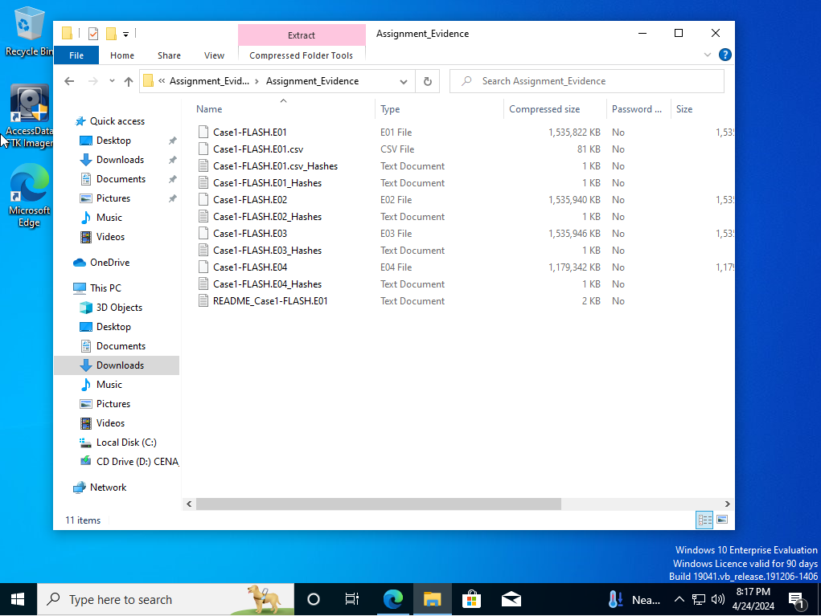
Here is a screenshot of me inputting the evidence into a software called autopsy which is used for a forensic investigation.
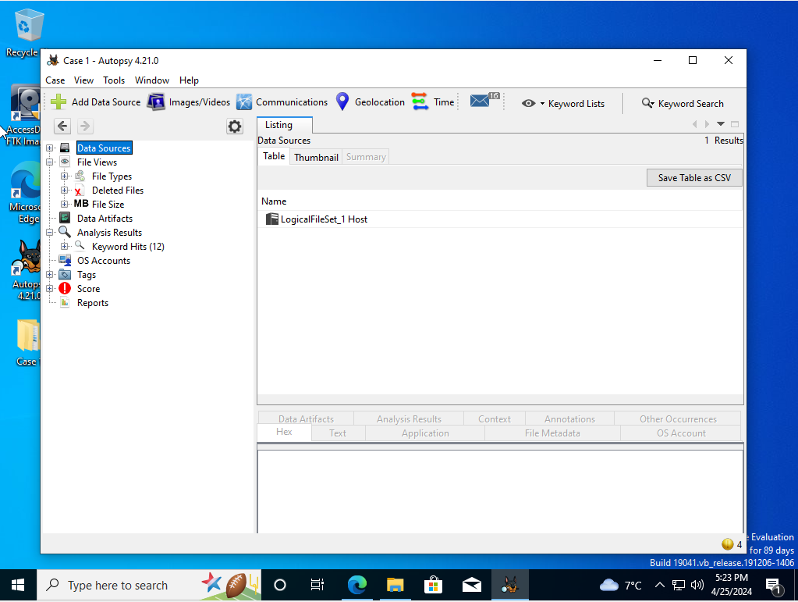
I inserted the file from the USB evidence into FTX forensic and I immediately saw the MD5 checksum and the SHA1 checksum which are the verification hash values from the file. These hash values are used to maintain the data's integrity and its especially needed to be used in court to ensure that no modifications of the file were done.
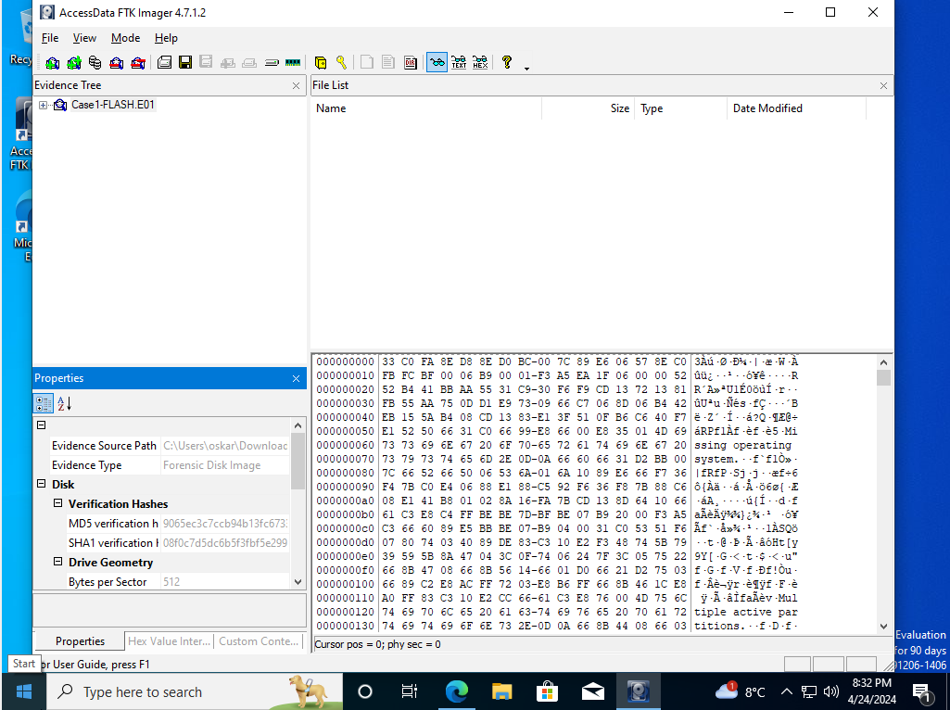
The screenshot below was taken from the software autopsy. After trying to uncover information and evidence from the cyberbullying crime, I couldn’t find anything. However, I managed to find the hash value data for every file which was found in the evidence folder. This will be used to confirm the integrity of the data.
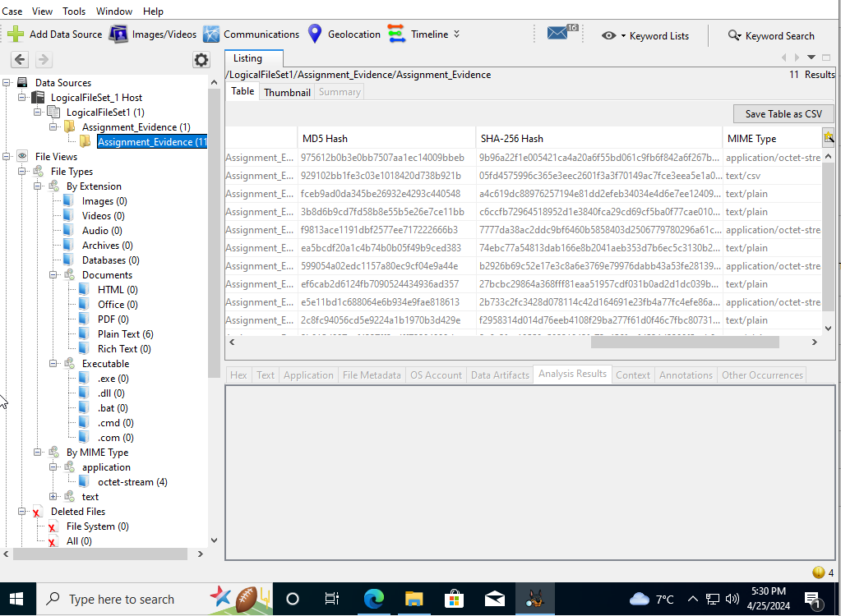

Chain of Custody
Case Number: Case 1 | Offense: Cyberbullying
Date Acquired: 11/03/2024 | Time Acquired: 17:00hrs

Description of evidence
Item | Quantity | Description
USB Drive | 1 | Inside of the USB drive, there were 4 .E0* files, 1 .csv file and 1 README file. The USB flash drive was 16Gbyte and this was found through Encase image file format. The MD5 checksum of the drive was 9065ec3c7ccb94b13fc67338fc88d1d1 and the SHA1 checksum was 08f0c7d5dc6b5f3fbf5e2997c29efe6efe6eb0a458cb. The software “HashCalc” was used to compute the file hashes.

Chain of Custody
Item | Date/Time | Released by | Received by | Comments
USB Drive | 11/03/2024, 17:00Hrs | Nitheesh | Jon Morgan | The file was created using FTK imager which was on an isolated virtual machine with a software blocking in place for all USB attached storage devices. When the file was received by me, I setup an isolated virtual machine and created a copy of the evidence to ensure its integrity after my investigation. I was the only person who was able to access and manage the evidence for security purposes. I ensured that there was no one else in the room while the investigation was taking place to ensure security.

Investigation findings

Figure 1
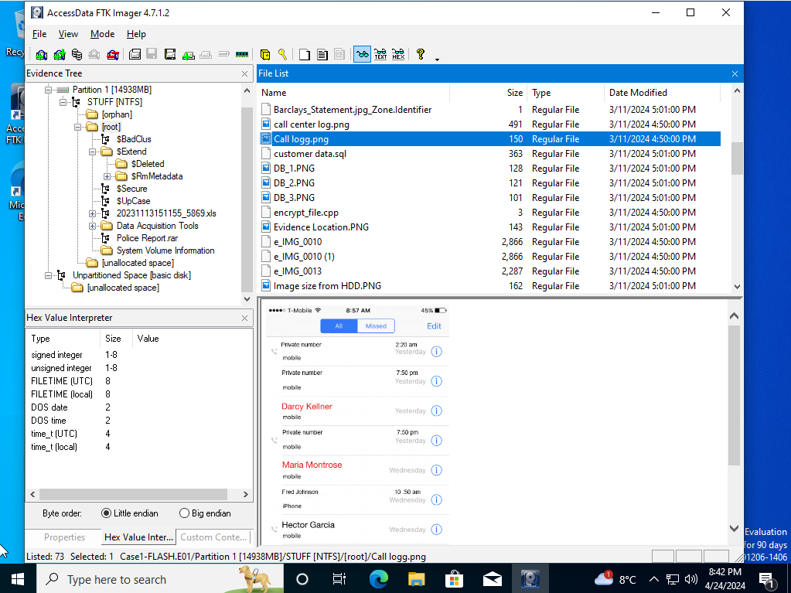

Figure 2
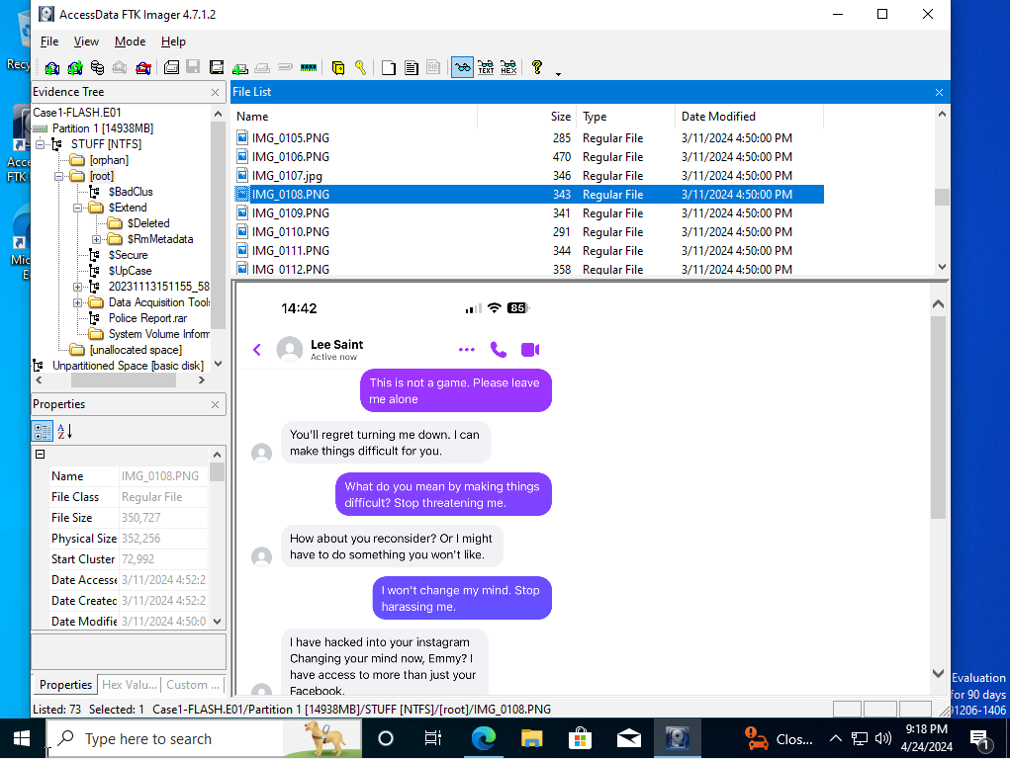

Figure 3
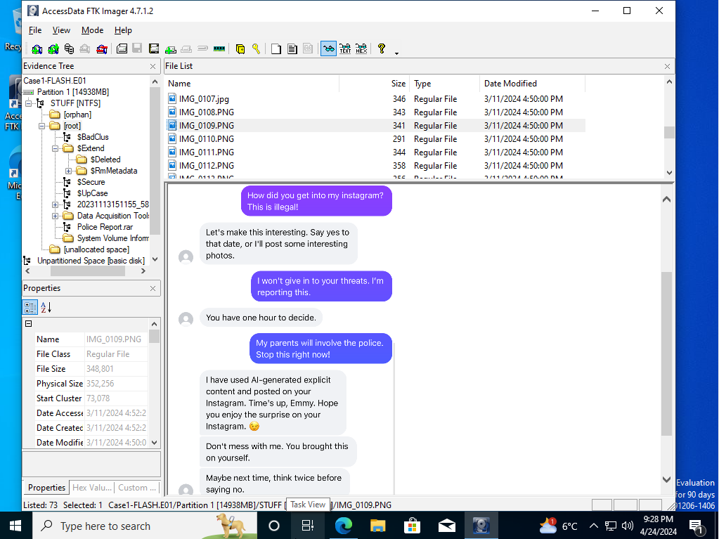

Figure 4
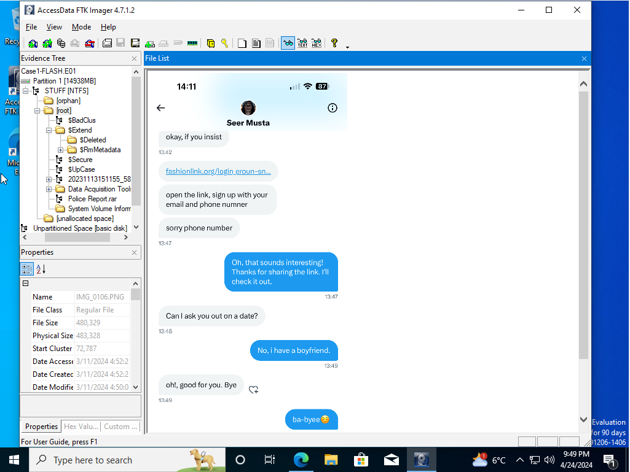

Figure 5
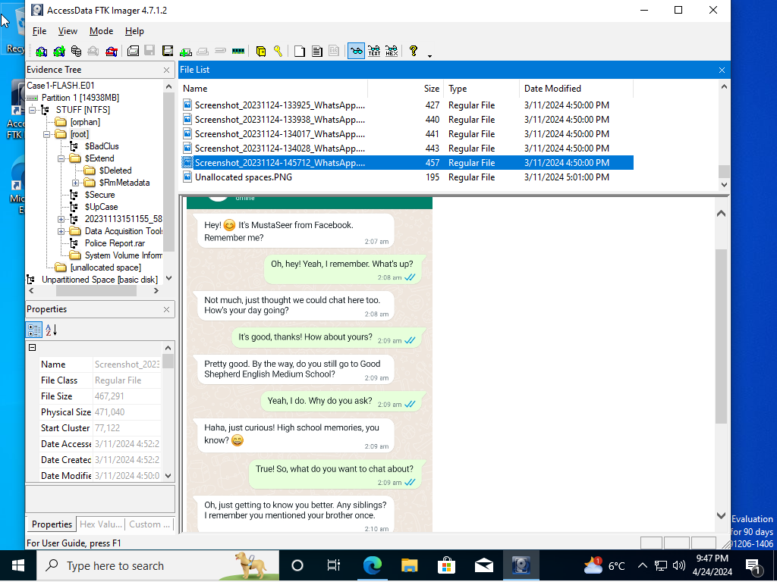

Figure 6
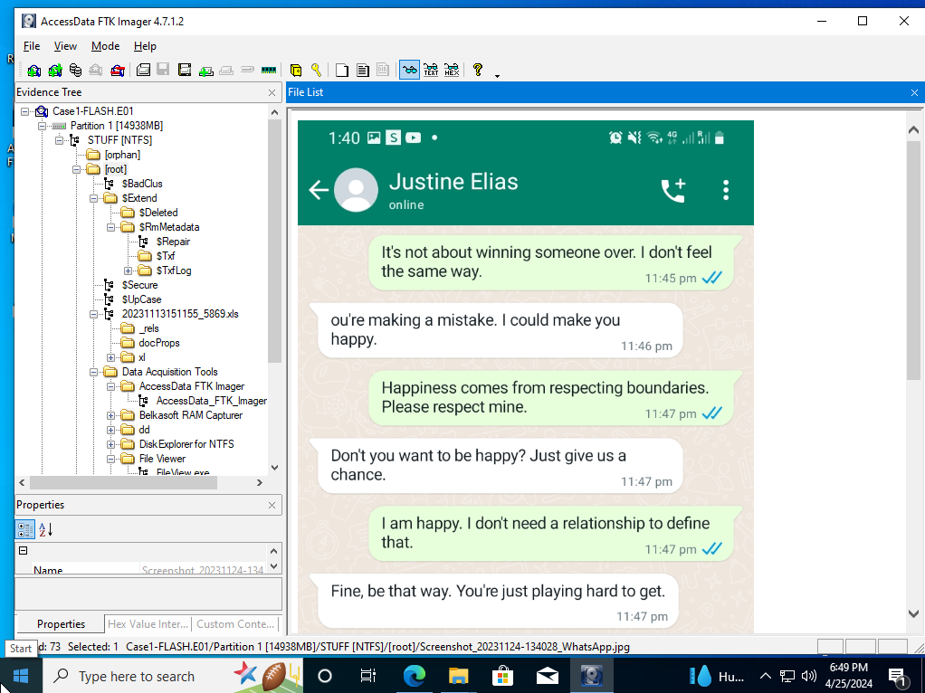

Figure 7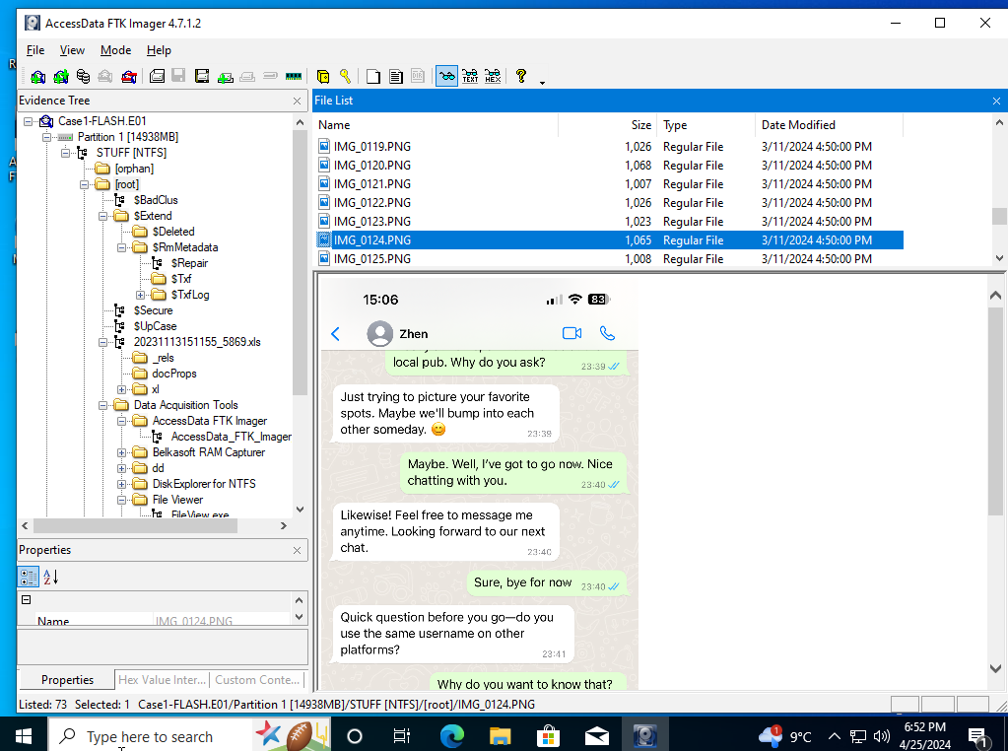

Figure 8
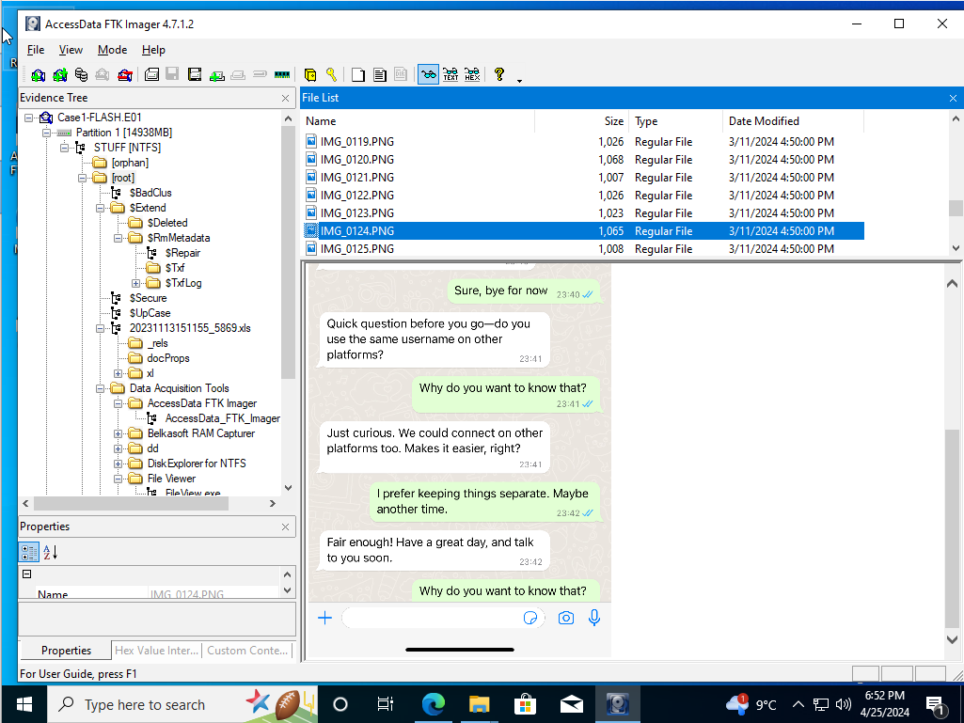

Figure 9
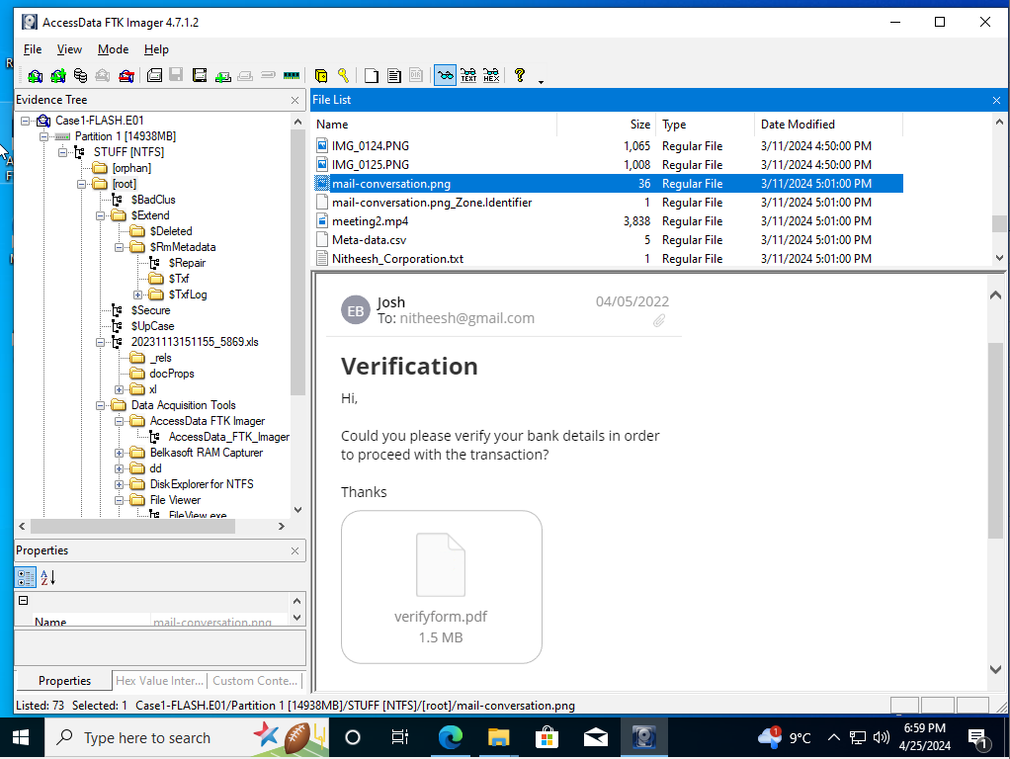

Figure 10
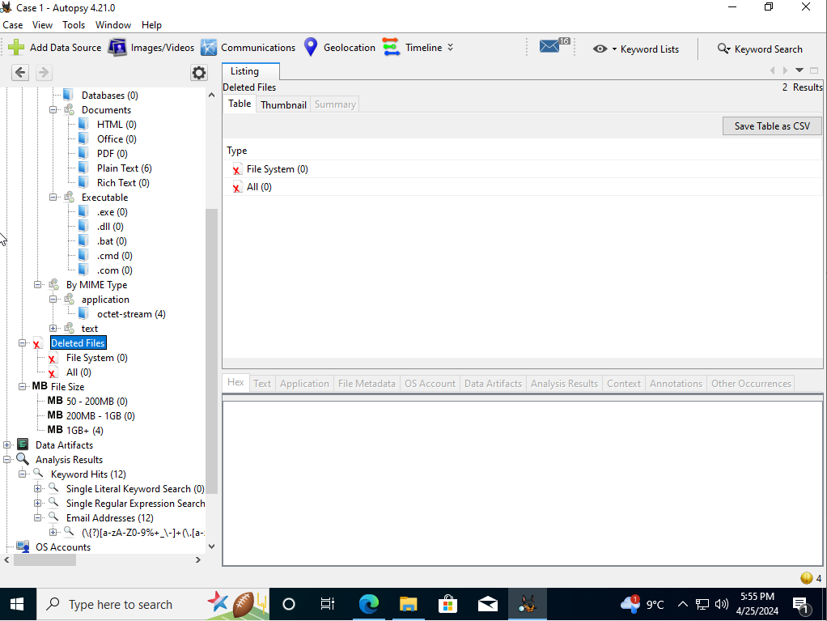

Investigation Analysis

Figure 1 - analysis
After a deep search for evidence, I uncovered many different images, chat logs and call logs. However, these weren't easy to come by as there are a lot of useless files and folders which were uncovered. These were originally hidden, and I used the FTX imager tool to uncover these.
Below I have found a call log, and I can see that there are calls made from a private number which I suspect could be a part of the cyberbullying. The reason that I think this is because the number tried to ring a couple of times and one of the calls was made at 2:20am. This gives me suspicion because calls made from an unknown number at that time are usually related to threats or cyberbullying. Apart from the unknown number, I can't see any more evidence here.

Figure 2 and figure 3 – analysis
Here I've found a piece of evidence which could be crucial in my investigation. These are text messages between the victim and “Lee Saint” who is threatening the victim. By saying “I can make things difficult for you” and “I have hacked your Instagram” strongly suggest to me that this could be a case of cyberbullying and threats. The victim clearly states “Stop harassing me” however “Lee” continues to message the victim.
In continuation of the conversation between Lee and the victim, here Lee said that he's hacked the victims Instagram and that he has posted explicit images onto the victims Instagram page. I see this as sign of cyberbullying because “Lee” is trying to make humiliate the victim through her social media platforms. Also, the images that “Lee” posted on the victim's social media are AI-generated which shows to me that this is part of the cyberbullying.
There are also more threats made by Lee such as “you brought this upon yourself” and “think twice before saying no” which makes me believe that there's more evidence of a cyberbullying crime being committed. The fact that the victim says “my parents will involve the police” suggests to me that this could be a serious case of either major threats and/or cyberbullying.

Figure 4 and figure 5 - analysis
Here I have found 2 separate conversations which involved the same person on 2 separate occasions. At first, I didn't think that this could be used as evidence however after further analysis I concluded that this could be used in the cyberbullying case. I wouldn't have used this as evidence if it was a conversation between 2 different people but due to it being the same person messaging the victim on different social media platforms raises suspicion.
The first image shows that “Musta” messaged the victim on Facebook. “Musta” also sent the victim a link and said to input their email and phone number which raises suspicion. I suspect that this link could either be used as a scam to get confidential information from the victim or “Musta” could use the phone number of the victim to further harass or bully the victim. This could potentially be linked to the unknown caller calls which the victim received at early hours in the morning.
The second image shows “Musta” reaching out to the victim through WhatsApp which means that he has the victim's number. Even though the messages don't show any signs of cyberbullying directly, I can infer that “Musta” could have some association with it. Also, I can see that “Musta” knows about the victim's personal life which suggests that he could have been stalking the victim previously.

Figure 6 - analysis
I have found another conversation with “Justine” and from this I can infer that the victim doesn't want any involvement with him by saying “I am happy, I don't need a relationship to define that.” Also, from the messages I can see that “Justine” is trying to put pressure on the victim by asking relationship questions every time. However, this isn't the strongest evidence for the cyberbullying case.

Figure 7 and figure 8 - analysis
Here is another conversation which I have uncovered, and this is from “Zhem.” The conversation is covered in 2 separate screenshots. From this conversation I can interpret that “Zhen” is harassing the victim by saying things such as “do you use the same username on other platforms?” which the victim responded, “Why would you want to know that.” Even though, I see this conversation more to the side of harassment, at times harassment can easily lead to cyberbullying which is why I have picked out this evidence.

Figure 9 - analysis
Here I have found an email which was sent by “Josh” and in a summary the email asks whether the victim can verify the bank details for the transaction to be processed. I didn't think much of it however, I believe that this could be either a scam or the “Josh” wants a payment from the victim to stop the cyberbullying. This evidence is more of an interpretation, and I haven't found any other evidence which would confirm my suspicion.

Figure 10 – analysis
The last thing that I managed to gather from autopsy is the deleted files section. After analysing this section, I found that there were no deleted files which I could gain access into. I believe that the files didn't contain any deleted evidence which could have helped me in my investigation.

Conclusion
In conclusion, from the evidence which I was presented, I was able to find multiple different things which helped me in my investigation. To start, I managed to find the meta data for all the files, and I found the hash values from the files by using different tools such as FTX forensic and autopsy. Throughout my investigation, I also managed to find things such as call logs, text messages, emails, WhatsApp messages, bank card numbers and deleted files. These were the only evidence which I was able to gather throughout my investigation.
From all the evidence which I managed to gather, I only found one strong piece of evidence which is related to cyberbullying and that is in figure 2 and figure 3. I suspect that “Lee” was a part of the cyberbullying crime due to the messages which he sent to the victim. In addition, I speculate that from the call logs, he was the one who called the victim from a private number at early hours in the morning however this is a speculation.
Throughout the other message logs, I couldn't see any evidence which I could bring forward for the cyberbullying case and I presume that majority of the messages are more threats towards the victim rather than cyberbullying. After my investigation, I compared the hash values between the original files and the final files which I used for the investigation and I can confirm that the evidence still holds its integrity, meaning there were no changes made to the files.

To conclude my entire investigation, I don't believe that my evidence is strong enough to say that there was a cyberbullying crime being committed. After looking back at the evidence gathered, I won't be able to present this in court due to evidence being weak.

References

[1] | R. Awati, “computer forensics (cyber forensics),” TechTarget, n/a february 2024. [Online]. Available: https://www.techtarget.com/searchsecurity/definition/computer-forensics. [Accessed 24 march 2024].
[2] | n/a, “What’s the difference between cyber security and digital forensics?,” University of Portsmouth, 4 december 2023. [Online]. Available: https://studyonline.port.ac.uk/blog/whats-the-difference-between-cyber-security-and-digital-forensics. [Accessed 23 march 2024].
[3] | A. T. Tunggal, “What is Digital Forensics?,” Upguard, 2 may 2023. [Online]. Available: https://www.upguard.com/blog/digital-forensics. [Accessed 24 march 2024].
[4] | n/a, “Two Arrested for Alleged Conspiracy to Launder $4.5 Billion in Stolen Cryptocurrency,” Office of Public affairs, 8 february 2022. [Online]. Available: https://www.justice.gov/opa/pr/two-arrested-alleged-conspiracy-launder-45-billion-stolen-cryptocurrency. [Accessed 24 march 2024].

