A CRITICAL EVALUATION OF
PROJECT MANAGEMENT
CONTRACTING METHODS:
ADVANTAGES,DISADVANTAGES
AND SUITABILITY IN A HOSPITAL CONSTRUCTION PROJECT

UNIVERSITY OF WALES TRINITY SAINT DAVID LONDON CAMPUS
MODULE LCBB6006_LON
@2337237 BOGDAN-FLORIN VASILE

Table of Contents
1. Introduction 3
2. Background of Contracts in Project Management 3
3. Turnkey Contracting Method 4
4. Multicontract Contracting Method 5
5. Do-It-Yourself (DIY) Contracting Method 6
6. Multicontract + DIY Contracting Method 7
7. Comparative Evaluation of Contracting Methods 8
8. Conclusion 8
9. Reference 10

1. Introduction
Project management involves coordinating, controlling, performing and managing project activities to ensure that they are completed within the bounds of time, cost, quality and resources to meet the required objectives (Saad, Alaloul and Ammad, 2022). Contracting is an important part of project management because it involves a formal agreement between project owner(s) and outside participants that are required to complete specific tasks or provide specific services. Good contracting allows organizations to gain access to expertise, risk-share and enhance project efficiency. In complex projects like the construction of a hospital, it is crucial to choose an appropriate contracting method, especially because of the multitude of stakeholders and the technical requirements that need to be met. This essay compares and contrasts the four different types of contracting (turnkey, multicontract, DIY, and multicontract + DIY) for hospital construction projects.

2. Background of Contracts in Project Management
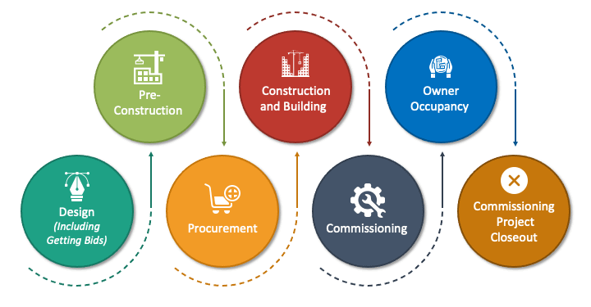
Figure 1: Construction Project Lifecycle Diagram
Project contracts play a crucial role in project management as they create contracts that are legally binding between project owners, contractors, and other entities. They specify the scope of the project, deliverables, responsibilities, schedule, quality, payment and risk allocation. Contracts define the rights and duties of each party in a clear manner, which increases accountability, minimize uncertainty and offer an organized means of controlling the project activity. They also ensure for efficient communication and decision making, with clear procedures for dealing with changes, disagreements and project risks throughout the project.
The choice of contracting method for a project is a strategic choice that can be important to the success of a project (Albtoush et al., 2022). It depends on the project complexity, skills of the organisation, budget, level of risk, etc., and the desired level of control by the project owner. When making decisions about the contract, large scale hospital building projects are more critical due to the fact that the project will incorporate architectural design, construction, specialised medical equipment, advanced technology systems, safety standards and strict healthcare regulations. If the type of contract chosen is inappropriate, then there will be cost overruns, delays, lack of coordination and quality problems. So, selecting the right contracting approach can help to optimise the allocation of risks, responsibilities and resources, as well as project governance and delivery of healthcare infrastructure.

3. Turnkey Contracting Method
Turnkey contracting is a process of delivery for the project where the contractor designs, builds and provides a fully functional facility to the client. One of the contractor's responsibilities is to oversee all significant project activities, planning, procurement, construction, coordination of sub-contractors, testing and final commissioning (Hughes and Champion, 2022). The project is delivered when complete to be used immediately. This way the client assumes the least amount of risk and responsibility for the project as compared to the contractor. The role of a contractor in a hospital building project can involve everything from designing the building, to the construction, to the installation and commissioning of medical equipment, systems and other aspects of the project.
One of the significant benefits of turnkey contracts is that there is a single point of responsibility. One contractor is responsible for the entire project, which makes communication easier, and eliminates the coordination problems that can arise among several contractors. This is especially important when it comes to integrating and co-ordinating construction, engineering, electrical and specialized medical installations, which are crucial in hospital projects. Turnkey contracts also alleviate the project management work for the client as the contractor is responsible for suppliers, subcontractors and technical work (Sharma, 2026). Therefore, health care institutions can work on clinical planning and operations instead of construction management. The other advantage is more cost and project schedule certainty since the contractor takes responsibility for completing the project within agreed budgets and deadlines.
Turnkey contracting has a number of drawbacks, however. The client has less control over the design and construction decisions made, which may be a problem for hospitals where healthcare staff has a high input in the design of the facility, to ensure that it fulfills the operational and patient-care needs. Poor client engagement at the design phase can lead to a building which fails to adequately meet future healthcare service needs (Carlini et al., 2023). Also the success of the project relies on the experience, technical expertise and financial strength of the contractor. If the contractor is not doing a good job, it can result in delays, poor quality and higher costs. Turnkey contracts could also be more costly as the contractors will provide risk premiums in their quotes.
In general, turnkey contracting is appropriate for projects with limited construction knowledge or for projects that would benefit from a “hands off” approach and/or expedient delivery. For more complex hospital projects, however, that involve a lot of stakeholders, compliance to regulations and specialized input of design, its limited client control can be a disadvantage. Thus, it is important to carefully assess the parameters so as to ascertain if the advantages of risk transfer and of efficiency justify the constraints.

4. Multicontract Contracting Method
Multicontract contracting is a project delivery method, where the client signs multiple separate contracts with specialist contractors that are to deliver a certain part of the project. Turnkey contracting is a project managed by a single contractor while, in contrast, the client has to be responsible for coordinating and integrating all contractors' work (Murali, Sreenivasan and Suresh, 2026). This way, one can be more flexible and choose specialists to work on various parts of the project. With regard to hospital construction, separate contracts can be issued for construction, electrical, plumbing, medical equipment and security systems, all of which have a part to play in the overall completion of the hospital.
One of the foremost benefits of the multicontract approach is that a client has a strong say on decisions regarding the project. The client can have a close eye on design, quality and performance of the project as each contractor they work with is independent. This is particularly relevant in the design of hospital buildings where the various requirements of the healthcare sector, patient safety and operational needs have to be carefully integrated into the final design. Other advantages include having access to specialized skills and experience, where contractors may be chosen due to their technical abilities and expertise in certain fields. HPE suppliers with high qualification can even be used to provide more complicated healthcare systems, for instance highly qualified medical equipment suppliers or specialist engineering contractors. Furthermore, by using competitive tendering, the costs can be reduced as the client can shop around and select the lowest price suppliers.
While there are advantages to multicontract contracting, there are several challenges. The client has to be more involved in coordinating multiple contractors, communicating, resolving conflicts and keeping the project activities on track. During a hospital project, if one contractor gets delayed, it can have a domino effect on the project as well as other contractors working in the project (Ying, Dai and Shen, 2025). Lack of synchronization can also result in integration problems, quality problems and contract issues. Additionally, operating more than one contract brings added administrative burden, and involves constant oversight of contractual requirements and compliance with those requirements, as well as monitoring of the contractor's performance.
In general, multicontract contract is appropriate for complex projects involving expertise and where clients want to exert more control on projects' results. But its success is dependent on having experienced project management, effective coordination and good governance in order to ensure multiple contractors are brought together to complete a built hospital facility.

5. Do-It-Yourself (DIY) Contracting Method
Do-it-yourself (DIY) contracting is a project delivery method in which the project activities will be carried out with the resources of the organisation, with less reliance on outside contractors. It is the responsibility of the organisation to plan, manage and implement project work such as allocating resources, making decisions and implementing. This approach gives full control and gives the internal teams control over the project, and they can manage the project as per organisational objectives. A healthcare organisation can employ DIY contracting methods in a hospital construction project by performing some of the project's operations with its own staff members and resources, such as planning the project, managing the procurement process, and preparing for the operations.
One of the best benefits to DIY contracting is the amount of organisational control over the choices made with reference to the project and the allocation of resources. Internal management guarantees that project results are closely in line with the goals and operation requirements of the organisation (Zada et al., 2023). One of the added advantages is that employees will acquire valuable project management experience and technical knowledge which can assist them in future projects. Not only that, but fewer outside entities are involved can enhance communication and facilitate faster decision making.
But, there are also a number of drawbacks to DIY contracting. The need for specific expertise, such as in engineering, construction, and regulatory compliance, is a requirement for large hospital construction projects that many healthcare organisations may not have. It's also possible to cause stress among employees when handling complicated projects in-house, as they have to juggle project work with daily tasks. Additionally, the organisation will take complete care of the risks associated with the project such as cost overrun, delays, and quality problems.
In general, DIY contracting is good for smaller projects for which there is enough in-house expertise and resources (Shojaei, Oti-Sarpong and Burgess, 2022). But large hospital construction projects are generally not suitable for use in this case owing to the fact that they are highly technical, have to comply with various regulations and require a lot of specialised knowledge in construction.

6. Multicontract + DIY Contracting Method

Figure 2: Hybrid Contracting Structure for Hospital Construction Projects
Multicontract + DIY contracting is a project delivery method that is a blend of multicontract and DIY where an organisation performs some of the work on the project and then hires out some other specialised work from various contractors. It enables the project owner to maintain control over some of the important project decisions and gain the benefit of specialist providers. Within the hospital construction project, the health care organization can coordinate project management, stakeholder communication, and day-to-day functioning of the hospital. The external contractors can take care of the construction, engineering, and medical equipment installation, as well as the advanced technology systems.
This has many benefits, not least because it allows the balance between organisational control and specialist expertise. The healthcare organisation can keep to quality standards, regulations and operational needs whilst also providing for the expertise and skill of contractors to carry out technically demanding jobs (Rane, Choudhary and Rane, 2024). It also supports the efficient use of resources by leveraging internal knowledge with external, external resources, and eliminates need to rely on one contractor and provides project flexibility.
This is the same time, however, that presents a challenge also. It is important to have strong coordination, communication and roles and responsibilities when managing a number of contractors with internal teams. If there are problems with integration between the participants, delays, misunderstandings and disagreements can be found especially in the implementation of the project. Moreover, it is essential for the organisation to have competent project management systems to manage schedules, track performance and manage conflicts among stakeholders for the successful implementation.
In summary, multicontract + DIY contracting is an ideal solution for hospital construction projects, as it allows healthcare organisations to have the best of both worlds: access to specialist construction/engineering expertise, whilst maintaining control over key hospital construction issues – quality, patient safety and regulatory compliance. This holistic method involves the engagement of parties from within the hospital, as well as those from the outside, and the technical expertise needed to ensure the successful implementation of such projects.

7. Comparative Evaluation of Contracting Methods
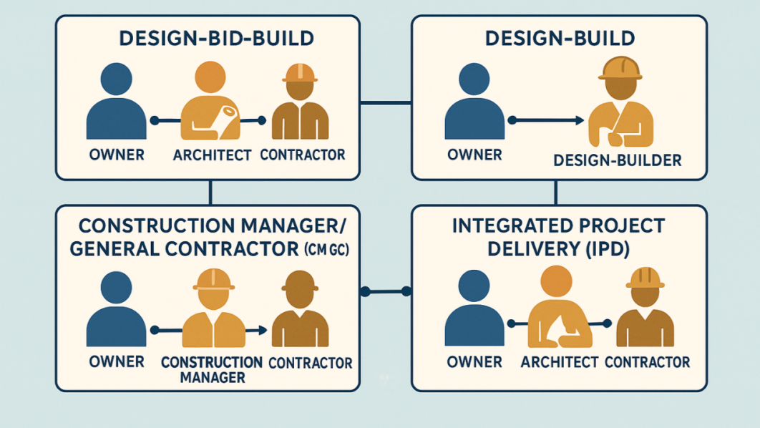
Figure 3: Overview of Project Management Contracting Approaches
There is no right or wrong approach to the contracting method, as it is determined by the complexity of the project, client's ability and risk factor. In the case of hospital construction projects, client control, risk allocation, the need for specialist expertise and coordination are all important. Turnkey contracting is an option that involves minimal client involvement, and shifts the majority of risk to the contractor, and is the best choice when a fast delivery is wanted (Smith et al., 2025). Multicontracting on the other hand offers higher client control, but means that the organisation has to deal with more than one contractor and risk. This form of contracting has the highest degree of control but is not a good option for large hospital constructions as most hospitals are not provided with the specialised construction experience and resources needed. The multicontract + DIY approach offers the best balance, in that internal oversight is combined with external knowledge and expertise. This blend of the two approaches allows healthcare entities to keep quality, regulatory and operational standards in check, but also gain the help of expert contractors, making it the best contracting solution for complex hospital construction projects.

8. Conclusion
For complex projects, the right contracting approach is key to their successful delivery. Every method has its own strengths and weaknesses based on the needs of a project, where risks are being transferred and how they are being handled by the project organisations. The trade-off between turnkey contracting and client control is that the former makes project management easier but decreases client control, while multicontracting increases flexibility but complicates project coordination. Self-contracted will lead to the most control from the organisation, but will demand expertise within the organisation which is less viable for large projects. The multicontract + DIY option offers the best balance of the four options by giving internal oversight and expert knowledge from a contractor, which helps to manage risks, ensure quality and compliance with regulations, and complete complex construction tasks.

9. Reference
Albtoush, A.M.F., Doh, S.I., Rahman, R.A. and Al-Momani, A.H. (2022). Critical success factors of construction projects in Jordan: an empirical investigation. Asian Journal of Civil Engineering, 23(7), pp.1087–1099. doi:10.1007/s42107-022-00470-8.
Carlini, J., Muir, R., McLaren-Kennedy, A. and Grealish, L. (2023). Transforming health-care service through consumer co-creation: directions for service design. Journal of Services Marketing, 38(3). doi:10.1108/jsm-12-2022-0373.
Hughes, W. and Champion, R. (2022). Procurement, contracts and project management. ICE Companion to Engineering Management, pp.1–52. doi:10.1680/icecem.65949.001.
Murali, D., Sreenivasan, A. and Suresh, M. (2026). Role of adaptive project method in turnkey construction projects. International Journal of Indian Culture and Business Management, 37(3), pp.316–332. doi:10.1504/ijicbm.2026.152305.
Rane, N., Choudhary, S.P. and Rane, J. (2024). Acceptance of artificial intelligence: Key factors, challenges, and implementation strategies. Journal of Applied Artificial Intelligence, 5(2), pp.50–70. doi:10.48185/jaai.v5i2.1017.
Saad, S., Alaloul, W.S. and Ammad, S. (2022). Fundamentals of construction project management. CRC Press eBooks, pp.1–21. doi:10.1201/9781003190134-1.
Sharma, S. (2026). Contract management—a collaborative approach. Infrastructure Project Completion, pp.105–118. doi:10.1007/978-981-95-6441-5_6.
Shojaei, R.S., Oti-Sarpong, K. and Burgess, G. (2022). Leading UK construction companies’ strategies to tackle BIM training and skills challenges. International Journal of Construction Education and Research, [online] 19(4), pp.1–22. doi:10.1080/15578771.2022.2123071.
Smith, M., Finn, M., Broome, J. and Maddox, C. (2025). Early contractor involvement. Emerald Group Publishing.
Ying, W., Dai, X. and Shen, W. (2025). Rapid project delivery through bricolage and planning: A case study of the huoshenshan hospital project. Journal of Construction Engineering and Management, 151(8). doi:10.1061/jcemd4.coeng-15066.
Zada, M., Khan, J., Saeed, I., Zada, S. and Jun, Z.Y. (2023). Linking public leadership with project management effectiveness: Mediating role of goal clarity and moderating role of top management support. Heliyon, [online] 9(5). doi:https://doi.org/10.1016/j.heliyon.2023.e15543.

