Report on-
Managing Projects in the Organization
Student Name: Firon Miah
Student ID: 1605305

Executive Summary
The report is all about a new project of Burger King, UK introducing a “new type of combo comprising two cheese chicken burger with French fries and milk shake”. In the report, I have as project manager, I analyzed the project theoretically and practically to achieve the goal. In addition, the report includes SWOT and Gantt chart analysis as well as others techniques to provide a snapshot to the board members to get approval to continue the tasks.
Table of Contents
Introduction 5
Background 6
Task 1 7
Project management 7
Types of project management 7
Project lifecycle 8
Benefits of projects 8
Project manager 9
Characteristic of a project manager 9
Project methodology 10
Organizational structure to support projects 11
Project management approaches 14
Risk management techniques 15
Task 2 17
Problem Statement 17
Project Strategy 17
Project definition 18
Project Objectives 18
Deliverables 18
Project Scope Statement 19
Project Assumptions 19
Implementation Plan 20
Prince2 method 20
Work Breakdown Structure 23
Gantt chart 24
Project Processes 25
Communication Plan with stake holders and colleagues 25
Task 3 26
Feedback process 26
SWOT analysis 28
Self-development plan 29
Recommendation 30
Conclusion 30
References 31

Introduction
Project management is a technique that comprises a set of activities such as organizing, leading and reporting the tasks to achieve certain objectives with the help of proper project management tools. The report about project management encompasses theoretical background about project and Burger King UK as the project is a new type combo Burger comprising two chicken and French fries of BK (BURGER KING®, 2018).
However, the new offer is focused on the particular market segment of different ages and classes of people. Different methodologies and SWOT analysis have been done to understand the company whether it support the project or not and to know what are the internal factors and external factors that may affect the decision of project managers to take proper decision.

Background
Burger King is an American global chain of hamburger fast food restaurants which was founded in 1953 as Insta-Burger King, a Jacksonvile, Florida based restaurant chain with having headquarter in the unincorporated area of Miami-Dade County, Florida. In 1954, due to financial difficulties, Insta-Burger King had been purchased by the two Miami-based franchisees David Edgerton and James McLamore and renamed it “Burger King” (BURGER KING®, 2018). With having large dimension of products of Burger King, it experiences problems to reformulate the products ingredients which creates impediment to achieve its goals and so as a project manager I took a new project to bring a dimension in its universe which is about “new type of combo comprising two cheese chicken burger with French fries and milk shake.”

Task 1

Project management
A project is a process of a unique set operations which are not routine works for an organization but it consists of specific goals, time, cost, constraints, quality and resources and all are employed to achieve an objective with coordinated efforts. For instance, the expansion of sales market and expanding product line of an organization are the example of project (Azendoo, 2018).

Types of project management
There are several types project management methodology and these are the following (Azendoo, 2018):
- Agile: It is a method of project management which offers extreme flexibility and speed. (Azendoo, 2018)

- Traditional: It is a process of managing project in a classic way with the help of a set of activities such as assessing various required activities for the project, (Azendoo, 2018).

- Waterfall: It requires that the tasks are to be accomplished sequentially hence the team members are reliant upon the other member which ensures everyone’s contribution to overarching the goals (Azendoo, 2018).

- Adaptive: The technique used to adapt any variation plan during the execution of the project and it gets adjusted any change to procure maximum output from each project (Azendoo, 2018).

- Critical Path: It is designed in such a way that all tasks are to be divided into critical and non-critical needed for the project by calculating the shortest and longest time to complete which are dependent on one another (Azendoo, 2018).

- PERT: PERT, standing for program evaluation and technique review, is a method of developing the process of manufacturing with the combination of critical path method (Azendoo, 2018).

Project lifecycle
The most five phases of project life cycle are the followings (Sharon and Dori, 2017):
- Initiation: It is the first stage of project Life Cycle whereby the project managers evaluate the project with the help of business case study and feasibility (Sharon and Dori, 2017).

- Planning: It considers broader plan, resources, time, cost, quality, and risks which help to guide and direct the team members to move forward the project (Sharon and Dori, 2017).

- Execution: In this stage, the project managers allocate the resources to execute the plan and keep the team members focused on their assigned tasks to satisfy customers (Sharon and Dori, 2017).
- Monitoring & Control: It is a process of overseeing the tasks of team members to keep track variation of allotted time and cost as well as measure the key performance indicators with strong control (Sharon and Dori, 2017).

- Closure: It is the last stage of project life cycle in which team members close the project with delivering finished project to the customers (Sharon and Dori, 2017).

Benefits of projects
A project is a set of unique coordinated and controlled activities to achieve objectives of an organization with proper management and when the project manager go for accomplishing anything, it requires system so it is proved that projects have some benefits and these are the following (Coombs, 2015):
- It helps the project managers to manage the project effectively.
- It reduces the costs with the help of increased efficiency as it develops new infrastructure for the projects (Coombs, 2015).
- It improves the level of productivity as it reduces operational errors (Coombs, 2015).

Project manager
A person who is responsible for executing the all activities with a team members and others resources from inception to execution of a project is called project manager (Techopedia.com, 2018). Burger King, the second largest fast food hamburger chain, recently has announced its project to expand its product line which is “new type of combo comprising two cheese chicken burger with French fries and milk shake” I am the project manager of the mentioned project and for implementing the project I took several steps which are discussed in the whole report in sequence.

Characteristic of a project manager
To be a good project manager requires a lots good characters because the project manager is responsible for leading the project from its inception to execution (Techopedia.com, 2018). The basics types of characteristics of a good manager are the followings:
- A Good Project Manager:
- Is proactive not reactive
- Has ownership mind
- Inspired & shared vision
- Has sound Judgement
- Is Diplomatic (Techopedia.com, 2018)

As a project manager I believe that majority of the above mentioned the qualities so I have firm belief on proper management of the project that Burger King announced recently.

Project methodology
Project methodology deals with a system of practices, procedures, techniques and rules to execute the various activities used by project managers to achieve the goals of the organizations. Following are some project methodology:
- Agile: Agile is one of the most useful project management methodology which requires a collaborative effort with self-motivation and cross functional teams of their customers to operate the activities properly and it is best for iterative and incremental projects (Azendoo, 2018).

- Scrum: It encompasses the five values such as courage, commitment, focus, openness, and respect to enable small, cross functional and self-organizing team to execute the tasks fast in order to achieve its certain goals (Azendoo, 2018).
- Lean: It is designed to maximize customer value with minimum wastages and it does it by streamlining the work process in such a way that it can eradicate the waste to improve its services (Azendoo, 2018).
- Waterfall: Waterfall is a set of structured process to complete the project activities in such a way that it helps to deliver quality products or services and in here it stresses the importance on the documentations (Azendoo, 2018).

- PRINCE2: It stands for projects in controlled environment which indicates that it is very developed and systematic methodology having furnished process to divide the stages of the tasks and it chalks out inputs and outputs in every phases of its process to ensure that the process leaves nothing to chance.
- PMI’s PMBOK: It is based on reference and guidelines by process management body of knowledge which comes through the project management institute.
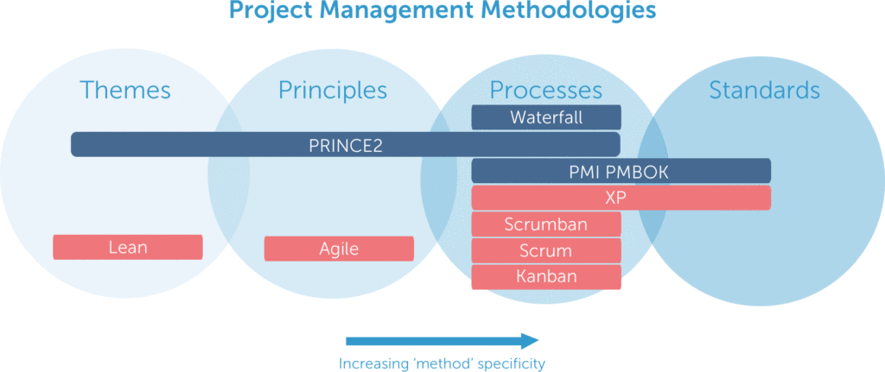

Organizational structure to support projects
Organizational structure represents the composition and systems of an organization to operate its business activities in proper way and Burger King has also a strong organizational structure for being global company. Burger King’s structure has been also changed several times. Being Global Company it operates under four global segments which are shown in the corporate structure of Burger King.

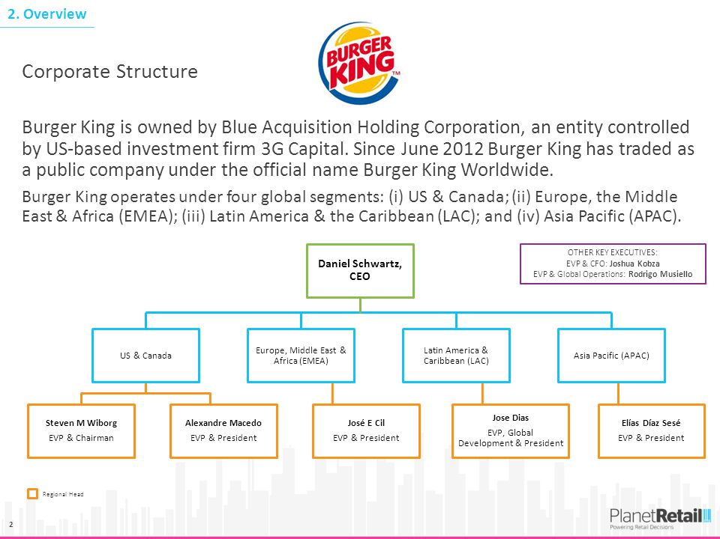
Source: Planet Retaill

As my project is for UK region customer. Burger King started its operation in UK in 1976 and now there are around 650 Burger King restaurants so it proves that the management is very strong in UK for BK so as a project manage I have sufficient human resources to support the project.
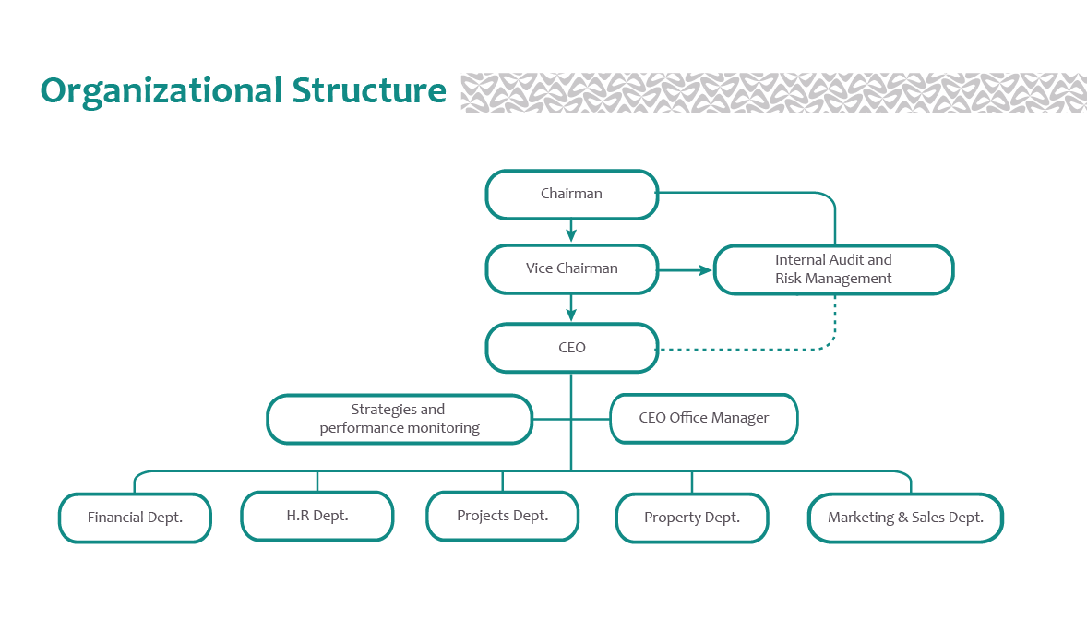
The food menu of Burger King is much diversified but in the early age of its initiation some of the menu were obsolete on the other hand providing QSR its demand in UK is increasing day by day and my project is also expanding product line in the UK market and below is the food menu of BK in UK.
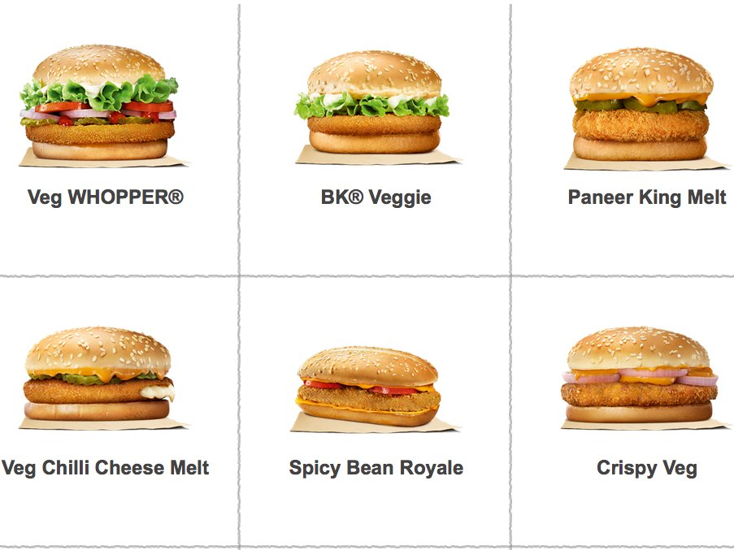

Project management approaches
Table of criteria | Approaches
Ease of understanding | There are several project management types which help to understand the project easily and the project management tools are also helpful to visualize the whole the process. Burger King is doing restaurants business and right now the world of food industry is very dynamic so process based tools will be helpful such as Prince2.
Fit with requirements of project within your area | The cultural environment of UK is very dynamic and changing every now and then so it is required that the new project management tools must have to align with the environment of UK. In this case the Prince2 will be fit as Burger King’s vision is to be the largest fast food chain in the world providing Quick Restaurant Service with quality as well as considering the preference of the customers.
Fit with organizational culture | Organizational Culture is a set of accumulated values (Gabriel, 2015), habits and traditions which influence the attitude of the employees of an organization so it is important to have a favorable organizational culture to take new project and the culture of Burger King is very supportive to pursue the higher performance of the employees. So I think BK’s culture enables me to complete my project.
Accessibility to others | Before going to implementing the project, I need to take approval from others personnel of BK and it requires the entire plan in written choosing proper project management tools by which the senior managers of BK can get an overview of the project. So I need to develop the whole plan regarding how to execute all the activities to complete the project and then I will submit to in Board Meeting to take the approval for the project.

Risk management techniques
Risk is the uncertainty associated with anything which can cause difference between expected and actual output and to manage it properly some often is called risk management (Musa, 2016). The project risk management risk management process is a set of activities such as planning, identifying, analyzing and monitoring the risks to accomplish the entire activities of the project. Following are the techniques of PRM:
- Identification of risk: It is designed to determine the risks that are likely to occur in the project if it is run by the project manager and it aids to trace the several things that can expose risk hence it helps to detect these risk (Musa, 2016).

- Quantification of risk: It is the method of expressing the risks associated with the project numerically and helps to estimate the effects as objective.

- Planning of risk: Planning is all about the process how to approach and set the project risk management techniques to manage the risks as well as other activities.

- Monitoring & Controlling risk: Project risk management(PRM) process requires effective monitoring & control to accomplish the entire activities properly.

Burger King’s new project about expanding product line also requires the process management techniques for minimizing the risks associated with the project.

Task 2

Problem Statement
In UK, BK has also several Burger which them few are obsolete in their early years of operation hence it is important to redesign its food menu for capturing the market of UK. So the project about “new type of combo comprising two cheese chicken burger with French fries and milk shake” is expected to reap the competitive advantages in the market of UK.

Project Strategy
To implement the project about “new type of combo comprising two cheese chicken burger with French fries and milk shake” of Burger King requires four strategies by which I can determine the project properly and these are the following:
Planning: In BK’s new project the PRINCE2 method is set which stands for project in controlled environment. It is very systematic method that leaves nothing to chance by dividing every phases of tasks.
Project appraisal techniques: The techniques are undiscounted methods and discounted methods.There is a subtle difference between two methods because discounted techniques consider time value of money whereas undiscounted methods do not. Payback period, accounting rate of return are the example undiscounted techniques and Net present value(NPV), Internal Rate of Return (IRR), DPBP are the example of discounted techniques and foe the project of Burger King, the discounted techniques are appropriate.
Risk analysis: Risk can be positive or negative associated with the project and through the risk analysis it can be determined to respond to the risks throughout the entire life of the project.
Stakeholder analysis (fair-trade initiatives, a green agenda): Stakeholder is an individual or group or institute who can affect the activity of the organization or be affected by the positive or negative outcomes by the project and analyzing and assessing the importance the key people involved in the project is called stake holder analysis. As without a lists of key people, one cannot carry out a large project so it is very important to have an analysis on stakeholders.

Project definition
Burger King UK possesses a lists of Burger in the UK fast food chain and to capture the market BK is going to announce a new project which about “new type of combo comprising two cheese chicken burger with French fries and milk shake” to expand product line. With the other Burger, the new type of combo will increase the dimension of BK in UK because it comprises two cheese chicken with French fries.

Project Objectives
Followings are the project objectives:
- Serving quality food (best Burger in the world) with reasonable price
- Quick Service
- Providing services in attractive way with clean surroundings
- Capturing the large portion of the Burger market in UK to attain leading position in the state

Deliverables
To develop services or products is not the end here because it has to be reached to the customers if a project managers want to attain its objectives so it is important to deliver product or service in proper way to entice customers. The following are the way how BK delivers its new Burger:
- Attractive Salesperson: In my project, I will have attractive salesperson to channel the products to the retailers and customers in a proper way.
- Attractive decoration: Decoration of product is a strong vehicle to entice customers to the product hence proper attractive shape of the new proposed Burger of BK is to be ensured so that it can keep back the customers.

Project Scope Statement
Project scope means the required works involved the entire project to be accomplished and project scope statement describes product scope, product criteria, project inclusions and exclusions etc.
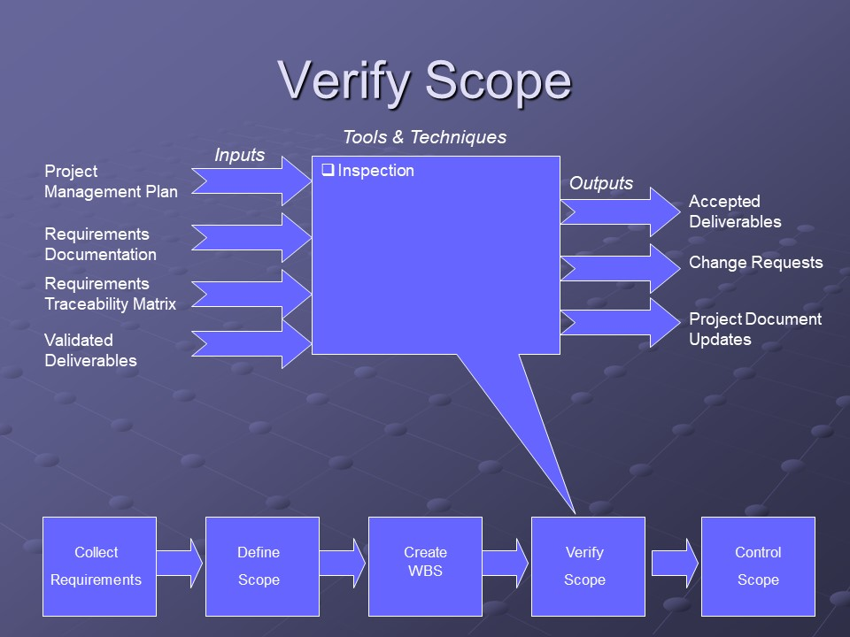
Figure: Process of verifying project scope.

Project Assumptions
The followings are the assumption that I have made for the project as a project manager:
- All resources available required by the new project
- The project can deliver quality Burger
- The higher management approves the project
- Stakeholders agree with the project
- New combo Burger can increase the revenue
- Operational management is skillful to develop the product
- Economic stability in UK will remain same at least two years
- Cultural environment suits with project.

Implementation Plan
Implementation plan means how a project manager can implement the activities involved in a project with proper project management tools to achieve objectives of the projects (Roberts, P., 2011). To implement the project of Burger King in UK about new combo Burger, I will use Prince2 method and it is discussed later.

Prince2 method
Prince2 method is a process management tool to execute a set of unique coordinated activities to attain certain objectives of the projects which is basically process based method and its every process defines inputs and outputs in every phases of its activities to ensure that it leaves nothing to chance (Anon, 2018).
The method’s process is the below and its explanation of every process is enumerated sequentially.
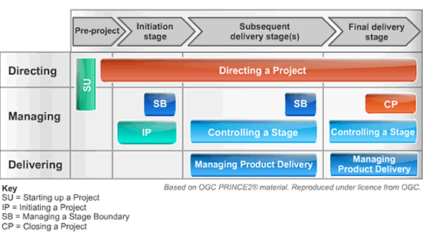

Directing a Project: Directing a project is to get the tasks done by the employees with proper direction until it declares its closures and I should consider the four main area which are the followings (Anon, 2018):
- Starting the project (Initiation)
- Checking the all available resources required for the project and develop commitment (Stage boundaries)
- Monitoring the progress with proper guidance and also reacting if it is required in any unfavorable situation (ad hoc monitoring)
- Closing the project with confirm of proper outcomes.

Starting Up the Project:
To do the pre-project activities in this stage for initiating the project finally I have to collect all required information, design and appoint a proper efficient project management team to initiate the project hence it should be very short.

Initiating a Project:
Generally, I have to initiate the project to achieve some objectives and these are the followings:
- To develop ownership among the stakeholders about the project
- To know whether there is sufficient logic behind the project to achieve its objectives
- To develop a management basis team
Managing Stage Boundaries:
In this stage, I have to do all the required tasks to provide key points to the project board to get authorization to continue the project as well as others objectives. I need to provide all required information to the project board about the current stage of completion and the board allow to continue the next phase of task if first phase is perfect.

Controlling Stage:
Controlling and monitoring stages deal with the day to day activities of a project to get better output and reduces the variances and this stages covers the following:
- Permission the work be done
- Monitor the works with collection information
Managing Product Delivery:
The stage describes the way how the combo burger is created and delivered by conforming the requirements which are set to execute for this and it covers several issues such as making certain that the product has been created properly with allocated resources, conforms to requirements, and ensures the approval for the completed product.

Closing the project:
The objectives of project closing are the followings:
- To obtain approval for the project to continue from the board members
- To check whether everything of the project has been properly or not
- To check the works, meet the requirements preparing project initiation documents
Planning:
Planning stage of Prince2 method is a continuous process and it can be charged on three levels of a project such as project, stage and team by which a project manager can get a bird’s eye view of the entire process of a project (Anon, 2018)
The above the process and stages of Price2 method are appropriate for the new project about new combo Burger of Burger King in UK.

Work Breakdown Structure
Work Breakdown Structure
Work breakdown structure is the step wise task of the project. (Project Management Docs, 2018)
New combo burger

Serial No of Works | Name of Works | Resources Required | Planning | Duration  (Days)
1 | Problem identification | Workers, customers | Market analysis | 1
2 | Opportunity | Competitors’ data | Market research | 2
3 | Resource allocation | Buns, cheese, chicken etc. | Supplier identification | 1
4 | Estimation of cost | Historical data | Budgeting | 2
5 | Financing | Reserves, loan | Source marking | 3
6 | Data collection | Computer, internet | Website analysis of competitors | 3
7 | Analysis and presentation | Manager’s prudency | Visual tools and virtual presentation | 2
8 | Recommendation and conclusion | Approval of the management | Pros and cons analysis | 1
9 | Initial sale | Combo packs | Initial feedback | 2
10 | Final checking | Flow of product | Continuous sales | Continuous

Gantt chart
Work breakdown structure is represented by Gantt chart (Clark, 2017).

Project Processes
Project process encompasses the components of whole implementation plan of a project and it is correspondent to the project management process and it considers the all steps of project start to implementation as well as it also takes into consideration internal process and procedures.

Communication Plan with stake holders and colleagues
By the help of following way I will drape my communication plan with stakeholders and colleagues:
Publish the plan in the internal website or group: Internal website is a strong vehicle for effective communication to the stakeholders or colleagues as every employee of the organization are concern about the update news in this website. So it will be better media to communicate with the stakeholders about the new project of Burger King in UK. Moreover, the internal Facebook group is also a strong tool for effective communication to let everyone know the project of BK in UK.
Email: Email is also a useful media to communicate with the stakeholders and colleagues easily as almost majority corporate employee must have to main email and keep it active always so sending an email about new combo Burger of Burger King in UK is very appropriate to let them know properly.

Task 3

Feedback process
Feedback is a process to gather information about any machines, inputs, individuals, team or organization about anything and it is a proper way to judge anything. To get feedback from the stakeholders as project manager is not an easy way so I need to move forward with a proper plan. The feedback process for getting feedback from team members are the following (Project Management Docs, 2018):
Show interest:
Showing genuine interest is a good approach to the employees or team members in an organization and by using it I can get proper feedback from the team members. In addition, asking question about how they feel actually about me and my project as well as work environment is important. For example,
    - How is your project coming along?
    - What do you need to achieve the goals?
    - How can I help?
    - What would I do for your betterment?
These questions help me as a project manager to get feedback about me and my project.
Pay attention to Nonverbal:
Nonverbal communication also gives positive and negative signals and I can catch it by paying attention to the nonverbal reaction when I talk to the team members and it differs between positive and negative signals.
Ask question to others:
Asking question to others in the organization such as your trussed colleagues who are not in my team members about how am I doing and what are the strength and weakness I have regarding the project is also viable to know myself. Moreover, sometimes project manager can ask question regarding himself from his life mentor or close friends.

Avoid Defensive:
Avoiding defensive behavior is very important when a project manager need feedback because it helps to get honest feedback which is very important for a project manager. It also helps a project manager to identify his/ her weakness and strength.
Own Your Mistake:
Admitting the shortcomings and mistakes helps to endear the employees to get proper feedback and it also develop trust in the mind of the employees when project managers admits own mistakes and appreciate them for good performance.

SWOT analysis
SWOT analysis is an effective technique to know about an organization, individual or team which encompasses strength, weakness, opportunity and threat about a person or organization and here two components are internal and two are for external. Followings are the things that I have got through feedback:
SWOT Analysis of project manager:

Self-development plan
Self-development plan is about the recording of own development in continuous learning activities and it shows how is one developing oneself through doing the activities of a project.

Recommendation
To implement a project like combo type of Burger comprising two chicken cheese and French fries requires much skills, knowledge and time as well as a good team so a project manager must have go through many blogs or sites to get proper understanding about a project and its management theoretically.
Without much knowledge regarding the project and the company a project manager cannot develop the project management methods theoretically as it requires the depth knowledge about the company’s strength, weakness, opportunities and threats so before going to take initiative a project need to go through about the company properly.
In every project there are certain risks involved in the tasks so one need to develop forecasting skills to estimate the risks which have negative or positive impact on the objectives of the project and it also requires a good risk analysis on the project. Finally, a project manager has to focus on cost benefit analysis to get approval from the stakeholders of the project to commence the entire tasks of the project which is prerequisite of further continuing the next phases of the project.

Conclusion
A project is a consists of a set of unique activities with having a specific time period to achieve certain objectives with a proper management and it is done by certain project management tools and techniques. In this report, the new project about “new type of combo comprising two cheese chicken burger with French fries and milk shake” of Burger King UK has been discussed with the help of project management tools sequentially.
Moreover, Burger King’s new project about new combo Burger requires SWOT analysis and Gantt chart analysis to understand the pros and cons about the project easily.

References
Panmore Institute. (2018). Burger King’s Vision Statement & Mission Statement - Panmore Institute. [online] Available at: http://panmore.com/burger-king-vision-statement-mission-statement
Azendoo. (2018). Top 13 Project Management Methodologies and Styles. [online] Available at: https://blog.azendoo.com/top-project-management-methodologies-and-styles/
BURGER KING®. (2018). About BK. [online] Available at: https://burgerking.ca/about-bk
Sharon, A. and Dori, D. (2017). Model-Based Project-Product Lifecycle Management and Gantt Chart Models: A Comparative Study. Systems Engineering, 20(5), pp.447-466.
Musa, S. (2016). Assessing the status of logged-over production forests. 9th ed. Bangkok: FAO.
Roberts, P. (2011). Effective project management. London, UK Philadelphia, PA: Kogan Page. http://www.tsd.ac.uk/en/lrc/onlineresources/e-books/
Maylor, H. (2005). Project Management. 3rd ed. Harlow, England: FT Prentice Hall.
Coombs, C. (2015). When planned IS/IT project benefits are not realized: a study of inhibitors and facilitators to benefits realization. International Journal of Project Management, 33(2), pp.363-379.
Techopedia.com. (2018). What is a Project Manager (PM)? - Definition from Techopedia. [online] Available at: https://www.techopedia.com/definition/677/project-manager-pm
Gabriel, K. (2015). Organizational Development, Organizational Culture and Organizational Change. SSRN Electronic Journal.
Anon, (2018). [online] Available at: https://www.simplilearn.com/prince2-structure-and-benefits-in-project-management-articlehttps://www.prince2.com/uk/prince2-processes
Clark, W. (2017). THE GANTT CHART. 12th ed.
Project Management Docs. (2018). Work Breakdown Structure (WBS) - Project Management Docs. [online] Available at: https://www.projectmanagementdocs.com/template/project-planning/work-breakdown-structure/
Project Management Docs. (2018). Work Breakdown Structure (WBS) - Project Management Docs. [online] Available at: https://www.projectmanagementdocs.com/template/project-planning/work-breakdown-structure/
Vaněk, M., Mikoláš, M. and Žváková, K. (2012). Evaluation Methods of Swot Analysis / Metody Vyhodnocení Swot Analýzy. GeoScience Engineering, 58(2), pp.23-31.

