August 2020
B TULLOCH (1905352)
Professional Career Development
Jo Walsh (BMSW4005)

Table of Contents

INTRODUCTION 2
MY REFLECTION 2
THE SKILLS AND KNOWLEDGE REQUIRED FOR WORKING EFFECTIVELY 3
UNDERSTANDING OF STRENGTH AND WEAKNESSES 3
SWOT Analysis 3
STRENGTHS 4
What Am I Good At? 4
What Personal Resources Do I Possess? 4
What Values Do I Believe In That Others May Not? 5
What I Do Better Than Anyone Else 5
What do others see as my strength? 5
WEAKNESS 5
What Are My Negative Habits? 5
What task do I avoid? 6
What Others May See As My Weaknesses? 6
OPPORTUNITIES 6
What New Technology Can Help Me? 6
How Can I Take Advantage Of The Current Climate? 6
How Can I Turn My Strengths into Opportunities? 6
THREATS 7
What Is My Competition Doing? 7
What Threats Could Harm Me? 7
CONCLUSION 7
References 8
APPENDIX 9

INTRODUCTION

I took up this course for no other reason than I just wanted something else to do whilst still working. Not necessarily thinking of a career change from the job I was doing for over 43 ½ years (Department of Works and Pensions), but as my children were big, and my granddaughter had left University and embarked on her chosen path (property development) I had the time.

MY REFLECTION

Finally, I had found my niche at work, working as a Union/Learning and Health and Safety Representative fighting in the corner for those who were too afraid/unwell to fight for themselves.
When I started University, a lecturer asked us to reflect back, and stating that we did not have to write it down as it was personal – so I did not. But I did look back as I do from time to time and smiled at where I had come from to where I am now. I reflected on having to look after my mum and family (2 girls and 4 boys), whilst my dad was at work. My youngest brother had a hole in his heart and Down Syndrome, with a life expectancy of 21 years (he died just after he was 21). I reflect on a lot as things which become much clearer as you get older, you (some of us) get wiser, along with learning life skills. The reason I had to look after the family was because my mother was schizophrenic, and in and out of hospital as she would not take her medications. On reflection I now realise that she probably had SAD (Seasonal Affective Disorder) and not schizophrenia, also that if she had been given the appropriate treatment she could have looked after herself and the family, and may still be alive. I reflect back and wonder on why white people can be diagnosed with SAD and most black people diagnosed with schizophrenia, when in fact it would make more sense for people of the sun to suffer from the lack it.
This was years later when I found out that the reasons for SAD was the lack of sunlight, so I thought yet again, another way the system tries to grind us down, buy not affording us the opportunity to get the right treatment to look after our families. I reflect back at having my daughter at 14 years of age, and then her sister 4 years later, and I smile when I see how well they have done (Support services Wandsworth Council and my youngest a construction Manager but since the lockdown she has started her own maintenance and repair business). I am proud that in spite of not finishing school (went to evening classes to study Pittman’s typing/audio) and teaching myself how to make clothes (because it was either me or the children), and of the statement that single mothers are the reason for so many delinquent children – I have done alright.
My journey has also changed, and I am surer now than ever of what I want to do, to support young vulnerable girls like I was, who are in abusive relationships. I remember that I was once there too, but the thought of having my children seeing their father beat me was enough to make me strong enough to get out. But not everyone can. From joining the department in 1977 from a typist to an audio typist, and because my face did not fit, nearly losing my job when the Department sole us out. Before TUPE (Transfer of Undertakings Protection of Employment) had expired I was being downgraded, and having to fighting my way up. I then began attending meetings with Managers, negotiating terms and conditions for members to drawing up a local learning agreement for the branches. It has shown me that I have the relevant skills, knowledge and confidence to try my hand at anything I am passionate about.
Having this accreditation will open the door to my new career, but I will do some voluntary work in the local community just to touch base. This course has also made me reflect on when I use to be a Lay Visitor (visit prisoners unexpectedly to ensure that they knew their rights, were fed and watered), adventure playground assistant and that my new desire to support the less fortunate has always been there, but probably I was afraid to take the leap with two young children.
My desire is to eventually run a community workshop and help support young BAME girls who fall pregnant young, and end up being physically and mentally abused, and feel that they have no way out.
University has given me the opportunity to work with other students from different countries and walks of life, enabling me to share different views and perspectives as outlined by Cottrell (2003:1) who states that “being at university gives you the opportunities to come across a variety of different people, learn new skills and activities whilst expanding your horizon “

THE SKILLS AND KNOWLEDGE REQUIRED FOR WORKING EFFECTIVELY

Attending University has enhanced my skills and helped me developed new ones whilst enriched my understanding of life, as everyone has a different story. I was pretty IT savvy but as the saying goes - if you do not use it, you lose it and most of what I had know was not required in my daily work, so doing this course has enhanced my IT and mental knowledge.

UNDERSTANDING OF STRENGTH AND WEAKNESSES

SWOT Analysis

A SWOT analysis is a tool that can be used to gauge your strengths and weaknesses and is beneficial to companies who want to employ the right people for the right roles. (Parsons, 2018)

STRENGTHS | WEAKNESS
What am I good at?  What personal resources do I possess?  What values do I believe in that others may not?  What I do better than anyone else  What do others see as my strength? | What are my negative habits?  What task do I avoid?  What others may see as my weaknesses?
OPPORTUNITIES | THREATS
What new technology can help me?  How can I take advantage of the current climate?  How can I turn my strengths into opportunities? | What is my competition doing?  What threats could harm me?

STRENGTHS

What Am I Good At?

My strengths are that I have grown to recognise only a fool knows it all, and that you learn something new every day – even from the fool. That mind set enables me to take every situation good or bad as a beneficial experience, which has enhanced my life skills. My ability of not judging people enables me to work with people I would not normally associate with and have a productive relationship. I am good at talking and listening and have the genuine ability to feel empathy to anyone going through sickness, bullying or unconscious bias of any kind. This has help me to connect with Management and make a case, then come to some sort of arrangements and mediate on behalf of team members.

What Personal Resources Do I Possess?

The personal resources that have assisted me throughout work, is my ability to connect with people and show support and commitment.
My confidence has given me the ability to liaise with Management and MP’s alike, as my upbringing has showed me that no one is better than anyone. This confidence has allowed me to feel confident to speak at conferences, and Regional meetings across the region as a Learning/ Union Representative.

What Values Do I Believe In That Others May Not?

Loyalty; is a value that I strongly believe in but sadly that seems to be a thing of the pass. Values play highly when I have to deal with people who have reneged on their word, or clearly try to manipulate instructions/regulations/policies that are regulated. This covers every aspect of life, because, if you arrange a time and place and do not attend, you have lost my trust/business and respect.

What I Do Better Than Anyone Else

What I do best is negotiate, somehow, I have the ability of persuasion. This ability has enabled me to acquire free goods from Sainsbury’s (food and drinks), WH Smiths (Book Vouchers), EE/T Mobile (USB sticks, Chocolate, balloons erasers), M&S (Food & Drinks). It has also enabled me to get free resources from the local gym (and discount membership\classes), and other resources that we would usually have to pay for to enable my colleagues to have a Learning At Work Day.

What do others see as my strength?

I have been told by others that my strengths are that I appear very confidence. They think because I walk around and keep in touch with everyone, whilst remaining on friendly terms with Management that they would be under sold when I have to negotiate on their behalf. They are surprised at how determined and dogmatic I am, to ensure that their best interest is gained. My love of communication, which is effective communication, ensures that everyone is fully aware of their expectations. Griffiths and Dunham (2017) state that teams need a compelling direction.

WEAKNESS

What Are My Negative Habits?

I tend to wait until the last hour to chase someone up, when waiting for a response. When chasing someone up I do not like to feel like I am being over eager, so I give them the opportunity to come good.

What task do I avoid?

I avoid tasks that I do not fully understand so in avoiding them, someone else might do it or ultimately show me exactly what is expected of me. Now I know the various learning styles, I understand my hesitation.

What Others May See As My Weaknesses?

I think that other people may perceive my friendly outgoing nature as not really knowing much, and this can lead to the misperception that I am an air head. The fact that I do not fall out with Managers because I do not take their obstructions as personal, confuses peoples. My take is Life is Too Short. Agree to disagree move on …… NEXT.

OPPORTUNITIES

What New Technology Can Help Me?

All technology is good technology because it can help me to tap into various support hubs, funding and local communities who are dealing in the specific area that I want to work. The lock down has seen a rise (good or bad), in the various modes of communication that have helped employees and victims, get in contact, and stay in contact. Duck and McMahan (2016:107), “technologies do influence your world”.

How Can I Take Advantage Of The Current Climate?

Unfortunately, the Plan Demic has seen a rise in people taking advantage to brutalise their partners and children. The Government has not taken it seriously enough, by injected inadequate funding to help the organisations support the victims on time. This has applied even more pressure on an area already suffering brutally, from the lack of resources (homes) and manpower required to provide the kind of support. So, the need for additional support, especially voluntary will be appreciated.

How Can I Turn My Strengths into Opportunities?

I can do this by completing my course then initially doing some voluntary, before embarking on my career path. The world will be my oyster once I have completed my course, and with the further knowledge and confidence I have gained, I know that I can make a difference.

THREATS

What Is My Competition Doing?

Where I wish to specialise I think most organisations are working under the Local Government, but if I do not keep up to date and current I could potentially lose sight of my objectives.

What Threats Could Harm Me?

Threats that can harm me and jeopardise my future prospects, is not being fully prepared mentally for working in an environment that I could have been in myself. Making sentiment take over, leaving me mentally and physically vulnerable, to be exploited by the organisation who may see my commitment as a weakness.

CONCLUSION

In this reflection I have identified the challenges that I have had to overcome, which have only served to make me stronger.
I have measured by capabilities and acknowledged all the new skills that I have gained, which I can utilize in my new career path.
Mostly, this has shown me where I really want to be.

References

https://www.nhs.uk/conditions/seasonal-affective-disorder-sad/

Cottrell, S. (2003) Skills for Success. Hampshire: Palgrave Macmillan.

Duck, S. and McMahan, D.T. (2016) ‘Technology and Media’ Maund, A., Schriek, M., and Tinkler, P. (ed) Certificate in Higher Education: Skills for the Workplace Student Yearbook. London: Sage Publication.
Cottrell, S. (2003) Skills for Success. Hampshire: Palgrave Macmillan.

Griffiths, B.A. and Dunham, E.B. (2015) ‘Communication’, in Maund, A., Schriek, M., and Tinkler, P. (ed) Certificate in Higher Education: Skills for the Workplace Student Yearbook. London: Sage Publication.

Parkhurst Consulting (2014) SWOT Analysis. Available at: www.parkhurst-consulting.com/wp-content/uploads/2014/03/SWOT-Analysis-CMYK.jpg (Accessed: 5th April 2020).

APPENDIX

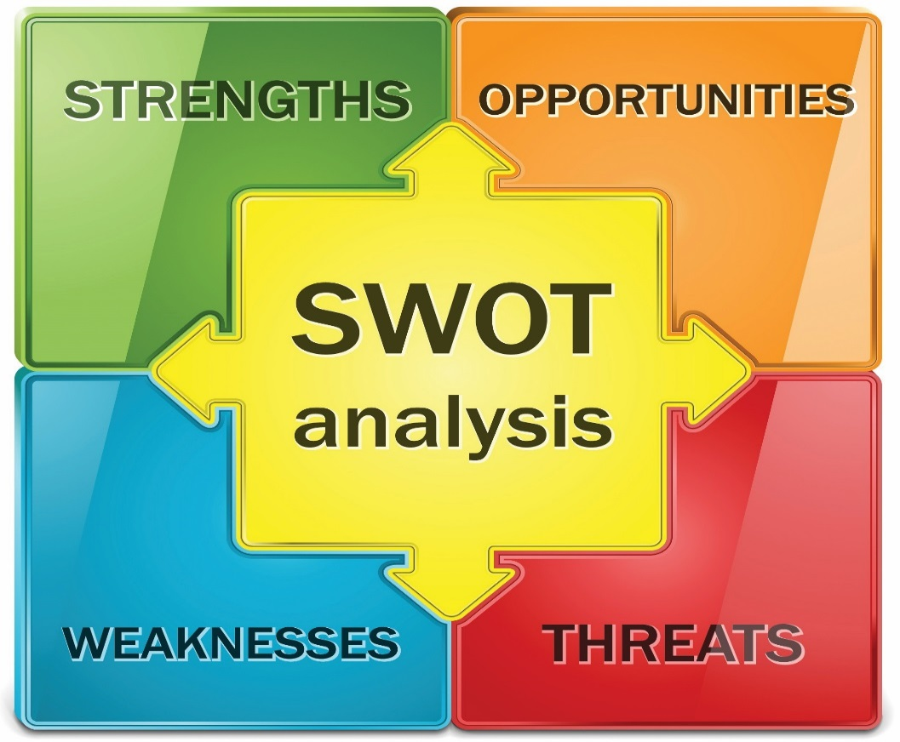
(Parkhurst Consulting, 2014)

