
Glenny maria rodriguez molina
Student Number: 2133847

UNIVERSITY OF WALES TRINITY SAINT DAVID
Effective team working and communication
(bmsw4002_lon)
Teacher: Anita Nan

Richard, N. (2019) stated that communication is the process of transmitting and receiving messages using verbal or nonverbal means, such as voice or oral communication; writing and graphical representations (such as infographics, maps, and charts); and signs, signals, and behaviour. Communication is defined as "the creation and exchange of meaning”.
The author of this report will demonstrate an understanding of the three communication models, the communication skills discussed (verbal, nonverbal, and listening), and the benefits of communication technology, particularly mobile phones, and the internet, in terms of how they affect students' learning. In addition, the author will apply group dynamics, teamwork, and communication theories to their own workplace instances.
Looking at communication as a fundamental organising component of human society, many academics applying various hypotheses and techniques constructed several paradigms to investigate and assess human communication over time.
Different communication models evolved over time as our comprehension of principles, elements, and rules changed (Narula, U. 20016).
The Shannon and Weaver Model of Communication, developed in 1948, asserts that human communication may be separated into six basic concepts: sender, encoder, channel, noise, decoder, and receiver. This paradigm was designed expressly to promote effective communication between sender and recipient. They also find "Noise" variables that change the communication process. Initially, the method was devised to improve technical communication. It was afterward widely employed in the realm of communication (Shannon, C. Weaver, W. 2015).

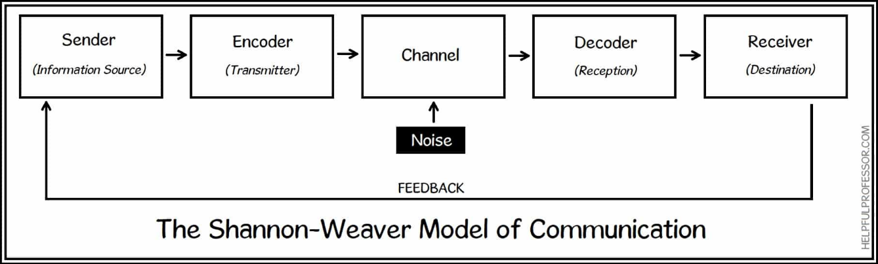
(Chris Drew, 2023)

The Shannon-Weaver communication model was initially suggested for technical communication, such as telephone calls. Nonetheless, it is widely used in a variety of areas of human communication. The author will exhibit his knowledge and understanding of the model he has implemented.
James works on a building site; Elizabeth is his wife. One day Elizabeth got in contact with James asking him if he could get her a bottle of wine, James agreed but misunderstood what Elizabeth has asked him to do. James got home and went to the kitchen to find Elizabeth, she asked him where was the wine that she asked him for, he looked confused and realized that he has misunderstood what Elizabeth said to him and brought her a bottle of milk.
Transmitter: Elizabeth
Phone as the encoder (Elizabeth)
Building: noise
Noise: cleaning listening
Phone number (James)
James is the recipient.
Elizabeth’s messages are difficult for James to understand due to transmission errors or background noise that interfere with their ability to communicate.
The Osgood and Schramm model (1954) defined communication as a dynamic interaction in which two active people exchange meaningful messages. Messages are encoded, transmitted, received, decoded, and interpreted by both the communicator and the recipient. Describes how humans communicate with one another, mostly through speech, writing, and discourse. It focuses on four fundamental principles:
The relationship is circular rather than linear. Most listeners can both receive and emit signals. Communication is typically equal and reciprocal. There is a lot of interpretation involved with receiving a message. Encoding, decoding, and message interpretation are all required phases in all communication (Steinberg, S. 1995).
Waiter and Costumer: “Could I have a glass of water; I have a sore throat” customer desired a glass of water when the waiter gave him/her a glass of wine. The waiter gave a different meaning. The customer and the waiter were not on the same grounds, the waiter did not comprehend the customer’s request.

David Berlo proposed a new type of model in 1960, whose purpose was to identify the characteristics that he thought were crucial in the communication process. The focus of Berlo's approach was on the qualities of the sender and the receiver as they passed through various components of the message route.
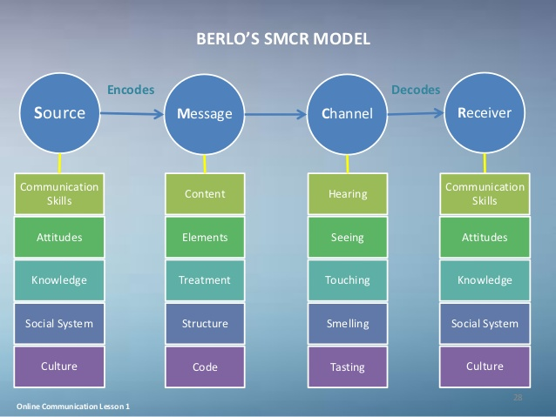
SMCR Model of Communication (Berlo, 1960)
Berlo's SMCR Model of Communication deconstructs the communication process. The model is made up of four components, each of which is influenced by a distinct element. The sender and receiver must share some common ground for the message to be communicated as efficiently as feasible.
Communication skills are essential in this. Culture, expertise, and attitude are also important considerations. What is considered impolite in one culture may be entirely acceptable in another. Communication is not always as easy as one would like. Disruptions, noise, and an asynchronous process, among other things, might block proper communication (Janse, B. 2018).
A well-known English professor at a Welsh university lived near a village where most of the villagers were uneducated and did physical labour. A house caught fire one day after someone smoked a pipe that had fallen on the ground. He screamed that the building was being consumed by a great conflagration, which the villagers did not understand. The next day, the professor asked why the villagers did not help him, and it turned out that the language used was very intellectual, which the villagers did not understand because they were uneducated.
Communication is essential for our health, relationships, and all the activities we engage in as functioning humans (hannawa & spitzberg, 2015).
Communication is an essential level on the professional and personal growth ladder. When we are confident in our communication, it boosts our self-esteem and self-worth.
According to David Kolb (1971), we should go from experience to contemplation to thinking about numerous concepts and theories. In the words of Hymes (1971), communication competence includes not only the ability to execute but also the knowledge of how to perform (Ellis, R. 2009).
Verbal communication refers to the use of spoken and written words to convey a message or information to another person. In other words, we vocally communicate whenever we use our words to describe ourselves, our feelings, and our thoughts. Yes, even when we write to someone, we are engaging in verbal communication.
Professional terminology and respectful but direct dialogues come to mind when we think of business communication. Furthermore, the workplace is one of the most important places for us to demonstrate our communication skills.
Your verbal communication skills should be on point whether you are speaking to your supervisor or a colleague. According to the research report "Communication in the workplace - guideline for improving effectiveness," there are various advantages to strengthening your workplace communication abilities. Let us name a few and discuss them.
There are two types of verbal communication: formal communication and informal communication. Formal communication occurs when you use a selective and complex preference of language to send a message to someone, such as a journalist, when writing a letter, or when speaking to someone with whom you do not have a strong relationship. Informal communication is when you interact in the way you normally talk daily: short phrases, a lack of vocabulary, or even sending a quick message on your mobile phone or when speaking to friends and family (Westland, G. 2015).
Your nonverbal communication triggers—how you listen, look, move, and react—tell the person with whom you are communicating the amount that you care about, if you are being accurate, and how effectively you are paying attention. When your nonverbal clues match what you are saying, trust, clarity, and rapport improve. If they don't, they can create friction, mistrust, and uncertainty. Nonverbal communication not only conveys feelings, but also aids in the regulation of the body's physiology (Cannon, 1927; Trevarthen, 2003).
For example, Martha went to the coffee shop to get her morning brew. When she arrived, the barista was speaking to a different customer. When Martha said good morning to the barista, the barista moved her face and gestured as if it were no bother to engage with her. Martha is repeatedly asked to repeat her order by the barista, indicating that the barista was not paying attention.
Increasing your awareness and control over your emotions can have a significant impact on your ability to listen well. Listening to others frequently occupies more time than reading, writing, and speaking together. It is most certainly the most crucial communication skill and social tool. The ability to receive and decode both verbal and nonverbal cues is required for good listening abilities (Debra, W. Margaret, F. 2015).
Listening to others frequently occupies more time than reading, writing, and speaking together. It is most certainly the most crucial communication skill and social tool. The ability to receive and decode both verbal and nonverbal cues is required for good listening abilities.
According to Jonassen (1996), Salaberry (1999), and Rost (2002), current computer technology provides significant advantages for second language learning. A computer and its associated language learning programs could provide second language learners with greater independence from schools by allowing them to work on their learning material at any time of day.
When computer technology and the Internet combine, it opens a path for students to receive a great amount of human experience and guides them into the "Global Community." In this way, students can not only widen their personal perspectives, cognition, and experience (Lee, 2000).
The invention of the computer was an important moment in history. Therefore, interaction is improved, and businesses can communicate more easily with foreign countries.
Research is also made easier. Companies benefit from developments in implementing strategic technology developments by saving time and consequently money (Ismail, N. 2017).
On the other hand, the progress of contemporary technology brings drawbacks, such as reliance on new technologies. Even if the calculator is a useful invention, human no longer performs mental calculations or exercises their memory. Most technical advances attempt to reduce human effort, implying that machines do more labour. This means less work for people.
Individuals who are unable to attend traditional classroom settings can also benefit from distance learning. These persons include those with disabilities and those who reside in rural areas where daily travel to a university or college would be difficult or impossible (McNaughton, 2001).
Educators may lack the time and experience to implement technology. Using technology carelessly can lead to lower learning outcomes and cause kids to miss social connections. These are the major disadvantages of using technology in the classroom and online education.
According to Gips, et al (2004), the primary downside of computers and their assisted language learning programs is that they will raise educational expenses and damage educational equity. When computers become a new basic requirement for students to purchase, low-income schools and students typically cannot afford one.
Technology is assisting adults in overcoming these challenges. Adults can benefit from flexibility, for instance, from online learning, which enables them to acquire the necessary skills at a time and location of their choosing5, without being constrained by physical limits or locally available resources (Department for Education) (DfE, 2019).

Communication involves more than just words; it also involves tone and body language. You may convey your message clearly by using tone and body language. When possible, making eye contact is preferred to other indirect communication methods. According to this article, it is crucial to communicate in business because failing to accomplish so might compromise your morals. The author of this article has highlighted the value of both verbal and nonverbal communication as well as its positive and negative aspects, establishing accurate interpretations of others in order to create good communication.
As stated in DfE in 2019, everyone will be able to communicate more quickly thanks to technology, which also makes it easier for people to engage and exchange information. However, it's crucial to be aware of the potential issues and misunderstandings that might arise due to both poor communication and technology.

REFERENCES

Baird, L. L. (1983). The search for communication skills. ETS Research Report Series, 1983(1), i-48.

Berlo, D. (1960). The process of communication: an introduction to theory and practice, Holt, Reinhart and Winston, New York.

Department for Education (2019). Realising the potential of technology in education: A strategy for education providers and the technology industry. Available at: https://assets.publishing.service.gov.uk/government/uploads/system/uploads/attachment_data/file/791931/DfE-Education_Technology_Strategy.pdf [Accessed on 22nd April 2023].

Dwyer, Francis M.., Moore, David Mike. Visual Literacy: A Spectrum of Visual Learning. United States: Educational Technology Publications, 1994.

Ismail, N. (2017). Modern Technology: advantages and disadvantages. Available at: https://www.information-age.com/modern-technology-advantages-disadvantages-5283/ [Accessed on 17th April 2023].

Janse, B. (2018). Berlo’s SMCR Model of Communication. Retrieved 2015 from toolshero. Available at: https://www.toolshero.com/communication-methods/berlo%E2%80%99s-smcr-model-of-communication/ [Accessed on 3rd April 2023].

Lee, K.W. (2000). English teachers’ barriers to the use of Computer-assisted language learning. The Internet TESL journal, Retrieved June, 25, Available at: http://www.4english.cn/englishstudy/xz/thesis/barrir [Accessed on 3rd April 2023].

Management study guide (1954). Schramm’s Model of communication. Available at: https://www.managementstudyguide.com/schramm-model-of-communication.htm [Accessed on 13th April 2023].

Narula, Uma. Communication Models. India: Atlantic, 2006.

Nordquist, R. (2022) "What Is Communication?" ThoughtCo. Available at: What Is Communication and How to Use It Effectively (thoughtco.com) [Accessed on 23rd March 2023].

Shannon, Claude E., Weaver, Warren. The Mathematical Theory of Communication. United States: University of Illinois Press, 2015.

Steinberg, S. (1995) Introduction to Communication Course Book 1: The Basics. South Africa: Juta.

The Handbook of Communication Skills. United Kingdom: Taylor & Francis, 2018.

Westland, G. Verbal, and Non-Verbal Communication in Psychotherapy. United States: W. W. Norton, 2015.

Worthington, et al. Listening: Processes, Functions and Competency. United Kingdom: Taylor & Francis, 2015.

