REPORT: DESTINATION MANAGEMENT
Name of the student: Oana-Lavinia Puravet
Name of the university: University of Wales Trinity Saint David
Student’s ID: 2129004
Module tittle: Sustainable Hospitality & Tourism Management
Module code: BMIH5006
Lecturer’s name: Kathryn Roberts

Executive summary
The report has followed the path of the famous hotel conglomerate JW Marriott. This report has elaborated on the recent accusations that the company has faced because of greenwashing in the industry. Along with this, the report has also given examples of greenwashing in the hospital industry in a holistic way. After this, the report has given an depth analysis of various strategies and recommendations on how to bounce back from this intellectual crisis that it is facing. There are recommendations for including the CSR policies in the company, using angel investors etc. Further, the paper has also discussed in detail the company's application of green technology in the company. Finally, the report has given recommendations on alternatives to self-evaluation.

Contents
Introduction 4
Greenwashing in Marriott 4
The hotel’s self-evaluation and its reasons 5
Recommendations to stop self-evaluation 6
Circular economy- a defiition 6
Benefits of a circular economy. 7
Marriott’s Circular Economy 8
Interrelation between Marriott and CSR 8
Benefits of CSR in the company 9
Conclusion 10
References 11

Introduction
Corporate social responsibility is a business model that is self-regulating and it helps the business to be self-sufficient. Additionally, businesses nowadays are turning to become more sustainable in nature. Corporate social responsibility marks the accountability of the business to society. This is relatively new in the corporate sector, especially after the pandemic. Since then, the companies have become more acquainted with maintaining their social responsibility for society as well as for their human capital. This model of business helps to regulate and coincide with their social responsibilities and in turn makes sure that the company understands them rather than compromising them in the long run. This department works closely with the human resources department of the company because their job roles are similar in framework, but different in application. In addition to this, corporate social responsibility also helps to make a business sustainable in nature as it follows the 16 sustainable development goals that the United Nations Organisation has put forward. They have also introduced several philanthropic endeavours in the corporate sector. Starting from youth engagement to community upliftment, CSR has helped society in many ways.

Figure1: JW Marriott, UK
(Source: JW Marriott, 2024)

Greenwashing in Marriott
There has recently been an uprising in the Marriott hotel conglomerate because of the accusations that the company has faced of greenwashing in the industry. Greenwashing is a heinous crime against human rights because it hurts the workers not only physically but financially as well (Gurlek, 2023). This process is highly exploitative in nature as it uses the expertise of the workers and does not acknowledge their contribution. Along with this, the customers also suffer because of this process as they are led to believe things about the establishment which are not actually true in the establishment. There have been accusations from several customers that the rooms of the hotel are not cleaned at regular intervals in the hotels and the rooms are unhygienic. Here, the reputation of the hotel suffers tremendous loss if a hotel chain of that charisma faces accusations of one of the biggest reasons for boycotts in the industry. The management has said that the housekeepers are doing their jobs perfectly despite the lack of resources (Ettinger et al., 2021). The investigation committee against the conglomerate is not ready to accept that as they are not ready to believe that a hotel chain of that high regard is having a loss of sponsorships.
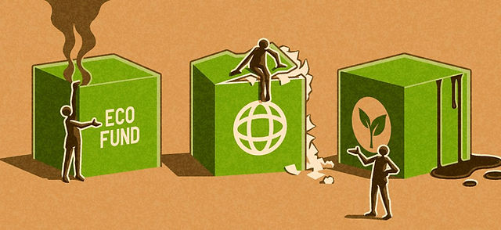
Figure 2: Greenwashing
(Source: Ettinger et al., 2021)

The hotel’s self-evaluation and its reasons
There are several reasons for a company to self-evaluate. It is mostly done by large industries that are well-established in the sector. However, in this case, the self-evaluation done by the company has become problematic for the company itself. The company was already accused of greenwashing which turned out to be even more grave after its self-evaluation. The constant feedback that companies receive through external sources has exposed them(JW Marriott, 2024). The customers have not been respectful in their evaluation of the company's shortcomings in this regard. As a result, the company has faced even more serious allegations against the human rights department. They had standards which used to be an ambition for many in the industry; however, that place has since been dismantled because of the accusations that the company faced. The subsequent self-evaluation has further hurt their cause because it was seen as an attempt to close the chapter and push it under the carpet. Thus, the accusations which were only alleged have since turned into serious proven accusations (Green Globe, 2024). There are ways that the company can use order to save its image, however, the loss of image that the company has faced will remain in its record forever.

Recommendations to stop self-evaluation
There are various ways which can be implemented by the company in order to save the company and their image. One of the foremost is the implementation and engagement of angel investors. This is important because the investors not only help through financial methods, but through intellectual inputs as well. In this situation, that is more important for the company. The company has the ability to bounce back from a financial crisis because of its asset-gain business model. However, it will be difficult for them to understand the green initiatives taken by them and follow them. In the following part, there have been several recommendations to be used as models of the business framework in order to help the business undertake the green initiative and go through with it (WTO, 2024). The angel investors will help tremendously in this because they will lend their expertise in the field. Angel investors are mostly used in startups in the industry, but this is a special case of gaining the trust of the customers, thus, the usage of angel investors will be helpful as well as innovative. Including that, they will also be a terrific marketing strategy in this regard.

Circular economy- a defiition
The circular economy is a model of production which includes sharing, reusing, refurbishing, leasing and recycling in its model. It also included consumption in it. There are three principles of circular economy, they are, eliminate waste and pollution, the products need to be circulated (Inkson and Minnaert, 2018). This is a model that includes recycling within itself, however, its type of recycling is more upcycling than re-cycling because it uses the resources in a circular pattern and manages to find new uses for old things in some ways. This is a green initiative which helps not only the economy but the environment as well. This is an alternative line of using one's resources and it is more effective as well. It is a type of alternative to the regular usage of resources as it indulges in using the resources to their highest extent. With the usage of this model, the wastage is also less because it uses the resources more than once and in ways more than one (Haski-Leventhal, 2018). This model of economy is cyclical in nature and has 7 stages, which are, collecting raw materials, designing a sustainable model, producing the object from the raw material, distributing them, consumption and subsequent repair, collection and finally, waste management.
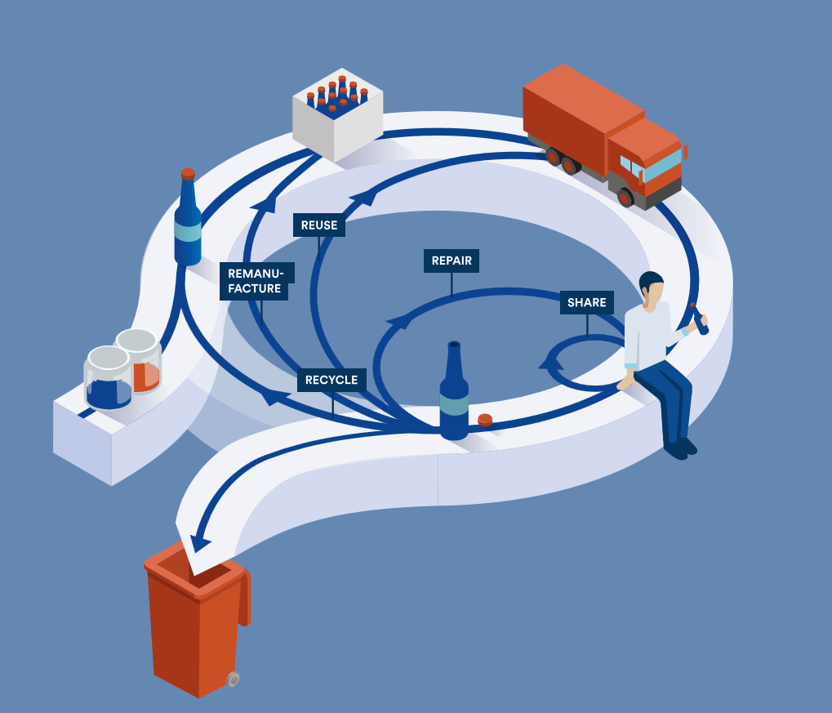
Figure 3: Circular economy
(Source: Inkson and Minnaert, 2018)

Benefits of a circular economy.
There are several benefits of a circular economy in society. Considering its model, it is not only efficient but it saves energy and cost too. It protects the environment from harmful greenhouse gas emissions. As per a survey conducted by the European Environment Agency, the companies and industries in the manufacturing sector do not list the entire statistics of their greenhouse gas emission (Inkson and Minnaert, 2018). This is harmful for the environment because there is a gaping lie in the index itself, thus, not allowing people to understand the reality. While, during the implementation of a circular economy, not only reduces greenhouse emissions but also has a committee that saves almost 80% of the environment and the environment derives advantages from it. Further, it also helps to create more sustainable social conditions in the world. Hence, it can be said that using a circular economy helps to induce more sustainability which in turn is advantageous for the world in general and people in particular. There are also several advantages of a circular economy within the corporate sector. It makes the industry more sustainable to the market competition, the model is relatively new, so that makes it a great marketing technique in a holistic way (Cooper, 2021). It further reduces the dependence on raw materials because, in a circular economy, raw materials are recycled to form new things for other industries, thus, by recycling batteries and electric engines, there can be the production of several types of electronic objects. It also generates more jobs in society as the circular economy brings about more competitiveness making it impossible for industries to do without hiring new talent. There are many kinds of jobs that grow because of a circular economy (Sloan et al., 2017). The jobs created are also innovative in nature which brings high levels of employee motivation and a liberal organisational culture.

Marriott’s Circular Economy
The losses that the company has faced because of the greenwashing accusation will be harmful, however, in case the company uses methods like CSR in the company, it can be redeemed. JW Marriott is one of the largest hotel conglomerates in the hospitality industry, however, they own very few hotels. This is one of the main attributes of using a circular economy in the company. The revenue that will be generated in the company within the hospitality industry will be done through leased lands from independent contractors with the assistance of real estate portfolio owners (Han, 2021). They can also micro-manage this sector of the industry with the help of managers who will be decentralised as per the business model. In addition to that, the model that the company has adopted has helped the company in many financial crises. It has assisted the company in generating high returns, saved the company from cyclical downturns and it also helps the company from getting static in the dynamic travel industry (Modica et al., 2020). Along with this, the company will also manage to gather high returns on investment, capital and the cash flow of cash within the levels of the company.

Interrelation between Marriott and CSR
The company has innumerable involvement in the hospitality industry. It works to fulfil numerous sustainable development goals of the United Nations organisation. The company has fixed numerous goals and objectives to be fulfilled within 2025, like zero- emissions by 2050. Along with this, the company has also introduced several kinds of bans in the company like banning plastic, and there is also a new soap recycling scheme in the company. The soap recycling scheme is directly coinciding with the Corporate Social Responsibility of the company (Legrand et al., 2022). The European branches of the hotel especially have a strong sustainability program which is focusing on the environmental areas of the company.
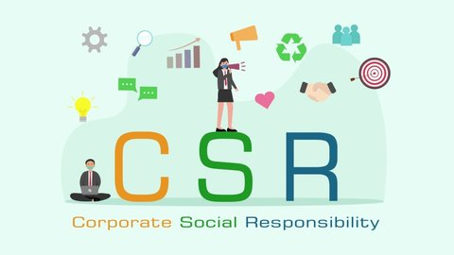
Figure 4: Corporate social responsibility
(Source: Legrand et al., 2022)

Benefits of CSR in the company
The company has several advantages in the case of brand recognition when the point of sustainable development goals is mentioned. This is why the hotel conglomerate is much more successful than the rest of the business entities in the industry. This conglomerate has the opportunity to grow under a circular economy model because it has modified its operations to suit the objectives of the policies. Along with this, the fulfilment of the Corporate Social Policy also increases customer loyalty in the sector because it manages the industry with the help of holistic development because of the objectives of the company (Lima Santos et al., 2020). Along with this, cost saving occurs because of the objectives that are used in the company. This is because the customers can experience new sorts of experiences in the hotel because of the objectives that the HRM has drafted in its policies. This can also contribute to organisational growth as the objectives taken up by the company had an advantage in contributing to multiple arenas of the business. Additionally, it also creates various new job roles because the policies need management and implementation in the market

Conclusion
The company has a history of hospitality and is one of the biggest names in the hospitality industry. As stated from a homestay, the hotel chain is one of the biggest examples of resilience. It has a stellar management team which helps the company to gather revenue which increases every year. Recently, the company has also initiated a policy of corporate social responsibility in its paradigm because of the environment and its situation. The company has seen multiple financial crises along with long operations which are still continuing, but it has managed to successfully bounce back from the crises. However, despite all of these brilliant ideologies and organisational culture, the company has still been accused of greenwashing. Thus, it can be concluded that sustainability and management in the tourism industry are not easy to uphold and the industry still needs some time in society to acclimatise to the notion.

References
Cooper, C. (2021). Essentials of tourism. Third edition. London: SAGE.
Ettinger, A., Grabner-Kräuter, S., Okazaki, S. and Terlutter, R., (2021). The desirability of CSR communication versus greenhushing in the hospitality industry: The customers’ perspective. Journal of Travel Research, 60(3), pp.618-638.
Green Globe, (2024). greenglobe.com. [online]. Available at: https://www.greenglobe.com/ [Accessed: 24 Feb. 2024].
Gurlek, M., (2023). Do isomorphic pressures impede greenwashing in hospitality industry? A theoretical framework. University of South Florida (USF) M3 Publishing, 16(9781955833097), p.2.
Han, H., (2021). Consumer behavior and environmental sustainability in tourism and hospitality: A review of theories, concepts, and latest research. Journal of Sustainable Tourism, 29(7), pp.1021-1042.
Haski-Leventhal, D. (2018). Strategic corporate social responsibility : tools & theories for responsible management. London: SAGE.
Inkson, C. and Minnaert, L. (2018). Tourism management : an introduction. 2nd ed. London: SAGE.
JW Marriott, (2024). JW Marriott. [online] www.marriott.com. Available at: https://www.marriott.com/en-us/hotels/longh-jw-marriott-grosvenor-house-london/overview/ [Accessed: 24 Feb. 2024].
Legrand, W., Chen, J.S. and Laeis, G.C., (2022). Sustainability in the hospitality industry: Principles of sustainable operations. Taylor & Francis.
Lima Santos, L., Cardoso, L., Araújo-Vila, N. and Fraiz-Brea, J.A., (2020). Sustainability perceptions in tourism and hospitality: A mixed-method bibliometric approach. Sustainability, 12(21), p.8852.
Modica, P.D., Altinay, L., Farmaki, A., Gursoy, D. and Zenga, M., (2020). Consumer perceptions towards sustainable supply chain practices in the hospitality industry. Current Issues in Tourism, 23(3), pp.358-375.
Sloan, P., Legrand, W. and Chen, J.S. (2017). Sustainability in the hospitality industry : principles of sustainable operations. 3rd edn. London: Butterworth Heinemann.
WTO, (2024). World Trade Organization. [online] Wto.org. Available at: https://www.wto.org/ [Accessed: 24 Feb. 2024].

