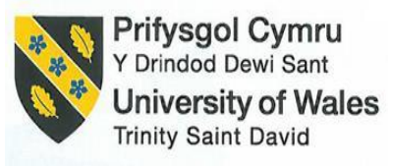

Intercultural Competence Report
Student name: Oleg Goncear
Student ID: 2231041
Module Name: Foreign Languages & Cultural Awareness
Module Code: BMIH5003
Lecturer: Heidi Prosser
Date: 15/02/2024

Executive summary
Paper exploration of cultural disparities between England and Spain, employing the GLOBE Project's insights. Delving into intercultural leadership challenges within the hospitality sector, concrete recommendations emerge. The report emphasizes cross-cultural training, cultural liaisons, and flexible policies as practical solutions, aiming to facilitate a seamless integration of Spanish employees into the Inclusivity Hotel & Spa team in London.
Table of Contents
Executive summary 2
Introduction 4
Main body 5
Culture Overview 5
The GLOBE Project 5
Conclusion 10
Recommendations 10
References 11

Introduction
Embarking on an insightful journey, this report delves into the complexities of intercultural management within the hospitality sector, focusing on the integration of Spanish employees into the Inclusivity Hotel & Spa in London. Through analysing cultural disparities using the GLOBE Project and addressing challenges, pragmatic recommendations are proposed to ensure a seamless and culturally inclusive work environment.

Main body

Culture Overview
England, renowned for its rich history and numerous populations, boasts a culture deeply rooted in lifestyle and modernity. The English society values politeness, punctuality, and a reserved demeanour (Darby, 2020). Tea-consuming rituals symbolize a loved cultural lifestyle, often observed by using polite conversations. The British are regarded for his or her recognize of private area and adherence to queuing etiquette. Furthermore, the multicultural nature of England is contemplated in its international delicacies, arts, and gala, fostering a spirit of inclusivity.
Spain is known for its vibrant and passionate culture, creating a relaxed and sociable atmosphere. Spaniards prioritize close-knit relationships, with their family gatherings at the core of their social fabric (Washabaugh, 2021). The culture of siestas underscores a leisurely tempo of life, and Spanish cuisine, celebrated for tapas and paella, emphasizes shared dining experiences. Expressive arts like Flamenco dancing and active galas contribute to Spain's heat and communal ambience, offering a stark contrast to the reserved nature of English society.
England's reserved culture, emphasizing politeness and personal space, contrasts with Spain's extra relaxed method (Burt and Archer, 2019). Challenges encompass bridging verbal exchange patterns, adapting to painting etiquettes, and information on numerous perspectives on hierarchy and teamwork. Overcoming those variations is critical for effective collaboration and harmonious integration of Spanish personnel into the professional and cultural dynamics of the London group.

The GLOBE Project
The GLOBE project, or the Global Leadership-Organizational-Behaviour-Process Study Project, is contributing to the cultural definition of knowledge narrative (Sochor, 2020). Examines cultural issues, including electronic distance, personal and collective interactions, uncertainty avoidance, gender, long-term targeting, and interests This research helps to hear how culture shapes business style and organizational behaviour. The cultural framework of the GLOBE project provides valuable insights for companies, and allows for complex pass-cultural language, organizational control, and leadership strategies tailored to precise contexts (Kiker et al and colleagues, 2019). The key is to enhance cross-cultural competence, which is essential for successful global business transactions.
Country Analysis and Comparison
The GLOBE project highlights the cultural differences between England and Spain, which are crucial for the successful integration of Spanish employees into the London team. In power terms, the familiarity of England means a surprisingly low Power Distance Index (PDI), with an emphasis on equality and participatory decision-making on the contrary Spain takes PDI Favors, indicating a preference for hierarchical structures and centralized authority (Paharia and Swaminathan, 2019). This separation further creates difficult situations in adapting management strategies and networks when Spanish personnel are part of the London team.
On the measurement of Individualism-Collectivism, England tends towards individualism, emphasizing non-public autonomy and achievement (Binder, 2019). In comparison, Spain demonstrates a more collective orientation, highlighting sturdy familial and social ties. This distinction underscores potential versions in crew dynamics, conversation preferences, and the position of the individual in the expert putting. Uncertainty Avoidance exhibits some other vast comparison. England, with a lower Uncertainty Avoidance Index (UAI), is famous for a desire for flexibility and an extra relaxed approach to uncertainty. Spain, with a barely higher UAI, can also lean closer to a greater structured and rule-based total approach.
In phrases of Long-Term Orientation (LTO) England tends towards a pragmatic, future-centred approach, while Spain may additionally exhibit a more normative and culture-oriented perspective. In the Masculinity-Femininity dimension, England strikes a balance between assertiveness and nurturing, even as Spain leans in the direction of masculinity, emphasizing success, opposition, and assertiveness (Pucik et al., 2023). Recognizing and reconciling these differences in leadership expectations and work lifestyle might be pivotal for the successful integration of Spanish employees into the London crew, fostering a collaborative and inclusive expert environment.
Country scores comparison from the GLOBE
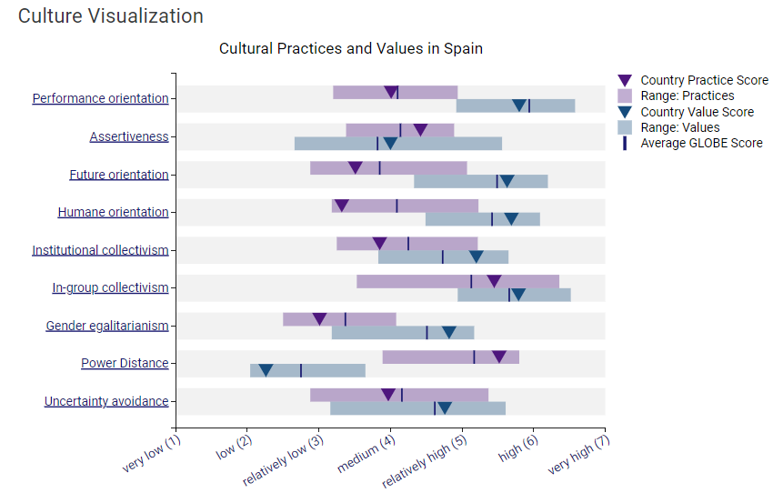
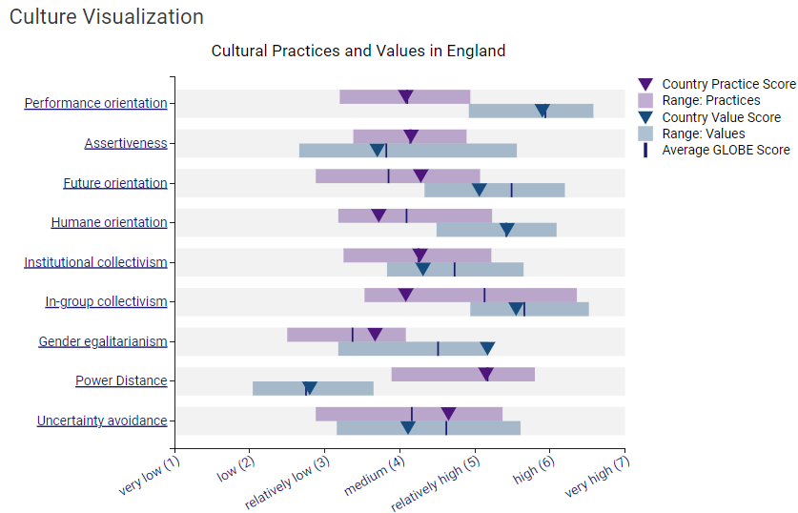
Examining the GLOBE Project rankings for Spain and England’s famous cultural nuances crucial for powerful integration. Spain exhibits a robust Performance Orientation (4.01), Assertiveness (4.42), and a destiny-orientated attitude (3.51). In-institution and institutional collectivism are stated, with gender egalitarianism reasonably embraced. Notably, Spain demonstrates an extensive Power Distance (5.52) but lower Uncertainty Avoidance (3.97). Conversely, England emphasizes a barely higher Performance Orientation (four.08), Assertiveness (4.15), and a future-oriented perspective (4.28) (Spain Results, 2024). Institutional and in-institution collectivism, at the side of gender egalitarianism, are determined, and observed through an important Power Distance (5.15) and lower Uncertainty Avoidance (4.65). Visualising these scores publications strategies for seamless integration.
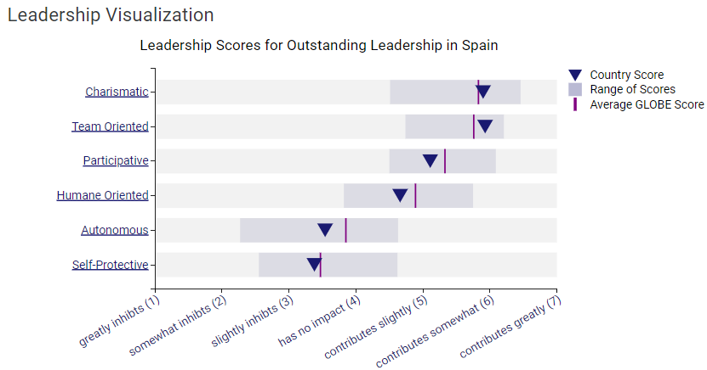
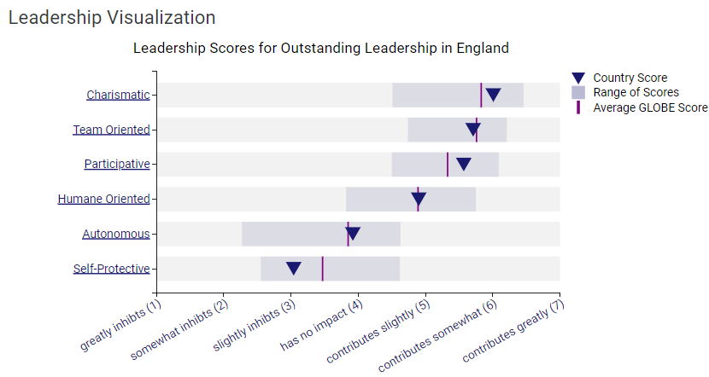
Examining the GLOBE Project's leadership rankings for Spain and England illuminates specific leadership styles. In Spain, splendid management manifests in excessive ratings for Charismatic (5.9), Team-Oriented (5.93), and Participative (5.11) dimensions. However, a lower Autonomous score (3. Fifty four) and Self-Protective rating (3.38) propose a choice for collaborative and people-oriented management, with less emphasis on autonomy and self-protection. Conversely, awesome management in England showcases higher scores in Charismatic (6.01), Team-Oriented (5.71), and Participative (5.57) patterns. Similarly, a balanced emphasis on Humane Oriented (4.9) aligns with a collaborative technique. Autonomous (3.92) and Self-Protective (3.04) rankings imply a slightly greater self-sufficient and less self-defensive management style.
Intercultural leadership challenges
Intercultural leaders in the profession face challenges such as communication gaps and different ways of working. For example, time management perceptions may interfere with synchronization tasks. England's emphasis on deadlines contrasts with Spain's more flexible approach. Additionally, different cultural perspectives on user populations can lead to misunderstandings in the decision-making process (Northouse, 2021). Addressing these challenges is important for a cohesive team, especially with the addition of Spanish staff to the London team at Inclusive Hotel & Spa. Addressing these cultural differences ensures effective collaboration and enhances the overall guest experience
.

Conclusion
In conclusion, understanding and managing cultural differences is crucial for effective team integration in the hospitality industry. Using the findings of the GLOBE project, as well as targeted training and flexible design, the Inclusive Hotel & Spa in London will be empowered to create a cohesive and culturally inclusive work environment.

Recommendations
- Cross-Cultural Training: Implement comprehensive move-cultural schooling packages to foster mutual knowledge among group participants, addressing communication patterns, painting ethics, and cultural nuances.
- Cultural Liaisons: Appoint cultural liaisons or mentors in the group, facilitating open communication channels and serving as intermediaries to deal with misunderstandings, selling a harmonious work environment.
- Flexible Team Policies: Adapt group policies to accommodate cultural differences, making sure of flexibility in painting techniques and recognizing various views to create inclusive surroundings, fostering a feeling of belonging among all team contributors.

References
- Binder, C.C., 2019. Redistribution and the individualism–collectivism dimension of culture. Social Indicators Research, 142(3), pp.1175-1192.
- Burt, R. and Archer, J. eds., 2019. Enclosure acts: sexuality, property, and culture in early modern England. Cornell University Press.
- Darby, W.J., 2020. Landscape and identity: Geographies of nation and class in England. Routledge.
- Kiker, D.S., Callahan, J.S. and Kiker, M.B., 2019. Exploring the boundaries of servant leadership: A meta-analysis of the main and moderating effects of servant leadership on behavioural and affective outcomes. Journal of Managerial Issues, pp.172-197.
- Northouse, P.G., 2021. Leadership: Theory and practice. Sage publications.
- Paharia, N. and Swaminathan, V., 2019. Who is wary of user design? The role of power-distance beliefs in preference for user-designed products. Journal of Marketing, 83(3), pp.91-107.
- Pucik, V., Björkman, I., Evans, P. and Stahl, G.K., 2023. The Global Challenge: Managing People Across Borders. Edward Elgar Publishing.
- Sochor, J., 2020. Comparison of selected attributes in cultural dimensions as defined by Hofstede and the GLOBE Project. Central and eastern Europe in the changing business environment, 270.
- Spain Results (2024) GLOBE Project. Available at: https://globeproject.com/results/countries/ESP%3Fmenu=list.html#list (Accessed: 25 January 2024).
- Washabaugh, W., 2021. Flamenco: passion, politics and popular culture. Taylor & Francis.

