Project Initiation Document

  - Name: Sarann Strange

Student Number: 1701763

University of wales Trinity saint David

Stream: B.Sc. Software engineering

Module Code:
ACDA5004

Module Lecturer: Sue Maw

Table of Contents
Table of Contents 1
1 Table of figures 2
2 Introduction 3
3 Project Definition (OSCAR) 4
3.1 Objectives 4
3.2 Scope 5
3.3 Constraints 5
3.4 Authority 5
3.5 Resources 6
4 Risks to the project 7
4.1 Risks with stakeholders 7
4.1.1 Team members 7
4.1.2 Governmental 7
5 Project plan 8
5.1 Task sheet 8
5.2 GANT chart 9
5.3 Full view network diagram 10
5.4 Meeting 1 Premise Investigation 11
5.5 Meeting 2 Company Identity 11
5.6 Meeting 3 Design overview 12
5.7 Meeting 4 Test plan 12
6 Conclusion 13
7 References 14
8 Appendices 15
8.1 Appendix 1 image of objectives 15
8.2 Appendix 2 Image of scope 16
8.3 Appendix 3 Image of constraints 17
8.4 Appendix 4 Image of authority 18
8.5 Appendix 5 Image of resources 19

Table of figures
Figure 1 Task sheet. Displays date & time of tasks 7
Figure 2 GANT chart 8
Figure 3 Full views of network diagram. 9
Figure 4 Meeting 1 premise investigation within network diagram. 10
Figure 5 Meeting 2 Company identity within network diagram 11
Figure 6 Meeting 3 Design overview within network diagram. 12
Figure 7 Meeting 4 Test plan within network diagram. 13

Introduction
The document includes an overview of the case given as detailed in project definition to the group the strategies and chosen system to be designed and created. The system obligations, scope, constraints, authority and resources.
The potential risks that could hinder or derail the project and the project plan and GANTT chart of the tasks of the overall project.

Project Definition (OSCAR)
The concept requires a system that resolves the communication issues between rescue workers that are assigned within a disaster area, the system must aid with the overall rescue and recovery of victims and ensure the safety of rescue workers themselves.

The system focuses on the resolution of the issues of communication and location of the rescue workers assigned to an area. When rescue workers enter disaster areas they must work quickly and efficiently to provide suitable support and rescue to victims within the area, when rescue workers are deployed they run the risk of being injured themselves or lost.
The system will provide a visual map with up-to-date information on each of the rescue workers with their current location, ensuring that all rescue workers can be located continually throughout their deployment.

Objectives
While discussing the main objectives of the application and project (as seen in appendix 8.1)the group discussed what the application would do, how it would work and the main tasks that would be discussed before continuing with the project or the creation of the application.
Using the SMART criteria, the group developed specific tasks that related to the creation of the application[1].
The objectives were specific to the creation of an application to aid rescue workers who could be tracked across different devices. The application was also measurable as the group would develop a task sheet and create a GANTT chart to measure the number of days that would be allocated to tasks and assigned to each member of the group. The objectives were relevant as it solved the issue of rescue workers being lost within an unknown area with the use of a live map displaying on all devices with the location of each rescue worker with enabled communication between different devices in the form of basic text.

Scope
Once the group discussed the scope of the project (see appendix 8.2) it enforced clear ideas of what was required and the overall aims of the project.
The scopes indicated that the project required the device to run on WIFI as it would be easier to design and create an application to work from WIFI than data. Bluetooth was also avoided as it would consume more battery power of the device rendering the application useless. Due to the highly stressful and fast paced environment that the application would be used, the application is required to be user friendly with a simple interface that is instinctive to use. The application is also designed for android as it is a common and easily accessible mobile OS, the application was also required to work across the same network as this will allow each device to communicate and share data with one another easily.

Constraints
The constraint of the system clearly defines what will not be present in the application (see appendix 8.3), they include the time restrictions from both the due date of the assignment and the presentation of the project to stakeholders. The lack of funding also dictates what the group could purchase for instance an application device there for designing the application to work on application devices was excluded from the project. There are also limitations on the open source code that google provides as it may not contain vital information or code that the project requires.
The overall unavailability of the resources could delay the project such as computer systems, meeting rooms within the university, software available on the computer systems within the university, closing times of the library.
The lack of knowledge and experience of group members in working on projects alongside others and to deadlines is also a constraint.

Authority
The authority of the group was discussed (see appendix 8.4) they include individuals who provide guidance on restrictions on what the group is able to create and what they are unable to. The authority of the project includes:
- Sue.
- Ian.
- Faculty & staff.

Resources
For this project a number of required resources were identified (see appendix 8.5) these resources include an android mobile device that the application will run on, the staff/lecturers within the university, Google maps software and open source code they provide on their website, members of the group Sarann Strange, James Millns, Richard, Dylan and Austin.
The university library and learning resource centre “Y Fforwm” and the other buildings of the university is also a resource as it provides meeting rooms, projectors, whiteboards, computer systems and software on the computer systems that can be used to design and create the application.

Risks to the project
Projects have the potential of encountering a variety of risks that can delay or disband a project entirely. Some risks are predicted in advance, unavoidable and unexpected. Through analysis of the project, risks are identified, and precautions are put in place to minimize their impact.
Some adverse risks include underdeveloped ideas on the direction or understanding of the project and its goals.

Risks with stakeholders

Team members
Members of the team working on the project run the risk of delaying a project and costing the projects time and money due to unexpected issues such as an absence due to illness, leaving the company, injury or death. If a key member within a project is absent for an extended period, the project manager must analyse the time allocated to tasks as the absent member of the team may be unable to complete vital tasks inevitably causing delays of the tasks of other members of the group and delay completion of the overall project.
If a member of the project unexpectedly leaves or is unable to continue working on the project they must be replaced which will alter the working dynamic of individuals within the group as they need to be given different roles or allocated various tasks.
The moment at which the individual abandons the project can impact the rate of recovery from adaptations made to tasks and alterations to the roles of members of the group or new members being brought into the project to fill the vacant position.
Miscommunication or members of the group unable to communicate due to issues with communication technologies or hardware and software issues could become a risk as they are unable to provide vital information to aid the project or indicate the completion of preparatory tasks that allow the group to continue working to complete the project.

Governmental
When a project is first proposed there are laws and legislation that dictate what can and cannot be done within reason, when designing a solution to a potential issue the groups, companies and businesses must follow the guidelines of the laws of the country and county that they are in. Updates and alterations of current laws can be made that potentially have an impact on how a project is being designed or created, for instance a revision is being discussed on the cookie-law that will influence how cookies are used on websites, this has an impact on how websites are created and designed as they must follow the updated law once the revisions are put in place [2][3]. There for it is vital that the team are aware of not only the current law but potential alteration that are being made to it.

Project plan
When a project is proposed it is important for a project plan to be designed and Setout so things can be analysed and given a direction that an organisation or group can follow so they know what is coming next and what is meant to be done[4].

Task sheet
A task sheet design was created to give a clear indication of proposed tasks that were required to be completed within a specific order to a specific date and time to coincide with the hand in dates of the assignments and the presentation of the designed application. As seen in figure 1 the tasks have a name, the predicted days it will take to complete, the start and finish date of the tasks, the group member that are assigned to each task. Before each new assigned tasks there will be meetings to discuss and confirm the completion of previous tasks and the new assignment of tasks to the appropriate team members.
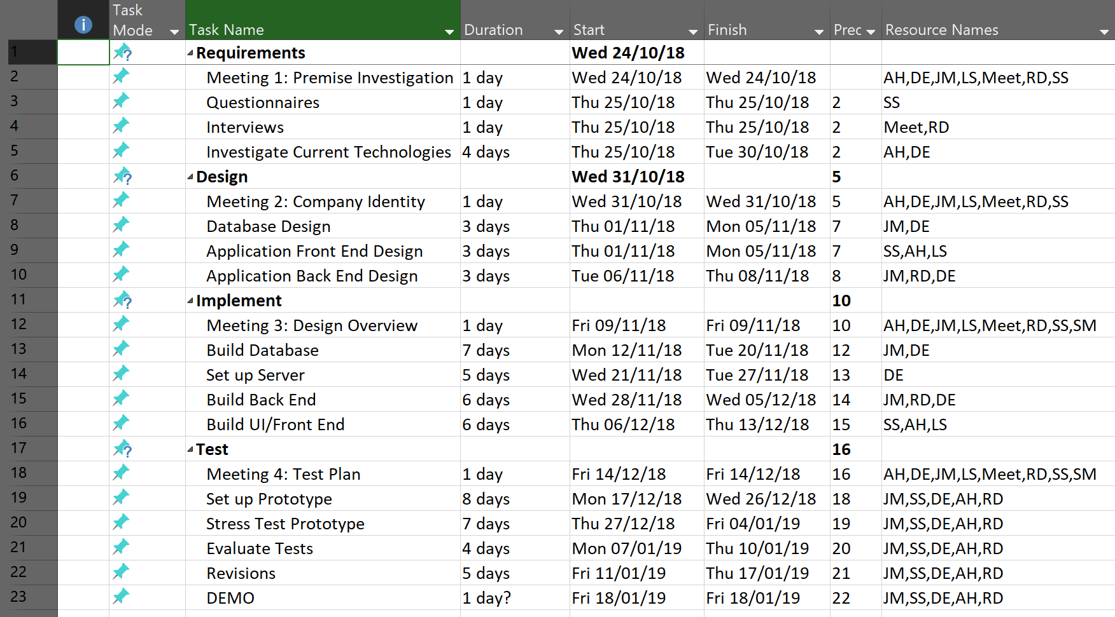
Figure 1 Task sheet. Displays date & time of tasks

GANT chart
The GANT chat within figure 2 indicates the individuals assigned to each task while displaying a visual representation of the time length of each task.

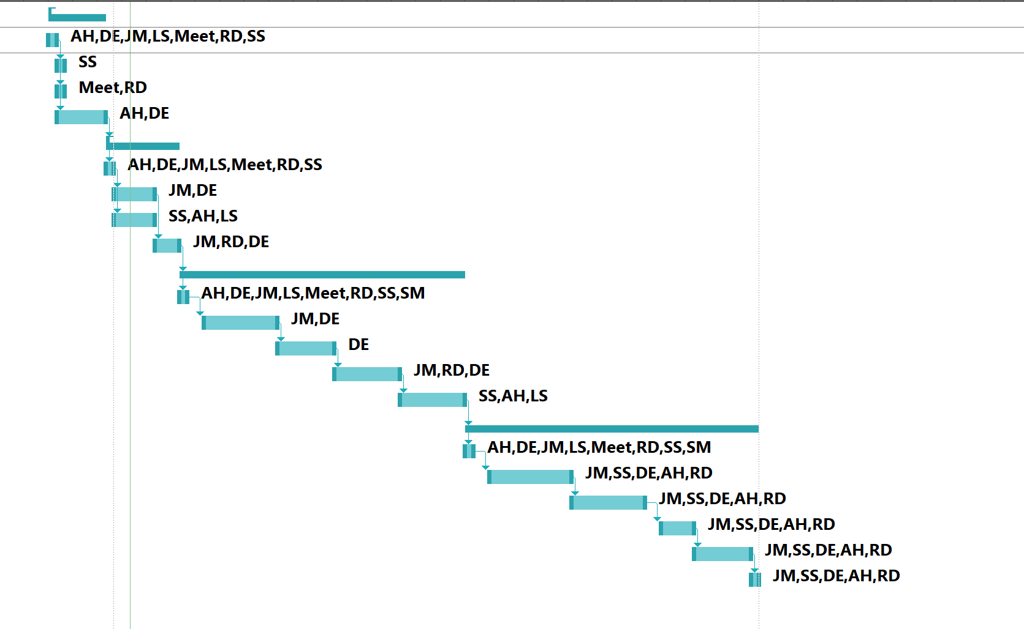
Figure 2 GANT chart

Full view network diagram
Figure 3 displays the full view of the tasks their end dates, their importance and the order in which tasks must be completed. For this project it is a linier path to the completion of the project.
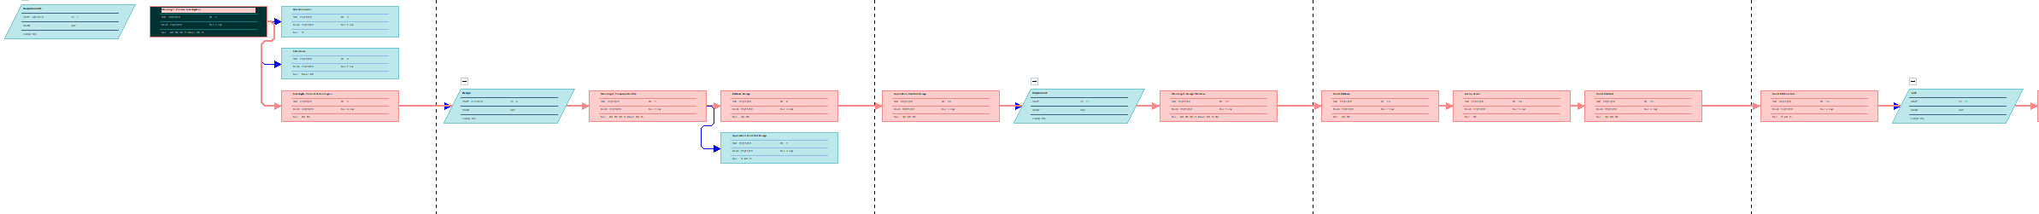
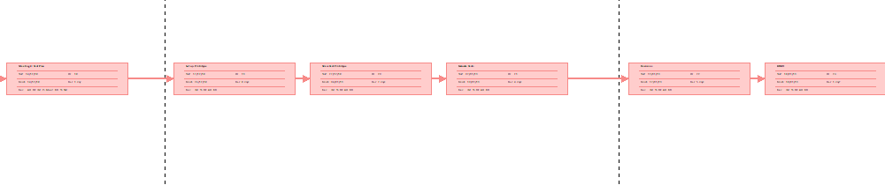
Figure 3 Full views of network diagram.

Meeting 1 Premise Investigation
The first meeting involved discussions of the premise of the project and the application that the group would be producing. During the first meeting an OSCAR is created to identify the important sections of the application the constraints and overall objective of the application.
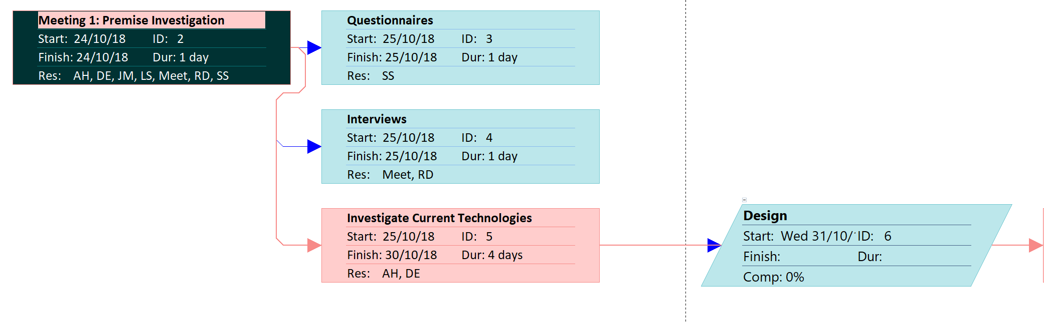
The tasks allocated during this section of the project include the design and creation of a questionnaire, interviews with stakeholders to discover what was required of the application and guidance on how the group could proceed with the project, an investigation into current technologies similar to the proposed application to discover potential solutions and information on how the group could design and create the application.
Figure 4 Meeting 1 premise investigation within network diagram.

Meeting 2 Company Identity
The second meeting involved the company identity how the group believed the application should work, how it should look, the name for the application and which group members would be best suited for each role that were required to successfully design, program and complete the overall project. The tasks assignment after the second meeting include: database design application front end design application back end design implement
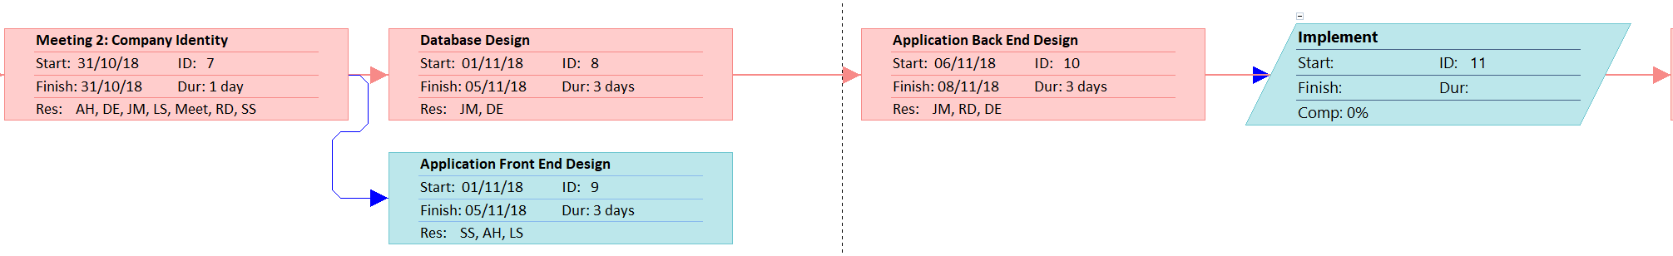
Figure 5 Meeting 2 Company identity within network diagram

Meeting 3 Design overview
The third meeting involves the design overview. Within this meeting the group present their designs on how they believe the backend and the frontend will both look and function, the group will discuss the implementation of the application.
The tasks of this section include the building of the database, setting up of the servers, building the backend of the application, using code and using the designs to build the front end of the application. The last task of this section involves testing the application to find bugs and issues with code.
Figure 6 Meeting 3 Design overview within network diagram.

Meeting 4 Test plan
The final meeting involves the group developing a range of tests and creating a method of testing the completed application to ensure that it functions as intended.
The tasks of this section of the project include the set up of the prototype, stress testing the prototype using a range of methods, evaluate tests to find solutions to fix potential bugs and issues that were found during the testing phase, revision of the application an attempt to fix the bugs and issues and the very last task is the demo of the application to the stake holders.
Figure 7 Meeting 4 Test plan within network diagram.

Conclusion
The assignment gives a clear understanding on the Objectives, scope, constraints and resources that the project requires to be successful along with images clearly indicating the progress that the group made within meetings.
A discussion on potential risks that could possibly arise due to stake holders was included to identify pitfalls and delays that the project may encounter, from this information solutions and strategies to avoid the project failing could be arranged and planed.
A full project plan and GANTT chart design was included and discussed to provide a coherent understanding on meetings, and the work ethics and deadlines that the group had bestowed to each member within the group.

References
[1] M. B. Bjerke and R. Renger, “Being smart about writing SMART objectives,” Eval. Program Plann., vol. 61, pp. 125–127, Apr. 2017.
[2] GOV.uk, “Cookie law comes into force - GOV.UK,” 2012. [Online]. Available: https://www.gov.uk/government/news/cookie-law-comes-into-force. [Accessed: 03-Nov-2018].
[3] “What exactly is The Cookie Law? | IT PRO.” [Online]. Available: https://www.itpro.co.uk/data-insights/30421/what-exactly-is-the-cookie-law. [Accessed: 03-Nov-2018].
[4] S. C. Wheelwright, “Creating Project Plans to Focus Product Development.,” Harv. Bus. Rev., vol. 70, no. 2, p. 13, 1992.

Appendices

Appendix 1 image of objectives
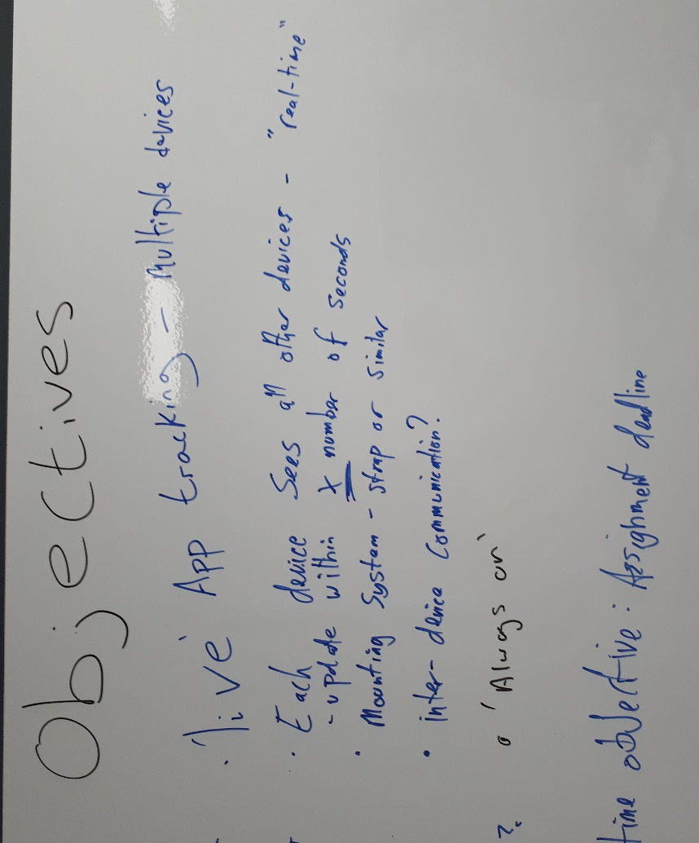
Image from the whiteboard after group meeting of the objectives discussed and noted by members of the group working on the project.

Appendix 2 Image of scope
Image taken from the whiteboard after a group meeting of the scopes discussed and noted by members of the group working on the project.

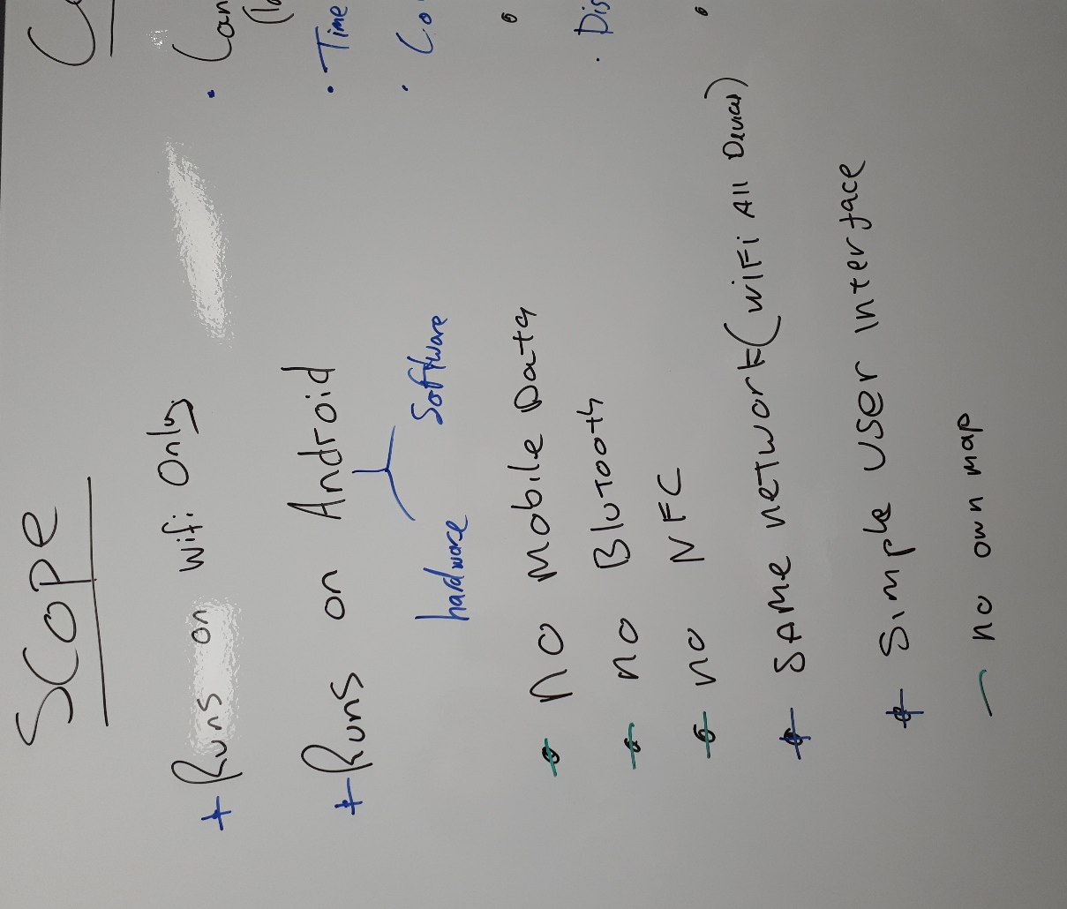

Appendix 3 Image of constraints
Image from the whiteboard after group meeting of the constraints discussed and noted by members of the group working on the project

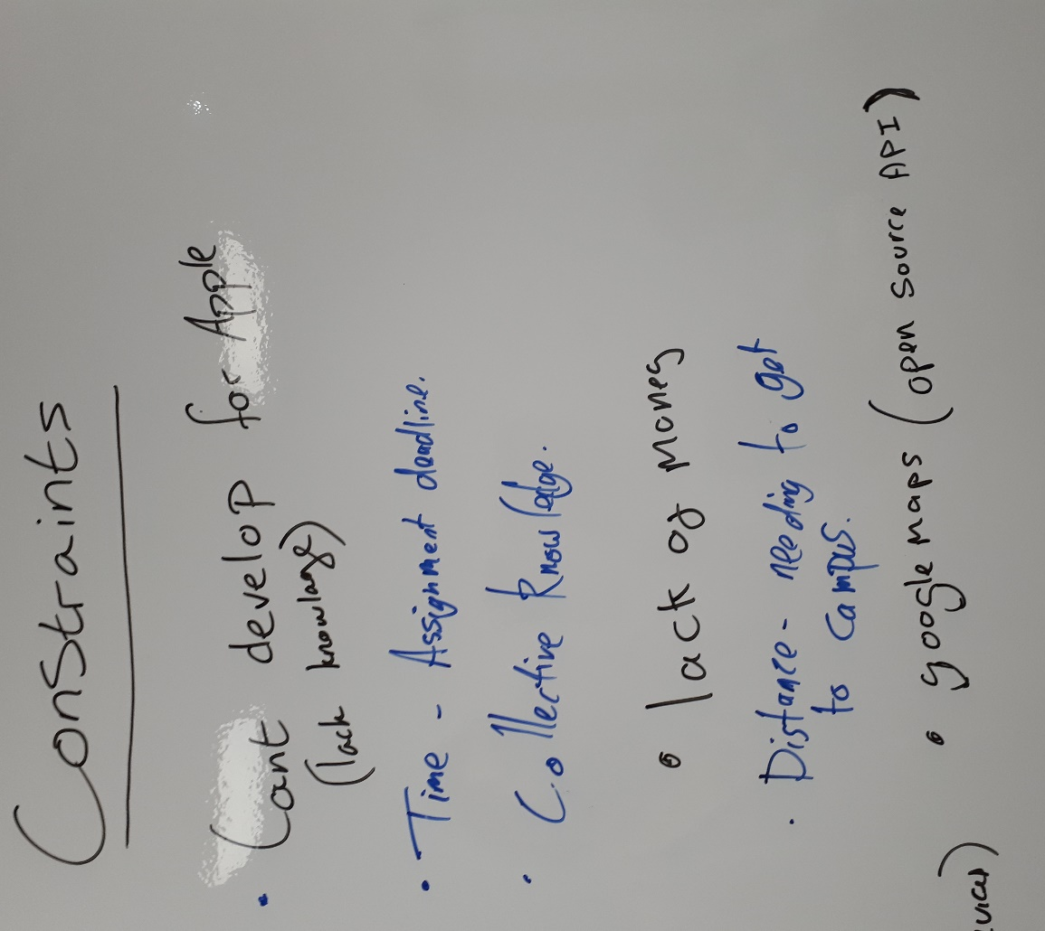

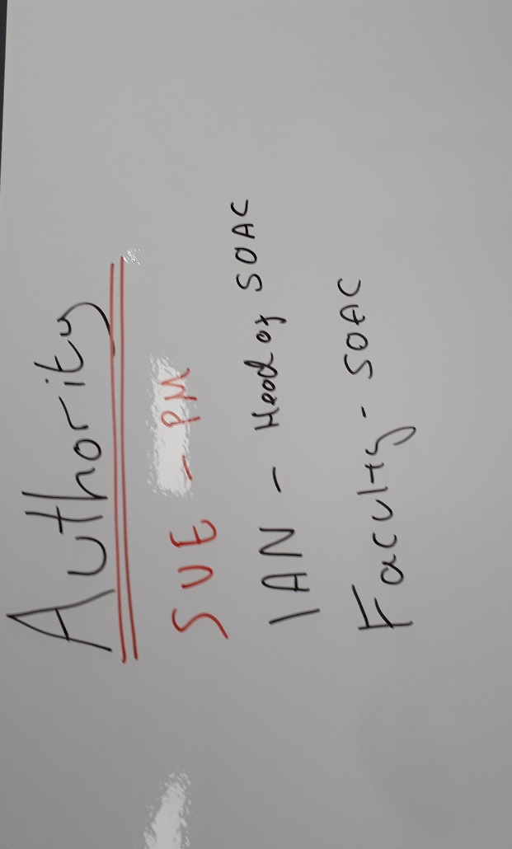
Appendix 4 Image of authority
Image from the whiteboard after group meeting of the authority discussed and noted by members of the group working on the project

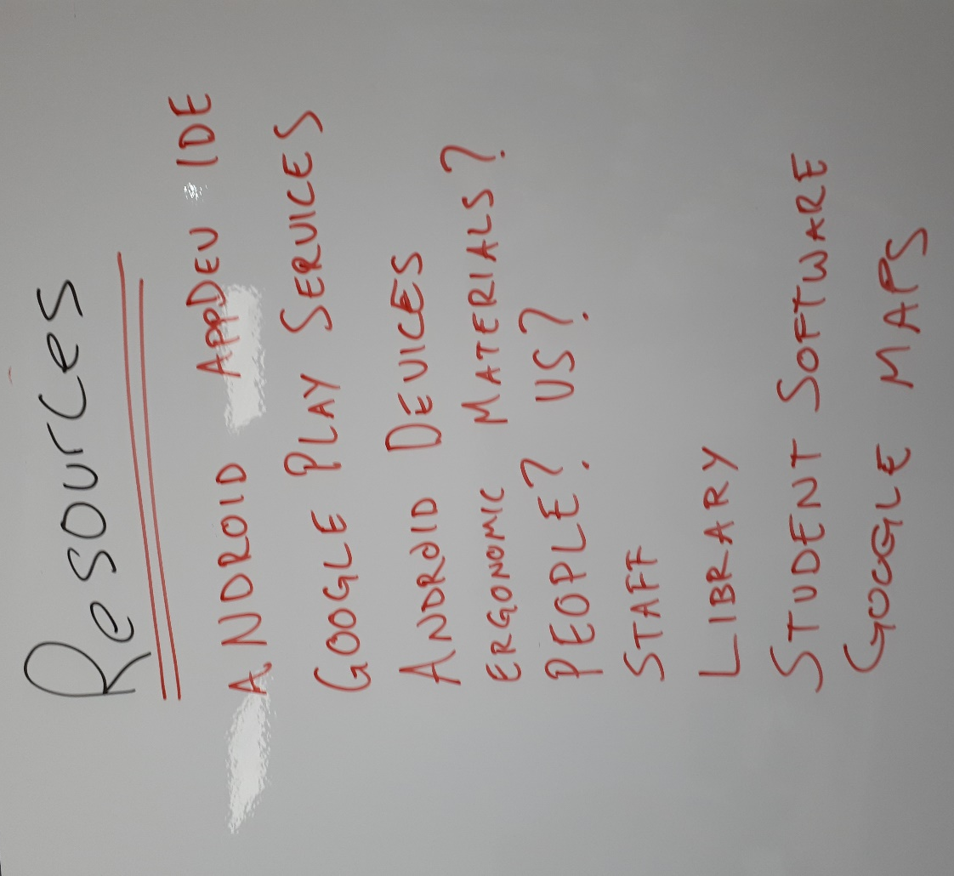
Appendix 5 Image of resources
Image from the whiteboard after group meeting of the resources discussed and noted by members of the group working on the project

