

Course Title: MBA - International Business
Term 2

Student Name: Charu Gautam
Student ID: 2432997

Module Name: International Marketing: Principles and Practices

Module Code: LCMB7026

Lecturer’s Name: Tushara Balendran

A Report on International Marketing: A Comparison and Contrast of India and the United Kingdom
Company: Mercedes-Benz

Table of Contents
Introduction 3
Background of the Company 3
Founders of the Company 3
Establishment and Formation 4
Mission and Vision (Home and Host Countries) 5
Entry into Host Countries 5
Section 1: Macro Environment Analysis 6
1.1 Macro Environment – Definition 6
1.2 PESTEL Analysis Diagram 6
1.3 PESTEL Comparison: India vs UK 7
1.4 PESTEL Similarities and Differences 13
1.5 Segmentation – VALS and Psychographic 15
1.6 Marketing Mix (7Ps) 18
1.7 Directional Development Strategy – Porter’s Generic Strategy (UK) 25
1.8 Ethical and Unethical Marketing Issues (India Example) 26
1.9 Recommendations 27
Section 2: Reflective Account 27
Conlusion 30
References 31
Appendices 34

Introduction
Globalisation has drastically changed the automotive industry as it has compelled the multinationals to expand beyond the local markets and adapt to other macro-environmental environments. Mercedes-Benz represents one of the most successful brands of cars that have managed to establish a niche in the international market due to a calculated market entry strategy, positioning, and adjusting promotional strategies (Andreeva and Petikhin, 2022). This is a critical analysis report on the international marketing of Mercedes-Benz in two respective markets in India and the United Kingdom (UK).
This report is a comparison of the international marketing of the Mercedes-Benz, based in India and in the UK. It covers macro-environmental, cultural differences, segmentation, targeting positioning and marketing mix to take into consideration the market performances and strategic adjustment. It also talks about direction tactics using the Generic Strategy by Porter, moral issues in the marketing operations and provides recommendations. Reflection account presented in consideration to Gibbs Reflective Cycle is also provided in order to evaluate learning outcomes (Brada and Park, 2024).

Background of the Company

Figure 1: Company logo
Source: (Mercedes-Benz, 2024)

Founders of the Company
Karl Benz
Mercedes-Benz is an automobile company that has its origin with a German engineer by the name Karl Benz who is widely believed to have invented the first viable car. In 1886, he patented the Benz Patent-Motorwagen, a three-wheel automobile, in which an internal combustion engine had been fitted (Mercedes-Benz, 2024). It was the first invention of the modern automotive industry, which formed the basis of further evolution of the vehicle in the world arena. It was the Benz innovation which demonstrated the commerciality of motorised transportation and has changed the flow of the individual.
Gottlieb Daimler
The second founder Gottlieb Daimler had the same periods of time, but came up with the high speed petrol engines on his own. Focusing on the efficiency and performance of engines, Daimler made efforts at this issue together with Wilhelm Maybach (Escandon-Barbosa, Salas-Paramo and Rialp-Criado, 2021). The work he did in the engineering field saw significant improvement in the speed of the car and its stability. Although Benz and Daimler do not consistently collaborate at the initial stage, they developed new technology that was quite well-paired, and finally, they were merged into becoming a luxurious car brand that was never any less luxurious.
Origin of the Brand Name
Mercedes is called so after the name of Mercedes Jellinek, a daughter of Emil Jellinek, an automobile tycoon who sold Daimler cars from the beginning of the twentieth century. The brand name implied the image of being classy, creative and exclusive which continues to define Mercedes-Benz to today.

Establishment and Formation
Early Origins (1886)
The history of Mercedes-Benz could be tracked down to the period of 1886 when Karl Benz patented his revolutionary auto. This was the new breakthrough to an automotive industry. In the next decades, Benz and Daimler expanded their companies and introduced superior models of cars in the entire Europe (Farooq and Raza, 2024).
Official Formation (1926)
The one brand Mercedes-Benz was literally invented in 1926 following Benz Cie and Daimler-Motoren-Gesellschaft merger. It was a joint venture Daimler-Benz AG who amalgamated the asset of both inventors. The iconic logo in the three-point stars had a symbolic value on the motility on tenure and water as well as the skies that represented the ambitious vision of Daimler (Feya A.M. Weijers, 2025). It is currently being operated under Mercedes-Benz group AG located in stuttgart Germany and remains a global leader in the art of an ultra-luxurious automobile.

Mission and Vision (Home and Host Countries)
Global Mission
Mercedes-Benz aims to provide the high-quality with innovation, safety, sustainability, and excellent performance luxury cars to the world (Mercedes-Benz, 2024). The company is always engaged in research and development to be technologically ahead of their time.
Global Vision
Mercedes-Benz has a mission of being the most-desirable luxury car brand in the world with the focus on high quality, high-tech engineering and consumer satisfaction (Mercedes-Benz, 2025).
Strategic Focus in Indian and UK
In India, Mercedes-Benz is concentrating on luxury mobility of high-end since it diffuses the utilization of electric cars. The company relies on the Mercedes-Benz India Pvt Ltd to upgrade the local production and to penetrate the high-income and aspirational consumer market, which is already thriving (Hemonnet-Goujot, Kessous and Magnoni, 2022).
Mercdes-Benz is focusing on the sustainability and electric mobility within the United Kingdom with the EQ drive. The company can ensure that it meets stringent environmental policies, though, the company is the leader in the competitive market of luxury automobile.

Entry into Host Countries
United Kingdom
The way of importing made the introduction of Mercedes-Benz in the UK in the early twentieth century. Over the years, it has developed a dense dealership and distribution network that made the UK one of its most significant markets in Europe (Kim, 2022).
India
India Mercedes-Benz auto was introduced first in India in 1994, hence making it the first luxury car manufacturer in India. It has established itself in the locality sense through establishing a manufacturing plant in Chakan Pune and this has provided it with competitive advantage (L Emma, 2025).

Section 1: Macro Environment Analysis

1.1 Macro Environment – Definition
The macro environment entails the broad category of extraneous and uncontrollable forces, which stain the overall output of an organisation as well as its strategic decision-making. These are forces outside the firm yet it directly affects the ability of the firm to carry out, compete and also develop in the foreign markets (Leonaviciene and Burinskiene, 2022). PESTEL is an analytical tool that is popular to examine the macro environment and, therefore, consists of Political, Economic, Social, Technological, Environmental, and Legal factors. Macro-environmental analysis plays a crucial role in the commodity analysis of a luxurious global company like Mercedes-Benz because the organisation operates in various countries with different regulation systems, consumer behaviour and market outcomes.

1.2 PESTEL Analysis Diagram
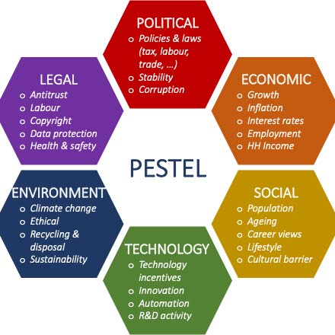
Figure 2: PESTEL diagram
Source: (SpringWorks, 2021)
PESTEL model has found massive application in the field of marketing in particular international marketing as a methodical study of macro environmental forces that have an influence on the operation of business (SpringWorks, 2021). India and UK are instances that can be used in this model to compare the regulatory systems, purchasing abilities of the residents, infrastructural growth, technological preparedness and sustainability policies, in the case of Mercedes-Benz. Based on the individual analysis of these dimensions, the enterprise will succeed in forecasting the external pressures and creating a strategic response peculiar to the two markets.

1.3 PESTEL Comparison: India vs UK
1. Political
India:
India is a stable democratic nation, the federal system and pro-industrial policy. Some of the policies that favour the production plant of Mercedes-Benz in Pune are the programs presented by the government such as the Make in India (Chotia et al., 2025). Posture, however, bureaucratic practice, severe approval practice and massive customs revenue on partially complete units contribute to the cost of operation.
UK:
United Kingdom has a stable political regime; the government is also transparent and trade laws are also clear. Regulatory transparency is on the high although the new changes in the trade and customs, which Brexit effects enforce, are in place (P Datta, 2024). Political stability contributes to the buildup of investor confidence and extension of strategic thinking.
Supportive manufacturing policies are given by India, but there are delays related to bureaucracy and high duties, which make the operation challenging. On the other hand, the transparent and stable political environment in the UK is more favourable for the automobile predictive business operations.
2. Economic
India:
India has been experiencing a constant growth in GDP and the number of disposable income and people in the upper-middle-income bracket. The net worth population is increasing enormously thus boosting the luxury car demand. Price sensitivity on the other hand is quite high compared to developed markets (Pereira and Bhat, 2024). There is also the price assigned to the cars depending on the fluctuations in exchange rates, and taxation systems. The economic growth of India is uneven and the medium inflation impacts on the power of purchasing, even than GNP rise and increase in Mercedes-Benz luxury car sales are driven by wealth growing and urbanization that boost the potential of market.
UK:
The UK market strength is high and there is the proven luxury car market. It belongs to the mature, competitive market and rigid competition of BMW, Audi and Jaguar. The level of economic development is not high as it was in the case of emerging markets (Ramadhani and Rahman, 2025). The UK is experiencing quite stable but dynamic rates of inflation that influence the consumer spending behaviour which has led to high GNP. The luxury cars are experiencing a steady sales and the growth rate is not as fast as the market is flooded and there is economic uncertainties that have come in.
Luxury car expansion in India is favourable because of the country’s growing economy and rising wealth, though there exists price sensitivity. On the other had UK is more stable and has a luxury market saturated with slow growth, which makes the country less favourable.
3. Social
India:
In India, luxury cars are one of the social symbols of prosperity and statuses not only economically but also as a professional achievement. Combined with the upward social mobility and status, the ownership of a Mercedes-Benz is associated with the business executives and corporate bosses of major cities (Ran et al., 2026). Aspirational consumption, urbanisation and exposure to social media increase the demand of luxury cars as lifestyle and not meant to be a means of transport.
Trends: The rising strength of digital lives, younger more wealthy purchasers and the rise in requests to have a more personalised luxury experiences, SUV models.
UK:
The decision to purchase a luxury vehicle is made within the context of heritage appreciation, quality of engineering as well as the environment in the United Kingdom. Consumers value performance and technological state of the art and emphasise more on sustainability. Electric and hybrid models have been preferred as a result of the climate change awareness and the need to consume ethical products (Rosário and Raimundo, 2021).
Trend: The trend is the growing popularity of the electric mobility, the green-oriented consumption, and the use of the well-technological and environmentally friendly vehicles.
The status-driven purchasing and aspirational consumption in India make the country more favourable, as it drives the high demand. Whereas, in the UK also favourable socially because of the country’s appreciation for quality engineering and luxury preferences focused toward sustainability.
4. Cultural
India:
India, being a collectivistic society, the role of the family factor, social status, and the recognition of the society are important in the buying decision making process and a Mercedes-Benz is a symbol of status and success when integrated with the increasing westernization of the society and brand consciousness in the luxurious consumption process (Farooq and Raza, 2024).
UK:
UK is a society of individualists whose buying behaviour is influenced by a personal decision and innovativeness, not to mention the brand tradition, and buyers value quality and subtle posh, the growing importance of the sustainability and responsible consumption trends.
The status-symbol purchase is pushed through collectivist culture in India, making Mercedes-Benz a success marker in the market hence, making it culturally favorable. Also, in the UK, it is favourable for luxury vehicle demand because of the individualistic values and appreciation of brand heritage.
Hofstede Dimensions Comparison:
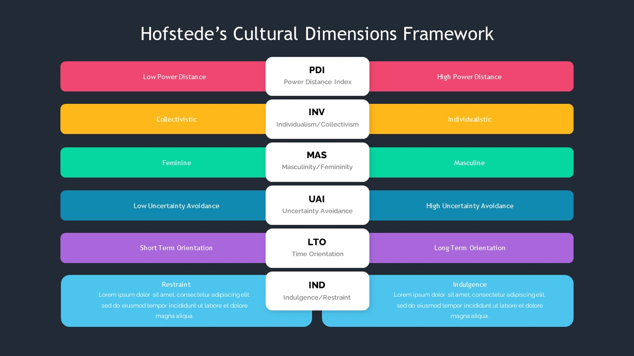
Figure 3: Hofstede’s framework
Source: (Brada and Park, 2024)
Power Distance: The massive cultural difference between the United Kingdom and India as implemented in all six dimensions of Hofstede is realised. The Indian power distance is high, and it is suggestive of the adaptation of hierarchy and status inequality, where the need to maintain luxury branding that is sensitive to exclusivity and prestige is preserved (Escandon-Barbosa, Salas-Paramo and Rialp-Criado, 2021). In contrast, UK scores low on power distance, and this implies that the country is more egalitarian and must have marketing communications that focus on individual performance rather than authority. (India – favourable; UK – unfavourable)
Individualism vs Collectivism: Individualism of the UK consumer is characterized by the fact that the consumers are more focused on personal preferences and deciding wherever they want to, and the individualism in India is not as high as in the UK and the decisions about buying the product are made by the family and the social group (Farooq and Raza, 2024). (UK – favourable; India – favourable for group focus)
Masculinity vs Femininity: Indian culture is more masculine, meaning that it is interested in achievement and publicity, which is not hard in aspirational luxury advertising. (India – favourable; UK – moderately favourable)
Uncertainty Avoidance: Concerning the uncertainty avoidance, the customers in the UK will be more comfortable with innovation and change, and this is why electric vehicles will be easier to adopt. The opinion that is not strongly positive does not mean that there is no usage of new technologies; the situation for India is moderate (Brada and Park, 2024). (UK – favourable; India – moderate)
Long-Term Orientation: The fact that the higher orientation is oriented towards the future in India with a preference to the future reward and value of investment as compared to that of the UK. (India – favourable; UK – less favourable)
Indulgence vs Restraint: The UK with higher indulgence rating is viewed as preference to take pleasure and enjoyment. These differences can help the marketing plans of Mercedes-Benz to be tailored in both nations (Kassab, 2023). (UK – favourable; India – less favourable)
Benefits of Hofstede Model
1. It provides a strict and measurable model, which triggers a comparison of cultural differences between various countries in a systematized manner.
2. The international marketing: This will help in marketing choices in the global market through the relationship of cultural values with consumer behaviour patterns (Feya A.M. Weijers, 2025).
3. Helps organisations to align the marketing, communication and management strategies to markets.
Disadvantages
1. As per the older studies, data that might not be applicable to the present cultural transformations and globalisation.
2. And probably generalizes on national culture and maybe even stereotypes entire peoples (Hemonnet-Goujot, Kessous and Magnoni, 2022).
3. It does not respect regional, generational and personal differences within a country.
5. Technological
India:
The electronics market in the Indian automotive industry is also developing and it is positive owing to the investments undertaken by the Indian state in promoting the use of electric mobility (Shamsuddoha and Nasir, 2025). Charging of EV is becoming widespread in the cities, and the demand in connected car technologies increases. However, the absence of a national charger station, high price of cars, and unwillingness of buyers inhibit the rapid uptake of EVs. The territories have an equalizing technology development that is not positive.
UK:
UK has built electric car infrastructure, electronic communications and government benefits to the use of electric cars. Consumers accept the smart mobility solutions and high-tech safety systems. The technologies preparedness will assist Mercedes-Benz in executing EQ electric range and compete better in the premium market (SM Bhome, 2023).
Technologically, India is less favourable due to its weak EV infrastructure, even though it provides a developing landscape for automotive tech. In contrast, the UK is more favourable due to its advanced EV network and consumers’ tech-readiness for the high-tech luxury cars.
6. Environmental
India:
India has already implemented BS6 guidelines of emissions to reduce pollution. This is a problem because, in the city environment, environmental awareness is on the increase and the problem of the infrastructure limitation, lack of consistency in its execution is evident. In order to achieve the balance between sustainability and affordability and cost of compliance, Mercedes-Benz will need to properly strike balance (SpringWorks, 2021).
UK:
UK is a country with stringent environmental laws and it aims at withdrawing internal combustion engines. This policy accelerates the electrification and innovations in sustainability. Regulatory certainty is a strategic direction, although in an organized manner, even in spite of the fact that adherence is demanding (Xu, Zhou and Ahmad, 2022).
The environmental favourability is less for the company in India, even with the progress on emission norms, because of gaps in infrastructure and inconsistencies. On the other hand, in the UK, there are strict environmental laws and more focus towards electrification, making the UK more favourable for the strategies related to sustainable mobility.
7. Legal
India:
The GST system in India, heavy duties imposed on imported goods and complex approval systems have an impact on the profitability. It has a problem of long legal procedures that result into contributing to operations problems (Zaino et al., 2024).
UK:
The UK has no ambiguous laws and good protection of intellectual property and a well-defined automotive legislation that has enabled a stable business establishment in the country.
The legal environment is unfavourable in India because of lengthy legal processing, high taxes, and complexity in approvals. Whereas, in the UK with efficient legal system, clear regulation, and strong IP protection make the country more favourable landscape for operations.

1.4 PESTEL Similarities and Differences
PESTEL Factor | India | United Kingdom | Similarity | Difference
Political | Supportive policies but bureaucratic delays | Stable, transparent regulations | Both politically stable | India has high procedural hurdles; UK easier to operate
Economic | Growing luxury market, rising wealth and GNP | Mature, saturated luxury market | Both support premium car demand | India fast-growing; UK slow but stable
Social | Status-driven, aspirational buying | Sustainability- and quality-driven | Both value premium brands | India status-focused; UK eco- and tech-focused
Cultural | Collectivist, status-oriented | Individualistic, heritage-oriented | Both appreciate luxury branding | India group influence; UK personal preference
Technological | Growing but limited EV infrastructure | Highly advanced EV ecosystem | Both adopting EV and connected tech | India slower adoption; UK highly tech-ready
Environmental | BS6 norms but inconsistent enforcement | Strict emission laws and EV push | Both promoting greener mobility | India infrastructural gaps; UK strong compliance
Legal | High taxes, complex approvals | Clear laws, strong IP protection | Both regulated automotive markets | India bureaucratic; UK streamlined and business-friendly
Table 1: Similarity and differences
Source: (Kim, 2022)
Factors that spur the development of the demand for electric vehicles include technical advancements and the need to save the environment.
1. Stiff environmental regulations that are affecting the car strategy.
2. More attention to quality technology, such as safety systems and internet connection.
3. Political stability that promotes long-term foreign investments (Kim, 2022).
4. Rules that create emission and consumer protection.
The convergence, according to the PESTEL analysis, is that the technological evolution, environmental policy orientation and the sustainability-related regulatory priorities in both nations are converged (Kassab, 2023). Although the different markets are in different levels of economic maturity, there still exists an opportunity to keep on transitioning towards electrification and innovation that would create a strategic opportunity to Mercedes-Benz in both markets.

1.5 Segmentation – VALS and Psychographic
The adapted strategies of Mercedes-Benz in India and UK is helped through the segmentation groups of consumer by shared needs (L Emma, 2025). Consumers are mainly segmented into Innovators and Achievers through the VALS profiles, valuing the status and premium quality. The brand demographically target the adults aged 30-60 with high-income, and geographically in both countries focuses on the big metropolitan cities where the demand for luxury is strong.
VALS Theory
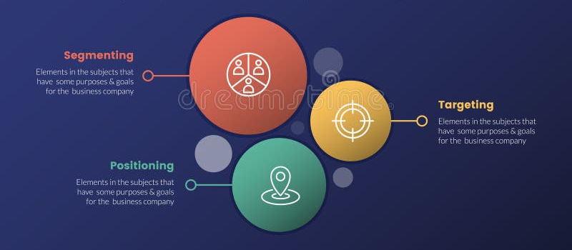
Figure 5: STP model
Source: (P Datta, 2024)
Psychographic Segmentation
India-Live status and luxury in-the-need and people who associate the premium car as something prestigious and status-providing.
UK - an environmentally-conscious competency-based consumer who values quality engineering and sustainability (Lukin, Krajnović and Bosna, 2022).
India:
Target group main- Achievers and Experiencers. Achievers are trendy individuals with lofty ambitions who want to be identified in the society and within their line of business. To them, having a Mercedes-Benz is a success and promotion. Experiencing luxury lifestyle, innovation, and high technology touches on the experiences of experiential consumers and majority are the young high-income consumers (Leonaviciene and Burinskiene, 2022). This concurs with the demand of the high-tech models and performance SUVs. Differentiated targeting strategy is used by Mercedes-Benz for providing different product line for different premium segments. This helps the brand to differentiate Achievers, Experiencers, and other groups which are luxury-oriented with tailored features and model.
UK:
Primary target- Achievers and Innovators. The UK achievers value success and quality yet they need realism and performance. The innovators are economically stable, progressive, and are technology receptive (Chotia et al., 2025). They are an early adopter of electric vehicles and appreciate sustainable luxury and, therefore, are the targeted customer of the EQ of Mercedes-Benz. Differentiated targeting strategy is used by company targeting Achievers with performance/luxury models and Innovators with sustainable electric EQ models.
Positioning: Brand Image
Mercedes-Benz in both the countries position itself as a status, high end luxury, well-engineered, high comfort and safety.
India- Status, prestige, aspiration success and social recognition and recognition amongst the rich consumers in India (Chotia et al., 2025).
UK to Tradition, classy performance, technical perfection, and friendliness to the environment.
Positioning ensures that the brand image follows the psychological motivations, cultural values and lifestyle preferences identified in the analysis of the segmentation so that Mercedes-Benz develops relevant value propositions to be communicated to the people in individual market places (Mercedes-Benz, 2024).
Perceptual Map
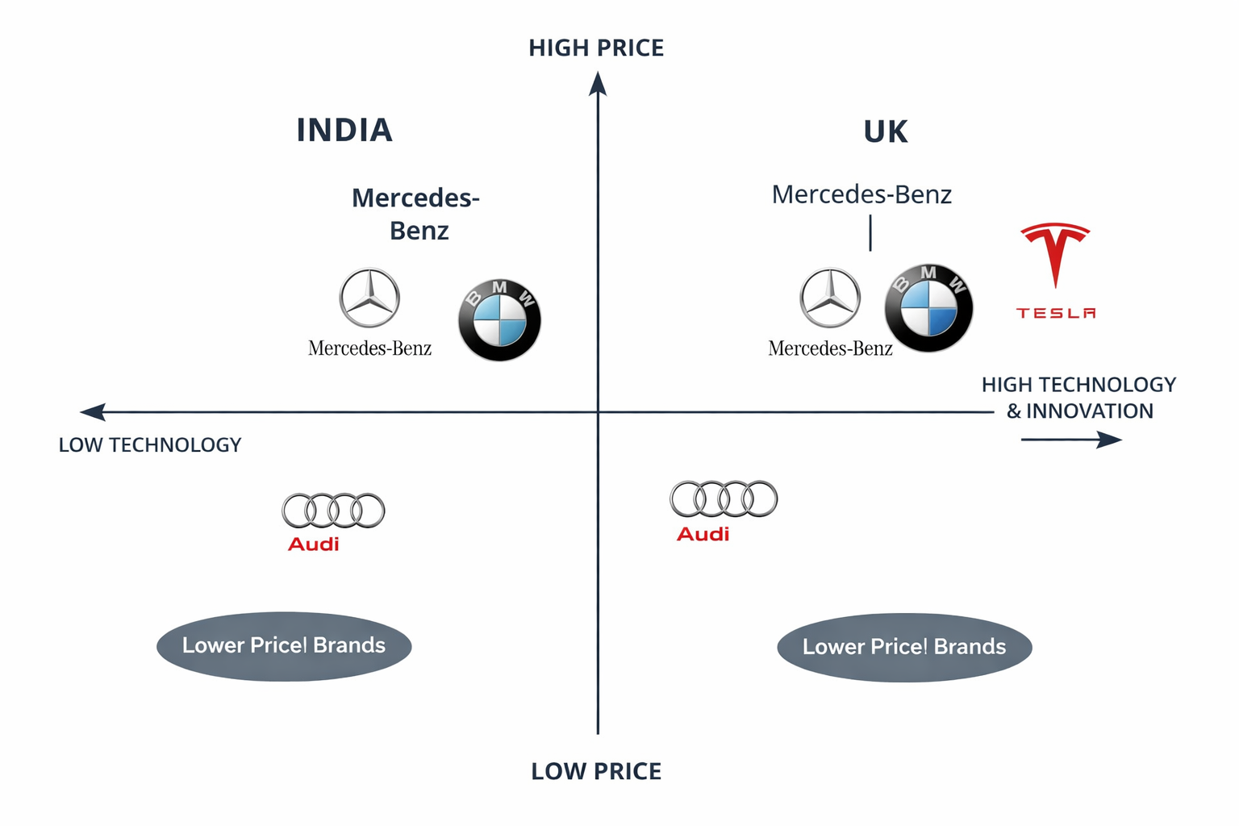
Figure 4: perceptual map
Source: (Chotia et al., 2025)
The position of Mercedes-Benz in the perceptual map in both India and the UK is high-price, high-technology luxury brand, and competition is direct with the brands like Audi and BMW. Tesla presence in India is limited but in UK it appears near to the Mercedes-Benz technologically because of its stronger adoption in EV (Andreeva and Petikhin, 2022).
Similarities
Mercedes-Benz in both India and the UK is a premium, status-driven, and technologically advanced luxury brand. In the psychographic segment the Achievers remains common in both markets (Chotia et al., 2025).
Differences
Aspirational success, status, and prestige is the main emphasis of the positioning of brand in India. Whereas, in the UK, especially in the EV range the positioning of the brand centres the sustainability, heritage, and engineering quality.

1.6 Marketing Mix (7Ps)
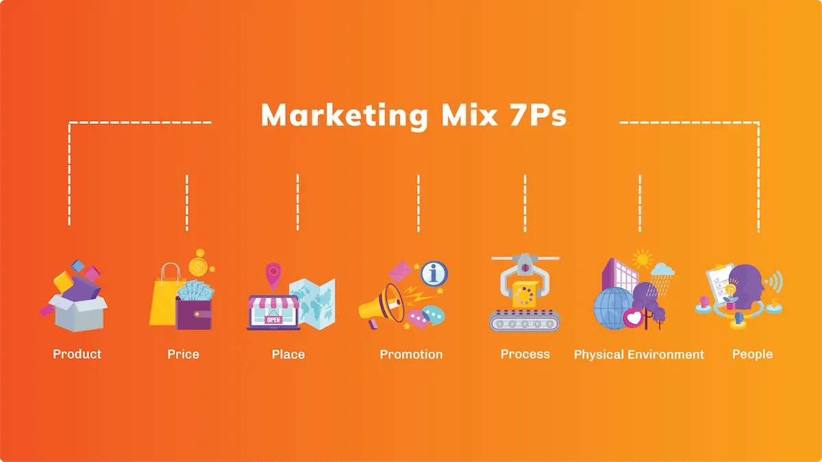
Figure 6: Marketing mix (7Ps)
Source: (Shamsuddoha and Nasir, 2025)
The marketing mix 7ps framework expands the marketing mix that existed in the past to include service based component, which forms the core of the luxury brands that market their products or services in the competitive global markets. In the example of Mercedes-Benz the 7ps will ensure stable premium experience and allow making local changes in order to satisfy the consumers preferences in India and the UK (SM Bhome, 2023).
Product
India –
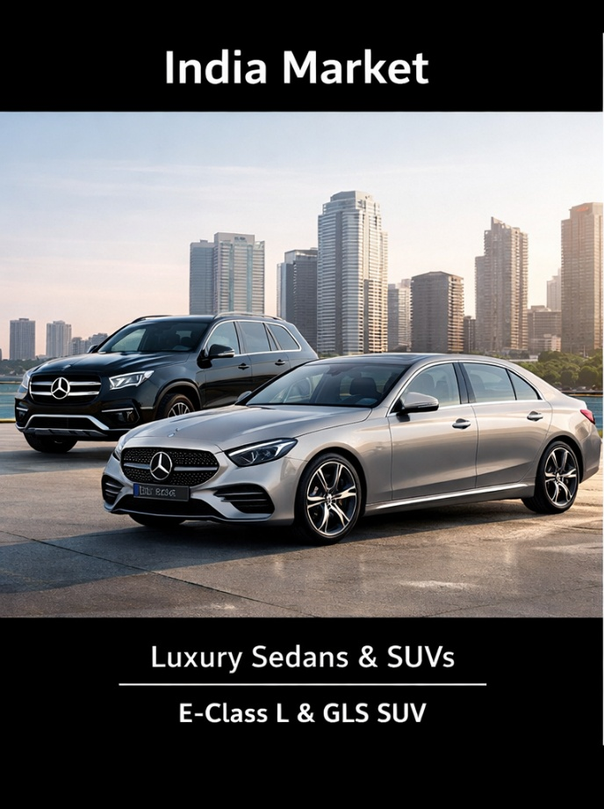
Figure 7: Mercedes-Benz product in India
Source: (SpringWorks, 2021)
Mercedes-Benz gives wide depth in high-end sedans (E-class L, S-class) and SUVs (GLC, GLE, GLS), they can be tailored according to the desires of the executive customers. Product width can be discussed through the range of brand extensions implemented. India recieves long-wheelbase vehicles to satisfy the chauffeurs as customers. The accent has been put on comfort, updated infotainment and quality interior that depicts status and clean interiors (SpringWorks, 2021).
UK –
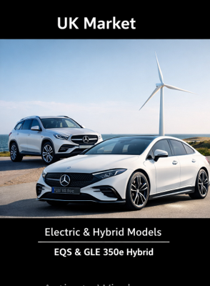
Figure 8: Mercedes-Benz product in UK
Source: (Xu, Zhou and Ahmad, 2022)
A fair deal consideration of the performance engineering (AGM line) and sustainability of EQ electric options and hybrid models (EQS, EQE, GLE hybrid). The portfolio also puts an accent on innovation, safety technologies as well as environmentally friendly mobility solutions that have met the standards of development (Xu, Zhou and Ahmad, 2022).
Price
India -The price is high because of the high importation duty, taxation systems and special rights. The idealistic aspect of ownership is imposed through pricing and the high and the exquisite nature of quality.
UK -Premium price competes in the luxury market that senses the rivalry with such brands as BMW and Audi, as well as offers the value created by innovation, performance and the well-developed electric vehicle technology (Zaino et al., 2024).
Place
India –
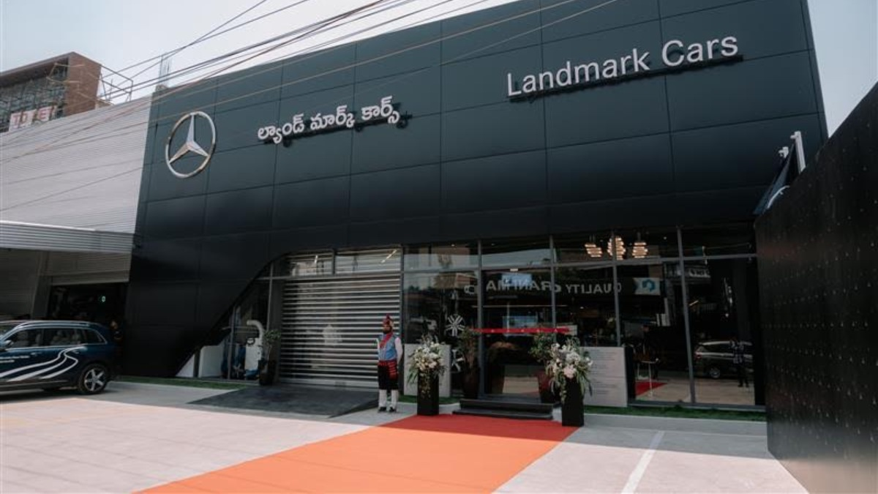
Figure 9: Mercedes-Benz dealership in India
Source: (Andreeva and Petikhin, 2022)
The location is in the major metros in those countries, which include, Mumbai, Delhi, Bangalore and Hyderabad where purchasing power and luxury demand are a major point of focus. The dealerships are exclusive as well and are placed in the city center so as to enhance accessibility and visibility of the brand (Andreeva and Petikhin, 2022). The company primary channels for distribution in India are direct dealership networks, certified service centres, and authorized franchise dealers.
UK-
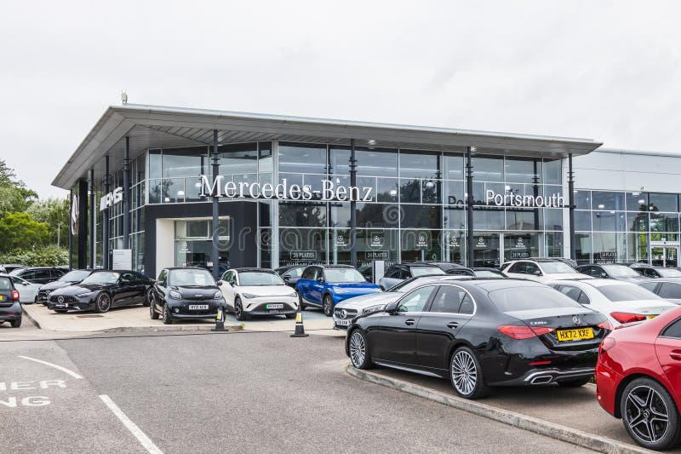
Figure 10: Mercedes-Benz dealership in UK
Source: (Kassab, 2023)
Nationwide dealership and licensed service network which will ensure large cities and regional markets availability and which will be complemented with online enquiry and vehicle design applications. Mercedes uses official dealerships, digital sales platforms, home-delivery options, and authorized retailers as multi-channel distribution.
Promotion
To give a unified and consistent brand message to the targeted audience by coordinating all promotional tools such as advertising, social media, events, PR, and digital platforms is known as IMC (Integrated Marketing Communication) (Ran et al., 2026).
India - Celebs testament, celebrity launch events as well as lifestyle oriented advertising campaigns with demanded prestige, ambition and success. The brand communication is significant on the social media and the luxurious magazines (Brada and Park, 2024).
UK - Sustainability, innovation and electric mobility online advertising. The promotional messages will focus on the green conscious nature, technology perfection and heritage engineering to attract current affluent consumers.
People
It possesses highly skilled salesmen, product specialists and consultants, service advisors that ensure provision of high quality customer service experience within the two markets. The employees are trained on offering a personalised consultation which is exclusivity and sophistication that is carried with the brand (Escandon-Barbosa, Salas-Paramo and Rialp-Criado, 2021). The operation employ staff of Mercedes-Benz across service, sales, and support functions in India is approximately 3,600 people, whereas, in UK the employs are approx. 3,000 direct people, supported by staff of dealership and retailer additionally.
Process
Luxury showroom experience in the form of smooth selling, financing and smooth delivery of services. The process is more convenient and rewarding with the help of relationship management and customer relationship management system in addition to digital booking system and open documentation (Farooq and Raza, 2024). The complaints of customer are submitted through the company website/app, dealerships, or customer care hotlines in both the countries India and the UK. The complaints are review and resolve by the service team after logged in the CRM system.
Physical Evidence
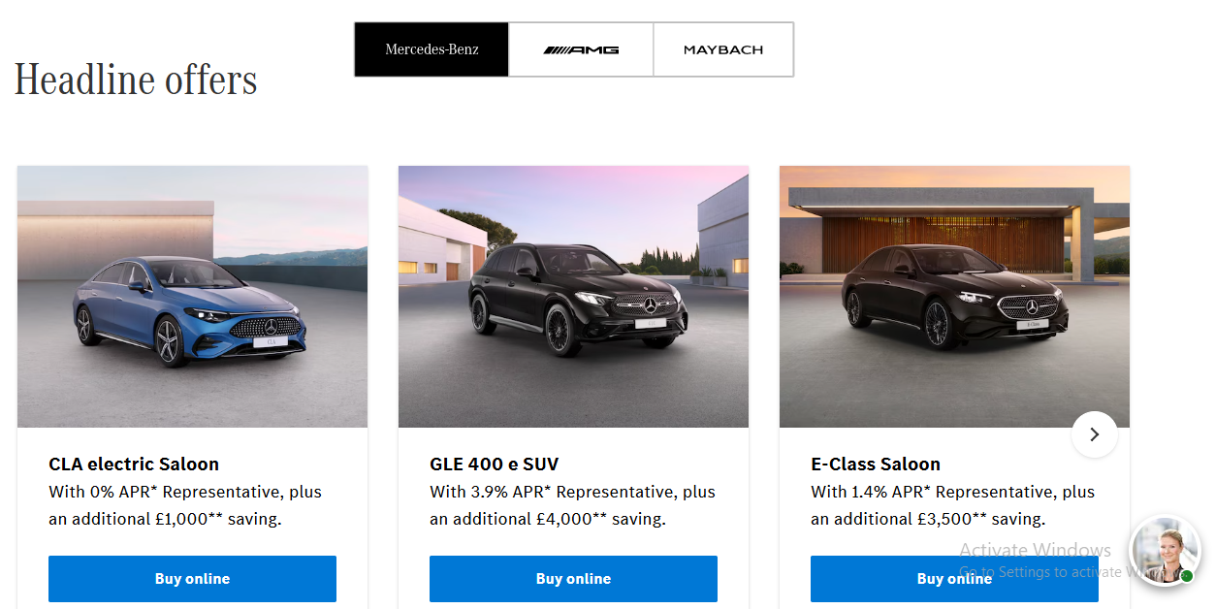
Figure 11: Mercedes-Benz website (UK)
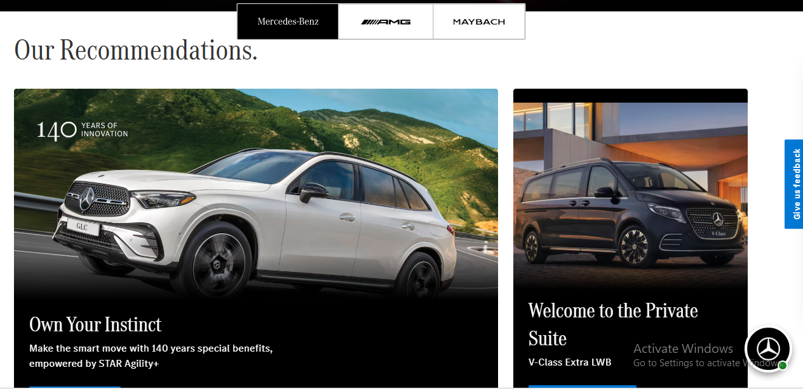
Figure 12: Mercedes-Benz website (India)
The existing show rooms, branded service centres and high quality ambience enhance the brand identity. The quality of the interior design, the display and well-taken up facilities make the impressions of quality, trustworthiness and quality in the luxury (Farooq and Raza, 2024).
Aspect (7Ps) | Similarities (India & UK) | Differences (India vs UK)
Product | Premium luxury cars, high quality, strong brand image | India: Comfort & long-wheelbase focus; UK: Performance, EVs & sustainability
Price | Premium pricing strategy in both markets | India: Higher due to taxes, status-driven; UK: Competitive, value-based
Place | Authorized dealerships & service centres | India: Metro-focused, limited reach; UK: Nationwide + strong digital channels
Promotion | Strong branding & digital marketing presence | India: Celebrity & lifestyle focus; UK: Sustainability & innovation focus
People | Skilled staff, personalised customer service | India: Relationship-focused selling; UK: Consultative & tech-enabled approach
Process | Smooth buying process, CRM systems used | India: Dealership-centric; UK: More digital, online & home delivery
Physical Evidence | Premium showrooms, branded environments | India: Grand & spacious; UK: Minimalist, modern & eco-friendly
Table 2: Similarities and differences
Source: (Dyankov and Fischer, 2022)

1.7 Directional Development Strategy – Porter’s Generic Strategy (UK)
Competitive Scope | Cost Leadership | Differentiation
Broad Market | Cost Leadership Strategy | Differentiation Strategy (Mercedes-Benz UK)
Narrow Market | Cost Focus | Differentiation Focus
Table 3: Porter’s Generic Strategy Matrix
Source: (Feya A.M. Weijers, 2025)
The cost leadership, differentiation and focus are competitive strategies that organisations use in the development of a competitive advantage as dictated by the framework of Generic Strategy by Porter. Mercedes-Benz within the UK motor vehicle market is positioned within a broad premium market and it does not span niche market. The company is not a cost leadership, which involves the prices being set as excellent engineering, new features and good brand equity (Hemonnet-Goujot, Kessous and Magnoni, 2022). Instead, Mercedes-Benz employs Differentiation Strategy on the UK market by transforming the message into the fact that the luxury manufacturer is technology-advanced and innovation-driven.
1. Future advancement in automotive technology.
Mercedes-Benz brings together the most recent security systems, computer-assisted driving, electronic dashboard, and infotainment technologies that are compatible with artificial intelligence. These spaces enhance the functionality, comfort and safety that offer an evident value over and above the elementary transport needs (Kim, 2022).
2. EQ series of electric innovation.
The EQ electric series represents the commitment to the environmentally-friendly movement and transportation that is based on low emissions. By adding more electric and hybrid models, Mercedes-Benz will be aligned with the environmental policies and demands of the UK consumers and even more consumers who are showing interest in cars that are environmentally friendly (Kassab, 2023).
3. Luxury brand image and legacy.
The brand capitalizes on its tenure in the engineering, German precision and reputation to quality. The tradition makes the brand usage stand off the crowd as it guarantees the loyalty of the customers.
This difference can assist Mercedes-Benz to achieve the top prices and be able to compete effectively with BMW and Audi (L Emma, 2025). The competitive advantage will be improved in the long run in a mature and competitive UK market because of the prioritisation on innovation, sustainability and brand prestige.

1.8 Ethical and Unethical Marketing Issues (India Example)
Ethical Issues
1. The electric car and hybrid cars help to curb the carbon emission to the greenhouse and contribute to the sustainability of India.
2. Customer loyalty and trust in the long run are built through open pricing and warranty schemes as well as easy financing (Leonaviciene and Burinskiene, 2022).
3. Responsible advertising that displays the right performance of vehicle, safety features along with the degree of fuel efficiency, protects the interest of the consumer and the credibility of the brand.
Unethical Examples
1. Fraudulent claims on mileage, fraudulent claims on performance or lack thereof of technology may be deceptive to the consumers.
2. The uncertain maintenance costs or any other concealed costs of service packages may impact negatively on customer satisfaction (Chotia et al., 2025).
3. The overexploitation of the multidimensional concept of status symbolism in marketing may facilitate materialistic coercion as well as artificial social ideals.
Ethical marketing will boost the brand equity and customer relationship whereas unethical marketing can attract negative publicity, law and losing customers in the competitive Indian luxury market in the automobiles.

1.9 Recommendations
Recommendations for India
1. Establish EV infrastructure partnerships with the charging network and the government, wanting to further the introduction of EVs and reduce the unwillingness of consumers.
2. Announce current small-end luxury designs and other alternative financing to expand the reach of customers as new high-end professionals (Lukin, Krajnović and Bosna, 2022).
3. Enhance the autonomy of cost services by educating customers about the cost of maintaining packages and long term ownership costs long before the development of trust and satisfaction channels.
4. Increase the online marketing campaigns including the social media as well as personalised online marketing campaigns to find the younger and techno-savvy professionals in the metropolitan cities (Chotia et al., 2025).
Recommendations for UK
1. Increase the manufacture of EVs and expand EQ line ups to meet the rigorous government electrification efforts.
2. Enhance carbon-neutral operations and green production through increasingly focusing on sustainability branding.
3. Nevertheless, to attract the trend of dynamic consumerism, the company should increase subscriptions and flexible ownership systems (Mercedes-Benz, 2024).
4. Differentiate by seeking to invest in AI–based customer experience technology in a congested luxury market.

Section 2: Reflective Account
Introduction to Gibbs Cycle of Reflective
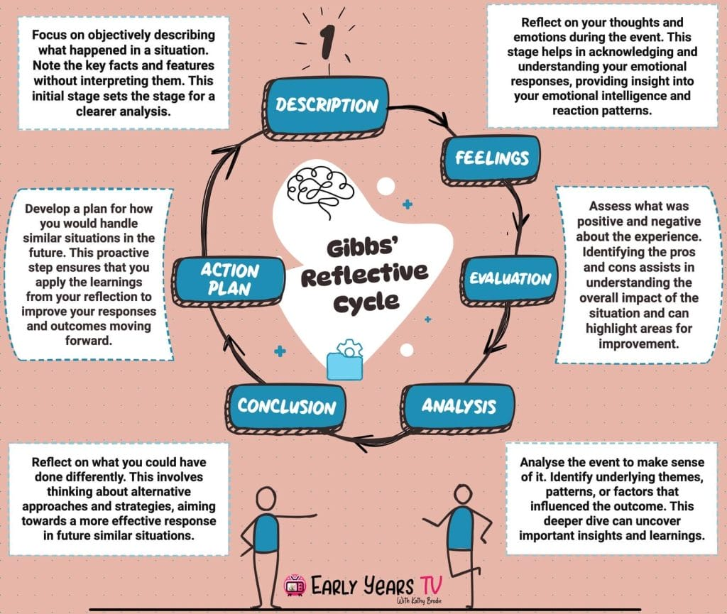
Figure 13: Gibbs’ reflective cycle
Source: (Ran et al., 2026)
Gibbs Reflective Cycle (1988) is a systematic model that helps an individual to reflect the experience in a systematic manner and improve the future performance. The model contains six steps namely Description, Feelings, Evaluation, Analysis, Conclusion and Action Plan. It encourages critical thinking in which it assists individuals to not only go beyond description, but also to acquire deeper insight and continuous upgrading (Pereira and Bhat, 2024). The model constructed by Gibbs, as applied to this evaluation, is among the most systematized methods of considering the research, analysis and compilation of the international marketing report about the organization of Mercedes-Benz in India and the United Kingdom. The assistance of this cycle helped me to analyze my research process, describe my strengths and weaknesses, as well as find out what I could improve in the academic and professional life.
1. Description
This report entailed extensive secondary research of the activities of Mercedes-Benz and its business presence in India and UK. The macro environmental analysis tools such as PESTEL were used to examine political, economic, social, technological, and environmental and legal environment in the two countries. I also used cultural dimensions of Hofstede to make comparison of the differences in culture and the consumer behaviour (Ramadhani and Rahman, 2025). The STP model and marketing mix (7Ps) were employed to test the targeting strategies and brand positioning. The comparison in the research involved the effects of the two economies: the developing market economy and the developed market economy of India and UK on the international marketing strategies. The analysis was logically and critically bound together using the academic journals, company reports and marketing textbooks.
2. Feelings
The initial stage of the research process was somewhat overwhelming to me because of the magnitude of the assignment particularly because there was the need to compare two nations that have hugely different economy and cultural characteristics. It was crucial to extract close information and analyze it in order to understand the macro-environmental complexities of India and UK. However, later, I became more sure about applying theoretical frameworks to those situations of real-life business (Ran et al., 2026). Another interesting part that I found introspectively stimulating was the comparative part since it highlighted how a global luxury brand must have its strategy shift according to markets. The final products of the process were satisfaction on the scope of analysis I had attained and the ability to conduct a structured international marketing research.
3. Evaluation
The research experience has been successful in enhancing my skills on the topic of international marketing strategies. The PESTEL analysis helped me to systematically speculate on the external forces that would influence the operations of Mercedes-Benz in the two markets. Similarly, the Hofstede model also performed useful cultural analysis which helped in making positioning decision (Rosário and Raimundo, 2021). However, I realised that we have some limitations. The cultural models are very simplistic in assuming the national attributes and may not depict the various regional attributions to the countries. Another factor that reduced the availability of real-time insights of the consumers is that secondary data was used as the central source. It was not these limitations that prevented the manuals and the methodic formats of the report that guaranteed transparency and scholarly scrupulousness throughout.
4. Analysis
On second analysis I was able to realise that international marketing entails standardisation and adaptation. Despite the similar global luxury perception by Mercedes-Benz, its application is also highly differentiated in India as compared in UK. Status symbolism and aspirational branding also play an important role in India when attracting rich buyers. On the contrary, in the UK, there is increased attention by consumers on sustainability, environmental and high-tech electric movement (Shamsuddoha and Nasir, 2025). Because of such kind of reflection, there was the need to educate about socio-cultural and economic environment when formulating marketing strategies. It also showed how the theoretical frameworks are useful in bridging the gap between the academic and real decision-making of businesses.
5. Conclusion
Altogether, I can say that using the implementation of the Reflective Cycle created by Gibbs contributed to my better analytical and critical thinking. The coexposition allowed me to assess the drawbacks and advantages of my methodology of research. I also realized that international analysis of comparative analysis requires quite keen interpretation of information and considering theory equally (SM Bhome, 2023). Overall, the experience allowed consolidating the knowledge on strategic marketing in the global environment and cross-cultural management.
6. Action Plan
Secondary data sources will be used in the research projects to enhance the richness of analysis and originality. I would also wish that I could become more critical when reading academic literature to refute assumptions of predetermined models (Leonaviciene and Burinskiene, 2022). Moreover, I will improve time management to make sure that I have allocated time to research on each analytical structure. By doing so, I will be in a position to write more effective arguments supporting evidence to come up with better international marketing analysis in future assignments.

Conlusion
This report has discussed international marketing strategy of mercedes-Benz in India and the United Kingdom using a macro-environment analysis, cultural based analysis, STP analysis, marketing mix analysis and strategic development model. As demonstrated in the paper, there is a significant variation between the way Mercedes-Benz applies its strategies in emerging and developed markets despite having a stable global luxury branding. India is highly potential in terms of growth considering the rise in income levels and inspirational consumption but the challenge is price sensitivity and regulatory complexities. UK is a developed, hygienic and technologically advanced market providing high concentrations of EV uptake amount but is thickly competitive with tight regulations of environmental compliance. Similar analysis has made it clear that the successful international marketing parameters are represented by environmental adaptability, cultural sensitivity and strategic differentiation. Digitization and customer transparency through electric mobility will enable Mercedes-Benz to stay competitive in the two countries. Overall, the article demonstrates how the macro-environmental analysis, as well as the strategy of adaptive marketing, was relevant in the successful global brand.

References
Andreeva, S. and Petikhin, D. (2022). Research on the marketing of technological innovations for car safety: case company: Mercedes-Benz. [online] www.theseus.fi. doi: https://www.theseus.fi/handle/10024/787064 [Accessed 18 Feb. 2026].
Brada, J.C. and Park, J. (2024). The fourth industrial revolution: Implications for the global economy and for the strategic competition between the United States and China. Asia and the Global Economy, 4(2), p.100097. doi: https://doi.org/10.1016/j.aglobe.2024.100097 [Accessed 20 Feb. 2026]
Chotia, V., Khoualdi, K., Broccardo, L. and Yaqub, M.Z. (2025). The role of cyber security and digital transformation in gaining competitive advantage through Strategic Management Accounting. Technology in Society, [online] 81, p.102851. doi: https://doi.org/10.1016/j.techsoc.2025.102851 [Accessed 18 April. 2026]
Escandon-Barbosa, D., Salas-Paramo, J. and Rialp-Criado, J. (2021). Hofstede’s Cultural Dimensions as a Moderator of the Relationship between Ambidextrous Learning and Corporate Sustainability in Born Global Firms. Sustainability, [online] 13(13), p.7344. doi: https://www.mdpi.com/2071-1050/13/13/7344 [Accessed 16 Feb.2026].
Farooq, H. and Raza, A. (2024). Cross-Cultural Consumer Behavior: A Comparative Study. Journal of Strategic Business Research, [online] 2(1), pp.36–52. doi: https://jsbrjournal.com/index.php/journal/article/view/39 [Accessed 20 Feb. 2026].
Feya A.M. Weijers (2025). Hofstede’s Individualism-Collectivism Dimension and Linguistic Adaptation on Social Media: How Mercedes-Benz Adapts Content on X for the USA and India and Its Effect on Brand Reputation . [online] doi: https://theses.ubn.ru.nl/server/api/core/bitstreams/df4759c3-e0a4-4906-bd88-4027354949ea/content [Accessed 18 Feb. 2026]
Hemonnet-Goujot, A., Kessous, A. and Magnoni, F. (2022). The effect of sustainable product innovation on the consumer–luxury brand relationship: The role of past identity salience. Journal of Business Research, 139, pp.1513–1524. doi: The effect of sustainable product innovation on the consumer–luxury brand relationship: The role of past identity salience [Accessed 20 Feb. 2026]
Kassab, A. (2023). Emerging Trends in Marketing Strategy: A Comprehensive Analysis Of 4ps. [online] www.theseus.fi. doi: https://www.theseus.fi/handle/10024/802512 [Accessed 19 Feb. 2026].
Kim, S. (2022). Critical Success Factors Evaluation by Multi-Criteria Decision-Making: A Strategic Information System Planning and Strategy-As-Practice Perspective. Information, [online] 13(6), p.270. doi: https://www.mdpi.com/2078-2489/13/6/270 [Accessed 18 Feb. 2026].
L Emma (2025). Strategic management approaches for enhancing competitive advantage in the digital economy . [online] doi: https://www.researchgate.net/profile/Lawrence-Emma/publication/388678693_Strategic_Management_Approaches_for_Enhancing_Competitive_Advantage_in_the_Digital_Economy/links/67a231ba96e7fb48b9b458c5/Strategic-Management-Approaches-for-Enhancing-Competitive-Advantage-in-the-Digital-Economy.pdf [Accessed 20 Feb. 2026].
Leonaviciene, E. and Burinskiene, A. (2022). Accelerating cultural dimensions at international companies in the evidence of internationalisation. Sustainability, 14(3). doi: https://www.mdpi.com/2071-1050/14/3/1524 [Accessed 19 Feb. 2026].
Lukin, E., Krajnović, A. and Bosna, J. (2022). Sustainability Strategies and Achieving SDGs: a Comparative Analysis of Leading Companies in the Automotive Industry. Sustainability, 14(7), p.4000. doi: https://www.mdpi.com/2071-1050/14/7/4000 [Accessed 18 Feb. 2026]
Mercedes-Benz (2024). Mercedes-Benz International: News, Pictures, Videos & Livestreams. [online] Mercedes-benz.com. doi: https://www.mercedes-benz.com/en/ [Accessed 20 Feb. 2026].
Mercedes-Benz (2025). Mercedes Benz Luxury Cars In India - Price, Models & Features. [online] www.mercedes-benz.co.in. doi: https://www.mercedes-benz.co.in/ [Accessed 14 April. 2026].
P Datta (2024). he impact of sustainable practices on consumer behaviour in the UK automobile sector . [online] doi: https://www.researchgate.net/profile/Palto-Datta-4/publication/380971323_The_impact_of_sustainable_practices_on_consumer_behaviour_in_the_UK_automobile_sector/links/66577d500b0d28457465199f/The-impact-of-sustainable-practices-on-consumer-behaviour-in-the-UK-automobile-sector.pdf [Accessed 19 Feb. 2026]
Pereira, C.S. and Bhat, K.S. (2024). A Systematic Review of Consumer Perception and Purchasing Behavior of Electric Vehicles. Zenodo. [online] doi: https://www.academia.edu/download/120108547/2._A_Systematic_Review_of_Consumer_Perception_and_Purchasing_Behavior.pdf [Accessed 20 Feb. 2026]
Ramadhani, N.R. and Rahman, T. (2025). MARKETING STRATEGIES OF BMT IN EFFORTS TO INCREASE THE NUMBER OF CUSTOMERS: A SYSTEMATIC LITERATURE REVIEW. Jurnal Ilmiah Al-Tsarwah, 8(1), pp.14–25. doi: http://jurnal.iain-bone.ac.id/index.php/altsarwah/article/view/9153 [Accessed 19 Feb. 2026].
Ran, Y., Ali, A.S., Shen, L., Salleh, H.B., Zhu, M., Jiang, K. and Zhao, Z. (2026). PESTEL Analysis of External Factors Influencing CSR Performance Toward Sustainable Development: Evidence from Small and Medium Construction Enterprises. Sustainability, [online] 18(4), p.1922. doi: https://www.mdpi.com/2071-1050/18/4/1922 [Accessed 18 Feb. 2026]
Rosário, A. and Raimundo, R. (2021). Consumer Marketing Strategy and E-Commerce in the Last Decade: a Literature Review. Journal of Theoretical and Applied Electronic Commerce Research, [online] 16(7), pp.3003–3024. doi: https://www.mdpi.com/0718-1876/16/7/164 [Accessed 10 April. 2026].
Shamsuddoha, M. and Nasir, T. (2025). The Road Ahead for Hybrid or Electric Vehicles in Developing Countries: Market Growth, Infrastructure, and Policy Needs. World Electric Vehicle Journal, 16(3), p.180. doi: https://www.mdpi.com/2032-6653/16/3/180 [Accessed 18 Feb. 2026].
SM Bhome (2023). Benefiting Businesses and Consumers in Indian Economy . [online] doi: https://www.researchgate.net/profile/Dr-Sonali-Bhujbal/publication/395586041_Online_FB_Impact_of_GST_on_Indian_Economy/links/68cbbb760f14e901fcd14897/Online-FB-Impact-of-GST-on-Indian-Economy.pdf#page=28 [Accessed 19 Feb. 2026]
SpringWorks (2021). How to conduct an effective PESTEL Analysis? [online] SpringWorks. doi: https://springworks.ch/en/pestel-analysis/ [Accessed 20 Feb. 2026]
Xu, S., Zhou, X. and Ahmad, Z. (2022). Measuring the Psychological Behavior of Tourism Service Providers in Low-Income Regions: Implementing Effective Service Marketing and Performances Strategies. Sustainability, 14(18), p.11459. doi: https://www.mdpi.com/2071-1050/14/18/11459 [Accessed 19 Feb. 2026]
Zaino, R., Ahmed, V., Alhammadi, A.M. and Alghoush, M. (2024). Electric Vehicle Adoption: A Comprehensive Systematic Review of Technological, Environmental, Organizational and Policy Impacts. World Electric Vehicle Journal, [online] 15(8), p.375. doi: https://www.mdpi.com/2032-6653/15/8/375 [Accessed 20 Feb. 2026].

Appendices

Competitive Scope | Cost Leadership | Differentiation
Broad Market | Cost Leadership Strategy | Differentiation Strategy (Mercedes-Benz UK)
Narrow Market | Cost Focus | Differentiation Focus

PESTEL Factor | India | United Kingdom | Similarity | Difference
Political | Supportive policies but bureaucratic delays | Stable, transparent regulations | Both politically stable | India has high procedural hurdles; UK easier to operate
Economic | Growing luxury market, rising wealth and GNP | Mature, saturated luxury market | Both support premium car demand | India fast-growing; UK slow but stable
Social | Status-driven, aspirational buying | Sustainability- and quality-driven | Both value premium brands | India status-focused; UK eco- and tech-focused
Cultural | Collectivist, status-oriented | Individualistic, heritage-oriented | Both appreciate luxury branding | India group influence; UK personal preference
Technological | Growing but limited EV infrastructure | Highly advanced EV ecosystem | Both adopting EV and connected tech | India slower adoption; UK highly tech-ready
Environmental | BS6 norms but inconsistent enforcement | Strict emission laws and EV push | Both promoting greener mobility | India infrastructural gaps; UK strong compliance
Legal | High taxes, complex approvals | Clear laws, strong IP protection | Both regulated automotive markets | India bureaucratic; UK streamlined and business-friendly

Aspect (7Ps) | Similarities (India & UK) | Differences (India vs UK)
Product | Premium luxury cars, high quality, strong brand image | India: Comfort & long-wheelbase focus; UK: Performance, EVs & sustainability
Price | Premium pricing strategy in both markets | India: Higher due to taxes, status-driven; UK: Competitive, value-based
Place | Authorized dealerships & service centres | India: Metro-focused, limited reach; UK: Nationwide + strong digital channels
Promotion | Strong branding & digital marketing presence | India: Celebrity & lifestyle focus; UK: Sustainability & innovation focus
People | Skilled staff, personalised customer service | India: Relationship-focused selling; UK: Consultative & tech-enabled approach
Process | Smooth buying process, CRM systems used | India: Dealership-centric; UK: More digital, online & home delivery
Physical Evidence | Premium showrooms, branded environments | India: Grand & spacious; UK: Minimalist, modern & eco-friendly

