THE GLOBAL BUSINESS ENVIRONMENT

LCBB4005

Assignment 1

Environmental Analysis of Automobile Industry

Jaguar Land Rover

Dr Nadeem Mirza

Lilija Tconeva
2029799
Word count: 2147

LONDON
January 2022
TABLE OF CONTENTS

1. Introduction 4
2. Jaguar Land Rover Automotive PLC SWOT Analysis 4
3. Value Chain Analysis 5
4. PESTEL 7
5. Porter’s Five Forces 9
6. Conclusion 10
7. Recommendations 10
REFERENCES 11
REFERENCES (FIGURES) 13

LIST OF FIGURES

Figure No | Description | Page No
1 | LR Defender 2021 World Car Design of the Year | 4
2 | Future Air Purification Technology inhibiting viruses and bacteria by up to 97% | 8
3 | Net Zero Scenario | 8

- Introduction
The automotive industry faces many challenges with globalization, individualizations, digitalization and competition. Companies are required to comply with regulations, safety and environmental commitments while automobile firms need to innovate constantly in order to remain successful in the market. (MarketLine, 2019)

At present, powerful global trends push and pull the industry in many directions. Manufacturers are developing new technology to get vehicles aligned with tough new regulations, while trying to remain profitable in unfavourable trading conditions. Moreover, some of the biggest aims of the industry involve autonomous and light weighing vehicles, solid state battery development, shared mobility and mergers and acquisitions. (MarketLine, 2019a, p.1)

In addition, slow charging infrastructure, broken or blocked chargers and confusing payment schemes turn off consumers and frustrate the sector. UK automakers also face high energy costs and business rates as well as global shortage of semiconductors leading to production delays and decimating output. Redouble efforts to support electric vehicle market and automotive sector competitiveness, says SMMT President (2021) This report reflects on the challenges Jaguar Land Rover faces, addressing their SWOT, Value Chain, PESTLE, Porter’s Five Forces analyses in order to critically evaluate their business environment.

- Jaguar Land Rover Automotive PLC SWOT Analysis
Jaguar Land Rover PLC is a company, supported by conglomerate TATA Motors, that designs and manufactures high segment cars under two brands- Jaguar and Land Rover. Based in Coventry, UK, its market network includes franchise and national sale dealers, import and export partners. It is In FY 2021 the company sold 439,588 vehicles globally. (MarketLine, 2021b)

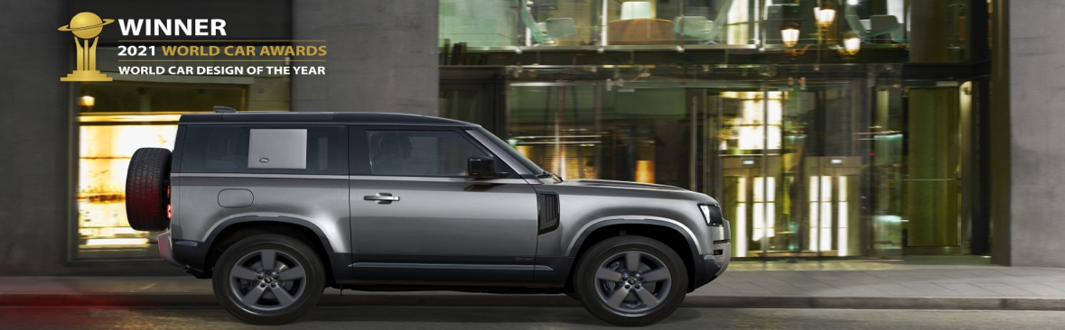
Figure 1: LR Defender 2021 World Car Design of the Year (Source: Land Rover, 2021)
Strengths
JLR is globally respected brand, characterised by quality and reliability. Luxurious interior and exterior design attract millions of consumers. It has several manufacturing plants which can make the vehicles more affordable, especially in India, Brazil and China. The control over the supply chain is cost saving. Strong geographical presence in the US is a major strength for the company, contributing 24.4% of the revenue in 2020. (MarketLine, 2021c)
It uses R&D to gain competitive edge. The parent TATA Motors further supports the competitiveness of the company with access to global leaders in technology and sustainability within the group.

Weaknesses
JLR focuses on luxury vehicles ignoring the average customer. Debt increasing 30% in 2020 to £5,884m could have an impact on its operational performance and cash flow, subsequently causing a concern amongst investors, which could impact finance.
Due to the pandemic, the total vehicle sales in 2021 decreased 13.57% with the company’s Land Rover retail sales standing at 341,919 vehicles, 7.1% decrease. (MarketLine, 2021c)

Opportunities
Changing lifestyle, JLR’s presence in the US market and shift in consumer demand create new growth opportunities. In 2020, it introduced three- cylinder plug in hybrid system, which delivers zero emissions. It launched Range Rover Evoque and Jaguar XE sedan and its variables in India. New agreement with Ricardo saw the company produce face shields for NHS. It partnered with Tata Power to develop electric car charging infrastructure in India. (MarketLine, 2021c)

Threats
Existing threat from competitors such as Volkswagen AG and Nissan Motor CO Ltd with some of them in better financial situation. Inflation and fluctuating currency market. There is a risk of raw materials and oil price increase or unavailability, resulting in higher product costs and lower productivity. (MarketLine, 2021c)
In 2020, due to the pandemic productions for UK and oversees market dropped 30.4%. The pandemic still opposes a threat in terms of restrictions and unfavourable Brexit rules. UK car production down- 29.3% as coronavirus slams brakes on sector (SMMT, 2021)

- Value Chain Analysis
Value chain analysis helps organisations gain a better understanding of the most important activities in achieving competitive advantage. The concept divides a company in sets of activities: primary, concern the creation or delivery of a product; and secondary- improve the effectiveness of the primary ones. (Johnson, 2017, p.108)

Primary activities
Inbound logistics
JLR needs to have strong relationship with suppliers and control over raw materials to finished product. To avoid challenges in product development suppliers’ support is necessary to receive, store and distribute the product. JLR outsources most logistics activities.
Operations
Analysing operational activities helps the company to improve its productivity and maximising efficiency to achieve economic growth. JLR has several manufacturing plants.
Outbound logistics
By optimizing outbound logistics JLR can increase customer satisfaction, timely delivering the product with minimum effect on the quality. JLR has an extensive distribution network.
Marketing and sales
High quality product with distinctive features and affordable price does not create value until JLR invests in marketing and sales. As a result, JLR would develop brand equity and stand out from competitors.
Services
Pre-sale and after- sale services of JLR are essential for the modern customer. Those activities should be carefully analysed to avoid damaging the brand reputation but create loyal customers.
Secondary activities
Firm infrastructure
Optimising the Infrastructural activities would strengthen the competitive positioning of JLR on the market. Finance and planning are managed at corporate level at the company and accounting and business issues are controlled at a busines unit level.
Human resource management
JLR heavily depends on their employees’ talent. Effective HR management would increase competitive advantage based on motivation, commitment and skills of the workforce.
Technology development
Almost all activities in the value chain depend on the technological support to gain competitive advantage. This category includes research and development department of JLR.
Procurement
Analysing these activities would improve JLR profitability by reducing raw materials cost and prices and identifying better sources of supply. It’s performance evaluation stage.

- PESTEL
PESTEL evaluates the broad macro- environmental factors of an organisation. It’s characterised by 6 points, including market and non-market aspects, feeding into environmental forecasts and scenario analyses. (Regner et al., 2020, p. 36)

Politics
SMMT (2021) has called for the Government’s attention on the UK automotive sector for future trade negotiations after generating a total of £74bn, nation’s most valuable exported good.
However, the import and export trade barriers, strict emissions regulations and the surrounding uncertainty around Brexit, play a significant role in the market decline. Brexit reduces competitiveness of the UK automotive sector because of the tariffs that make vehicles less affordable for Europeans.
Due to Brexit, the car components sourced from EU, are pricier than before. The UK automotive sector- challenges and opportunities (PES, 2019)
The biggest challenge will be the shortage of new vehicles in the short term.

Economics
Brexit has negative effect on the UK economy causing instability and market decline. As a result, expenditure and income in the UK changed. In 2020, household and business spending fell. Due to the pandemic, financial support was provided, which largely increased the Government borrowing but improved unevenly the financial position of households and increased their net lending position. Coronavirus and the impact on UK households and businesses. (ONS, 2020) JLR could leverage this trend by employing different marketing campaign to gain new customers. The Government Budget is a factor for automakers and the current deficit budget may lead to an increase in inflation over medium term. Inflation rates affect JLR products but increasing price in line with inflation could lower the brand loyalty.

Social
There is a shift towards purchasing eco- friendly vehicles, according to the increase in electric cars purchases. Production of alternatively fuelled vehicles rose to 172,857 showing the UK’s ability to build vehicles for Net Zero future. UK car production down- 29.3% as coronavirus slams brakes on sector (SMMT, 2021) It shows that UK consumers are happy to embrace new technology. Increased availability of data and information shape these social trends. The corporate strategy of JLR includes sustainable future with zero emissions, zero accidents and zero congestion. (MarketLine, 2021b)

Technology
JLR uses research and development to innovate its products through latest technology, advanced design and engineering. It uses virtual engineering and 3D design rooms that reduce expense and time in making a vehicle. (MarketLine, 2021c)
JLR are investing heavily into electric vehicles and show consumers their commitment to a greener future. JLR use aerospace technology to develop future lightweight vehicles. Latest video packs (JLR, 2020)
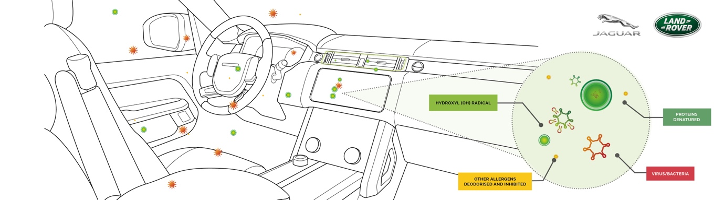
Figure 2: Future air purification technology, inhibiting viruses and bacteria by up to 97% (Source: JLR, 2021)

Ecological
According to BNEF (2021), the net zero scenario includes reaching 100% hydrogen or electricity run vehicles by 2050.

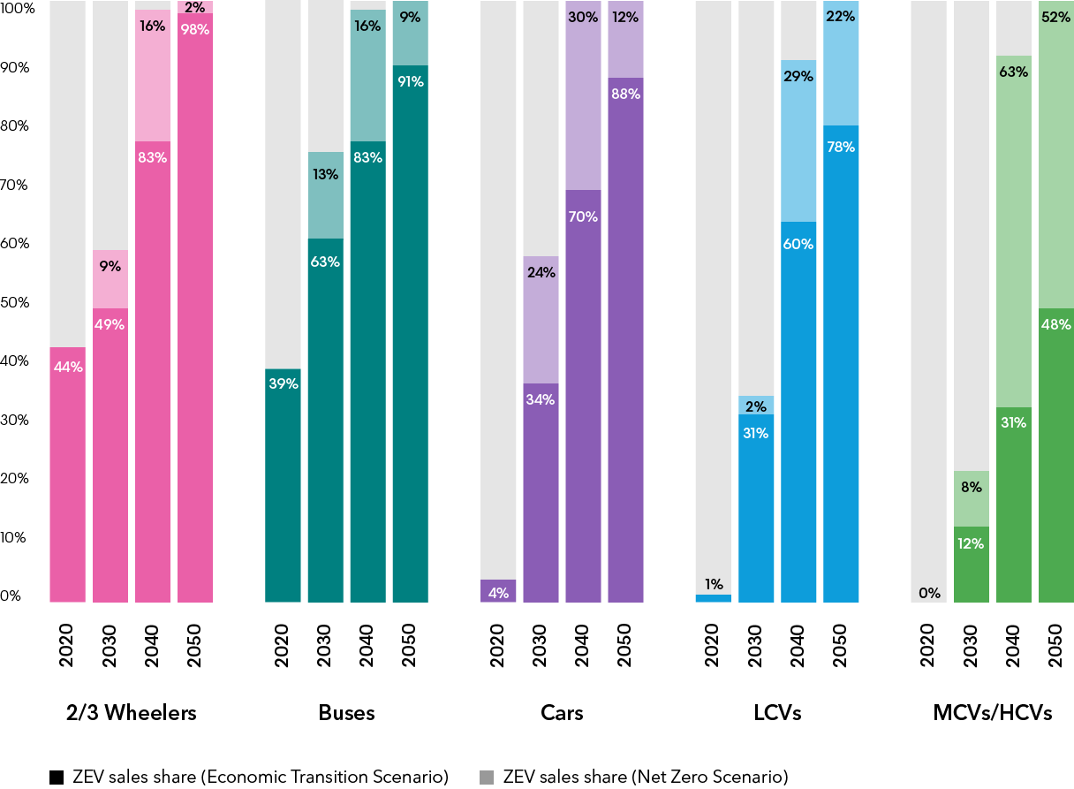
Figure 3: Net Zero Scenario (Source: BNEF, 2021)

Passenger cars and light commercial vehicles are on a positive transition but need policy support. By 2035, the last combustion vehicles need to be discontinued. Electric Vehicle Outlook (BNEF, 2021)
JLR’s new global strategy ‘Reimagine’ marks the journey to net zero carbon business across all operations, products and supply chain by 2039 and involves the electrification of Land Rover and Jaguar brands. They plan for battery recycling and scrap materials to be used for new batteries, minimizing waste and increasing profitability. JLR reimagines the future of modern luxury by design (JLR, 2021)

Legal
Affordability, charge point availability and infrastructure reliability are concerns that need attention. SMMT calls for reduction of tariffs and regulatory barriers. It recommends establishing Rules of Origin to regulate the suppliers base and manufacturers recruitment policies to ensure growth. Vehicles remain Britain’s most valuable trade good as export reach £27bn (SMMT,2021) The law not only constrains businesses but also assists in achieving their commercial goals. It enables and protects businesses as they enter into contracts, crucial for their operations. (Worthington and Britton, 2006, p. 179) JLR will adopt a flatter structure to right- size, repurpose and reorganise it into more agile operation.

- Porter’s 5 Forces

- Competitive rivalry- high
Luxury automobile industry is very competitive, offering vehicles that differ in design and features.
Increased rivalry due to large investments in new models and exit barriers, however the industry where JLR operates is upscale, meaning the number of competitors is very few with large market share, likely to focus on capturing the market share from each other.
- Threat of new entrants- low
Entry barriers is negatively corelated because of JLR’s brand reputation, high capital requirements and product differentiation. Strict government regulations to enter the industry. Cost of marketing and unlikely achievement of economies of scale in the JLR industry, make the new entrants force low.
- Buyer power- medium
Buyers have many companies to choose from in the luxury industry where JLR operates. However, buyers’ power is undermined by the export of as much as 80% of cars and with the remaining 20% they have no power over prices. This force is increased by the various electric vehicles from other companies combined with the detailed product information available to consumers, which provides opportunities to switch. JLR buyers are usually brand loyal, have larger income, appreciate quality and innovation as well as the customer experience which decreases buyers power force. JLR offers differentiated products, which further weakens this force.
- Supplier power- low to medium
JLR has their own manufacturing plants, reducing the need for third party suppliers in backwards integration which decreases the power of suppliers. However, luxury automakers need high quality, raw materials such as real leather or real wood, distributed by limited number of suppliers increasing their power. Suppliers rely on the company and tend to accept its terms.
- Substitutes- low
There are no substitutes of Jaguar or Land Rover, their buyers prefer this brand for its rich heritage and prestige and don’t tend to switch.
The threat from rival companies is limited by higher switching cost.

- Conclusion
JLR promises strong market performance and long-term shareholder value through the new Reimagine strategy, which sets the company as a world leader in electrified luxury vehicles, new technology, sustainability. Their electric future will see JLR working to drive better synergies within Tata Group in areas like connected services, clean air and software development. In summary, JLR are coming out of the pandemic optimistic about the future, improving on their performance and setting foundations in place to ensure growth.

- Recommendations
Although there is a slight recovery of the automobile industry in 2021, the main objectives of the industry in the UK, as a result of the pandemic, are to recover the production and sales and compete for world leadership. Government should cooperate with the automobile sector through industrial policies involving the transition to zero emission vehicles by stronger incentives, investing, improving the charging infrastructure and securing giga- factory in UK. New markets will rise and JLR need to act strategically to address the changes that are coming. They should focus on getting competitive advantage through cost adjustments on operations, marketing and transportation to optimise the profitability, and obtain a strong differentiation base through rare or scarce recourses such as human resource, technology, services and infrastructure. As a result, product quality will be enhanced. JLR should consider the higher price justified by the customers’ perceived value, compared to the competitors’ in order to achieve cost and differentiation objectives.

REFERENCES

MarketLine (2019) United Kingdom Automotive Manufacturing. Available at: https://advantage-marketline-com.ezproxy.uwtsd.ac.uk/Analysis/ViewasPDF/united-kingdom-automotive-manufacturing-108521 (Accessed: 13 December 2021)

MarketLine (2019a) Automotive Industry Themes: Autonomy, shared mobility, solid state batteries, vehicle light weighting and M&A. Available at: https://advantage-marketline-com.ezproxy.uwtsd.ac.uk/Analysis/ViewasPDF/automotive-industry-themes-autonomy-shared-mobility-solid-state-batteries-vehicle-light-weighting-and-ma(Accessed: 13 December 2021)

SMMT (2021) Redouble efforts to support electric vehicle market and automotive
sector competitiveness, says SMMT President. Available at: https://www.smmt.co.uk/2021/11/redouble-efforts-to-support-electric-vehicle-market-and-automotive-sector-competitiveness-says-smmt-president (Accessed: 13 December 2021)

MarketLine (2021b) Jaguar Land Rover Automotive Plc. Available at: https://advantage-marketline-com.ezproxy.uwtsd.ac.uk/Company/Profile/jaguar-land-rover-automotive-plc?companyprofile (Accessed: 20 December 2021)

MarketLine (2021c) Jaguar Land Rover PLC. Available at: https://advantage-marketline-com.ezproxy.uwtsd.ac.uk/Company/Profile/jaguar-land-rover-automotive-plc?swot#W0 (Accessed: 13 December 2021)

SMMT (2021) UK car production down- 29.3% as coronavirus slams brakes on sector. Available at: https://www.smmt.co.uk/2021/01/uk-car-production-down-29-3-as-coronavirus-slams-brakes-on-sector/ (Accessed: 13 December 2021)

Johnson, G. et al. (2017) Exploring strategy: Text and Cases. 11th Ed. Harlow: Pearson Education

Regner, P. et al. (2020) Exploring Strategy. 12th Ed. Harlow: Pearson Education

PES (2019) UK automotive sector- challenges and opportunities. Available at:
https://www.pesmedia.com/uk-automotive-industry-challenges-opportunities (Accessed: 15 December 2021)

ONS (2020) Coronavirus and the impact on UK households and businesses. Available at: https://www.ons.gov.uk/economy/nationalaccounts/uksectoraccounts/articles/coronavirusandtheimpactonukhouseholdsandbusinesses/2020 (Accessed: 14 December 2021)

Land Rover (2020) Jaguar Land Rover uses aerospace technology to develop lightweight vehicles. Available at: https://media.jaguarlandrover.com/video-pack/jaguar-land-rover-using-aerospace-technology-develop-future-lightweight-vehicles (Accessed: 20 December 2021)

BNEF (2021) Electric Vehicle Outlook 2021. Available at: https://about.bnef.com/electric-vehicle-outlook (Accessed: 13 December 2021)

Land Rover (2021) JLR reimagines the future of modern luxury by design. Available at: https://media.landrover.com/en-gb/news/2021/02/jaguar-land-rover-reimagines-future-modern-luxury-design (Accessed: 20 December 2021)

SMMT (2021) Vehicles remain Britain’s most valuable trade good as export reach £27bn. Available at: https://www.smmt.co.uk/2021/10/vehicles-remain-britains-most-valuable-trade-good-as-export-revenues-reach-27-billion (Accessed: 13 December 2021)

Worthington, I. and Britton, C. (2006) The business environment. 5th Ed. Harlow: Pearson Prentice Hall

REFERENCES (FIGURES)

Land Rover (2021) Land Rover Defender crowned 2021 World Car Design of the Year [Figure 1]. Available at: https://media.landrover.com/news/2021/04/land-rover-defender-crowned-2021-world-car-design-year (Accessed: 20 December 2021)

JLR (2021) Jaguar Land Rover future air purification technology proven to inhibit viruses and bacteria by up to 97% [ Figure 2]. Available at: https://media.jaguarlandrover.com/news/2021/03/jaguar-land-rovers-future-air-purification-technology-proven-inhibit-viruses-and-0 (Accessed: 20 December 2021)

BNEF (2021) Electric Vehicle Outlook 2021 [ Figure 3]. Available at: https://about.bnef.com/electric-vehicle-outlook/ (Accessed: 20 December 2021)

