Student Name: Abu Sufian Ronee
Student Number: 1086570
Lecturer Name: Rexon Nting
Moodle Title: Managing Enterprise in the 21st Century
Moodle Code: BMSK4006

Table of Contents:
Introduction 3
Overview of the company 3
Market and industry analysis 3
Competitive analysis 5
STP Analysis 5
Financial Reflection: 6
Key performance indicators (KPI): 7
Balance Scorecard: 7
Need for having a proper Organizational Structure 8
Organisational chart: 9
Conclusion 9
Reference: 10

Introduction
This is a reflective essay based on new opening business and it is a reflective writing from part-1 presentation. Business plans are used by many successful companies to get success in this highly competitive market. These plans are used to set up an organization with a predetermined plan to focus on goals and objectives. The main aim of this project report is to find out how a new opening business sustain in the market and business plans can help in rising up the company to the top. This report is going to focus the business plans used by Pure Bean coffee house to attract their customers and make their products different from others. The objectives of this report are as follows:
- To find out the different business plans used by Pitha Ghor Cafe
- To increase the scope of their brand among customers
- To analyze their strengths and finding opportunities
- To find their weaknesses and threats that they face

Overview of the company
Pure Bean Cafe has the vision to introduce high quality food product to premium customer. They try to give their best to their customers. They bring their raw material from good planters of the world and provide fresh and sweet coffee to their customers. There would be around more than 10 outlets in more than 2 regions in UK. The projected annual growth is about 6% yearly. Pitha Ghor Cafe has been planning to expand their company in other countries also. They have many competitors like Bella Barista and Starbucks etcetera. They also provide some other food items with coffee such as ice creams, milk, and snack, etc. They are known for their quality, consistency and hygienic food (Jackson and Ahuja 2016). The whole report is going to discuss based on the Gibbs reflective model.

Products and services
There exists four P’s (product, Price, place, and promotion) that define the methodology to decide these factors. This proves very useful for the organization to gain the attention of their customers.
- Price: Since the company knows, its success lies in the hands of the customers. Hence they focus on providing their products at low cost and affordable prices. They made only nominal changes in their price policy from time to time. Their price ranges from only Rs 45 to Rs 100.
- Product: They provide a wide variety of their products and make a difference in their products seasonally. For example, they provide Frappe in summers while Cappuccino in winters. They also focus on the merchandising of their products (Baker 2016).
- Place: they know that the location of the branches makes a great difference in the distribution of their products. They are mostly available at all locations of the world. While locating their branches they follow a proper strategy as they focus in crowd areas. They also provide coffee machines of their brands in college canteens and in offices.
- Promotion: For the promotion of their brand they focus mainly on youths and follows sales promotion methods. They use different offers from time to time to attract a number of customers (Halpin 2017).

Market and industry analysis
While analyzing the market and industry it is important to consider all the factors that are included in the internal environment as well as the external environment. While analyzing the internal environment of the business it is important to consider the SWOT Analysis procedure. And if the organization is required to be analyzed externally then the PESTEL Analysis must be followed.
Internal environment analysis:
While analyzing the internal environment of Pitha Ghor Cafe there are four factors that need to be considered. The four factors are strength, weakness opportunities, and threats. When these four factors are analyzed the procedure is known as SWOT analysis.
- First of all, it is important to identify all the strengths of the organization. The strength will help the organization to develop in such a manner that these strengths can help in availing more profit (Withers et al. 2017).
- Along with strength, the weak points are also important to be considered. After identifying the weak points, it will become easier to overcome them and use them in a positive manner.
- While analyzing the opportunities, the organization will get to know what options it can adapt to grow the Cafe business in developing a direction.
- The last point that is required to be analyzed is threats. Threats include several factors like the social factors, the competitive factors, the political factors and other issues that can be raised in the future. In order to get succeed it is important to identify all the Threads and work on them accordingly (Yan et al. 2016).
External Environment (PESTLE Analysis)
While analyzing the external environment of the organizations there are some factors that need to be considered. The factors include political factors, economic factors, social factors, technological factors, legal factors, and environmental factors.
Political Factors and Legal Factors:
In order to gain political prominence, it is important to you who laid great emphasis on the coffee producing methods. High standards must be chosen and all the legal procedures must be followed properly. Nowadays, for every business, there is great pressure to trade ethically. The ethical trade includes the features lies in social responsibilities, environmental responsibilities, and economic responsibilities (Bustinza et al. 2015).
Economic Factors:
There is a great impact of coffee business on the economy of Brazil. In the Brazilian economy, more than 63 % of the country exports depend on coffee production and foundation. Furthermore, there is an increasing trend of overproduction of coffee in the UK. The development prospects of this country depend upon the issues related to the commodities. Hence it is important to consider all the economic factors properly.
Social Factors:
Nowadays, young people are becoming more health conscious. The decision of being health conscious is making the consumers less attracted to coffee consumption. Now energy drinks and health drinks are being the first choice of youth. And these drinks are also becoming great competitors for the coffee business. Hence it is important for the coffee business to be adaptive about the changes in the attitude of the customers (Ashkenas et al. 2015).
Technological Factors:
Nowadays people are less inclined towards purchasing coffee or tea from the supermarket because there is a great variety of coffee available in the cafes. Furthermore, a great variety of hot and cold beverages also plays an important role in changing consumer preferences. Now consumers are more acknowledged about the fresh coffee and tea range available.
Environmental Factors:
It is important to consider all environmental factors. The impact of the environment plays an important role in the development of Coffee Business. The best part is there is a positive relationship between the coffee business and the environmental factors as well. While considering the Environmental factors it is important to take care of the quality. The quality standards must match the requirements of the user (Olson et al.2018).

Competitive analysis
Strategic research that specializes in the collection and review of information about rival firms includes Porter's five forces that are given below:
- The threat of substitution: This includes the threat of being getting replaced with any other product. This theory helps to keep their position without being got replaced. This threat is high in the case where more substitutions are available.
- The threat of entry of new firms: Entrance of new firm in the market increase the completion which result in tough competition and thus needs more resources to maintain their position. This theory helps to analyze this threat and preparing plans to cope up with it.
- Rivalry: This issue is mainly with small retailers in comparison to big companies. This is because big companies tend to spoil the scope of small companies. This increases the level of completion among them and hence small companies got very much affected. This theory is helpful for that kind of small companies.
Bargaining power of suppliers: Due to the advancement of technological innovation bargaining power of suppliers has increased and given a high power to them affecting the manufacturers very much (Winnubst, 2017)

STP Analysis
STP analysis helps the organization to analyze the offering of the product and to evaluate the benefit you get from it.
- Segmentation: This includes dividing the organization according to the needs and requirements of the customers. It includes dividing it into small segments. So Pure Bean follow this plan and hence focus on youth whose age group ranges from 16 to 30 years.
- Targeting: After segmenting the organization they target their customers. Pure Bean’s main target is the middle class and upper-class youths. They provide their products in medium range to make their products affordable for them.
- Positioning: Place and position of the outlet also help the organization to rise up with high pace. Keeping it in mind Pure Beam make their outlets at places far from homes and colleges so that they can have fun and can enjoy their products more happily and comfortably (Akter et al. 2016).

Financial Reflection:
 | LABOR (£) |  | MATERIALS |  | BUDGET (£)
TASK | HRS | RATE | UNITS | $/UNIT
Study of Market and process of planning
The Procedure for researching the market | 75 | 15.00 | 1 | 10 | 11250
Analyzation of market and trends | 34 | 10.00 | 1 | 20 | 6800
Payment made to the researchers at the cost included in service | 80 | 10.00 | 1 | 10 | 8000
Benefits are given to the Employees along with incentives | 0 | 0.00 | 0 | 0 | 0
 |  |  |  |  | 26050
Cost of promotion
Advertisement cost including the audio and visuals | 80 | 25.00 |  |  | 2000
PR activity cost | 80 | 10.00 |  |  | 800
The Cost involved in designing the website | 30 | 12.00 |  |  | 360
The Cost involved in social media marketing | 28 | 14.00 |  |  | 392
The Cost of advertisement through billboards and Glow signs | 55 | 4.00 |  |  | 220
 |  |  |  |  | 3772
The Cost involved in designing and purchase of products and services
The Cost indulged in architectural and designing procedures | 100 | 22.00 |  |  | 2200
Shipment cost and purchasing cost of products and machinery | 1 | 1560.00 |  |  | 1560
The Cost of warehousing | 1 | 10000.00 |  |  | 10000
Technical cost | 8 | 7800.00 |  |  | 62400
Supervising cost | 3 | 6500.00 |  |  | 19500
 |  |  |  |  | 95660
TOTAL |  |  |  |  | 125482

Key performance indicators (KPI):
The key performance indicators and the balanced scorecard are considered as the best method for monitoring the performance and strategies that are ongoing to develop the Cafe business. There are four indicators that need to be followed for developing the Pitha Ghor Cafe business (Scholes 2015) .
The four indicators to be considered are:
- Financial key performance indicators
- Customer key performance indicators
- Marketing key performance indicators
- Organizational Capacity key performance indicators

Balance Scorecard:
Vision | The vision of the company is to provide the best quality food and coffee services to the customers and satisfied them with the quality.
Mission | The main objective of the pure Bean Cafe is to be on top in the Cafe and food business
Business perspectives | KPI | Measures | Targets
Financials | Raised income  Raised Profitability  Lower working expense | Net profit margin  Operating cash flow (OCF)  Generated revenue in the target market (McKeever 2016) | 7 Percent Annual Increase  5 Percent Annual Increase  15 Percent Annual Increase
Customer | Improved Clarity of the administration  Improved market recognition  Upgraded client experience | Percentage of Market share  Percentage of customer satisfaction index | 5 Percent Annual Increase  7 Percent Annual Increase (Ward 2016)
Marketing process | Better quality advertising  Better quality data expectations  Better convenience for client (Burns and Dewhurst et al. 2016) | Percentage of new concept delivery  Brand awareness index  User experience index | 15 Percent Annual Increase  6 Percent Annual Increase  In every reporting period, there should be an increase of 96 percent
Organizational Capacity | Better learning and aptitudes  Improved idea  Better innovation | Employee development schemes  Technology awareness index  Concept efficiency index | Annual Increase of 96 Percent  Efficiency up to 98 Percent  98 Percent

Need for having a proper Organizational Structure
Every business requires a particular organizational structure to achieve success and to maximize their profit. Planning and organizing help to find out the required resources available. This ensures availability of the required human resource in the organization. This helps to define their work, skills, and responsibilities to each and every employee. This helps to integrate individual goals with organizational goals. The good organizational structure ensures better communication between employees and employers. This helps in creating good functional relationships and thus results in the expansion and growth of the organization. Organizational structure should be maintained in such a way that it fits the organizational needs and can help to take measures if any kind of deviation occurs in the future (McKenzie 2015).

Organizational chart:
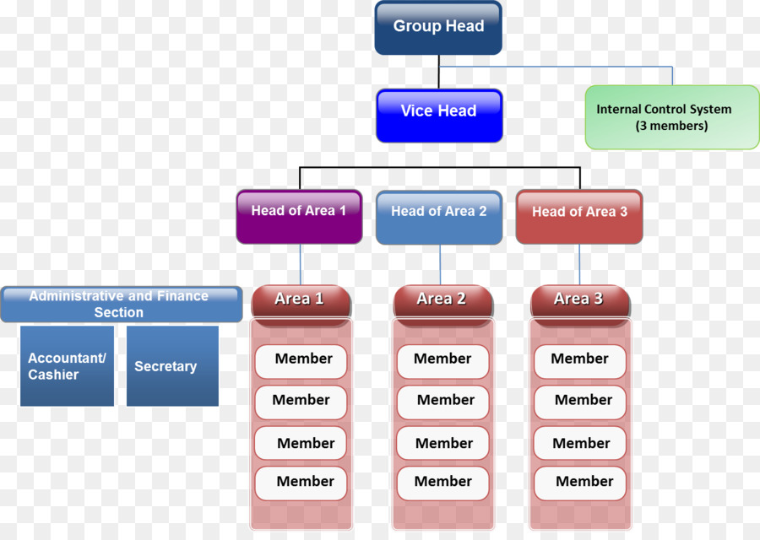

Conclusion
This study has focused on finding valuable resources and to find the use of various business plans in an organization. This report has also focused on increasing sales of the Pitha Ghor Cafe by analyzing its strength and weaknesses and helping them to identify their opportunities and eliminating threats from their way. This was done with the help of SWOT analysis method. STP analysis helps them to segment their organization and target their customers by positioning their outlets at good places. They also focus on some external factors that affect their organizations by PESTEL method. Use of four p's also helped to enhance the distribution of their products and expanding their organization all over the world. This report focuses on simplifying the business plans for the organizational and telling them the use of organizational structure in the organization.

Reference:

Akter, S., Wamba, S.F., Gunasekaran, A., Dubey, R. and Childe, S.J., 2016. How to improve firm performance using big data analytics capability and business strategy alignment?. International Journal of Production Economics, 182, pp.113-131.
Ashkenas, R., Ulrich, D., Jick, T. and Kerr, S., 2015. The boundaryless organization: Breaking the chains of organizational structure. John Wiley & Sons.
Baker, M.J., 2016. What is marketing?. In The Marketing Book (pp. 25-42). Routledge.
Burns, P. and Dewhurst, J. eds., 2016. Small business and entrepreneurship. Macmillan International Higher Education.
Bustinza, O.F., Bigdeli, A.Z., Baines, T. and Elliot, C., 2015. Servitization and competitive advantage: the importance of organizational structure and value chain position. Research-Technology Management, 58(5), pp.53-60.
Halpin, J.C., 2017. Primer on Composite Materials Analysis, (Revised). Routledge.
Jackson, G. and Ahuja, V., 2016. Dawn of the digital age and the evolution of the marketing mix. Journal of Direct, Data and Digital Marketing Practice, 17(3), pp.170-186.
McKeever, M., 2016. How to write a business plan. Nolo.
McKenzie, D., 2015. Identifying and spurring high-growth entrepreneurship: experimental evidence from a business plan competition. The World Bank.
Olson, E.M., Slater, S.F., Hult, G.T.M. and Olson, K.M., 2018. The application of human resource management policies within the marketing organization: The impact on business and marketing strategy implementation. Industrial Marketing Management, 69, pp.62-73.
Scholes, M.S., 2015. Taxes and business strategy. Prentice Hall.
Ward, J., 2016. Keeping the family business healthy: How to plan for continuing growth, profitability, and family leadership. Springer.
Winnubst, J., 2017. Organizational structure, social support, and burnout. In Professional burnout (pp. 151-162). Routledge.
Withers, P.J., Hodgkinson, R.A., Rollett, A., Dyer, C., Dils, R., Collins, A.L., Bilsborrow, P.E., Bailey, G. and Sylvester-Bradley, R., 2017. Reducing soil phosphorus fertility brings potential long-term environmental gains: A UK analysis. Environmental Research Letters, 12(6), p.063001.
Yan, Y., Chen, Z., Yue, J. and Fu, Z., 2016. STP approach to model controlled automata with application to reachability analysis of DEDS. Asian Journal of Control, 18(6), pp.2027-2036.

