ASSESSMENT 1

Table of Contents
Introduction 3
1. Description of the company and the business 3
2. Identification of Demand and Market Equilibrium 4
3. Indication of elasticity of demand 7
Conclusion 9
References 10
Appendices 12

Introduction
This study is focused on identifying the conditions of demand and market equilibrium for a product Coca-Cola of the famous soft drinks and beverage company Coca Cola Company. The study would discuss the business of the company and even its elasticity of demand in the industry.

1. Description of the company and the business
The Coca-Cola Company is a one of the leading American manufacturer and retailer of non-alcoholic beverages which is popularly known for its iconic soft drink product, Coca-Cola (Ridder, 2022). The soft drink products that are produced and marketed by the Coca-Cola Company is Diet Coke, Sprite, Minute Maid, Aquarius and Fanta. The historical origin of Coca-Cola started in 1886 when Dr. John S. Pemberton, a pharmacist from Atlanta, made a flavoured syrup having a distinctive taste. Gradually, the company was established in 1892 with its headquarters in Atlanta, GA. The Coca-Cola Company is one of the dominant players in the global beverage industry and has more than 200 bottling partners all across the globe. Coca-Cola has remained in the position of being the number one soft drink brand globally with an international brand value of around 74 billion (Rudnicka, 2022). In 2021 around one third of the revenue of the Coca-Cola Company was generated from North America. However, Coca-Cola Company’s sales growth in terms of volume is highest in the Asia Pacific region. Again, Coca-Cola Company is ranked as the leading carbonated soft drink (CSD) company in the US with a market share of around 45% in the industry. In 2021 the net operating revenues of Coca-Cola Company was estimated to be 38 billion USD. Apart from this, as of 2021, the company has a workforce of 79,000 people. One of the biggest competitors of the Coca Cola Company is PepsiCo as it holds a strong grip over a quarter of the US market. PepsiCo is also a globally popular and leading MNC operating in the food and beverage industry. The company has been owning a diverse range of household brands, such as Mountain Dew, Lays, Lipton Iced Tea and others. Coca-Cola is a very famous beverage product which has a strong global customer base that makes an analysis of its demand conditions and price elasticity factors highly important.
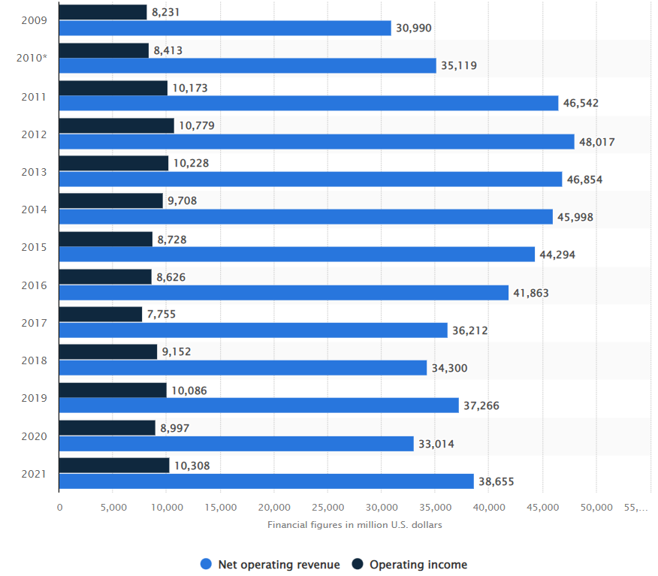
Figure 1: Key financial data of Coca-Cola between the years 2009 to 2021
(Source: Ridder, 2022)

2. Identification of Demand and Market Equilibrium
The law of demand (LD) is a very popular economic laws that provides that when other factors affecting the demand of any product in a market remains constant (ceteris paribus), a rise in the price of the product results in a decline in the amount of market demand of that good and vice versa (Cerreia-Vioglio et al. 2022). Hence, as per the LD demand and price of a good are inversely related to each other. The law explains that it is the natural choice behaviour of consumers to buy less of a good when its price is high and more when price is low as they fear going out of cash and even want to maximise their profit. Hence, the demand curve of a commodity is negatively sloped as shown in the following figure.
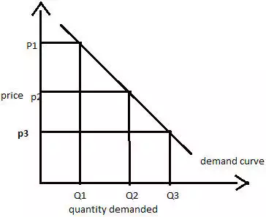
Figure 2: Demand curve of a commodity when other factors are constant
(Source: Learner)
Now, apart from that other factors that impact the demand of any commodity in a market involves Price of substitute products, income of consumers, demographic changes, Price of complementary products, future price expectations and consumers taste and preferences. On this note, the impact of these factors on the demand for Coca-Cola in the beverage industry is discussed below:
Price of substitutes
As stated by Berry et al. (2013), when two commodities substitute for each other, they have a positive relationship in terms of the price of one commodity and the demand of another. When a product has a close substitute, any change in the price of its substitute can change its demand. In the fast-moving consumer goods industry, products such as soft drinks have a high number of close substitutes. In this context, there are several soft drink brands that are offering similar beverages that are close substitute of each other (Sanchez et al. 2020). For the Coca-Cola Company, its closest competitor is PepsiCo. Hence, Coca-Cola and Pepsi substitute soft drink products for each other. Now, if the price of Pepsi rises, then people would be more likely to buy Coca-Cola which will increase the sale amount of Coca-Cola. This is because people have a low switching cost and want to buy a soft drink of same quality at low price.
Price of complements
As stated by Gabszewicz et al. (2001), when two commodities are complementary to each other, they have an inverse relationship in terms of the price of one commodity and the demand of another. In the case of Coca-Cola, it has several complementary goods such as chips and popcorn. The four when the price of popcorn will decline the demand for Coca-Cola would increase. This is because with popcorns becoming cheap people would buy more of them and consume popcorn with Coca-Cola. Therefore, this would increase the total quantity of sales of Coca-Cola within the market and increase its market demand.
Consumers Income
The effect of income of consumers on the sales of a product depends on the type of commodity (Devereux et al. 2020). In the case of normal goods such as Coca-Cola, the income of consumers and the amount of the commodity they demand are directly proportional to each other. Hence, for Coca-Cola when consumer income rises, its market demand will increase as people would have more income to spend on the consumption of any consumer goods or product. However, when the income of the consumers would decline, they would have less disposable income in their hands to spend on non-essential consumer goods such as soft drinks like Coca Cola.
Consumers taste and preferences
The demand for a good within a market is also immensely determined by the tastes and preferences of the consumers in the industry. As stated by Gowrisankaran and Rysman (2012), a good’s demand goes up in the market when the tastes and preferences of the consumers in the industry are in its favour and when a product does not match the tastes and preferences of the consumers its demand falls. Therefore, in the case of Coca-Cola, within the market where the consumers have a high taste and preference for Coca Cola and are hard core loyalists of the Coca Cola brand, the demand for Coca Cola would remain high even if its prices increase. On the other hand, in a market where people do not have any taste and preference in favour of Coca-Cola, then its demand would decrease if its price goes up.
Consumer expectation of the future price of a product
The expectations that consumers within a market have regarding the future price of a commodity is also a crucial player in determining its current market demand (D’Acunto et al. 2021). It has been identified that, when consumers expect that the price of a commodity is likely to increase in future, they have a higher tendency of buying it at present to save cost. Therefore, under such situation the overall market demand for that commodity increases. However, if the consumers expect the price of a product to fall in future, they would demand it less in present which would bring down the market demand of that commodity. On this note, when the consumers would expect the price of Coca Cola to fall in future, they would demand it less in the present which would bring down the market demand of Coca Cola in the present.
Demographics
The changes in the demographic conditions of a country is likely to impact the demand of different commodities that are demanded within the economy (Bielecki et al. 2022). For instance, when a country has a large ageing population, the demand for various commodities that are used by elderly increases. On the other hand, when the majority of the population of a country is composed of the younger generation, demand for commodities that are consumed by youngsters increases. In the case of Coca-Cola, the target customer segment of this product is people from all the age group, income group and gender. Therefore, when the population of a country in which the company is selling its product increases, the demand would increase. The age group, the income group, age group, gender or any other demographic category would not impact the market demand of Coca Cola.

3. Indication of elasticity of demand
Price elasticity (PE) of demand of a commodity measures the extent of change in its consumption in the context of a given change in its price (Jawad et al. 2018). A good is found to be perfectly elastic when its PE is infinite meaning that its demand changes immensely even with minute price change. Now, when PE is more than 1, the commodity is elastic; when PE is less than 1, the commodity is inelastic (Refer to Appendix 1). Again, a good’s PE is 0 meaning that it doesn't change at all with any amount of price change, it has perfectly inelastic demand. Finally, when PE is equal 1 meaning the percentage price change is equivalent to the percentage demand change, it has unitary PE. As per the views of Fridstrøm and Østli (2021), when a price change for a commodity leads to significant change in its supply in market or its demand in market, it is viewed to be price elastic in demand. In General, it means that such a commodity has many acceptable substitutes and is a normal good. Hence, Coca Cola has many substitutes and has elastic demand. When a price change for a commodity doesn't change its supply or demand, it is viewed to be price inelastic. In general terms, it means that the product is a necessity good or a luxury good for addictive constituents. For instance, milk, sugar, gasoline and iPhones. As per the views of Jawad et al. (2018), knowledge of the PE of demand of a commodity allows its producers to make informed decisions regarding its pricing strategy. This metric helps sellers to get information regarding the consumer pricing sensitivity. Thus, commodities with elastic demand cannot be sold at higher prices but need to be sold at competitive market prices to deal with substitutes. This is the reason why Coca-Cola has adopted a competitive pricing strategy. The PE of demand curve of Coca-Cola is shown in the following figure.
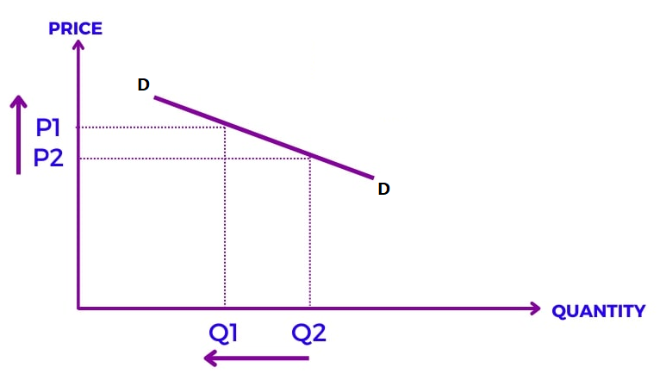
Figure 3: PE of demand curve of Coca-Cola
(Source: Learner)
Income elasticity (IE) of demand of a commodity measures the extent of change in its consumption in the context of a given change in consumer income (Dong et al. 2019). In the case of highly elastic goods, the quantity demanded of such goods changes significantly with changes in income, while in the case of inelastic goods the same quantity of the commodity will be demanded even if there is consumer income change (Refer to Appendix 2). In this context, Normal goods have a positive IE of demand. Thus, as the income of consumers rises, the goods are demanded more in the market at each price level. Hence, in the case of Coca-Cola, it is a normal good. Therefore, when the income of the consumers within the market increases, there is an increase in the demand for Coca-Cola as people have more disposable income in their hand to consume a non-essential commodity like Coca-Cola. On the other hand, when the income of consumers in the market falls, their purchasing power declines as they have low income at their disposal to spend. This brings down the market demand for Coca-Cola.
The cross elasticity (CE) of demand of a commodity measures the extent of change in its consumption in the context of a given change in the price of another good (Fridstrøm and Østli, 2021). The CE of demand in case of substitute commodities is always positive. This is due to the fact that the demand for one commodity rises when the price of its substitute commodities increases. Likewise, the CE of demand in the case of complementary commodities is negative (Refer to Appendix 3). This is due to the fact that the demand for one commodity rises when the price of its complementary commodities falls. Companies make use of the information about the CE of demand of goods to determine their selling prices. It is possible to set high prices for Products that have no substitutes due to the fact that there is no CE of demand to consider. On the other hand, products which have several close substitutes cannot be sold at higher prices. This is because of the availability of many substitutes in the market which calls the consumers to buy the product of a brand which is offering the same quality but at a lower price (Jawad et al. 2018). consumers always have the tendency of maximising their utility by paying the lowest possible price for the best possible product. Therefore, the price of Coca-Cola is competitive and not set at a very high price.

Conclusion
The study has identified that Coca-Cola is a normal good with many substitutes in the industry. The product has an elastic demand in the market due to which any slight change in its price impacts its demand immensely as there are many substitutes of this product. Hence, Coco-Cola makes use of a competitive pricing strategy to compete in the industry which is highly competitive.

References
Berry, S., Gandhi, A. and Haile, P., 2013. Connected substitutes and invertibility of demand. Econometrica, 81(5), pp.2087-2111.
Bielecki, M., Brzoza‐Brzezina, M. and Kolasa, M., 2022. Demographics, monetary policy, and the zero lower bound. Journal of Money, Credit and Banking.
Cerreia-Vioglio, S., Maccheroni, F., Marinacci, M. and Rustichini, A., 2022. Law of demand and stochastic choice. Theory and Decision, 92(3), pp.513-529.
D’Acunto, F., Malmendier, U., Ospina, J. and Weber, M., 2021. Exposure to grocery prices and inflation expectations. Journal of Political Economy, 129(5), pp.1615-1639.
Devereux, S., Béné, C. and Hoddinott, J., 2020. Conceptualising COVID-19’s impacts on household food security. Food Security, 12(4), pp.769-772.
Dong, K., Dong, X. and Sun, R., 2019. How did the price and income elasticities of natural gas demand in China evolve from 1999 to 2015? The role of natural gas price reform. Petroleum Science, 16(3), pp.685-700.
Fridstrøm, L. and Østli, V., 2021. Direct and cross price elasticities of demand for gasoline, diesel, hybrid and battery electric cars: the case of Norway. European Transport Research Review, 13(1), pp.1-24.
Gabszewicz, J., Sonnac, N. and Wauthy, X., 2001. On price competition with complementary goods. Economics Letters, 70(3), pp.431-437.
Gowrisankaran, G. and Rysman, M., 2012. Dynamics of consumer demand for new durable goods. Journal of political Economy, 120(6), pp.1173-1219.
Jawad, M., Lee, J.T., Glantz, S. and Millett, C., 2018. Price elasticity of demand of non-cigarette tobacco products: a systematic review and meta-analysis. Tobacco control, 27(6), pp.689-695.
Ridder, M., 2022. Revenue and financial key figures of Coca-Cola 2009-2021. Statista. Available at: https://www.statista.com/statistics/264423/revenue-and-financial-results-of-coca-cola/ [Accessed on 10th December 2022]
Ridder, M., 2022. Revenue distribution of the Coca-Cola Company worldwide 2021, by operating segment. Statista. Available at: https://www.statista.com/statistics/271136/coca-colas-revenue-distribution-worldwide-by-operating-segment/ [Accessed on 10th December 2022]
Rudnicka, J., 2022. Coca-Cola Company - statistics & facts. Statista. Available at: https://www.statista.com/topics/1392/coca-cola-company/#topicHeader__wrapper [Accessed on 10th December 2022]
Sanchez, J., Abril, C. and Haenlein, M., 2020. Competitive spillover elasticities of electronic word of mouth: an application to the soft drink industry. Journal of the Academy of Marketing Science, 48(2), pp.270-287.

Appendices
Appendix 1: Price elasticities of demand
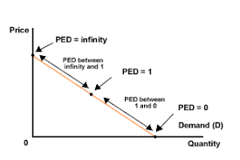
(Source: https://www.google.com/url?sa=i&url=http%3A%2F%2Fwww.sanandres.esc.edu.ar%2Fsecondary%2Feconomics%2520packs%2Fmicroeconomics%2Fpage_71.htm&psig=AOvVaw1ay_03gvRNaMXZqk0uHAKb&ust=1671466389732000&source=images&cd=vfe&ved=0CAMQjB1qFwoTCICJ9dXHg_wCFQAAAAAdAAAAABAE)
Appendix 2: Income elasticities of demand
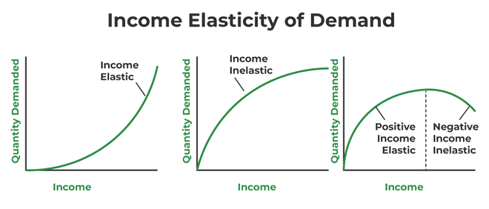
(Source: https://www.geeksforgeeks.org/income-cross-elasticity-of-demand/)
Appendix 3: Cross elasticities of demand
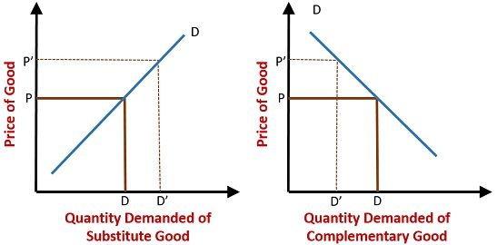
(Source: https://www.google.com/url?sa=i&url=https%3A%2F%2Fkeydifferences.com%2Fdifference-between-substitute-goods-and-complementary-goods.html&psig=AOvVaw0CQMX8m5Asjy_qdC1-LAE1&ust=1671467090434000&source=images&cd=vfe&ved=0CAMQjB1qFwoTCJj79KPKg_wCFQAAAAAdAAAAABAE)

