MANAGING GUEST SERVICE OPRRATIONS
Placement Journal Marriot Hotel Leicester

10/03/2023
Susana Da Cunha Balinha (2016797)
Module code: BMIH6003 Lectures: Dr Jayne Griffith-Parry & Robyn Griffith
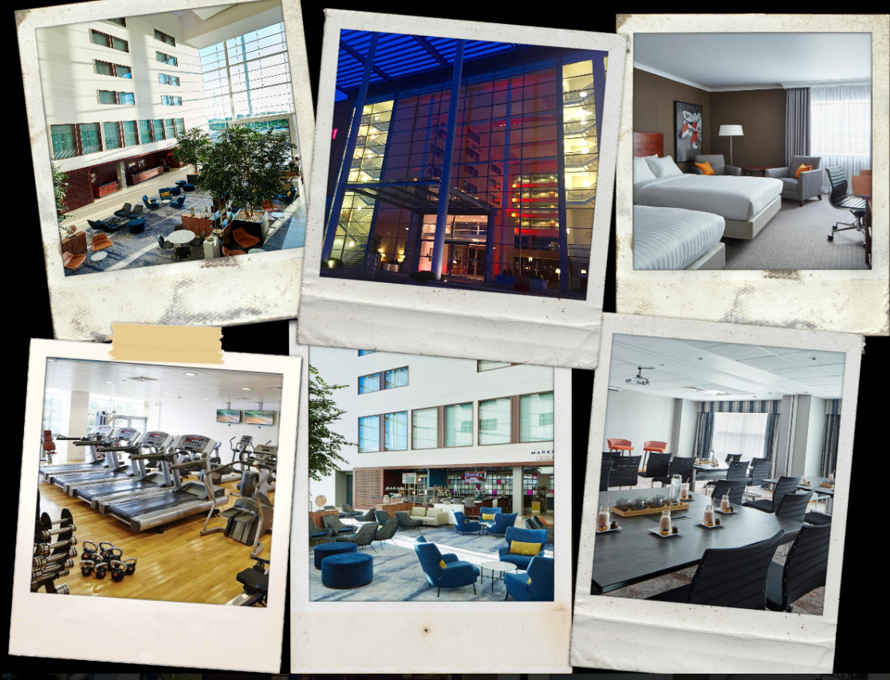
The present journal was written within the scope of the work placement carried out with the induction date on the 9th of January ongoing at the Marriot Leicester Hotel (2023), a 4 stars hotel with a nice environment for a casual, party, or business function.
The document aims to describe several activities carried out on the placement. Furthermore, some other benefits can be gathered from the experience, according to Indeed Editorial Team, (2022) and Brooks & Youngson, (2014 ). There are numerous ways to gain experience through the placement; it help us develop our skills, as well as use our expertise and backgrounds, it can also help us build connections and clarify our career goals, the experience gain can be rewarding and, prepare myself for a future job by allowing me to upgrade my CV to be more employable.
Furthermore, three distinct areas will be mentioned in this journal, as part of the Meeting and events the experience was made thru the department C&B, which will also cover the area of housekeeping and front office, fourth department would be the leisure club however regarding this one is not much to describe as per result of covid this department closed 90% of its activities leaving only the gym working what any of the guests are welcome to use. This information was obtained internally and by the negative reviews left by some customers, however, Marriot fails when omitting this information from its clients leaving some of them frustrated and leaving a bad review (Swimming.org and TripAdvisor, 2022).

C&B
C&B 3 weeks placement.
I had a very welcoming start and I shadow Liga the supervisor most of the day and had the opportunity of questions about the department. The management team is formed by Celestino the manager, Suzanne, Carl, and Liga supervisors.
The C&B department does cover 21 meeting rooms where the 2 biggest ones are downstairs and the remaining ones on the 1st floor those are utilised for a wide range of outstanding events, including weddings, conferences, and mainly business meetings, I have managed to gain some extra expertise with a variety of events occurring, including how to set them up, get ready for them, and operate them (Marriott, 2023). The setups are also by the standard as it is shown in Pict 1 and for each customer exists a BO that specifies the kinds and amounts of breaks to be served, along with any pertinent details on delivery, setup, and clean-up ( Boley, 2020). The banqueting order is used to make sure that all preparations are completed and that the event goes off without a hitch for that each evening a board is prepared for the next morning with all the upcoming meetings Pict 2 and shows the staff timings for the customer breaks with 30 minutes advantage to make sure is all served in time. In quieter times loads of polishing and preparations are made in advance for the busiest times.
In the setup of each room to start with it has to be filled up with glasses and one jar of water and a brief-case with pens, control and click share to connect the laptop, at the same time, the small break lounge always has to be filled up with tea coffee milk flavoured water and biscuits. Pict 4
For the customers' breaks in this department, there are a few aspects of the food and beverage service, such as plated service sandwich meals however most of the clients have their main meals at the restaurant, Market kitchen, however, most of the small breaks are provided from the kitchen even the ones that no need cooking. Pict 3
One of the biggest issues found in this department it is the small number of full-time staff, the majority of them are part-timers and for this reason, many of them do not really make their jobs as meant to.
Pict 1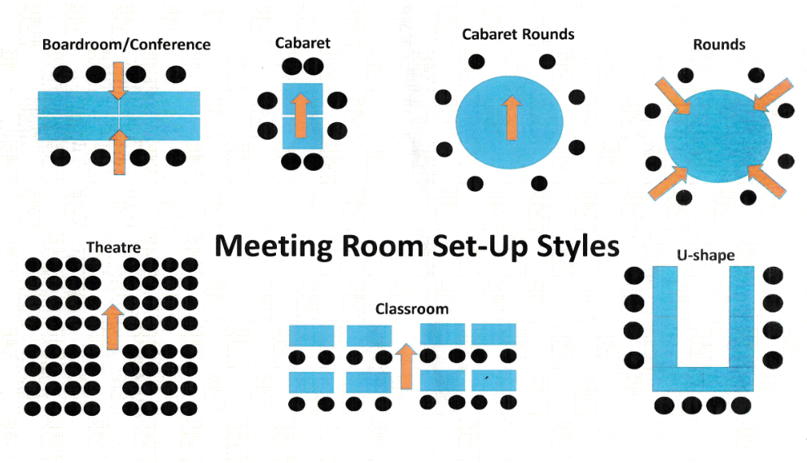
Pict 2 Pict 3
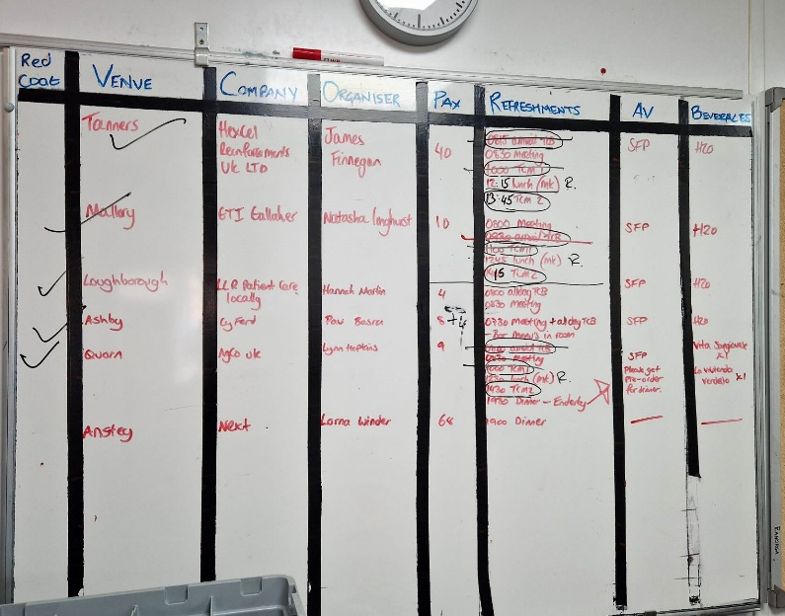 | 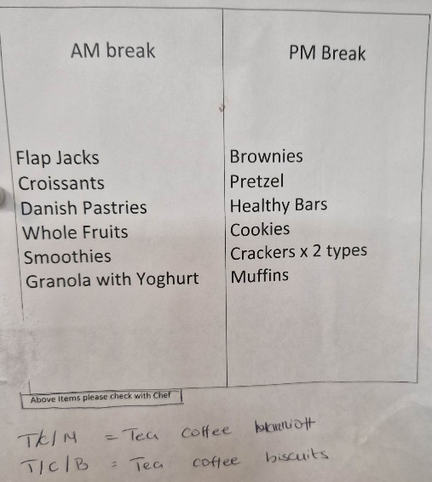
Pict 4 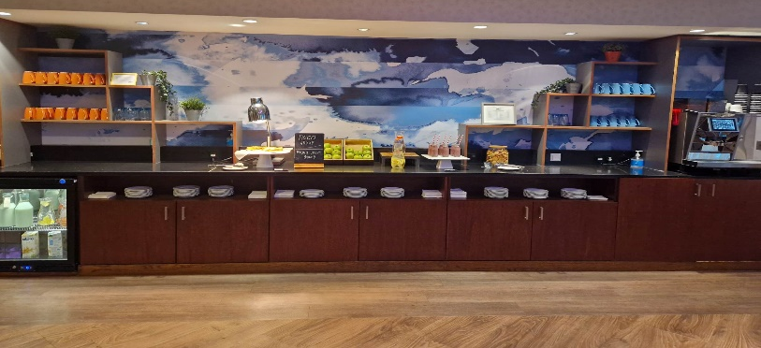
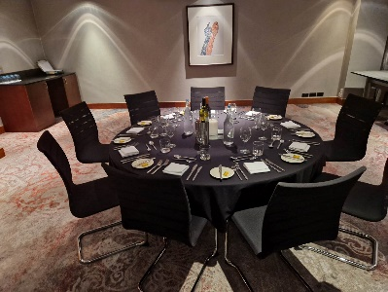 | 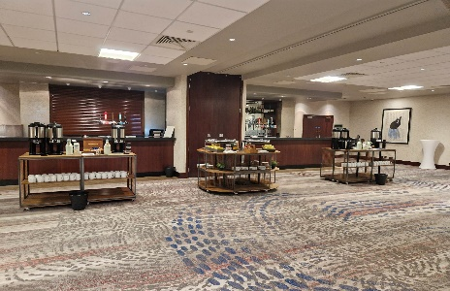 | 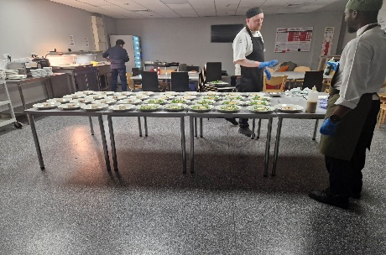

F.O.

For one day only I had the opportunity to shadow in Front office. Diana, the assistant manager, and other F.O. colleagues demonstrate to me that this department has a crucial role in delivering exceptional customer service and ensuring the smooth operation of the hotel. There are various tasks that this department is responsible for but may the most important one is to ensure guest satisfaction.
The front office team is also responsible for guest check-in and check-out, managing reservations ( not made them, as this is made by the sales department team), and coordinating with other departments to ensure guest needs are met. The front office team must possess excellent communication and interpersonal skills to build a connection with guests and ensure their needs are met, (Kennedy, 2020).
Some daily steps are crucial to the functioning of the day and the satisfaction and fulfilment of the guests.
Tasks for all colleagues at F.O. and management
- Sign in to GXP platform that provides digital experiences to their guests, (IRIS, n.d.). this platform also informs any “Ambassador” guests that may arrive (guest members that often stay with Marriott).
- Sign in in OPERA, the hotel PMS, and divide the daily jobs by the colleagues
- Every two hours need to be printed the “downtime reports” where is a paperback backup system in case anything happens
- Respond to any TripAdvisor and Expedia reviews or questions, as these sites only sell the occupancy and leave it to our colleagues to answer any questions or requests
- Login to Guestlink, to see all the bookings and make sure they are on OPERA. However, to be changed as information from Guestlink website (2023) this system will cease on 31st march 2023
- Print updates for the 10@10 meeting.
- Do check-in, normally start after 2 pm, and check-out until 11 am, complementary stay is available for £10 p/h (Booking.com, 2023).
- Always check if the guest is a Marriott Bonvoy customer, if not invite them to join as a member, and if it is welcome them back.
The colleagues have incentives, competition between them which make them feel more motivated in their jobs. Staff incentives have been identified as one of the most important factors that influence employee motivation and job satisfaction (Naile & Selesho, 2014).

Housekeeping

Housekeeping 3 weeks placement

The housekeeping department has under its wing 227 rooms and all public area, (Marriott, 2023)
This was a valuable experience, during this time there, I was shadowing, to start some other colleagues in different areas, starting with public areas where been show all the steps to follow, this area is one of the most important because is access to all the guests, the face of the hotel, following for the cleaning of the rooms, for 3 days I follow some different colleague’s and had the opportunities to help but also to observe the different ways that everyone works. Most of the colleagues that work for the hotel are self-checkers, which means that after cleaning they can call the system and put the room thru as available, or any other status that the room may have, however, there are many agency workers and for those, they will have the supervisor, manager of a competent colleague to check their room. This was another job that I could witness and help with, for the rest of the days I could shadow Claudia, the supervisor, and Mr. Dickson the manager by checking the rooms. The most issues we identify when checking the rooms were items in the fridges, rubbish in the bins, towels behind the doors of the toilets.
Moreover, the hotel does not have laundry so one colleague is responsible to receive and distribute laundry for the stock rooms around the hotel, also guests can request laundry for the day if the item is put on before 9 am.
From the management side of HSK.
- Every morning a list is made for each staff member with the number of rooms to clean
- Agency used is Indeed
- Weekly requests for agency members have to be requested by email to admin and explained the amount of staff needed
- A WhatsApp group is used for communication between the team
- Daily discrepancy forms were made for the issues that occurred with the rooms
A very miss concept from other departments is that when something needs to be cleaned HSK is the department to run to when everyone should be responsible for their departments.
In conclusion, this experience, help me capture a lot of the essence of the hotel and its management in general, even though they never did inquire about my experience in management or customer service skills, however, eventually, they get me some value even offering me a job if interested as my performance did exceed their expectations according with either C&B and Housekeeping management Donald et al. (2019) suggest that people are different after experiencing transformational learning and that this difference is recognisable by others and the individual themselves.

Key Words
- C&B conference and banqueting
- F&B food and beverage
- F/O front office
- W/C week commencing.
- BO banqueting order
- GXP- Guest Experience Platform
- HKP housekeeping

Reference

Boley, M. (2020) Banquet event orders for venues: Everything to know about beos, Banquet Event Orders for Venues: Everything to Know About BEOs | Cvent Blog. Available at: https://www.cvent.com/en/blog/hospitality/banquet-event-order (Accessed: February 28, 2023).
Brooks, R. and Youngson, P.L. (2014) “Undergraduate work placements: An analysis of the effects on career progression,” Studies in Higher Education, 41(9), pp. 1563–1578. Available at: https://doi.org/10.1080/03075079.2014.988702.
Donald, W. E., Baruch, Y., & Ashleigh, M. (2019). The undergraduate self-perception of employability: Human capital, careers advice, and career ownership. Studies in Higher Education, 44(4), 599-614.
Guestlink (2023) Guestlink. Available at: https://www.guestlink.co.uk/ (Accessed: March 9, 2023).
Indeed Editorial Team (2022) How to get work experience (with tips) | indeed.com UK, What are work placements? (And the benefits of doing them). Available at: https://uk.indeed.com/career-advice/finding-a-job/work-experience (Accessed: February 19, 2023).
IRIS (n.d.) Work with US – IRIS hospitality GXP Technology, IRIS Guest Experience Platform. Available at: https://www.iris.net/careers#:~:text=The%20IRIS%20Guest%20Experience%20Platform,their%20guests%20and%20their%20staff. (Accessed: March 8, 2023).
Kennedy, D. (2020) How to help your front desk colleagues overcome "compassion fatigue": By Doug Kennedy, Hospitality Net. Hospitality Net. Available at: https://www.hospitalitynet.org/opinion/4096524.html (Accessed: March 8, 2023).
Marriott (2023) Leicester Function Rooms - meeting venues: Leicester Marriott Hotel, Leicester Function Rooms - Meeting Venues | Leicester Marriott Hotel. Available at: https://www.marriott.com/en-gb/hotels/emalm-leicester-marriott-hotel/events/ (Accessed: February 18, 2023).
Marriott (2023) Leicester Marriott Hotel, Marriott International. Available at: https://www.marriott.co.uk/hotels/travel/emalm-leicester-marriott-hotel/ (Accessed: February 19, 2023).
Swimming.org (no date) Poolfinder: Marriott Leisure Club (Leicester), Swimming.org. Available at: https://www.swimming.org/poolfinder/pools/1003297/Leicester/Marriott+Leisure+Club+%28Leicester%29/ (Accessed: February 28, 2023).
Tripadvisor (2022) Review: Great hotel, terrible restaurant, swimming pool gone. - Leicester Marriott Hotel, Enderby, Tripadvisor. Available at: https://www.tripadvisor.co.uk/ShowUserReviews-g2147907-d596422-r838087763-Leicester_Marriott_Hotel-Enderby_Leicester_Leicestershire_England.html (Accessed: February 28, 2023).
Booking.com (2023) ★★★★ Leicester Marriott Hotel, Leicester, UK, Booking.com. Available at: https://www.booking.com/hotel/gb/leicester-marriott.en-gb.html?aid=2172952&label=1c19d81e-e0bb-429e-9b7f-c9b0415df74b&sid=ec34a227c2a884651be9ab3b67078f34&all_sr_blocks=3689313_95159673_0_2_0%3Bcheckin&#hotelTmpl (Accessed: March 9, 2023).
Naile, I., & Selesho, J. M. (2014). The role of leadership in employee motivation. Mediterranean Journal of Social Sciences, 5(3), 175-182. doi:10.5901/mjss.2014 .v5n3p175

