Lydia Smith: p141878
digital marketing – e-marketing communication
  - Case Study: AirAsia

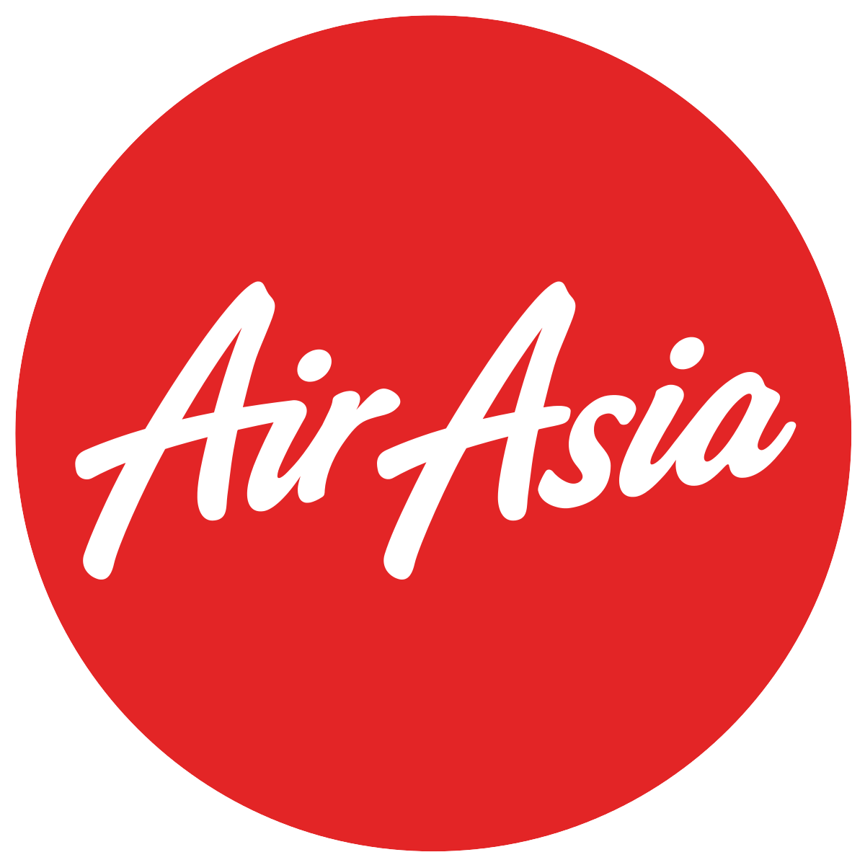

Contents
1. Aim of the report 2
2. E-marketing 3
2.1 Advantages of E-Marketing 3
2.2 Disadvantages of E-Marketing 4
2.3 Internet Marketing Tools 4
3. Air asia 6
3.1 Company Goals 7
3.2 Air Asia Social media 8
4. AirAsia - Facebook 10
4.1 So why use Facebook? 11
4.2 Is Facebook suitable for the target audience (RACE ANALYSIS) 13
4.3 Social Media Alignment (AIDA) 15
5. E-MARKETING plan 17
6. References 19

Aim of the report
To critically evaluate the use of E-marketing; in this case social media and the impact it has on an organisation, to make recommendations of how to utilise digital marketing efficiently.
- Understand how E-marketing can maximise sales.
- Investigate the drivers and challenges associated with social media use, particularly Facebook.
- Use theory and framework to make recommendations to Air Asia of how to improve their Facebook channel of communication.

E-marketing
What is it? Emarketing is the marketing of products or services over the internet. The terms e-marketing, internet marketing and online marketing often interchange and are considered synonymous (Chaffey and Smith, 2013).
Why do we use it? Access to the internet has grown at an excessive rate over the last 10 years, meaning the potential to market to millions of people has become very possible (The Guardian, 2017). Access to the internet can be commonly found on a desktop computer or a handheld device. There are multiple digital marketing platforms that can be used to target people using the internet, these can be on: Desktop browser, desktop app, email and video marketing. In recent years social media has become one of the most popular digital marketing tools due to its growth, they can be collectively classified as ecosystem platforms to reflect their supporting interfaces and tools (Smith and Chaffey, 2013).

2.1 Advantages of E-Marketing
- Very low risk
- Decreased marketing costs due to automation and use of electronic media
- Faster response to customers
- Increased ability to collect data and feedback
- Increased exposure of product or service
- Universal accessibility (Traffic.com, 2017)

2.2 Disadvantages of E-Marketing
- Dependent on technology
- Security risk
- Increased competition on price
- Maintenance cost of platforms (Traffic.com, 2017)
Given the scale and benefits of E-Marketing and what it can offer its businesses and their customers, it will be a big part of all businesses in the future (Chaffey and Smith, 2013).

2.3 Internet Marketing Tools
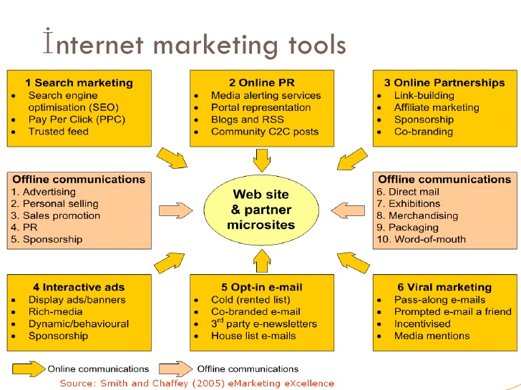
There is a large collection of tools a business can choose from to market its product or service online, Smith and Chaffey, 2005 identified these tools into six categories (See below for figure 1).

This report will focus on the social media side of E-marketing, marketing on these platforms can be a form of media alert service, RSS feed, sponsorship, affiliate marketing, display banners and or media mentions. These tools can be used individually on different social media sites to attract a person to buy a product or service from said company. It is in the goal of companies to attract customers through social media directly to their website for purchase as opposed to older techniques such as SEO (Doyle, 2011).

Air asia
The case study selected is Air Asia. This section will include company background and their aims and goals to grow the company further, including a snap shot of their social media activity.
Air Asia is a Malaysian low-cost airline head- quarted near Kuala lumpur, Malaysia. Founded in 1993, and owned by CEO and co-founder Tony Fernandes since 2001.
- Largest airline by fleet and destinations in Malaysia
- Slogan – ‘’Now Everyone Can Fly’’
- Domestic and international flights to 165 destinations spanning 25 countries
- Sister companies include, Thai AirAsia, India AirAsia and AirAsia X
- AirAsia operates at the world’s lowest unit cost of $0.023 per available seat per kilometre
- AirAsia has hedged the next 3 years of fuel consumption
- ‘’Conquering the Asian market, no competition is close in comparison’’ (Head of PR AirAsia, 2017).
- AirAsia sponsor Queens park rangers and most recently UFC - a multi- million-dollar company

3.1 Company Goals
AirAsia vision is ‘To be the largest low- cost airline in Asia to serve the 3 billion people who are currently undeserved with poor connectivity and high fares’ (AirAsia, 2018). To achieve their vision, they adhere to these objectives and values:
Objectives:
- Create a globally recognisable ASEAN brand
- To attain low cost so that ‘everyone can fly with AirAsia’
- To embrace technology to reduce costs
- Maintain the highest quality product
They live by these values:
- Safety: the guest’s safety is their main priority
- Caring: care for the guests in a way that makes them feel at home
- Passion: going the extra mile to achieve a purpose much large than ourselves, passion can change the world and that’s something that they hold close
- Integrity: ‘everything that is worth doing is worth doing right’.
- Hardworking: One team working together towards a common goal
- Fun: To celebrate life and share ideas and solutions to making things better
(AirAsia, 2018)

3.2 Air Asia Social media
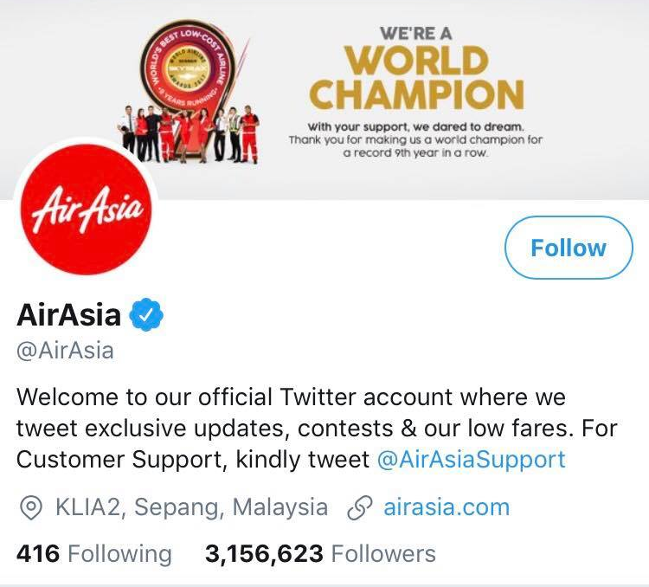
Figure 2. Twitter

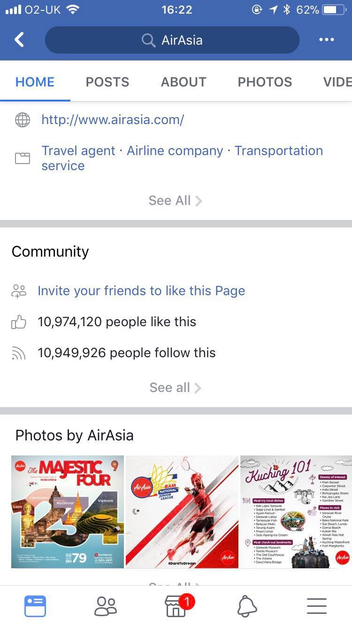
Twitter: AirAsia have 3,156,623 followers in comparison to their competitors Malindo Air who have 25,800 followers (Twitter, 2018).
Figure 3. Facebook

Facebook: Their Facebook following is by far the highest of their social media accounts reaching nearly 11million followers and posting up to 8 times a day, in comparison to another competitor Malaysian airlines who has 2.1million followers/ likes and only posts 4 times per day.
Instagram: Instagram is taking off in the industry of tourism, especially amongst the younger market, AirAsia opened their account in 2015 and has achieved 522,000 followers in that time.
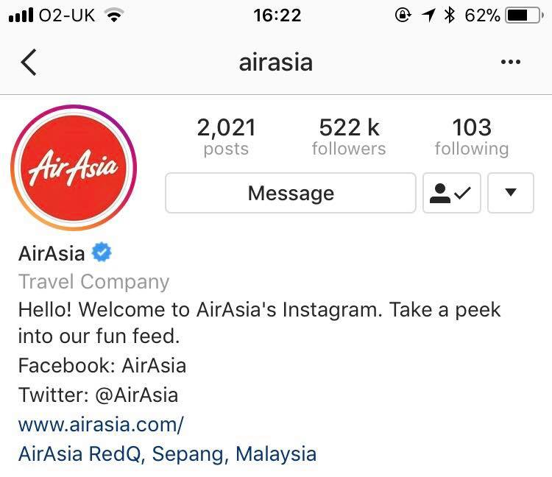
Figure 4. Instagram

Snapchat: There was an attempt made by the researcher to monitor the companies snapchat account however it seems it is currently not being used.
AirAsia social media following is much higher than that of its competitors Malindo Air and Malaysian Airlines. (122 times bigger on Twitter and 5 times as high on Facebook). From the statistics, it is clear to see that Facebook is used more by its customers than any other media. For this report, Facebook will be the main interest.

Airasia - Facebook
AirAsia strongly agrees that social media is playing an important role in driving sales and enhancing the consumer brand, so it can be trusted and valued (AirAsia, 2018). Their Facebook following of 11million is of the highest of all its competitors in Asia. At a meeting at the HQ in Kuala Lumpur in December 2017 the researcher learnt that the company is dominating the Low- cost market in Asia and doesn’t feel under threat from its current competitors. AirAsia mission is to grow a globally recognisable brand which they are effectively pursuing through Facebook (AirAsia, 2017).
Good use of Facebook:
- Share on average 8 posts per day
- Update customers on passenger updates, new routes, deals/offers and other travel news/ goals.
- They encourage sharing and tagging, through the use of competitions with some posts been shared up to 10,000 times.
- Visually the brand consists of a solid theme, which flows throughout every post, picture, video and event notice.
Problems occurring:
- Negative comments on posts made public

4.1 So why use Facebook?
Advantages:
- Have over 1 billion users
- Custom page design to attract through visuals
- Engagement, Facebook is ideal for showcasing a product or service, followers will see posts and can then share to friends leading to increased exposure. (Tiago and Verissimo, 2014)
- Facebook advertising platform, to target any demographic, by age, sex or location, this platform is an excellent means to directly targeting any audience
Disadvantages:
- Time and Resources, the bigger the company the more staff needed to run Facebook to ensure posts are responded to in good time
- Social media is a powerful modern marketing tool which must be monitored by someone of experience to ensure the companies vision shines through correctly.
- Reputation of company could be destroyed if complaints are not dealt with as they can be posted in the public eye on any post
(TheimpactofFacebook, 2017)

It has been disputed by many that Facebook is the more powerful and popular social media choice for businesses (FinancialTimes, 2017). It entirely depends on the nature of the business when choosing which social media channel to focus on, however it is sensible to attract more customers by utilising all social media platforms (Tiago and Verissimo), more effort should be focused on the platform that has the most followers. Figure 5. Facebook in comparison to other Social Media Platforms.
 | Advantages | Disadvantages
Facebook | 1 billion daily active users  Not limited to video size  Direct targeting through advertising platform | Photos/ videos now being shared on Instagram instead
Instagram | 500 million active users  Higher percentage of engagement  95 million photos shared per day | Limited to 15 second video  Less advertisement opportunities
Twitter | 284 million monthly users  Create customer alerts to keep them up to date | Post frequency, some followers put off by lack of or too many posts  Limited message size
Snapchat | Target large youth market – 71% under age of 34 | Low advertising opportunity  Expensive Ads start at $10k per month
(Entrepreneur.com, 2017)

Facebook has more than double the active users of any other social media channel and has a direct platform to target the target audience. Instagram however has been proven to have a higher percentage of engagement with its viewers sharing a total of 95 million photos per day proving it is growing in reach. Twitter is massively limited by the message size of its posts as it limits companies on making full announcements. Overall Facebook is the more sensible choice, with a bigger audience at reach with an advertising platform at hand to attract the correct demographic. Though they already do AirAsia should make a strategic plan to further grow their Facebook following, maybe starting a Europe to Asia campaign to attract more consumers from the international market.

4.2 Is Facebook suitable for the target audience (RACE ANALYSIS)
The target audience of AirAsia has been identified as: middle class earners and young adult’s due to the pricing strategy. They have 11 million followers on Facebook the most of all their social media sites, therefore this must be a suitable platform for the target audience to use. The researcher has conducted a RACE analysis (Smith and Chaffey, 2013) to evaluate how AirAsia are using Facebook to connect with their target audience.
Reach – They have 11 million followers on Facebook so they are reaching the target audience, to reach further they need to focus on advertising opportunities based on their search engine and exploit current followers through competition initiatives.
Act- increase the option for consumer to engage with the brand, they have done this well through sponsorship opportunities, they should exploit this through the media. For example, AirAsia recently sponsored UFC, UFC is a multi- million-dollar company with millions of fans, more sponsorship stunts would increase awareness of the brand.
Convert – Further enforcement of the brands slogan/ campaign ‘Now Everyone can fly’ will help convert the idea of a flight into a reality, when the strategy was first released sales increased in line with new flights to different destinations. To enhance the brand AirAsia could target a new market further afield than Asia to encourage backpackers and western travellers to use the service domestically when visiting Asia. Head of PR for AirAsia said that AirAsia were not looking to advance into the European market for flights’ this being said they should still be targeting the millions of travellers who visit Asia every year.
Engage – encourage loyal customers to act as advocates for the company by sharing and mentioning AirAsia posts on Facebook, they could be offered rewards/ discount for putting forward a new customer. Keeping the customer engaged through the use of attracting visuals is important – the AirAsia brand does this well, it just needs to sell itself to a larger market of travellers who travel in and out of Asia. Once the brand has been established online globally the company should look to explore into the market outside of Asia, if the brand can gain awareness it can grow into new markets.
To summarise: Facebook has many advantages as a marketing tool and has the most reach in comparison to other channels, boasting 1 billion active daily users. AirAsia utilise their Facebook efficiently by posting up to date content 8 times daily, to their 11 million followers / consumers. Further and continued engagement with its followers should increase interest and desire with the consumer which may lead to more sales in short and long-term.

4.3 Social Media Alignment (AIDA)
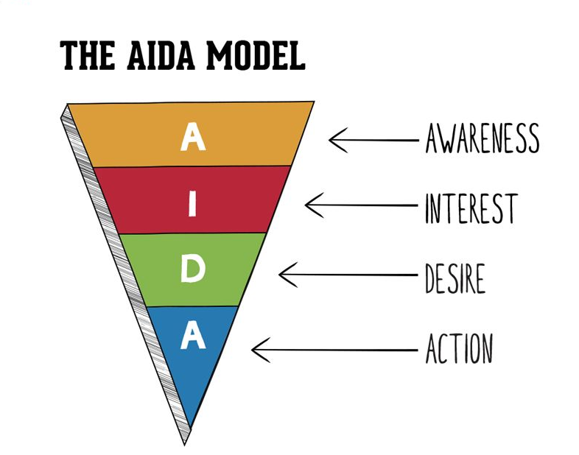
Figure 6. AIDA marketing model (Doyle, 2011).

The AIDA model can be used to evaluate how the company is turning awareness into action, it can be used to break down company objectives by category to see if they align with the company’s social media activity.
Awareness- AirAsia create awareness through initiatives such as sport sponsorship, sustainability projects etc. They should utilise these awareness opportunities as often as possible so they can reach newer audiences that fit their demographic for sale. Facebook is a brilliant tool to share new projects the company is investing in, as this may encourage the consumer based on their shared interests with the company. Creating awareness of the brand in the western world should be of importance to AirAsia in line with their objective of creating a globally recognisable ASEAN brand. Social media is the perfect communication channel to showcase low cost promotions and new announcements.
Interest – To increase interest AirAsia has expanded its flight network to New Zealand and Australia and adds new domestic flights throughout Asia incrementally throughout the year. They should increase interest in areas where they plan to travel months in advance through individual Facebook campaigns so they can use the advertising platform to attract the target audience.
To keep the interest of its consumers and 11 million Facebook followers Air Asia need to continue to exploit Facebook as a marketing tool by posting news and regular deals to maintain their objective of making flying cheap for everyone.
Desire – to encourage the consumer into wanting to purchase that product you have to sell the brand by its best points. AirAsia inform its consumers of awards they have won through Facebook to sell themselves as a great quality product to encourage people to want to buy a ticket, ensuring a great quality product and service is a main mission for AirAsia.
Action – AirAsia encourage purchase through seasonal offers and often sell some flight tickets for free as a publicity stunt (BBC, 2017). Initiatives alike these should be utilised as much as possible to further encourage people to fly with AirAsia and remain loyal customers.
In summary, it is clear through the evaluation of AIDA that AirAsia aligns its social media activity with its company’s goals and mission.

E-MARKETING plan
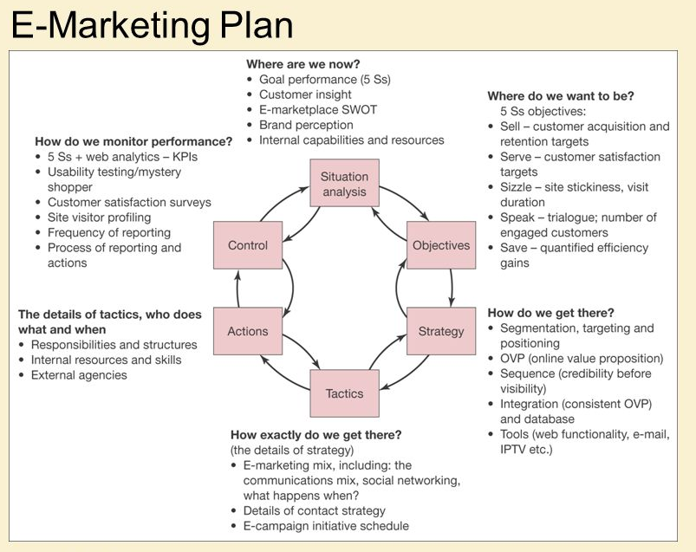
Figure 7. SOSTAC generic E-Marketing plan (Smith, 2011).

The objectives were set: To grow a globally recognisable ASEAN brand, to remain low- cost so that everyone can fly and to provide a high-quality product/ service which Is enforced on consumers through public posts – ‘Now everyone can fly’.
The strategy to achieve these objectives was to utilise initiatives such as sponsorship to create awareness and by connecting more destinations through new routes, this information is shared on Facebook platform when relevant.
Tactics were used in social media i.e. Facebook campaigns to encourage people to purchase tickets for new destinations at a very low price.
Actions taken to produce up to date material on Facebook are working.
Monitoring Facebook clicks through web analytics can help the company collect information about the consumers habits. They can also monitor customers feedback through Facebook posts answering any concerns that may arise to protect the image of the company.
Situation Analysis: So where are AirAsia now?
- Reaching capacity goals on most flights due to promotional initiatives sold through Facebook
- Investing in sustainable and community projects to further their brand image to appeal to new demographics.
- The brand is still very Asian, they need to focus on appealing to the western market as millions of international consumers travel to and from Asia every year.
Recommendations to improve Facebook channel of communication further:
- Appeal to new markets for example the western world through new campaign and to new demographics through the use of sponsorship/ media opportunities. Publicity stunts can be the best way to gain attention once they go viral.
- Invest in more advertisement opportunities on Facebook to increase followers
- Engage the consumer with competitions and quizzes
- Enforce Facebook ‘like’ when using AirAsia Wi-fi on board planes so that future deals and news can be relayed to consumer via Facebook after their flight.

References

AirAsia, 2017. Statisitcs
AirAsia, 2018 . AirAsia About Us.
Available at: https://www.airasia.com/my/en/about-us/airasia-mission-vision-values.page
AirAsia, Head of PR, 2017.
Anon, 2017. Blog: The impact of facebook
BBC, 2017
Chaffey, S. a., 2005. eMarketing and eXcellence. :Routledge .
Doyle, Charles., 2011. A Dictionary of marketing,
Entrepreneur.com, 2017 . Facebook vs Snapchat
Entrepreneur.com, 2017. Facebook vS Instagram
Entrepreneur.com, 2017. Facebook vs Twitter,
Guardian, T., 2017.
Smith, C., 2013. E-Marketing Excellence, managing digital marketing. Routledge.
Smith, P., 2011. A guide to writing a SOSTAC plan
Traffic.com, 2017. Ad's/ Dis Ad's of E-Marketing.
Twitter.com, 2018. Twitter.com.
Available at: https://twitter.com/malindoair
Verissimo, Tiago, 2014. Digital marketing and social media why bother

