University of Wales Trinity Saint David School of Engineering



Lean & Six Sigma Methodologies for Process Improvement

Advanced Manufacturing Operations / Engineering Management
Module code: ACMA4004

Christopher Davey
2108666
21/01/2022

Contents
1 Introduction 1
1.1 Aims 1
2 Six Sigma 2
3 Lean Principles & Implementation 5
4 Conclusions 12
5 References 13

Figure 1 DMAIC Process Key Elements 3
Figure 2 DMAIC vs DMADV 4
Figure 3 A Brief History of Lean 5
Figure 4 The 5 Lean Principles 6
Figure 5 Value Stream Mapping 6
Figure 6 Jidoka 8
Figure 7 Two Bin Kanban System 9
Figure 8 The 8 Steps to TQM 10
Figure 9 Continuous improvement 11

Introduction

This is a report based on research into Lean and Six Sigma methodologies for improvement of existing manufacturing processes. In this report I will be highlighting the different tools and techniques available using Lean Manufacturing and Six Sigma approach to problem solving and continuous improvement.

Aims

Clearly identify and discuss the main elements (steps) of Six Sigma for improvement of existing manufacturing processes. Discuss the implementation of Lean principles and how they may be utilised to improve / optimise operational performance by reducing waste in manufactured goods and therefore reducing costs associated with their production. The report will cover the DMAIC process associated with Six Sigma and will also cover the 5 Lean principles and the different tools and techniques associated with these principles.
Describe the similarities and differences between Lean & Six Sigma principles.

Six Sigma

Six Sigma is a methodology that focuses on eliminating defects by reducing variation in a product, service, or process. Six Sigma is a systematic approach to process improvement that relies on statistical and scientific methods to reduce defect rates and variation in a product / process or service.
(Jordan, 2021)
Many people credit ‘Bill Smith’ as the founder of Six Sigma, but with a little research into Six Sigma the principles can be found to have been used many years previously before ‘Bill Smith’.

1880’s – Fredrick Taylor experiments with scientific management. (Data driven Decisions).
1900’s – William Gosset introduces statistical analysis into quality control at Guinness brewery.
1930’s – Walter Shewhart develops the concept of statistical process control at Bell laboratories.
1950’s – William Deming develops 14 for quality control improvement and laid the groundwork for TQM.
1970’s – Mikel Harry experiments with problem solving through statistical analysis at Motorola.
1990’s – Bill Smith coins the term Six Sigma to describe the statistical quality improvement at Motorola.
(Jordan, 2021)
Six Sigma targets for defect-free product / process or service performance. Sigma, s, σ is the Greek letter that is used by statisticians to measure the variability in a product / process or service. A sigma level measures a business’s product / process or service performance. Historically, Businesses were happy with three or four Sigma, even though this created between 6,200 and 67,000 problems per million opportunities. The Six Sigma standard of 3.4 defects-per-million opportunities (DPMO) is a response to the increasing standards of customers complicated and technologically advanced products and processes. Six Sigma is dependent on techniques that have been tried – tested and proven for many years. In Comparison, Six Sigma is more complicated and difficult to implement than Total Quality Management (TQM). Six Sigma uses a group of proven techniques and trains a business’s selected leaders to a level of Six Sigma Black Belts, this is a level of proficiency in the application of these techniques. Some of the tools and applications that these Black Belts use have an added level of complexity, including technologically advanced computer software or programmes for measuring and analysing data. These techniques and tools are applied using a simple performance improvement model known as Define-Measure-Analyse-Improve-Control, or DMAIC. DMAIC is described briefly as follows:
Define the goals of the improvement activity.
Measure the existing system.
Analyse the system to identify ways to eliminate the gap between the current performance of the system or process and the desired goal.
Improve the system.
Control the new system.
(Pyzdek, 07-09-2018)
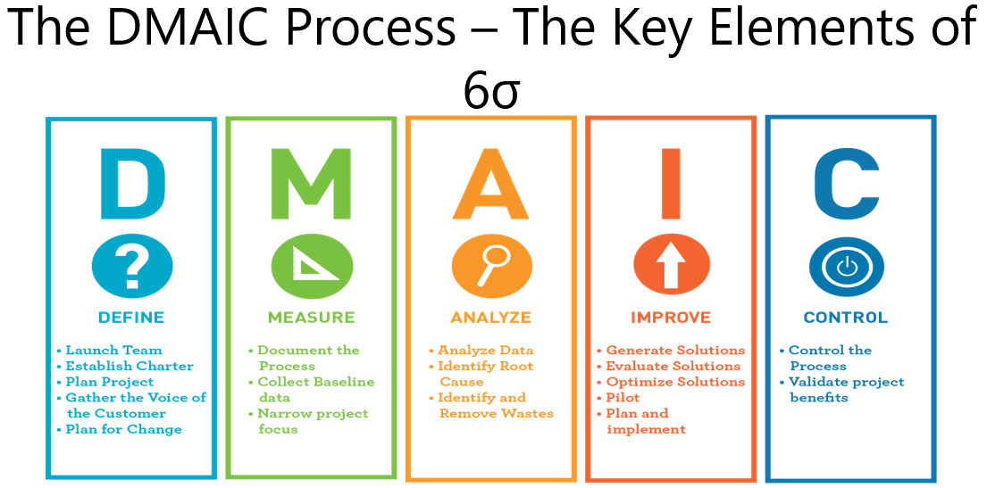
Figure 1 DMAIC Process Key Elements
(Jordan, 2021)
Although DMAIC is the main process that is used in Six Sigma, there are also other processes that could be used and utilised.
DMADV – Define, Measure, Analyse, Design & Verify.
One process that we currently use in my place of work for continuous improvement projects is below:
DMEDI – Define, Measure, Explore, Develop & Implement.
DMAIC and DMADV share the first three letters of their names and the first two of DMEDI, but there are some notable differences between them. The main difference exists in the way the final two steps of the process are handled. With DMADV, the Design and Verify steps deal with redesigning a process to match customer needs, as opposed to the Improve and Control steps that focus on determining ways to readjust and control the process. DMAIC typically defines a business process and how applicable it is; DMADV defines the needs of the customer as they relate to a service or product.
With regards to measurement, DMAIC measures current performance of a process while DMADV measures customer specifications and needs. Control systems are established with DMAIC to keep check on the business’ future performance, while with DMADV, a suggested business model must undergo simulation tests to verify efficacy.
DMAIC concentrates on making improvements to a business process to reduce or eliminate defects; DMADV develops an appropriate business model destined to meet the customers’ requirements.
(Daily, 2022)
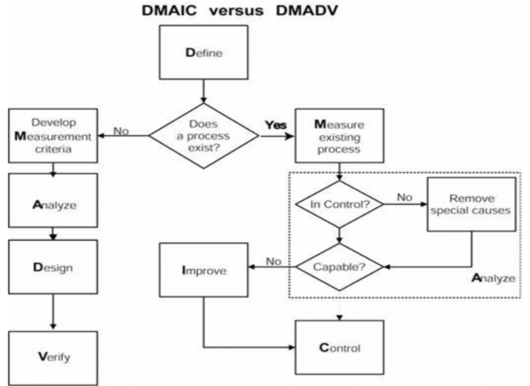
Figure 2 DMAIC vs DMADV
(Kralikova, n.d.)

Lean Principles & Implementation

Womack & Jones coin the phrase ‘Lean Manufacturing’ in the late 1900’s. But with a little research there is evidence of Lean Manufacturing principles being used in the late 1700’s.
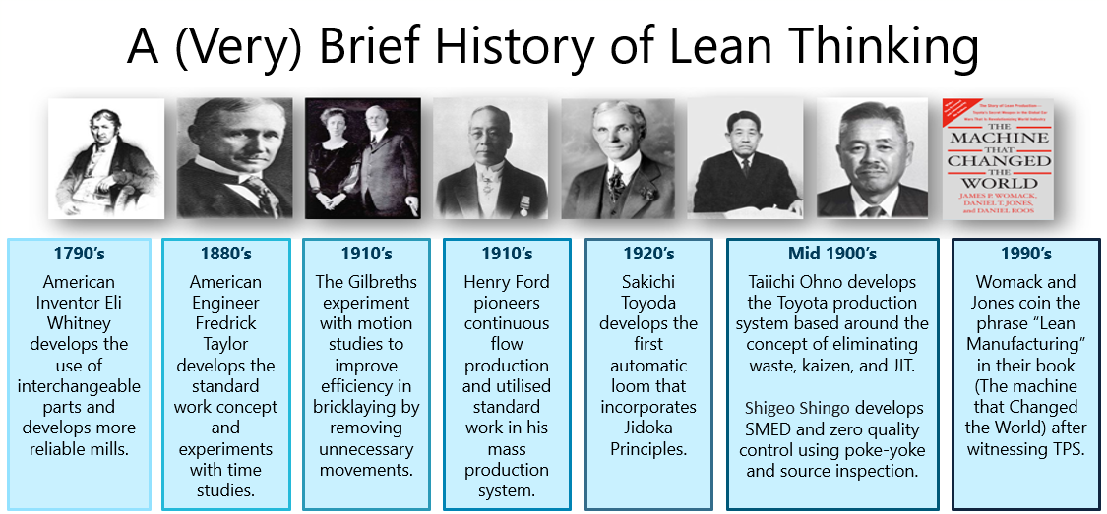
Figure 3 A Brief History of Lean
(Jordan, 2021)
Lean Manufacturing is a philosophy that targets maximising productivity and generates maximum value whilst systematically minimising waste for a process / product or service.
(Bedfordshire, n.d.)There are 5 key principles associated with lean manufacturing which are explained below: -
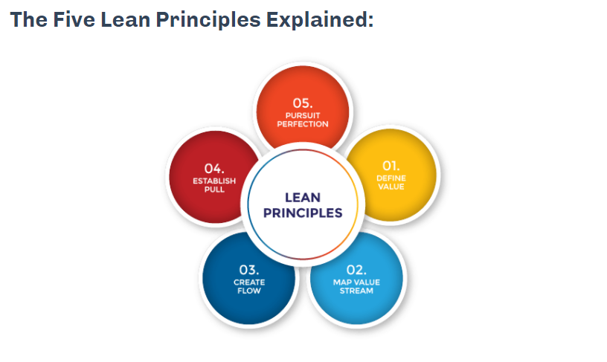
Figure 4 The 5 Lean Principles
(Doanh, 05.08.2017)

Identifying / Defining Value: - This is extremely important to ensure the correct development opportunities have been identified to increase value for the customers’ requirements and needs. Within my place of work, we used this to change the specification of a finished product after consultation with one of our customers, we were spending hundreds of hours of filtration on a final product and trying to get the particulates to a specific PPM requirement when it was highlighted by the customer that the product did not need to be filtered. Instead, the customer wanted the final product to have a reduced volatile content which was an easy process change to make, so not only did we add value to customers’ needs by reducing the final volatile content of the product, but we also saved hundreds of hours of NVA on filtration which enabled us to meet the customers’ orders on time.

Map the Value stream: - This process enables goal setting and understanding of exactly what the customers’ needs are, this also enables waste to be identified. Wastes can be categorised into 2 different types: non-value added but necessary and non-value added & unnecessary. By eliminating process waste, you can reduce the cost of a product / process or service.

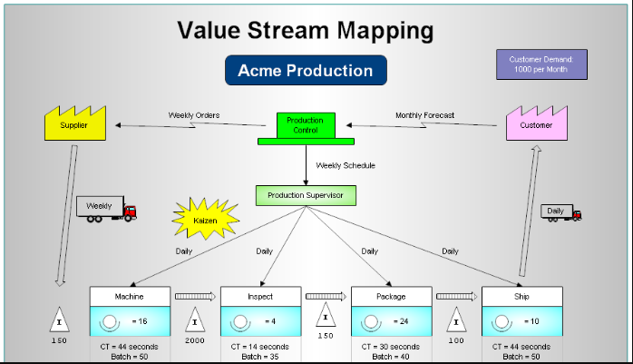
Figure 5 Value Stream Mapping
(Trumpold, n.d.)

Create Flow: - Good Flow describes progress in the production process steps without creating any bottleneck or que times, this flow moves steadily and continuously without interruption. Bad Flow is when the process has interruptions that stop the continuous movement of flow. An example of this is a breakdown on a production line that stops the fluent flow of the manufacture of a product. An example of good flow is when an item is scanned/booked out this item is automatically ordered, and the lead time is sufficient to when the item will be required again.
(Bedfordshire, n.d.)
Jidoka sometimes is called “autonomation,” “intelligent automation,” “automation with a human touch” or “automation with human intelligence.”
It provides machines and operators the ability to detect when an abnormal condition has occurred and immediately stop work when a problem first occurs. This enables operations to build in quality at each process by eliminating the root causes of defects. It also increases work efficiency by separating workers and machines, which eliminates the need for operators to continuously watch machines, as they can handle several machines at once.
Jidoka is one of the two pillars of the Toyota Production System, along with just-in-time (JIT). It is considered a key element in successful Lean Manufacturing implementations.
It is a quality control process that applies the following four principles:
Detect the abnormality
Stop
Fix or correct the immediate condition
Investigate the root cause and install a counter measure
The concept of Jidoka was developed by Sakichi Toyoda, founder of the Toyota Group, in the early 1900’s. He invented a textile loom that stopped automatically when any thread broke. Previously, if a thread broke the loom would produce defective fabric, so each machine needed to be watched by an individual operator.
(Sigma, n.d.)
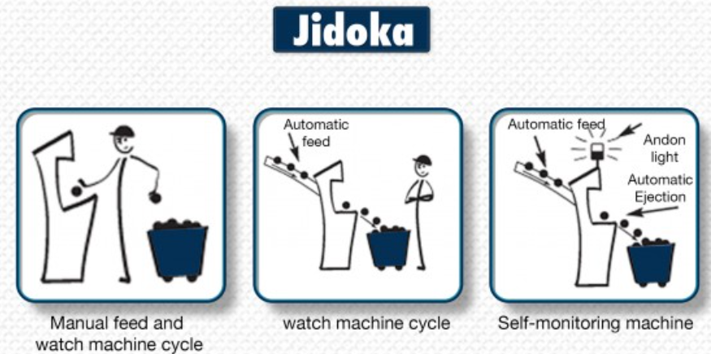
Figure 6 Jidoka
(Sigma, n.d.)
Heijunka is a production levelling and scheduling tool that is used in lean manufacturing to utilize the available capacity within an organization effectively. Responding flexibly to customer demand increases profitability.
The reality necessitates production levelling and scheduling in the business world where customer demand tends to fluctuate on a day-to-day basis but when looked at from a longer-term perspective almost always remains constant.
Heijunka in Lean Manufacturing
Lean manufacturing calls for producing only what the customer demands when they demand it. However, doing so will, result in erratic production. On one week you may be producing large quantities of a product while in the next week you will find that the resources within the organization are underutilized.
Because of this uneven production schedule, the supplies coming into the organization will also be erratic – meaning that inventory levels will increase to unmanageable levels. There will also be many incidences of stock-outs as it is virtually impossible to keep large quantities of all stock items.
It is therefore not a wise decision to try to run a strictly build-to-order system because of the inherent difficulty of keeping optimal inventory levels. Such a system will result in hidden problems such as quality defects and very high lead times that will make it challenging to fulfil customer demand.
Heijunka solves this problem by levelling out the production schedule resulting in better customer service and quality. In fact, some of the best lean manufacturing firms such as Toyota do not insist on a build-to-order system in the strictest sense of the word but work out the best process that will lead to efficient production.
Production levelling works by not trying to fulfil customer order as they come but by accumulating orders then levelling the production schedule. By using such a process, a firm becomes much better at fulfilling orders through shorter lead times, better quality and higher profits caused by a reduced inventory of parts.
Implementing Heijunka Production Levelling
The fact that build-to-order might work against the goals of lean manufacturing shows that it is not always prudent to try and apply tools with considering the big picture of whether they will achieve their intended purposes. Many companies when implementing lean go about trying to remove the seven wastes but in the process end up hurting the organization.
(Factories, n.d.)
Establishing Pull: - Pull is a key process / step to the Lean Manufacturing process. Pull enables a business to have lower inventory levels that frees up capitol that would otherwise be sat on a shelf or stored within a warehouse. There are multiple tools that can be used and utilised to establish pull these are as follows: - Kanban, JIT, SMED, and TQM. Kanban is the most recognised system within the pull process of lean manufacturing. One Bin System is Once a component or part is removed from its inventory location a new one is ordered to replenish the one removed. This item should then reach its required location before this item is needed again. This will help reduce inventory on components. A Two Bin System is used when the system can produce an order faster than what can be consumed. A visual diagram of this is below.
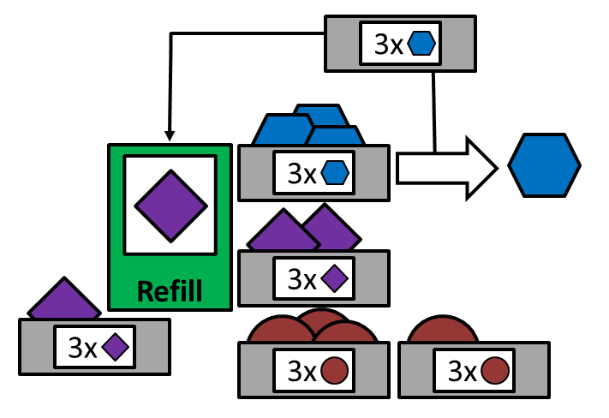

Figure 7 Two Bin Kanban System
(Roser, 2017)

JIT – Just in time manufacturing is a process developed by Japanese engineers ‘Taiichi Ohno & Shigeo Shingo’ this process was first developed and implemented at Toyota in Japan between 1950’s – 1970’s. The Ultimate objective of JIT is to have the required items at the right time, this reduces the amount of storage space that a business could require, and it will also reduce inventory levels which in turn helps to reduce costs.
TQM – Total Quality Management is organised and structured framework that aims for continuous quality improvements for a product / process or service. TQM partners with the JIT approach of establishing pull within lean manufacturing. There are 8 key principles / steps to TQM, and these are identified below.
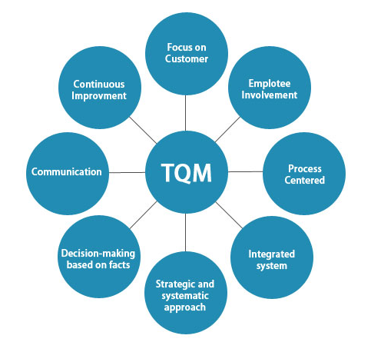
Figure 8 The 8 Steps to TQM
(Educba, 2020)

Seek Perfection: - “Perfection is not attainable, but if we chase perfection, we can catch excellence.” -- Vince Lombardi.
The Shingo principle seek perfection is about challenging the status quo; always wanting to be better and do better. While perfection will never be obtained, the pursuit of perfection creates a mindset and culture of continuous improvement.
Challenging the status quo is the very essence of Kaizen. Good enough is never enough! No process is perfect, and a leader should always be looking for a process where perfection is required. Perfection is possibly only when a leader is observant.
While we tend to think of perfectionism as being incompatible with an open mind and questioning mentality, they not only go together but are in integral aspect of Lean leadership and Lean organisations. The lean leader is not focused on momentary success, but on continuous improvement. Everything that is done well can be done better, with more efficiency and a less wasteful process.
For this a decent amount of time must be spent in Gemba. Striving for perfection does not imply that we must make the processes more complicated. Simplicity is the key. The leader needs to have a daily routine of simplification and develop an eye for finding waste.
Seeking for perfection is about constantly looking for opportunities to get better. It is helpful to set attainable goals and work diligently towards achieving them. When everyone is working together to achieve goals the continuous improvement mindset will spread.
(Journey, 2021)
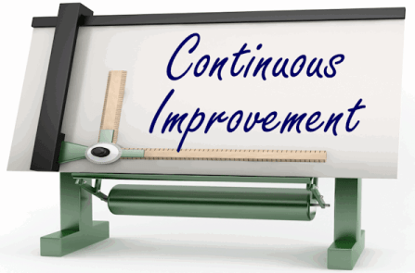
Figure 9 Continuous improvement
(advisors, 2018)

Conclusions

During this report I have identified similarities and differences between Lean & Six Sigma principles.
Six Sigma methodology focuses on identifying waste form process variation whilst using statistical process analysis and control tools to enable a more predictable and stable process which reduces variation within a process. This also covers the 7 quality tools that are covered by Pareto Analysis. Root Cause Analysis and SPC are also key tools used for Six Sigma.

Lean Manufacturing Methodology focuses on maximising customer value whilst reducing and minimizing waste form products / processes and procedures. Lean aims to remove and reduce NVA, overproduction (inventory), defects and reprocessing of products.

Both Lean Manufacturing and Six Sigma aim to reduce waste, increase quality, and supply its customers with the best possible cost for a product / process and service. These methodologies work hand in hand together and utilising the Six Sigma approach to reduce variation and create stability of a product / process and service followed by implementation of Lean Manufacturing principles is best sequence to maximising the value from the use of these methodologies.

References
advisors, T., 2018. Transformance advisors. [Online]
Available at: WWW.Transformanceadvisors.com
[Accessed 31 January 2022].
Bedfordshire, U. O., n.d. The Lean Six Sigma Company. [Online]
Available at: www.theleansixsigmacompany.co.uk
[Accessed January 2022].
Daily, S. S., 2022. Six Sigma Daily. [Online]
Available at: www.sixsigmadaily.com/dmaic-vs-dmadv
[Accessed 03 February 2022].
Doanh, D., 05.08.2017. The Lean Way. [Online]
Available at: https://theleanway.net/The-Five-Principles-of-Lean#:~:text=Womack%20and%20Jones%20defined%20the%20five%20principles%20of,using%20a%20pull%20system%2C%20and%205%29%20pursuing%20perfection.
[Accessed 30 January 2022].
Educba, 2020. Educba. [Online]
Available at: www.Educba.com
[Accessed January 2022].
Factories, L., n.d. Lean Factories. [Online]
Available at: www.leanfactories.com
[Accessed February 2022].
Jordan, J., 2021. Introduction to Six Sigma - Class materials. Swansea: s.n.
Journey, A. L., 2021. A Lean Journey. [Online]
Available at: http://www.aleanjourney.com
[Accessed 31 January 2022].
Kanbanize, n.d. Kanbanize. [Online]
Available at: www.kanbanize.com
[Accessed January 2022].
Kralikova, R., n.d. ResearchGate. [Online]
Available at: www.researchgate.net/figure/The-relationship-between-DMAIC-and-DMADV
[Accessed 03 February 2022].
Palange, A. & Dhatrak, P., 2021. Lean manufacturing a vital tool to enhance productivity in. Materials Today: Proceedings, p. 8.
Pyzdek, T., 07-09-2018. The Six Sigma Handbook. s.l.:McGraw-Hill.
Roser, C., 2017. All About Lean. [Online]
Available at: www.allaboutlean.com
[Accessed January 2022].
Sigma, L. S., n.d. Lean Six Sigma Definition. [Online]
Available at: www.leansixsigmadefinition.com
[Accessed February 2022].
Trumpold, M., n.d. Design Technology. [Online]
Available at: www.ruthtrumpold
[Accessed 30 January 2022].

