

Changemakers: Creativity and Value Creation
Professions (BMHP5014)

Component 1: Online portfolio of set exercises- The use of NHS virtual wards

Student name: Gabriela Arapu
Student number: 2311889
Lecturer’s name: Caroline Salami (module
leader)

Table of Contents
Introduction 3
Task 1- Defining Key Concepts in Practice 3
Task 2 - Mind Map The use of NHS virtual wards 5
Task 3 - Self-Reflection of Group Activity 6
Task 4 - Case Study Analysis of a UK Innovation. 7
Task 5 - Research Task. 7
Task 6 - Exploring Digital Innovation in Health and Social Care 8
Task 7 - Understanding the NHS Leadership Framework. 9
Task 8 - Self-Reflection Journal Entry. 10
References 12

Introduction
Using NHS Virtual Wards as the primary focus, this portfolio critically examines the ideas of innovation, creativity, value creation, and transformation in modern health and social care. In the UK, virtual wards—also known as the "hospital at home" model—represent a substantial shift in the provision of healthcare. Through coordinated multidisciplinary teamwork and remote monitoring technologies, they allow patients with both acute and chronic diseases to get hospital-level care in the comfort of their own homes. This strategy addresses the growing demands on the NHS, such as hospital capacity limitations, labour shortages, and increased service demand.

The portfolio exhibits both theoretical comprehension and real-world implementation of important ideas. Using well-established academic frameworks, it defines innovation, creativity, value creation, and change and applies them directly to the deployment of virtual wards. It also looks at how leadership practices, patient-cantered care, and service design are affected by digital transformation. A case study examination assesses the innovation's stated results and scalability, while a graphic mind map highlights its interrelated advantages and difficulties. The significance of cooperative thinking, a common goal, and organised change management in fostering sustainable innovation is highlighted by reflection on group projects and leadership frameworks.

Overall, this portfolio makes the case that leadership, systems thinking, equity, and reflective practice are just as important to the effective transformation of health and social care as digital technologies.

Task 1- Defining Key Concepts in Practice
Innovation in health and social care is the application of novel strategies that enhance service effectiveness, safety, and quality. Instead of just technology, organisational context, leadership, and system preparation all play a role in the effective adoption of innovation in healthcare (Greenhalgh et al., 2004). Through integrated multidisciplinary teams and remote monitoring technologies, virtual wards within the NHS offer hospital-level care in patients' homes, representing an innovative style of care delivery. This strategy considers the need for more sustainable care models, pressures on bed capacity, and rising demand (NHS England, 2022).

In the workplace, creativity involves generating and applying practical new ideas. In healthcare, it often emerges through teamwork, adapting existing practices to meet complex patient needs (West and Anderson, 1996). Virtual wards demonstrate this by transforming traditional inpatient care into digitally supported home-based care, combining clinical expertise, technology and communication to maintain patient safety. Value creation focuses on improving outcomes while using resources efficiently. The Triple Aim framework highlights enhancing patient experience, improving population health and reducing costs (Berwick, Nolan and Whittington, 2008). Virtual wards support these goals by reducing hospital admissions, improving patient comfort and increasing system efficiency.

Change refers to the structured transition from traditional practices to improved care models. Effective change requires understanding organisational culture, professional behaviour and potential barriers (Grol and Wensing, 2004). The implementation of virtual wards depends on staff training, digital capability and strong leadership, as innovations may fail without structured change processes (Grol and Wensing, 2004).

Overall, innovation introduces new service models, creativity supports solution development, value creation measures impact and change ensure sustainability. However, challenges such as digital exclusion, workforce capacity and resistance to change may limit equitable implementation within health and social care systems.

Task 2 - Mind Map The use of NHS virtual wards
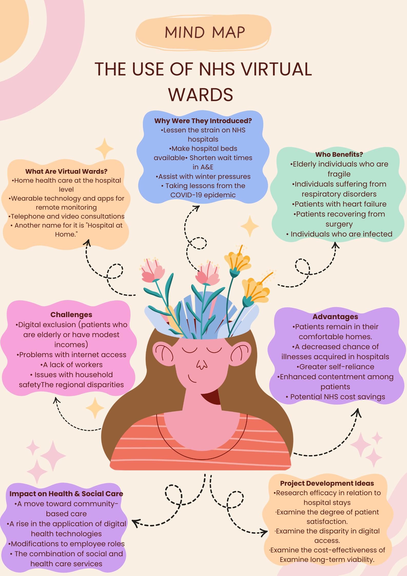

The mind map's focal point is the NHS Virtual Wards, which show how digital innovation is changing the way health and social care are delivered. Integrated care principles, which encourage collaboration across providers to optimise efficiency and patient outcomes, are reflected in the move from hospital-based treatment to home monitoring (World Health Organization, 2016). The benefits that have been observed, such as greater independence and fewer hospital-acquired infections, are consistent with patient-cantered care, which places an emphasis on each patient's unique requirements and experience (Institute of Medicine, 2001).

Structural health disparities within healthcare systems are highlighted by issues like workforce shortages and digital barriers (Marmot, 2010). Determining the long-term worth of service innovation also requires assessing sustainability and cost-effectiveness (Porter and Lee, 2013). All things considered, NHS virtual wards signify not only a development in technology but also a more extensive shift in the integration and delivery of care.

Task 3 - Self-Reflection of Group Activity
I examined my experience with the group exercise on convergent and divergent thinking using Kolb's experiential learning cycle as a reflective framework. Divergent thinking entails coming up with several original ideas, while convergent thinking concentrates on reducing those ideas to the best workable solution. I originally used a convergent approach during the task by pushing the group to assess ideas fast and come to a decision. But when opposing viewpoints surfaced, I realized how crucial it was to give room for divergent thought in to consider different angles.

When we were having trouble coming to a consensus, I proposed putting all our thoughts in writing before assessing them. Collaboration improved and the group dynamic changed as a result. By allowing people to critically analyze their experiences and modify their future behavior, reflective practice promotes deeper learning (Nguyen et al., 2014). After some thought, I concluded that, despite my innate preference for methodical decision-making, productive teamwork necessitates a balance between analytical examination and creative inquiry. To make sure that everyone's opinions are heard, I would priorities organized brainstorming over evaluation in future sessions.

Task 4 - Case Study Analysis of a UK Innovation.
The creation of NHS Virtual Wards aims to alleviate the increasing strain on hospital capacity, especially because of an ageing population with complicated chronic illnesses and an increase in emergency admissions. Overcrowding and delayed discharges are the results of traditional inpatient care models' inability to keep up with the growing demand (Bardsley et al., 2013). With the use of integrated multidisciplinary teams and remote monitoring technology, virtual wards were created to deliver hospital-quality treatment in patients' homes.

By changing the idea of acute care from a physical hospital setting to a home environment with digital support, creativity helped to rethink the way services are delivered. This strategy is part of a larger shift toward technology-enabled care, where digital innovation improves service coordination and continuity (Lewis et al., 2020). Safe alternatives to hospitalisation have been made possible by the innovative fusion of clinical knowledge, data exchange, and patient-cantered monitoring.

Service users have benefited from increased comfort, reduced risk of hospital-acquired infections, and increased autonomy. According to research, hospital-at-home models can improve healthcare systems' use of resources and reduce hospital stays without compromising clinical outcomes (Bardsley et al., 2013). Reports of improved patient satisfaction and system efficiency serve as evidence of scalability across integrated care systems. However, the effectiveness of virtual wards may differ based on staff preparedness and patient access to digital technology, underscoring the significance of resolving disparities to guarantee inclusive and long-lasting deployment.

Task 5 - Research Task.
A major obstacle to the growth of remote NHS services, such as virtual wards and online consultations, is digital inequality. The term “digital exclusion” describes unequal access to devices, internet connectivity, and digital literacy abilities. Digital poverty and limited digital literacy reduce patient participation in technology-enabled care, as individuals may lack access to devices, reliable internet or the skills required to use digital health tools effectively. Research indicates that those with lower socioeconomic status, older adults, and those with less education are more likely to face obstacles to digital involvement (Robinson et al., 2015). This implies that if structural disparities are not addressed, digital change may inadvertently increase health inequities.

Additional study demonstrates that exclusion from digital health is closely linked to more general social variables, such as geographic location, income inequality, and infrastructural accessibility (Beaunoyer, Dupéré, and Guitton, 2020). From a systems approach, rather than being the result of personal opposition to technology, digital inequality reflects interrelated social and economic variables. This could have an impact on continuity and equity of care in NHS practice by making it harder for some patients to use virtual ward services or remote monitoring.
Both pieces stress that systemic measures like infrastructure spending and focused assistance for digital literacy are necessary to alleviate digital inequality. However, Beau Noyer et al. investigate the consequences of digital exclusion particularly in health situations, while Robinson et al. concentrate on patterns of social inequality. This implies that rather than reducing current health disparities, digital innovation may inadvertently exacerbate them in the absence of focused measures.

Task 6 - Exploring Digital Innovation in Health and Social Care
Wearable health technologies, such as smartwatches and remote monitoring devices, support chronic condition management by enabling continuous data collection outside clinical settings. They monitor indicators like heart rate and glucose levels, allowing early detection of deterioration. Evidence shows remote monitoring improves self-management and reduces hospital admissions (Inglis et al., 2015). Real-time data sharing also supports timely intervention. According to the Technology Acceptance Model, usage depends on perceived usefulness and ease of use (Davis, 1989). However, digital literacy and access may limit effectiveness.

How Electronic Health Records (EHRs) Improve Communication
Electronic Health Records (EHRs) improve communication by centralising patient data and enabling real-time access across services. This enhances continuity of care, reduces errors and avoids duplication. Research shows EHRs improve clinical decision-making and teamwork (Campanella et al., 2016). Shared records allow faster access to patient information, improving efficiency. Adoption depends on perceived usefulness and ease of use (Davis, 1989). However, system integration and training challenges may affect implementation.

Digital Technology Supporting Preventative Care and Health Promotion
Digital technology supports preventative care through early intervention, education and behaviour change. Mobile apps and remote tools help monitor risk factors such as inactivity and obesity. Evidence suggests digital interventions improve lifestyle behaviours and prevent long-term conditions (Free et al., 2013). In NHS practice, digital platforms support screening and health promotion. Engagement depends on perceived usefulness and ease of use (Davis, 1989). However, unequal access may limit impact.

Task 7 - Understanding the NHS Leadership Framework.
The behaviours needed to provide safe, efficient, and compassionate care across health and social care systems are outlined in the NHS Healthcare Leadership Model. Inspiring a shared purpose, leading with care, assessing information, involving the team, and promoting development are among the nine fundamental elements identified by the framework (NHS Leadership Academy, 2013). The concept highlights that leadership is exhibited through observable behaviours at all organisational levels rather than characterising leadership by rank. This strategy is especially crucial in the health and social care sectors, where patient-centred values, accountability, and collaborative practice all have a direct impact on service quality. The approach facilitates workforce growth and promotes ongoing improvement in complex systems by offering an organised behavioural framework.

Motivating a common goal is one of the framework's essential leadership behaviours. A clear vision that links team goals with patient results is created by leaders who exhibit this attitude. Leaders can encourage innovation and creativity by coordinating professional motivation with organisational objectives. According to transformational leadership theory, leaders that inspire their people with their vision and intellectual stimulation are more likely to foster creativity and boost output (Bass, 1999). By highlighting the ways in which digital innovation enhances patient safety and system sustainability, a leader putting virtual wards into practice could motivate a sense of shared purpose. Adoption of innovative service models is encouraged, and engagement is strengthened by this behavioural approach.

My knowledge of creativity and value creation in health and social care has greatly changed because of this training. At first, I thought that innovation mostly referred to changes in technology. But after looking at leadership frameworks and service redesign, I have come to understand that strategic leadership, teamwork, and cultural transformation are all infused with creativity. Examining virtual wards and digital transformation brought to light the ways in which effective innovation is influenced by leadership characteristics. By promoting proactive engagement, facilitating team communication, and an openness to evidence-based improvement initiatives, this lesson will influence my future professional practice.

Task 8 - Self-Reflection Journal Entry.
My knowledge of creativity, innovation, and value creation in the context of health and social care has greatly expanded because of this module. I initially saw innovation primarily as the advent of digital tools. But my analysis of digital inequality and NHS Virtual Wards made it clear to me that innovation also calls for systems thinking, collaborative leadership, and equitable consideration. By motivating practitioners to critically assess experiences and apply insights to future practice, reflection plays a significant role in professional development (Boud and Molloy, 2013). I started to realise that value creation encompasses more than just cutting costs it also involves enhancing patient experience, safety, and sustainability—after finishing the case study and leadership framework assignments. I became more conscious of the dangers of exclusion if innovation is not applied carefully after investigating digital transformation. I plan to actively participate in conversations about service improvement and offer suggestions that put patient-cantered and equitable care first in future placements. During my studies, I recognised that my creative skills required further development, particularly in presenting ideas clearly. To address this, I enrolled in a PowerPoint skills course to improve my ability to communicate ideas visually and creatively. This action increased my confidence in presenting information and demonstrated my commitment to developing practical skills that support innovation in health and social care.

References
Allemani, C. et al. (2013) ‘Colorectal cancer survival in the USA and Europe: a CONCORD high-resolution study’, BMJ Open, 3(9), e003055. Available at: https://doi.org/10.1136/bmjopen-2013-003055 (Accessed: 22 February 2026).

Bass, B.M. (1999) ‘Two decades of research and development in transformational leadership’, European Journal of Work and Organizational Psychology, 8(1), pp. 9–32. Available at: https://doi.org/10.1080/135943299398410 (Accessed: 10 April 2026).

Beaunoyer, E., Dupéré, S. and Guitton, M.J. (2020) ‘COVID-19 and digital inequalities: Reciprocal impacts and mitigation strategies’, Computers in Human Behavior, 111, p. 106424. Available at: https://doi.org/10.1016/j.chb.2020.106424 (Accessed: 10 April 2026).

Berwick, D.M., Nolan, T.W. and Whittington, J. (2008) ‘The Triple Aim: Care, health, and cost’, Health Affairs, 27(3), pp. 759–769. Available at: https://doi.org/10.1377/hlthaff.27.3.759 (Accessed: 20 February 2026).

Boud, D. and Molloy, E. (2013) ‘Rethinking models of feedback for learning: the challenge of design’, Assessment & Evaluation in Higher Education, 38(6), pp. 698–712. Available at: https://doi.org/10.1080/02602938.2012.691462 (Accessed: 10 April 2026).

Campanella, P., Lovato, E., Marone, C., Fallacara, L., Mancuso, A., Ricciardi, W. and Specchia, M.L. (2016) ‘The impact of electronic health records on healthcare quality: a systematic review and meta-analysis’, European Journal of Public Health, 26(1), pp. 60–64. Available at: https://doi.org/10.1093/eurpub/ckv122 (Accessed: 10 April 2026).

Davis, F.D. (1989) ‘Perceived usefulness, perceived ease of use, and user acceptance of information technology’, MIS Quarterly, 13(3), pp. 319–340. Available at: https://doi.org/10.2307/249008 (Accessed: 10 April 2026).

Free, C., Phillips, G., Watson, L., Galli, L., Felix, L., Edwards, P., Patel, V. and Haines, A. (2013) ‘The effectiveness of mobile-health technologies to improve health care service delivery processes’, PLOS Medicine, 10(1), p. e1001363. Available at: https://doi.org/10.1371/journal.pmed.1001363 (Accessed: 10 April 2026).

Greenhalgh, T., Robert, G., Macfarlane, F., Bate, P. and Kyriakidou, O. (2004) ‘Diffusion of innovations in service organizations: systematic review and recommendations’, The Milbank Quarterly, 82(4), pp. 581–629. Available at: https://doi.org/10.1111/j.0887-378x.2004.00325.x (Accessed: 20 February 2026).

Grol, R. and Wensing, M. (2004) ‘What drives change? Barriers to and incentives for achieving evidence-based practice’, Medical Journal of Australia, 180(S6). Available at: https://doi.org/10.5694/j.1326-5377.2004.tb05948.x (Accessed: 20 February 2026).

Inglis, S.C., Clark, R.A., Dierckx, R., Prieto-Merino, D. and Cleland, J.G. (2015) ‘Structured telephone support or non-invasive telemonitoring for patients with heart failure’, Cochrane Database of Systematic Reviews, (10). Available at: https://doi.org/10.1002/14651858.cd007228.pub3 (Accessed: 10 April 2026).

Institute of Medicine (2001) Crossing the Quality Chasm: A New Health System for the 21st Century. Available at: https://www.ncbi.nlm.nih.gov/books/NBK222274/ (Accessed: 10 April 2026).

Marmot, M. (2010) Fair Society, Healthy Lives (The Marmot Review). Available at: https://www.instituteofhealthequity.org/resources-reports/fair-society-healthy-lives-the-marmot-review (Accessed: 10 April 2026).

Nguyen, Q.D., Fernandez, N., Karsenti, T. and Charlin, B. (2014) ‘What is reflection? A conceptual analysis of major definitions and a proposal of a five-component model’, Medical Education, 48(12), pp. 1176–1189. Available at: https://doi.org/10.1111/medu.12583 (Accessed: 10 April 2026).

NHS England (2022) Virtual wards. Available at: https://www.england.nhs.uk/virtual-wards/ (Accessed: 20 February 2026).

NHS Leadership Academy (2013) Healthcare leadership model. Available at: https://www.leadershipacademy.nhs.uk/resources/healthcare-leadership-model/ (Accessed: 10 April 2026).

Porter, M. and Lee, T. (2013) ‘The strategy that will fix health care’, Harvard Business Review. Available at: https://hbr.org/2013/10/the-strategy-that-will-fix-health-care (Accessed: 10 April 2026).

Robinson, L., Cotten, S.R., Ono, H., Quan-Haase, A., Mesch, G., Chen, W., Schulz, J., Hale, T.M. and Stern, M.J. (2015) ‘Digital inequalities and why they matter’, Information, Communication & Society, 18(5), pp. 569–582. Available at: https://doi.org/10.1080/1369118x.2015.1012532 (Accessed: 10 April 2026).

World Health Organization (2016) Framework on integrated, people-centred health services. Available at: https://apps.who.int/gb/ebwha/pdf_files/WHA69/A69_39-en.pdf (Accessed: 10 April 2026).

