Awe and Wonder – science, mathematics and the outdoors

Part 1
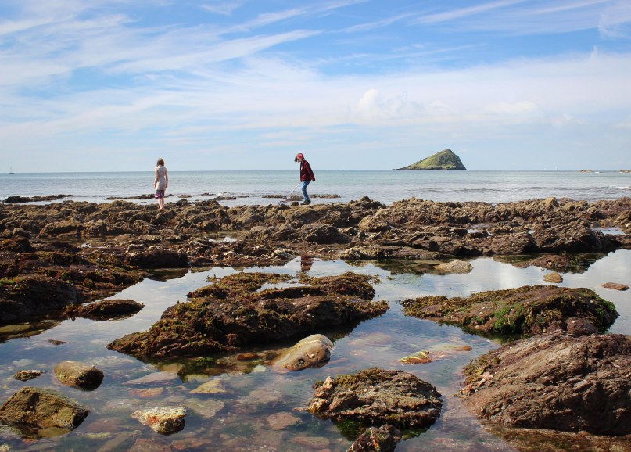

(South Devon, 2018)

Part 2
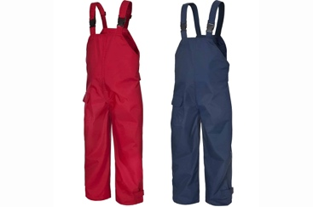

9:20 am
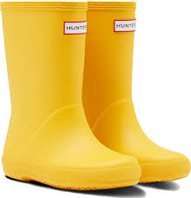
The children were buzzing with excitement as they put on their waterproofs and wellies in preparation for the trip that they are going on to the beach. The trip to the beach is as a result of the children learning about the oceans and what ecosystems and species we can find on our local coastline. The children were asked to get into pairs to be counted to then go onto the bus. The children were encouraged to count along with the staff to ensure that everyone who was going on the trip was present. The equipment that we were taking was carried along by two children and a member of staff as the box was deemed too heavy for 2 people, so an extra pair of hands was needed to help distribute the weight. The equipment that is being brought on the trip has been chosen by the children of what they would like to use to view the animals.
(Garden4Less, 2023)
(Yorkshire wonders , 2017)
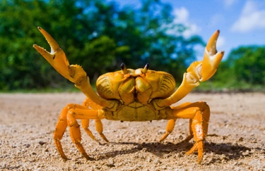
9:30
The children were all on the bus. Child A said to Child B “do you think we will be able to find out how many legs a crab has?” child B replied, “we can count the crabs’ legs if we find one in the rockpool!”
The excitement of all the children on the bus and how they wanted to expand their knowledge of the ecosystems that are accessible to them.
(AZ Animals, 2022)
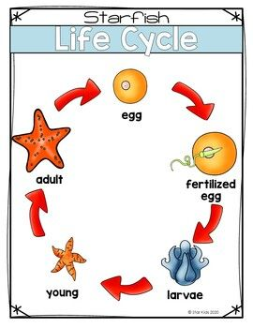
One child expressed interest on the bus to a member of staff that they wanted to see some of the animals that they had learnt about as babies to see how different they looked this is expanding the child’s knowledge on animals and their life cycles.

(Pinterest, 2023)

9:45
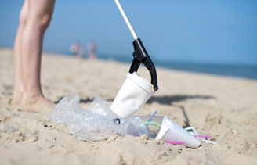
Arriving at the beach location the children were very excited to have arrived and were ready to explore the new environment. The children were spoken to on the boat about boundaries that will need to be followed in order to keep everyone safe. The children were told that if they find any sea creatures, they can pick them up with their buckets and nets or ask a teacher if they are unsure if they can touch the animal. The children were shown two large yellow flags and were told that was the boundary of how far the children can venture to ensure they are safe from large drops or tides from the sea. The children were told that if they find any litter on the beach that they can call over an adult and they will put the rubbish in recycling bags to help promote the health of the planet and teaching the children to recycle and become ‘ethical and informed citizens of wales’ and he world which is one of the outcomes that is to be achieved following the new curriculum for wales (Welsh Government, 2020).
(Cromwell Polythene, no date )

9:50
Beginning the walk down towards the beach the children were faces with the obstacle of an uneven winding path down to the sand, the children needed to use their balance and tilt their body backwards to allow them to slow down and control their body and how fast it is moving.
Once the children had got down the path safely, we then found an area in the sand to place the equipment and loose parts that the children have suggested that is brought for them to carry out their experimentation and exploration in the environment.
The children witnessed the yellow boundary flags being placed in the sand.

9:55
The children set of and began exploring the rock pools while the adults supervised the children while in this area to ensure they are safe and respecting the environment, some children immediately began building with stones and shells that they found discovering how to balance all the different shape and sizes.

10:15
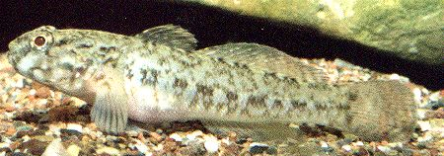
A group of children had begun to gather around one specific rockpool. A member of staff went over to investigate what they had discovered. The children had gathered round a rockpool and had spotted a fish with a group of eggs that was being guarded by the adult fish. The children wanted to learn about what species of fish it was, the staff member brought out the interactive tablet to use technology to research what the fish was the children were listing off the species of fish that they knew “clown fish” “pufferfish” and “tuna”. The fish turned out to be a Blenny and its babies, the children did their own research while observing the fish and the eggs and learnt what they eat through their own research, the children found out that they enjoy eating barnacles that grow on the rocks of rockpools. Some of the children began to count how many eggs they could see that the fish was guarding child A said they could see 12 eggs whereas child B said they could count 26 eggs.
British marine life study society (2020)

10:35
One child was finding different materials that they found on the beach and was placing the items in the tray with water and watching them to see if they float or sink, if they floated the child would blow gently to make item move across the tray. The child was putting the floating items in one bucket and the sinking ones in another and holding the item that floated the fastest, the child had set up their own experiment. The practitioner didn’t interfere with the child until the child looked for guidance to carry the bucket that contained the objects that sunk as the child explained that the objects that sunk were heavy and the objects that floated were light, the child had explained their conclusion to the member of staff regarding the experiment they had carried out.

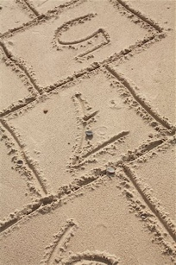
10:45
On the sandy part of the beach there was a group of children using a stick were drawing out a grid int the sand the practitioner watched as the children worked together to make the grid line up together, the children decided they wanted to use the shapes squares and rectangles to make a hopscotch grid to play on. The children then began to write the numbers in the grid and ensuring the sequence was in the right order, once completed the children couldn’t find a dice in the loose parts box so they compromised and used a rock to throw onto the number and the children would count along as the other child jumped child A landed on number 7 and the children counted along and also counted how many squares to go till child A got to number 10.
(Masterfile,2022)

10:55
The children were all called over to come and have a group discussion and to bring anything interesting they have found or what they have made. The children all gathered around and spoke about what they had found and the facts they learnt from exploring some children had found a crab and told their friends that they counted, and it has 8 legs and 2 big claws the children all took turns looking. The children were intrigued and asked lots of where did you find it? What did you use? Where does it live? Does it have and babies? The children that ad fund the crab were then educating their peers on the knowledge of the crab. Some of the children were talking about how they wanted to help the planet and stop global warming and endangering their planet and spent a lot of time picking up litter and showed their friends that they collected 2 bags of litter out of the rockpools and on the sanded area with an adult.

11:20
After packing up and walking back up the windy bumpy path and back on the bus the children were still buzzing with excitement with all the knowledge thy have gained from the outdoor environment.

Part 3

RISK BENEFIT ASSESSMENT

Location / Activity: | Beach/Rockpool exploration day | Date: | 25/03/2023
Assessor: | Hannah Thomas | Review date: | 25/01/2023

The boxes in the table below will expand as you type into them; pre-entered text is simply for illustration. You should delete irrelevant items and replace with text relevant to your circumstances.
Your overall risk rating – Low, medium or high – is based on your judgement about whether the BENEFITS of the activity or opportunity outweigh the RISKS.

Experience exploring outdoor space in photograph | How will young people BENEFIT from this activity? | Hazards and risks | Who is at risk? | PRECAUTIONS in place to reduce the risk of injury | Overall risk RATING: L/M/H
Exploring rockpools for organisms | The children will develop an understanding of what lives on the beaches that live on their doorsteps. The children will also have the first-hand experience of witnessing these animals instead of just seeing an image, the children get a perspective of the size of the animals as envisioning it may be difficult and having a visual will be beneficial to the child’s understanding.  Children can learn about different habitats that different species live in.  Sizes and depth exploration in the rockpools.  Textures of the seaweed, rocks and sand. | Rockpools can be slippery and uneven ground.  Water can look deeper than expected children at risk of drowning in deep water.  Animals may bite children if they are provoked or frightened | Children and Adults | To reduce the risk children will be supervised by adult when exploring rockpools. The children will also be wearing suitable shoes for walking and getting wet in to prevent the children from tripping.  The children will be told to not climb into rockpools without an adults help; adults will tightly supervise children when near water as of drowning risk  With regards to the children and animals the children will be provided with the equipment that is needed to collect the animals correctly without the children causing harm to themselves or the animal or its habitat. The children will be educated on animals that they will be allowed to touch with their hands and the animals that they will only be allowed to look at if they pose a danger to the child. | M

tide times ensuring the tide is out for entire period of activities. | Children have plenty of time to explore and the activity won’t be rushed as a result of the tide.  Children will learn about the tide and the tide movements and the behaviour of water.  The water cycle, the sea and the sun will provide the staff with two visuals for the children to witness the water cycle in real life. | Children may become fascinated with watching the movement of the water and may venture close to the edge.  Tide times may be subject to change and may affect the access and the safety of the children exploring the rockpools as they may be submerged by the sea, activity may not be carried out. | Adults and Children | Children will be supervised closely when near open water by an adult. Boundaries that are marked clearly so they children know the limits. Children are not permitted to get into any body of water without the permission and supervision of adults.  Tide times will be constantly revisited to ensure they don’t interfere with the selected date and time of this exploration trip. Tide times will be checked the day before, the night and the morning of to ensure the trip is safe to go on. | M

Weather conditions. Mild day. Children may need extra layers or children may need to have removable layers to be suited to child’s preference and potential change in weather. Children may need spare clothes if they get wet too. | Children will feel comfortable if dressed in correct clothes and more confident to explore and won’t feel constricted.  If children are dressed appropriately, they won’t have reservations of getting wet or dirty and will have a fulfilling hands-on experience in the new learning environment.  Children will feel safe if they have the correct clothes for the weather | Hypothermia if the child isn’t dressed appropriately and weather conditions are cold and wet.  Heat stroke if the child isn’t wearing clothes of a breathable material if temperatures are higher or sun is out.  Incorrect clothing that doesn’t cover children’s legs may leave openness for the children to get hurt on rocks. Long trousers act as a barrier. Children may hold back if they are frightened of getting hurt | Adults and Children | Letters to parents will be sent out to send the child on the trip and will also include a list of essentials that the child should bring. This would include the children’s wellies, sun cream, hat, waterproofs and for the child to be dressed in easily removable layers and extra layers in their bag dependant on the unpredictable weather conditions on the day. Spares will be on standby for children that may have forgotten. Parents will be encouraged to put their child in long trousers and long sleeve tops to reduce the risk of the child scratching themselves on a rock or be affected by stinging plants such as stingy nettles.  Wellies or walking boots are the shoes that children will be requested to wear as the provide good grips on the bottom and can prevent water getting the children’s feet wet.  In the case of a child becoming soaked through the parents will have been requested to provide spare changes of clothes for the children in this eventuality.  First aid kits will be brought in the event of an injury or accident occurs. | M
Buckets, nets, clear plastic trays, magnifying glass, spades, measuring jugs | These loose parts will allow the children to take control and use their imagination and their experimenting mind to expand their own learning with the support of these objects. There is no definite way to describe how the children will use these loose parts, but the child’s mind will be working to accompany why and how these will be used and what they can aid them with. Loose parts will open a window for learning to be expanded. | Some may get broken if they are of a material that breaks easy.  Children may not use them appropriately e.g., hitting each other or using magnifying glasses as hammers. | Children and adults | Adults will inform the children if they are finished with one of their tools or loose part to return it to the box and not leave them on the floor to stop them getting stood on or broken.  Children will be informed that some of the materials are easily broken and to use them respectfully and to be kind to each other using them and not to use the magnifying glass to hit rocks with. | M

Part 4

Within the life of the child, it may not be expected but maths and science are a partnership that work very closely together. The two topics go hand in hand as many traits and problems can be found and fixed the same way for both. The importance of science and maths in the early years is far more crucial then thought, science and maths are often cast as difficult subjects or too complex for children in the early years, what will be surprising is science and maths can be found everywhere even in the great outdoors (McDonald, 2022).
Science and maths don’t always have to be explored by children at a classroom level, science and maths can occur when a baby begins to move their arms or kick their legs against the floor in a motion to move (Gopnik, 2010).

Science and mathematics are always beneficial to children’s learning, however having a strict classroom rule where learning is kept indoors where the children can’t observe or experience these wonders and visualise these occurrences or test this knowledge or theory. Studies have shown that learning outside of the classroom environment has greatly benefited the learners within the setting and information has been understood more, attention from the pupils was higher, the children were engaged and participating more with tasks, there was also a noticed improvement with the children’s behaviour when being in the outdoor area (Marchant, 2020). If the correlation between children’s improved engagement, participation and behaviour and learning from the outdoor environment why is there such a lack of practitioners moving forward with this understanding of the benefits of outdoor learning?
Why do practitioners withhold themselves and the children from learning outdoors frequently? This may be a result of practitioners own self confidence to remove themselves from the uniform and security of the classroom space. Practitioners may feel intimidates by the new risks that may come with outdoor learning and health and safety regulation to follow. Many practitioners may not have had their own experience with outdoor learning from their own childhood, on the other hand practitioner’s may have not learnt about the benefits in depth in their education which may cause the practitioner to feel as they won’t be able to provide a stimulating environment for the children as a result of lack of experience. Some barriers may not be in regard to practitioner’s confidence or experience a different barrier may be as a result of funding, equipment, staff and also having that environment for the children to learn In, in addition changes to curriculum may leave practitioner’s confused as they will be making adaptations to how they teach in the classroom and may be left uncertain of how these changes effects the learning that is to occur in the outdoor environment (The Outdoor Playbook, 2023).

Outdoor learning is supported and praised by many different theorists, however Froebel greatly supported children and them learning outdoors, Froebel believed ‘Children need space and light in order to learn effectively, and that children developed their understanding of the world through direct experience with it.’ Froebel was the founder of kindergartens which is translated to a garden for children this is one key part of why Froebel believed that being outdoors and being within that environment is a fundamental part to children and their development and their learning (Tovey, 2016).
Froebel and his outlook on the outdoor environment and children learning within it and learning from it. Froebel provides examples of using science in the outdoors that may not be typically labelled as science, learning in the outdoor environment will allow children to learn all about the changes in the phases of the moon and the stars and planet, this will link to learning about gravity in the solar system, science in the outdoors can also be linked to children exploring a pond and finding frogspawn which would then stem to the lifecycle of the animals and the ecosystems that live in these specific habitats, this is seen in forest schools where the children are given the opportunity to explore the outdoors and the environments take risks and learn from the environment they are in Froebel and forest schools go hand in hand in collaboration (Bruce, 2012).
Froebel and the creation of kindergarten which is commonly known as the garden for children encourages the children to participate in tasks such as gardening and frequent nature walks this technique provides the children with the visual of progression and growth, the children would have the responsibility of. Growing and nurturing the plants within the setting, this will provide the children with a sense of responsibility and in addition will also allow the child to take control of their learning ad they will witness the growth of flowers and plants Infront of their eyes and will feel fulfilment and excitement as they have witnessed their own learning as a result of themselves. The children may be faced with challenges when growing their plants and will use problem solving methods as a result of flowers facing strong winds the stems may be fragile, the child will recognise the stem needs to be in a straight line and will need to be tied to something strong which supports maths as the child is debating length and weight to ensure the flower grows correctly (d’Ascol and Hunter 2022). A theorist who supports Froebel strong views on outdoor play Is Maria Montessori. Montessori believed that to children ‘that the outdoor environment is a natural extension of the classroom’ (Montessori Community School, 2023). Another theorist who supports Froebel and his passionate views is Jean Piaget, Piaget stated that children are ‘Little scientists’ Piaget believe that children are always learning and solving problems from the environment they are given and often without the need for intervention from adults, the children take control of how they want to learn and how they can solve the problems and find efficient solutions, the use of problem solving, trial and error calculations and experiments all like to science and maths it is hidden in everything children do even outside of the classroom walls (Sherell, 2021).

Children can be inspired and engaged from the environment that they are in or provided with from the support of an inspiring and supportive practitioner. Some children may not be confident within the outdoor environment so it is important the practitioner can offer the child support and alternative activities that may be better suited to the child, every child is different some children preferer to be scaffolded when trying new things or carrying out day to day activities, this is relevant to Jerome Bruner and Lev Vygotsky’s scaffolding theory and the zone of Proximal development that was also developed by Vygotsky, the scaffolding theory can include the child learning from a more knowledgeable other which could be an advanced peer or the adult within the setting or environment, the zone of proximal development is a term for describing that the child can achieve tasks with the help of others but unassisted the child may struggle, it highlights the level that the child’s working at and what they currently can achieve (Petrick-Steward, 1994).
When children learn from the environment they are in, it allows the child to reflect on their memory of learning about the water cycle for example, teaching young children about the water cycle basic terms will be used and the cycle will be kept short and easy to remember this then turns over of the memory of learning and witnessing the water cycle happening will then cause a schema to occur when the topic is revisited and new terms can be added as the child will have previous knowledge and experience with this and it will be expanding and growing with the child as they progress (Beswick, 2013).

There are different methods is where practitioners can offer an engaging outdoor learning to the children, the practitioner could be laid back and allow the children’s minds and ideas run free and the adult is there to observe and offer support when it is wanted or needed, the adult can also be very hands on with the children and possibly set out examples of how the children could use the environment and the practitioner can also be the provider and the inspirer(Mullan, 2019). the way an adult can be an inspire is providing the children with the resources to expand their knowledge, a good way of doing this in the outdoors is providing ‘loose parts’.
Loose parts can range from the smallest cup to the biggest tire these natural, upcycled and all-round loose parts can provide the child with endless opportunities to problems solve, experiment and become creative and a team player. A child’s imagination is endless regarding changing their view of something and its purpose into something else is incredible the way the child’s mind can perceive loose objects as a precious and important part in their play or development of their skills and experiments (Daly and Beloglovsky, 2014). The use of loose parts when performing activities outdoors or in a new area can support maths and science as the loose parts can aid the children with their findings or the loose parts can be part of the experiment or the key part the child needed in solving a problem. Maths and science go hand in hand with loose parts as loose parts pave the way for children to become inquisitive and evaluative earners as the loose parts can promote the children to problems solve if they need specific materials, measurements, weighted objects or objects with elasticity, objects that are different shapes to help thing roll faster, all the loose parts is open gateways for the children to become the best they can and the outdoors promotes all of this as the environment is ever changing and opportunities are endless outdoors and the sky is the limit in what children can achieve. The outdoor environment provides the children with not only health benefits but holistic benefits for the whole child (McLennan, 2017).

In summary, from a number of sources and experience from professionals in the field of outdoor learning it is highlighted greatly the awe and wonder that the outdoor world provides for young children. The outdoors creates determined problems solvers and ‘little scientists’ and it has been proven to support children’s engagement within the school environment. following provisions such as forest schools should become mandatory as of the benefits it would provide for children and their learning for this new curriculum.

refence list

AZ Animals (2022) Crab poop: Everything you’ve Ever Wanted to Know [image]
Available at: https://a-z-animals.com/blog/crab-poop-everything-youve-ever-wanted-to-know/
(Accessed :29 March 2023)

Beswick, C etal (2013) Understanding Schemas in Young Children: Again! Again!. London: Bloomsbury Publishing plc

British Marine Life Study Society (2020) British rockpool fish [image]
Available at: https://www.glaucus.org.uk/fish2.htm
(Accessed : 30 March 2023)

Bruce, T. (2012) Early Childhood Practice Froebel Today. London: SAGE Publications

Cromwell Polythene (no date) Litter Picking & Street Cleaning Bags [image]
Available at: https://www.cromwellpolythene.co.uk/litter-picking-sacks/
(Accessed-: 30 March 2023)

Daly, L. Beloglovsky, M. (2014) Loose Parts: Inspiring Play in Young Children . Minnesota: Redleaf Press

d’Ascoli, H. Hunter, D. (2022) A Froebelian approach Re-engaging with nature. [pdf}
Available at: https://www.froebel.org.uk/uploads/documents/FT_Re-engaging-With-Nature_Pamphlet_INTERACTIVE_REV-1.pdf
(Accessed: 2 April 2023)

Garden4less (2023) Kids First Hunter Wellies – Yellow [image]
Available at: https://www.garden4less.co.uk/product/hunter-kids-first-wellies-yellow
(Accessed: 29 March 2023)

Gopnik, A. (2010) ‘Little Scientists: Babies Have Scientific Minds’, Scientific American, 1st July.
Available at: https://www.scientificamerican.com/article/little-scientists-babies-have-scientific-minds1/
(Accessed: 31 March 2023)

Marchant et al.(2019) ‘Curriculum Based Outdoor learning for children ages 9-11’, Children and Young people Now, 28th July
Available at: https://www.cypnow.co.uk/features/article/special-report-research-outdoor-learning-research-evidence-study-1
(Accessed: 31 March 2023)

Masterfile (2022) Hopscotch in the sand [image]
Available at: https://www.masterfile.com/search/en/hopscotch+in+the+sand
(Accessed: 30 March 2023)

McDonald, S. (2022) ‘Glasgow Science column: Maths can be found everywhere and anywhere’ Glasgow Times, 29th September.
Available at: https://www.glasgowtimes.co.uk/news/22866800.glasgow-science-column-maths-can-found-everywhere-anywhere/
(Accessed:31 March 2023)

McLennan, D.P (2017) ‘Math Learning – and a Touch of Science- in the Outdoor World’. Naeyc [blog] April/May
Available at: https://www.naeyc.org/resources/pubs/tyc/apr2017/math-learning-outdoors
(Accessed: 2 April 2023)

Montessori Community school (2023) Outdoor Learning.
Available at: https://mcsdurham.org/beyond-the-classroom/outdoor-learning
(Accessed: 2 April 2023)

Mullan, C. (2019) ‘The Importance of outdoor exploration play In Early years’ Acorn House Schools [blog]. 6 April.
Available at: https://www.acornhouse.school/2019/04/06/the-importance-of-outdoor-exploratory-play-in-early-years/
(Accessed: 2 April 2023)

Petrick-Steward, E (1994)Beginning Writers in the Zone of Proximal Development. New Jersey: Lawrence Erlbaun Associates, Inc, Publishers

Pinterest (2023) Starfish in English and Spanish for K-1 [image]
Available at: https://www.pinterest.co.uk/pin/starfish--213287732341724399/
(Accessed: 29 March.2023)

Sherrell, Z. (2021) ‘What are Piaget’s stages of development, and what are examples of each?’, Medical News Today, 22nd December.
Available at: https://www.medicalnewstoday.com/articles/325030#summary
(Accessed: 2 April 2023)

South Devon (2018) Top Beaches to Go Rockpooling in South Devon [image].
Available at: https://www.visitsouthdevon.co.uk/blog/read/2018/07/top-beaches-to-go-rockpooling-in-south-devon-b225
(Accessed: 29 March 2023)

The Outdoor Playbook (2023) Overcoming Barriers.
Available at: http://outdoorplaybook.ca/learn/education-research/barriers-to/
(Accessed: 1 April 2023)

Tovey, H. (2016) Bringing the Froebel Approach to your Early Years Practice. 2nd edn. New York: Routledge.

Welsh Government (2020) Curriculum for Wales: Overview.
Available at: https://www.gov.wales/curriculum-wales-overview
(Accessed: 29 March 2023)

Yorkshire Wonders (2017) Kids Waterproofs - Weatherproof Clothes for WET Days Out! [image]
Available at: https://yorkshirewonders.co.uk/kids-waterproofs
(Accessed: 29 March 2023)

