

MARKETING MANAGEMENT ASSESSMENT 1

A PROJECT SUBMITTED TO
UNIVERSITY OF WALES TRINITY SAINT DAVID FOR
MBA GENERAL MANAGEMENT.

SUBMITTED BY
ZIYA ERAM FEROZ DAULA
STUDENT ID : 2211758

UNDER THE GUIDANCE OF
PROF. TUSHARA BALENDRAN

UNIVERSITY OF WALES TRINITY SAINT DAVID
LONDON CAMPUS

Table of Contents
1 Introduction 3
2. Definition of communication 3
3. Communication model 3
4. Definition of IMC: 4
5. New Promotional strategies used by Amazon to boost brand awareness 5
5.1 Advertising: 5
5.3 Difference between Advertising and sales promotion: 5
6. Branding and brand equity 6
6.1 Advantages and disadvantages of the Keller’s brand Equity model: 8
7. Brand awareness strategy used by Amazon: 8
8. Overview 8
9. Current challenges of the organization 10
10. Market development strategies 11
11.Customer Touch Point…………………………………………………………………………………13
13. Customer Journey Map 14
14. “Total engagement mode / definition / explain in customer journey” 16
15. Innovative marketing strategies for raising brand awareness 16
15. Conclusion 19
References 20

1 Introduction
The great multinational company Amazon has their greatest strategy to innovate the marketing development in the international market. Amazon US has a variety of "traditional marketing strategies" to prime its sales and increase production. Amazon is the greatest e-commerce company in the international market. This multinational company has its online facility all over the globe. In this budget, the statement describes the different types of financial ratios on the basis of the financial profitable ratio. EBay is also a strong e-commerce company like Amazon. EBay is one of the tough competitors of Amazon. Order to increase its marketing strategy the company has faced many challenges in the current situation. therefore, to increase the global marketing strategy the company has to flow different marketing strategy t, the strategy are "Pay-per-click (PPC) advertising", "Search engine optimization (SEO)","Email marketing", "Video marketing", "Web design", "Conversion rate optimization (CRO)", "User-generated content", "User data".

2. Definition of communication
Communication is a process of sharing information from the producer to the end user to make a uniform structure of business. Amazon uses different communication technology to promote its business mission and vision in the global context. There are different types of communication that mainly used in the organisation like verbal communication and non verbal communication. The manager states to the employees the organization's major goals, strategies for success, and interpersonal relationships. This facilitates communication among the various departments and staff. As a result, the organization's collaboration is built on communication.

3. Communication model
Shannon and weavers communication model helps to describe the standard steps of communication used in the organisation. This model was made specifically to help senders and receivers communicate more effectively. Additionally, they discover "Noise," which influences communication. The initial goal of the model's development was to enhance technical communication. Later, it finds widespread use in communication.
The concepts of “information source, transmitter, noise, channel, message, receiver, channel, information destination, encode, and decode are all addressed in the model”. This model helps to human communication structure of Amazon for determining the importance of the different communication channel. It is more effective in person to communication in the organisation in maintaining a unique culture.
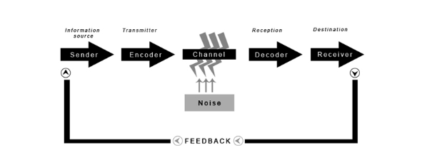
Figure 1: communication model
(Source: Communicationtheory.org, 2022)

4. Definition of IMC:
Integrated marketing communication refers to the all forms of communication messages are linked together for increasing the efficiency of the promotion and brand awareness in the organisation. IMC is a process of communication planning that all brand contacts received by a customer or prospect for a product or service to determine the consistency of the consumer over the time. Integrated marketing communication provides benefits for determining the loyal consumer to the product.

5. New Promotional strategies used by Amazon to boost brand awareness
"Digital marketing strategy" is one of the most vital paths that the multinational organisation Amazon used as the mean of the purpose of promotion of its brand. Through the use of digital marketing, strategy Amazon reaches a large number of customers in order to aware of them the brand. Most importantly, social media has been largely used by Amazon as the mean of digital marketing. This organization advertises its variety of products on social media with the support of Facebook, Instagram, Twitter, and YouTube. Amazon takes the benefits from those who relate to the social sites and sends the link to the pages of Amazon to the people in order to increase brand awareness on a large scale (Caetano, 2021). Through the use of this strategy, brand awareness has been increased for Amazon and besides that, the sales of the products have been largely boosted. Most importantly, this made up for the big as well as the small influencers in the country which help to reach its audience more in an effective as well as efficient manner. Electronics and mobiles are the most selling products of the company and the majority of its transaction in online platform made on electronics item.

5.1 Advertising:
Advertising is a way to get in touch with people who use a product or service. According to the definition provided by the Advertising Association of the United Kingdom, advertisements are messages whose senders pay for them and whose purpose is to inform or influence recipients. Amazon uses social media advertising platform with over 12 million products available online for meeting the customers need. In point of fact, according to eMarketer, Amazon outsells ecommerce marketplace eBay and retail giant Wal-Mart to capture nearly half of the entire ecommerce market in the United States (Akram et al. 2018). Amazon uses print media and news paper media for for promoting the offers and selling price of most valuable item.

5.3 Difference between Advertising and sales promotion:
Sales promotion consists of short-term incentives that are offered by identified sponsors to consumers and traders in order to persuade them to purchase and stock his products, while advertising is a message that promotes ideas, goods, or services and is communicated through one or more media by an identified sponsor (Paul, 2018).

6. Branding and brand equity
The branding of Amazon implies the listening of the requirements of the consumers and give response to them. Branding has been mostly used regarding the customer service of Amazon and the thousand off the managers off Amazon give stress on the branding or brand equity. In this regard the “kellers brand equity model” become appropriate in this way:
Identification of brand
Amazon use strong brand identity in order to represent the products to its large number of customers. Most importantly, the customers can rely on this brand and in that case the salience becomes too vital for Amazon (Stukalina and Pavlyuk, 2021).
Communication for the brand
This stage regarding the branding off Amazon contains the performance as well as the imagery. The performance of the brand in Amazon depends on the characteristics of the products, reliability, durability, servicing of the products, effectiveness, efficiency as well as the empathy of the products and services, the style and the design of the product and the price of the products.
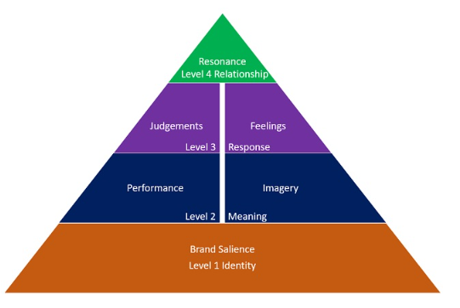
Figure 6: “Kellers brand equity model”
(Source: Kodrat and Melinda, 2021)
Presentation of brand to customers
The customers of Amazon continuously make assumption regarding the service and the product of this brand. This stage is known as the stage of observation on a large scale (Francis et al. 2021).
Making of relationship with customers
This stage implies the resonance and brand resonance is tough for the customers to reach to the brand and it makes the relationship with the customers and the brand. Loyalty program, engagement off customers through social media, and making of the emotional connection from the perspective of Amazon are the integral part of this.

6.1 Advantages and disadvantages of the Keller’s brand Equity model:
Advantages: Kellers brand identity model establishes the brand awareness and promotes brand identity for the organisation. The model creates brand knowledge for the consumer to get unique experience of the product. Promotion of brand knowledge creates consumer response to the market.
Disadvantages: Highly competitive in nature as creates niche competition in the same industry.

7. Brand awareness strategy used by Amazon:
There is different innovative strategy the organization follows in case the sale and marketing strategy (de Oliveira et al. 2019). In general, the company may set their prices moderately in order to appeal to the "urban crowd". The corporation limits the price that can be combined based on local customs. The business offers top-notch goods for sale at fair market rates (Ahler, et al. 2019). The business operates in India and the US according to a worldwide protocol that benefits individuals in all nations equally. Additionally, "Competitor-based pricing and product cost-based pricing”, which is advantageous to increase in the Indian and US retail, market (Aversa et al. 2012). According to this strategy, the business should base the price of its product on the product variations of the competition. If not, the product value won't be acceptable to the target market. Because of this, the business should "study competitors' prices" and "study the local market" (Huang et al. 2020).

8. Overview
In this statement analysis, the different financial ratios such as liquidity ratio, investment ration, profit ratio, company capital, and Amazon is based on the US which captures the whole use market. This chapter, there is an analysis of Amazon’s company in marketing strategy. Moreover, the investigation of the total income and gross sales of the company and net worth helps to determine position (Strand et al.2018). This provides the company to understand of the company's financial condition and overall profit ( Cortner et al. 2029). In this analysis, eBay is taken as a competitor and taking g the data of eBay and comparing these two companies' financial growth and profit from "2017 to 2018’. Amazon has been channelled with further reduction, but the association and public acceptability of the context have been reduced by "up to 80%". The central authority of the organization must create creative policies in this current situation to increase satisfaction and ensure that all rights to protection are properly analyzed and managed, particularly in the US (Antunes et al.2019).
The company uses some marketing development strategies to innovate need innovate in the marketing development (amazon.in, 2022). The company basically follows the stagy like “Cover the basics", "Invest more in advertising", '" Bring in more off-Amazon traffic", "Use a coupon with Amazon advertising", and "Invest in high-quality videos". These are the main strategy the company needs to follow. Company use
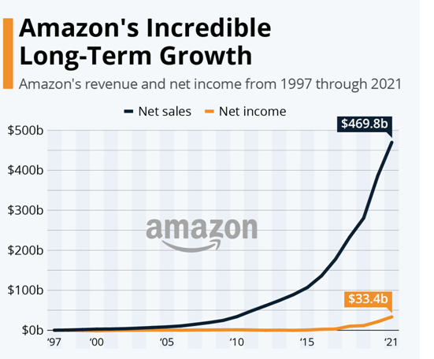
Figure 1: Amazon's Incredible Long-Term Growth
(Source: statista.com)

9. Current challenges of the organization
The Organization has some innovative strategies to build a strong marketing plan in the UK market although the organization faces some challenges in the US business marking. the key challenge that the company faces in the US market that is "Compromised Cash Flow", "High Degree of Competition”, “Packaging Restrictions, "Strict Inventory Expectations", "High Amazon Fees", and "Way Forward"(Mazzone, A., 2020).
Nevertheless, other academics believe that Amazon will lose "$1.08 and -$0.07" in 2022. According to "Amazon.com, Inc. (AMZN)" data analysis The Company’s highest estimate for the upcoming year is "121.39 billion," its highest estimate for the upcoming year is "133.37 billion," and its highest estimate for the upcoming year's sales growth is "8.7%" (Lai et al. 2022).The trader and the investor are making investments in the massive e-commerce sector with the expectation that the stock will increase in value and yield large returns in the future. In the upcoming few years, Amazon stock "(AMZN stock)" will return “$200”. The corporation suddenly "froze its employment activity," according to the TV report and the social media analyst, because it has an adequate number of employers and no storage (Williamson et al. 2019).
the main challenge that the company faces in the US intention market that are “Amazon Prime is not cheap" Amazon doesn't always offer the best deal", "personally inspect Amazon produce", "It's hard to identify counterfeit products", "Reviews are sometimes misleading", "It's not always the most convenient choice", "Online returns may be a hassle". The business offers top-notch goods for sale at fair market rates. The business operates in India and the US according to a worldwide protocol that benefits individuals in all nations equally (Bennett et al. 2018).
The online transaction missed there for the customer period the negative feedback that make a negative impact bayou the company in the us international business market, the revise in the company produce some time strategy to the customer satisfaction the customer buy the wrong product. The delivery process of the Amazon faces different challengers in the US marketing development. Amazon faces in the US market that is “Continuous Fulfillment”, moreover, “Intensive Management", "Better Automation", "Bigger Warehouses" is the key issue of the company. "Last-Mile Logistics"
"Imitable business model" another problem the company face in the US marking. The limited physical present in the international market is cause a challenges issue for the company. Moreover, the company has not any physical stoke in the global countries. Therefore the company faces issue in the AI system. Accosting to the global research the more hazarded the company facing is “Amazon Prime is not cheap”, Amazon doesn't always offer the best deal, “personally inspect Amazon produce”, It’s hard to identify counterfeit products”, “Reviews are sometimes misleading’, “It’s not always the most convenient choice”, “Online returns may be a hassle”. The trader and the investor are making investments in the massive e-commerce sector with the expectation that the stock will increase in value and yield large returns in the future.

10. Market development strategies
Throughout the year, the group of Amazon Company develops fresh concepts of marketing strategies in the US business. The company's ability to be sustainable in the future will constantly benefit from new technologies. According to certain predictions, the corporation would likely experience minor losses in 2023. Therefore, it's possible that the company needed fresh technological advancement to boost its annual income. The fundamental method for improvement is working with a reputable business or brand. The costume promotes this positional strategy. Both the participating company and Amazon will benefit from the partnership by gaining customers.
These are the primary needs for the year 2023. The corporation should therefore adapt its data management technique after considering the enormous dynamic potential. There is a significant gap in the subset due to the enormous geophysical diversity. The customer's preferences vary, thus diversity is avoided. The business must ensure that the data analysis is tailored to the demographics. Amazon is ranked among the top 100 fastest-growing companies for the year 2022, but there are a few issues to consider for the foreseeable future. The important technological innovation strategy that the company needs to develop in ore they make in order to sustainably in the US market are “Internet Business innovation", "And Internet Business innovation", Customer service innovation". These innovations help full to prove the technical support to the company in the US market. The organization needs to develop a marketing strategy to compete with the new competitor in the US (Huera-Lucero et al.2020).
The best marketing strategy that the company needs to follow up the in the UK business market is "print and digital advertising", which is the new generation technique hare to promote the project and attract the customer (Rahe et al. 2019). In addition the company also provides "promotions", "product placement", and "pay-per-click (PPC) campaigns" to increase the sales. the company in the US also manages the managing communication strategy such as "Increase customer traffic to our websites", "Create awareness of our products and services", "Promote repeat purchases", "Develop incremental products" and "service revenue opportunities", "Strengthen and broaden the Amazon.com brand name". The company has some unique strategies to develop their market dement in the US market.
Jeff Bozos the founder who started this company in “Bellevue, Washington”, from the stating the company has a unique marketing development strategy in the US Market in to build its innovation in the business market. Therefore this report is mainly highlighted the innovation strategy that the company takes in order to gain the marketplace in the international business industry. The company gained suitability in 2017; hence the company stated its physical store as a footprint. The business operates in India and the US according to a worldwide protocol that benefits individuals in all nations equally. Therefore, its sales and increase production Amazon is the greatest e-commerce company in the international market.

11. Customer touch point
The customer touch point is an integral part regarding the business of Amazon on a large scale. This section majorly implies the “AWS” or “Amazon Web Services”. On the basis of this the major business of Amazon depends on.
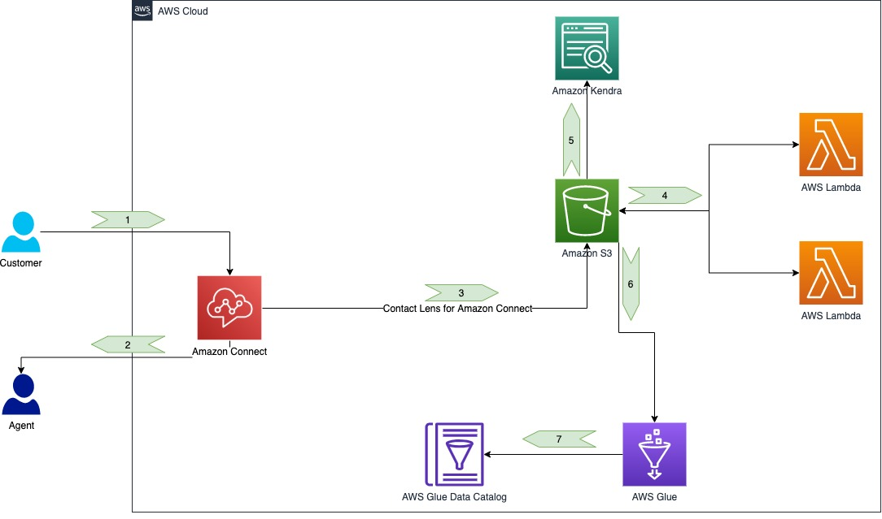
Figure 12: Customer Touchpoint of Amazon
(Source:Amazon.in, 2022)

12. Customer Journey Map
“Customer Journey Map” refers to the representation of all the journey phases of the consumers with the company visually. It will help to strengthen the relationship between the company and its consumers. The “customer experience” can be assessed by reflecting the “Customer Journey Map” (Shiratori et al. 2021). The phases of the "Customer Journey" have been identified and detailed elaboration has been represented in tabular form. A consumer named "Richard" has been chosen among all the consumers of Amazon and the consumers' activities, feelings, needs and potential opportunities will be illustrated in the "Consumer Journey Map".
Creation of customer journey map:
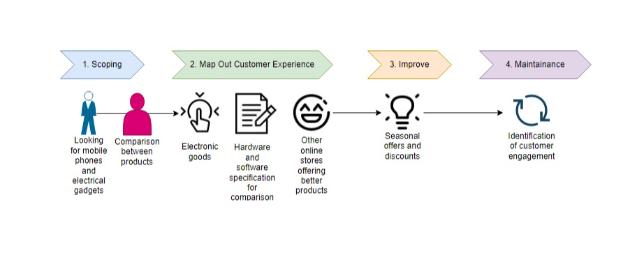
Figure 13: Customer journey creation

Customer journey map | Awareness | Discover | Purchase | Use | Bond
Website |  | 3) Review of available products |  | 7) Review of product and service
Store |  | 5) Stock of potential phone in store | 6) New phone purchase
Call center
Face book
Web Forum |  | (4) Reviewing phones for better option
Word of mouth |  |  |  |  | 8) Express positive interest on phone
Email | (2)Searching in E-mail for updates
Post |  |  |  |  | (1)Existing customer with online shopping

Table 1: Customer Journey Map
(Source: Self-developed)
The above Journey Map has described Richard’s needs, feelings and activities in the relationship with Amazon Company.

13. “Total engagement mode / definition / explain in customer journey”
The map indicating customer journey related to Amazon is effective in handling the brand value and a healthy commercial relation. The engagement mode accentuates the factors related to “customer value proposition, brand advertising, culture, and customer experience” related to the e-commerce platform of Amazon (Amazon.in, 2022). As per its definition, the “customer journey” helps in mitigating the consumer needs and complements the market demand. As per its accessibility standard, Amazon requires to increase a proper structure based on the market factors like stores or online services.

15. Innovative marketing strategies for raising brand awareness
It seems that brand awareness can be considered one of the must-have business portfolios that can help the company in developing long-term business modules. A brand awareness campaign has also helped companies in enhancing sustainable business growth and so on. In case of the global business expansion, it is very necessary to improve the brand recognition strategy as well as the brand awareness strategy (Algharabat et al. 2020). Therefore; the companies must have implemented several innovative marketing strategies to enhance marketing factors and so on. In order to improve brand awareness and sales drive of the company it is quite essential to know about market research.
Based on the research it can be stated that brand awareness can be also considered as the measurement based on which the consumer can identify the business quality and services. "Brand awareness is a concept that touches on many different KPIs, from traffic to social share of voice". It seems that the strong brand awareness of the company can refer that the company has been searched by consumers (Bhimani et al. 2019). However; in this current consumers are providing their thoughts on the website of the company, which can also help in increasing brand awareness as well as brand recognition. Therefore; it is quite essential for companies to implement several strategies in order to improve the higher brand awareness rate. Thus; the company has also developed social content in order to communicate with several stakeholders and consumers (Bilgin, 2018). It can help companies in developing a long-term consumer base. Besides that, the stakeholder's engagement can be also considered as one of another process of improving barbed awareness as well as the brand recognition process. It may help the business organization in enhancing business properties as well as help the business industry in mitigating consumers' demands of the business industry (Ebrahim, 2020).
Therefore; as one of the well-known e-commerce business organizations Amazon should have implemented several strategies and innovative business marketing modules in order to improve its brand awareness (Fahy and Jobber, 2019). However, it is quite essential for the e-commerce business organization to maintain the brand awareness process. It can help them in enhancing business productivity as well as business feasibility. On the other hand; some of the researchers have also shared that, most valuables business organizations are having most high-level recognition rates, although thus the company can be considered one of the largest retailers in the UK the company has been expanding its business entity through globalization well as whole worlds (Foroudi et al. 2019). therefore; it is quite essential for the e-commerce giant to improve its brand awareness as well as stakeholder engagement, in this research study; several strategies have been described to improve barbed awareness and brand recognition. In addition; it can also help the company improve business productivity and feasibility (Hien et al. 2019).
Therefore; innovative marketing strategies should include:
Rebranding:
It seems that rebranding can be considered one of the recognizable marketing strategies that can help in improving the rebranding process. It can help the company in improving barbed witness and so on. It can also help companies in improving their business objectives and goals of the company (Iglesias et al. 2021). The rebranding process can also help the company in enhancing business opportunities, the other huge brands will also collaborate. Thus; it can be stated that the companies should have implemented the rebranding process to enhance their bard awareness process.
Retaining existing customers:
It seems that the business organization should have implemented several strategies to retain the consumer's rate. During the covid-19 pandemic solution, it becomes so challenging for companies to retain their consumption rate. Most business organizations are facing huge business challenges, during this phase. Thus, it is necessary to improve innovative marketing strategies to retain consumers' experiences and consumers rates (Krizanova et al. 2021). Besides that during the recent pandemic age; Amazon has been to maintain its highest sales rate activities due to developing a well-built service system. The company has been sending products to the doorstep of consumers. Therefore; most of the consumers shared good reviews. It can help the company in improving its brand awareness capabilities as well as other perspectives.
Expanding business at the new business region:
It seems that; the company must have implemented several strategies in order to expand the business entity in the new region (Liulov et al. 2021). It can help the company in enhancing its global; presence and the global presence of the company can also help in improving business objectives as well as the business environment. Amazon itself is a global business environment; therefore, the company should improve its global presence more in order to enhance brand awareness strategies (Lou and Yuan, 2019). It can also help the company in improving IRS brand marketing as well as the content marketing process. The company can also improve the digital marketing process in that particular region. Thus; it is necessary for the companies to improve business criteria as well as business perspectives in order to enhance its global presence.
Increasing the social media presence
It seems that the company should improve the presence of the social media platform in order to enhance business criteria and so on. The presence of the social need can help the company in improving social media marketing. It can also help the company in improving consumers' preferences and so on. This; it can be stated that the company must have implemented several strategies to implement the business Strategy. It seems that brand awareness can be considered one of the must-have business portfolios that can help the company in developing long-term business modules (Paul, 2019). A brand awareness campaign has also helped companies in enhancing sustainable business growth and so on. In case of the global business expansion, it is very necessary to improve the brand recognition strategy as well as the brand awareness strategy. Therefore; improving the social media presence can help the company in enhancing its business cafeteria as well as raising awareness regarding brand awareness (Fahy and Jobber, 2019).
Improving stakeholder communication
In addition, improving stakeholder engagement can be also considered as one of the processes of raising the brand awareness of other companies. It can help the company in improving several business perspectives. However; it is necessary

15. Conclusion
The research study has been concluding that; multinational company has its online facility all over the globe. In this budget, the statement describes the different types of financial ratios on the basis of the financially profitable ratio besides that; the strategically approaches of the company. It has been also developed in thus research study. It seems that the company should improve the presence of the social media platform in order to enhance business criteria and so on. The presence of the social need can help the company in improving social media marketing. The study also concludes that; Amazon has adopted many special features for the Indian and Chinese markets For instance; Amazon provides sales in the Indian festival to gain the attention of the customers and increase the customer engagement rate with the company.

References
Ahler, D.J., Roush, C.E. and Sood, G., 2019. The micro-task market for lemons: Data quality on Amazon's Mechanical Turk. Political Science Research and Methods, pp.1-20.
Algharabat, R., Rana, N.P., Alalwan, A.A., Baabdullah, A. and Gupta, A., 2020. Investigating the antecedents of customer brand engagement and consumer-based brand equity in social media. Journal of Retailing and Consumer Services, 53, p.101767.
Amazon.com, 2022. “spend less. smile more”. Available at: https://www.amazon.com/ (Accessed: December 15, 2022).
Amazon.in, 2022. Amazon. Available at: https://www.amazon.in/. [Accessed on: 20.12.2022]
Antunes, A.P., Rebêlo, G.H., Pezzuti, J.C.B., de Mattos Vieira, M.A.R., Constantino, P.D.A.L., Campos-Silva, J.V., Fonseca, R., Durigan, C.C., Ramos, R.M., do Amaral, J.V. and Pimenta, N.C., 2019. A conspiracy of silence: Subsistence hunting rights in the Brazilian Amazon. Land use policy, 84, pp.1-11.
Athayde, S., Mathews, M., Bohlman, S., Brasil, W., Doria, C.R., Dutka-Gianelli, J., Fearnside, P.M., Loiselle, B., Marques, E.E., Melis, T.S. and Millikan, B., 2019. Mapping research on hydropower and sustainability in the Brazilian Amazon: advances, gaps in knowledge and future directions. Current Opinion in Environmental Sustainability, 37, pp.50-69.
Aversa, P., Haefliger, S., Hueller, F. and Reza, D.G., 2021. Customer complementarity in the digital space: Exploring Amazon’s business model diversification. Long Range Planning, 54(5), p.101985.
Bennett, A., Ravikumar, A. and Paltán, H., 2018. The Political Ecology of Oil Palm Company-Community partnerships in the Peruvian Amazon: Deforestation consequences of the privatization of rural development. World Development, 109, pp.29-41.
Bhimani, H., Mention, A.L. and Barlatier, P.J., 2019. Social media and innovation: A systematic literature review and future research directions. Technological Forecasting and Social Change, 144, pp.251-269.
Bilgin, Y., 2018. The effect of social media marketing activities on brand awareness, brand image and brand loyalty. Business & management studies: an international journal, 6(1), pp.128-148.
Caetano, M.A.L., 2021. Political activity in social media induces forest fires in the Brazilian Amazon. Technological Forecasting and Social Change, 167, p.120676.
Cortner, O., Garrett, R.D., Valentim, J.F., Ferreira, J., Niles, M.T., Reis, J. and Gil, J., 2019. Perceptions of integrated crop-livestock systems for sustainable intensification in the Brazilian Amazon. Land use policy, 82, pp.841-853.
Dawes, J., 2018. The Ansoff matrix: A legendary tool, but with two logical problems. But with Two Logical Problems (February 27, 2018).
de Oliveira, A.S., Rajão, R.G., Soares Filho, B.S., Oliveira, U., Santos, L.R., Assunção, A.C., van der Hoff, R., Rodrigues, H.O., Ribeiro, S.M., Merry, F. and de Lima, L.S., 2019. Economic losses to sustainable timber production by fire in the Brazilian Amazon. The Geographical Journal, 185(1), pp.55-67.
Ebrahim, R.S., 2020. The role of trust in understanding the impact of social media marketing on brand equity and brand loyalty. Journal of Relationship Marketing, 19(4), pp.287-308.
Fahy, J. and Jobber, D., 2019. EBOOK: Foundations of Marketing, 6e. McGraw Hill.
Foroudi, P., Jin, Z., Gupta, S., Foroudi, M.M. and Kitchen, P.J., 2018. Perceptional components of brand equity: Configuring the Symmetrical and Asymmetrical Paths to brand loyalty and brand purchase intention. Journal of Business Research, 89, pp.462-474.
Francis, S. and Samuel, B., The Digital Marketing Power of Transmedia: Applying Keller’s Brand Resonance Pyramid to the Marvel Cinematic Universe. In Transmedia Earth Conference Medios, narrativas y audiencias en contextos de convergencia (p. 235).
Grünig, R., Kühn, R. and Morschett, D., 2022. Developing and Assessing Strategic Options for the Company. In The Strategy Planning Process (pp. 111-122). Springer, Cham.
Gyenge, B., Máté, Z., Vida, I., Bilan, Y. and Vasa, L., 2021. A new strategic marketing management model for the specificities of E-commerce in the supply chain. Journal of Theoretical and Applied Electronic Commerce Research, 16(4), pp.1136-1149.
Hien, N., Phuong, N., Tran, T.V. and Thang, L., 2020. The effect of country-of-origin image on purchase intention: The mediating role of brand image and brand evaluation. Management science letters, 10(6), pp.1205-1212.
Huang, Y., Obada-Obieh, B. and Beznosov, K., 2020, April. Amazon vs. my brother: How users of shared smart speakers perceive and cope with privacy risks. In Proceedings of the 2020 CHI Conference on Human Factors in Computing Systems (pp. 1-13).
Huera-Lucero, T., Labrador-Moreno, J., Blanco-Salas, J. and Ruiz-Téllez, T., 2020. A framework to incorporate biological soil quality indicators into assessing the sustainability of territories in the Ecuadorian Amazon. Sustainability, 12(7), p.3007.
Iglesias, O., Markovic, S. and Rialp, J., 2019. How does sensory brand experience influence brand equity? Considering the roles of customer satisfaction, customer affective commitment, and employee empathy. Journal of Business Research, 96, pp.343-354.
Khajezadeh, M., Niasar, M.S.F., Asli, S.A., Davari, D.D., Godarzi, M. and Asgari, Y., 2019. Application of neural network in portfolio product companies: Integration of Boston Consulting Group matrix and Ansoff matrix. International Journal of Economics and Management Engineering, 13(6), pp.821-825.
Kodrat, D.S. and Melinda, T., 2021. CREATING A BRAND STRATEGY FOR THE FOOTWEAR INDUSTRY.
Krizanova, A., Lăzăroiu, G., Gajanova, L., Kliestikova, J., Nadanyiova, M. and Moravcikova, D., 2019. The effectiveness of marketing communication and importance of its evaluation in an online environment. Sustainability, 11(24), p.7016.
Lai, G., Liu, H., Xiao, W. and Zhao, X., 2022. “Fulfilled by Amazon”: A Strategic Perspective of Competition at the e-Commerce Platform. Manufacturing & Service Operations Management.
Liulov, O.V., Chyhryn, O.Y. and Pimonenko, T.V., 2018. National brand as a marketing determinant of macroeconomic stability.
Lou, C. and Yuan, S., 2019. Influencer marketing: how message value and credibility affect consumer trust of branded content on social media. Journal of Interactive Advertising, 19(1), pp.58-73.
Mazzone, A., 2020. Thermal comfort and cooling strategies in the Brazilian Amazon. An assessment of the concept of fuel poverty in tropical climates. Energy Policy, 139, p.111256.
Niemczyk, J., Trzaska, R. and Trzaska, M., 2019. Scalability 4.0 as the main rent in Industry 4.0: the case study of Amazon. Informatyka Ekonomiczna. Prace Naukowe Uniwersytetu Ekonomicznego we Wrocławiu, (2 (52)).
Paul, J., 2019. Masstige model and measure for brand management. European Management Journal, 37(3), pp.299-312.
Rahe, V., Buschow, C. and Schlütz, D., 2021. How users approach novel media products: Brand perception of Netflix and Amazon Prime video as signposts within the German subscription-based video-on-demand market. Journal of Media Business Studies, 18(1), pp.45-58.
Sastry, V.V.L.N., Katvi, S. and Tourani, P., 2019. AMAZON’S STRATEGIC ANALYSIS AND IT’S ENTERPRISE STRATEGY FOR THE CLOUD. Advance and Innovative Research, p.186.
Shiratori, E.K.A., Trevisan, A.H. and Mascarenhas, J., 2021. The customer journey in a product-service system business model. Procedia CIRP, 100, pp.313-318.
Strand, J., Soares-Filho, B., Costa, M.H., Oliveira, U., Ribeiro, S.C., Pires, G.F., Oliveira, A., Rajao, R., May, P., van der Hoff, R. and Siikamäki, J., 2018. Spatially explicit valuation of the Brazilian Amazon forest’s ecosystem services. Nature Sustainability, 1(11), pp.657-664.
Stukalina, Y. and Pavlyuk, D., 2021. Using customer-based brand equity model in the higher education context: simulating the current university’s brand. Business, Management and Economics Engineering, 19(2), pp.272-288.
Williamson, B., Gulson, K.N., Perrotta, C. and Witzenberger, K., 2022. Amazon and the new global connective architectures of education governance. Harvard Educational Review, 92(2), pp.231-256.
Akram, U., Hui, P., Khan, M.K., Tanveer, Y., Mehmood, K. and Ahmad, W., 2018. How website quality affects online impulse buying: Moderating effects of sales promotion and credit card use. Asia Pacific Journal of Marketing and Logistics.
Paul, J., 2018. Toward a'masstige'theory and strategy for marketing. European Journal of International Management, 12(5-6), pp.722-745.

