Assignment Title
Digital Skills and Research Methods

Group B
Ratchada Caliendo-Chan
(1916134)
Danna Michelly Quinones Rodriguez
(1916136)

Programme
Certificate of Higher Education in Skills for the Workplace
(Digital Skills and Research Methods)

Module Code
BMSW 4003

Lecturer
Balendran Kandasamy

Assignment Due Date

7th May 2020

Table of Contents

- Slide 1................................................................................................................ p. 3

- Slide 2................................................................................................................ p. 4

- Slide 3................................................................................................................ p. 5

- Slide 4................................................................................................................ p. 6

- Slide 5................................................................................................................ p. 7

- Slide 6................................................................................................................ p. 8

- Slide 7................................................................................................................ p. 9

- Slide 8................................................................................................................ p. 10

- Slide 9................................................................................................................ p. 11

- Slide 10.............................................................................................................. p. 12

- Slide 11...............................................................................................................p. 13

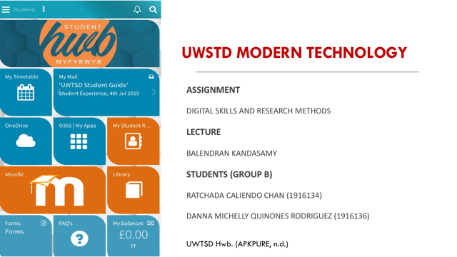
SPEAKER 1: RATCHADA CALIENDO-CHAN (1916134)

This presentation will show how the University of Wales Trinity Saint David uses modern technology to improve its University efficiency in these elements.
The presentation includes:
- The background of the University.
- The challenges before the introduction of modern technology.
- Insights to the modern technology introduced
- The impact of the technology introduced.
- Lessons that can be drawn from the case study.

Please see the link to our PowerPoint presentation, Available at: https://uowtsd-my.sharepoint.com/:p:/g/personal/1916134_student_uwtsd_ac_uk/EZF8aUD1VVpEnd12YtiMcx0BBRwxKhCU_B6eSpwbqV-ZxA?e=F9kp1X

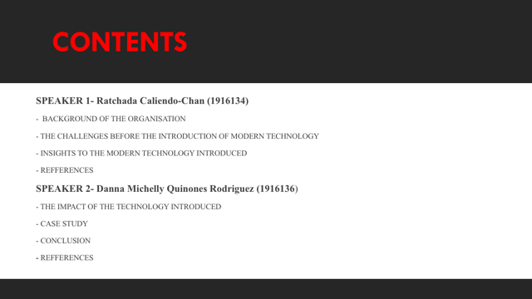
SPEAKER 1: RATCHADA CALIENDO-CHAN (1916134)

The first part of the presentation will be presented by speaker 1 which includes, the background of the University, the challenges before the introduction of modern technology and insights to the modern technology introduced.

The second part of the presentation will be presented by speaker 2 which includes the impact of the technology introduced, lessons that can be drawn from the case study.

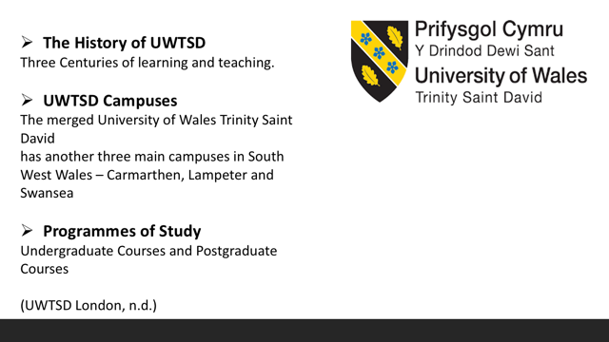
SPEAKER 1: RATCHADA CALIENDO-CHAN (1916134)

The History: University of Wales Trinity Saint David was established in 2010 through the merger of the University of Wales Lampeter and Trinity University College, Carmarthen. On 1 August 2013 Swansea Metropolitan University merged with UWTSD. The University’s 1828 Royal Charter is the oldest in Wales and the third oldest in Wales and England after Oxford and Cambridge. HRH the Prince of Wales is the Patron of the University. Following the merger, substantial progress has been made on integrating the governance and academic frameworks of the founding institutions. The History of UWTSD (UWTSD London, n.d.)
Other Campuses: University of Wales Trinity Saint David has three campuses in Carmarthen (founded 1848), Lampeter (founded 1822), London (established 2010/operating since 2012) and Swansea (founded 1853). It also has a presence in Cardiff with the Wales International Academy of Voice and, through its dual-sector partners, in Aberystwyth, Ammanford, Cardigan and Llanelli. There is no single ‘main’ or ‘home’ campus. The geographical spread of the University has seen the development of strategies for multi-campus working, including effective video-conferencing facilities and shared electronic resources. All staff have a ‘home’ campus in the sense of an office base, but the majority will work across campuses. The University’s London campus, or ‘UWTSD London’, has been operational since March 2012. It was originally located in Islington, however, in October 2013 it relocated near Kennington Park and the Oval cricket grounds in the heart of London. Other Campuses (UWTSD London, n.d.)
Programmes of Study Undergraduate Courses: Business Management (BA (Hons), Cloud Computing (BSc (Hons) Health and Social Care BSc (Hons), Leadership and Management Skills for the Workplace (BA) (Hons), Skills for the Workplace (CertHE) and Skills for the Workplace (Health & Social Care) (CertHE). Postgraduate Courses: Banking and Finance (MBA), Doctor of Business Administration, Entrepreneurship (MBA), General Management (MBA), Human Resource Management (MBA), Information Management (MBA) and Marketing (MBA).Historically the University and its founding institutions have placed their degree-awarding powers in abeyance and offered degrees of the University of Wales. UWTSD began to award its degrees in July 2014. Programmes of Study (UWTSD London, n.d.)
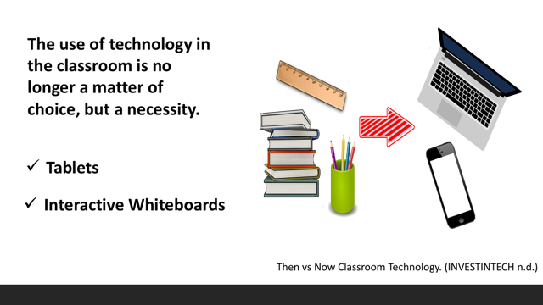
SPEAKER 1: RATCHADA CALIENDO-CHAN (1916134)
Tablets have successfully succeeded books and those old bulky computers. Students don’t need to lug heavy stuffed backpacks around anymore. They can go beyond the boundaries of a book and find the most up-to-date information in a matter of seconds. Although some educators argue that tablets are only hampering student's attention span, the vast majority highlights the benefits of using these devices in classrooms.
To quote from INVESTINTECH (n.d.), “According to a survey, 81% of teachers believe tablets enrich classroom education. First of all, they are intuitive and easy to use, even toddlers know how to use them. Also, there is a myriad of educational smartphone and tablet apps that can be installed with a few taps of a finger. Furthermore, having a device that replaces school supplies like books, calculators, pen and paper is quite handy and money-saving.” Some of us may remember the old days when we had to turn in our assignments on a sheet of paper; it is now history. The submission has to be digital via tablets. Student turn in homework online and Lecturer will grade them in no time.
Interactive whiteboards were not conceived as teaching tools when it first came out in a known, instead, they were first used for office presentations. Not until after Lecturers realized the great potential of it. Interactive whiteboards make the learning more interactive and entertaining and especially these boards replaced chalk and dusty blackboards for noble. It is really good for lecturer and student’s health all round. Moreover, these smart boards enable student’s learning experience and participation is enhanced. They are more involved and attentive as they do not need to worry about note-taking. Also, students simultaneously write and solve Lecturer to cover the teaching materials in creative and entertaining ways that were not possible before. Also, various tasks on interactive whiteboards. This leads to better collaboration among themselves as they try to find the best solutions as teamwork. Then vs Now Classroom Technology. (INVESTINTECH, n.d.)

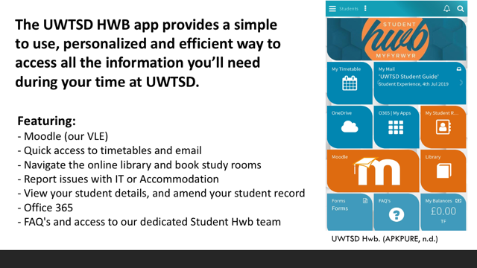
SPEAKER 1: RATCHADA CALIENDO-CHAN (1916134)
Benefits of Myday
The UWTSD HWB app provides a simple way for students and staff to use, personalised and efficient way to access all the information teamwork among themselves as they try to find the best solutions as a team. The app includes academic support, finance queries, campus life, health and wellbeing, and so much more; it is a one-stop-shop for all UWTSD queries. My day enhances the academic experience and drives result for the campus. The app allows staff and students to be connected when on the go increasing engagement, satisfaction and ultimately retention rates. It is an intuitive design and practical use increases participation whilst UWTSD can cut the IT and administrative costs down. The platform allows UWTSD to connect its existing systems without lengthy coding or large resource requirements which is good for students who want the ability to manage their lives by having access to all relevant information at any given time, from any location. Myday also has several of bespoke features to assist in building UWTSD’s digital campus to meet those needs. Myday additional services make developing and launching UWTSD digital campus quicker and easier. Myday presents an easy to use and intuitive interface which enables push notifications to deliver key messages to users. This is via both the web and a mobile device. A native mobile app is available in the stores for all Myday subscribers. Access a full Myday experience on the move, online or offline. It is built in the cloud enabling quick deployment, global scalability, frequent updates and a high level of security that UWTSD can rely on. Connecting all systems is one of the most effective ways to reduce costs for UWTSD, increase quality, and standardise processes. By ensuring all its systems and their data are integrated, its institution will be able to improve on its connection with students, staff and visitors. Hence, Myday is a highly personalised and secure student portal. Increasing student engagement leads to an increase in UWTSD retention rates which results in a more profitable and reputable campus. UWTSD Hwb. (APKPURE, n.d.). Myday by collabco. (Myday by Collabco, n.d.)
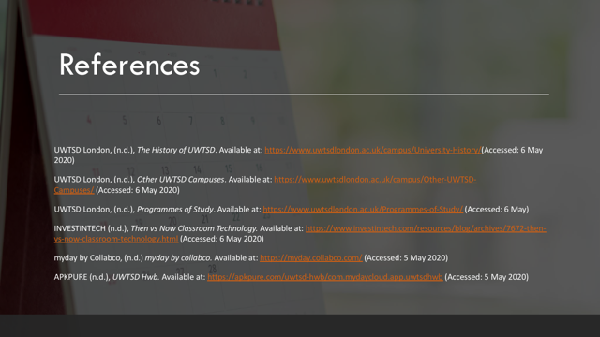
SPEAKER 1: RATCHADA CALIENDO-CHAN (1916134)

References
UWTSD London, (n.d.), The History of UWTSD. Available at: https://www.uwtsdlondon.ac.uk/campus/University-History/(Accessed: 6 May 2020)
UWTSD London, (n.d.), Other UWTSD Campuses. Available at: https://www.uwtsdlondon.ac.uk/campus/Other-UWTSD-Campuses/ (Accessed: 6 May 2020)
UWTSD London, (n.d.), Programmes of Study. Available at: https://www.uwtsdlondon.ac.uk/Programmes-of-Study/ (Accessed: 6 May)
INVESTINTECH (n.d.), Then vs Now Classroom Technology. Available at: https://www.investintech.com/resources/blog/archives/7672-then-vs-now-classroom-technology.html (Accessed: 6 May 2020)
Myday by Collabco, (n.d.) Myday by collabco. Available at: https://myday.collabco.com/ (Accessed: 5 May 2020)
APKPURE (n.d.), UWTSD Hwb. Available at: https://apkpure.com/uwtsd-hwb/com.mydaycloud.app.uwtsdhwb (Accessed: 5 May 2020)

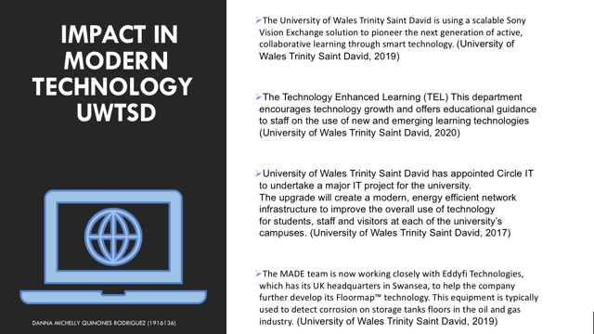

SPEAKER 2: DANNA MICHELLY QUINONES RODRIGUEZ (1916136)

- The University of Wales Trinity Saint David has had a considerable impact in the technological field, being thus a university that works in alliances with institutions, making the university innovative, researching technologies for the improvement of engineering manufacturing products and sustainability throughout wales, thus, also collaborating in projects to detect corrosion on storage tanks.

- MADE that helps businesses evolve in engineering since these businesses can consult and want their services. the funds of the european union for projects counting on the university to go ahead and advance in moving steps for new technologies, which will bring new visions, improvements and innovation in this field.

- Exist The Technology enhanced Learning (TEL) department that help support members of the university in the area of technology through to teaching and researching technology enhanced learning. It also promotes new ways of learning with the tools that the department has; Audio / Visual, visual effects, web design and graphic design.

SPEAKER 2: DANNA MICHELLY QUINONES RODRIGUEZ (1916136)
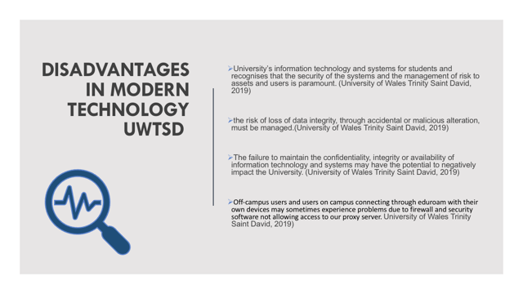
SPEAKER 2: DANNA MICHELLY QUINONES RODRIGUEZ (1916136)

- Any type of error in the development of the technological systems within the university can cause a negative impact and directly or indirectly harm human, non-human, natural, accidental or deliberate, therefore a policy is needed to protect and reduce exposure of the University.

- Another disadvantage when it comes to technology is the irrigation parameters that occur in the system is that there is no complete confidentiality, with modern times privacy has vanished, affecting students.

- It may happen that the campus platform that works with eduroam fails and slows down work or that the signal is lost causing classes, research or homework to be interrupted.
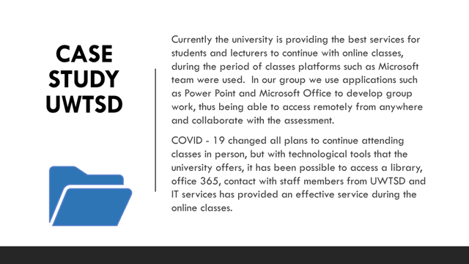

- Microsoft Team was used during the class period, our lecturer Tim, carried out the activities with the Microsoft team, we all participated, reading, quizzes and finally generating questions. The lecturer created through the application of notes, folders that were personalized with each number of the students to write the answers of the quizzes also to contact in case of any questions and in order to check some type of homework he edited the comment in the same notes. The folders were named respectively as class notes, handouts, homework and quizzes.

SPEAKER 2: DANNA MICHELLY QUINONES RODRIGUEZ (1916136)

————————————————————————————————————————

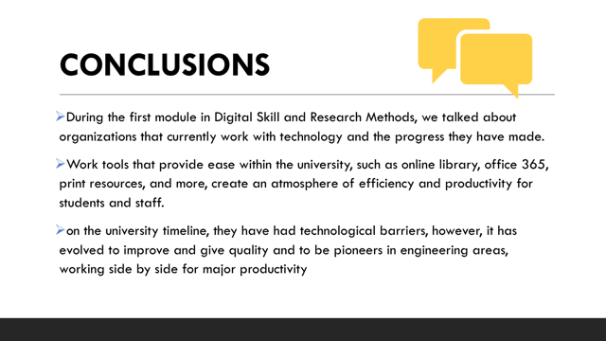

SPEAKER 2: DANNA MICHELLY QUINONES RODRIGUEZ (1916136)

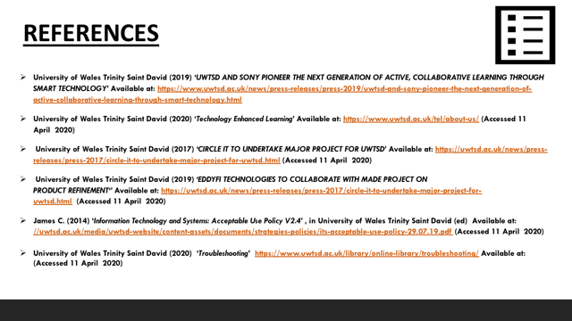
SPEAKER 2: DANNA MICHELLY QUINONES RODRIGUEZ (1916136)

