Statistical Programming (ADDB5021)
Assignment 1: Data manipulation

Adam Smith (2317631)
Digital Degree Apprenticeship

Contents
Code Documentation 3
Code Walkthrough 3
Question 1 3
Question 2 7
Question 3 8
Question 4 10
Reflection 12
Copilot usage and prompts 13

Code Documentation

Question 1
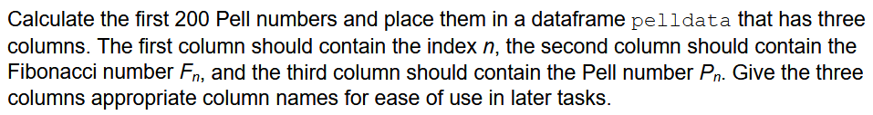

Flow chart (pell)
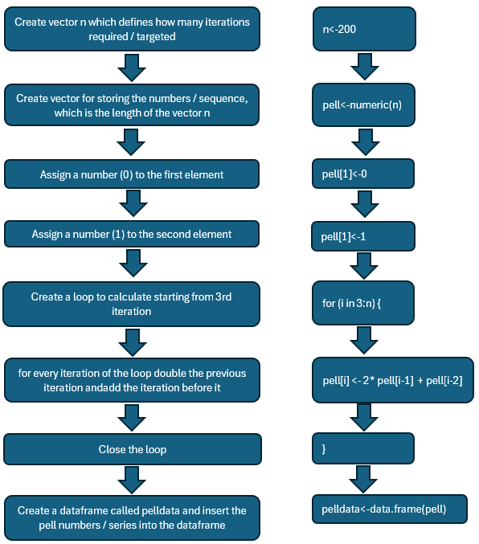

Code walkthrough (pell)
The code starts by stopping scientific notation, forcing R to use full numbers and avoid rounding [1] – this affects all code written after this statement.
A vector is created labelled n which is utilised to store the target number of iterations for all elements of the data frame.
A vector named pell is created which is numeric, the length of the predefined vector n and populated with 0’s.
Numbers are manually assigned to the first 2 iterations – 0 and 1. Once these have been assigned a loop can be created.

A for loop is created, starting from the 3rd iteration which adds the previous 2 iterations together and then multiplies by 2. The loop will run for the predetermined number of 200 iterations.
Once the series has been populated a data frame is created and the series inserted into it and labelled Pell.

Testing (pell)
A visual check is made to ensure the vectors n and pell are created correctly.
A further visual check is made to ensure the first 2 iterations of the vector have been manually assigned as intended, the series calculated correctly and entered into the data frame.
AI was utilised to provide the first 16 iterations of the pell series to check against the series calculated for accuracy checking.

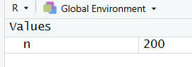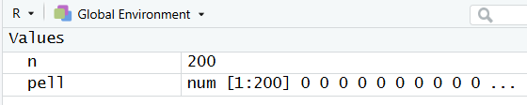
Figure 1 – Vector n, Figure 2 – Vector pell

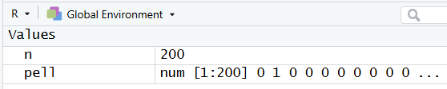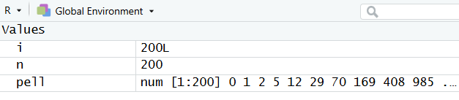
Figure 3 – pell series with first 2 entries added Figure 4 – pell series completed

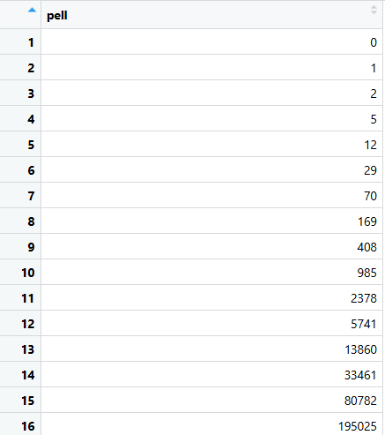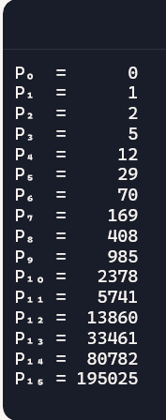
Figure 5 – pell series in data frame Figure 6 – copilot created series

Flow chart (Index_n)
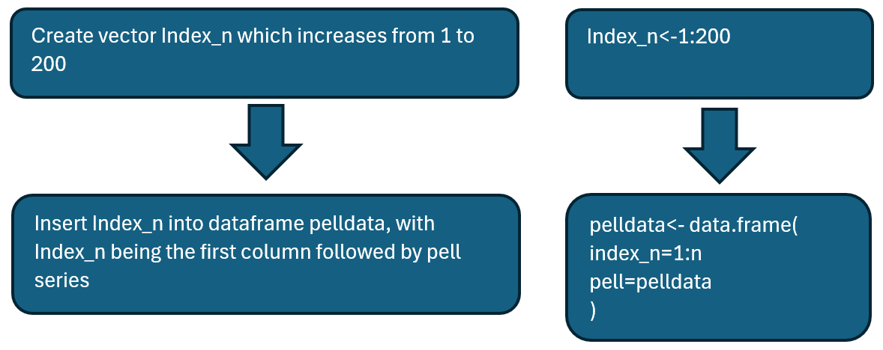

Code (Index_n)
A vector Index_n is created scaling from 1-200.
Index_n is inserted into the data frame pelldata as the first column, followed by the column Pell.

Testing (Index_n)
A visual check is utilised to ensure the creation of the vector Index_n, and that it scales correctly. A visual check is also used to ensure that it has been added to the data frame correctly and in the specified order.

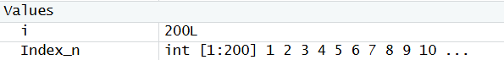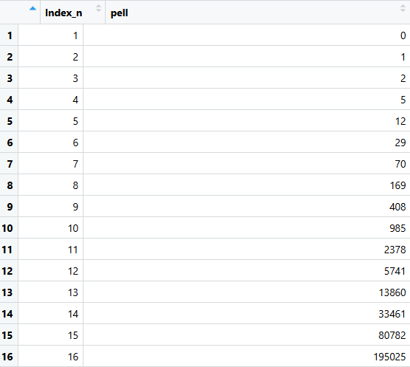
Figure 7 – Index_n vector created, scaling from 1 to 200 Figure 8 – Index_n added to pelldata data frame in specified order of columns

Flow chart (fib)
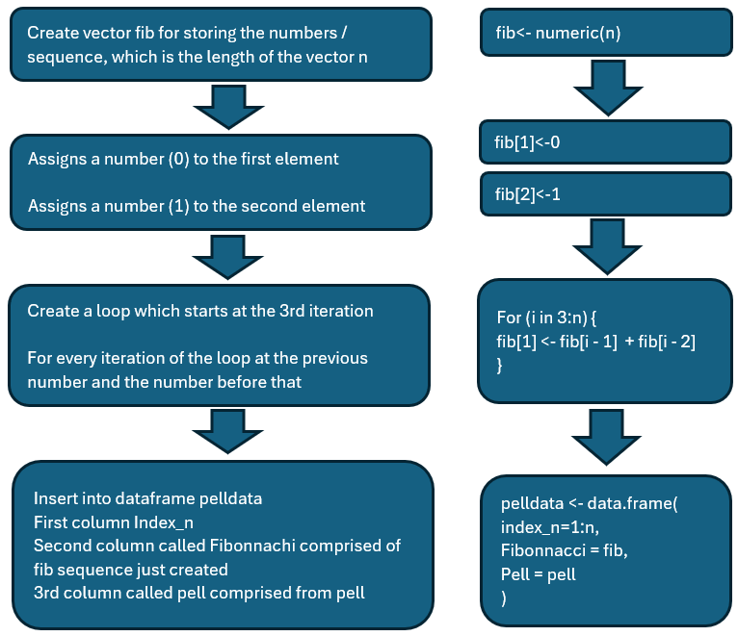

Code walkthrough (fib)
A vector fib is created which is numeric, the length of the predefined vector n and populated with 0’s.
The first 2 iterations of the fib series are manually assigned as 0 and 1.
A for loop is created, starting from the 3rd iteration, whereby the previous 2 iterations are added together for the predetermined number of 200 iterations.
The data frame pelldata is overwritten, starting with column Index_n, the second column named Fibonnaci, consisting of the newly created fib sequence, and a third column called Pell consisting of the pell series.

Testing (fib)
A visual check is made to ensure the vector fib is created, the first 2 iterations populated correctly and the series filling the vector correctly.
A visual check that the series has been added to the data frame correctly and in the specified order. AI has been utilised to check the sequence is produced correctly. MS Copilot was asked to produce the first 16 iterations of the sequence which are then checked against the sequence generated to ensure they match.

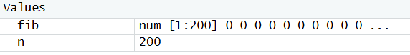
Figure 9 – vector fib created containing 200 numbers populated with 0’s

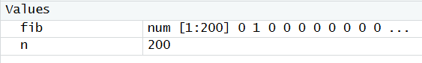
Figure 10 – first 2 iterations manually assigned

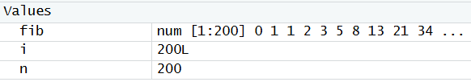
Figure 11 – fib series populated

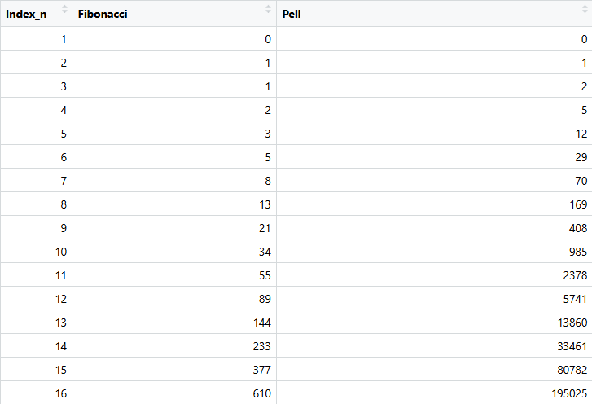
Figure 12 – data frame populated correctly

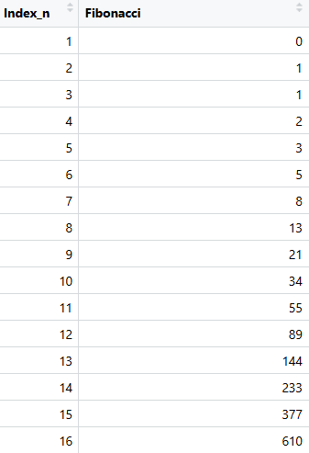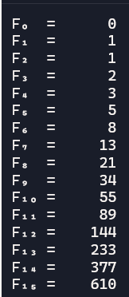
Figure 13 – Fibonacci sequence populated Figure 14 – Copilot generated Fibonacci sequence

Question 2
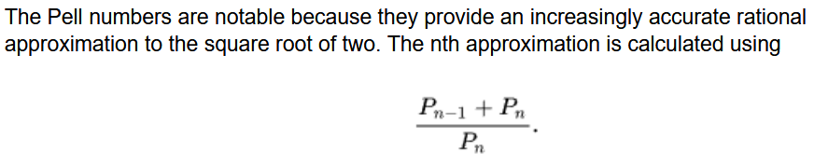

Flow chart (pell_ratio)
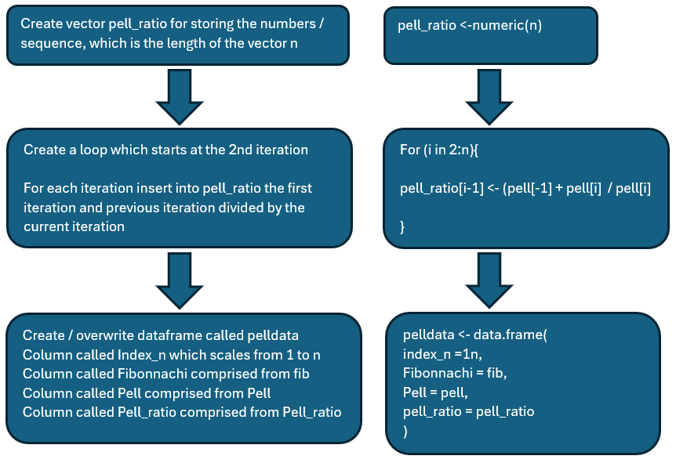

Code walkthrough (pell_ratio)
A vector pell_ratio is created which is numeric, the length of the predefined vector n and populated with 0’s.
A for loop is created which starts at the second iteration, whereby the current iteration in the pell series is added to the previous iteration in the pell series and then divided by the current iteration in the pell series.

The data frame pelldata is overwritten, starting with column Index_n, the second column named Fibonnaci, consisting of the fib sequence data, third column called Pell consisting of the pell series data and the fourth column called Pell_ratio consisting of the pell_ratio data.

Testing
A visual check is used to ensure the vector is generated correctly, the first 2 terms are assigned and that it calculates correctly. A check is made that the vector is added to the data frame correctly, and a further check against AI generated series to ensure the series is correct.

Figure 15 – Pell_ratio vector
Figure 16 – Pell_ratio vector populated
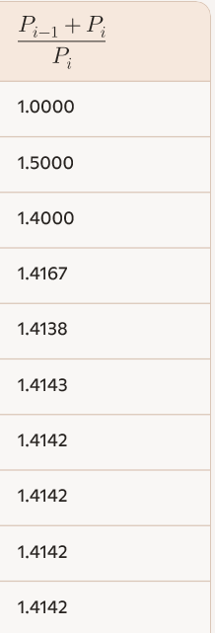
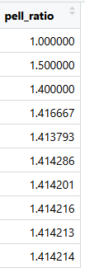
Figure 17 – Pell ratio in data frame Figure 18 – AI generated series for comparison

Question 3

Flow chart (pell_ratio)
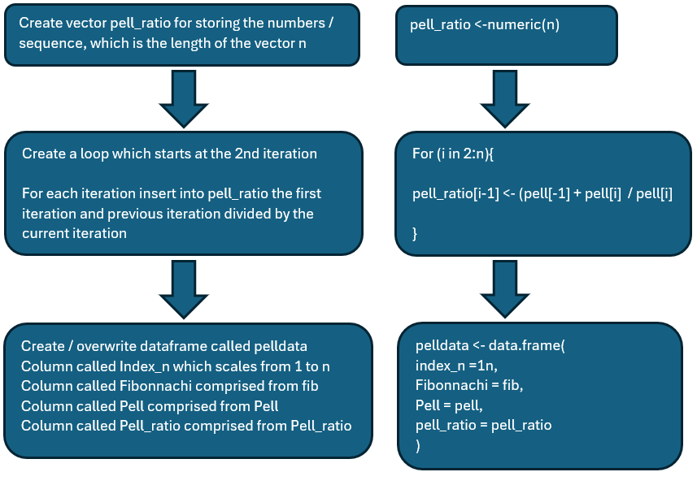

Code walkthrough (pell_ratio)
A vector pell_ratio is created which is numeric, the length of the predefined vector n and populated with 0’s.
A for loop is created which starts at the second iteration, whereby the current iteration in the pell series is added to the previous iteration in the pell series and then divided by the current iteration in the pell series

The data frame pelldata is overwritten, starting with column Index_n, the second column named Fibonnaci, consisting of the fib sequence data, third column called Pell consisting of the pell series data and the fourth column called pell_ratio consisting of the pell_ratio data.

Testing (pell_ratio)
A visual check is made to check the vector is created and entered into the data frame correctly.
AI is used to generate the series to ensure the code calculates and scales correctly.

Figure 19 – pell_ratio created correctly
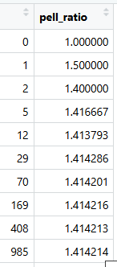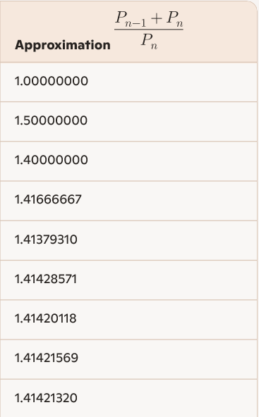
Figure 20 – Pell_ratio added to data frame correctly. Figure 21 – AI generated series for comparison

Question 4

Flow chart
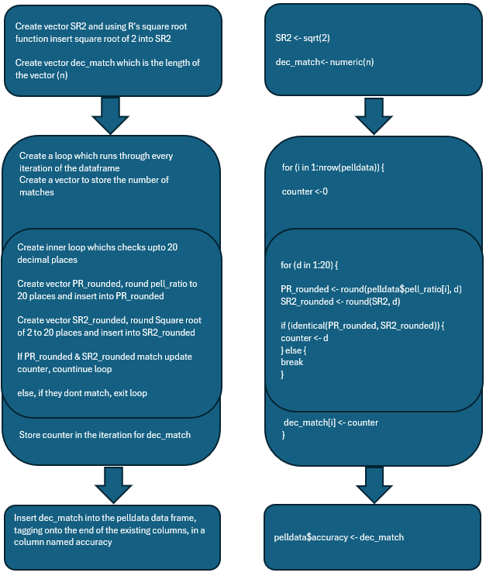

Code walkthrough
Create a vector named SR2, using R’s square root function calculate the square root of 2 and insert into the vector SR2.
Create vector dec_match to store the number of decimal matches which is numeric and the length of vector (n).
Start a for loop which runs through every iteration of the pelldata data frame.
Create vector counter to store the number of matches.
Create an inner for loop which will run for upto 20 iterations (20 decimal places)
Round pell_ratio to 20 decimal places so it will be captured in the loop, created vector PR_rounded to hold this information
Round SR2 to 20 decimal places so it will be captured in the loop, create vector SR2_rounded to hold this information.
Inner loop will check if the rounded SR2 and rounded PR vectors match using the identical function. If they match it updates the counter and continues the loop. At the point they no longer match, exit the loop.
Store the counter data in dec_match.
Insert dec_match (counter number) in the data frame as a column named accuracy.

Testing
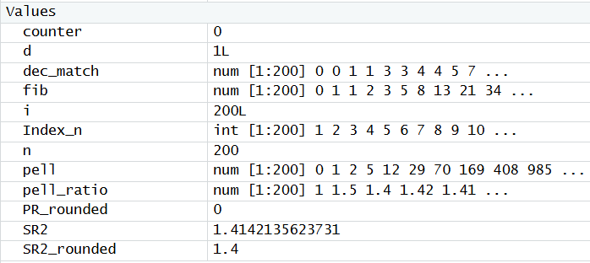
Figure 22 – All vectors created as intended
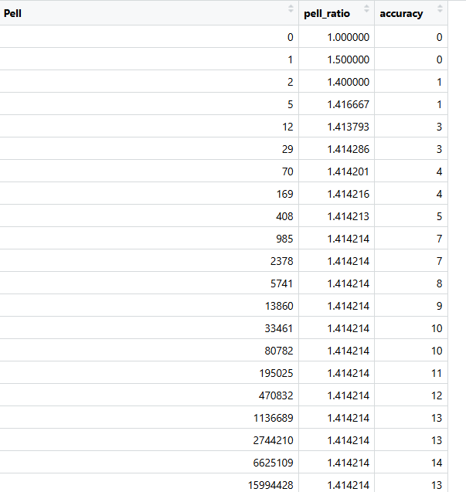
Figure 23 – accuracy column added to the data frame as intended and increase throughout sequence as expected.

Reflection
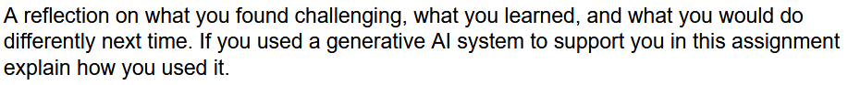

Challenges
I struggled with 4 specific issues whilst writing the R script to complete the task, cbind functions into a data frame, understanding the math required for 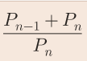 and the difference between this method and the Newton Raphson method and testing my results. I have researched and managed to rewrite and update the code to overcome these issues and complete the task.

When initially starting the task, I attempted to add the index_n column using cbind, however this didn’t work as intended. I also attempted the cbind method to join the fib column which did add and setup the data frame however it stripped out the header for the columns. I replaced the cbind with a method of rebuilding the data frame each time and specifying each column.
Figure 23 – Cbind join which didn’t work as intended

Figure 24 – Cbind join which did work, however stripped the column titles.

Figure 25 – updated code which worked as intended

I struggled to understand the math required for (Pn-1+Pn) / Pn. Whilst researching I kept finding results for the Newton Raphson method, which uses a different mathematical formula and so produces different results – I was able to overcome this using AI to explain the formula in a step-by-step fashion.
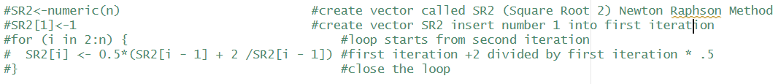
Figure 26 – Newton Raphson Method

Whilst testing I compared my 3 series side by side with AI generated series. At this point I realised I had made an error in all my series as I had manually started each iteration with 1 rather than 0.
Were I to complete the task again I would possibly look to set up my vectors as null rather than with defined limits as this would allow for it to scale more efficiently if the limit of iterations were to be increased.

Copilot usage and prompts
- Please provide a vertical display of the first 16 iterations of the Pell sequence.
- Please provide a vertical display of the first 16 iterations of the Fibonacci sequence.
- Using the sum please provide the first 16 iterations of the series.
- Please explain loops in R with a step by step process.
- Please explain counting loops in 5 step by step
- Please explain a method for comparing 2 vectors of decimal numbers to count accuracy.
- If comparing vectors of decimals should I round?
- Please explain the Newton Raphson Method.
- pelldata<-cbind(pelldata$Index_n,fib,pelldata$pell) why does this R code remove the titles from the data frame?
- Please explain as though I’m 5 years old.

References
[1]. “Scientific notation in R”, DataKwery.com [online], 11/06/2020, Available: https://www.datakwery.com/post/2020-07-11-scientific-notation-in-r/ Accessed: 03/11/2025

