

Understanding and Engaging Stakeholders

LCM5001
Daniel Fratczak
Student Number 2424154
Lecture Number; Nadeem Mirza / Kazeem Oseni / Sukhpreet Grewal or Muhammad Tareeq
Session ; Feb 2026

Executive Summary
This report evaluates the importance of stakeholder involvement in implementing the project successfully of StaySmart+ in the InterContinental Hotels Group PLC. The report has examined the major internal and external stakeholders and their roles, responsibilities, advantages and some of their challenges across the project lifecycle. The Stakeholder Power-Interest Matrix, RACI Matrix, and engagement models are considered the strategic tools that are used to understand effective stakeholder management. In this report, the stakeholder engagement is based on the 4Cs model, which includes communication, collaboration, consultation, and commitment. Moreover, it analyses how stakeholder engagement affects the performance of organisations, innovation in service delivery, and guest satisfaction, and at last, recommendations are provided on enhancing future relations between stakeholders and the success of the project.

Table of Contents
1. Introduction to the Organisation and Project 6
1.1 Overview of InterContinental Hotels Group (IHG) 6
1.2 Overview of the StaySmart+ Project 7
2. Situational Analysis of IHG 7
2.1 SWOT Analysis 8
2.2 PESTLE Analysis 8
2.3 SMART Objectives for StaySmart+ 10
3. Identifying the key stakeholders, both internal and external, their roles and responsibilities, and their importance in the project. 11
3.1 Internal Stakeholders 11
3.1.1 Project Management and Development Team 11
3.1.3 IT and AI Technology Team 11
3.1.4 Marketing and Sales Departments 12
3.1.5 Senior Management 12
3.2 External Stakeholders 12
3.2.1 Customers or Hotel Guests 12
3.2.2 Technology Providers and Travel Agencies 12
3.2.3 Investors and Shareholders 13
3.2.5 Local Communities and Government 13
3.3 RACI Matrix for the StaySmart+ Project 13
3.4 A stakeholder map/matrix 15
3.5 Benefits Stakeholders Bring to the Project 16
3.6 Challenges Stakeholders May Face 16
3.7 Stakeholder Engagement Plan 17
3.8 Communication Plan 18
4. Critical Analysis of Stakeholder Engagement Process (4C’s Model) 18
4.1 Communication 19
4.2 Collaboration 19
4.3 Consultation 20
4.4 Commitment 20
5. Impact of Stakeholder Engagement on Business Performance 20
5.1 Positive Impact on Organisational Performance 20
5.2 Challenges and Ethical Considerations 21
5.3 Recommendations for Future Stakeholder Engagement 21
6. Conclusion 22
Reference 23

List of Figures
Figure 1: IHG revenue by ownership type worldwide 2024| Statista. 5
Figure 2: What Is Situational Analysis and How to Conduct It. 7
Figure 3: SWOT Analysis 8
Figure 4: PESTLE Analysis: The CEO’s Guide to Future-Proofing a Business. 8
Figure 5: United Kingdom Inflation Rate. 9
Figure 6: Internal and External Stakeholders in IT. 11
Figure 7: RACI Matrix for the StaySmart+ Project. 14
Figure 8: A stakeholder map/matrix. 15
Figure 9: Stakeholder Engagement Plan. 17
Figure 10: Communication Plan. 18
Figure 11: The 4 C Model of Marketing - How to Implement? 19

1. Introduction to the Organisation and Project

1.1 Overview of InterContinental Hotels Group (IHG)
InterContinental Hotels Group PLC is among the global top hospitality organisations, which has a wide portfolio of hotel brands in many market segments. The company is headquartered in Denham, the United Kingdom. The size of IHG indicates this brand has 6,963 hotels, 1,026,000 rooms and the revenue of £3.91 billion in 2025 (Smith, 2020). The operational activities of IHG include franchising, management contracts, and owned and leased models. The InterContinental brand was founded by Juan Trippe in 1946 (IHG, 2024). IHG's brand portfolio comprises popular hotel chains like InterContinental Hotels and Resorts, Crowne Plaza and Holiday Inn, and other luxurious hospitality brands. The company has been putting more emphasis on digital innovation, sustainability, and personalised guest experience in recent years.
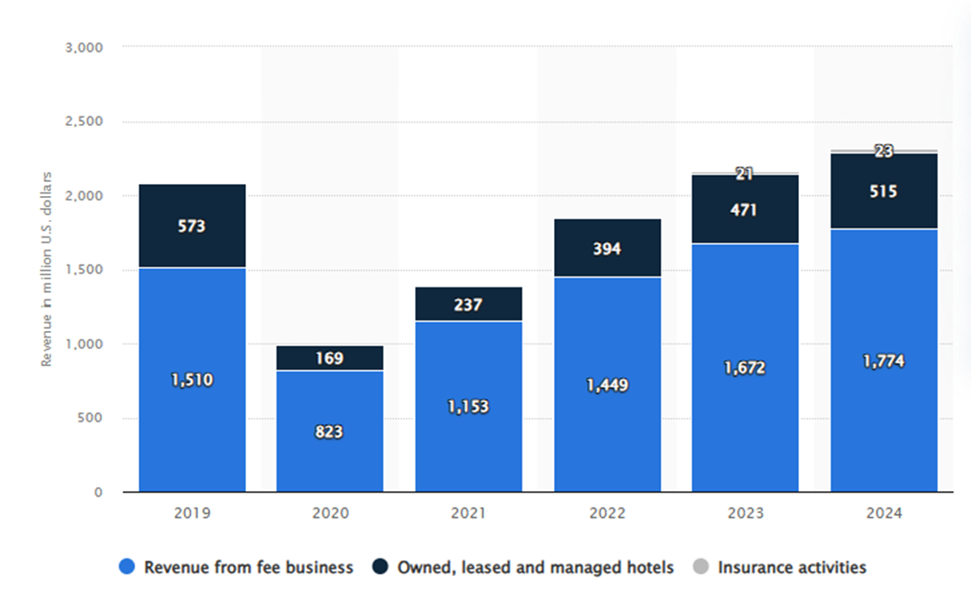
Figure 1: IHG revenue by ownership type worldwide 2024| Statista.
(Source: Statista, 2024)

1.2 Overview of the StaySmart+ Project
IHG is developing a new offering at the premium service in an attempt to remain competitive and adapt to the evolving traveller expectations by offering a new premium service, StaySmart+. The project intends to change the conventional hotel experience and combine the use of innovative technologies and excellent services in hospitality. In order to assist in communication with guests, Artificial intelligence remains one of the main functions of the project. Personalised travel planning is another feature of StaySmart+. The system will suggest the local attractions and spaces to dine, along with personalised journeys by analysing the interests of guests and their past behaviour when travelling (Benbrahmi and Mehor, 2025). This strategy is aimed at establishing a more personalised travelling experience, which is also demanded by modern travellers. IHG will impleme nt the StaySmart+ in the local market and international market in a period of six months in selected hotels. The main aim of the project is to maximise the level of guest satisfaction and their brand differentiation, as well as to increase the long-term competitiveness of the company in the global hotel market.

2. Situational Analysis of IHG
Situational analysis refers to the examination of internal capabilities as well as the external environment of the organisation (Karadzhov, 2025). In the case of InterContinental Hotels Group PLC, situational analysis can enable the managers to determine strategic strengths, any perceived risks and successful implementation of the StaySmart+ project.
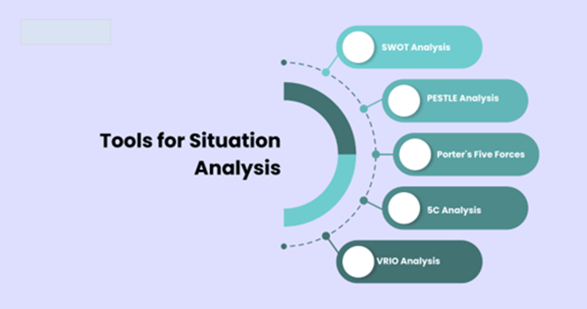
Figure 2: What Is Situational Analysis and How to Conduct It.
(Source: Nishanth, 2025)

2.1 SWOT Analysis
SWOT Analysis
Strengths | Weaknesses
- One of the assets of InterContinental Hotels Group PLC is that it has an excellent portfolio of internationally recognised brands, such as Holiday Inn, Crowne Plaza, and InterContinental Hotels and Resorts (IHG, 2024).  - Global presence and the correctly implemented loyalty programme, IHG One Rewards, which helps with customer retention and brand loyalty, are also strengths of the company. | - Operational costs are high in most cases because of the coordination of managing a large international hotel network.  - The use of modern technologies like artificial intelligence in IHG hotels can cause expenses and training issues.
Opportunities | Threats
- An increase in the need for AI-driven services and sustainable tourism presents opportunities for IHG to improve customer services and leverage its brand name. | - The hotel industry has been very competitive, especially due to international hotel chains like Marriott International and Hilton Worldwide Holdings, and economic uncertainty may also influence the demand for travel.
Figure 3: SWOT Analysis
(Source: Self-created)

2.2 PESTLE Analysis
Political factors - Government tourism policies, international travel, and visa laws also have a direct impact on the hospitality industry, and these are critical political factors. In the case of IHG, the new opportunities in expansion can also be observed because of the UK government's investment in tourism infrastructure.
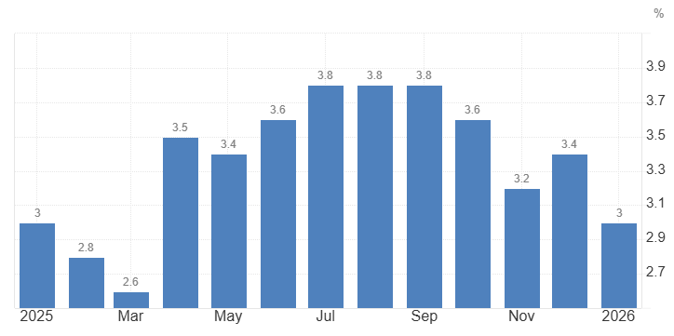
Figure 4: United Kingdom Inflation Rate.
(Source: Trading Economics, 2025)
Economic factors - Inflation, changes in exchange rates, and purchasing power are some of the factors that affect consumer spending regarding travelling and accommodation. IHG can also be affected by these factors as the economic conditions become unstable after COVID and Brexit. For example, UK consumer price inflation eased to 3.0% in January 2026, which impacted consumers' spending on travelling (Trading Economics, 2025).
Social factors - Social trends in tourism, such as contemporary travellers appreciate convenience, online services and local experiences. Such shifting expectations are influencing IHG to be innovative with the services that promote customer satisfaction and the general experience of the guests.
Technological factors - Data analytics, artificial intelligence, and digital platforms allow hotels to offer personalised recommendations. IHG utilises such technologies successfully, able to acquire a competitive edge in the international market.
Legal factors - Legal policies like the data protection, consumer protection policies, and UK tourism policies on compliance are important. IHG need to comply with the Data Protection Act 2018, which allows firms to ensure they follow the guidelines of collecting consumer data (UK Government, 2025).
Environmental factors - The environmentally conscious hotels also use green practises like energy saving operations, minimising waste, and responsible sourcing. One of the reasons why travellers are willing to stay in IHG is that they are environmentally responsible.
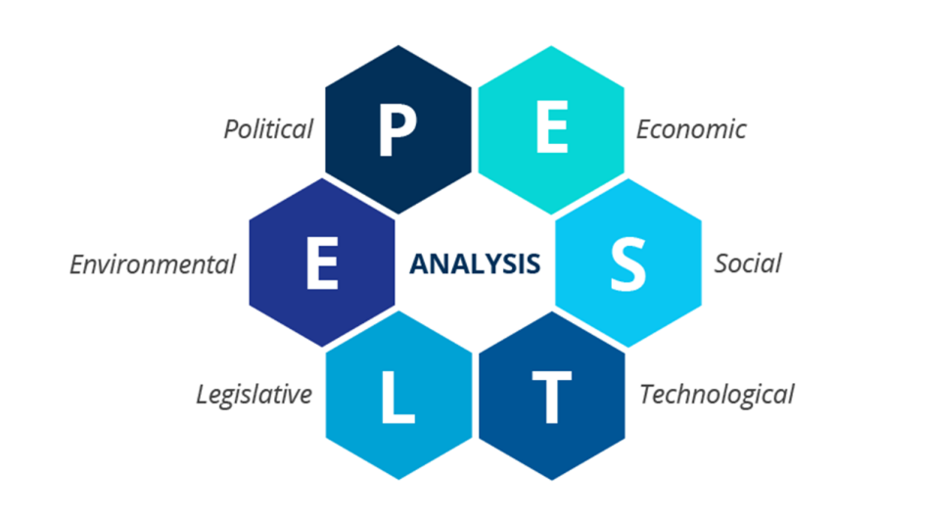
Figure 5: PESTLE Analysis: The CEO’s Guide to Future-Proofing a Business.
(Source: Iqbal, 2025)

2.3 SMART Objectives for StaySmart+
- Specific: Introduce StaySmart+ service into the market and deploy it in select hotels to achieve a better experience, based on AI-powered technology.
- Measurable: Improve the guest satisfaction scores at least by 15% and boost IHG One Rewards engagement.
- Practical: Service deployment by utilising available technology infrastructure and a trained multicultural workforce.
- Relevant: Support the strategic focus of thriving IHG based on innovation, customer experience, and sustainable hospitality services.
- Time-based: A 6-month implementation period in some of the selected properties throughout the world.

3. Identifying the key stakeholders, both internal and external, their roles and responsibilities, and their importance in the project.
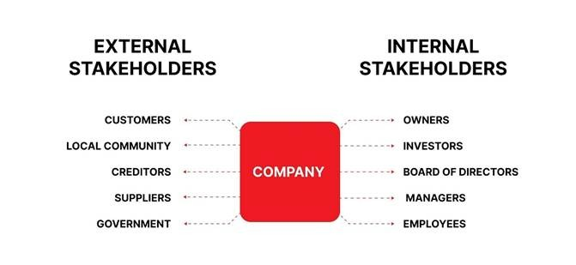
Figure 6: Internal and External Stakeholders in IT.
(Source: Zaichenko, 2024)

3.1 Internal Stakeholders

3.1.1 Project Management and Development Team
The product development unit remains important in developing the StaySmart+ service features. They work on creating personalised hospitality solutions so that the service can be in line with the expectations of the guests and IHG’s strategic goals. The project management team will be assigned the responsibility of planning, coordinating, and monitoring the StaySmart+ initiative. Project managers have a role in the training of the staff, administration of the work, and the delivery of services and the quality of the experience of the guests at various places (Salimimoghadam et al., 2025). They are important in making sure that the project is completed within the specified time, money and quality.

3.1.3 IT and AI Technology Team
The IT and artificial intelligence team is important as they create and implement artificial intelligence-based tools to be implemented in interaction with the guests and provide personalised services (Tan et al., 2025). Their role and responsibilities are to deliver the effectiveness and security of the technological infrastructure at IHG. The technological functionality of the IT departments plays a crucial role in creating and integrating the StaySmart+ project with AI-led technology tools that would facilitate the ease of interaction with guests, recommendations of holiday plans, and the delivery of services in digital ways. Maintenance of system reliability, data security, and continuous technical support of AI-based services are the responsibility of IT teams.

3.1.4 Marketing and Sales Departments
The offers of the StaySmart+ service are advertised to the target markets by marketing and sales teams and convey the value of the service to the potential guests. Their roles and responsibilities are to boost brand awareness and make customers adopt the new service offered by IHG. The sales and marketing departments play a strategic role in advertising the new service to the customers worldwide (Ramdinpuii et al., 2026). They interpret market trends, formulate promotional campaigns, and communicate the advantages of the service to the travellers. The marketing department is important for delivering the correct information regarding the StaySmart+ service and making sure that the promotion strategies are based on the needs of the customers and the market trends.

3.1.5 Senior Management
Top management is an important internal stakeholder of the firm; they set a strategic direction for the project, offer financial support, and give leadership to the project (Zaichenko, 2024). The influence of IHG's top management and board of directors is dominant in the delivery of the initiative in line with the long-term business strategy of the firm. They have a strategic role and responsibility to make decisions that influence the quality of the service at the hotel properties, which lies with the hotel operations managers who make sure that their employees are informed and trained on how best to provide the new experience.

3.2 External Stakeholders

3.2.1 Customers or Hotel Guests
The main clients of the StaySmart+ service are the customers; they are the most important stakeholders in the whole process. They do not have specific roles and responsibilities, but their general expectations and their feedback shape how the service is provided and enhanced. The ultimate success of the initiative will be based on customer satisfaction.

3.2.2 Technology Providers and Travel Agencies
Technology providers and Travel agencies are some important external stakeholders who provide AI systems, software platforms, and digital tools that will be needed to implement StaySmart+ service. Their role and responsibilities are the creation of high-tech solutions, which enhance the efficiency of the operations as well as the communication between the guests of IHG hotels. Travel agencies are also significant in market suggestions of hotel services to travellers; IHG’s partnership with Booking.com is an example (IHG Hotels and Resorts, 2024). Their partnership with the company assists in growing the booking and increasing market share, especially in international tourism markets.

3.2.3 Investors and Shareholders
Investors and shareholders are interested in the financial performance of the organisation; their role is important throughout the process (Sawaya et al., 2025). They examine whether the StaySmart+ project would add to the brand value, boost profitability, and leverage the competitive advantage of the IHG. Investors have a financial and strategic role and responsibility of facilitating innovation by investing as well as ensuring that projects are directed to the long-term organisational goals. Investors and shareholders have the responsibility of offering finance and will be strategically overseeing the performance of the project.

3.2.5 Local Communities and Government
Hotel operations and tourism development have an indirect impact on the local communities (Godovykh, Fyall and Pizam, 2025). Good relationship building with local stakeholders remains important for organisations in order to have a good reputation in a sustainable tourism environment. The government regulatory bodies are external stakeholders important in developing legal regulations involving tourism activities, data security, and commercial competence. For example, the Data Protection Act 2018 protects the data of customers collected by the firm.

3.3 RACI Matrix for the StaySmart+ Project
Project Activities / Tasks | IT & AI Teams | Top Management | Hotel Managers | Marketing Department | Technology Partners | Employees | Investors | Guests
Develop AI and digital systems | R | A | C | C | R | I | I | I
Strategic project approval | C | A | I | I | I | I | C | I
Implement AI services in hotels | R | A | R | C | C | I | I | I
Promote StaySmart+ services | C | A | C | R | I | I | I | I
Provide operational feedback | I | A | C | C | C | I | I | C
Service updates and communication | I | A | C | R | I | I | I | I
Figure 7: RACI Matrix for the StaySmart+ Project.
(Source: Self-created)
Responsible (R) - The Responsible stakeholders are those who remain responsible for accomplishing the project tasks. For example, the IT and AI teams in the StaySmart+ project are responsible for creating and integrating the systems for IHG on an international level, on which the individual services to guests will be based.
Accountable (A) - Accountable stakeholders are those who have authority and control of the project deliverables and outcomes, on which objectives will be achieved (Basyar, Mardiyanta and Setijaningrum, 2025). The top management at IHG remains accountable for making strategic decisions and approving projects, and also accountable for the outcome.
Consulted (C) - The consulted stakeholders are the ones who give advice, expertise, and feedback on the undertaking of the project or event. In the case of IHG, hotel managers, marketing departments, and technology partners are consulted in order to make sure that operational and market views are taken into account when working on StaySmart+.
Informed (I) - The informed stakeholders will be informed of the progress of StaySmart+, but not the decision-makers. They can be the employees, investors, or guests staying at this hotel, and they can be updated on the launch of the services and the improvements made.

3.4 A stakeholder map/matrix
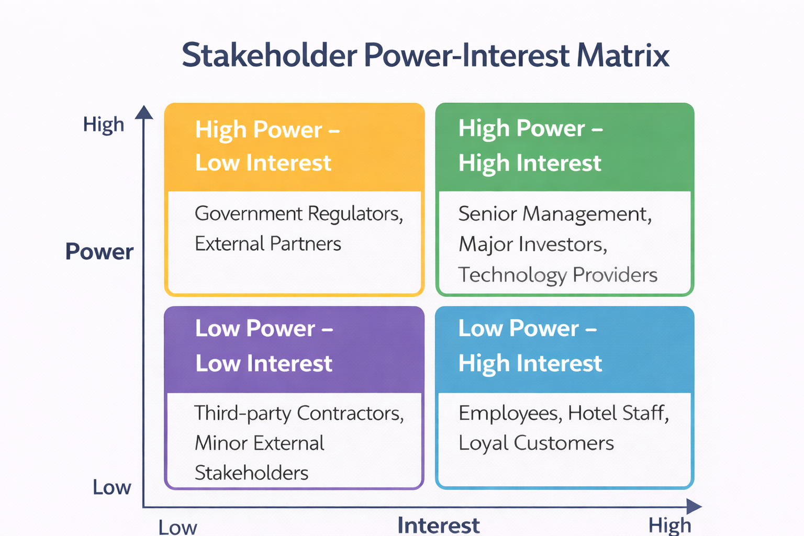
Figure 8: A stakeholder map/matrix.
(Source: Self-created)
High Power – High Interest: High-power stakeholders remain a priority as they can influence the whole project. In IHG, senior management, major investors, and technology providers have high power and high interest in the project with regard to resources and strategic direction.
High Power – Low Interest: Some outside partners and regulators may also have a strong level of authority but not be involved in the project on a day-to-day basis (Civera et al., 2025). These stakeholders of IHG must be maintained since they should be met by observing the regulations and updating them regularly.
Low Power – High Interest: The lower power of employees, hotel staff, and loyal customers does not influence decisions; however, they have a high interest in the success of the new service. These IHG stakeholders are expected to be informed as well as actively engaged via training, updates and feedback systems.
Low Power – Low Interest: The stakeholders in this strategic group have very low power and low interest in the project. They only need general observation and regular communications to make sure that they are understood without involving a lot of resources, such as stakeholders, for example are third-party contractors.
3.4.1 Stakeholder Assessment
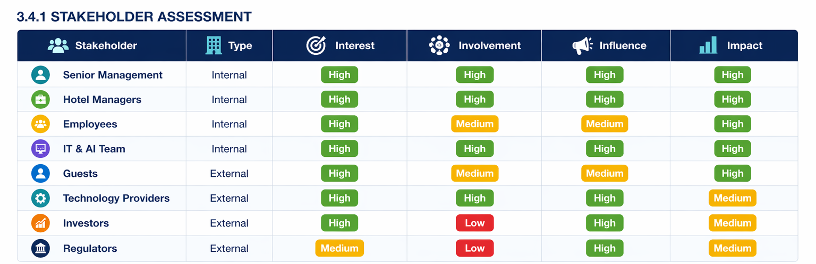

This stakeholder assessment table helps to prioritise key stakeholders based on their level of interest, involvement, influence and the extent to which they are affected by the project. It supports effective decision-making and ensures appropriate allocation of resources throughout the project lifecycle.

3.5 Benefits Stakeholders Bring to the Project
The benefits that are offered by the stakeholders help the implementation of the StaySmart+ initiative to be successful. Expertise and knowledge are two of its advantages. The IT specialists, marketing professionals and hotel managers are internal teams who have technical and operational experience that can benefit in the innovation of hospitality services development and delivery. Financial investment is another important advantage (Mohamed et al., 2025). Financial resources needed in the technological development, upgrade of the infrastructure and global marketing relating to the project are provided by the investors and shareholders. There is also a significant benefit of operational implementation. Hotel managers and employees make sure that strategic plans are converted into real service delivery within the hotels. Their field experience would ensure that the StaySmart+ service is working effectively and meets the expectations of the guests.

3.6 Challenges Stakeholders May Face
Resistance to technological change is one of the major challenges. Workers might have doubts about the use of the new artificial intelligence system, especially where they are not properly trained to operate digitally and are not confident in its use. The other issue deals with differences in culture in the international markets (Alam et al., 2025). Due to the high number of global destinations in which InterContinental Hotels conducts its business, the expectations of guests and service preferences can differ significantly. It might have to make further modifications to its operations to accommodate the services in other cultural settings. The problem of the privacy of data is also crucial, leading to concerns for guests to make the experience customised. The organisation should make sure that data privacy is high and that privacy laws are also followed, keeping the customers confident.

3.7 Stakeholder Engagement Plan
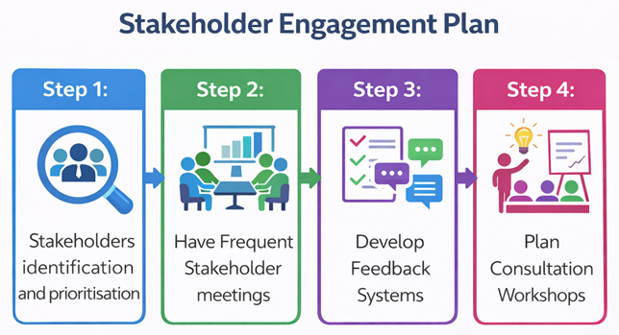
Figure 9: Stakeholder Engagement Plan.
(Source: Self-created)
Step 1: Stakeholder identification and prioritisation - The first step that the IHG undertakes is to establish essential stakeholders such as internal teams and investors, customers and technology providers and how much influence and interest they have in the StaySmart+.
Step 2: Have Frequent Stakeholder meetings - Meeting with project managers, senior leaders, and operating teams regularly can facilitate keeping track of the StaySmart+ progress and addressing difficult situations during implementation (Motalebi et al., 2025).
Step 3: Develop Feedback Systems - Customer surveys, staff consultation, and digital feedback systems are all types of feedback loops which allow IHG to get insights and constantly increase the StaySmart+ service.
Step 4: Plan Consultation Workshops - The collaboration, sharing of knowledge, and decision-making will be encouraged in various project phases using workshops with hotel managers, marketing teams, and technology partners (Christopher, Payne and Ballantyne, 2013).

3.8 Communication Plan
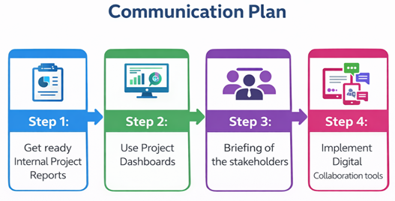
Figure 10: Communication Plan.
(Source: Self-created)
Step 1: Prepare for the Internal Project Reports - Communicators within the reports regularly give reports on the schedule, performance and progress. These reports assist the top management in keeping track of how StaySmart+ is performing and making sound decisions regarding the strategy.
Step 2: Use Project Dashboards - Digital project dashboards provide real-time data relating to milestones, progress and possible risks (Grady et al., 2025). The tools help project teams to monitor the implementation and find the problem within a short period of time.
Step 3: Briefing of the stakeholders - Stakeholder briefings are arranged where the stakeholders, such as the investors, hotel managers, and employees, are informed of at least significant project developments, the introduction of new services and expected results.
Step 4: Implement Digital Collaboration tools - Digital collaboration tools will enable workgroups in various hotels to be in contact and share documents, as well as coordinate project operations during the implementation of the StaySmart+.

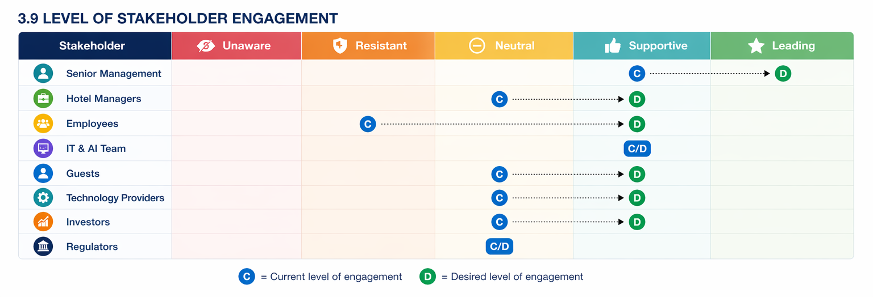
C= Current Level of engagement
D = Desired Level of engagement
The Matrix shows that several stakeholders are current at a neutral or supportive level of engagement. The aim is to move key stakeholders, such as senior management, hotel managers, employees and guests, towards a supportive or leading level. This helps improve collaboration, reduce resistance to changes and support successful project implementation.
3.10
Third, managers help resolve conflicts between stakeholders. Different groups may have different priorities, and managers must balance these to support overall project success.
Managers also use interpersonal techniques such as the Feel–Felt–Found method to reduce resistance. For example, a manager may say: “I understand how you feel. Others have felt the same about the new system, but they found that it improved efficiency once they became familiar with it.” This helps build trust and encourages acceptance of change.
Finally, managers monitor stakeholder feedback and maintain relationships throughout the project. Their role is essential in ensuring engagement remains strong and aligned with project objectives.

4. Critical Analysis of Stakeholder Engagement Process (4C’s Model)
The 4Cs stakeholder engagement model, which is comprised of Communication, Collaboration, Consultation and Commitment, provides a detailed review of how organisations manage relationships when implementing projects with stakeholders.
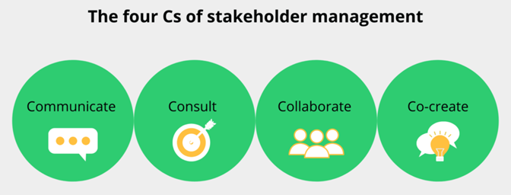
Figure 11: The 4 C Model of Marketing - How to Implement?
(Source: College Vidya, 2025)

4.1 Communication
Communication is a major part of stakeholder engagement since it helps an organisation spread information, creates harmony in expectation and also in transparency in the implementation of projects. In the StaySmart+ project, the communication strategies should be clearly developed, since they include internal teams, hotel managers, investors, and customers, who should be aware of the benefits and the purpose of the new service. Clear communication may enhance the level of trust among the stakeholders by making sure the decisions, milestones of the project, and other changes in operations are made available (Siregar, 2025). Diverse information to employees, managers and customers can be interpreted in different ways depending on their cultural background, hence a barrier to communication. For example, the language barrier, the structure of the organisation, and the cultural expectations towards decision-making can affect the information sharing and perception. In case the StaySmart+ updates are not provided promptly or are not clear, there is a risk that the project will lack direction among the stakeholders.

4.2 Collaboration
Collaboration can be described as the process in which stakeholders collaborate to reach common project goals. Under the project StaySmart+, coordination is made between various departments, and these include IT teams, marketing experts, hotel operations managers, and top management. The good cooperation enables organisations to pull together technical knowledge, operating experience and market when coming up with innovative hospitality services. International collaboration is also highly valued since InterContinental Hotels Group PLC is in many countries and cultures where it performs its business. The cooperation between departments is important to make the AI technologies available and practical in day-to-day hotel operations, and to coordinate with customer expectations (Madanchian and Taherdoost, 2025). Teamwork can also enable collective problem-solving in the process. However, the teamwork among big organisations may also pose some dangers. Other departments might work against each other, such as the IT department, which looks into technological performance, and operations managers, whose priority is service efficiency.

4.3 Consultation
Consultation is encompassed by the term concerning the involvement of stakeholders in decision-making by way of enquiring their viewpoints, reactions and skills. Consultation is also especially beneficial in the context of hospitality projects like StaySmart+ since both customers and employees have a first-hand experience of the services developed. By involving such stakeholders, organisations can get hands-on knowledge that can enhance the design and provision of new services. An example of this is that operational issues that may not be seen on the strategic planning level can be detected by consulting the hotel staff during the implementation stage. Frontline service workers are usually in a better position to understand the customer expectations and the realities of operations than the top management (Grewal et al., 2026). On the same note, customer response via surveys, loyalty programmes and online platforms may offer helpful information about customer satisfaction and preference.

4.4 Commitment
Commitment can be explained as the pledge of the stakeholders to a project over time to ensure the success of a product. The high level of stakeholder commitment is key to making sure that even when challenges arise during the implementation, projects are still supported at the organisational level. The commitment among the employees, managers, investors, and customers should be sustained in the StaySmart+ project in order to make the service sustainable. Leadership will also be significant in the creation of stakeholder commitment. Senior leaders and project managers should clearly explain the strategic importance of the project and also show how the project serves organisational objectives, cost efficiency to organisations in terms of better customer experience, technological advantage, and competitive advantage (Siregar, 2025). However, it might be difficult to be committed in a large organisation like Intercontinental Hotels Group plc, where the stakeholders have various priorities and expectations. Tensions are also possible between departments, especially when there is a need for change in operation or an increase in resources for the projects.

5. Impact of Stakeholder Engagement on Business Performance

5.1 Positive Impact on Organisational Performance
Better Service Innovation - Engagement of stakeholders in hospitality organisations is helpful for in-service innovation. When technology partners, internal teams and hotel managers work together in the development of the project, they have a wide array of skills and viewpoints that enhance the development of a new service (Benbrahmi and Mehor, 2025). About the StaySmart+ initiative, work with IT specialists and operations managers is facilitated to devise AI-based guest engagement and talks to improve the hotel experience on a broader level.
Increase in Customer Satisfaction - Customer feedback, reviews, and loyalty programmes are crucial in meeting the quality of services in hospitality organisations. For example, rewards programmes like IHG One Rewards allow hotels to receive useful data on the behaviour of the guests and the level of their satisfaction. The ability to enhance the service quality and providing more personalised hospitality experiences, organisations can do so by engaging customers with feedback systems and personalised services.
Stronger Brand Reputation - Another way that stakeholder engagement facilitates is by building a positive brand reputation for organisations. By staying transparent and showing attention to stakeholder issues, the companies will establish better relationships with the customers, employees and investors (Madanchian and Taherdoost, 2025).

5.2 Challenges and Ethical Considerations
Data Privacy with AI - Management of customer data is one of the biggest challenges of stakeholder engagement in digital hospitality services. Personalised travel planning is one of the AI-driven services that demand gathering and processing of information about guests (Salimimoghadam et al., 2025). Although it is able to enhance customer experience, there is also an issue of measuring the storage, processing and protection of personal data.
Application of Ethical Artificial Intelligence - Another ethical issue with the use of AI is how ethically organisations use it. The methods of designing and implementing AI systems should be done in a way that follows the considerations of fairness, transparency and accountability. Unless the process of AI-based decision-making is adequately controlled, it can give biased results or reduce the emotional factor of the hospitality services. The organisation should therefore make sure that the technological innovations do not compromise ethical values or service quality.
Cultural Differences - The hospitality organisation in the international market should also deal with the cultural differences in its interaction with the stakeholders. Depending on the regions, the expectations of the guests, the mode of communication and the preferences in terms of the services can differ. Without the proper knowledge of the cultural contexts, an organisation may not be able to provide an excellent quality service experience.

5.3 Recommendations for Future Stakeholder Engagement
Recommendation 1: Strengthen Tools of Digital Engagement
Organisations in the hospitality industry are supposed to invest in an improved digital platform of engagement, which will enable stakeholders to communicate and coordinate more effectively. The use of digital dashboards, customer engagement and application and internal work collaboration platforms can enhance the information sharing among different teams and offer real-time insight into stakeholders’ feedback.
Recommendation 2: Have Continuous Stakeholder Feedback Systems
It is recommended to have a continuous feedback mechanism to make sure that the opinions of stakeholders are habitually gathered and processed. The digital review system, employee feedback platform and customer surveys can help provide essential information regarding the service performance (Salimimoghadam et al., 2025). Through these systems, organisations are able to detect any possible problems in time and make the improvement more efficiently.
Recommendation 3: Educate Cross-Cultural Stakeholders
Employees and managers should undergo cross-cultural training since international hospitality organisations deal with stakeholders who might have different cultural backgrounds. Through this training, the staff will be in a position to learn various communication styles, expectations of services and cultural values, hence enhancing the relationship and service delivery to the stakeholders.

6. Conclusion
This report has examined the importance of stakeholder engagement in the new projects of the organisation. The report focused on StaySmart+, which is a new service InterContinental Hotels Group PLC is planning to introduce to improve the customer experience with the help of AI-based interaction with guests, individual travel planning and environmentally friendly options. This report has conducted the situational analysis using the SWOT and PESTLE analysis models. This situational analysis revealed that despite having a positive impact from the organisation in terms of strong global presence and proven brand reputation, IHG still needs to address technological, economic and competitive factors in the hospitality sector. Later, this report identified internal and external stakeholders, their roles and responsibilities and their importance in the development of StaySmart+. This report included the RACI matrix, the stakeholder map/matrix, and the communication and stakeholder engagement plan. The critical analysis of the 4C model revealed that communication, collaboration, consultation and commitment remain important in maintaining stakeholder relationships. At last, key recommendations are provided to IHG to improve the overall performance of the firm.

References
Alam, S., Dong, Z., Kularatne, I. and Rashid, M.S. (2025). Exploring approaches to overcome challenges in adopting human resource analytics through stakeholder engagement. Management Review Quarterly, 412(6). Available at: https://doi.org/10.1007/s11301-025-00491-y.
Ashcroft, J. (2017) The relational lens: understanding, measuring, and managing stakeholder relationships. Cambridge: Cambridge University Press. Available at: https://www-cambridge-org.ezproxy.uwtsd.ac.uk/core/books/relational-lens/value-and-importance-of-relationships/718C31032061BDFA3F480BA2A53F45D4#CN-bp-1
Bartoli, C., Baccelloni, A., Di Leo, A. and Mattiacci, A. (2025). Blending digital and physical experiences in luxury wine hospitality: an experiential approach to technology integration. British Food Journal, 127(13), pp.72–95. Available at: https://doi.org/10.1108/bfj-03-2024-0248.
Basyar, M.R., Mardiyanta, A. and Setijaningrum, E. (2025). Multi-Stakeholder Analysis in Building Tourism Resilience: Collaborative Governance Implementation in the Majapahit House Heritage Area, Indonesia. Tourism and Hospitality, 6(1), pp.5–5. Available at: https://doi.org/10.3390/tourhosp6010005.
Benbrahmi, F.Z. and Mehor, H.M. (2025). THE IMPACT OF ARTIFICIAL INTELLIGENCE ON ENHANCING THE TRAVEL EXPERIENCE FOR TOURISTS: AN ANALYSIS OF SUCCESSFUL MODELS. Business Excellence and Management, 15(S.I.5), pp.5–13. Available at: https://doi.org/10.24818/beman/2025.s.i.5-01.
Christopher, M., Payne, A. and Ballantyne, D. (2013). Relationship Marketing. [online] Routledge. Available at: https://books.google.co.in/books/about/Relationship_Marketing.html?id=cP60SQrJlJgC&redir_esc=y [Accessed 13 Mar. 2026].
Civera, C., Casalegno, C., Morelli, B. and Chiaudano, V. (2025). Multi-stakeholder marketing: mapping the field. Review of Managerial Science, 412(12). Available at: https://doi.org/10.1007/s11846-025-00849-2.
College Vidya (2025). The 4 C Model of Marketing - How to Implement? [online] College Vidya Blog. Available at: https://collegevidya.com/blog/4-c-of-marketing/ [Accessed 13 Mar. 2026].
Godovykh, M., Fyall, A. and Pizam, A. (2025). Exploring the Impacts of Tourism on the Well-Being of Local Communities. Sustainability, 17(13), pp.5849–5849. Available at: https://doi.org/10.3390/su17135849.
Grady, C.L., Murtagh, E., Ng, K., Bengoechea, E.G. and Woods, C.B. (2025). Communicating physical activity messages with adolescents: what works? A scoping review with stakeholder consultation. International Journal of Behavioral Nutrition and Physical Activity, 22(1). Available at: https://doi.org/10.1186/s12966-025-01717-8.
Grewal, D., Ludwig, S., Herhausen, D., Grewal, L., Ordenes, F.V., Kopalle, P.K. and Bohling, T. (2026). EXPRESS: How Frontline Employees’ Relational Communication in Online Service Interactions Drives Customer Satisfaction. Production and Operations Management, 3(12). Available at: https://doi.org/10.1177/10591478261420001.
IHG (2024). Our History. [online] InterContinental Hotels Group PLC. Available at: https://www.ihgplc.com/en/about-us/our-history [Accessed 13 Mar. 2026].
IHG Hotels and Resorts (2024). IHG Hotels & Resorts Revolutionizes Booking Experience through Next-Gen Cloud Solutions. [online] www.prnewswire.com. Available at: https://www.prnewswire.com/news-releases/ihg-hotels--resorts-revolutionizes-booking-experience-through-next-gen-cloud-solutions-301924628.html [Accessed 13 Mar. 2026].
Iqbal, A. (2025). PESTLE Analysis: The CEO’s Guide to Future-Proofing a Business. [online] Medium. Available at: https://medium.com/techno-preneurship/pestle-analysis-the-ceos-guide-to-future-proofing-a-business-877e6c4e20ea [Accessed 13 Mar. 2026].
Karadzhov, V. (2025). How to create the best SWOT analysis. International Journal of Research and Review, 12(1), pp.66–75. Available at: https://doi.org/10.52403/ijrr.20250110.
Madanchian, M. and Taherdoost, H. (2025). Barriers and Enablers of AI Adoption in Human Resource Management: A Critical Analysis of Organizational and Technological Factors. Information, 16(1), pp.51–51. Available at: https://doi.org/10.3390/info16010051.
Mohamed, A., Ojiako, U., Al-Mhdawi, M.K.S., Chipulu, M. and Dweiri, F.T. (2025). Ways in which Different Stakeholders Perceive Benefits, Challenges, as well as Barriers in the Implementation of Green Technology Projects. Sustainability, 17(21), pp.9849–9849. Available at: https://doi.org/10.3390/su17219849
Motalebi, M., Heffernan, E., McCarthy, T., Marzban, S. and Rashidi, A. (2025). Sustainability as well as Stakeholder Engagement while Building Information Modelling-Enabled in Construction: A Review of Critical Success Factors in Design and Planning Phases. Sustainability, 17(3), p.1086. Available at: https://doi.org/10.3390/su17031086.
Nishanth, P.K. (2025). What Is Situational Analysis and How to Conduct It. [online] SurveySparrow. Available at: https://surveysparrow.com/blog/what-is-situational-analysis/ [Accessed 13 Mar. 2026].
Ramdinpuii, O., Chaudhary, K., Gupta, S. and Bali, S. (2026). A generalized Vidale–Wolfe model on existing and new customers advertising strategy in a segmented market. Results in Control and Optimization, 22(453), p.100673. Available at: https://doi.org/10.1016/j.rico.2026.100673.
Salimimoghadam, S., Ghanbaripour, A.N., Tumpa, R.J., Rahimi, A.K., Golmoradi, M., Rashidian, S. and Skitmore, M. (2025). The Rise of Artificial Intelligence in Project Management: A Systematic Literature Review of Current Opportunities, Enablers, and Barriers. Buildings, 15(7), pp.1130–1130. Available at: https://doi.org/10.3390/buildings15071130.
Sawaya, C., Jabbour Al Maalouf, N., Hanoun, R. and Rakwi, M. (2025). Impact of auditor independence, expertise, and industry experience on financial reporting quality. Asia Pacific Management Review, 30(1), p.100357. Available at: https://doi.org/10.1016/j.apmrv.2025.100357.
Siregar, T. (2025). Effectiveness of the Problem-Based Learning Model in Improving Students’ Mathematical Communication Skills and Learning Motivation. Effectiveness of the Problem-Based Learning Model in Improving Students’ Mathematical Communication Skills and Learning Motivation, 643(453). Available at: https://doi.org/10.20944/preprints202510.1562.v1.
Smith, C. (2020). Intercontinental Hotels Group. [online] DMR. Available at: https://expandedramblings.com/index.php/intercontinental-hotels-group-statistics-facts/ [Accessed 13 Mar. 2026].
Statista (2024). IHG revenue by ownership type worldwide 2024| Statista. [online] Statista. Available at: https://www.statista.com/statistics/223419/intercontinental-hotels-group-revenue-by-segment/?srsltid=AfmBOoqYncDXiailOLNejRDL0xTFz_cIhg7fivhIMPKWCzSlM9-RLe88 [Accessed 13 Mar. 2026].
Tan, K.-L., Yeap, P.-F., Cheong, K.C.-K. and Loganathan, S.R. (2025). Crafting an organizational strategy for the new era: a qualitative study of artificial intelligence transformation in a homegrown Singaporean hotel chain. Business Process Management Journal, 31(8), pp.104–123. Available at: https://doi.org/10.1108/bpmj-11-2024-1086.
Trading Economics (2025). United Kingdom Inflation Rate. [online] Trading Economics. Available at: https://tradingeconomics.com/united-kingdom/inflation-cpi [Accessed 13 Mar. 2026].
UK Government (2025). Data Protection Act. [online] Gov.uk. Available at: https://www.gov.uk/data-protection [Accessed 13 Mar. 2026].
Zaichenko, M. (2024). Internal and External Stakeholders in IT. [online] Custom Software Development Company. Available at: https://maddevs.io/blog/internal-and-external-stakeholders-in-it/ [Accessed 13 Mar. 2026].

