
Module name: Marketing Management
Module Code: LCMB7024
Decathlon for Sustainable Growth Buy, Play, Return, Renew, Resport
Student Name : Ankit Gopalbhai Rabari
Student ID : 2535776

Table of Contents
Element 1: Sustainable Brand Extension Poster Presentation 3
Element 2: Segmentation, Targeting, Differentiation and Positioning (STDP) 4
2.1 Introduction 4
2.2 Market Segmentation 4
2.3 Targeting Strategy 5
2.4 Differentiation Strategy 6
2.5 Positioning Strategy 7
Element 3: Marketing Mix 8
3.1 Introduction 8
3.2 Product 8
3.3 Price 10
3.4 Place (Distribution) 11
3.5 Promotion 11
Element 4: Reflection 12
4.1 Description 12
4.2 Feelings 12
4.3 Evaluation 13
4.4 Analysis 13
4.5 Conclusion 14
4.6 Action Plan 14
References 15

Element 1: Sustainable Brand Extension Poster Presentation
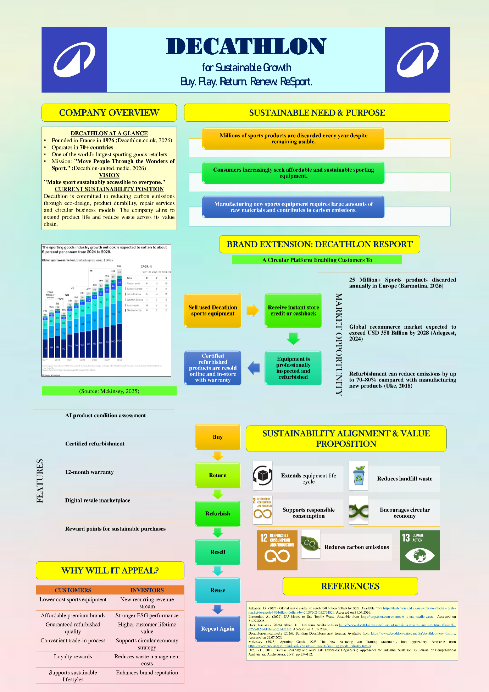

Element 2: Segmentation, Targeting, Differentiation and Positioning (STDP)

2.1 Introduction
STDP stands for Segmentation, Targeting, Differentiation, and Positioning, which is a strategic marketing model that allows companies to select lucrative customer segments and create a value proposition in the market (Sholikhah et al., 2026). In the case of Decathlon, it is important to utilise the STDP framework as it represents a brand extension that involves implementing a circular economy model, which contrasts with Decathlon's standard retail activities. By targeting affordable, sustainable, and quality-conscious consumers, Decathlon will achieve the most out of its business activities.

2.2 Market Segmentation
Market Segmentation involves subdividing a diverse market into small segments having similar features and thus helps in offering products that would cater to the demands of the customers (Kara and Kaynak, 1997).
Segmentation Variable | Target Market
Geographic | UK cities with Decathlon stores like London, Birmingham, Manchester, Leeds, and Glasgow
Demographic | Ages 18 to 45, university students, young professionals, families with kids, and sport enthusiasts
Psychographic | Eco-conscious consumers, people leading an active lifestyle, value-minded consumers, and those who support circular consumption
Behavioural | Decathlon existing customers, sports fans, online consumers, those interested in second-hand purchases, and those willing to exchange used products
Table 2.1: Market Segmentation
(Source: Self-developed)
As far as geography is concerned, Decathlon will have to concentrate on those areas which already have Decathlon outlets. In this way, they will gain access to a vast clientele, but at the same time they will be able to collect their equipment for inspection and repair.
From a demographic standpoint, the most appealing clients would be those who are aged 18 to 45 years. Students in universities and young professionals look for reasonably priced sporting goods because of their low disposable income, while parents buy new sports equipment for their growing children (Friedman, 2013). These demographics are more inclined to use refurbished equipment due to its quality and reduced costs.
Psychographic segmentation includes consumers who value living a sustainable lifestyle (Leal Filho et al., 2009). With the growing environmental consciousness among consumers, they have been buying products that produce less waste and carbon emissions. Decathlon caters to these consumers through product life cycle extension via refurbishing and reselling.
Lastly, behavioural segmentation involves purchasing and usage patterns. The existing customers of Decathlon will be comfortable buying products because of their prior experience and brand loyalty. In the same manner, those who are involved in sports activities and those who purchase second-hand items are more likely to adapt to a circular marketplace due to its advantages to the environment and economy.

2.3 Targeting Strategy
Decathlon's focus would be on two main segments of customers, such as Generation Z and Millennials (18 to 35), and families with kids and recreational athletes (35 to 50).
The first and foremost customer segment would include Generation Z and Millennials who are aged between 18 and 35 and take part in any form of physical activity, purchase products online, and possess high levels of environmental consciousness. Such people would be quite interested in the circular economy and would always try to look for cheaper options without compromising on quality.
The secondary target market consists of families with kids and recreational athletes aged 35 to 50 years old. The families often need new sports equipment, which they outgrow fast. They can benefit from trade-in and reconditioning services offered by the firm (Paras et al., 2018). The recreational athletes are also in a constant search for new sports equipment.

2.4 Differentiation Strategy
Decathlon is distinguished by merging the trustworthiness of an internationally known global sports retailer brand with a circular business strategy. In contrast to eBay or Facebook Marketplace, where the quality of products is determined by individual sellers only, Decathlon offers AI-based product condition analysis, professional refurbishing, guaranteed product quality, and a 12-month warranty period.
Feature | Decathlon ReSport | eBay/Facebook Marketplace | Vinted
Product Focus | Refurbished sports equipment | General second-hand products | Fashion and lifestyle resale
Quality Assurance | Certified inspection and refurbishment | Seller-dependent | Seller-dependent
Warranty | 12-month warranty | No | No
Trade-in Service | Store credit & trade-in | No | No
Key Advantage | Trusted brand with circular economy model | Low-cost peer-to-peer selling | Sustainable fashion resale
Table 2.2: Competitive Differentiation
(Source: Self-developed)
Whereas fashion-oriented specialist resellers such as Vinted concentrate on fashion items, Decathlon is distinguished by its expertise in the sporting equipment sector, with qualified technicians able to evaluate and repair technical sports equipment. Moreover, the company benefits from being integrated with the network of Decathlon’s stores across the country, enabling customers to exchange their goods for instant store credit and support.
Instead of simply aiding the second-hand sale of products, Decathlon proactively increases equipment life cycle, minimizes waste sent to landfills, and decreases the carbon footprint created by the production of new items (Kucukvar et al., 2014). As a result, Decathlon offers more functional, emotional, and environmental value while enhancing the image of its brand.

2.5 Positioning Strategy
For the eco-conscious and value-oriented sports consumers, Decathlon offers a reliable circular platform wherein they can acquire, exchange, remanufacture, and repurchase the warranted sporting equipment (Hong, 2025).
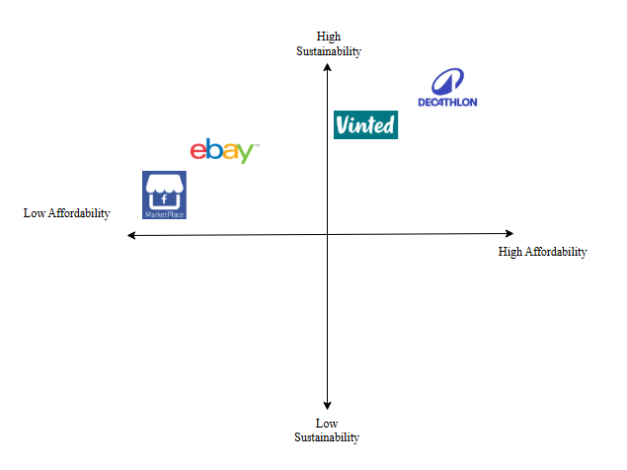
Figure 2.1: Perceptual Map
(Source: Self-developed)
In a perceptual map for Affordability vs. Sustainability, Decathlon will appear before rather than second-hand retailers, such as eBay, Vinted, and Facebook Marketplace, as it is not only affordable but also comes with guarantees of quality and sustainability. This makes sense in light of Decathlon’s vision of providing access to sports to all people in a sustainable way.

Element 3: Marketing Mix

3.1 Introduction
The marketing mix provides a model for integrating Decathlon ReSport through linking sustainability objectives with customer value (Líbalová, 2025). Becoming a circular economy brand extension, these products need to be carefully structured, and it influences responsible consumption, refurbishment and encourages reuse. Through using Decathlon's existing sustainability commitments, digital capabilities and retail infrastructure, the marketing mix creates sustainable environmental and economic value, enhances brand loyalty and customer adaptation while reinforcing company’s objectives of making sport accessible near everybody.
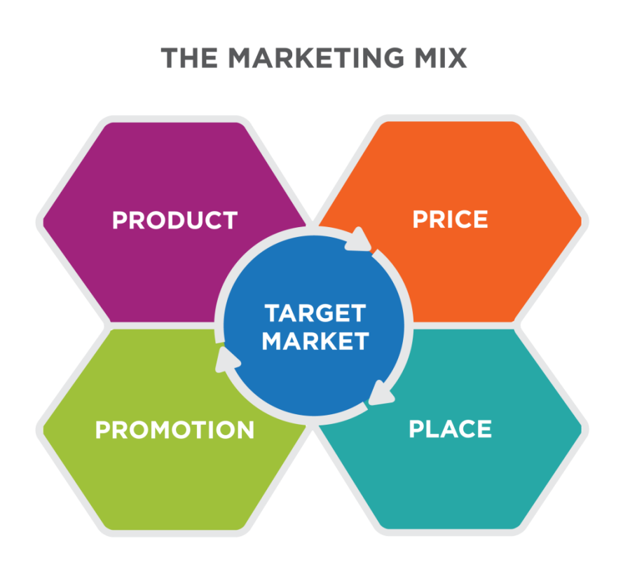
Figure 3.1: Marketing Mix Introduction
(Source: Lumenlearning, 2026).

3.2 Product
Decathlon ReSport offers their core products which are certified refurbished sport equipment and empower the users to buy high quality sporting goods at the minimum prices while decreasing the waste from the environment. As a result, these aided the company's wider sustainability strategy, and outlined extending product lifecycles with the help of the recycling initiatives second life sales, rental and repair. Therefore, the certification “exemplary” in the year 2023 from the AFAQ label evaluation, an ISO14006 based, allows the company to show their mobilization and team's expertise in decreasing the environmental footprint of Decathlon products (DECATHLON SUSTAINABILITY, 2026).
Apart from that the Decathlon ReSport significant features are AI-assisted condition assessment systems, as it assesses the return products depending on the functionality, wear and usage. On the other hand, the same kind of technologies are utilised through the firms like Refurbed and Back Mark which have integrated digital assessment processes to aid electronic products refurbishment (Barkhi et al. 2024). Upon evaluation, all equipment is sent to the refurbishment process, and professional quality inspection to adhere with industry standard safety performance, so it is safe for resale.
To raise the user’s confidence, the refurbished products will be sold by giving the 6-month warranty same as the Back Market (refurbishment leaders) where warranty protection decreases the perceived purchasing issues. Therefore, users will engage in the trade in programmes where they become able to exchange the utilised sports products for store credit. As a result, these initiatives match Decathlon's existing “Second Life” approach which runs in different European markets and their users return utilised products that are resold and repaired.
Utilising the Kotler's Five Product Levels, the Decathlon ReSport key benefits assisted users to access sports accessories at the minimum cost while building the sustainable choice (Baharun and Diana, 2023). Besides these, augmented products involve integrated digital platforms, after sales services, trade in rewards, warranty protection along with the AI assessment. Decathlon ReSport with the help of these features develops both sustainability benefits and customers value through minimising carbon emissions and decreasing the waste related with promoting circular consumption patterns and new production.
Product Level | Decathlon ReSport Example
Core Benefit | To sports equipment, sustainable and affordable access
Generic Product | Refurbished sports equipment
Expected Product | Quality-tested products
Augmented Product | - 12-month warranty,  - AI assessment,  - trade-in credit  - after-sales support
Potential Product | - Personalised recommendations,  - Predictive maintenance  - Expanded circular services
Table 3.1: Application of Kotler's Five Product Levels
(Source: Self developed)

3.3 Price
Decathlon ReSport will utilise the mix of the competitive pricing with value-based pricing to catch the attention of the users while aided long term goals. Therefore, refurbished sport equipment will be sold at 30 to 50% minimum prices than similar new products and creating the sports but with maximum prices which are sold without certification on the platforms like Facebook Marketplace and eBay. As a result, these pricing strategies highlight the additional value and offer with the help of the warranty protections, refurbishment services and quality inspections.
Therefore, the pricing strategy also aided through the enhancing consumer requirements for second-hand products. As per ThredUp (2024), the international second hand market will touch $350 billion (2028) and it reflects the growing acceptance of the refurbished products (Walk-Morris, 2024). Moreover, users can spend money more for the certified refurbished goods which involve the warranty protections and quality inspections in comparison with the goods sold within peer-to-peer platforms like Facebook Marketplace or eBay. This strategy is appropriate as affordability emerges as the significant reason to buy second hand products to customers. On the other hand, competitive pricing also brings issues as setting the price minimum range may create a perception in customers' minds that products hold cheap quality and decrease their trust (Agustian et al. 2023). Besides that, competing basically on price has lowered profitability and made it complex to recover the warranty cost. As a result, Decathlon ReSport must mix value based pricing with competitive pricing through outline the sustainability benefits, warranty protection and quality assurances. These initiatives permit the company to justify their purchases and will create differentiation themselves from the peer-to-peer marketplaces.

3.4 Place (Distribution)
Decathlon ReSport distribution strategy will follow an omnichannel approach, with implementing Decathlon's physical stores to offer a seamless user experience (Yang, 2023). Therefore, users will be capable of trading in purchasing refurbished products, used equipment, and gathering online orders with the help of the existing Decathlon stores. This strategy will be aided through the Decathlon's broad retail network, which runs their business in more than 1800 stores (Marynissen et al. 2026). On the other hand, depending highly on the physical stores has raised the inventory management expenses, staffing and rent. Besides that, customers who live far from the company's stores will find collection services and trade-in less convenient (Yang, 2023). Though it can correct issues, using the existing sites is justified as it decreases users perceived risk when buying the refurbished equipment and aided resale refurbishment and collection procedure that emphasised the circular economy models. As a result, these links with the Decathlon ReSport's sustainability goals through decreasing waste and extending product life cycles.
Moreover, these firms' mobile applications and websites will emerge as important distribution channels and permit the users to check availability, browse refurbished products, and arrange delivery. As per (Gupta, 2022) Omni channel strategy raises the user’s convenience through developing a continuous experience within offline and online touchpoints. In the research context of Decathlon ReSport, it is mainly significant as users describe the perceived issues and raise trust.

3.5 Promotion
Decathlon ReSport will utilise the Integrated Marketing Communications strategy to educate users, encourage participation and create awareness, about circular consumption. Therefore, the social media platforms and digital marketing like Facebook, TikTok and Instagram will be utilised to highlight the sustainability benefits and promote refurbished products (Harju, 2023). This approach is justified a s almost more than 5 billion customers globally utilise social media and build it an important channel for engaging the young users (Nkegbe and Abor, 2023). On the other hand, digital advertising is very competitive which highlights that promotional messages can be ignored easily.
These marketing mix elements aided Decathlon ReSport's success in sustainable brand extension. Together these elements avoided circular economy objectives through promoting responsible consumptions, describing waste from society. As a result, it develops the customer’s value and commits to sustainable business growth.

Element 4: Reflection

4.1 Description
This project consisted of the development of Decathlon ReSport. It is a sustainable brand extension to support the circular economy through the buy-play-return process for our customers. On the other hand, it aims to renew and resell our sports stuff. The process involved in this analysis of market trends, development of the STDP strategy, and design of the marketing mix as per sustainability objectives. Also, I designed a poster to explain the brand extension and prepared a presentation showcasing its value proposition, competitive advantage, and how it contributes to sustainable business growth.

4.2 Feelings
At the start of the assignment, I didn’t seem to find a way to take the concept sustainability into a brand extension that was practical and commercial. It took a lot of thought and research to marry creativity to the principles of marketing. As I worked on the project, my confidence rose as I merged theory with real business practice. Through the poster design and presentation enhancement, creativity has grown, and confidence has improved in delivering marketing presentation ideas.

4.3 Evaluation
There were several successful components of the project. The Decathlon ReSport proposed extension was a good mix of sustainability principles and added value to the customer through reuse, refurbishment and responsible use of the product. The STDP analysis helped gain insight into the target market while the marketing mix demonstrated how brand repositioning can help create competitive advantage (Kumar, 2026). The poster captured the idea clearly through an attractive visual layout and precise content. There were ways to make it better. A more thorough analysis of the competitors and more evidence from the industry could have been achieved through more time. Moreover, better visual balance and consistency are appropriate professionalism for the poster.

4.4 Analysis
This initiative helped me to learn more about strategic marketing and sustainable branding concepts. My ability to enhance marketing theories in a real organization improved my linkage between business decisions and marketing concepts. The development of STDP framework enhanced my market analysis and customer segmentation abilities while the design of marketing mix refined my integrated marketing strategy formulation to help in achieving organisational goals. The critical thinking skill was enhanced by the requirement to assess various perspectives first before justifying strategic decisions when conducting research through academic literature (Campo Carrasco et al., 2023). My communication skills help in encouraging me through making a poster and a presentation to present complex information in a concise and persuasive way across different audiences. Throughout my work experience, I have further developed a range of transferable skills including problem solving, analytical thinking, creativity and strategic planning, which are required for postgraduate study and graduate employment in marketing or brand management. This project has made me aware of how sustainability as well as innovation is becoming increasingly important to gain a long-term competitive advantage.

4.5 Conclusion
It can be concluded that the project gave insights into developing a sustainable brand extension backed by relevant marketing principles. Theoretical knowledge of business practice problems strengthened my understanding of the impact of sustainability, customer value and business growth on marketing strategy.

4.6 Action Plan
In my next projects, I will improve my presentation skills by practicing more and getting more comprehensive market data to support my recommendations. I also want to bring in new knowledge about sustainable marketing, digital marketing technologies, and AI-enabled marketing analytics so that I can build more innovative marketing strategies backed by evidence by monitoring consumer and business evolution.

References
Agustian, K., Mubarok, E.S., Zen, A., Wiwin, W. and Malik, A.J., (2023). ‘The impact of digital transformation on business models and competitive advantage’. Technology and Society Perspectives (TACIT), 1(2), pp.79-93. http://journal.literasisainsnusantara.com/index.php/tacit/article/download/55/57
Baharun, H. and Diana, U., (2023). ‘Consumer Behavior in Choosing Madrasah‎ Education Institutions: Kotler’s Perspective’. TADRIS: Jurnal Pendidikan Islam, 18(1), pp.52-67. https://ejournal.uinmadura.ac.id/index.php/tadris/article/download/8422/3517
Barkhi, F., Ahmadi, S., Shokouhyar, S., Filieri, R. and Ramezaninia, M., (2024). ‘Key drivers and priorities of consumer decisions for refurbished electronics: A mix-method approach’. Heliyon, 10(24). https://www.cell.com/heliyon/pdf/S2405-8440(24)17008-9.pdf
Campo Carrasco, L., Galindo Domínguez, H., Bezanilla Albisua, M.J., Fernández Nogueira, D. and Poblete Ruiz, M., (2023). ‘Methodologies for fostering critical thinking skills from university students’ points of view’. Education Sciences, 13(2). https://www.frontiersin.org/journals/psychology/articles/10.3389/fpsyg.2022.913219/full?utm_source=chatgpt.com
DECATHLON SUSTAINABILITY (2026). Designing our products to reduce their environmental impact. Available from:https://sustainability.decathlon.com/its-because-we-design-our-products-that-we-can-ecodesign-them (Accessed on: 1st Augest, 2026)
Friedman, H.L., 2013. Playing to win: Raising children in a competitive culture. Univ of California Press. https://www.museumofplay.org/app/uploads/2022/01/7-1-book-review-1_0.pdf
Gupta, V., (2022). ‘EXPLORING THE WORLD OF NON-STORE RETAIL CHANNELS’. SPECIAL ISSUE ON STRATEGIC RETAIL MANAGEMENT July 2022, p.111. https://saarj.com/wp-content/uploads/special-issue/sajmmr/2022/SAJMMR-JULY-2022-SPECIAL-ISSUE.pdf#page=111
Harju, M., (2023). ‘Impact of branding & social media marketing in the digital era: Sports apparel brands’. https://www.theseus.fi/bitstream/handle/10024/802772/Harju_Matias.pdf
Hong, T.K., 2025. Strategic International Marketing Plan: Patagonia’s Entry into India. https://www.researchgate.net/profile/Kwan-Hong-Tan/publication/391661964_Strategic_International_Marketing_Plan_Patagonia's_Entry_into_India/links/68219de7d1054b0207ee4bdf/Strategic-International-Marketing-Plan-Patagonias-Entry-into-India.pdf
Kara, A. and Kaynak, E., 1997. Markets of a single customer: exploiting conceptual developments in market segmentation. European journal of marketing, 31(11-12), pp.873-895. https://www.researchgate.net/profile/Erdener-Kaynak/publication/247614643_Markets_of_a_single_customer_Exploiting_conceptual_developments_in_market_segmentation/links/585300ec08ae7d33e01ab438/Markets-of-a-single-customer-Exploiting-conceptual-developments-in-market-segmentation.pdf
Kucukvar, M., Egilmez, G. and Tatari, O., 2014. Evaluating environmental impacts of alternative construction waste management approaches using supply-chain-linked life-cycle analysis. Waste Management & Research, 32(6), pp.500-508. https://www.academia.edu/download/74215534/004635394c2ec2b134000000.pdf
Kumar, S., (2026). ‘Strategic Marketing: Planning and Positioning’. Educohack Press. https://books.google.com/books?hl=en&lr=&id=ShHjEQAAQBAJ&oi=fnd&pg=PT7&dq=The+STDP+analysis+helped+gain+insight+into+the+target+market+while+the+marketing+mix+demonstrated+how+brand+repositioning+can+help+create+competitive+advantage&ots=3ZWDPdKeru&sig=LKdvJzav6GNIsbbW9e1Hw_bs88o
Leal Filho, W., Finisterra Do Paco, A. and Raposo, M.L.B., 2009. Identifying the green consumer: A segmentation study. marketing, 3, p.4. https://www.academia.edu/download/42762966/Identifying_the_green_consumer_A_segment20160217-15377-1duotdy.pdf
Líbalová, V., (2025). ‘Marketingová strategie společnosti Decathlon’. https://theses.cz/id/wa12lv/zaverecna_prace.pdf_
Lumenlearning (2026). Marketing Mix Introduction. Available from: https://courses.lumenlearning.com/suny-hccc-introbusiness/chapter/marketing-mix-introduction/ (Accessed on: 1st Augest, 2026)
Marynissen, H., Meulemeester, R., Domínguez-Ortega, J.M., van Dis, H. and Rijkers, A., (2026). ‘From theory to practice: Resilience as the foundation for governmental effectiveness’. Antwerp Crisis Issue Papers, (01). https://medialibrary.uantwerpen.be/files/1603861/5e61929a-ab80-4d07-8e35-d2610d477ffd.pdf
Nkegbe, F. and Abor, Y., (2023). ‘The role of social media in enhancing customer engagement and brand loyalty’. Journal of Policy Options, 6(3), pp.26-34. http://resdojournals.com/index.php/jpo/article/download/305/775
Paras, M.K., Ekwall, D., Pal, R., Curteza, A., Chen, Y. and Wang, L., 2018. An exploratory study of Swedish charities to develop a model for the reuse-based clothing value chain. Sustainability, 10(4), p.1176. https://www.mdpi.com/2071-1050/10/4/1176
Sholikhah, D.P., Setiawan, B. and Wibisono, A.B., 2026. Application of Segmentation, Targeting, Positioning, and Differentiation in CV Slimeday Indonesia’s Slime Advertisements as a Sensory Play Medium for Children Aged 5-6 Years. Golden Ratio of Data in Summary, 6(3), pp.394-406. https://goldenratio.id/index.php/grdis/article/download/2222/1713
Walk-Morris., T (2024). ThredUp: US secondhand market to hit $73B by 2028. Available from:https://www.retaildive.com/news/resale-secondhand-apparel-market-growth-projections/711476/ (Accessed on: 1st Augest, 2026)
Yang, Y., (2023), ‘November. The Digital Transformation of the Retail Industry, Taking Decathlon as an Example’. In 2023 International Conference on Image, Algorithms and Artificial Intelligence (ICIAAI 2023) (pp. 817-824). Atlantis Press. https://www.atlantis-press.com/article/125994516.pdf

