DS 1 Template

My Screenshots/Photos Sean Michael Breen-Carroll

Screenshot/Photo 1

I use this app for business and quoting jobs

Screenshot/Photo 2
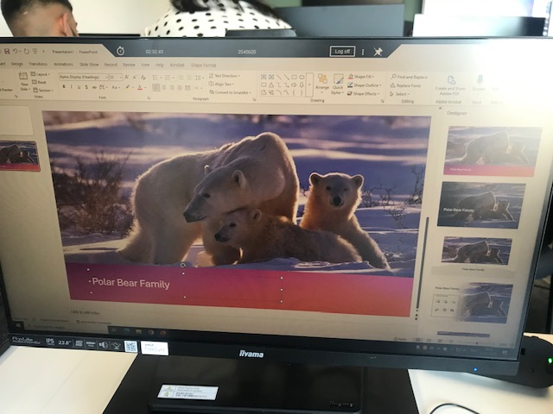
I use this PowerPoint presentation for my digital skills classes.

Screenshot/Photo 3
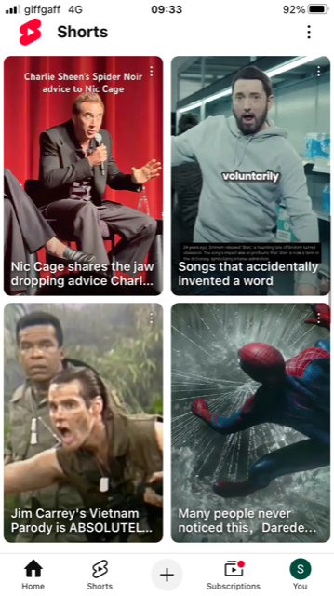
I use YouTube for leisure and news

Screenshot/Photo 4
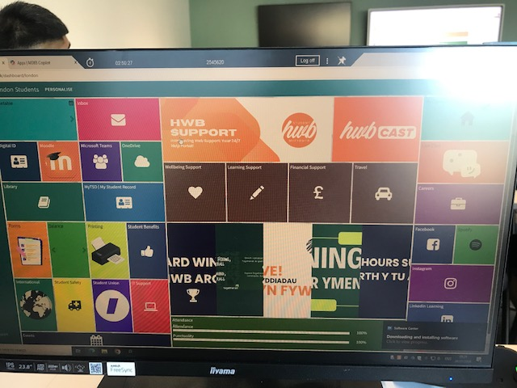
I use Moodle for university

My Short Reflection
- Write 5–8 simple sentences about your digital life.
- You can use the sentence starters below if helpful.
I have learnt about using moodle
I also know how to use word better
I can access my email from university computers
I can insert links in powerpoint presentation
I use whatsapp to communicate with my family

Sentence starters
- I use digital tools to …
- I feel confident when I …
- I want to improve …
- I often use these tools: …
- I sometimes feel nervous about …
- I hope this module will help me …
- Digital skills are important for me because …
You can write more if you want.

Submission Checklist
Before you submit, please check:
​​​ ☐ I added 4–6 screenshots
☐ I wrote short sentences for each screenshot
☐ I wrote my short reflection
☐ My work is my own
☐ My file opens correctly
​​☐ My file opens correctly

