A Report on
Ransomware Awareness

CryptoWall and Your Business

Issue 1

Matthew Satterthwaite

10th November 2019

I declare that this report is the product of my own work and is not being submitted as part of any other assignment for this or any other degree subject

Contents
Contents i
1 Introduction to Cyber threat 1
1.2 What is a Cyber Threat? 1
1.3 Types of attack 3
1.4 Ransomware 3
2 The CryptoWall Trojan 4
2.1 What is CryptoWall? 4
2.2 How does It work? 4
2.3 What happens next? 5
3 Defense 6
3.1 Back it up 6
3.2 Saying No 6
3.3 Patch and Block 6
4 Conclusion 7
5 References 7
6 Appendices 8
6.1 Appendix A 8

List of Figures
Figure 2-1: Random Demand 5
Figure 6-1: Vulnerable Filetypes [4] 8

List of Tables
Table 1-1 : Types of Attack 1

Acronyms
C&C | Command & Control Centre
Doc | Word Document
DoS | Denial of Service
IoT | Internet of Things
MitM | Man in the Middle
OS | Operating System
PDF | Portable Document Format
XSL | Excel Spreadsheet

Introduction to Cyber threat

This document has been written to educate you the business owner, on the subject of cyber threat, and specifically the CryptoWall Trojan.

Firstly, we will start by explaining what a cyber treat could be.

What is a Cyber Threat?

A cyber or cybersecurity threat is a malicious act that seeks to damage data, steal data, or disrupt digital life in general. Cyber-attacks include threats like computer viruses, data breaches, and Denial of Service (DoS) attacks. [1]

There are currently ten types of cyber-attack, all of which are described in Table 1-1. [1]

Table 1-1 : Types of Attack
Threat Type | What is it?
Malware. | Software that performs a malicious task on a target device or network, e.g. corrupting data or taking over a system.
Phishing | An email-borne attack that involves tricking the email recipient into disclosing confidential information or downloading malware by clicking on a hyperlink in the message.
Spear Phishing | A more sophisticated form of phishing where the attacker learns about the victim and impersonates someone he or she knows and trusts.
Man in the Middle (MitM) | Where an attacker establishes a position between the sender and recipient of electronic messages and intercepts them, perhaps changing them in transit. The sender and recipient believe they are communicating directly with one another. A MitM attack might be used in the military to confuse an enemy.
Trojans | Named after the Trojan Horse of ancient Greek history, the Trojan is a type of malware that enters a target system looking like one thing, e.g. a standard piece of software, but then lets out the malicious code once inside the host system.
Ransomware | An attack that involves encrypting data on the target system and demanding a ransom in exchange for letting the user have access to the data again. These attacks range from low-level nuisances to serious incidents like the locking down of the entire city of Atlanta’s municipal government data in 2018.
DoS | Where an attacker takes over many (perhaps thousands) of devices and uses them to invoke the functions of a target system, e.g. a website, causing it to crash from an overload of demand.
Attack On Devices | Internet of Things (IoT) devices like industrial sensors is vulnerable to multiple types of cyber threats. These include hackers taking over the device to make it part of a DoS attack and unauthorized access to data being collected by the device. Given their numbers, geographic distribution and frequently out-of-date operating systems, IoT devices are a prime target for malicious actors.
Data Breach | A data breach is a theft of data by a malicious actor. Motives for data breaches include crime (i.e. identity theft), a desire to embarrass an institution (e.g. Edward Snowden or the DNC hack) and espionage.
Mobile App Malware | Mobile devices are vulnerable to malware attacks just like other computing hardware. Attackers may embed malware in app downloads, mobile websites or phishing emails and text messages. Once compromised, a mobile device can give the malicious actor access to personal information, location data, financial accounts and more

Cybersecurity threats come in three broad categories of intent. Attackers are after:
- Financial gain
- Disruption
- Espionage (including corporate espionage – the theft of patents or state espionage)

Types of attack

Additionally, threats like Drive-by Downloads, Botnets, Wiper attacks and intellectual property theft are also popular amongst Cybercriminals.

Unpatched software, seemingly the simplest vulnerability, can still lead to the largest leaks, such as the case of Panama Papers. The Panama Papers are 11.5 million leaked documents that detail financial and attorney–client information for more than 214,488 offshore entities. These documents were accessed by cybercriminals from Mossack Fonseca, which prior to this attack where one of the world’s largest providers of banking services. [2]

Ransomware

As previously mentioned, this document focuses solely on the possible threats of and damages associated with ransomware. Despite a recent decline, ransomware is still a serious threat. Here's everything you need to know about the file-encrypting malware and how it works.

There are a number of vectors ransomware can take to access a computer. Once they're downloaded and opened, they can take over the victim's computer. [3]

There are several things the ransomware might do once it’s taken over the victim's computer, but by far the most common action is to encrypt some or all of the user's files disabling you from using them. If the files are of high value, a financial ransom is usually offered for their release – with no guarantee of safe return.

In some forms of ransomware, the attacker might claim to be a law enforcement agency shutting down the victim's computer due to the presence of pornography or pirated software on it, and demanding the payment of a fine. This method usually makes the victim less likely to report the issue to authorities.

Some organizations are tempting targets because they seem more likely to pay a ransom quickly. For instance, government agencies or medical facilities often need immediate access to their files. Law firms and other organizations with sensitive data may be willing to pay to keep news of a compromise quiet — and these organizations may be uniquely sensitive to attacks. [3]

An example of such ransomware would be CrytoWall.

The CryptoWall Trojan

What is CryptoWall?

CryptoWall is a particularly nasty form of ransomware. It does much more than just encrypt your files and prompt you to pay for the key; it tries to hide inside the operating system (OS) and adds itself to the Startup folder. Worse still, CryptoWall deletes volume shadow copies of your files – making it almost impossible to restore your data. [4]

While it Is embedded in, it is also trying to access all your passwords and especially your Bitcoin wallet.

How does It work?

CryptoWall is most likely to attack your company via an opened phishing email although this is not the most common form of attack.

The next most common attack method is as part of an exploit kit, which take advantage of security vulnerabilities to deploy malware needed to execute the attack. Known vulnerabilities can be in the operating system, or within unpatched applications.

CryptoWall installs itself into the registry and your startup folder: restarting won’t clear things up – if you don’t remove all of the CryptoWall software while you are in Safe Mode, it will start right back up when you log in again.

CryptoWall needs to communicate with a Command and Control server(C&C) to continue the ransomware attack. The C&C sends CryptoWall the encryption key that it will use to encrypt your files. CryptoWall then runs through all of your files, both locally and on any connected networks, and encrypts your most personal data, for example, your documents, presentations, code, music files, and pictures, music files, and pictures. [4]

What happens next?

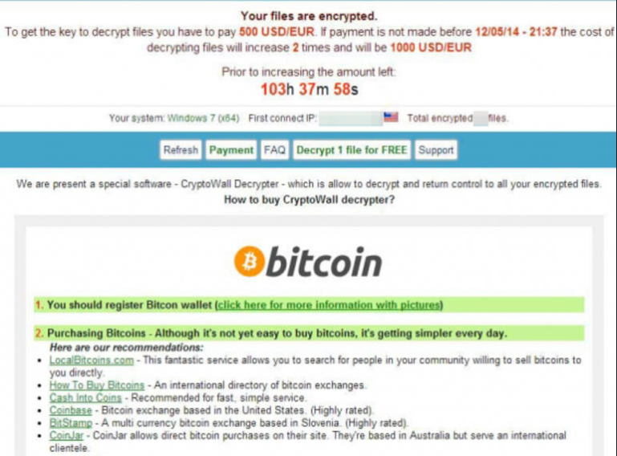
Figure 2-1: Random Demand [5]

Figure 2-1 shows the typical sight you would see if you had been attacked by the CryptoWall Trojan. At this stage your files are now full encrypted.

It is not uncommon for the attackers to decrypt one or two files to show motive and good faith, but there is no guarantee that they will release the remaining files once the ransom is paid.

These payment links are usually untraceable, and authorities will not be able to assist you in getting any monies back.

How did it get you?

CryptoWall can latch on to most file types, including Documents (Doc), Excel Spreadsheets (XSL) and portable document format (PDF). A full list of all possible vulnerabilities is shown in Appendix A.

Defense

Back it up

The best defense against ransomware is to outwit attackers by not being vulnerable to their threats in the first place. This means backing up important data daily, so that even if your computers and servers get locked, you won't be forced to pay to see your data again. [6]

Saying No

When it comes to phishing attacks, experts are divided about the effectiveness of user training to educate workers on how to spot such attacks and right-click on email attachments to scan them for malware before opening. With good training though you can actually get a dramatic decrease in click-happy employees getting caught out. [6]

Patch and Block

No security product is infallible, otherwise individuals and businesses wouldn't be getting hit with so much ransomware and other malware these days. That's why companies should take other standard security measures to protect themselves, such as patching software security holes to prevent malicious software from exploiting them to infect systems. [6]

As an additional method, rather than letting thousands of employees access files on a single server, they can break employees into smaller groups, so that if one server gets locked by ransomware, it won't affect everyone. This tactic also forces attackers to locate and lock down more servers to make their assault effective. [6]

Conclusion

Ransomware is potentially a serious threat to your business. It can cause your both security and financial issues without you even knowing you have been attacked.

Educate your employees on the typical signs of the attack and back up all of your data in several places so you don’t have to pay to get it back from cyber criminals.

Use adequate firewalls and antivirus software to help protect yourself, if

References

[1] | P. Project, "What are Cyber-Threats," [Online]. Available: https://preyproject.com/blog/en/what-are-cyber-threats-how-they-affect-you-what-to-do-about-them/. [Accessed Nov 2019].
[2] | M. B. a. J. Temperton, "www.wired.co.uk/article," Wired.co.uk, 2016. [Online]. Available: https://www.wired.co.uk/article/panama-papers-mossack-fonseca-website-security-problems. [Accessed 10 November 2019].
[3] | J. Fruhlinger, "www.csoonline.com," IDG Communications, 2018. [Online]. Available: https://www.csoonline.com/article/3236183/what-is-ransomware-how-it-works-and-how-to-remove-it.html. [Accessed 10 Nov 2019].
[4] | J. Petters, "Crytowall Blog," 2018. [Online]. Available: https://www.varonis.com/blog/cryptowall/. [Accessed 11 Nov 2019].
[5] | J. Vigo, "Security," TechRepublic, 2016. [Online]. Available: https://www.techrepublic.com/article/cryptowall-what-it-is-and-how-to-protect-your-systems/. [Accessed 2019].
[6] | K. Zetter, "Security," Wired.co.uk, 2016. [Online]. Available: https://www.wired.com/2016/05/4-ways-protect-ransomware-youre-target/. [Accessed 13 Nov 2019].

Appendices

Appendix A
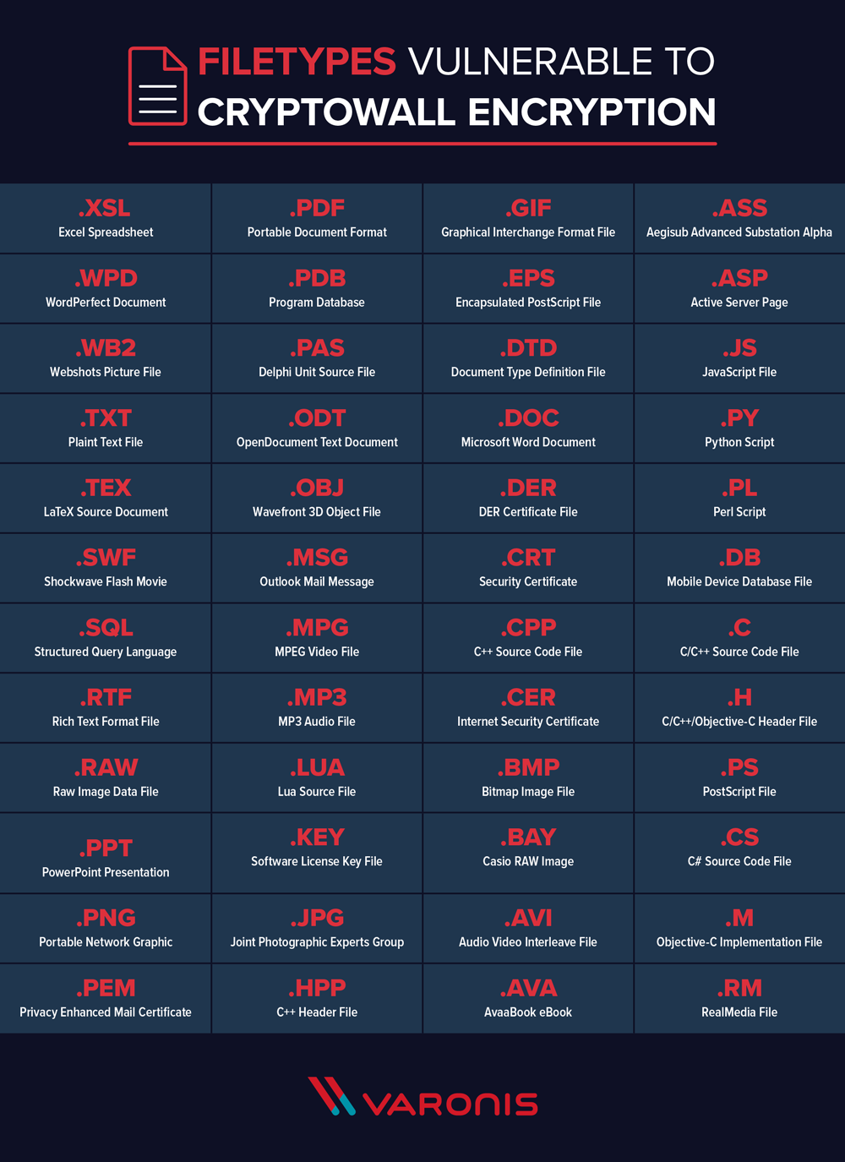
Figure 6-1: Vulnerable Filetypes [4]

