Module Title: THE GLOBAL BUSINESS ENVIRONMENT
Tutor’s Name: Syed Jaffery
Student Name: Mihaela Mindrila
GROUP 2, TERM 2
Student Number: 1916800
Assignment Title: Environmental Analysis of an industry - Assessment 1

Contents
Discussing the business environment using various environmental scanning tools……….3
- The changes occurred in the industry in last few years……………………………..3
SWOT analysis ……………………………………………………………………………......4
PESTLE analysis……………………………………………………………………………...5
Critical assessment of opportunities, challenges, and finding competitive advantage ……6
- Identification of opportunities and challenges ……………………………………...6
- Strategies to gain competitive advantage…………………………………………...8
Conclusion 9
Reference list 10

Introduction
The business environment is a summation of all the internal and external factors that affect the functioning of an organisation (Cherunilam, 2016). The external environment of a business consists of various outside forces like government regulation, customer taste and preferences and more, whereas the internal factors are related to the micro-environments within which organisation functions (Muddaha et al., 2018). It includes organisation management, employee productivity and more. For instance, the demand trends of the electric car industry of which Toyota is a part is subject to changes that are beyond control. In this assignment, several factors affecting the business environment of the car industry and the specified organisation Toyota has been analysed so that the changes that have taken place over the last few years could be evaluated, and the competitive strategies of the organisation to gain a better position in the industry has been stated.
Discussing the business environment using various environmental scanning tools
- The changes occurred in the industry in last few years
Few robust changes have taken place in the car manufacturing industries over time. Earlier it took 60 hours to create a new car where is now with developed Technologies a maximum of 16 hours is required for new car production. It has been the most changing and evolving industry (Yin et al., 2018). Redefining has been noticed in the ways car users started to incline with hybrid-electric and solar energy system displacing the internal combustion and fuel-fed engines. There have been establishments in self-driving models by indicating growth in autonomous technology. The car manufacturing industries are producing models which have greater user interactivity and, also smart technologies defining the future class. Recently the industry has also recorded a fall in sales of vehicles to several economic crises. The on-going pandemic has also changed the dynamics of this industry. Manufacturing sectors have decreased their production due to lack of workforce, resources and demand. Such an impact has not been witnessed in the past (Lee and Tan, 2019). Moreover, the automobile industry is a crucial driver of the global economy is displaying disruptive conditions. It has also been analysed that in recent years, people have become more inclined towards environmental sustainability. That is why electric car sale has increased significantly for last 5 years by 23% (Toyotauk, 2020).
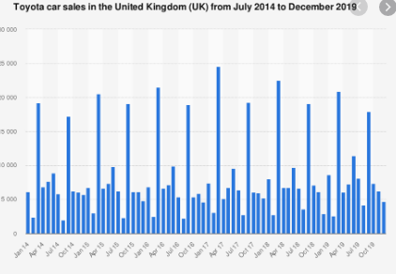
Figure 1: Sales of Vehicles
(Source: Toyotauk, 2020
SWOT analysis
Toyota being a well-known firm capturing the considerable amount of global-market share that is 10.24%, has several internal strengths which include their sharp brand image and a global supply chain in the industry with the capability of rapidly innovating Technologies (Toyotauk, 2020). Whereas there are several internal strategic weakening factors which the organisation faces. For instance, that they had hierarchical organisation structure as a result of which the face several internal conflicts. The company has also faced some backlash in previous years regarding product quality dispute, which has caused major financial loss for the company (Toyotauk, 2020).
The opportunities that Toyota enjoys belong to its external environment, and it is mainly by the emerging markets. Toyota’s technologies have provided them with opportunities to acquire a rising demand for their products (Sosnovskikh, 2016). One such example is the Toyota Hybrid System (THS) that was indulged in the first-generation Prius in 1997, which has evolved into the THS II in the year 2003 (Toyotauk, 2020). Irrespective of their favourable situation in the market, there are also affected by several external threats which are growing low-cost competitors like Honda and Ford and, also rapid innovations made by them (Liu, 2018).
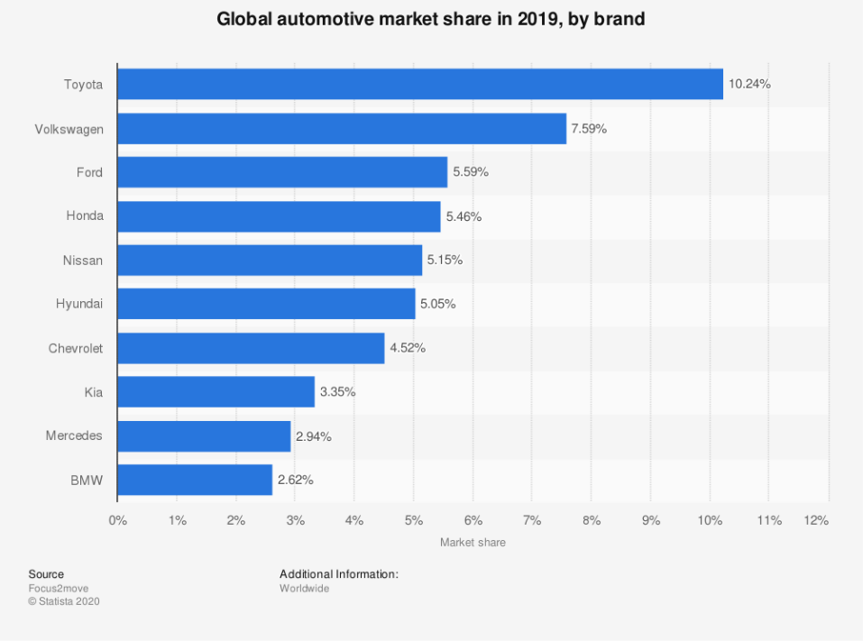
Figure 3: Market share of Toyota
Source: (Statista, 2020)
PESTLE analysis
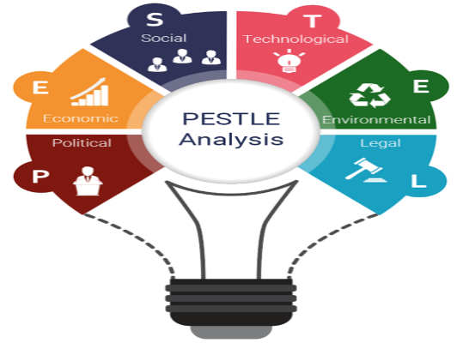
Figure 5: PESTLE
(Source: Lee and Tan, 2019)
The government of a specific country implicates the tax-laws, labour-laws and several regulations. The departments dealing with automobile policies in the UK are the SMMT Public Policy and Vehicle Legislation (PPVL) Department. The policies status by the government affects their macro-environment, which brings down impact on the firm. For instance, before BREXIT, Toyota expects to increase sales figure by 2.4% in UK. However, after BREXIT, it reduced to 1% (Toyotauk, 2020). From the year 2007 until date, Toyota faced several losses due to technical errors in manufacturing and their improper organisational structure as a result of these economic-factors their HR policies were also impacted (MotorTrend, 2020). The on-going critical condition of COVID-19 has also affected the industry as it has faced intense pressure as a result of sloping down demand for automobiles. In relation to social factor, it has been found that the purchasing pattern of automobile industry has changed much in last few years. People have started to focus more on environmental and social sustainability.
They have made several technological developments (like car subscription technology named KINTO) and has achieved advancement in the technologies that they have incorporated in the system is the worldwide automatic real-time purchase in a system that helps them to eliminate time-wasting and administrative hassles (Toyotauk, 2020). Toyota put much emphasis on the legal-policies of the nation in which their functioning and they have also draught a document which explains the legal rights of their employees, considering the complexity of global operations. (Lee and Tan, 2019). Low Carbon Vehicles Innovation Platform of the UK provides funds for developing low-carbon cars and initiate methods for charging ultra-low carbon vehicles in the market, of which electronic is essential (Lee and Tan, 2019). Toyota has formulated the “Toyota charter” which has the guiding principles which are undertaken to adopt environmental initiatives and also they have announced the Toyota environmental challenge 2050 in which they are striving to reduce the environmental burden. It is caused due to the automobiles and trying to bring the ill effects down (Takahashi et al., 2018).

Critical assessment of opportunities, challenges, and finding competitive advantage
- Identification of opportunities and challenges
This section of the essay discusses the opportunities and challenges based on Porter’s 5 forces of Toyota. This theory was developed by Michael Porter (Bhatia, 2016). The management of the Toyota has given enough significance to hybrid cars. As of the first quarter of 2020, the organisation passed 15 million hybrid electric vehicles global sales (Toyotauk, 2020). The organisation collaborated with Sharp and NEDO to manufacture cars that will run on solar energy (Toyotauk, 2020). This model has 5 different factors such as threat of new entrants, threat of substitutes, bargaining power of the suppliers, bargaining power of the customers, and Competitive rivalry.
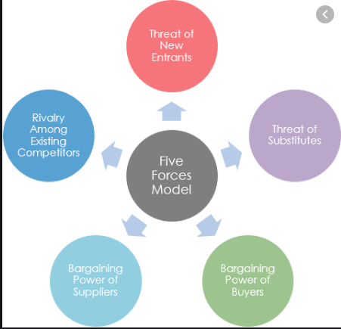
Figure 6: Porters five forces
(Source: Bhatia, 2016)
- The threat of new entrants is a low for Toyota. The reason behind this is that new entrants need to have high capital investment and the cost of the supply chain is also high. Apart from that, Toyota is a reputed industry, and they have strong sales growth. They sold more than 10.74 million cars in 2019 around the world (ETAuto, 2020). Therefore, they can use their brand image to gain a competitive advantage.
- The threat of substitutes is a moderate threat to Toyota. The reason behind this is the moderate availability of substitutes of electric automobiles in the UK market. However, the organisation offers its products at an affordable rate, so this threat is not a concern for them. The bargaining power of the suppliers imposes a weak threat to Toyota. They have a range of suppliers, namely Tesla Motors, Bridgestone America, Cypress and many others.
- The bargaining power of the customers is a severe threat to Toyota. The reason behind this is the low switching cost. The customers can easily switch from Toyota to other brands. They can choose any other brand because an ample quantity of information about other brands is readily available.
- Competitive rivalry. It also imposes a high threat to Toyota. In the market of the UK, Toyota faces competition from Ford, Nissan, Volkswagen, Honda, Chevrolet and many others. The market share of Toyota is 8.05% in June 2020, whereas the market share of Ford, BMW and Volkswagen are 9.37%, 7.32% and 8.55 % respectively (Statista, 2020).

- Strategies to gain competitive advantage: This section of the essay discusses how Toyota can gain a competitive advantage. These strategies are developed based on the forces discussed above. Porter's diamond strategy analysis of Toyota is used here for that purpose. It is based on six components (Vlados, 2019).
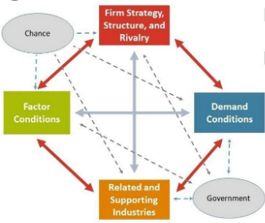

Figure 7: Porters Diamond network
(Source: Vlados, 2019)
- Factor conditions: Toyota can think of enhancing their business in the UK due to the availability of skilled labourers (Vlados, 2019). However, the petrol price is steady in the UK; still, they can think of launching an electric car in the UK as that will be profitable, and that can gain a competitive advantage. It is mainly due to the fact, that customers of UK have become more inclined towards sustainable automobiles (Vlados, 2019).
- Demand condition: The sale of a car is getting low in the UK as it fell by 2.4% in 2019 (Frangoul, 2020). However, the demand for electric car has increased rapidly worldwide. There has been a 144% growth of electric car in 2019 (Frangoul, 2020). The sale of the electric car also topped 2.1 million in 2019 worldwide (IEA, 2020). Therefore, Toyota can give a high focus on an electric car in the UK and even in other countries so that they gain an advantage over its competitors.
- In terms of related and supporting industry, the UK has more than 2,500 component providers which is beneficial for Toyota (SMMT, 2020).
- The government of the UK provides a plug-in grant of a maximum of £3,000 for low-emission vehicles and it is a significant opportunity for Toyota to work on electric cars in the market of UK (GOV, 2020).
- In the case of chance, there is a low chance of natural disasters in the UK, so it is not a concern for Toyota.
Based on the overall analysis, it can be stated that Toyota’s technologies like Toyota Hybrid System (THS) have provided them with opportunities to acquire a rising demand for their products (Sosnovskikh, 2016). Hence, in order to get competitive advantage, Toyota can consider electric cars as one of the strengths associated with future sustainability both for the UK and, also the world, as it has a promising future.

Conclusion
In this assignment, the major forces that are shaping the business environment to the car manufacturing industry have been analysed with a critical assessment of the opportunities and the challenges prevailing in the industry. Several factors that affect the competitive environment of the industry has been portrayed in detail using Porter's diamond and five forces framework.

Reference list

Bhatia, J., 2016. Porter's Five Forces Industry Analysis of Indian Passenger Car Industry. Pacific Business Review International, 8(7), pp.113-123.
Cherunilam, F., 2016. Business environment. Himalaya Publishing House.
Dudovskiy, J., 2020. Toyota Value Chain Analysis - Research-Methodology. [online] Research-Methodology. Available at: <https://research-methodology.net/toyota-value-chain-analysis/>
ETAuto.com. 2020. Toyota's 2019 Global Vehicle Sales Trail Volkswagen's - ET Auto. [online] Available at: <https://auto.economictimes.indiatimes.com/news/passenger-vehicle/cars/toyotas-2019-global-vehicle-sales-trail-volkswagens/73762625#:~:text=Toyota%20Motor%20Corp.%20said%20Thursday,out%20Toyota%20for%20the%20No.> [Accessed 24 July 2020].
Frangoul, A., 2020. UK Car Sales Hit 6-Year Low But Electric Vehicles See Surge In Demand. [online] CNBC. Available at: <https://www.cnbc.com/2020/01/06/uk-car-sales-hit-6-year-low-but-electric-vehicles-see-surge-in-demand.html#:~:text=New%20car%20registrations%20in%20the,compared%20to%202%2C367%2C147%20in%202018.> [Accessed 24 July 2020].
GOV.UK. 2020. Low-Emission Vehicles Eligible For A Plug-In Grant. [online] Available at: <https://www.gov.uk/plug-in-car-van-grants> [Accessed 24 July 2020].
IEA. 2020. Global EV Outlook 2020 – Analysis - IEA. [online] Available at: <https://www.iea.org/reports/global-ev-outlook-2020> [Accessed 24 July 2020].
Lee, J.W. and Tan, W.N., 2019. Global Corporate Citizenship: Cross-cultural Comparison of Best Practices in the Global Automotive Industry. The Journal of Asian Finance, Economics and Business (JAFEB), 6(1), pp.261-271.
MotorTrend. 2020. The Toyota Recall Crisis - A Chronology Of The Toyota Pedal, Floormat Recall - Motor Trend. [online] Available at: <https://www.motortrend.com/news/toyota-recall-crisis/>
Muddaha, G., Kheng, YK and Sulaiman, Y.B., 2018. Learning capability and nigeriansme's marketing innovation–the moderating influence of dynamic business environment. International Journal of Management Research and Reviews, 8(3), pp.17-29
SMMT. 2020. UK Automotive Industry - SMMT. [online] Available at: <https://www.smmt.co.uk/industry-topics/uk-automotive/> [Accessed 24 July 2020].
Sosnovskikh, S., 2016. Toyota Motor Corporation: Organizational Culture. Philosophy Study, 6(7), pp.442-454.
Statista. 2020. Automobile Market Share Worldwide 2018 | Statista. [online] Available at: <https://www.statista.com/statistics/316786/global-market-share-of-the-leading-automakers/>
Takahashi, T., Ueno, N. and Sakuma, D., 2018. Development of Hydrogen Burners and Vacuum Insulated Furnaces for Zero CO 2 Emissions (No. 2018-01-0658). SAE Technical Paper.
Toyotauk.com. 2020. Overview. [online] Available at: <https://www.toyotauk.com/toyota-in-the-uk/#:~:text=Toyota%20in%20the%20UK,at%20Deeside%20in%20North%20Wales.> .
Vlados, C. and Chatzinikolaou, D., 2019. Methodological redirections for an evolutionary approach of the external business environment. J. Mgmt. & sustainability, 9, p.25.
Vlados, C., 2019. Porter’s diamond approaches and the competitiveness web. International Journal of Business Administration, 10(5), pp.33-52.
Yin, Y., Stecke, K.E. and Li, D., 2018. The evolution of production systems from Industry 2.0 through Industry 4.0. International Journal of Production Research, 56(1-2), pp.848-861.

