Part C
Problems
There were a number of problems that occurred when producing the game, these include:
- Randomizing an array of numbers (cards)
- Asking the user to enter what cards they want to turn over.
- Checking if the cards match
  - If the cards do match, the score will increase by one and a message output saying “match”.
  - If the cards do not match, a message will output saying “no match”.
- Loop the program when the user wants to have another go of the game.
- Adding a scoring system.
- Writing the name and score to a file.
Solutions
The solutions to the problems are below:
  - A solution to the problem of randomizing an array is making sure that every time the game is run the set of numbers produced will not be the same and before games. This is done by using the ‘srand’ command that will randomise the function.
The enhanced solution for randomising an array of numbers for the game is using a randomising function that will randomise an array of numbers. Every time the function is called, the set of numbers will not be the same as before. Below is a piece of pseudocode that will help structure the final produced code.

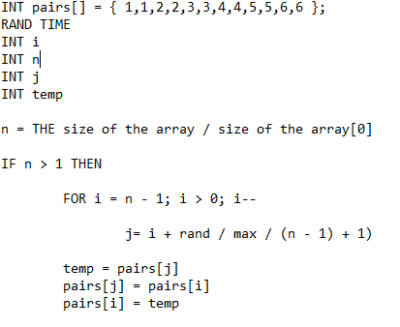

2.1. A solution to asking the user what cards they want to turn over is making sure that the user gets to pick to cards and by not using excessive amounts of code. Recalling functions will help reduce the amount of code and it will be quicker and a more effective way of using the code. Below is a piece of pseudocode that shows how the code will function.

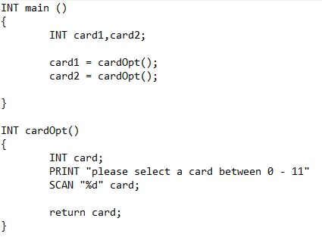

3.1. A solution to checking if the cards match is making sure that if the cards match then output a message saying that the cards match, and make sure that the value of the cards is now 0. This will show that you have already picked that card. Below is a piece of pseudocode that will show how it will function.

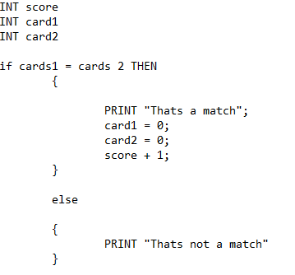

4.1 Looping the program will allow the user to have an option whether to have another go at the game. Below is the pseudo code that will help structure the code.
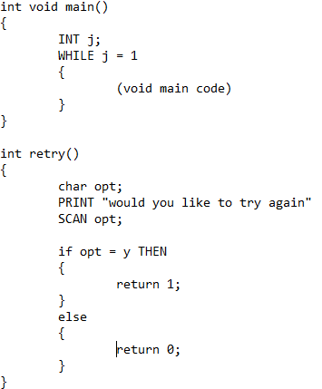

5.1. Adding the scoring system will help show how the user is doing throughout the game. Below is a piece of pseudocode that will help structure the code for scoring. Every time there is a pair of cards, the score will add 1 to its value.
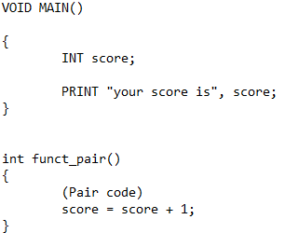

6.1. Writing the name and score to a text file will enable the text file to be read into a database or such. Writing to a text file includes the FILE *fp command that will allow the data to be writing to a file. Below is a piece of pseudocode that will help structure the code.
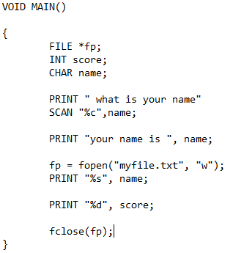

Code with annotations
#include <stdio.h>
#include <stdlib.h>
#include <time.h>
#define MAX 20 // defining a global a max amount of characters.
int CardOpt(); // creating prototypes for all the functions.
int rand_funct();
int Funct_Pair(int card1, int card2,int score);
int funct_retry();
int pairs[] = { 1,1,2,2,3,3,4,4,5,5,6,6 }; // a global array for the cards.

void main()
{
int i, card1, card2, j = 1,score = 0,value = 0; // variables for the numbers to be stored in.
char opt; // variable for characters to be stored in.
FILE *fp; // inistilizing the file command to allow data to be writing to a file.
char name[MAX]; // variable for the name of the user to be stored with a max of 20 characters.
char * str; // variable for the string of characters.

printf("what is your name? \n"); // outputting a question to the user.
str = fgets(name, MAX, stdin); //
printf("Your name is %s\n", str);

fp = fopen("myfile.txt", "w"); // opening the file ready to write to it.
fprintf(fp, " %s ", name); // writing the users name to the file

while (j == 1) // creating a while loop to loop the program until j = 1.
{
rand_funct(); // calling the rand_funct function to perform it's operation.
for (i = 0; i < 12;i++) // creating for loop to print out all the numbers in the array.
{
printf("%d ", pairs[i]);
}
card1 = CardOpt(); // calling the function CardOpt twice to get to number cards for the user.
card2 = CardOpt();

Funct_Pair(card1, card2,score); // calling the funct_pair function to see whether there is a match or not.
printf("\nScore = %d", score); // outputting the score

j = funct_retry(); // calling the retry function to see whether the user wants to have another go of the game.
}
fprintf(fp, " \nScore = %d ", score);
fclose(fp); // closes the file

}

int CardOpt() // int function
{
int card; //variables
printf("\n Please select Card :(0-11)"); // outputting message
scanf("%d", &card); //recording input

return card; // returning the variable card

}

int Funct_Pair(int card1, int card2, int score) // int function
{

if (pairs[card1] == pairs[card2]) // if statement to see whether the cards match
{

printf("Thats a match\n");
pairs[card1] = 0;//take out of the game
pairs[card2] = 0;//take out of the game
score = score + 1; // score + 1
}

else

{
printf("Sorry not a match");
}
return score; //returns the variable score.
}

int rand_funct() // int function
{
srand(time(NULL)); //declating the time
int temp, i, x, j; // varaibles
int n = sizeof(pairs) / sizeof(pairs[0]); //seeing whether there is new set of numbers needed
if (n > 1)
{
for (i = n - 1;i > 0;i--)
{
int j = i + rand() / (RAND_MAX / (n - i) + 1); // for loop to randomize the numbers.

temp = pairs[j];
pairs[j] = pairs[i];// storing the pairs in different orders to make it a fair game.
pairs[i] = temp;
}
}

return 0;
}

int funct_retry() //retry function
{
char opt;

printf("\nWould you like to try again: Y/N");
scanf(" %c", &opt);

if (opt == 'Y' || opt == 'y') // if the opt is Y then the value 1 will return. This will then allow the while loop to loop again.
{
return 1;
}
else
{
return 0;
}
}
Testing
- Testing if numbers sort randomly.
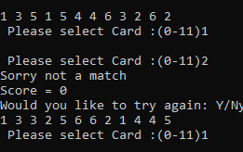
The two sets of numbers are different, this shows that the random sort works.

- Testing if the card select works.
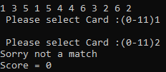
Card select works because the cards that are picked do not match.

- Testing if the cards show matching pairs.
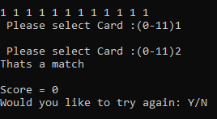
The match function works because all the values in the array are set to 1. The only right answer would be a match and it outputted match.

- Testing if the cards show not matching.
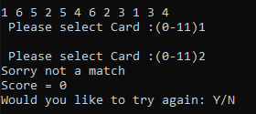
As you can see the cards do not match. And the program outputs do not match.

- Testing if the retry function works.
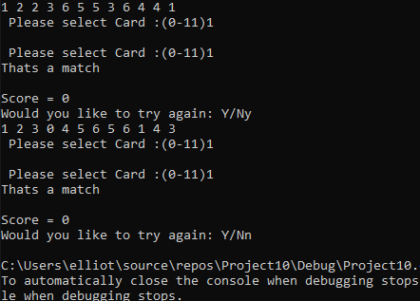
As you can see the program restarts if the user enters ‘y’ and ends if the user enters ‘n’.

- Testing if the username that is entered is saved in the memory correctly with no memory leaks.
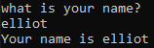
As you can see the program stores the string and outputs it underneath.

- Testing if the cards turn over works.
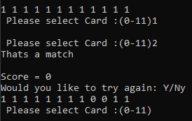
As you can see the two card values are changed to 0 showing that the cards are turned over.

- Testing if the scoring system works.
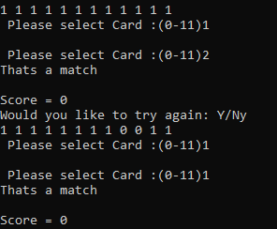
The scoring system does not function properly. At this moment in time, the writer is not sure why.

- Testing if the writing to a file works.
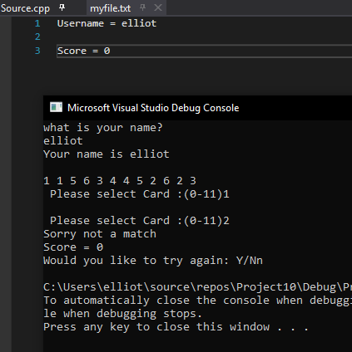
The program writes the username and score to the file.

