Anna Mcphee
(1807581)

E Portfolio

Workplace Practice

Tania Davies

Contents page

- Title page
- Contents
- Introduction of myself, future and why I want to be a Nurse
- Continued why I want to be a nurse
- Continued why I want to be a nurse
- CV
- Certificates
- Certificates
- Certificates and work experience
- Certificates
- Payslips
- Current and experience continued
- Smart action plan
- Smart action plan

My name is Anna Mcphee I am currently a first-year nursing student at USTWD. My goal is to become a qualified nurse and complete a degree in adult nursing. I am furthering my education now as I feel that I have the experience and determination to become a qualified nurse. I have nine years of experience in the health care sector. My working experience has provided me with a sound grounding of basic nursing care, knowing that I have made a difference to a patient’s wellbeing and the skills and qualities I have gained have inspired me to gain further knowledge and qualifications at Trinity Saint David to prepare me for the adult nursing degree. My current course has really helped me academically and this has been proven by myself that I have been able to meet deadlines and show my organizational skills. My course covers physiology and anatomy which I am finding interesting learning about the human body. I am really looking forward to progressing my knowledge of the human body and learning how to treat the body when damaged. I really enjoyed the first module of my university course which was introduction to health research, I found it interesting reading through numerous research papers on health and finally writing a report on critiquing a research paper.

In my present and previous employment as a Health Care Support worker I have worked alongside nurses caring for elderly vulnerable patients suffering with various debilitating health conditions, such as stoke, dementia and frailty. My duties include providing personal care such as bathing, toileting and ensuring patients have adequate nutrition by helping them eat and drink fluids. The most rewarding part of my role is ensuring the individual under my care is happy and comfortable just simply to see a smile on a patient’s face would make my day. I have learnt to adapt to patient’s individual needs, some patients have presented challenging behavior due to illness and sometimes become aggressive or anxious. I have gained experience to manage these situations by adapting differing communication techniques and sensitivity.
Over the years of my experience and especially in my first job of being a health care assistant I have showed my ability to reassure patients with dementia even though this was quite a challenging role it was extremely fulfilling. I have been in situations where I have had to provide palliative care, being very emotionally challenging for myself I found the courage to always show compassion and provide dignity
to the patient throughout. I have shown the ability to support family members in which were very difficult times for them, ensuring them and more importantly showing them that their family members were receiving the best care and support.
I have received appreciation of my work from previous and present managers and team members and most importantly patients and their family members. It has been shown from my last supervision that I use effective communication at work, feeding back to my clinical team of nurses and on handovers to my colleagues. I write reports, document skin bundles and I am skilled at recording temperature, blood pressure and administrating medication via a percutaneous endoscopic gastrostomy.

Anna Louise Mcphee
10 Curwen Close
Pontrhydyfen
Neath Port Talbot
SA12 9UT
E-mail: Annamcphee1990@hotmail.co.uk

Tel: (01639) 641979 Mobile: 07983730761

Date of Birth: 11/02/90 Geographically mobile/ Full UK Driving Licence

Personal Profile
An experienced and committed Health Care Assistant furthering my education to become a qualified Nurse. I have relevant experience both in Residential homes and community work. I am looking for different experiences of different Health Care settings. I am motivated, able to use effective communication and work at my own initiative and as a team.

Education
University of Wales Trinity Saint David Present – May 2019
HE Nursing Studies and Health

Modules Include:
Introduction to Physiology of the Body
Communication and Counselling
Introduction to Heath Research
Workplace Practice
Managing Organisations
Personal and Academic Development
NVQ Level 2 in Health and Social Care 2015-2016
Essential Skills Maths/English Level 2 2015-2016

I have achieved all training over the years such as:
Manual Handling
Food Safety
Data/Child Protection

Languages
English

Other employment
I started my working life working with children in a school setting I then decided that I wanted to go into the care sector which I really found where I wanted to be. I gained experience in different settings such as mental health, dementia and community work with vulnerable young adults.

Present University
Shown that I can make deadlines and shown my organisational skills. It has been shown that I am able to involve myself into group work and able to voice my opinion accordantly.

Skills
I have a sound knowledge of how to use Microsoft word this has been shown by completing my assignments. I have shown the ability to communicate well, this is known from my supervisions at work. I work well as a team and on my own, teamwork is important in the health care sector and I feel I am confident at it. I feel I am very reliable and trustworthy and can be trusted with any task that is given to me.

Achievements
Over the years of my working life I have achieved an NVQ in level 2. I have previously raised money for dementia and the British Heart Foundation which are both charity’s close to my heart.

References
References are available on request

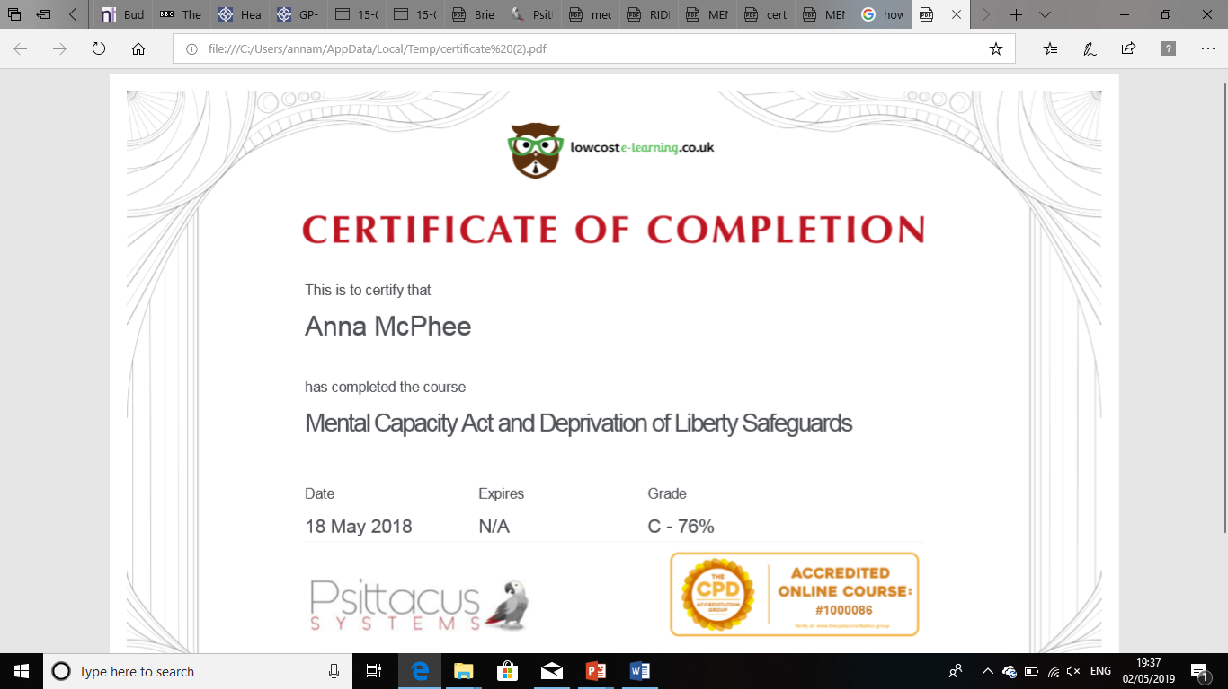

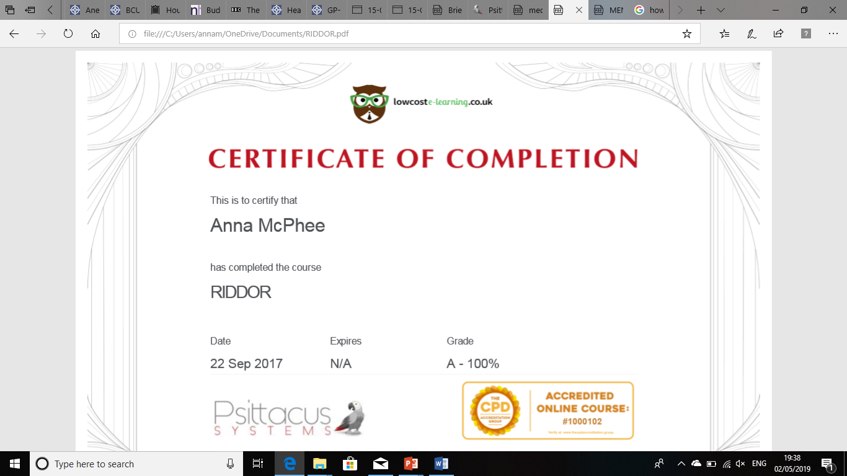

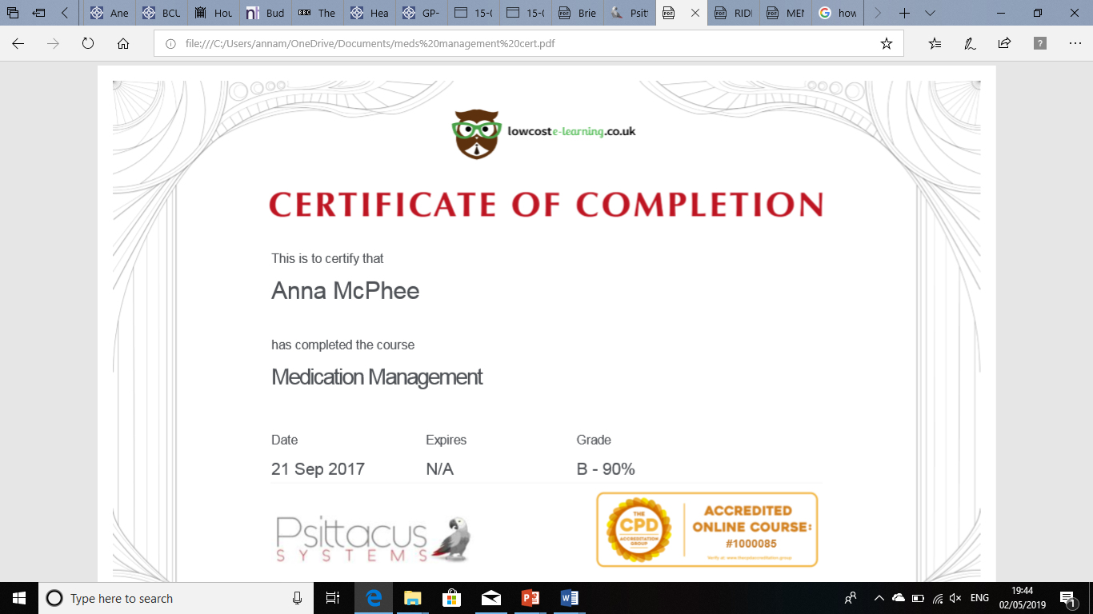

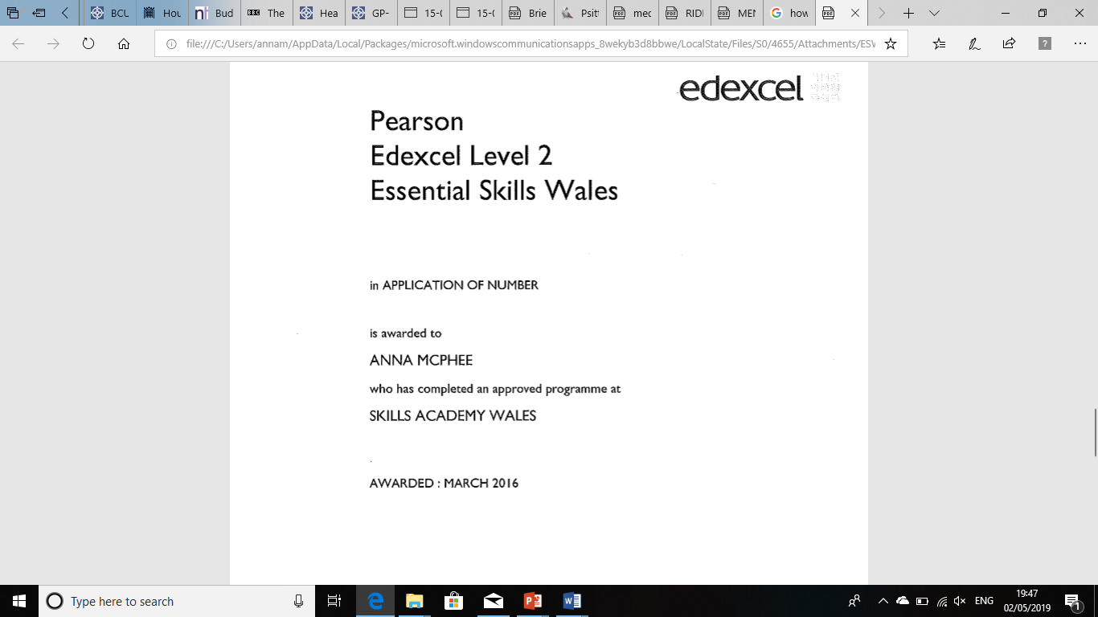

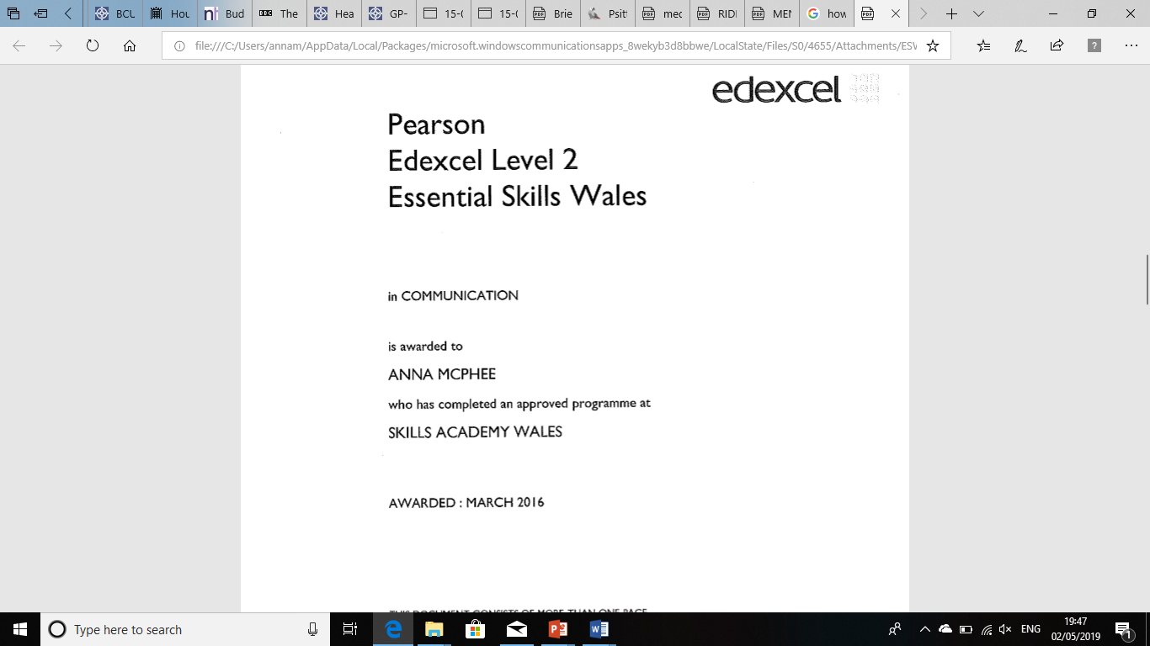

I have an overall nine years’ experience in the health care sector. I have worked with people who have dementia working alongside experienced support workers and managers in my first role I progressed to a senior member of staff within two years, I thoroughly enjoyed this role. I assisted residents with personal care, day to day activities and mostly promoting independence.

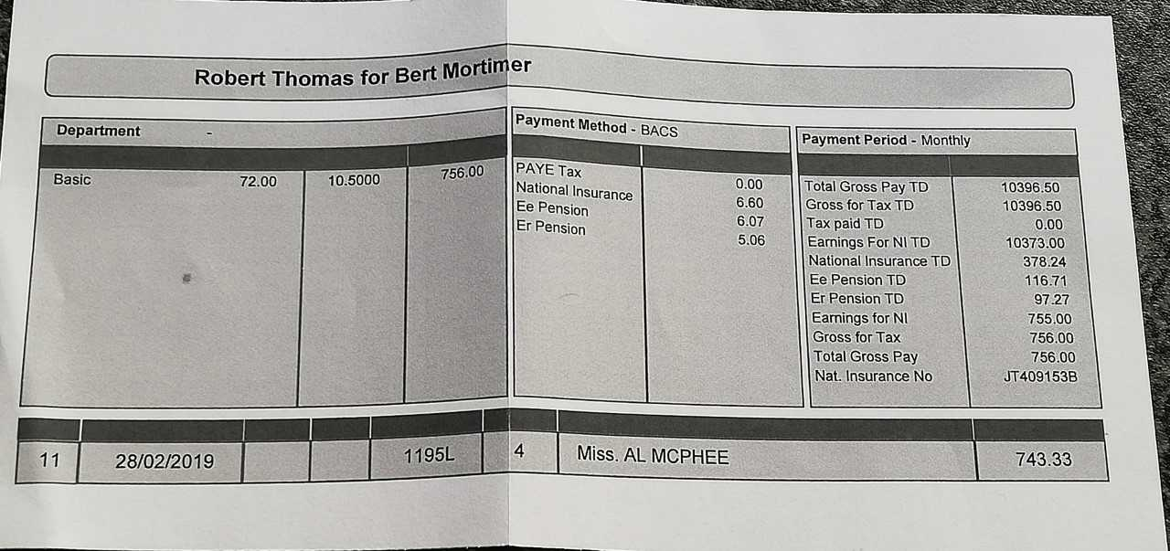
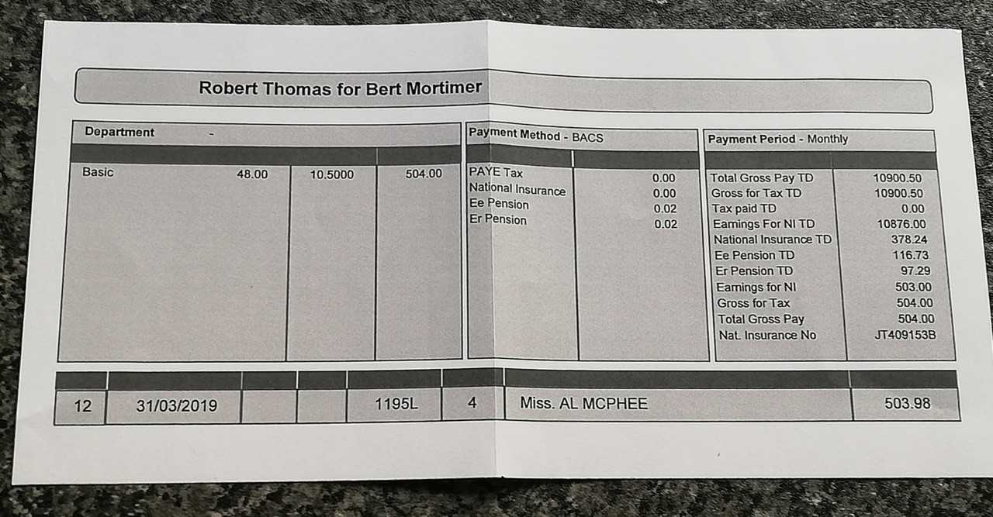

My second role was a community health care assistant which thoroughly
enjoyed. I helped clients of all ages with personal care, medication and cooking within their homes. I also took residents out into the community shopping, to the hairdressers and cinemas. Whilst I was working, I undertook an NVQ level.
My current role is a job that I sincerely adore. I care for a man in his home who has sustained a brain injury. It is a challenging role but extremely rewarding. I assist my client with personal care, eating, fluids, cooking, taking him out into the community and most all supporting himself and his family.
Overall, I have a real passion for caring for people I have always wanted to become a nurse and further my education to eventually start a nursing degree.
Below is my Smart action plan
SMART Action Plan
Long Term Goal | Deadline for completion
To become a qualified Nurse | 2023

Short Term Goals (SMART)

Goal 1:
Specific | Clearly state what the task/action is that you want to do/take. Why is this important at this time? How are you going to do it? | To continue to work to the best of my ability to pass my nursing studies course. This will give me the qualification to progress onto the nursing degree.
Measurable | Have a clearly defined outcome. How will you know if you have reached/achieved this goal/task? What evidence will you have to show you have reached/achieved it? | The perfect outcome for me will be the completion of this course with a pass grade.  Up to this present time I have shown to meet the goal of deadlines.  If a pass is achieved for this course my goal will then be achieved to go onto the nursing degree.
Achievable | Will you be able to achieve this goal? Will you need any help to achieve it? Do you have the resources you need to achieve it? Which factors will enable you to achieve the goal? Are there any potential barriers which might prevent/delay you in achieving this goal? How will you overcome these? Who can help you? You could break it down into more manageable steps here. | I will be able to achieve this goal if I really work hard to finish all assignments and pass my last exam.  Potential barriers may include being a single mother to my son and difficulties could arise for me being able to revise or work on my assignments.  My mother is a great help to me and helps me whenever possible with childcare. If I am desperate for childcare my friend does step in to help me.
Realistic | Is this goal relevant? Does this goal fit in with your longterm goal? If so, how? Is this goal easy or difficult to achieve? Can you realistically achieve this goal? (taking into consideration, time, ability, finances etc). | This goal is relevant as I have a passion and real determination to become a nurse.  I do feel it will be difficult to achieve but I feel with determination and help form family I will achieve this.  Finances may be problem but from the help of family and childcare I will be able to achieve this.
Timescale | Set yourself an achievable time frame with set deadlines and points to check your progress. When will you start? What is the target deadline for reaching this goal? | The timeframe of my goal will rely on the passing of my current course and being accepted into university for my chosen degree.

Goal 2:

Specific | Clearly state what the task/action is that you want to do/take. Why is this important at this time? How are you going to do it? | Achieve my maths level 2
Measurable | Have a clearly defined outcome. How will you know if you have reached/achieved this goal/task? What evidence will you have to show you have reached/achieved it? | To achieve my maths level 2  If I work hard to finish the course, I will achieve this by the end of the year.  I have attended the days which I need to be at college to achieve this and will continue to work hard.
Achievable | Will you be able to achieve this goal? Will you need any help to achieve it? Do you have the resources you need to achieve it? Which factors will enable you to achieve the goal? Are there any potential barriers which might prevent/delay you in achieving this goal? How will you overcome these? Who can help you? You could break it down into more manageable steps here. | I will be able to achieve this goal if I continue to commit my self to going to classes and prepare myself for the exam.  I will achieve this goal before the end of June, factors of being confident to complete and remaining positive will let me achieve this goal.  The possible barrier of being a single mother to my son can be an issue but I have enough support around me to complete this and achieve my goal.
Realistic | Is this goal relevant? Does this goal fit in with your longterm goal? If so, how? Is this goal easy or difficult to achieve? Can you realistically achieve this goal? (taking into consideration, time, ability, finances etc). | This goal is relevant as it is a requirement for me to do my nursing degree.  I have felt that it is difficult, but I have remained positive and confident that I will complete.  I will achieve this goal as I have enough support off my family to give me the time to study.
Timescale | Set yourself an achievable time frame with set deadlines and points to check your progress. When will you start? What is the target deadline for reaching this goal? | The end of June I hope to complete this course, I will try my hardest to complete with a pass.

Goal 3:

Specific | Clearly state what the task/action is that you want to do/take. Why is this important at this time? How are you going to do it? | To be confident in interviews
Measurable | Have a clearly defined outcome. How will you know if you have reached/achieved this goal/task? What evidence will you have to show you have reached/achieved it? | To be more confident in interviews.  I feel that I will achieve this goal with more experience of interviews. I will prepare my self for my nursing degree interview.
Achievable | Will you be able to achieve this goal? Will you need any help to achieve it? Do you have the resources you need to achieve it? Which factors will enable you to achieve the goal? Are there any potential barriers which might prevent/delay you in achieving this goal? How will you overcome these? Who can help you? You could break it down into more manageable steps here. | I feel I will achieve this goal, my panel interview for my current course helped me and the feedback I received give me the reassurance that I can do it.  My auntie interviews nurses with the NHS and she will help me prepare for it.  The only potential barrier is myself and my nervousness but if I overcome this, I feel I will achieve this goal.
Realistic | Is this goal relevant? Does this goal fit in with your longterm goal? If so, how? Is this goal easy or difficult to achieve? Can you realistically achieve this goal? (taking into consideration, time, ability, finances etc). | This goal is relevant as I need to undertake an interview for my chosen degree.  I feel it could be difficult if I leave my nerves get the better of me, but I know I have the knowledge to do this.
Timescale | Set yourself an achievable time frame with set deadlines and points to check your progress. When will you start? What is the target deadline for reaching this goal? | I hope this year I will have an interview for my chosen degree.

